Operating System

Lab Experiment 6

Name : Om Ashish Mishra

Reg. No.: 16BCE0789

Slot: A1+TA1

**ROUND ROBBIN**

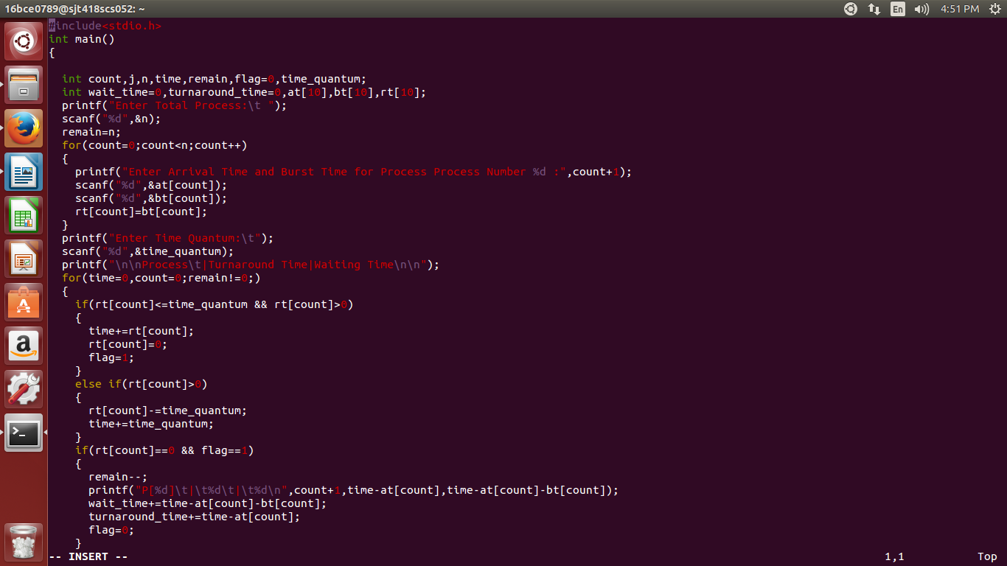

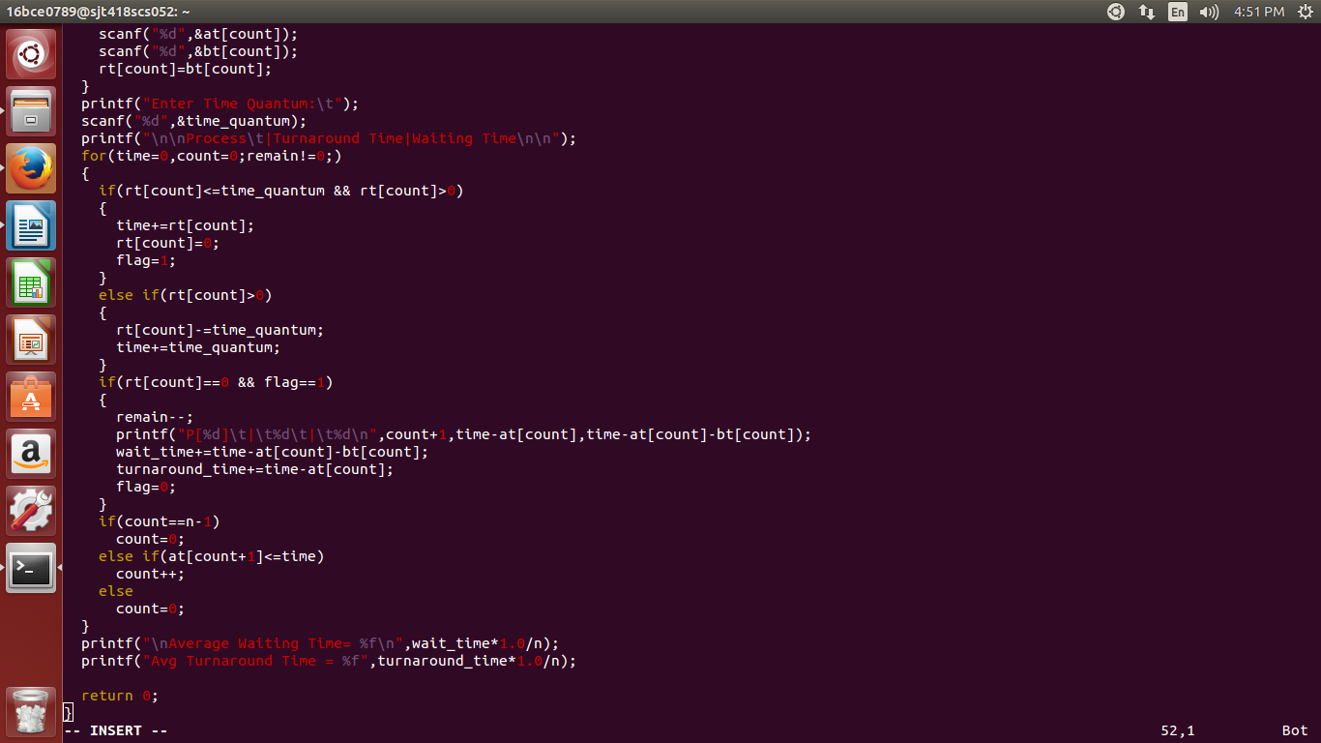

The Output:

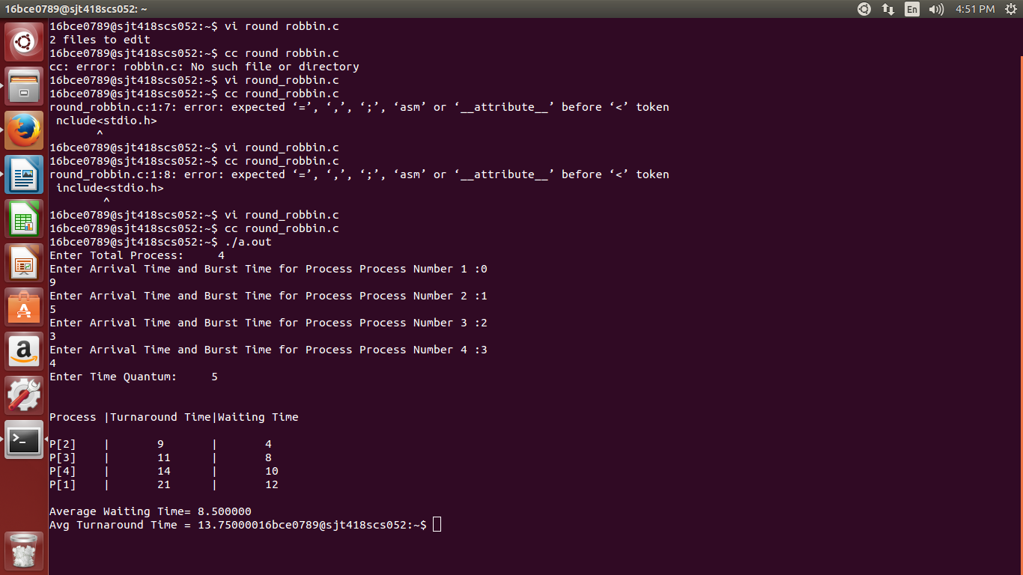

**SHORTEST REMAINING TIME FIRST**

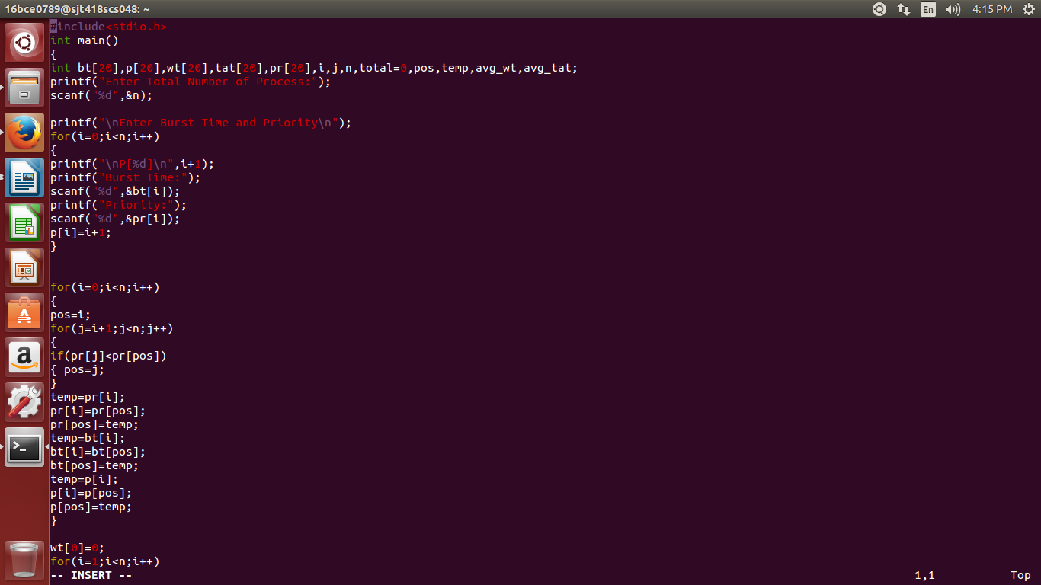

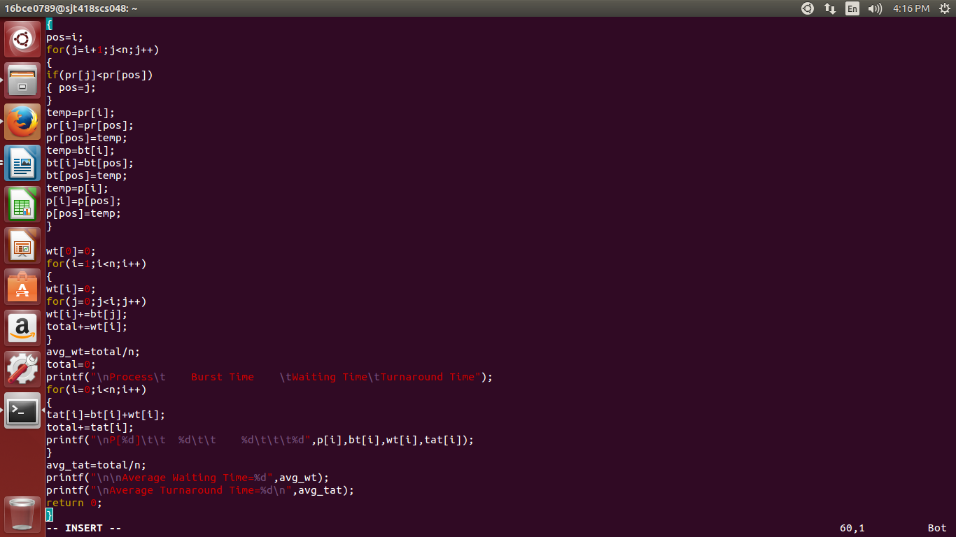

The Output:

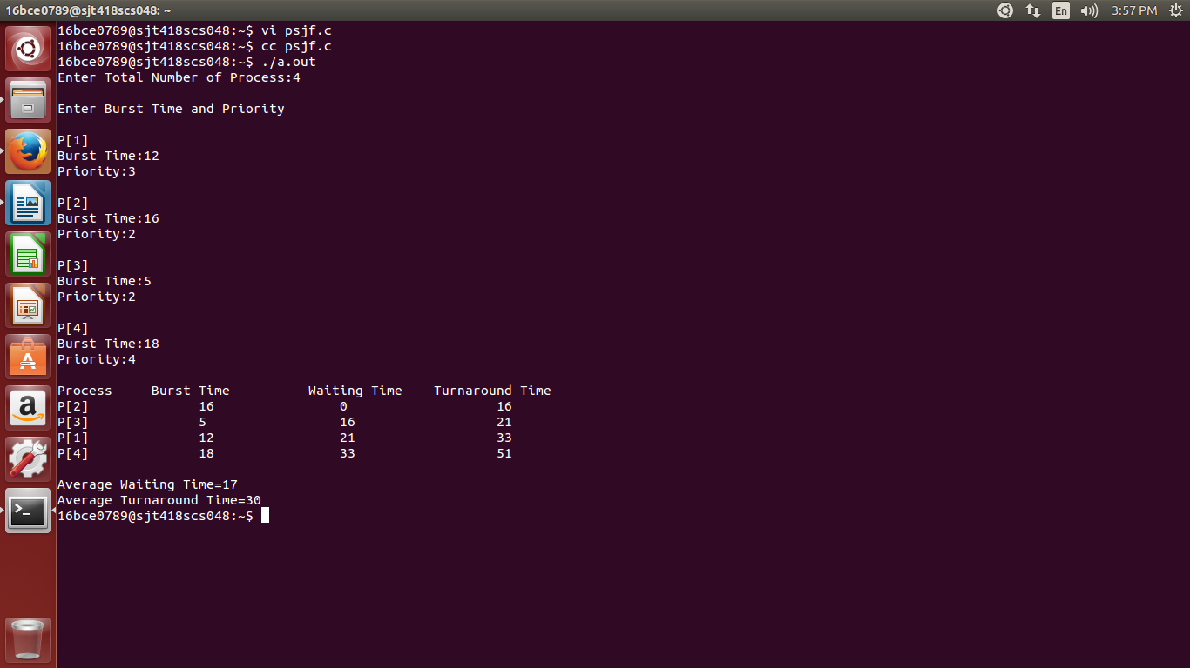

**PREEMPTIVE PRIORITY SCHEDULING**

#include<stdio.h>

int main()

{

int i,j,n,time,sum_wait=0,sum_turnaround=0,smallest;

int at[10],bt[10],pt[10],rt[10],remain;

printf("Enter no of Processes : ");

scanf("%d",&n);

remain=n;

for(i=0;i<n;i++)

{

printf("Enter arrival time, burst time and priority for process p%d :",i+1);

scanf("%d",&at[i]);

scanf("%d",&bt[i]);

scanf("%d",&pt[i]);

rt[i]=bt[i];

}

pt[9]=11;

printf("\n\nProcess\t|Turnaround time|waiting time\n");

for(time=0;remain!=0;time++)

{

smallest=9;

for(i=0;i<n;i++)

{

if(at[i]<=time && pt[i]<pt[smallest] && rt[i]>0)

{

smallest=i;

}

}

rt[smallest]--;

if(rt[smallest]==0)

{

remain--;

printf("P[%d]\t|\t%d\t|\t%d\n",smallest+1,time+1-at[smallest],time+1-at[smallest]-bt[smallest]);

sum_wait+=time+1-at[smallest];

sum_turnaround+=time+1-at[smallest]-bt[smallest];

}

}

printf("\nAvg waiting time = %f\n",sum_wait*1.0/n);

printf("Avg turnaround time = %f",sum_turnaround*1.0/n);

return 0;

}

The Output:

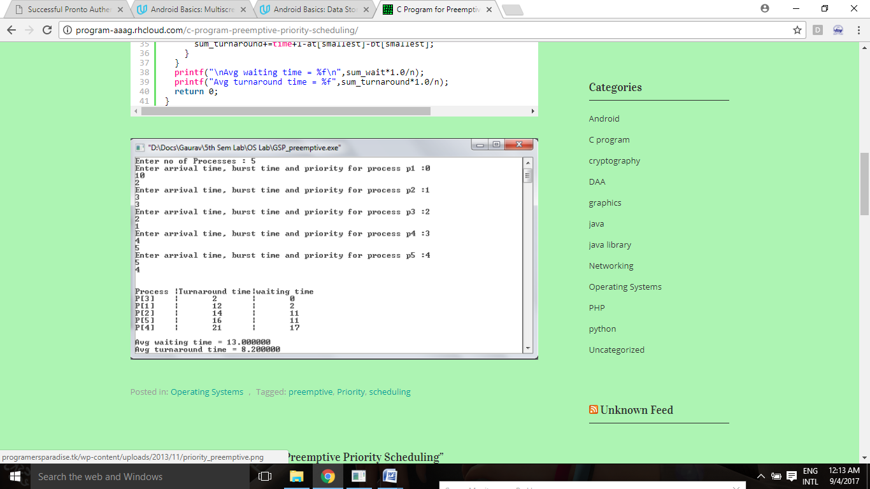

**THANK YOU**