Operating System

Lab Experiment

Name : Om Ashish Mishra

Reg. No.: 16BCE0789

Slot: B1+TB1

First Program(sum of two numbers)

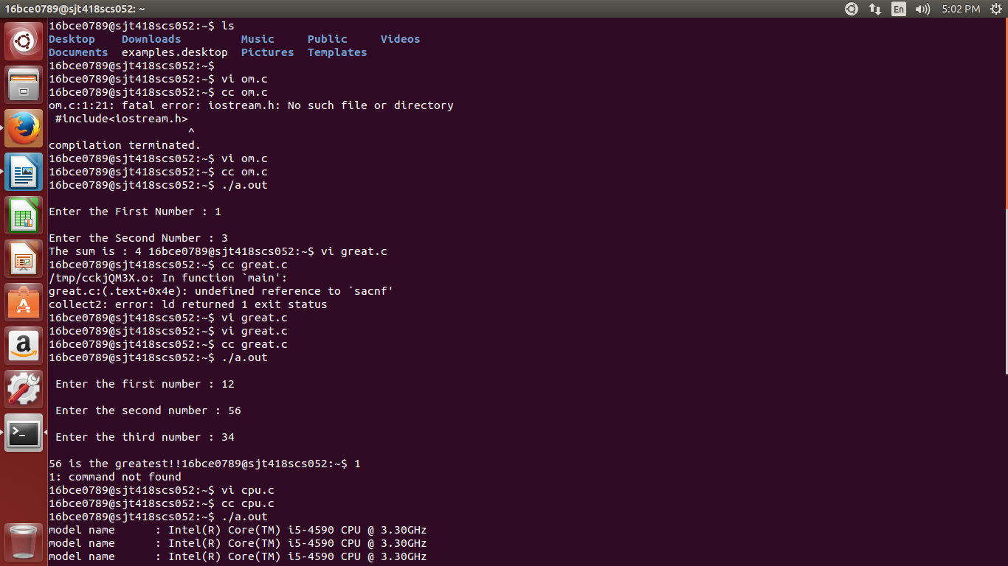

The program:

#include<stdio.h>

void main()

{

int a,b,c;

printf("\nEnter the First Number : ");

scanf("%d",&a);

printf("\nEnter the Second Number : ");

scanf("%d",&b);

c=a+b;

printf("The sum is : %d ",c);

}

Second Program(Greatest of 3 numbers)

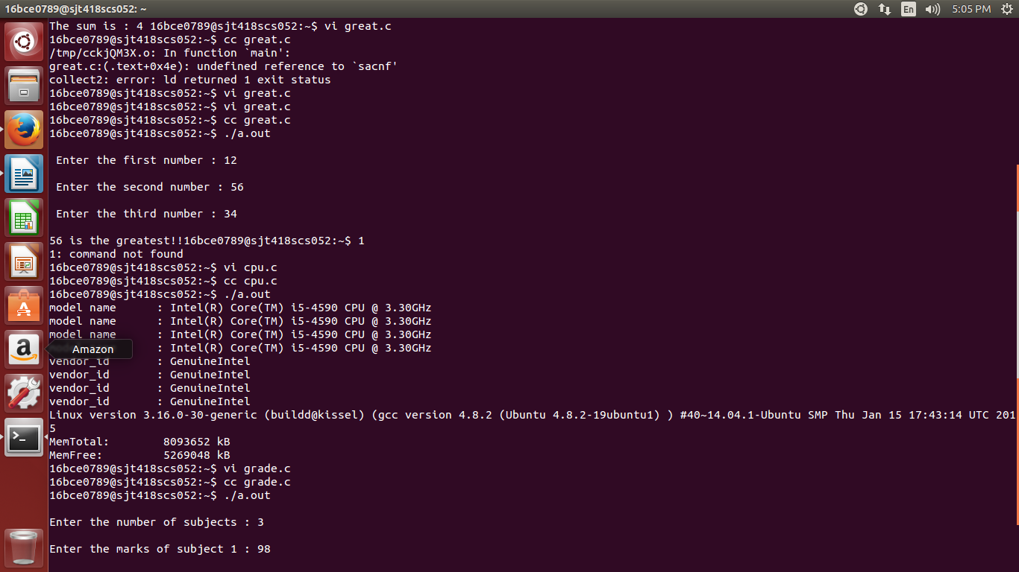

The program:

#include<stdio.h>

void main()

{

int a,b,c;

printf("\n Enter the first number : ");

scanf("%d",&a);

printf("\n Enter the second number : ");

scanf("%d",&b);

printf("\n Enter the third number : ");

scanf("%d",&c);

if(a>b && a>c)

printf("\n%d is the greatest!!",a);

else if(b>a && b>c)

printf("\n%d is the greatest!!",b);

else

printf("\n%d is the greatest!!",c);

}

Third program(cpu details)

The program:

#include<sys/types.h>

#include<stdio.h>

int main()

{

system("cat /proc/cpuinfo|grep 'model name' ");

system("cat /proc/cpuinfo|grep vendor_id");

system("cat /proc/version");

system("cat /proc/meminfo|grep MemTotal");

system("cat /proc/meminfo|grep MemFree");

return(0);

}

Forth program(grades)

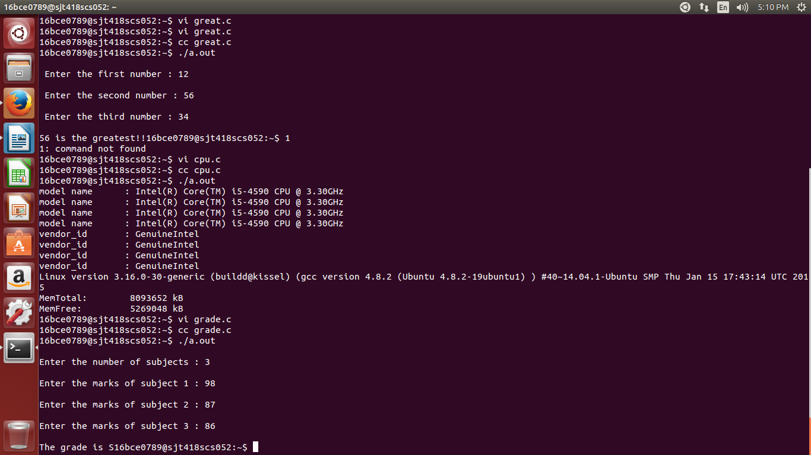

The program:

#include<stdio.h>

void main()

{

int n,i;

int a[100];

int sum=0,avg;

printf("\nEnter the number of subjects : ");

scanf("%d",&n);

for(i=0;i<n;i++)

{

printf("\nEnter the marks of subject %d : ",(i+1));

scanf("%d",&a[i]);

}

for(i=0;i<n;i++)

{

sum=sum+a[i];

}

avg=(sum/n);

if(avg>=90)

printf("\nThe grade is S");

else if(avg<90 && avg>=80)

printf("\nThe grade is A");

else if(avg<80 && avg>=70)

printf("\nThe grade is B");

else if(avg<70 && avg>=60)

printf("\nThe grade is C");

else if(avg<60 && avg>=50)

printf("\nThe grade is D");

else if(avg<50 && avg>=40)

printf("\nThe grade is E");

else

printf("\nThe grade is F");

}