Operating System

Lab Experiment

Name : Om Ashish Mishra

Reg. No.: 16BCE0789

Slot: A1+TB1

**INFO:**

The program:

#!/bin/bash

echo "Hello$LOGNAME"

echo "Current Date is `date`"

echo "User is `whoami`"

echo "Current Directory is `pwd`"

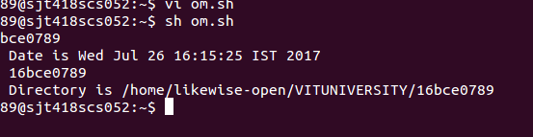

**READ THREE NUMBERS FROM STANDARD INPUT AND PRINT THE MINIMUM VALUE AND MAXIMUM:**

echo Enter 3 numbers with spaces in between

read a b c

l=$a

if [ $b -gt $l ]

then

l=$b

f

if [ $c -gt $l ]

then

l=$c

fi

echo Lagest of $a $b $c is $l

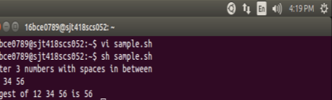

**TO SWAP TWO NUMBERS WITHOUT USING 3RD VARIABLE:**

#!/bin/bash

echo "enter frst number"

read a

echo "enter second number"

read b

echo "a before swapping is $a and b is $b"

#swapping

a=$((a+b))

b=$((a - b))

a=$((a-b))

echo "a after swapping is $a and b is $b"

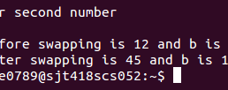

**TO READ THE MARKS OF A STUDENT AND PRINT THE GRADE:**

echo "Enter name of the student"

read name

echo "Enter Reg. number"

read num

echo "Enter the marks of the student"

read m1 m2 m3 m4 m5

echo "Name of the student is $name"

echo "Reg. number of the student is $num"

echo "Marks obtained"

echo "M1 M2 M3 M4 M5"

echo $m1 $m2 $m3 $m4 $m5

per=`echo \($m1 + $m2 + $m3 + $m4 + $m5\) /5|bc`

echo Percentage is $per

if test $per -ge 60

then

echo "Grade : First"

elif test $per -ge 50 -a $per -le 59

then

echo "Grade : Second"

elif test $per -ge 40 -a $per -le 49

then

echo "Grade : Third"

else

echo "Fail”

fi

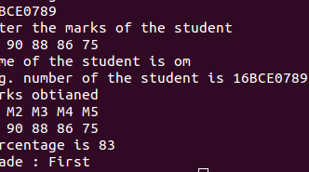

**TO READ TWO INTEGER NUMBERS AND PERFORM BASIC ARITHMETIC OPERATIONS BASED ON**

**USER’S CHOICE (USE ‘CASE’ STRUCTURE):**

clear

sum=0

i="y"

echo " Enter the frst no."

read n1

echo "Enter the second no."

read n2

while [ $i = "y" ]

do

echo "1.Addition"

echo "2.Subtraction"

echo "3.Multiplication"

echo "4.Division"

echo "Enter your choice"

read ch

case $ch in

1)sum=`expr $n1 + $n2`

echo "Sum ="$sum;;

2)sum=`expr $n1 - $n2`

echo "Sub = "$sum;;

3)sum=`expr $n1 \* $n2`

echo "Mul = "$sum;;

4)sum=`expr $n1 / $n2`

echo "Div = "$sum;;

*)echo "Invalid choice";;

esac

echo "Do u want to continue ?"

read i

if [ $i != "y" ]

then

exit

fi

done

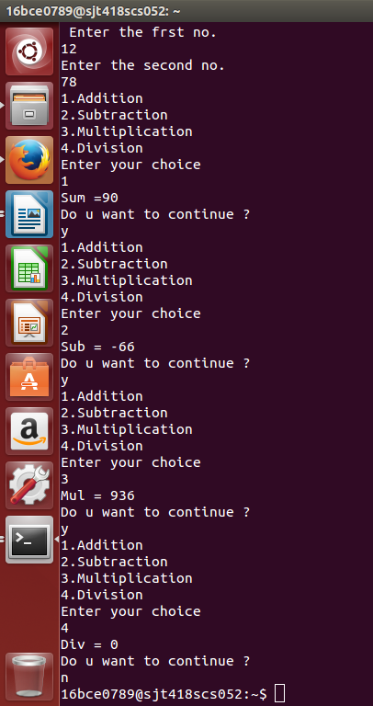

**TO FIND THE SUM OF FIRST ‘N’ NATURAL NUMBERS (USE ‘WHILE’ STRUCTURE):**

echo -n "Enter the value of n : "

read n

# store single digit

i=1

# store number of digit

sum=0

# use while loop to caclulate the sum of all digits

while [ $i -le $n ]

do

sum=$(( $sum + $i )) # calculate sum of digit

i=$(( $i + 1 ))

done

echo "Sum of all $n natural numbers is $sum"



**THANK YOU**