Lab Experiment 4

Name: Om Ashish Mishra

Registration Number: 16BCE0789

The Orphan process

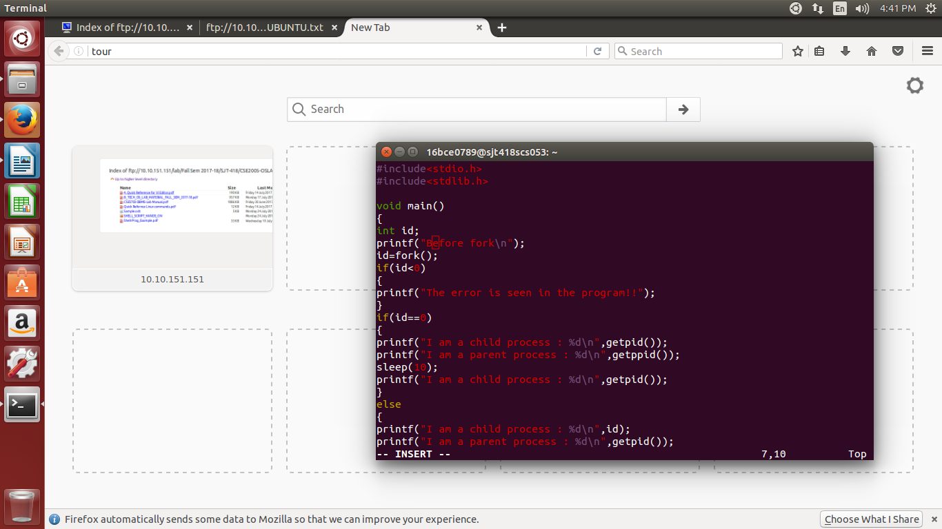

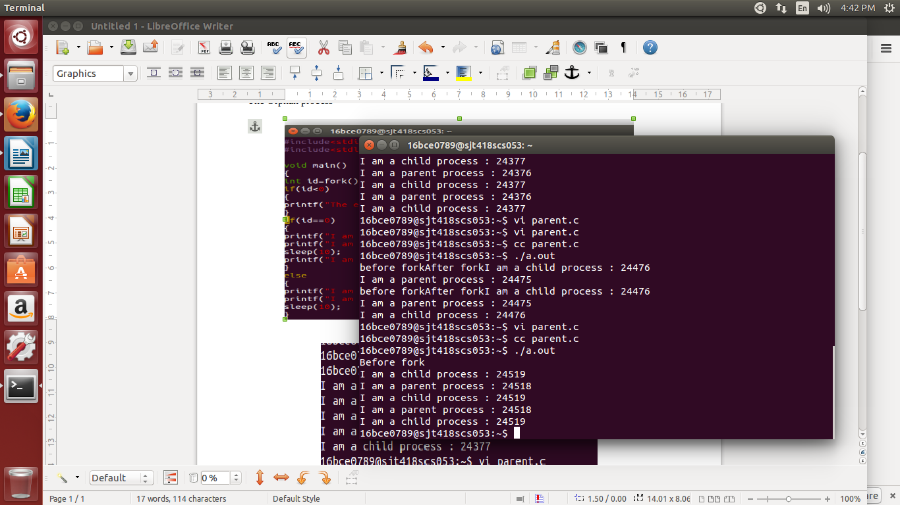

First Come First Serve(FCFS)

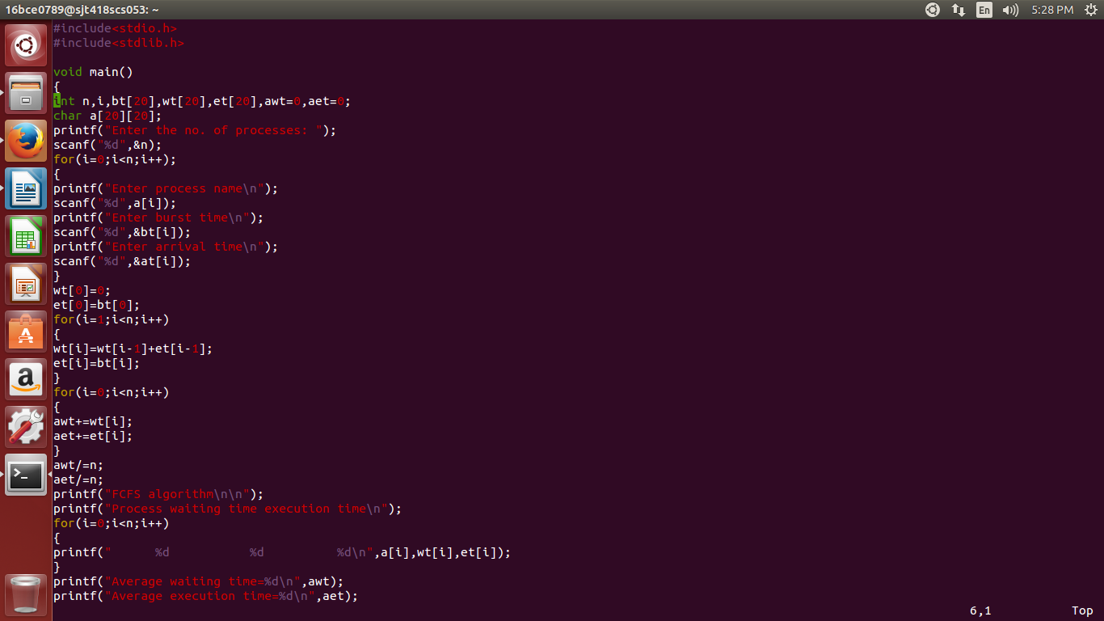

The OUTPUT: