Name : Om Ashish Mishra

Registration Number: 16BCE0789

**A. Round Robbin**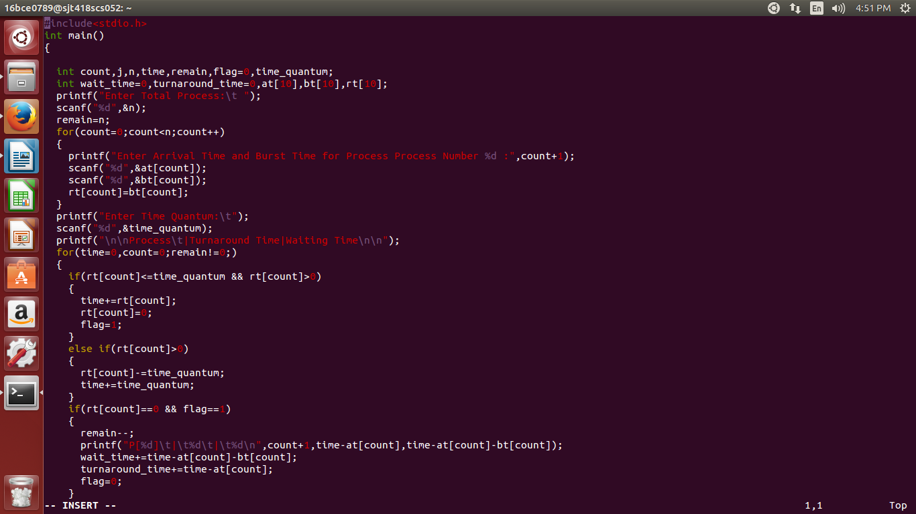

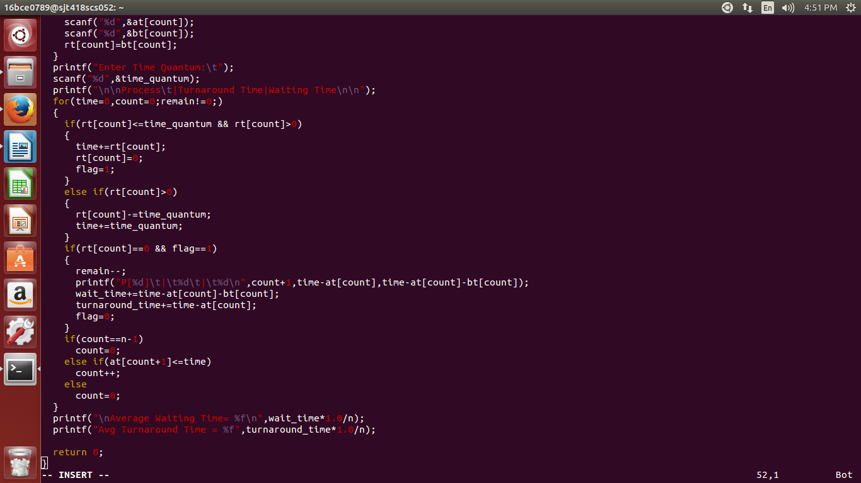

The Output:

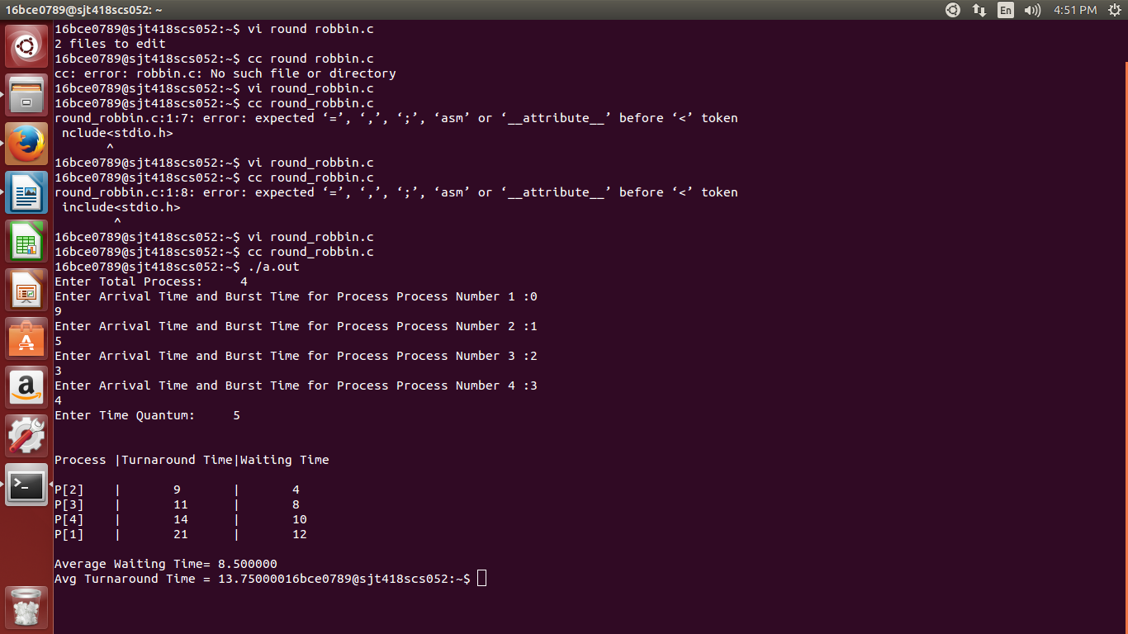

#include<stdio.h>

int main()

{

int count,j,n,time,remain,flag=0,time_quantum;

int wait_time=0,turnaround_time=0,at[10],bt[10],rt[10];

printf("Enter Total Process:\t ");

scanf("%d",&n);

remain=n;

for(count=0;count<n;count++)

{

printf("Enter Arrival Time and Burst Time for Process Process Number %d :",count+1);

scanf("%d",&at[count]);

scanf("%d",&bt[count]);

rt[count]=bt[count];

}

printf("Enter Time Quantum:\t");

scanf("%d",&time_quantum);

printf("\n\nProcess\t|Turnaround Time|Waiting Time\n\n");

for(time=0,count=0;remain!=0;)

{

if(rt[count]<=time_quantum && rt[count]>0)

{

time+=rt[count];

rt[count]=0;

flag=1;

}

else if(rt[count]>0)

{

rt[count]-=time_quantum;

time+=time_quantum;

}

if(rt[count]==0 && flag==1)

{

remain--;

printf("P[%d]\t|\t%d\t|\t%d\n",count+1,time-at[count],time-at[count]-bt[count]);

wait_time+=time-at[count]-bt[count];

turnaround_time+=time-at[count];

flag=0;

}

if(count==n-1)

count=0;

else if(at[count+1]<=time)

count++;

else

count=0;

}

printf("\nAverage Waiting Time= %f\n",wait_time*1.0/n);

printf("Avg Turnaround Time = %f",turnaround_time*1.0/n);

return 0;

}

**B. Shortest Remaining Time First**

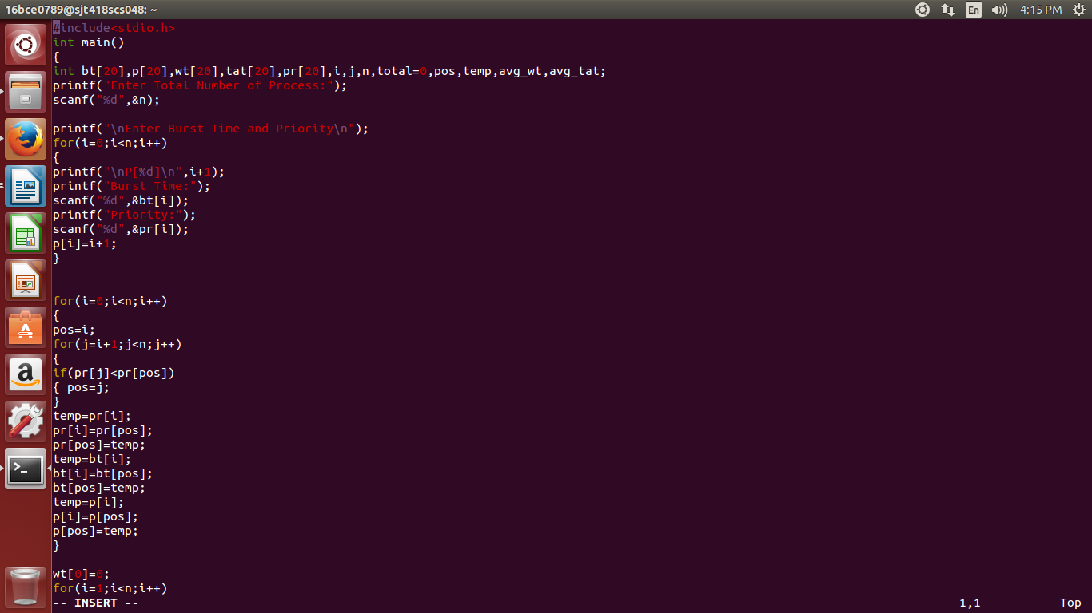

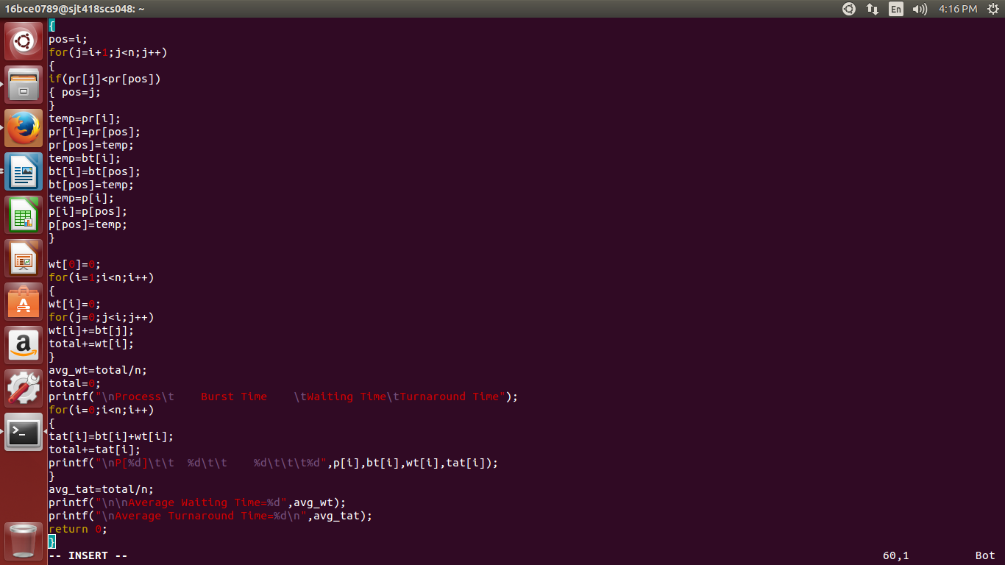

The Output:

**C.Proirity SJF**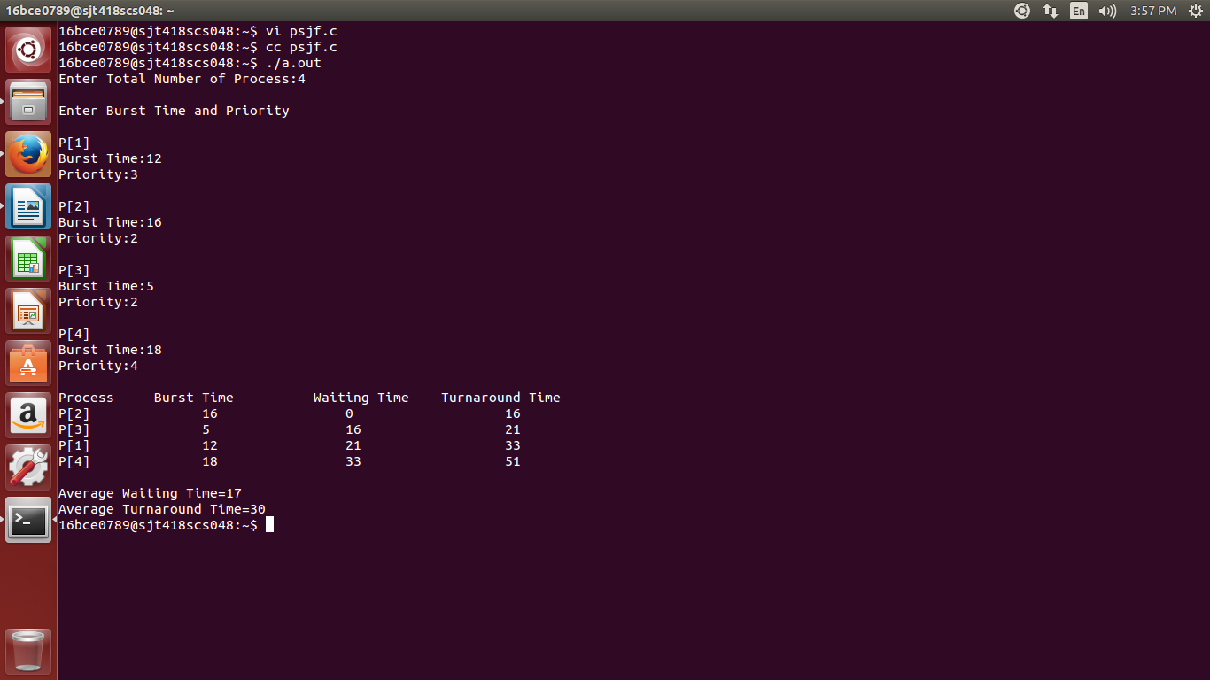





The Output:



**D. Priority Scheduling:**

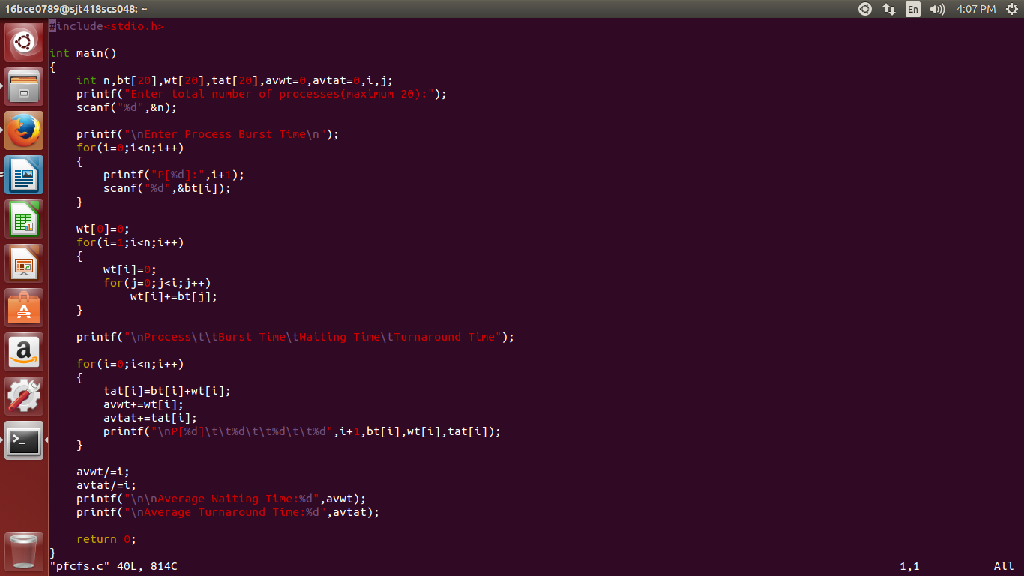

The OUTPUT:

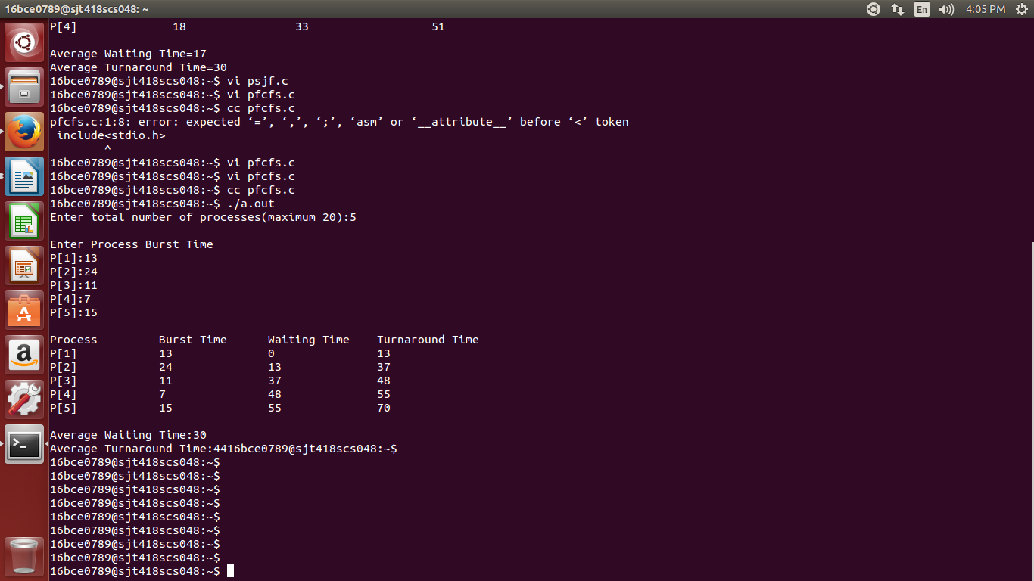

**E. FCFS**

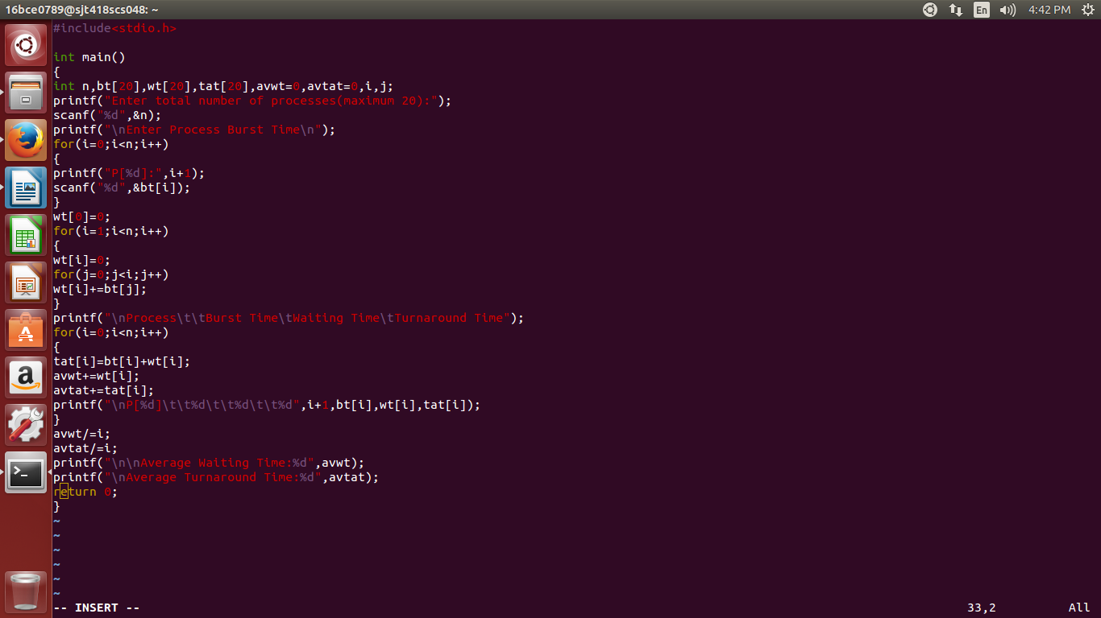

The Output:

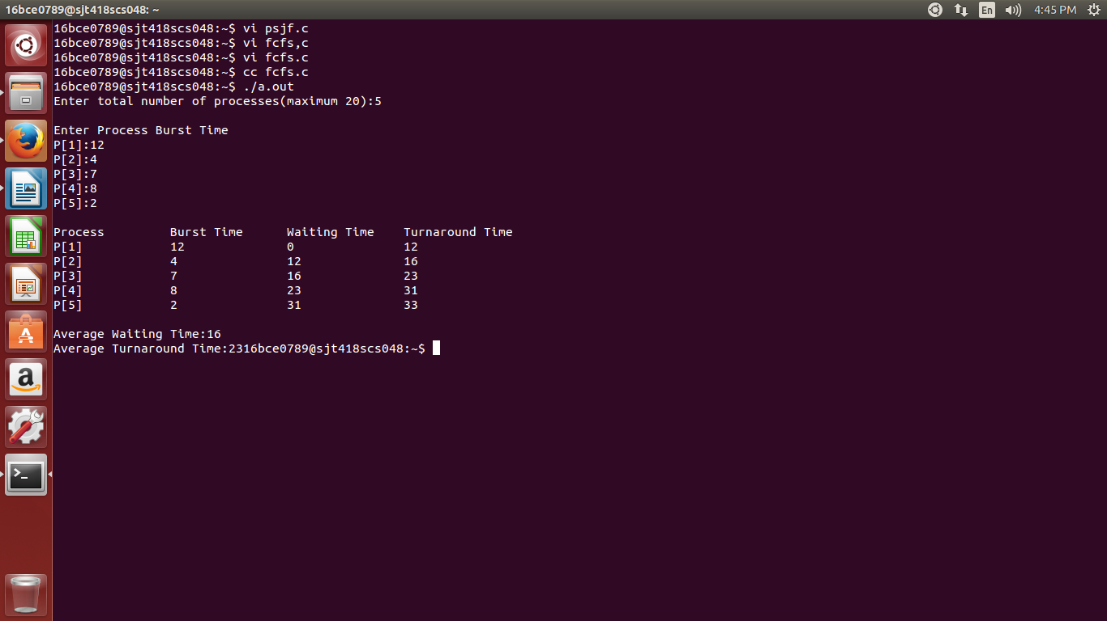

**F. SJF**

