Microprocessor and Interfacing Lab Experiment

Name: Om Ashish Mishra
Registration Number: 16BCE0789
Slot: B2

1. Write an ALP to perform the sum and average of 5 numbers stored in the address location 2000h
onwards and put the result in memory locations starting from 5000h onwards.

Title of the program : Average of 5 numbers

Aim : Calculating the average using address space given by the user

Memory Address Instruction and Result :

Instruction | Memory Address | Hex Code
mov bx, 02000h
mov al,[bx]
inc bx
mov cl,[bx]
add al,cl
inc bx
mov dl,[bx]
add al,cl
inc bx
mov dl,[bx]
add al,dl
mov cl,04h
div cl
mov [5000h],al
mov [5001h],ah
hlt

Test Cases : Input Value and the result:

Input Value:

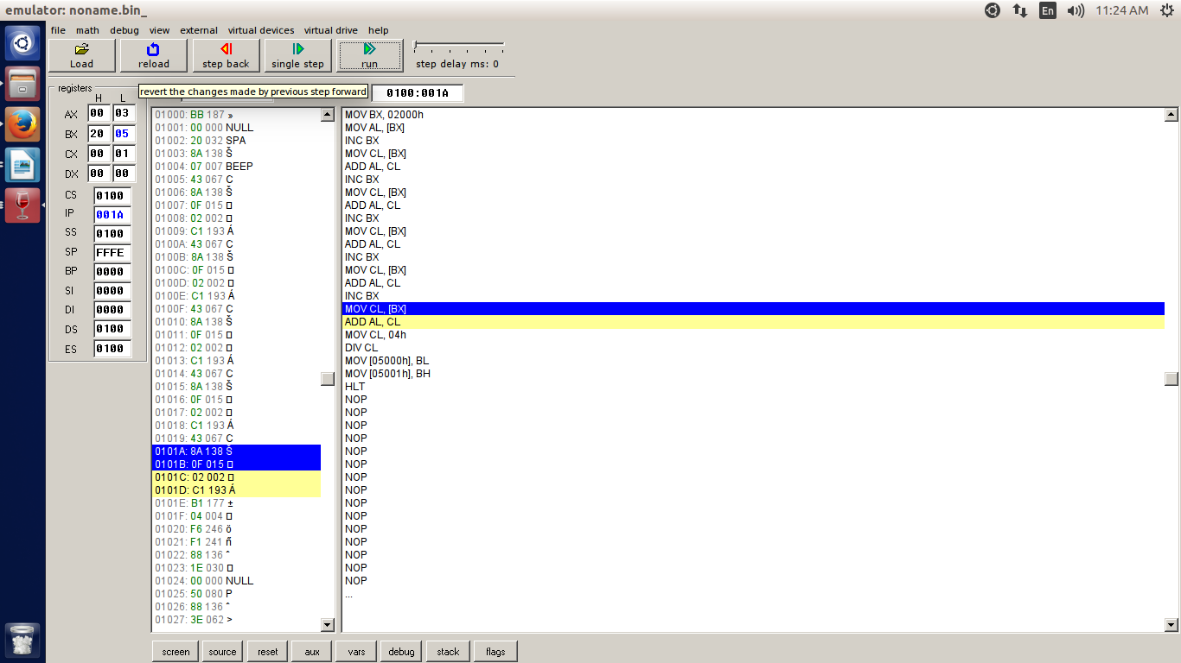
Result:

Test Cases : Input Value and the result:

2. Write a program to count the number of zeros in the given set of five numbers in the memory
.(Hint: put the data in the memory location starts from 2000h)

Title of the program : Number of Zeroes

Aim : Calulate the Numbert of Zeroes in a given set of 5 numbers

Memory Address Instruction and Result :

mov bx, 2000h
mov cl, 00h
mov al,[bx]
cmp al,00h
jne next1
inc cl
next1:inc bx
mov al,[bx]
cmp al, 00h
jne next2
inc cl
next2: inc bx
mov al,[bx]
jmp al,00h
jne next3
inc cl
next3:inc bx
mov al,00h
jne next4
inc cl
next4: inc bx
mov al,[bx]
cmp al,00h
jne stop
inc cl
stop: hit

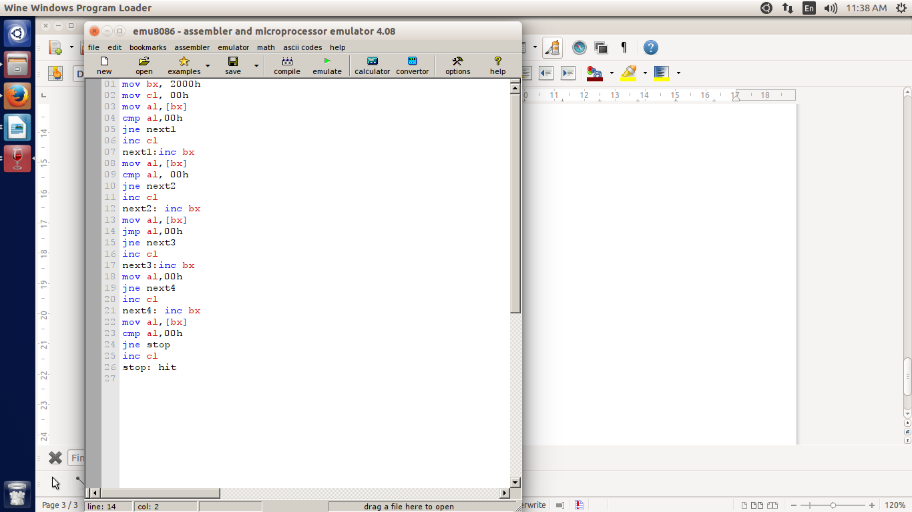

Test Cases : Input Value and the result:

Input Value:

Result:

