Microprocessor and Interfacing Lab Experiment

Name: Om Ashish Mishra
Registration Number: 16BCE0789
Slot: B2

1 Count number of vowels

Write a program to count number of vowels.
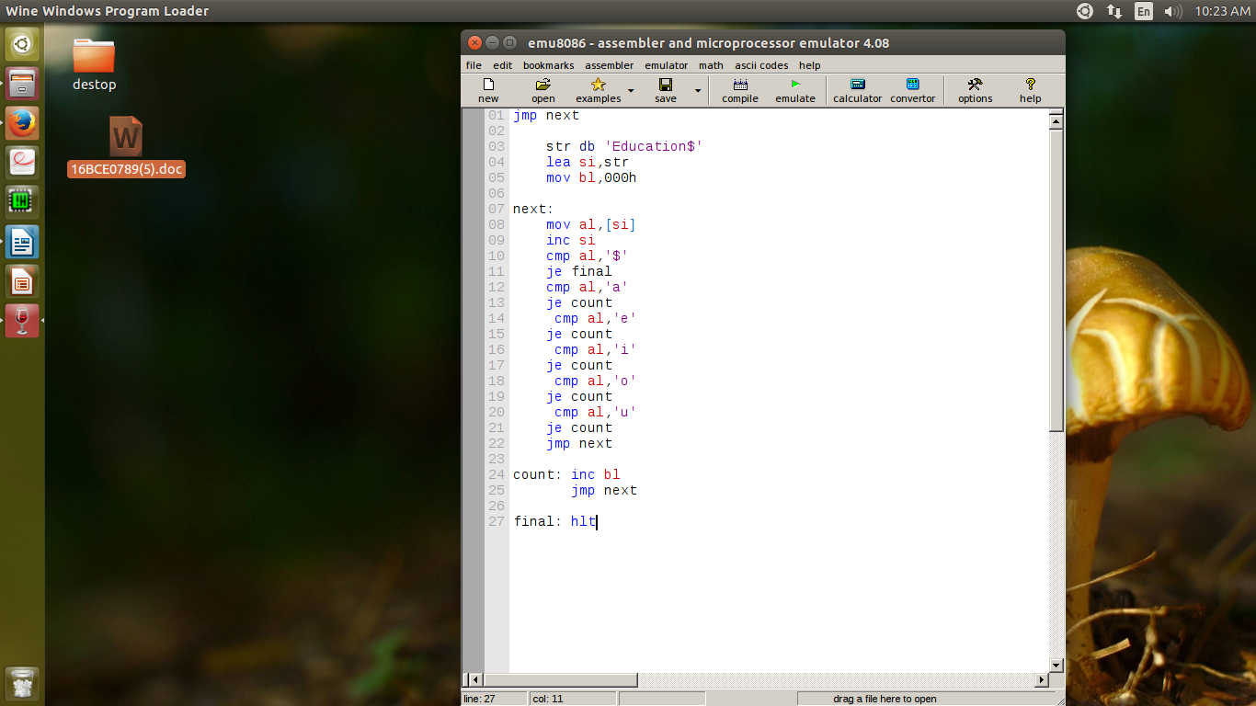
Aim: Count number of vowels.

Algorithm:

Step 1: First we take a string and store it (here the string is Education)
Step 2: Then we change the value of bl as 0h as we are going to use it for counter.
Step 3: Then we run a loop where we check if it is a vowel('a','e';'i','o','u').
Step 4: If vowel the value of bl is increased else we chech the next element by incresing si and going back to the loop.
Step 5: On every count the value of count increases
Step 6: Thus we get the value no of vowels and we stop.

Memory Address | Instruction | Hex code
1000 1001 | Jmp next | EB,0F
1002 1003 | Str db 'education$' | 8A,D8
1004 1005 | Lea si,str | FE,CB
1006 1007 | Mov bl,000h | 8A,4F
1011 1012 | Next: mov al,[si] | 8A,4f
1013 | Inc si | 46
1014 1015 | Cmp al,'$' | 3C,24

1016 1017 | Je final | 74 1A
1018 1019 | Cmp al,'a' | 3C 61
101A 101B | Je final | 74 0B
101C 101D | Cmp al,'e' | 3C 65
101E 101F | Je final | 74 0E
1020 1021 | Cmp al,'i' | 3C 69
1022 1023 | Je final | 74 0A
1024 1025 | Cmp al,'o' | 3C 6F
1026 1027 | Je final | 74 06
1028 1029 | Cmp al,'u' | 3C 75
102A 102B | Je count | 74 02
102C 102D | Jmp next | EF E4
102E 102F | Count: inc bl | EB E3
1030 1031 | Jmp next | FE E3
10321033 | Final: hlt | F4

Result:

The result of number of vowels is 05h.

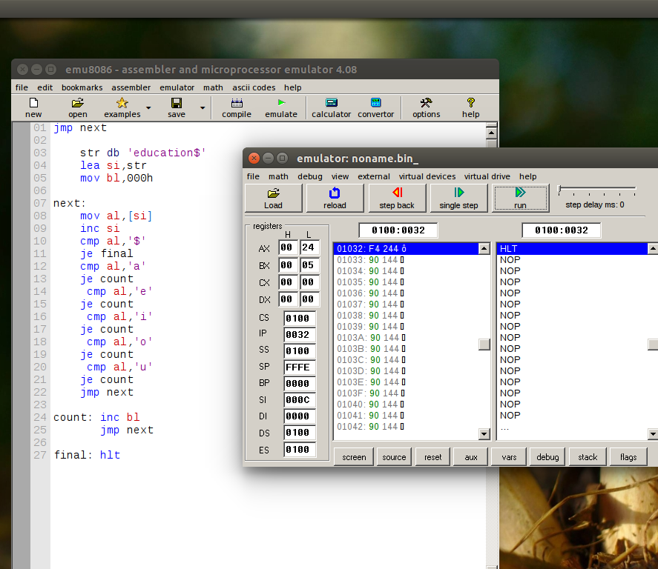

2 ALP to compare 2 strings

Write a program to compare two strings
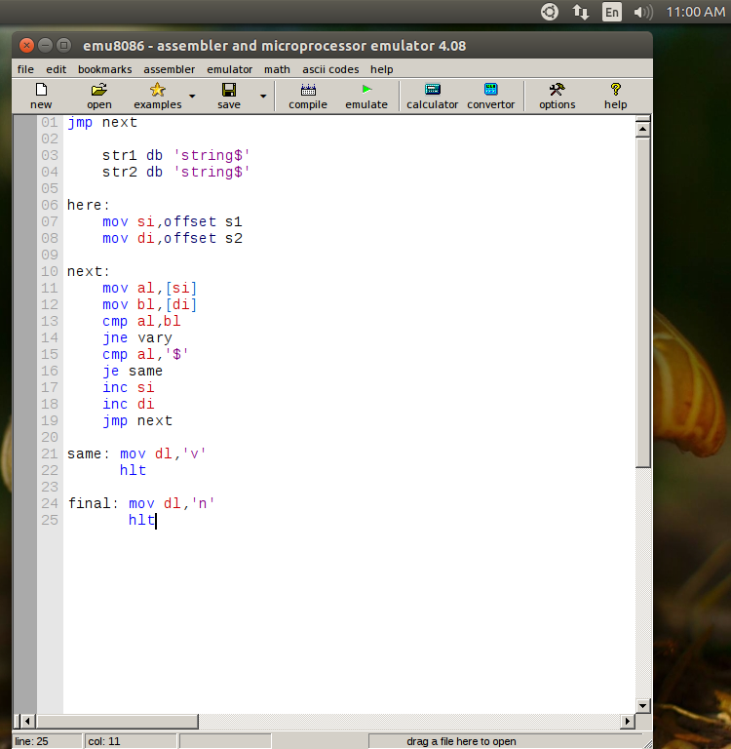
Aim: Compare two strings

Algorithm:

Step 1: First we store the value f two strings one in si and other in di using offset.
Step 2: Then we compare them using cmp instruction.
Step 3: If it varies we go to vary and stop else we continue.
Step 4: Then we check whether we reached the end if yes we go to same and stop.
Step 5: Inorder go back into the loop we use increase of si and di.
Step 6: We get the result same or not.

Memory Address | Instruction | Hex code
1000 1001 | Jmp next | B0,05
1002 1003 | Str1 db 'string$' | 8A,D8
1004 1005 | Str2 db 'string$' | FE,CB
1006 1007 | Here: mov si,offset s1 | F6,E3
1008 1009 100A | Mov di, offset s2 | 80,FB,02
100B 100C | Next: mov al,[si] | 75,F7
100D | Mov bl, [di] | F4

1016 1017 | Cmp al,bl | 74 1A
1018 1019 | Jne vary | 3C 61
101A 101B | Cmp al,'$' | 74 0B
101C 101D | Je same | 3C 65
101E 101F | Inc si | 74 0E
1020 1021 | Inc di | 3C 69
1022 1023 | Jmp next | 74 0A
1024 1025 | Same: mov dl, 'v' | 3C 6F
1026 1027 | hlt | 74 06
1028 1029 | Final: mov dl,'n' | 3C 75
102A 102B | hlt | 74 02

Result:

The result is both the strings are equal.

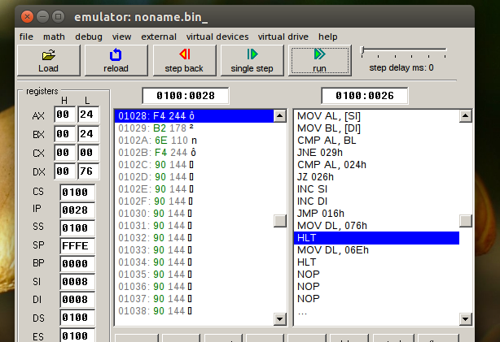

3 Find length of the string

Write a program to find the length of the string.

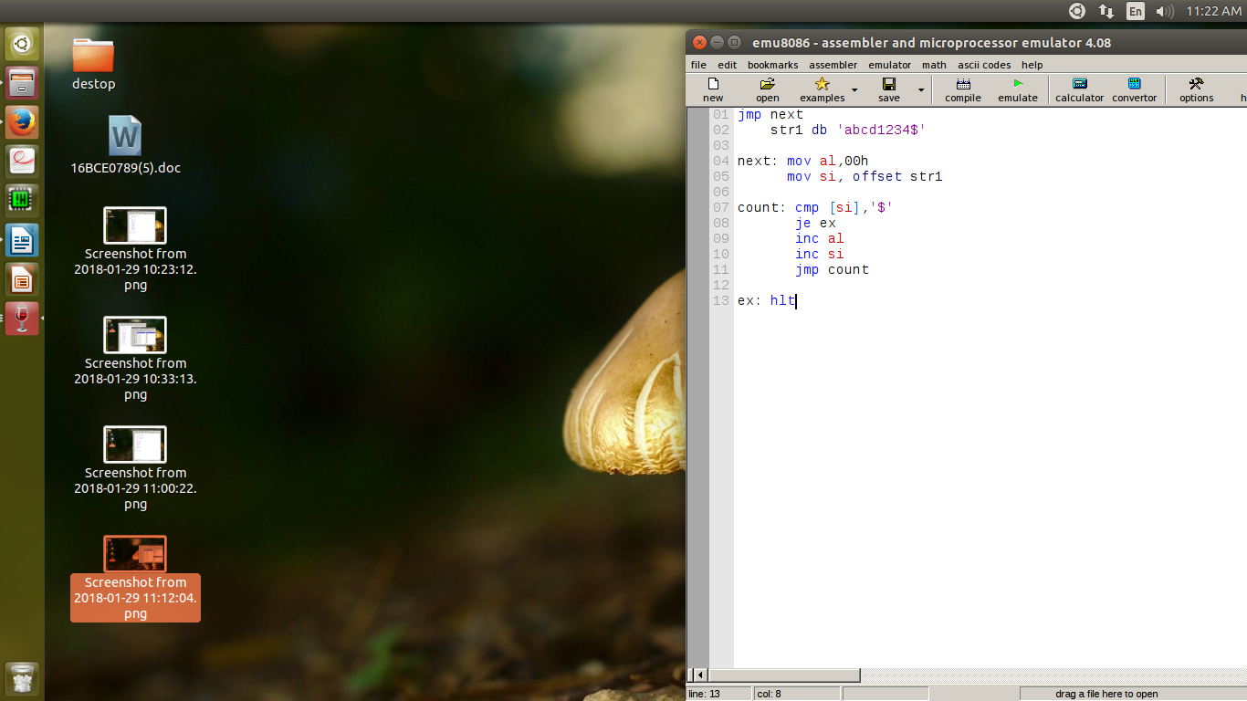

Aim: Lenth of the string

Algorithm:

Step 1: First we store the value of the string
Step 2: Then we run a loop check if we have reached the end.
Step 3: In the process the value of counter keeps on incresing and thus the program ends
Step 4: We get the result.

Memory Address | Instruction | Hex code
1000 1001 | Jmp next | B0,05
1002 1003 | Str1 db 'abcd1234$' | 8A,D8
1004 1005 | Next: mov al,00h | FE,CB
1006 1007 | mov si,offset s1 | F6,E3
1008 1009 100A | Count: cmp [si], '$' | 80,FB,02
100B 100C | Je ex | 75,F7
100D | Inc al | F4

1016 1017 | Inc si | 74 1A
1018 1019 | Jmp count | 3C 61
101A 101B | Ex: hlt | 74 0B

Result:

The length of the string is 8.
