Microprocessor and Interfacing Lab Experiment 4

Name: Om Ashish Mishra
Registration Number: 16BCE0789
Slot: B2

LOOP

Factorial

Write a program to find the factorial of a number with /without using loop instruction.

Without Loop
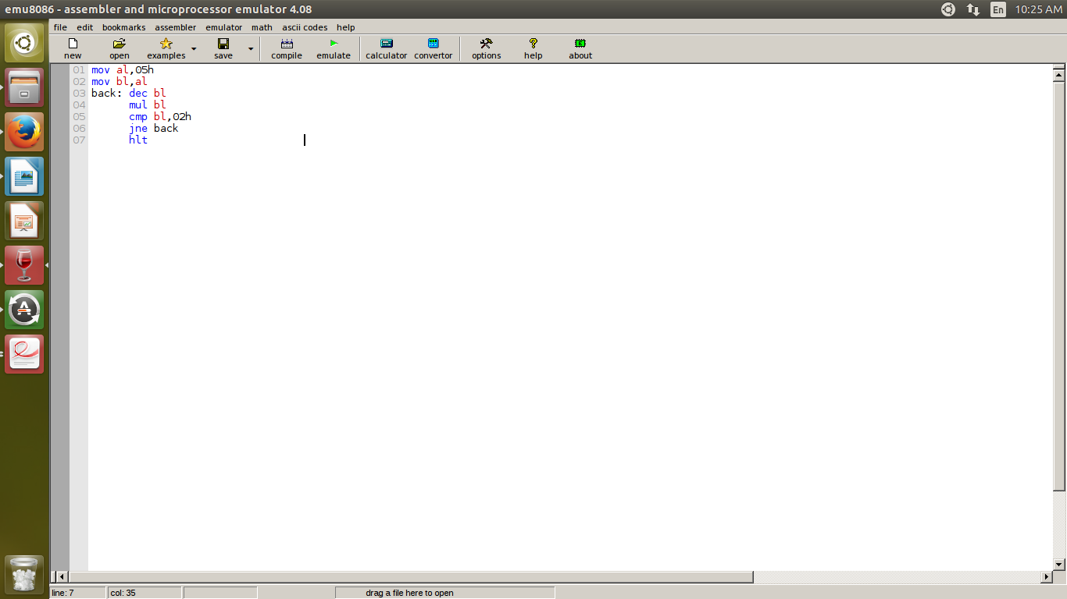
Aim: Factorial without loop

Algorithm:

Step 1: First we store the value of the 5 in al.
Step 2: Then we store the value of al in bl which will calculate the factorail
Step 3: Then we decrease the value of bl.
Step 4: The multiplication takes place between bl prevoius value and bl.
Step 5: Compare the new value with 02h
Step 6: if not euql then we back to dec bl and to multiply with bl.
Step 7: else we got to hlt
Step 8: We get the result.

Memory Address | Instruction | Hex code
1000 1001 | Mov al,05h | B0,05
1002 1003 | Mov bl,al | 8A,D8
1004 1005 | Back: dec bl | FE,CB
1006 1007 | Mul bl | F6,E3
1008 1009 100A | Cmp bl,02h | 80,FB,02
100B 100C | Jne back | 75,F7
100D | hlt | F4

Result:

The result of factorial is 78h.

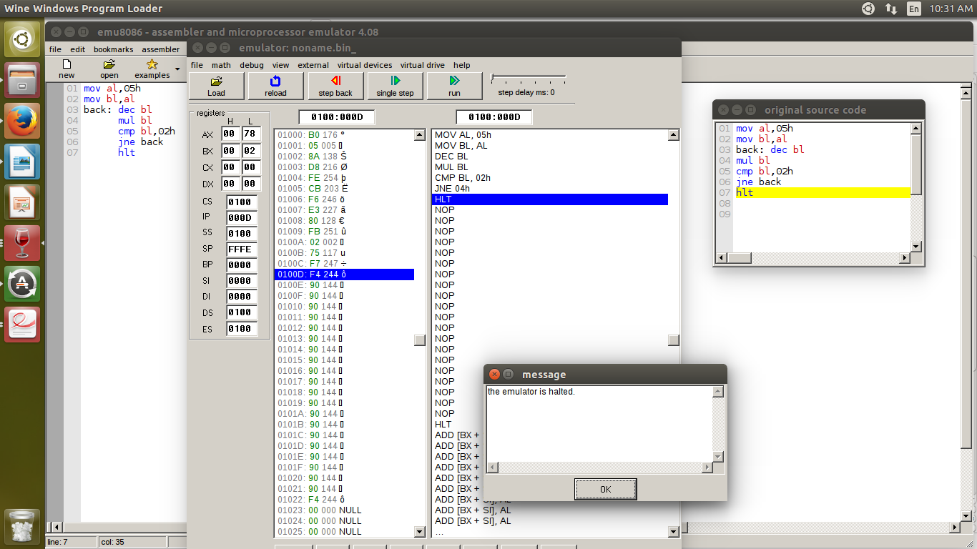

With Loop
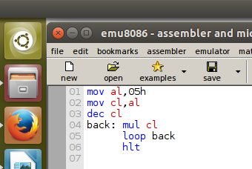
Aim: Factorial with loop

Algorithm:

Step 1: First we store the value of the 5 in al.
Step 2: Then we store the value of al in cl which will calculate the factorial
Step 3: Then we decrease the value of cl.
Step 4: The multiplication takes place between cl prevoius value and cl.
Step 5: We continue to loop in 01h
Step 8: We get the result.

Memory Address | Instruction | Hex code
1000 1001 | Mov al,05h | B0,05
1002 1003 | Mov cl,al | 8A,C8
1004 1005 | dec cl | FE,C9
1006 1007 | Back: mul cl | F6,E1
1008 1009 | Loop back | E2,FC
0110A | hlt | F4

Result:

The result of factorial is 78h.

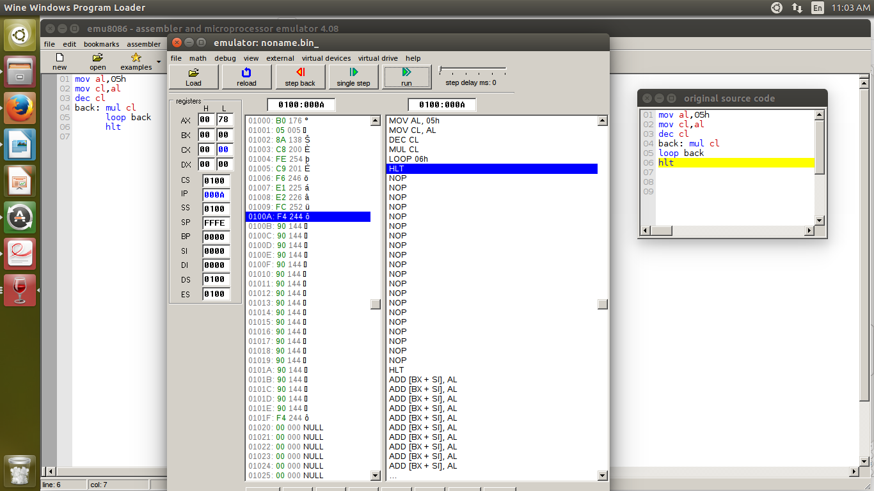
Multiplication of table 5
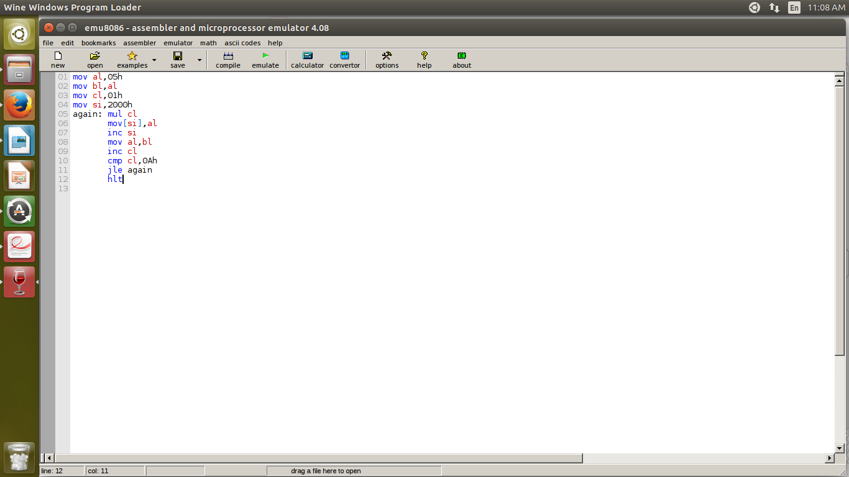
Aim: Multiplication of table 5

Algorithm:

Step 1: First we store the value of the 5 in al.
Step 2: Then we store value of al in bl
Step 3: Then we store value of 01h in cl which is the counter.
Step 4: We call si(stack Initailor) to store the value of address 2000h.
Step 5: Now the looping starts and we multiply cl's value with bl.
Step 6: increase the value of the address location
Step 7: Refresh the value of the al from bl
Step 8: increaswe the counter value
Step 9: comapare for equal to 10h
Step 10: if yes we hlt and get the result.
Step 11: else we go back into the loop

Memory Address | Instruction | Hex code
1000 1001 | Mov al,05h | B0,05
1002 1003 | Mov bl,al | 8A,D8
1004 1005 | Mov cl,01h | B1,01
1006 1007 1008 | Mov si,2000h | BE,00,20
1009 100A | Agian: mul cl | F6,E1
0100B 0100C | Mov [si],al | 88,04
0100D | Inc si | 46
0100E 0100F | Mov al,bl | 8A,C3
01010 01011 | Inc cl | FE,C1
01012 01013 01014 | Cmp cl,0Ah | 80,F9,0A
01015 01016 | Jle, again | 7E,F2
01017 | hlt | F4

Result:

The table represents multiplication of 5 from 1 to 10.

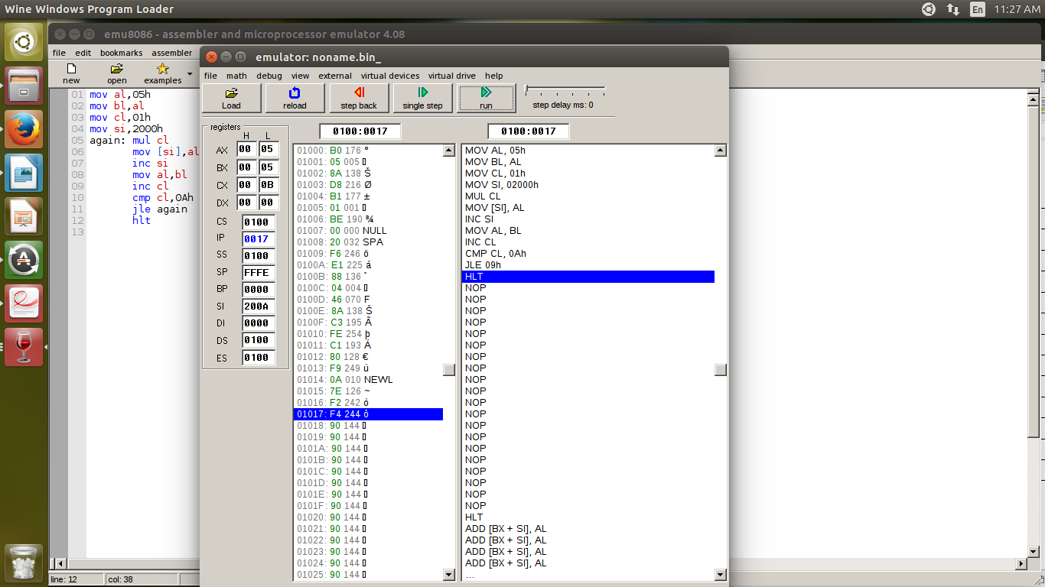

Multiplication through Rotation
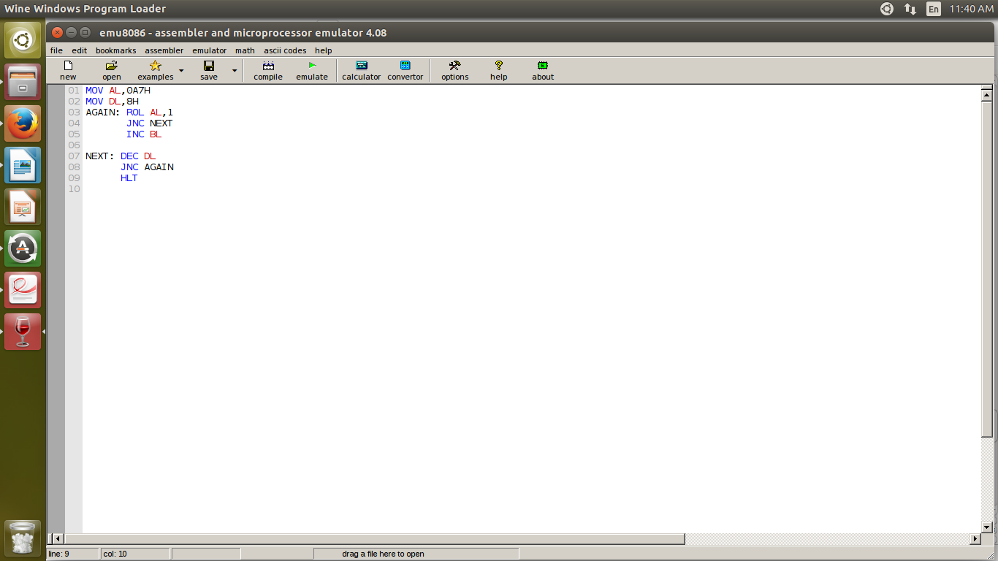
Aim: Multiplication through Rotation

Algorithm:

Step 1: First we store the value of the 0A7h in al.
Step 2: The value of 8 is stored in dl.
Step 3: Then we run a loop to ratate the al by 1
Step 4: if carry has 1 then we decearse by 1 else we increse the value by 1
Step 5: then we increse the value of bl and go back into the loop till the end is considered
Step6: The result is shown.

Memory Address | Instruction | Hex code
1000 1001 | Mov al,0A7h | B0,A7
1002 1003 | Mov dl,08h | B2,08
1004 1005 | Again: rol al,1 | D0,C0
1006 1007 | Jnc next | 73,02
1008 1009 | Inc bl | FE,C3
0110A 100B | Next: dec dl | FE,CA
100C 100D | Jnz again | 75,F6
100E | hlt | 23

Result:

The representation of multiplication through rotation.

