DevOps
RESOURCES 2
Some Resume Ready DevOps projects (Part-I) 2
Some Resume Ready DevOps projects (Part-II) 3
Some Resume Ready DevOps projects.(Part-III) 4
Real-world Prometheus Deployment: A Practical Guide for Kubernetes Monitoring 4
DevOps With AWS 5
Course Details 5
AWS Certifications 5
Client Server Architecture 5
1-Tier Architecture (Single Layer) 7
2-Tier Architecture 8
3-Tier Architecture 10
Network Infrastructure and DNS 13
HTTP & HTTPS Concepts 15
OSI Model (Open Systems Interconnection) 17
AWS Services Overview 18
AWS Overview and Shared Responsibility Model 18
Elasticity 20
High Availability (HA) 21
AWS Global Infrastructure - Regions and Availability Zones (AZs) 22
EC2, Load Balancer, Elastic Beanstalk & LightSail 24
AWS Lambda for EC2 Automation 26
AWS Elastic Block Storage (EBS) 28
AWS S3 (Simple Storage Service) 30

RESOURCES

Some Resume Ready DevOps projects (Part-I)
1⃣ 𝗝𝗲𝗻𝗸𝗶𝗻𝘀 𝗖𝗜𝗖𝗗 𝘄𝗶𝘁𝗵 𝗚𝗶𝘁𝗛𝘂𝗯 𝗜𝗻𝘁𝗲𝗴𝗿𝗮𝘁𝗶𝗼𝗻
🔗 https://lnkd.in/gbDBEASe

🔢 𝗗𝗲𝗽𝗹𝗼𝘆 𝗝𝗮𝘃𝗮 𝗮𝗽𝗽𝗹𝗶𝗰𝗮𝘁𝗶𝗼𝗻 𝘄𝗶𝘁𝗵 𝗖𝗼𝗺𝗽𝗹𝗲𝘁𝗲 𝗖𝗜/𝗖𝗗 𝗽𝗶𝗽𝗲𝗹𝗶𝗻𝗲 𝗝𝗲𝗻𝗸𝗶𝗻𝘀
🔗 https://lnkd.in/gSJaF4VN

🔢 𝗗𝗲𝘃𝗢𝗽𝘀 𝗖𝗜𝗖𝗗 𝗣𝗶𝗽𝗲𝗹𝗶𝗻𝗲 𝗦𝗲𝘁𝘂𝗽 𝗧𝗵𝗿𝗼𝘂𝗴𝗵 { 𝗝𝗲𝗻𝗸𝗶𝗻𝘀 | 𝗡𝗲𝘅𝘂𝘀 | 𝗦𝗼𝗻𝗮𝗿𝗾𝘂𝗯𝗲 | 𝗧𝗼𝗺𝗰𝗮𝘁 | 𝗠𝗮𝘃𝗲𝗻 }
🔗 https://lnkd.in/gvDYKMxV

🔢 𝗝𝗲𝗻𝗸𝗶𝗻𝘀 𝗖𝗜𝗖𝗗 𝘄𝗶𝘁𝗵 𝗚𝗶𝘁𝗛𝘂𝗯 𝗜𝗻𝘁𝗲𝗴𝗿𝗮𝘁𝗶𝗼𝗻
🔗 https://lnkd.in/g-eaM_EA

🔢 𝗖𝗼𝗻𝘁𝗶𝗻𝘂𝗼𝘂𝘀 𝗗𝗲𝗹𝗶𝘃𝗲𝗿𝘆 𝗣𝗶𝗽𝗲𝗹𝗶𝗻𝗲 𝗳𝗼𝗿 𝗔𝗺𝗮𝘇𝗼𝗻 𝗘𝗖𝗦 𝗨𝘀𝗶𝗻𝗴 𝗝𝗲𝗻𝗸𝗶𝗻𝘀, 𝗚𝗶𝘁𝗛𝘂𝗯, 𝗮𝗻𝗱 𝗔𝗺𝗮𝘇𝗼𝗻 𝗘𝗖𝗥
🔗 https://lnkd.in/gN7WXAnX

🔢 𝗣𝗿𝗼𝘃𝗶𝘀𝗶𝗼𝗻𝗶𝗻𝗴 𝟮-𝘁𝗶𝗲𝗿𝘀 𝗮𝗻𝗱 𝟯-𝘁𝗶𝗲𝗿𝘀 𝗔𝗪𝗦 𝗩𝗣𝗖 𝗶𝗻𝗳𝗿𝗮𝘀𝘁𝗿𝘂𝗰𝘁𝘂𝗿𝗲 𝘂𝘀𝗶𝗻𝗴 𝗧𝗲𝗿𝗿𝗮𝗳𝗼𝗿𝗺
🔗 https://lnkd.in/g2Y_Nk6N

🔢 𝗕𝗲𝘀𝘁 𝗝𝗲𝗻𝗸𝗶𝗻𝘀 𝗣𝗶𝗽𝗲𝗹𝗶𝗻𝗲 𝗧𝘂𝘁𝗼𝗿𝗶𝗮𝗹 𝗙𝗼𝗿 𝗕𝗲𝗴𝗶𝗻𝗻𝗲𝗿𝘀
🔗 https://lnkd.in/gF93WwrB

🔢 𝗘𝗻𝗱 𝘁𝗼 𝗘𝗻𝗱 𝗖𝗜/𝗖𝗗 𝗽𝗶𝗽𝗲𝗹𝗶𝗻𝗲 𝘂𝘀𝗶𝗻𝗴 𝗚𝗶𝘁𝗛𝘂𝗯 𝗔𝗰𝘁𝗶𝗼𝗻𝘀 𝗳𝗼𝗿 𝗔𝗻𝗱𝗿𝗼𝗶𝗱 𝗔𝗽𝗽𝗹𝗶𝗰𝗮𝘁𝗶𝗼𝗻
🔗 https://lnkd.in/gB-Vvi7r

🔢 𝗖𝗿𝗲𝗮𝘁𝗲, 𝗽𝘂𝗯𝗹𝗶𝘀𝗵, 𝗮𝗻𝗱 𝘀𝘁𝗼𝗿𝗲 𝗡𝗴𝗶𝗻𝘅 𝗗𝗼𝗰𝗸𝗲𝗿 𝗶𝗺𝗮𝗴𝗲 𝗶𝗻 𝗔𝗪𝗦 𝗦𝟯 𝘂𝘀𝗶𝗻𝗴 𝗗𝗼𝗰𝗸𝗲𝗿 𝗮𝗻𝗱 𝗕𝗮𝘀𝗵
🔗 https://lnkd.in/g4iUncv9

Some Resume Ready DevOps projects (Part-II)

➡️ Real-Time CI CD Pipeline From Scratch with Jenkins:-
🔗 https://lnkd.in/day6k4GE

➡️ Creating AWS EKS Cluster using Terraform:-
🔗 https://lnkd.in/gjtjHuw4

➡️ Cost Optimization through AWS Lambda Function:-
🔗 https://lnkd.in/drDazJ9E

➡️ AWS Ninja — Convert EBS Volume from gp2 to gp3:-
🔗 https://lnkd.in/d6mUFdEK

➡️ Real-World CI/CD DevSecOps Pipeline for Deployment of Python Web-app:-
🔗 https://lnkd.in/d-TJisDn

➡️ AWS S3 Event Triggering Shell Script Used by Netflix, Airbnb, Adobe, Expedia, and Others :-
🔗 https://lnkd.in/dXhzdwP8

➡️ Deploy Multi Stage CICD Pipeline with Amazon EKS :-
🔗 https://lnkd.in/dEn7Vexj

➡️ Deploying Spring Boot application on K8S :-
🔗 https://lnkd.in/d8E_N_eg

➡️ Netflix Clone application via K8's:-
🔗 https://lnkd.in/d2zBUdMG
🔗 https://lnkd.in/dPVTDK9r

➡️ Deploy a Flask Application to a EKS Cluster using Jenkins and ArgoCD :-
🔗 https://lnkd.in/dn8WtnWj

Some Resume Ready DevOps projects.(Part-III)
➡️ Deploying Super Mario on Amazon EKS
🔗 (https://lnkd.in/d2JVCw6M)

➡️ 🚀 Designing a 10-Microservices Application Deployment on EKS! 🤖
🔗 (https://lnkd.in/dFuq9mMA)

➡️ Uber Clone DevSecOps Project
🔗 (https://lnkd.in/dTXm9_h9)

➡️ 3-Tier Robot Shop App On EKS
🔗 (https://lnkd.in/dtFK8Xj7)

➡️ Full Stack CICD Virtual Browser Project
🔗 (https://lnkd.in/d2ZErR2b)

Real-world Prometheus Deployment: A Practical Guide for Kubernetes Monitoring

🔗 Source Link: https://github.com/NotHarshhaa/Learning-Prometheus

🔗 Blog Link: https://blog.prodevopsguy.xyz/real-world-prometheus-deployment-a-practical-guide-for-kubernetes-monitoring

DevOps With AWS

Course Details
Section | Details
Course Strategy
Part 1: AWS - Manual | Focus on understanding and manually working with AWS core services.
Part 2: DevOps - Automation | Learn DevOps tools and practices for automating workflows and deployments.
Part 3: AWS with DevOps | Combine AWS services with DevOps practices for end-to-end cloud solutions.

AWS Certifications

Level | AWS Certifications | Description
Foundational | Cloud Practitioner | Covers AWS basics and is designed for individuals starting their cloud journey.
Associate | Developer Associate | Focuses on using AWS for application development and maintenance.
 | SysOps Admin Associate | Centers on deploying, managing, and operating scalable and fault-tolerant systems on AWS.
 | Solutions Architect Associate | Targets those designing distributed systems on AWS.
Professional | DevOps Engineer | Combines advanced AWS skills with DevOps principles for managing and automating infrastructure.
 | Solutions Architect Professional | Focuses on complex AWS architectures and advanced solution designs.

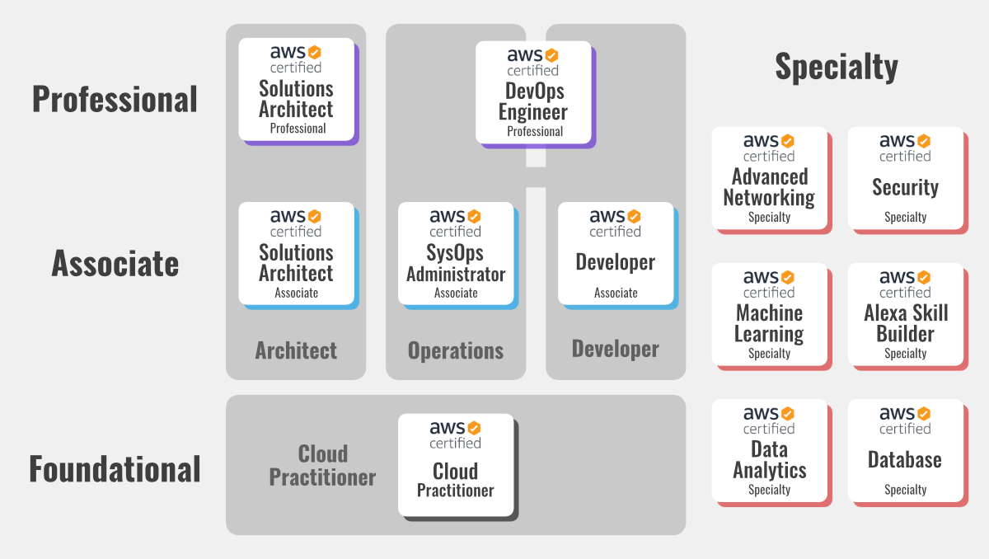

Client Server Architecture
Fundamentals
- Resource: Information or data that a client requests from a server.
- Client: A device or program that requests resources or services from a server. (e.g., Web browser, email client)
- Server: A device or program that provides resources or services to clients. (e.g., Web server, email server)
- Network: The communication pathway that connects clients and servers. (e.g., Internet, local network)
Key Concepts
- Request-Response Model:
  - Clients initiate communication by sending requests to the server.
  - Servers process requests and send back responses to the client.
- Role Flexibility: Devices can act as both a client and a server depending on the situation.
Example: Web Browsing
- You type "google.com" into your web browser (client).
- The browser sends a request over the internet to the Google server.
- The Google server receives the request and processes it.
- The server sends the requested webpage (resource) back to your browser.
- Your browser displays the webpage.
Advantages of Client-Server Architecture
- Centralized Data Management: Data is stored and managed on the server, making it easier to control access, maintain data integrity, and perform backups.
- Scalability: Servers can be upgraded or more servers can be added to handle increasing client demands.
- Security: Servers can implement security measures to protect data from unauthorized access.
- Flexibility: Clients and servers can be different types of devices running different operating systems.
Disadvantages of Client-Server Architecture
- Single Point of Failure: If the server fails, the entire system can be affected.
- Network Dependency: The system relies on a stable network connection.
- Cost: Servers can be expensive to purchase and maintain.
Additional Notes:
- Client-server architecture is a fundamental concept in networking and distributed computing.
- Many applications and services we use daily rely on this model (e.g., the web, email, online gaming).
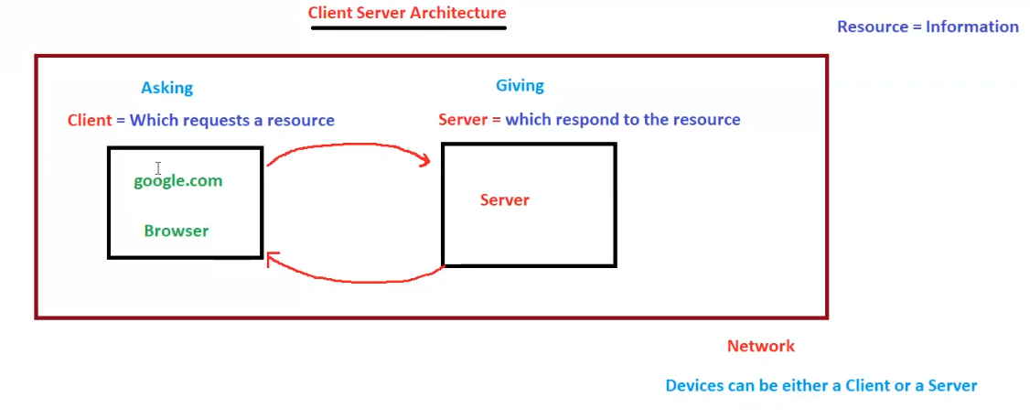

1-Tier Architecture (Single Layer)

Fundamentals
- Single Layer: All components (presentation, business logic, and data storage) reside on a single machine, often the user's local machine or a standalone server.
- Localhost: A hostname that refers to the current computer on which the code is running.
- Client/Server on Same Machine: The application acts as both the client and the server, running on the same system.
- Limited Scalability: Difficult to scale as all processing occurs on a single machine.
- Suitable for Simple Applications: Ideal for basic applications with low user traffic and minimal resource requirements.
Example: Local Development Environment
- A developer (like Ganesh in the diagram) builds and tests a website on their laptop.
- The website files, database, and browser all reside on the same machine.
- The developer accesses the website using "localhost" in the browser's address bar.
Advantages of 1-Tier Architecture
- Simplicity: Easy to set up and maintain due to its single-layer structure.
- Cost-Effective: No need for separate servers or network infrastructure.
- Suitable for Offline Use: Can function without a network connection.
Disadvantages of 1-Tier Architecture
- Limited Scalability: Cannot handle large numbers of users or complex applications.
- Security Concerns: Data might be more vulnerable as it resides on the same machine as the client.
- Performance Bottlenecks: All processing occurs on a single machine, which can lead to performance issues.
Additional Notes
- 1-tier architecture is often used for personal projects, small-scale applications, or during the initial development phase of larger projects.
- It is less common in production environments due to its limitations.
DEAD
- The "DEAD" label likely signifies that this architecture is not suitable for large-scale or complex applications due to its limitations in scalability and performance.
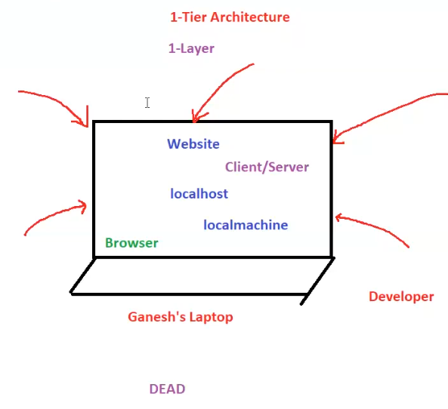

2-Tier Architecture

Fundamentals
- Two Layers:
  - Client Layer: Handles user interface and user interactions.
  - Server Layer: Houses the application logic and the database.
- Direct Communication: Clients communicate directly with the server.
- Suitable for Moderate-Scale Applications: Can handle more users and complexity than 1-tier but has limitations compared to 3-tier.
Components
- Clients: Various devices (e.g., computers, mobiles) running client applications.
- Server: A dedicated machine running the application and database.
- Application: Processes client requests, performs business logic, and interacts with the database. (e.g., written in Java, .NET, Python)
- Database: Stores and manages application data. (e.g., MySQL, Oracle, MS SQL)
Advantages of 2-Tier Architecture
- Improved Performance: Compared to 1-tier, separate server handles processing, potentially improving performance.
- Easier Development: Simpler to develop and maintain than more complex architectures.
- Cost-Effective: Less expensive than 3-tier as it requires fewer servers.
Disadvantages of 2-Tier Architecture
- Scalability Challenges: Can become a bottleneck as the number of users increases.
- Security Concerns: Direct client-server communication can pose security risks.
- Maintenance Overhead: Updates and modifications can be more complex as the application and database are tightly coupled.
"BIG NO FOR PROD"
- The image emphasizes that 2-tier architecture is generally not recommended for production environments, especially for large-scale or critical applications.
- This is due to its limitations in scalability, security, and maintainability.
Potential Issues Illustrated
- Server Overload: Multiple clients accessing the server simultaneously can lead to errors, slowdowns, crashes, and poor performance.
- Security Vulnerability: A "hacker" is shown, highlighting the potential security risks of direct client-server communication.
- Resource Constraints: The server having limited resources (2GB RAM) for both the application and database can further impact performance.
Example: "Tom and Jerry" Analogy
- "Tom" (application) and "Jerry" (database) constantly fighting represents the potential conflicts and performance issues when both reside on the same server with limited resources.
Additional Notes
- 2-tier architecture was more common in the early days of client-server computing.
- While not ideal for large production systems, it can still be suitable for certain applications with moderate user loads and less demanding requirements.
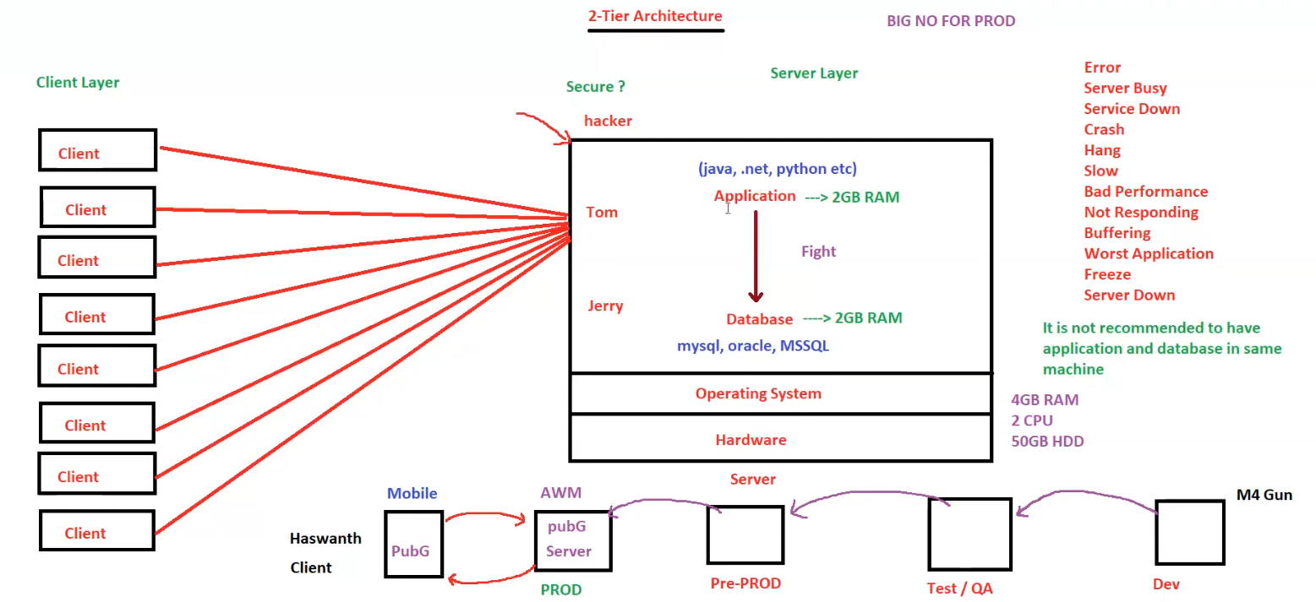

3-Tier Architecture

3-Tier Architecture
Fundamentals
- Three Layers:
  - Client Layer: Presentation tier (user interface) - interacts with the user.
  - Application Layer: Logic tier (business logic, application code) - processes data and handles business rules.
  - Database Layer: Data tier (data storage) - stores and manages data.
- Indirect Communication: Clients do not directly access the database; they interact with the application server.
- Enhanced Scalability and Security: Each tier can be scaled independently, and the database is protected behind the application server.
- Suitable for Complex Applications: Ideal for large-scale applications with high user traffic and complex requirements.
Components
- Clients: Devices like web browsers accessing the application.
- Web Server: Handles client requests and redirects them to the application server (e.g., Nginx, Apache, httpd).
- Application Server: Hosts the application logic and processes client requests (e.g., Tomcat, IIS).
- Database Server: Stores and manages the application's data (e.g., MySQL).
Communication Flow
- Client sends a request to the web server.
- Web server redirects the request to the application server.
- Application server processes the request, interacts with the database server if needed, and sends the response back to the web server.
- Web server forwards the response to the client.
Network Security
- Public Network: The web server is accessible from the public internet.
- Private Network: The application server and database server are in a private network, protected from direct access from the internet. This enhances security.
N-Tier Architecture
- Extends 3-Tier: Can have more than three tiers, with additional layers for tasks like security, caching, load balancing, etc.
- Increased Flexibility: Offers greater flexibility and scalability for complex applications.
Advantages of 3-Tier/N-Tier Architecture
- Scalability: Each tier can be scaled independently to handle increased load.
- Maintainability: Easier to maintain and update as changes in one tier don't necessarily affect others.
- Security: Database is protected behind the application server.
- Reusability: Components can be reused across multiple applications.
Disadvantages of 3-Tier/N-Tier Architecture
- Complexity: More complex to design and implement than 2-tier.
- Performance: Can be slower than 2-tier if not designed and optimized properly.
- Cost: May require more hardware and resources.
Additional Notes
- 3-tier and N-tier architectures are widely used for enterprise-level applications and web services.
- They provide a robust and scalable solution for handling complex applications and large user bases.
Diagram Explanation
The diagram illustrates the different tiers, components, and communication flow in a 3-tier architecture. It also highlights the importance of keeping the application server and database server in a private network for security reasons.
Key Terms
- IP Address: A unique identifier for a device on a network.
- Hostname: A human-readable name for a server.
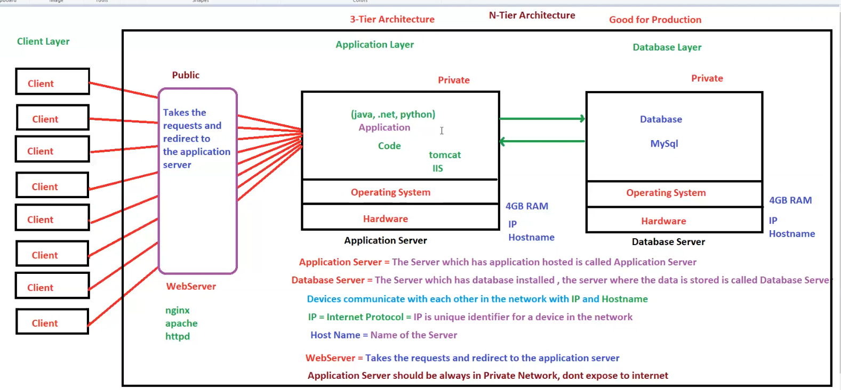

Tier 1 vs Tier 2 vs Tier 3
Feature | 1-Tier Architecture | 2-Tier Architecture | 3-Tier Architecture
Layers | Single | Two (Client, Server) | Three (Client, Application, Database)
Components | All components on one machine | Client and server | Client, web server, application server, database server
Communication | N/A (all on one machine) | Direct client-server | Client <-> Web Server <-> Application Server <-> Database Server
Scalability | Very limited | Moderate | High
Security | Low | Moderate | High
Complexity | Simple | Moderate | Complex
Performance | Limited by single machine | Can be improved over 1-tier | Potentially high with proper optimization
Cost | Low | Moderate | High
Typical Use Cases | - Personal projects  - Small-scale applications  - Local development | - Applications with moderate user load | - Enterprise applications  - High-traffic web services  - Complex systems
Suitable for Production? | No | Generally, not recommended | Yes
Advantages | - Simplicity  - Cost-effectiveness | - Improved performance over 1-tier  - Easier development than 3-tier | - High scalability  - Maintainability  - Security  - Reusability
Disadvantages | - Limited scalability  - Security concerns  - Performance bottlenecks | - Scalability challenges  - Security concerns  - Maintenance overhead | - Complexity  - Potential performance overhead  - Higher cost

Network Infrastructure and DNS
1. Domain Name System (DNS)
- Function: Translates human-readable domain names (e.g., google.com) into machine-readable IP addresses.
- Hierarchy:
  - Root Name Servers (RNS): The top of the hierarchy, responsible for delegating to Top-Level Domain (TLD) servers.
  - Top-Level Domains (TLDs): .com, .org, .in, etc.
  - Name Servers: Authoritative servers for specific domains, holding the actual IP address records (A records).
  - Local DNS: Cached records on a local network (e.g., your ISP's DNS server or a DNS server within your organization).
2. Network Components
- Firewall: A security device that controls network traffic based on rules (allow/deny), protecting against unauthorized access.
- Load Balancer (LB): Distributes incoming network traffic across multiple servers (e.g., web servers) to ensure high availability and performance.
3. Web Communication
- Browser: The client software used to access websites.
- Web Server: Hosts the website's files and serves them to users.
- Application Server: Handles the logic and processing of web applications.
- Database Server: Stores the data used by the application.
4. Protocols
- HTTP (Port 80): Unsecured protocol for transferring web content.
- HTTPS (Port 443): Secure protocol using SSL/TLS encryption for safe communication.
- SSH (Port 22): Secure protocol for remote access to Linux machines.
- RDP (Port 3389): Protocol for remote access to Windows machines.
5. Network Packet Flow
- Browser: Sends a DNS request for the hostname (e.g., google.com) to the Local DNS.
- Local DNS: Checks its cache. If not found, forwards the request up the DNS hierarchy.
- DNS Resolution: The request travels up to the Root Name Servers, then to the TLD server, and finally to the authoritative Name Server for the domain, which returns the IP address.
- Browser: Receives the IP address and sends an HTTP or HTTPS request to the web server at that address.
- Firewall: Checks the request against its rules.
- Load Balancer: If present, directs the request to an appropriate web server.
- Web Server: Responds with the requested web page.
6. Other Concepts
- /etc/hosts: A local file on a computer that can be used to override DNS mappings.
- nslookup: A command-line tool used to query DNS servers.
Remember:
- DNS is essential for navigating the internet.
- Firewalls and Load Balancers are critical components for network security and performance.
- Understanding protocols like HTTP, HTTPS, SSH, and RDP is important for secure communication.
Additional Notes:
- The diagram shows a simplified network architecture. Real-world networks can be much more complex.
- The "Data Packets contain information" note highlights that network traffic carries the actual data being exchanged.
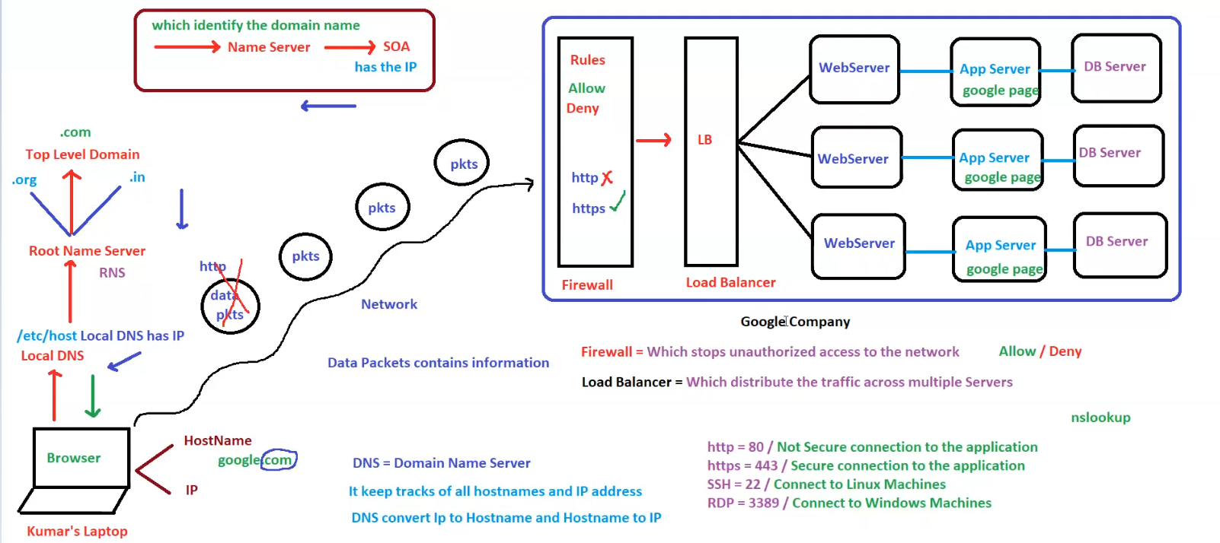

HTTP & HTTPS Concepts
HTTP & HTTPS Concepts
- HTTP (HyperText Transfer Protocol)
  - Default port: 80
  - Used to transfer data between browsers and servers.
  - Not secure as data is transferred in plain text.
- HTTPS (HyperText Transfer Protocol Secure)
  - Default port: 443
  - Uses SSL/TLS certificates for encryption.
  - Secure as data is encrypted.
HTTP Status Codes
- 404 – Page not found
- 500 – Internal Server Error
- 503 – Service Unavailable
- 200 – Page Found / Success
Protocols & Ports
- Protocol Format: protocol://domainname:portnumber
- Examples:
  - http://192.168.10.20:80
  - http://192.168.10.20:8080
  - http://192.168.10.20
- Port Customization:
  - Ports can be customized at the application level.
  - For customers, standard ports (80 or 443) should be used.
Transmission Control Protocol (TCP)
- Establishes connection between two hosts.
- Works as a bridge for data transfer.
- More reliable than UDP.
User Datagram Protocol (UDP)
- Used for faster data transmission.
- Not reliable compared to TCP.
Network Communication
- Client (google.com) ↔ Server via HTTP/HTTPS.
- HTTP over TCP/IP ensures communication between servers.
- Example:
  - Server 1 (Ameerpet) ↔ Server 2 (Miyapur) using TCP.
Security Concerns
- HTTP is vulnerable to hacking as data is transferred in plain text.
- Hackers can intercept data packets.
- HTTPS ensures encryption and secures data.
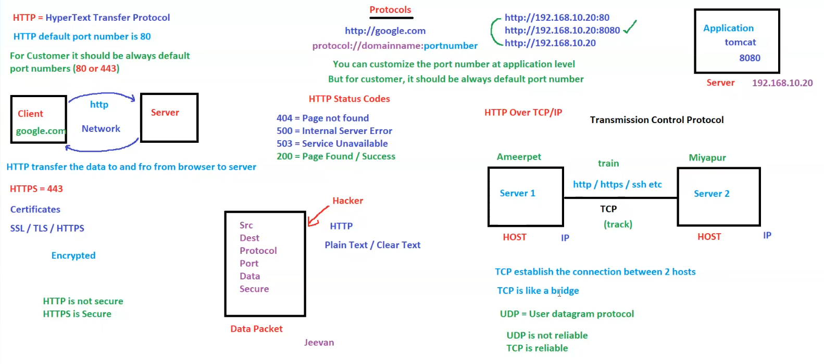

OSI Model (Open Systems Interconnection)
OSI Model (Open Systems Interconnection)
- The OSI model consists of 7 layers, each responsible for a specific aspect of network communication.
7 Layers of OSI Model
- Application Layer
  - Provides network services to end-users.
  - Examples: HTTP, HTTPS
- Presentation Layer
  - Ensures data is in a readable format.
  - Examples: SSH, RDP
- Session Layer
  - Manages and controls connections between computers.
- Transport Layer
  - Ensures reliable data transfer between devices.
  - Examples: TCP, UDP
- Network Layer
  - Handles addressing and routing of data.
  - Example: IP (Internet Protocol)
- Data Link Layer
  - Manages data transfer between directly connected nodes.
- Physical Layer
  - Concerned with the physical transmission of data (cables, signals, etc.).

Network Communication Example
- Host 1 (Boy) ↔ Host 2 (Girl)
  - Connected through TCP or UDP for communication.
  - This represents two devices communicating over a network.

Key Protocols
- TCP (Transmission Control Protocol)
  - Reliable, connection-oriented communication.
- UDP (User Datagram Protocol)
  - Faster but unreliable communication.
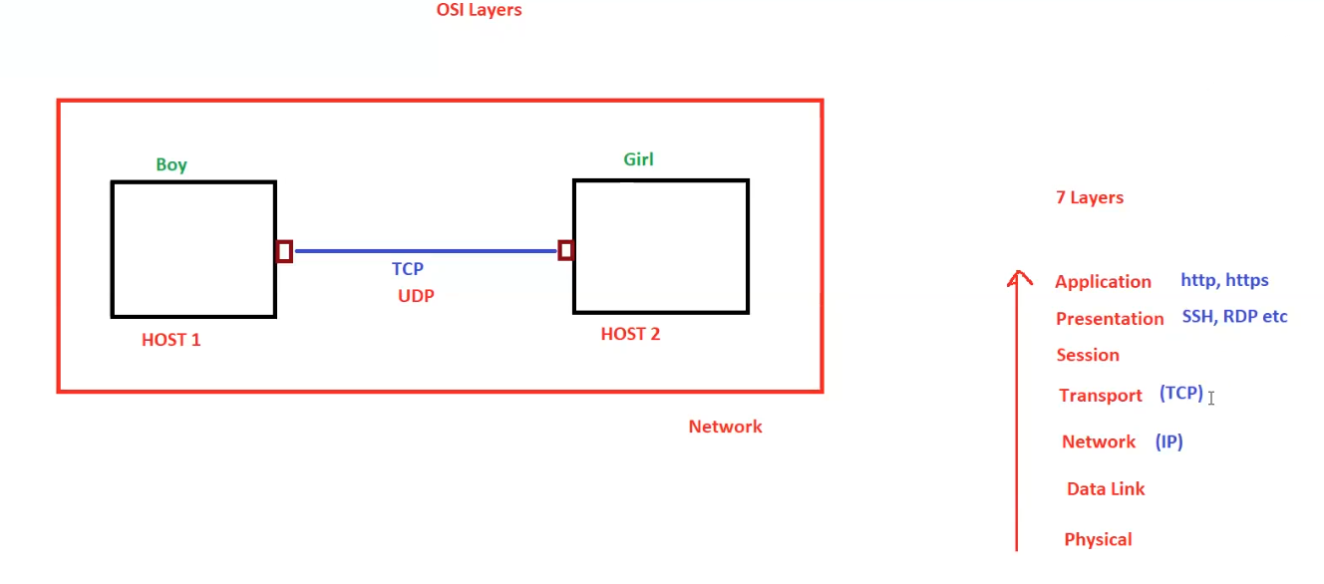

AWS Services Overview

AWS Overview and Shared Responsibility Model
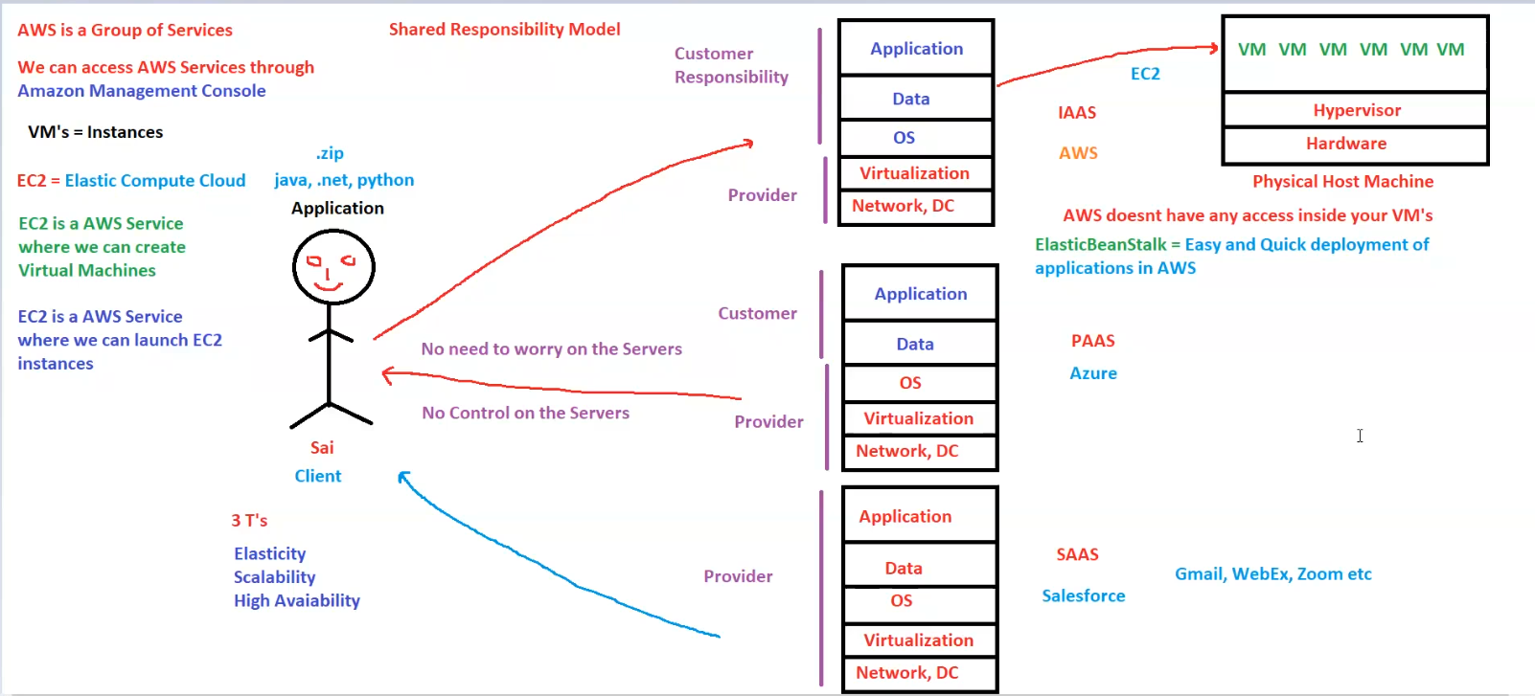
Here are the notes based on the image:

AWS Overview and Shared Responsibility Model
1. AWS Basics
- AWS (Amazon Web Services) is a group of cloud services.
- We can access AWS services via the Amazon Management Console.
- VMs (Virtual Machines) = Instances in AWS.
2. EC2 (Elastic Compute Cloud)
- EC2 is an AWS service that allows users to create and launch virtual machines.
- EC2 falls under the Infrastructure as a Service (IAAS) model.
- AWS does not have access inside your virtual machines.
3. Shared Responsibility Model
- Customer Responsibility: Application and Data management.
- Provider Responsibility: Network, Data Center, and Virtualization.
- Shared Responsibility:
  - Customers do not need to worry about servers.
  - Customers have no control over the physical servers.
4. Cloud Service Models
- IAAS (Infrastructure as a Service)
  - Example: AWS EC2
  - Customers manage applications, data, and OS, while AWS handles virtualization and infrastructure.
- PAAS (Platform as a Service)
  - Example: Azure, AWS Elastic Beanstalk
  - Provides an environment for application development and deployment.
- SAAS (Software as a Service)
  - Examples: Salesforce, Gmail, WebEx, Zoom
  - Fully managed applications accessible via the internet.
5. Benefits of AWS (The 3 T’s)
- Elasticity
- Scalability
- High Availability
6. AWS Infrastructure
- AWS physical host machines run multiple virtual machines (VMs) using a Hypervisor.
- Elastic Beanstalk is an AWS service for easy and quick application deployment.

Elasticity

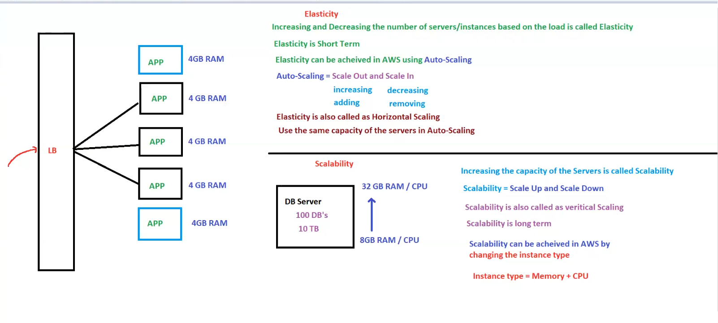
Elasticity
- Definition: Increasing and decreasing the number of servers/instances based on the load is called Elasticity.
- Characteristics:
  - Elasticity is short-term.
  - Achieved in AWS using Auto-Scaling.
  - Auto-Scaling involves:
    - Scale Out (increasing/adding instances)
    - Scale In (decreasing/removing instances)
  - Also known as Horizontal Scaling.
  - Uses same capacity servers in Auto-Scaling.

Scalability
- Definition: Increasing the capacity of servers is called Scalability.
- Characteristics:
  - Scalability = Scale Up and Scale Down.
  - Also called Vertical Scaling.
  - Scalability is long-term.
  - Achieved in AWS by changing the instance type.
  - Instance Type = Memory + CPU.

Key Differences
Feature | Elasticity (Horizontal Scaling) | Scalability (Vertical Scaling)
Definition | Adjusting the number of instances | Increasing server capacity
Timeframe | Short-term | Long-term
AWS Feature | Auto-Scaling | Changing Instance Type
Process | Scale In/Out (adding/removing instances) | Scale Up/Down (increasing/decreasing resources)
Capacity | Uses same capacity servers | Increases capacity of the same server

High Availability (HA)

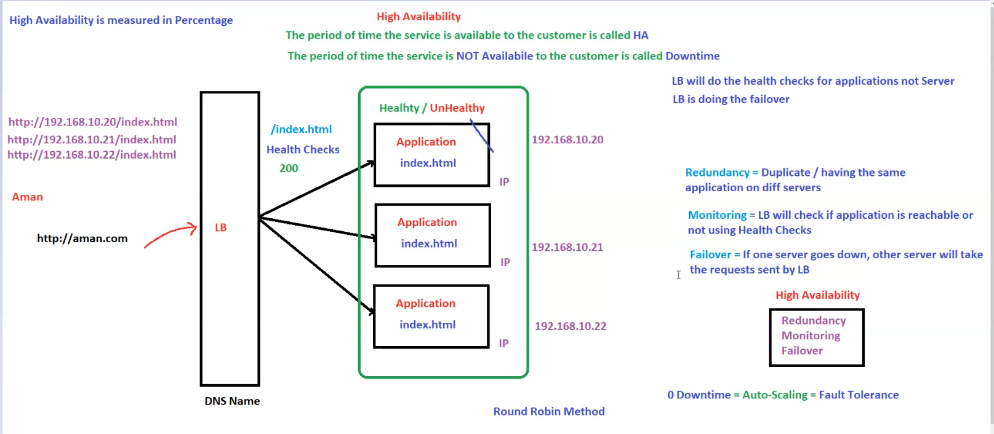
High Availability (HA)
- Definition: The period of time the service is available to the customer is called High Availability (HA).
- Downtime: The period of time the service is not available to the customer is called Downtime.
- HA is measured in percentage.

Key Components of High Availability
- Redundancy:
  - Definition: Having duplicate instances of the same application on different servers.
- Monitoring:
  - Definition: Load Balancer (LB) checks if the application is reachable using Health Checks.
  - Health Check: Verifies the availability of index.html and expects a 200 status.
- Failover:
  - Definition: If one server goes down, other servers take over the requests handled by the Load Balancer.

Load Balancer (LB)
- Handles incoming traffic and distributes it across multiple servers.
- Performs Health Checks for applications (not servers).
- Performs failover to redirect traffic if a server goes down.
- Uses Round Robin Method for load distribution.

Ensuring 0 Downtime
- Auto-Scaling = Fault Tolerance
- Combining:
  - Redundancy
  - Monitoring
  - Failover
Leads to High Availability.

Example Setup
- DNS Name: http://aman.com
- Backend servers with IPs:
  - 192.168.10.20
  - 192.168.10.21
  - 192.168.10.22
- Each server hosts index.html, and the Load Balancer distributes traffic among them.

AWS Global Infrastructure - Regions and Availability Zones (AZs)
AWS Global Infrastructure - Regions and Availability Zones (AZs)
1. AWS Global Infrastructure Overview
- Region: A physical location where AWS has infrastructure (e.g., Mumbai).
- Availability Zone (AZ): A data center within a region.
- A Region has multiple AZs, and each AZ is a group of data centers (DCs).
- Servers (EC2 Instances) are placed within AZs.

2. AWS Region and Availability Zones
- Example: AWS Region Mumbai (ap-south-1) has three AZs:
  - ap-south-1a
  - ap-south-1b
  - ap-south-1c
- AZs are managed by AWS and are interconnected via a network.
- Best Practice: Distribute instances across multiple AZs for high availability.

3. Communication Between AZs & Regions
- AZs within a region can communicate with each other by default.
- Regions do NOT communicate by default, but it can be enabled if required.
- Low Latency (1 sec) is good, while high latency (5 sec) is bad.

4. Load Balancing & Traffic Distribution
- Load Balancer (LB):
  - Distributes traffic across multiple EC2 instances in different AZs.
  - LB is specific to a region, not an AZ.
- Instances across AZs can share data if required.

5. High Availability & Fault Tolerance
- Very low chance that an entire AZ goes down.
- Distributing instances across AZs ensures fault tolerance.
- If one AZ fails, others continue running.

6. Example Mapping (Mumbai Region)
- ap-south-1a: Dadar, Thane, Bandra
- ap-south-1b: Airoli, Kalyan, Kurla
- ap-south-1c: CST, Juhu, Panvel

7. Summary
✅ Region = Group of AZs.
✅ AZ = Group of Data Centers (DCs).
✅ AZs within a region can communicate.
✅ Regions do NOT communicate by default.
✅ Load Balancers distribute traffic across AZs.
✅ Best practice: Use multiple AZs for high availability & redundancy.

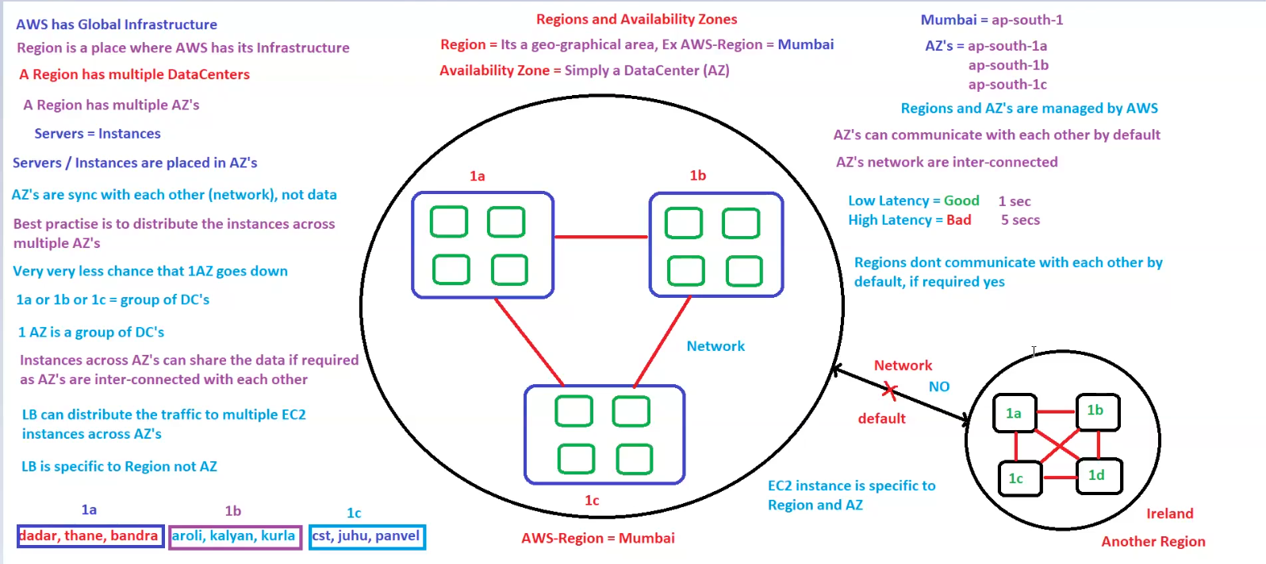

EC2, Load Balancer, Elastic Beanstalk & LightSail
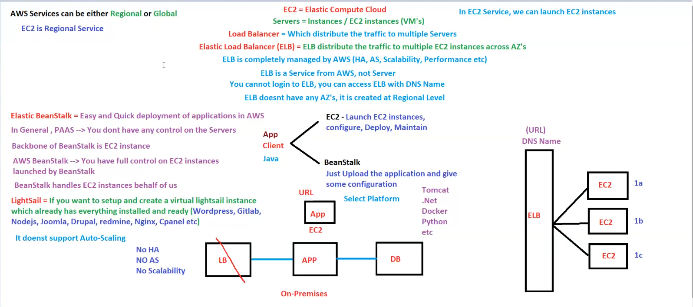
1. AWS Services - Regional vs Global
- AWS Services can be either Regional or Global.
- EC2 (Elastic Compute Cloud) is a Regional Service
  - It means EC2 instances exist within a specific AWS region.
  - EC2 instances are virtual machines (VMs) in the cloud.

2. EC2 Instances
- EC2 = Elastic Compute Cloud → Allows launching virtual servers (instances).
- Servers = Instances (EC2 VMs).
- EC2 instances need to be configured, deployed, and maintained manually.

3. Load Balancer (LB)
- Distributes incoming traffic across multiple EC2 instances.
- Elastic Load Balancer (ELB)
  - ELB distributes traffic across EC2 instances in different AZs.
  - Managed by AWS (High Availability, Auto Scaling, Performance Optimization).
  - Created at the Regional Level, not tied to a specific AZ.
  - Cannot log in to ELB, only access it via DNS name.

4. Elastic Beanstalk (PaaS)
- Simplifies application deployment on AWS.
- Fully managed service, handling EC2 instances, Load Balancing, and Auto Scaling.
- Key Features:
  - Uses EC2 instances as the backbone.
  - You have full control over EC2 instances.
  - Just upload your application and provide configuration.
  - Supports multiple platforms like Tomcat, .Net, Docker, Python, etc.

5. AWS LightSail (Simplified VM Hosting)
- Pre-configured cloud service for hosting applications quickly.
- Supports WordPress, GitLab, Node.js, Joomla, Drupal, Nginx, Cpanel, etc.
- Limitations:
  - ❌ No Auto-Scaling.
  - ❌ No High Availability (HA).
  - ❌ No Scalability (Cannot dynamically scale like EC2 with ELB).

6. EC2 Deployment Options
A. EC2 with ELB (Recommended)
✅ EC2 instances are deployed across multiple AZs.
✅ ELB distributes traffic to maintain high availability.
✅ Auto Scaling ensures instances scale up/down as needed.
B. EC2 with Beanstalk
✅ Easy deployment and management.
✅ AWS manages scaling & load balancing.
✅ Ideal for developers who don’t want to manage infrastructure.
C. EC2 Without Load Balancer (Not Recommended)
❌ Single EC2 instance without redundancy.
❌ No auto-scaling = No ability to handle high traffic.
❌ If the instance fails, the application is down.

7. Summary
AWS Service | Use Case | Key Features
EC2 | General-purpose compute | Manual setup, requires maintenance
ELB | Load balancing traffic | Auto-distributes requests across EC2 instances
Elastic Beanstalk | Easy application deployment | PaaS, fully managed, supports multiple platforms
LightSail | Quick app hosting | Simple VM setup, no scaling, no HA
✅ Use EC2 + ELB for scalable and fault-tolerant architecture.
✅ Use Beanstalk for easy deployment with AWS-managed scaling.
✅ Use LightSail for simple, pre-configured environments without scaling needs.

AWS Lambda for EC2 Automation
1. AWS Lambda Overview
- Lambda is a Serverless service → No need to manage servers.
- You can run code without provisioning infrastructure.
- Supports multiple languages like Java, Python, .NET, Ruby, etc.
- Lambda can be triggered by events (e.g., EC2 state changes, scheduled tasks, etc.).

2. Automating EC2 with Lambda
- Lambda can perform EC2 operations:
✅ Launch
✅ Stop
✅ Start
✅ Reboot
✅ Terminate/Delete
- Lambda is triggered based on:
  - EventBridge Rules (For Scheduled Events).
  - Launch Events (For EC2 instance events).

3. Event-Based EC2 Management Using Lambda
A. Scheduled Stop & Start of EC2 Instances
- 9 PM → STOP EC2 Instances
  - EventBridge Rule triggers STOPFn Lambda function.
  - Lambda stops all EC2 instances.
- 6 AM → START EC2 Instances
  - EventBridge Rule triggers StartFn Lambda function.
  - Lambda starts all EC2 instances.

B. EC2 Termination Using Lambda
- Lambda can terminate EC2 instances using Python Code (TerminateFn).
- This can be invoked manually or automatically via EventBridge.
- Example Use Case: Auto-terminate idle EC2 instances to reduce costs.

4. AWS Services Involved
Service | Purpose
Lambda | Runs Python code to start/stop EC2 instances.
EventBridge | Schedules events (9 PM Stop, 6 AM Start).
EC2 | Instances managed via Lambda automation.

5. Summary
✅ AWS Lambda is used for automating EC2 instance operations.
✅ EventBridge rules can trigger Lambda functions to start/stop EC2 instances on schedule.
✅ Lambda functions can be used for launching, stopping, and terminating EC2 instances automatically.
✅ Serverless automation reduces manual effort & optimizes cloud costs.

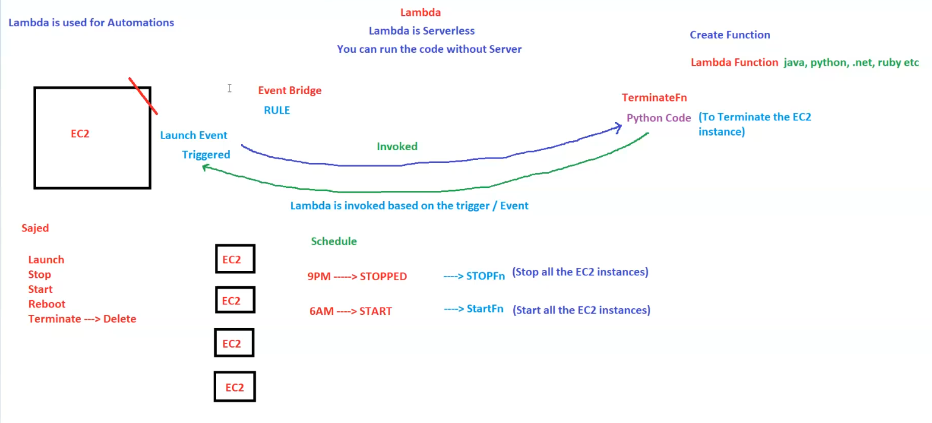

AWS Elastic Block Storage (EBS)
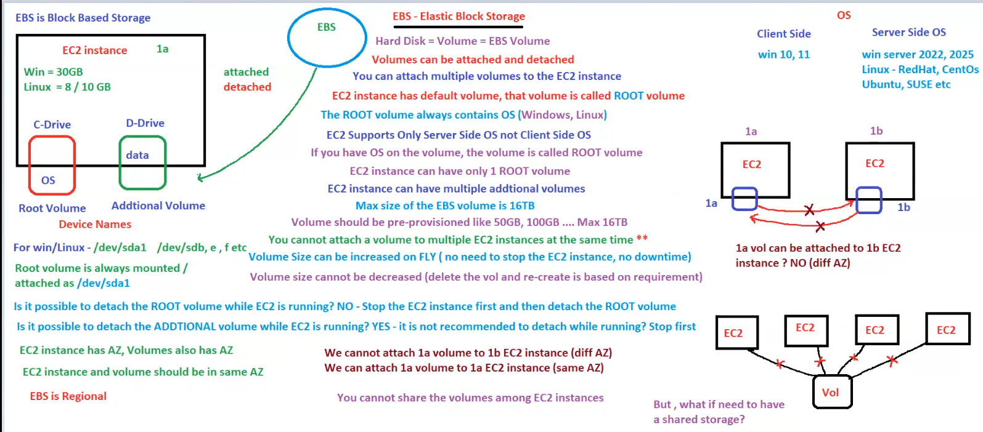

1. What is EBS (Elastic Block Storage)?
- EBS is a block-based storage system for EC2 instances.
- Acts like a hard disk (volume) that can be attached and detached from EC2 instances.
- EBS is Regional → Volumes exist within a specific AWS region.
- Each volume is tied to a single Availability Zone (AZ).

2. EC2 and EBS Volumes
- Every EC2 instance has a default volume, called the ROOT volume.
- The Root Volume always contains the OS (Windows/Linux).
- EC2 instances can have multiple additional volumes for storing extra data.

3. Volume Types in EC2
- Root Volume:
  - Contains the OS.
  - Always mounted at /dev/sda1 on Linux/Windows.
  - Cannot be detached while EC2 is running → Instance must be stopped first.
- Additional Volume:
  - Used for storing data.
  - Can be detached while EC2 is running, but not recommended.

4. EBS Features & Limitations
✅ Supports only Server-Side OS (Windows Server, Linux).
✅ Max EBS Volume Size = 16TB.
✅ EBS Volume can be increased on the fly (No need to stop the EC2 instance).
❌ Cannot decrease volume size (Need to create a new volume and migrate data).
❌ A volume cannot be attached to multiple EC2 instances at the same time.
❌ An EBS volume is limited to a single AZ (Cannot attach to EC2 in another AZ).

5. Attaching & Detaching Volumes
Action | Allowed? | Notes
Detach Root Volume while EC2 is running | ❌ No | Stop EC2 first, then detach.
Detach Additional Volume while EC2 is running | ✅ Yes | Not recommended, may cause data corruption.
Attach Volume to another EC2 in the same AZ | ✅ Yes | Allowed if in the same AZ.
Attach Volume to an EC2 in a different AZ | ❌ No | EBS is AZ-specific.

6. Shared Storage Between EC2 Instances?
- EBS volumes cannot be shared across multiple EC2 instances.
- Alternative: Use EFS (Elastic File System) or FSx for shared storage.

7. Summary
Feature | Details
Root Volume | OS Storage, Mounted as /dev/sda1, Cannot detach while running.
Additional Volume | Extra storage, Can be attached/detached while running.
Max Volume Size | 16TB
Resize Volume | ✅ Increase without downtime, ❌ Cannot decrease.
Multi-Attach | ❌ Cannot attach to multiple EC2 instances at the same time.
Cross-AZ Attachment | ❌ EBS volume is restricted to a single AZ.
✅ Use EBS for block storage.
✅ For shared storage, use EFS or FSx.

AWS S3 (Simple Storage Service)
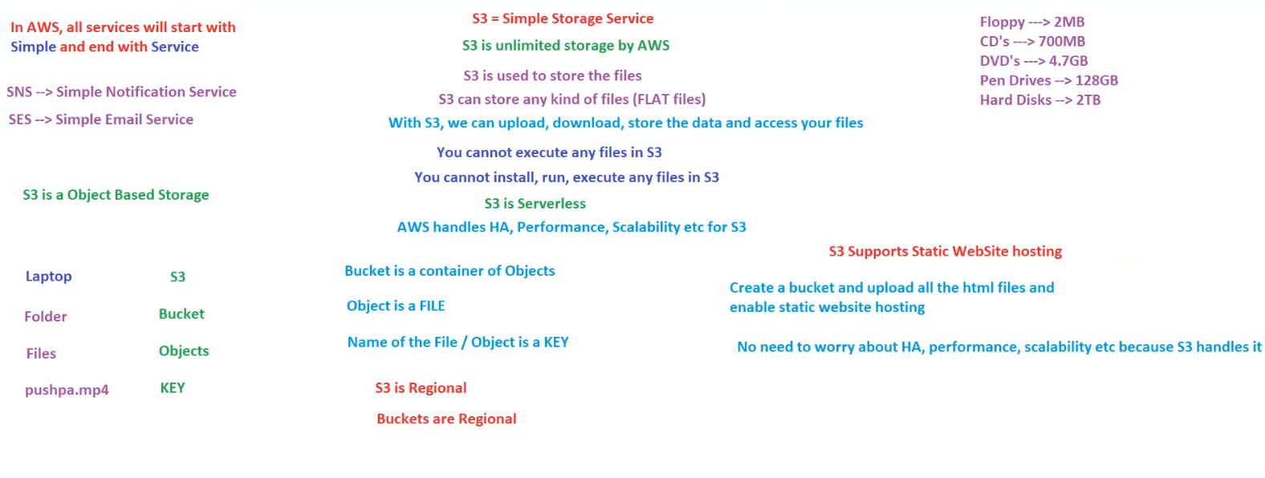

1. What is AWS S3?
- S3 = Simple Storage Service.
- S3 provides unlimited storage managed by AWS.
- S3 is used for storing files (object-based storage).
- Supports any type of file (flat files like images, videos, documents, backups, etc.).
- S3 is Serverless – No need to manage infrastructure.
- AWS handles High Availability (HA), Performance, and Scalability.

2. How S3 Works? (Folder & File Concept)
Local System (Laptop) | S3 Equivalent
Laptop | S3
Folder | Bucket
Files | Objects
File Name | Key
- Bucket: A container for storing objects (files).
- Object: A stored file.
- Key: The unique name assigned to an object (file name).

3. S3 Storage Features & Limitations
✅ Can upload, download, and store files.
❌ Cannot execute, install, or run any files directly in S3.
✅ Supports Static Website Hosting (for hosting HTML files).
✅ S3 is Regional → Buckets exist within a specific AWS region.
❌ Buckets are also Regional (Cannot access from different regions unless configured).

4. S3 Static Website Hosting
- S3 supports static website hosting.
- Steps to host a website on S3:
  - Create a Bucket.
  - Upload HTML files.
  - Enable static website hosting.
  - S3 will manage HA, Performance, and Scalability.
✅ No need for additional infrastructure like EC2.

5. Comparison of Traditional Storage vs S3
Storage Type | Capacity
Floppy Disk | 2MB
CD | 700MB
DVD | 4.7GB
Pen Drive | 128GB
Hard Disk | 2TB
S3 | Unlimited ✅

6. Summary
Feature | Details
Type | Object Storage
Storage Limit | Unlimited ✅
Execution | Cannot execute files ❌
Static Website Hosting | Supported ✅
Region | S3 is Regional ✅
Bucket Region | Buckets are Regional ✅
✅ Use S3 for file storage, backups, and hosting static websites.
✅ For shared storage across multiple regions, enable S3 Cross-Region Replication.

