

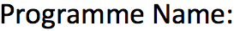
Programming for Data Analytics

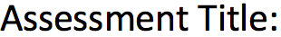
Exploratory Data Analysis of Sales Data

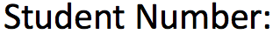
25238053

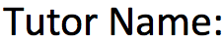
Ahmed Hassa



Table of Contents
Table of Contents 2
1. Introduction 3
2. Data Understanding and Methodology 3
2.1 About the dataset 3
2.2 Tools used 3
3. Data Pre-processing 4
3.1 Initial data quality check 4
3.2 Data types and missing values 4
3.3 Outlier detection and treatment 4
4. Exploratory Data Analysis 6
4.1 Sales person performance over time 6
4.2 Correlation between priority and sales value 8
4.3 Revenue by shipping mode 9
5. Discussion 10
6. Conclusion and Recommendations 11
7. References 12
Appendix A – Python Code 13
Appendix B – GitHub Repository 17

1. Introduction
This report presented an exploratory data analysis (EDA) carried out for One Time Sales and Marketing Ltd. The work was produced in response to a request from the sales manager, who wanted a clearer picture of how individual sales persons were performing and whether the priority level attached to an order related in any meaningful way to the value of that order.
Sales Data PDA 4052 was the dataset analyzed, having recorded 1,001 transactions made within a six-month period from June through November 2020. The dataset included order id, customer id, sales person, priority, shipping mode, order date, and the sales amount in pounds. The entire analysis was conducted in Python, utilizing several standard libraries for data analysis, statistics, and visualization.
This report was structured to reflect each stage of the analysis process. While Section 2 explained the dataset and tools employed, Section 3 addressed pre-processing measures, proving how much better the cleaned dataset turned out compared to the initial one. The actual exploratory data analysis was explained in Section 4, addressing the questions asked by the sales manager. Section 5 provided information about the implications of the results, while Section 6 summarized the recommendations based on the outcomes of the analysis. The complete Python script was included in Appendix A, and the GitHub repository URL was listed in Appendix B.

2. Data Understanding and Methodology

2.1 About the dataset
This sales tracker had 1,001 entries and 7 columns. Order_id and value_£ were numerical, where order_id was an integer while value_£ was the monetary amount (floating point number). Date was in timestamp format while the rest of the variables - customer_id, sales_person, priority and ship_mode - were categorical. Sales_person could take up to 3 values (Kelly, Peter and Pryia); priority could have any of the five values - Low, Medium, High, Critical and Not Specified while ship_mode could take Plane, Lorry or Van.
Sales_person, date, value_£ and priority are the variables used in this study.

2.2 Tools used
Everything in this study was done in Python using Google Colab, which provided a convenient notebook that did not require installation and allowed for easy sharing of codes. The main libraries included:
- pandas – for loading the spreadsheet, tidying column names, and grouping the data.
- numpy – for handling missing values represented as NaN.
- matplotlib and seaborn – for producing the boxplots, histograms, bar charts and line charts shown throughout the report.
- scipy.stats – for the Spearman and Pearson correlation tests used in Section 4.2.
The workbook was read in with pd.read_excel(..., skiprows=1) because the first row of the spreadsheet contains a title rather than the column headers. Git and GitHub were used to version the notebook (details in Appendix B).

3. Data Pre-processing

3.1 Initial data quality check
Firstly, the data structure was checked with the functions of df.info() and df.describe() which demonstrated that there are 1,001 rows without any empty fields and pandas has transformed the date variable into a datetime64 type variable, without need for additional manipulations. As a result, the application of df.duplicated().sum() gave zero and thus there is no need in duplication elimination.
Regarding the missing values, using df.isnull().sum() we found out that there are 0 missing observations, however, applying value_counts() to priority variables, 213 rows turned out to have priority equal to Not Specified. This is how pandas has interpreted this value; however, it should be considered an unknown category due to the significance of this feature within our analysis.
The descriptive statistics applied on value_£ variable show that there are likely some outliers in the sample since the mean of the distribution is £1,778 which is about four times higher than the median, while the standard deviation of £3,457 is almost twice higher than the mean itself. The maximum of £27,448 is about 16 times higher than the mean.

3.2 Data types and missing values
Having revealed the previously unnoticed 'hidden missing' category, the subsequent action was replacing instances of "Not Specified" in the priority column with NaN using df['priority'].replace('Not Specified', np.nan). As a result of this transformation, the number of missing values returned by isnull().sum() in the priority column became equal to 213, which is closer to the truth.
It seemed unwise to impute the values in these 213 records using either the mode (most frequent category) or randomly selected categories. The replacement values would be imaginary priorities that were never actually used, and their introduction would thus cause a distortion in the correlation testing conducted in Section 4.2. In general sales analysis, however, where the correlation does not matter, the missing values stay in the table along with the rest of information such as value, date, and sales person.

3.3 Outlier detection and treatment
The most crucial pre-processing operation in this dataset was managing the outliers found in the value_£ field. The IQR approach was adopted, which is one of the most commonly used rules of thumb for detecting outliers. First, the lower quartile (Q1) and upper quartile (Q3) of value_£ were determined, then the IQR was estimated by subtracting Q1 from Q3. If value_£ was less than Q1−1.5×IQR or greater than Q3+1.5×IQR, it was flagged as an outlier.
Statistic | Value | Notes
Q1 (25th percentile) | £134.40 | Lower quartile of value_£
Q3 (75th percentile) | £1,816.93 | Upper quartile of value_£
IQR (Q3 − Q1) | £1,682.53 | Spread of the middle 50%
Lower bound | −£2,389.39 | Not binding (values are positive)
Upper bound | £4,340.73 | Rows above this are outliers
Outliers removed | 122 of 1,001 | About 12.2% of the rows
Table 1 – IQR bounds and outlier count for value_£.
A diagrammatic representation of the result of this transformation can be found in Figure 1 and Figure 2 below. As seen in Figure 1, prior to cleansing, the box plot on the left had an excessive amount of points in the tail section beyond the upper whisker; the highest value among the ordered set was £27,448, which was nearly six times the value of the 75th percentile. The new box plot, on the other hand, after using the IQR filter was relatively tight.
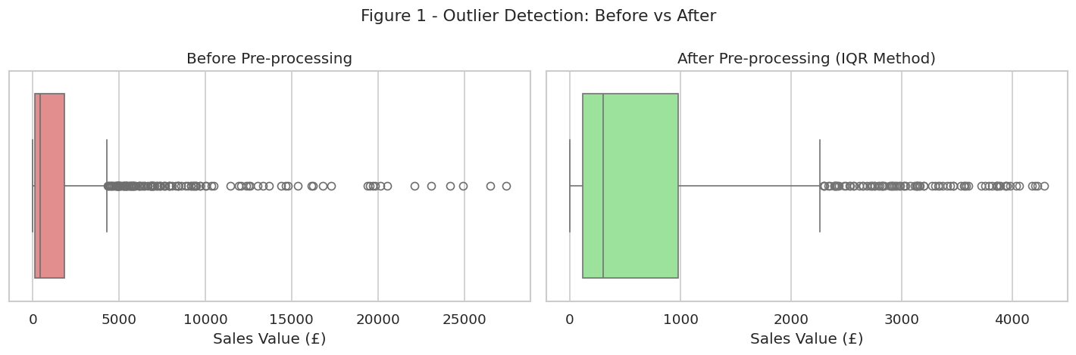
Figure 1 – Boxplots of value_£ before (left) and after (right) outlier removal.
Histograms tell the same tale in Figure 2 below. Prior to any treatment, the histogram is compressed towards the lower end of the x-axis due to some orders being very large, which stretches the graph to about £30,000. After applying the IQR rule, the histogram is decipherable, revealing a skewed right distribution, which is normal for sales data.
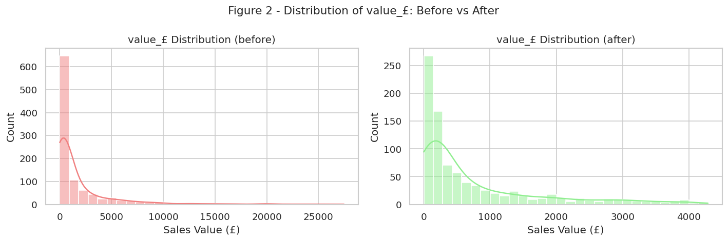
Figure 2 – Histograms of value_£ before (left) and after (right) outlier removal.
The effects on the descriptive statistics, presented in Table 2, were significant. Specifically, the average decreased from £1,778 to £747, coming much closer to the median, the standard deviation decreased from £3,457 to £962, and the skewness decreased from 3.77 to 1.76. The closeness of the mean and median values suggested that the cleaned dataset was significantly less skewed due to a few outlier observations.
Statistic (value_£) | Before cleaning | After cleaning
Count | 1,001 | 879
Mean | £1,778.40 | £747.30
Median | £417.58 | £297.97
Standard deviation | £3,457.46 | £961.98
Maximum | £27,448.24 | £4,286.74
Skewness | 3.77 | 1.76
Table 2 – Summary statistics for value_£ before and after IQR-based outlier removal.
The consequences of dropping 122 observations (12.2%) should be noted. Unlike sensor or measurement data, where outliers are often errors, the high-value orders here were most likely legitimate cases reflecting bulk purchases or special accounts. Removing them tidied the statistics but lost a meaningful chunk of revenue from the sample. As a sensitivity check, the sales person totals were recalculated using the raw figures: Pryia again led in both cases (£672k raw vs £230k cleaned), followed by Kelly (£559k vs £227k) and Peter (£549k vs £200k). The gap between Pryia and the others is much wider once high-value orders are kept, which suggests Pryia handles an unusually large number of bulk orders. The cleaned data should therefore be used to assess everyday performance, while the raw figures should be borne in mind when discussing revenue contributions or bulk-order handling. Another option would be to apply IQR on log(value_£), which would retain all rows.

4. Exploratory Data Analysis
Having prepared the cleaned dataset which consisted of 879 entries, the analysis proceeded based on two main questions raised by the Sales Manager related to the performances of three different sales reps throughout the whole time period and the correlation between priority and sales. The third analysis conducted, i.e., profits from each shipping mode, was included since it was relevant to the discussion in Section 6.

4.1 Sales person performance over time
As a first step, Kelly, Peter and Pryia were compared on three measures: total revenue, average transaction value, and number of transactions. The results are shown in Table 3.
Sales Person | Total Revenue (£) | Avg Sale (£) | Transactions | Max Sale (£)
Pryia | 229,755.92 | 795.00 | 289 | 4,227.02
Kelly | 226,801.95 | 804.26 | 282 | 4,286.74
Peter | 200,322.99 | 650.40 | 308 | 4,182.90
Table 3 – Aggregated performance of each sales person (after cleaning).
With total revenue of £229,756, Pryia was ahead of Kelly who had a revenue of £226,802 while Peter brought up the rear with revenues of £200,323. The difference between Pryia and Kelly in the six-month period was quite negligible (below £3,000). Figure 3 below showed the graphical representation of the above statistics.
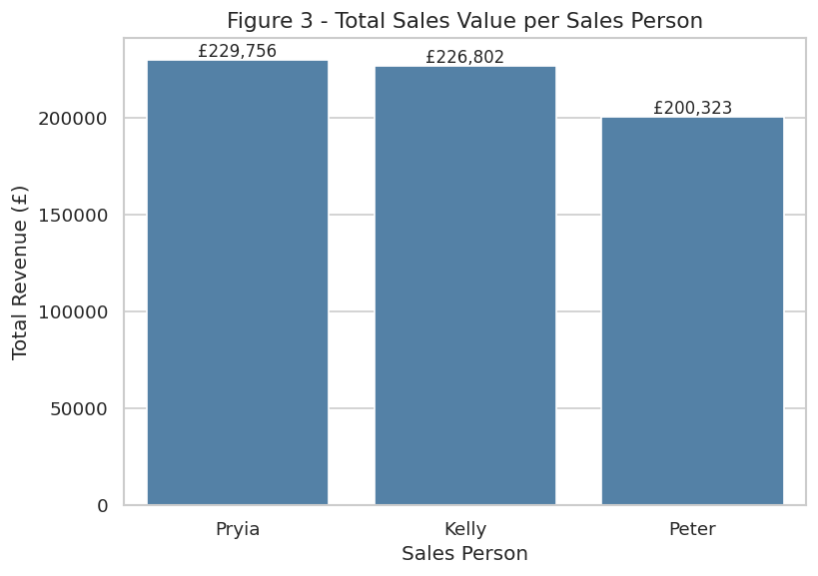
Figure 3 – Total sales value per sales person.
A look at the average transaction provided another insight into each employee’s performance. Kelly ranked first with an average sale amounting to £804, followed by Pryia’s average of £795. Both these numbers far exceeded the average for Peter who made £650 per transaction. However, while Peter actually closed more deals than Kelly (308 compared to her 282), he managed to close more orders than Pryia whose average was the second highest, albeit only by £5. This implied that Peter relied on volume while Kelly and Pryia closed smaller amounts but earned larger commissions.
All the figures were illustrated on an individual month basis in Figure 4 below. All three peaked in July (since data collection started from June mid-way, so June was only a partial month). However, for Kelly and Pryia, there was another peak in August where the two sales agents made sales worth more than £50,000 in one month. For Kelly and Pryia, their performances were almost steady as they varied from £25,000 to £50,000 in sales.
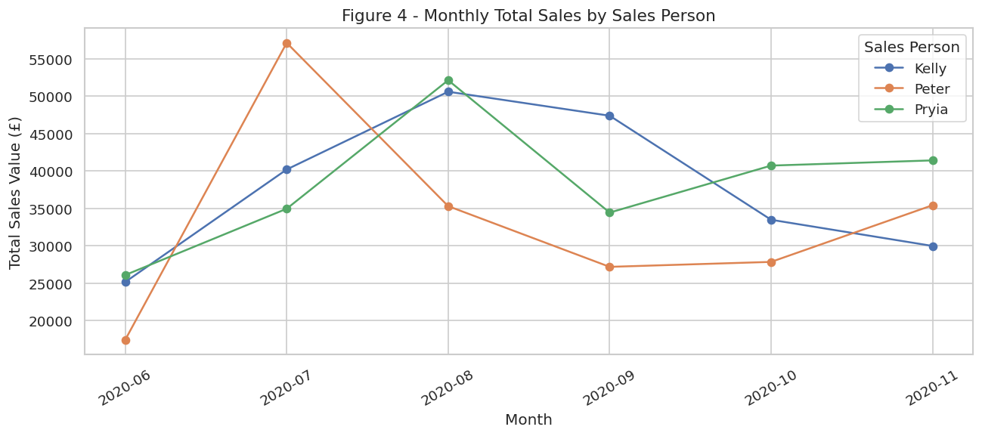
Figure 4 – Monthly total sales by sales person, June–November 2020.
The volatility of Peter’s monthly income was another interesting business insight. While the difference between the highest earning month for him (£57k in July) and lowest earning month (£17k in June) amounted to more than three times his income from other months, the variations between Kelly and Pryia remained small. Hence, the monthly averages of all team members inevitably varied depending on Peter’s monthly income.

4.2 Correlation between priority and sales value
The sales manager’s second question concerned the relationship between the priority assigned to an order and its value. It was easy to assume the two were linked — high-value orders being processed quickly — but this needed to be tested empirically.
Priority is an ordinal variable: there is a natural order between the four states (Low < Medium < High < Critical). For correlating two such variables, the Spearman rank correlation was used instead of Pearson’s, which assumes linear dependency and was therefore inappropriate. The gaps between values could not be assumed to be equal either (e.g., Medium to High versus High to Critical). The four priority values were encoded as integers 1 to 4, and the Spearman coefficient was computed on the 691 rows excluding "Not Specified".
Test | Correlation r | p-value
Spearman (primary) | 0.046 | 0.226
Pearson (reference) | 0.046 | 0.224
Table 4 – Correlation tests between priority level and value_£ (n = 691).
Both methods provided virtually identical results. The value of Spearman correlation was 0.046 and its corresponding p-value equalled 0.226, which was considerably greater than the usual significance level of 0.05. From a business perspective, the meaning of the p-value was that there was a possibility that the weak association observed in the data could occur randomly; thus, the presumption that the orders with a higher priority had greater values did not hold from a statistical point of view.
Moreover, Figures 5 and 6 reinforce this. The average sales value across priority groups falls within a narrow range, from about £688 for Low priority to £847 for Critical.
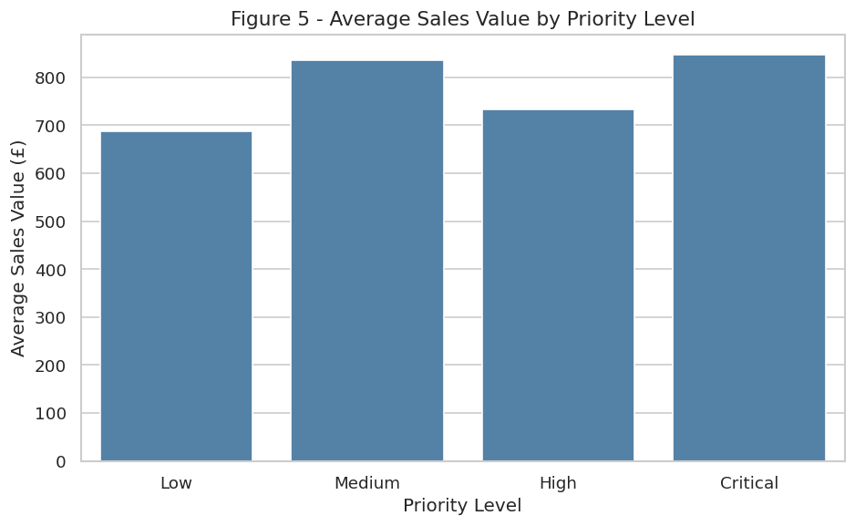
Figure 5 – Average sales value by priority level.
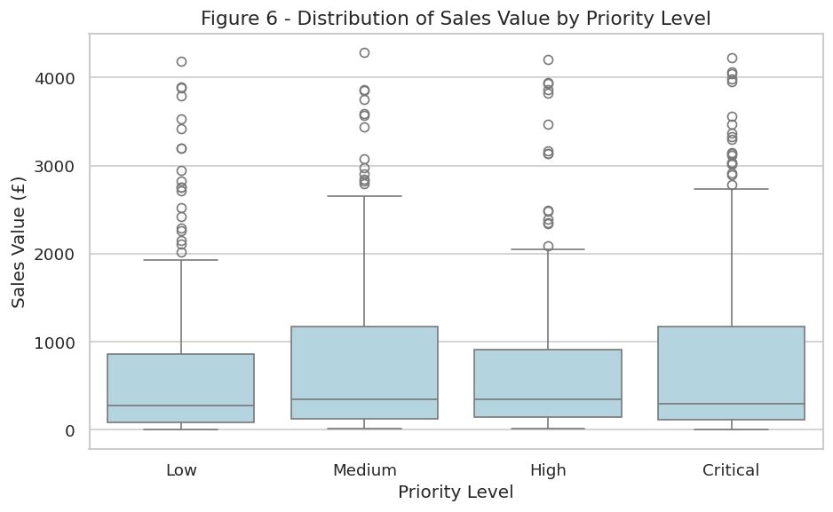
Figure 6 – Distribution of sales value by priority level.
This was certainly an unexpected discovery in a business context. Given that the prioritization process depended upon the perceived significance of the issue, it would have been expected that the higher the value of the order, the higher its priority would be rated. This not being the case suggested that there were factors determining the priority of an order other than its value. These factors could have been the customer himself, the delivery deadline, or the nature of the product.

4.3 Revenue by shipping mode
Although outside the two main questions, a brief review of revenue by shipping mode was included as a supporting business insight. The data is shown in Table 5.
Ship Mode | Total Revenue (£) | Transactions | Avg Sale (£)
Plane | 435,939.99 | 708 | 615.73
Lorry | 137,453.28 | 74 | 1,857.48
Van | 83,487.59 | 97 | 860.70
Table 5 – Revenue and transaction count by shipping mode.
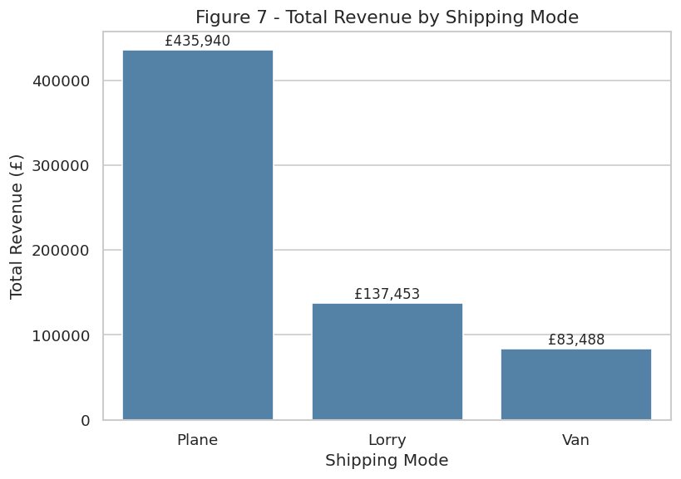
Figure 7 – Total revenue by shipping mode.
Plane was clearly the predominant means of transport in terms of sales value (£435,940, about 66%) and transaction number (708 out of 879). Lorry transported much fewer consignments (74), but had the highest average purchase price (£1,857), which suggested the company used it for high-value, low-volume bulk shipments. Van had a moderate number of transactions and the smallest revenue among all three modes of transport analyzed. The reliance on one particular transport type was a potentially serious problem which was addressed in Section 6.

5. Discussion
Three conclusions can be drawn from the analysis presented above. Firstly, it turns out that the pre-processing phase did make an impact on the analysis. For example, the average value of value_£ before any processing was quite high (at £1,778), influenced by a very few very abnormal orders; however, after the data were cleaned, the average decreased to £747, closer to the median (£298). Therefore, any measure based on the average value (for instance, the ranking table of the sales persons) was going to be biased towards just a few abnormal orders. This is clearly illustrated in Table 2 and Figures 1 and 2.
Secondly, while the three sales persons had very close results in terms of total sales, they had completely different performance dynamics. Pryia and Kelly were similar in terms of total sales, while Kelly was much more efficient (per one order). However, Peter had the highest number of orders closed, yet a much lower average sales order by about 20%. Additionally, he demonstrated much higher variability in month-to-month performance. It was critical to note the differences for making any predictions regarding the future performance of these salespeople.
The final observation was that there was no correlation between priority and sales value. The Spearman coefficient of 0.046 with p = 0.226 fitted neatly into the category of "no effect," and this was also reflected in the graph presented in Figure 5. This finding needed to be mentioned to the manager because it showed that the priority classification used was simply not correlated to what was often supposed to be correlated. It could either mean that priorities were given under criteria different from value or that priorities were given inconsistently across the three sales persons.
First, it was worth noting that the sample was too small to test for seasonality effects, since it only spanned six months, not allowing for accounting for quarter-end pushes, holiday demand, or year-end effects; thus, it would have made sense to obtain data for at least twelve months. Second, 21% of orders had priority "Not Specified," meaning that either priority was optional at the time or people were entering it inconsistently; thus, making this field mandatory would help significantly with future correlation analysis. Finally, even if all fields were filled in, correlation did not imply causation: if a positive correlation were found between priority and value, further experiments would have been needed to prove it.
From a technical perspective, our analysis involved only a few key operations, which can be easily adapted to work with bigger samples. We used grouping and aggregation functions (df.groupby() with named aggregations) in order to replace potentially labor-intensive filtering and counting of sums of values for every sales person. Since we need the Spearman test to work, we had to ordinal-encode our "Priority" field into numbers (Low = 1, Medium = 2, High = 3, Critical = 4). It would be useful to keep our priority replacement, IQR calculation, and group aggregation separated from each other and name them accordingly for easier reuse of the script.

6. Conclusion and Recommendations
The analysis was a full-cycle exploratory process that included data loading from the Excel file, data cleaning for missing values in priority, identifying and removing outliers from the value_£ based on the IQR rule, and producing a clean dataset for analysis. The clean dataset with 879 observations allowed the following logical conclusions: Pryia and Kelly were strong overall performers; there were specific patterns in the work of each sales person so that individual performance tracking provided better insights; there was no correlation between priority and sales value in this particular case.
In light of the above information, five recommendations can be considered valuable for the management of the sales department:
- Monitoring and reporting sales person’s performance should be done individually. Month-to-month changes in Peter's performance significantly exceed the changes in Kelly's or Pryia's performance so that averaging their monthly performance would distort the real level of instability.
- Setting a rule for defining the order priority. As the priorities are assigned without a relationship to the order value, they most probably reflect different criteria across the employees. Priority assignment could include the following criteria: value of the order, tier of the customer, deadline window, and SLA associated with the client.
- Constrain data input regarding priority. In the raw dataset, nearly one in five orders lacked information on priority. Ensuring that priority is marked in the CRM, perhaps with a mandatory default of “Medium” and a changeable override, would increase the quality of future analyses conducted on this variable.
- Reduce reliance on plane as the dominant shipping mode. Plane accounts for over two-thirds of total revenue, so if that carrier becomes unavailable or raises rates, the business has limited fall-back options. Negotiating secondary contracts with lorry and van operators would reduce this concentration risk.
- Finally, as a logical next step for research, an expansion of the timeframe of analysis along with the introduction of the customer view would enable more sophisticated analyses. Merging information from the customer database would enable investigation into the possibility of repeat customers working with the same representative.

7. References
Behrens, J.T. (1997) 'Principles and procedures of exploratory data analysis', Psychological Methods, 2(2), pp. 131–160. Available at: https://doi.org/10.1037/1082-989X.2.2.131 (Accessed: 18 April 2026).
Hauke, J. and Kossowski, T. (2011) 'Comparison of values of Pearson's and Spearman's correlation coefficients on the same sets of data', Quaestiones Geographicae, 30(2), pp. 87–93. Available at: https://doi.org/10.2478/v10117-011-0021-1 (Accessed: 18 April 2026).
Hunter, J.D. (2007) 'Matplotlib: A 2D graphics environment', Computing in Science & Engineering, 9(3), pp. 90–95. Available at: https://doi.org/10.1109/MCSE.2007.55 (Accessed: 18 April 2026).
McKinney, W. (2010) 'Data structures for statistical computing in Python', in Proceedings of the 9th Python in Science Conference, Austin, TX, pp. 51–56. Available at: https://conference.scipy.org/proceedings/scipy2010/mckinney.html (Accessed: 18 April 2026).
NIST/SEMATECH (n.d.) Box Plot. e-Handbook of Statistical Methods. Available at: https://www.itl.nist.gov/div898/handbook/eda/section3/boxplot.htm (Accessed: 19 April 2026).
The pandas development team (n.d.) pandas.DataFrame.describe. Available at: https://pandas.pydata.org/docs/reference/api/pandas.DataFrame.describe.html (Accessed: 19 April 2026).
The pandas development team (n.d.) pandas.to_datetime. Available at: https://pandas.pydata.org/docs/reference/api/pandas.to_datetime.html (Accessed: 19 April 2026).
Provost, F. and Fawcett, T. (2013) Data Science for Business: What You Need to Know about Data Mining and Data-Analytic Thinking. Sebastopol, CA: O'Reilly Media.
SciPy community (n.d.) scipy.stats.spearmanr. Available at: https://docs.scipy.org/doc/scipy/reference/generated/scipy.stats.spearmanr.html (Accessed: 20 April 2026).
Tukey, J.W. (1977) Exploratory Data Analysis. Reading, MA: Addison-Wesley.
Waskom, M.L. (2021) 'seaborn: statistical data visualization', Journal of Open Source Software, 6(60), p. 3021. Available at: https://doi.org/10.21105/joss.03021 (Accessed: 18 April 2026).

Appendix A – Python Code
The full Python code used for this analysis is shown below in the form of code listings (screenshots from Google Colab, Python 3.12). The code reproduces every table, figure, and numerical result referenced in the report.

A.1 Imports and Initial Data Loading
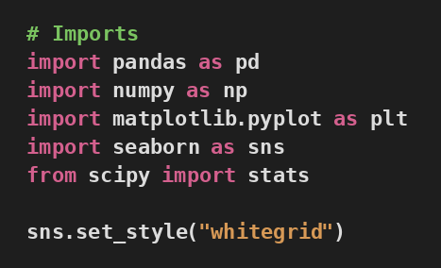
Figure A.1.1: Import Libraries
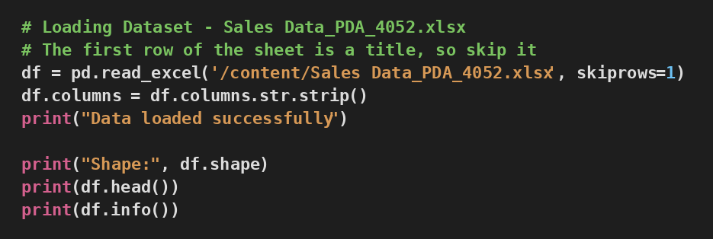
Figure A.1.2: Initial Data Loading

A.2 Data Type Fixes and Initial Inspection
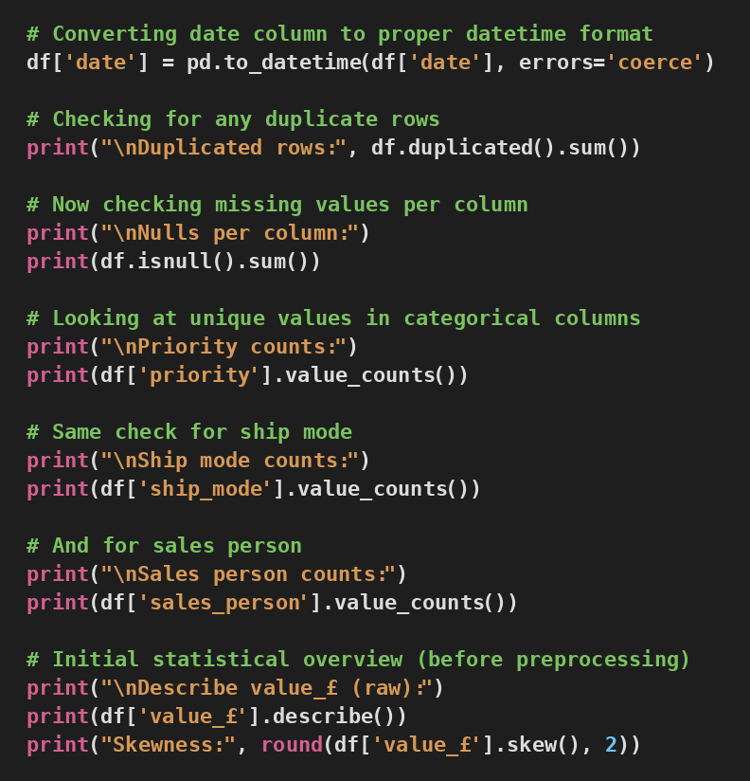
Figure A.2.1: Data Type Conversion and Initial Data Quality Checks

A.3 Missing Value Treatment
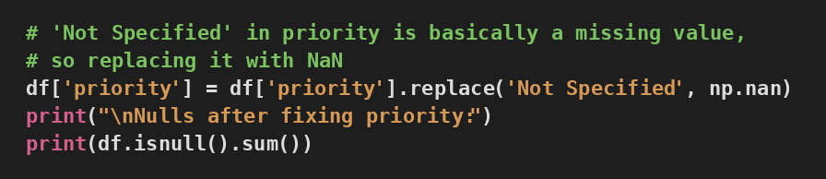
Figure A.3.1: Handling 'Not Specified' Values in Priority Field

A.4 Outlier Detection and Removal (IQR Method)
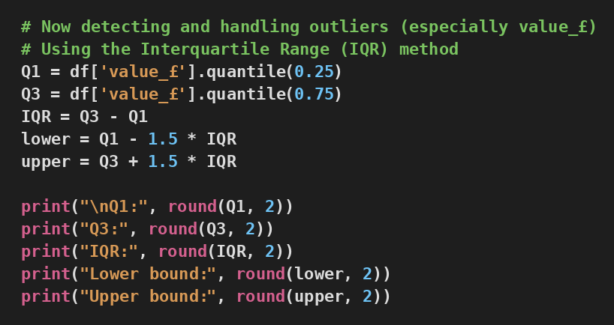
Figure A.4.1: Outlier Detection using the IQR Method
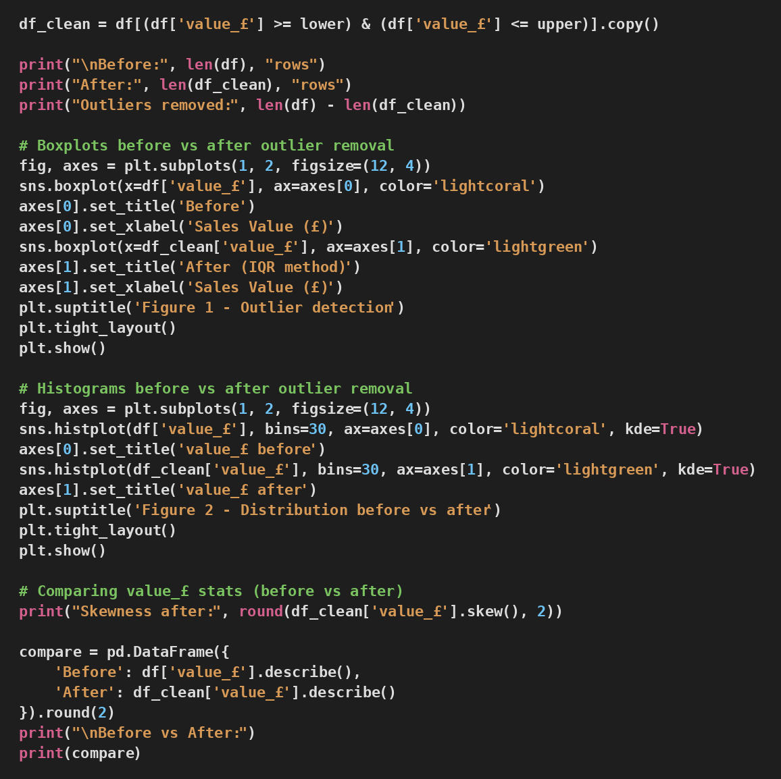
Figure A.4.2: Removing Outliers and Comparison Plots

A.5 EDA – Sales Person Analysis
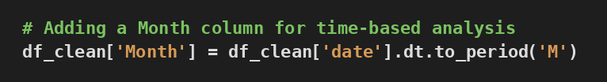
Figure A.5.1: EDA – Adding Time-Based Columns from Date Field
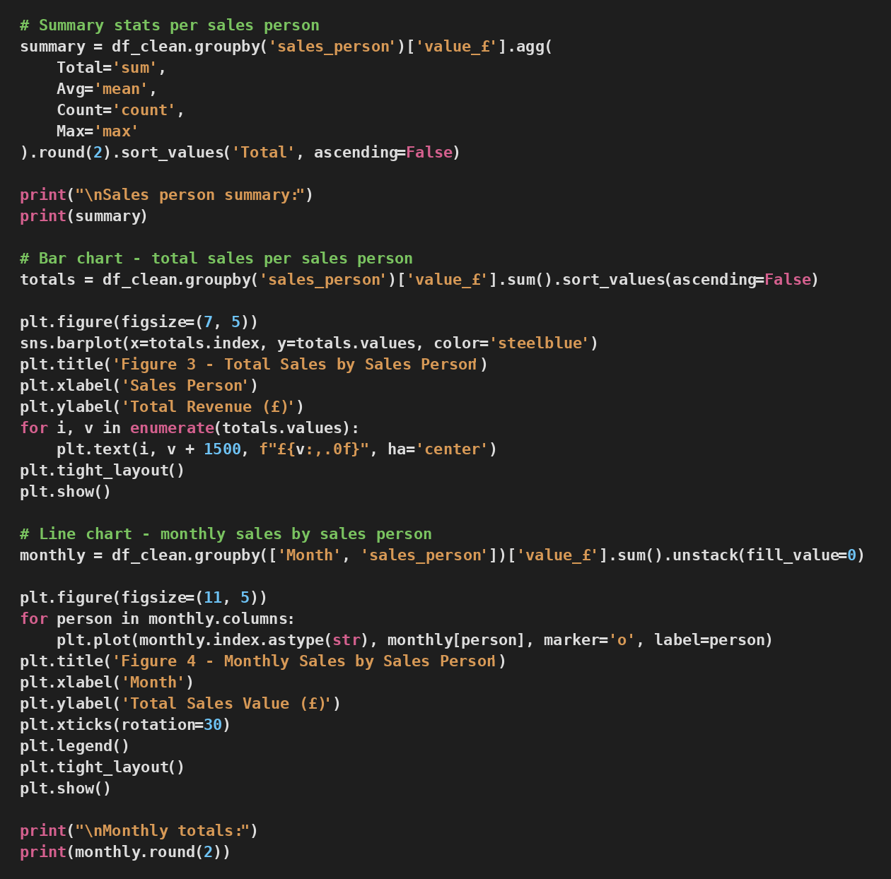
Figure A.5.2: EDA – Total and Mean Sale Value Grouped by Sales Person

A.6 Priority vs Sale Value – Correlation Analysis
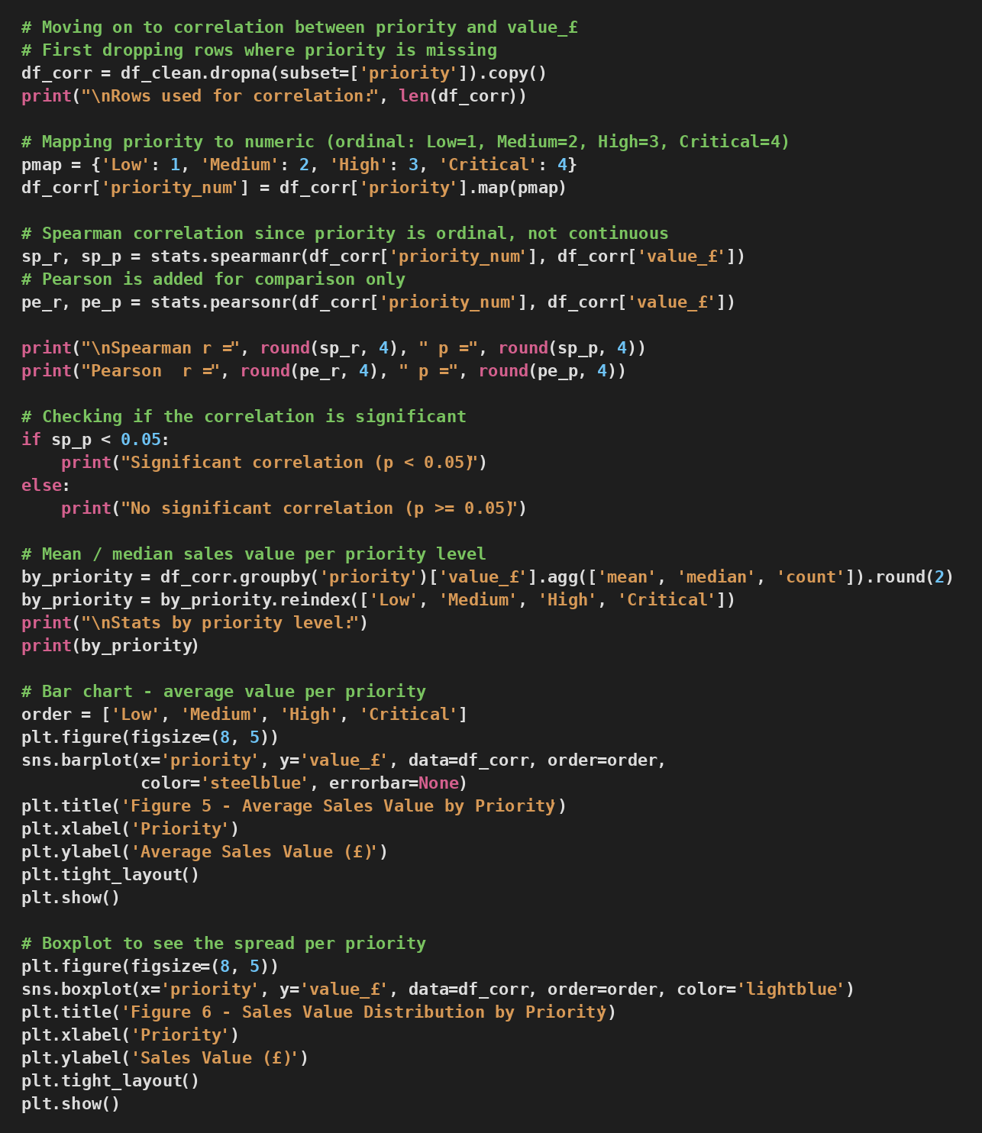
Figure A.6.1: Priority vs Sale Value Correlation Analysis

A.7 Revenue by Shipping Mode and Saving Cleaned Dataset
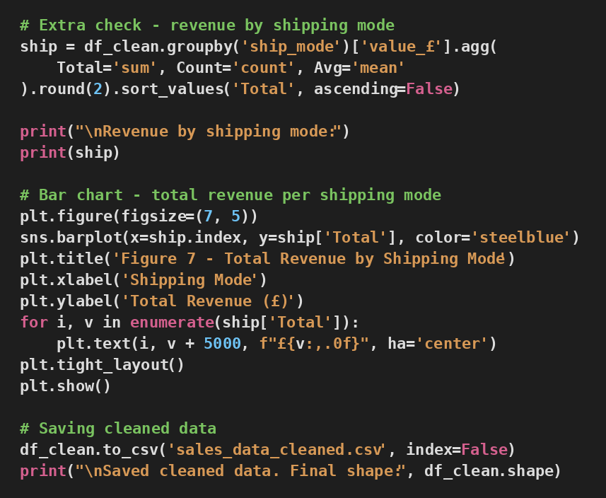
Figure A.7.1: Revenue by Shipping Mode and Saving Cleaned Dataset

Appendix B – GitHub Repository
The notebook, the raw dataset, the cleaned dataset, and a copy of this report have been uploaded to a GitHub repository for versioning. Details below.
- Python version: 3.12 (Google Colab)
- GitHub: https://github.com/OmBhingradiya/Programming_for_Data_Analytics_COM_7024
- Dataset: Sales Data_PDA_4052.xlsx
- Cleaned dataset: sales_data_cleaned.csv
- Colab Notebook: Programming_for_Data_Analytics.ipynb
- This report: 25238053 - Programming for Data Analytics - COM7024 [4048].pdf

