PROJECT REPORT
On
Building A Machine Learning Model to Forecast
Sales
(CSE VI Semester Mini project )
2023-2024

Submitted to: Submitted by:
Miss. Manika Mr.Om Bijalwan
(CC-CSE-G-VI-Sem) Roll. No:2118865
Session: 2023-2024
DEPARTMENT OF COMPUTER SCIENCE AND INFORMATION TECHNOLOGY
GRAPHIC ERA HILL UNVERSITY, DEHRADUN

CERTIFICATE

Certified that Mr. Om Bijalwan (Roll No.- 2118865) has developed mini project on “Building A Machine Learning Model To forecast Sales ” for the CS V Semester Mini Project Lab in Graphic Era Hill University, Dehradun. The project carried out by Students is their own work as best of my knowledge.

Date:12/07/2024

(CSE Department)
GEHU Dehradun

ACKNOWLEDGMENT

We would like to express our gratitude to The Developer Ashish, the most Beneficent and the most Merciful, for completion of project.
We wish to thank our parents for their continuing support and encouragement. We also wish to thank them for providing us with the opportunity to reach this far in our studies.
We would like to thank particularly our project Co-ordinator Mr Purushottam Das for his patience, support and encouragement throughout the completion of this project and having faith in us.
At last but not the least We greatly indebted to all other persons who directly or indirectly helped us during this work.

Mr. Om Bijalwan
Roll No.- 2118865
CSE-G-VI-Sem
Session: 2023-2024
GEHU, Dehradun
TABLE OF CONTENTS

CHAPTER NO. TITLE
1. INTRODUCTION About Machine Learning
Sales Forecasting
2. Jupyter Notebook
3. Data Cleaning
4. Preprocessing
Label Encoding
Splitting of data
Standardisation
5. Model Building
Linear Regression
Random Forest Regressor
6. Hyper parameter tunning
7. REFERENCES
- INTRODUCTION
Machine Learning
Machine learning is a type of artificial intelligence (AI) that allows computers to learn from data and improve their performance on a specific task over time. Instead of being programmed with a set of rules, these algorithms can identify patterns and relationships in data, enabling them to make predictions, classify information, and even generate creative content.
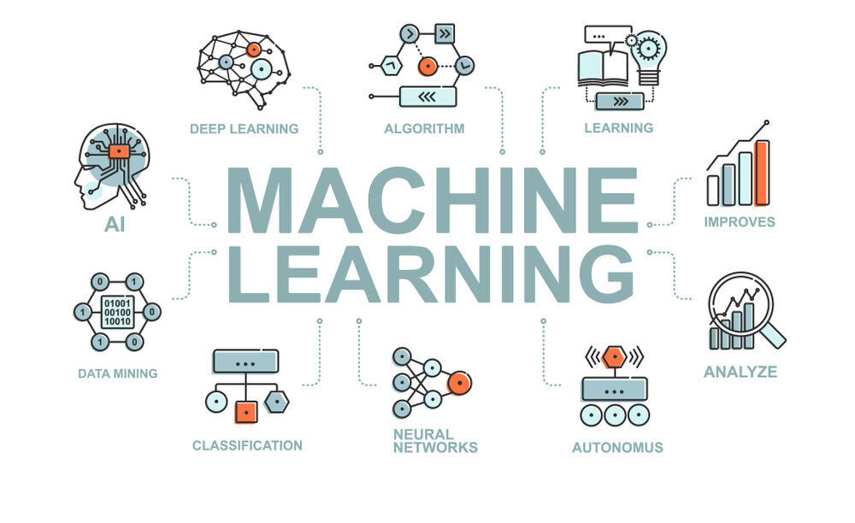
The applications of machine learning are vast and ever-growing. Here are just a few examples:
Personalized recommendations: From the movies you watch to the products you buy, machine learning algorithms power the personalized recommendations you see online and in stores.
Fraud detection: By analyzing financial transactions, machine learning can identify suspicious activity and prevent fraud before it happens.
Medical diagnosis: By analyzing medical images and data, machine learning can help doctors diagnose diseases more accurately and quickly.
Self-driving cars: The brains behind self-driving cars are powered by sophisticated machine learning algorithms that can perceive their surroundings and make decisions in real-time.

Sales Forecasting
In the ever-changing landscape of business, navigating uncertainty is crucial. For any company, understanding what lies ahead in terms of sales is not just desirable, it's essential. This is where the art and science of sales forecasting comes into play.
In the fast-paced world of retail, accurate sales forecasting is a superpower. Knowing what, when, and how much customers will buy empowers businesses to optimize inventory, pricing, and staffing, ultimately boosting profitability and customer satisfaction. Traditionally, forecasting relied on historical trends and intuition, often falling short in the face of dynamic market shifts and consumer behavior. Enter the game-changer: Machine Learning (ML).
ML breathes life into data, transforming numerical figures into actionable insights. By analyzing vast datasets of past sales, promotions, economic indicators, and even weather patterns, ML algorithms uncover hidden trends and predict future sales with remarkable accuracy. This is precisely the weapon Walmart wields in its fight against uncertainty.


Jupyter Notebook
Jupyter Notebook is an open-source web application that allows you to create and share documents called notebooks. These notebooks are like workbenches where you can combine:
Live code: You can write code in various languages like Python, R, Julia, and more, and see the results executed right there in the notebook.
Explanatory text: Don't just crunch numbers, explain your thought process and findings with rich text formatting, markdown, and even LaTeX for complex equations.
Visualizations: Bring your data to life with interactive charts, graphs, and images, making complex trends and relationships easily understandable.
Multimedia: Embed audio, video, and even interactive widgets to create rich and engaging presentations of your work.
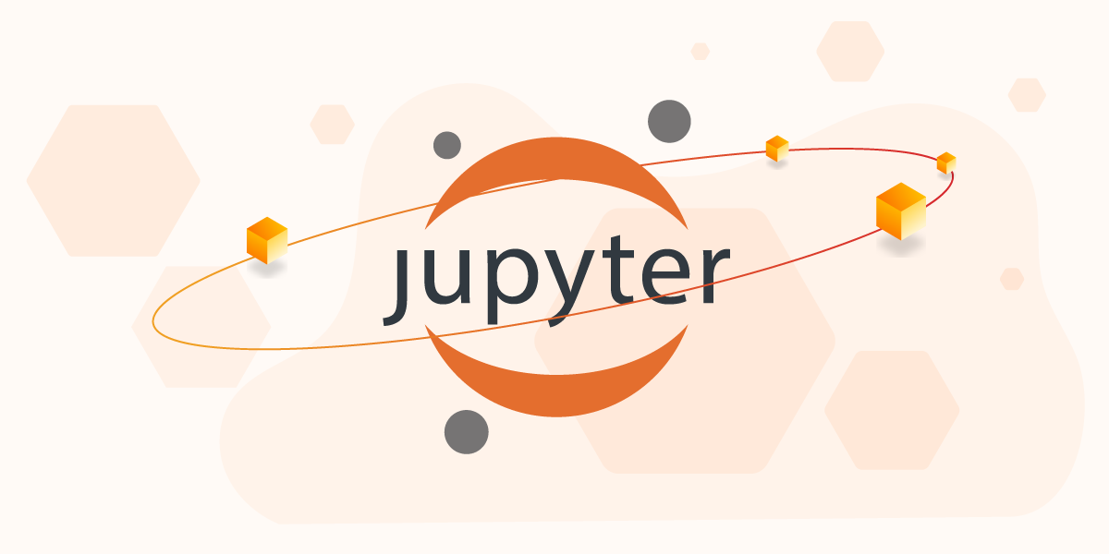

Important Libraries
1. Pandas
Pandas is your data maestro, the master organizer who transforms raw numbers into structured DataFrames and Series. Think of it as a supercharged spreadsheet on steroids, where data manipulation becomes a seamless ballet of filtering, cleaning, and merging. With Pandas, you can explore trends, calculate statistics, and slice your data with laser precision, uncovering hidden insights within.
2. Numpy
NumPy is the computational powerhouse, the behind-the-scenes magician who crunches numbers with lightning speed. Its multidimensional arrays, akin to powerful matrices, are the playgrounds for complex calculations, vectorized operations, and advanced scientific computations. NumPy fuels the engine of your analysis, ensuring even the most demanding tasks are tackled with effortless efficiency.

3. Matplotlib
Matplotlib is the visual storyteller, the artist who breathes life into your data. Its canvas is diverse, offering a multitude of plot types, from simple line graphs to intricate histograms and bar charts. You can customize fonts, colors, and layouts to your heart's content, shaping your data into compelling narratives that speak a thousand words. Matplotlib's interactive capabilities let you zoom, pan, and explore, adding a dynamic layer to your visualizations.
4. Seaborn
Seaborn is the statistician's stylist, the artist who elevates Matplotlib's creations to stunning heights. It builds upon Matplotlib's foundation, infusing statistical knowledge into the aesthetic. Seaborn focuses on revealing relationships and trends within your data, crafting visually appealing histograms, boxplots, and violin plots that highlight statistical significance. With Seaborn, your visualizations not only tell a story, but they do so with statistical rigor and undeniable beauty.
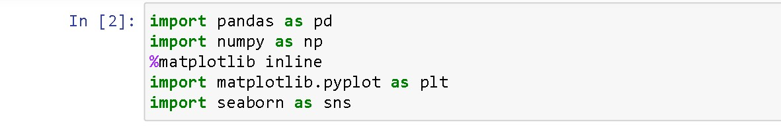

Data Cleansing
Data cleansing is the process of identifying and correcting or removing errors and inconsistencies from a dataset to ensure its quality, accuracy, and usefulness for analysis and modeling. It's a crucial step in any data-driven project, as it directly impacts the reliability of your insights and predictions.
Common data cleansing tasks include:
1. Handling Missing Values:
Identify missing values (NaNs, blanks, or inconsistent placeholders).
Choose appropriate strategies based on data type and importance:
Remove rows or columns with excessive missingness.
Impute missing values using mean, median, mode, or predictive models.

2, Identifying and Correcting Errors:
Detect typos, inconsistencies, out-of-range values, or invalid formats.
Correct errors based on domain knowledge or data validation rules.

3. Removing Duplicates:
Identify and remove duplicate rows that represent the same data point.

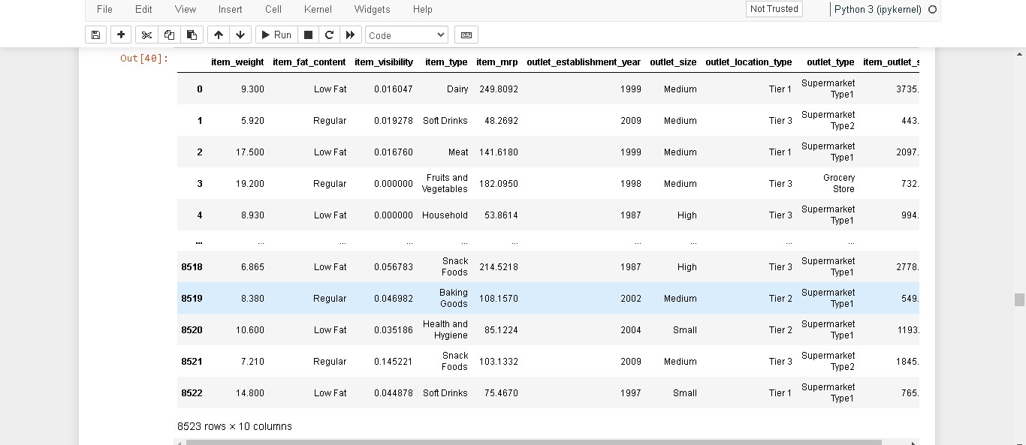

Preprocessing
Before feeding your data to hungry machine learning models or building insightful analyses, it needs a good pre-processing makeover. Think of it as taking your data from raw ingredients to a perfectly seasoned dish ready to impress. Here's a breakdown of the three processes you mentioned:
1. Label Encoding: Transforming Categories into Numbers
Imagine your data has categories like "red", "green", and "blue". While models understand numbers better than colors, directly feeding these strings wouldn't do! Label encoding comes to the rescue by assigning unique numerical values to each category. Now, "red" might be 1, "green" might be 2, and "blue" might be 3, making the data machine-friendly without losing the meaning of categories.
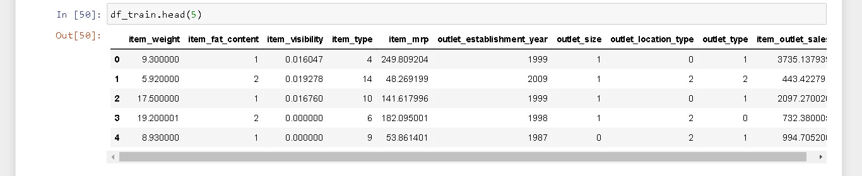

2. Splitting the Data: Training, Validation, and Testing
Think of your data as a delicious cake. You wouldn't eat the whole cake before knowing how good it is, right? Similarly, we split our data into training, validation, and testing sets. The training set is the main course, where the model learns the patterns and relationships within the data. The validation set is like a small side dish, used to fine-tune the model and check its performance on unseen data. Finally, the testing set is the dessert, revealing the model's true accuracy on completely new data.

3. Standardization: Scaling Everyone to the Same Level
Imagine athletes competing in a race where some have longer legs than others! To ensure a fair contest, we standardize the data by scaling features to a common range, often between 0 and 1. This removes biases caused by features with vastly different scales, ensuring all features get equal consideration when the model learns.

Model Building
Model building in machine learning is like constructing a magnificent building; you lay the foundation with data, choose the right architectural style (model type), and carefully assemble the components to achieve your desired outcome. In this case, we'll explore two popular building materials for regression tasks: linear regression and random forest regressor.
1. Linear Regression: The Classic Architect
Imagine a clean, minimalist building with elegant lines. That's linear regression! It assumes a linear relationship between your feature variables (independent variables) and your target variable (dependent variable). Think of it as a straight line that best fits the points in your data.
Strengths:
Interpretability: You can easily understand the relationship between features and the target variable by looking at the coefficients of the line equation.
Fast & Efficient: Simple calculations make it computationally efficient, ideal for smaller datasets.
Good for linear relationships: If your data truly exhibits a linear pattern, it can be highly accurate.
Weaknesses:
Assumes linearity: Can't capture complex non-linear relationships well.
Sensitive to outliers: A single outlier can significantly skew the line.
Limited feature importance: Only provides direction and strength of influence, not complex interactions.

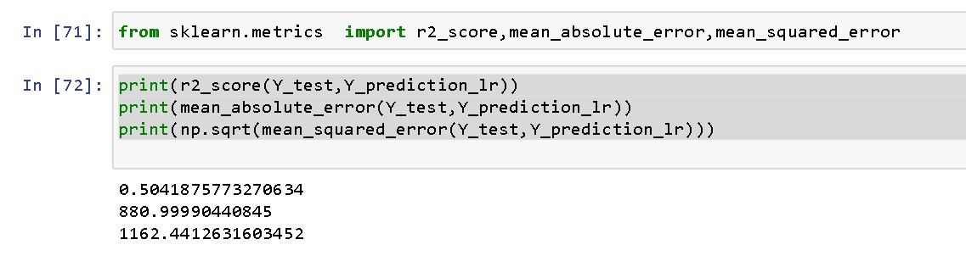

2. Random Forest Regressor: The Ensemble Powerhouse
Picture a vibrant, eclectic building formed by combining different architectural styles. This is the random forest regressor! It creates an ensemble of many decision trees, each predicting the target variable based on a subset of features and random splits. The final prediction is the average of all individual trees.
Strengths:
Handles non-linear relationships: Can capture complex patterns that linear regression misses.
Robust to outliers: Less sensitive to individual data points that might skew the results.
Provides feature importance: Reveals which features contribute most to the prediction.
Weaknesses:
Can be computationally expensive: Training many trees can take longer compared to linear regression.
Overfitting risk: Requires careful tuning to avoid overfitting to the training data.
Choosing the Right Model:
Here we got the r2 score of random forest regressor ie 54% accuracy and r2 score of linear regression 50%n so we will choose random forest regressor here .
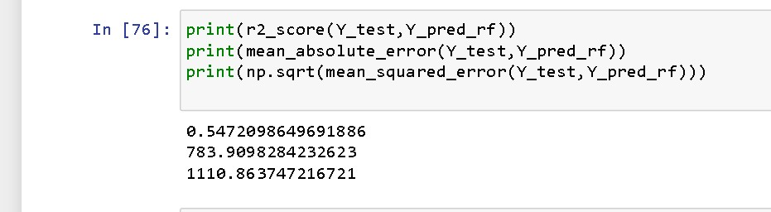

Hyper parameter Tunning
Hyperparameter tuning is the secret sauce in the machine learning kitchen! Imagine your model as a powerful race car, but with knobs and dials controlling its engine. Tuning those knobs, called hyperparameters, is like fine-tuning the car's suspension and gears for peak performance. It's all about finding the perfect settings that make your model learn efficiently and avoid pitfalls like underfitting or overfitting. This involves trying different combinations of parameters, evaluating how well the model performs on unseen data, and adjusting accordingly. It's an iterative journey, but mastering this art unlocks your model's true potential and lets it zoom past the competition!

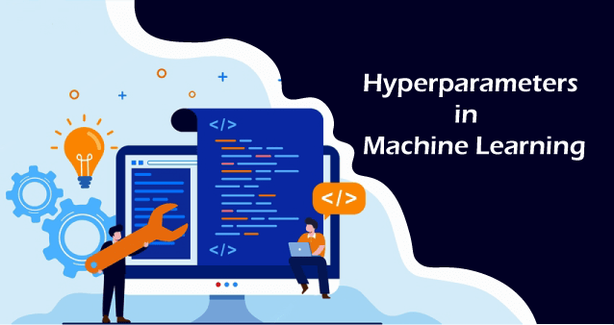

13 REFERENCES
- https://tudip.com/blog-post/qwiklabs/
- https://www.infoworld.com/article/2683784/what-is-cloud-computing.html
- https://google.qwiklabs.com/

