Name → Om Butala

PRN no → 22120149

Roll no → 323071

Subject → CC

Batch → C3

Assignment No 3

Deploy Web application on AWS Cloud (or any cloud)(PHP/Python/Node js any application)

STEP 1

→ LOGIN TO AWS

STEP 2

→ Go to E2C Instance via compute or access it directly from from frequently used section

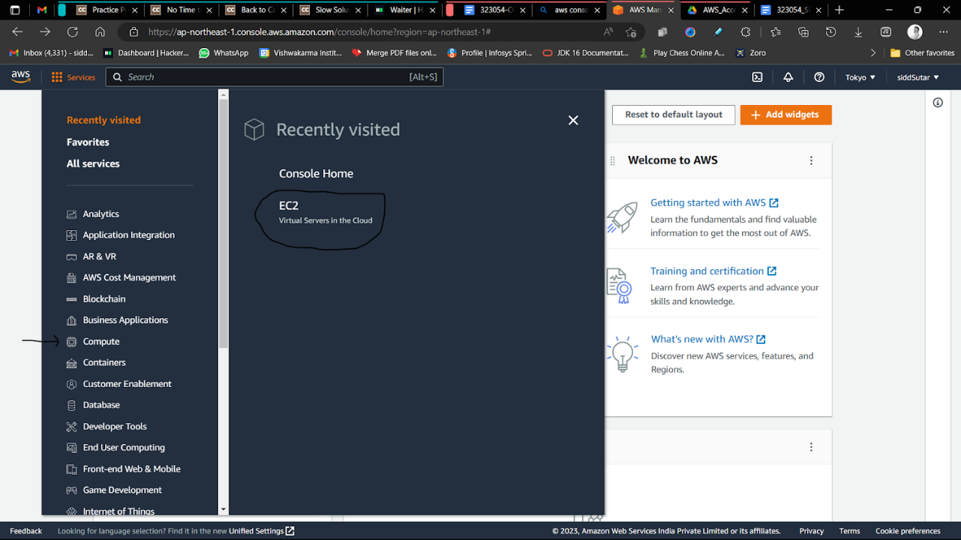

STEP 3

→ Configure the Instance

Name → Any name you like

OS → aws linux

Architecture → 64 bit

Create keys (Give any name to them and download it)

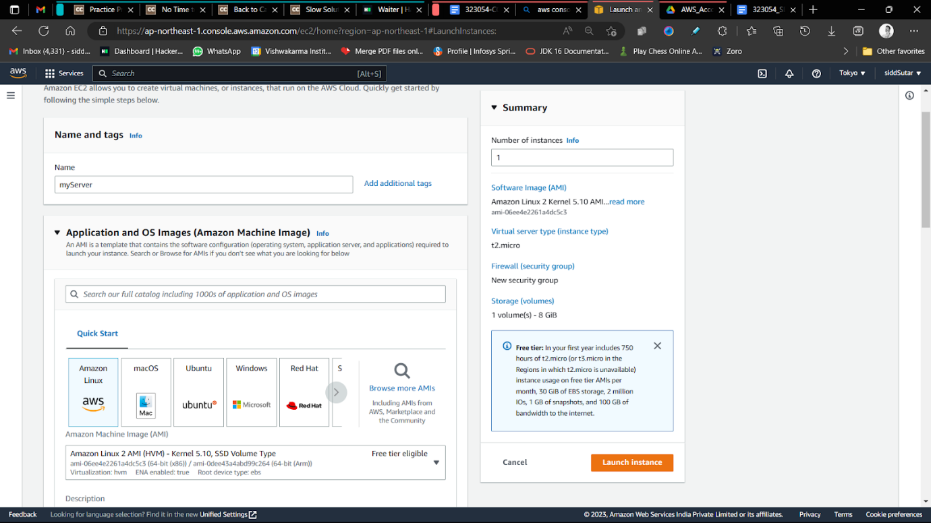

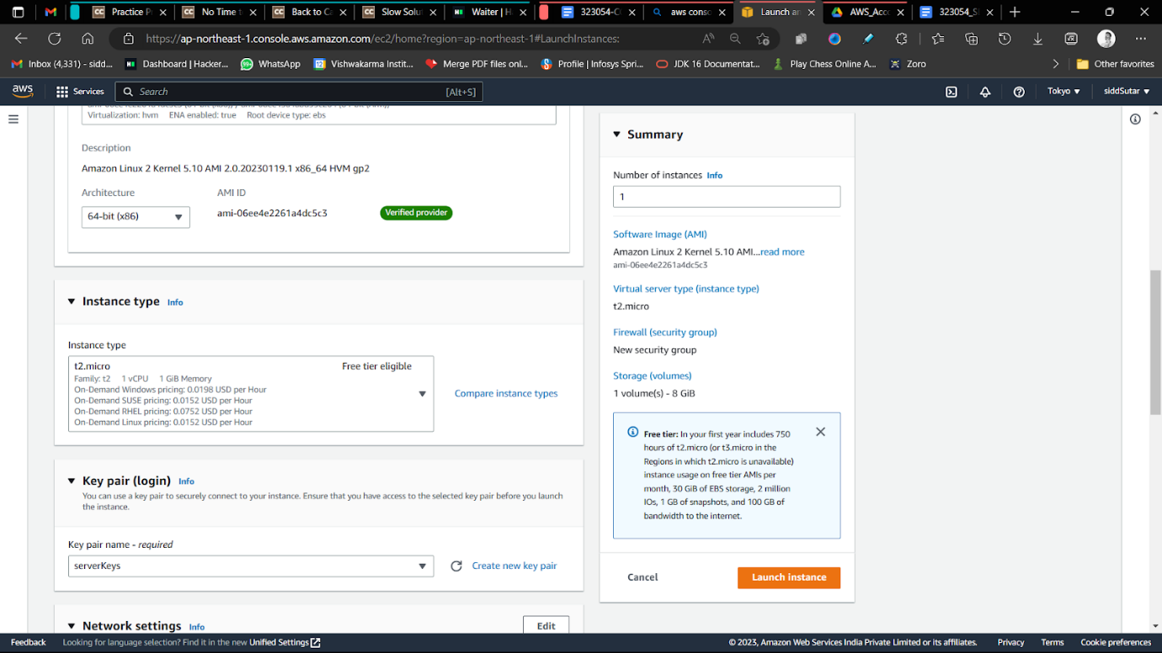

STEP 4

→ Launch the instance

→ After clicking at right bottom launch instance button it show look like this

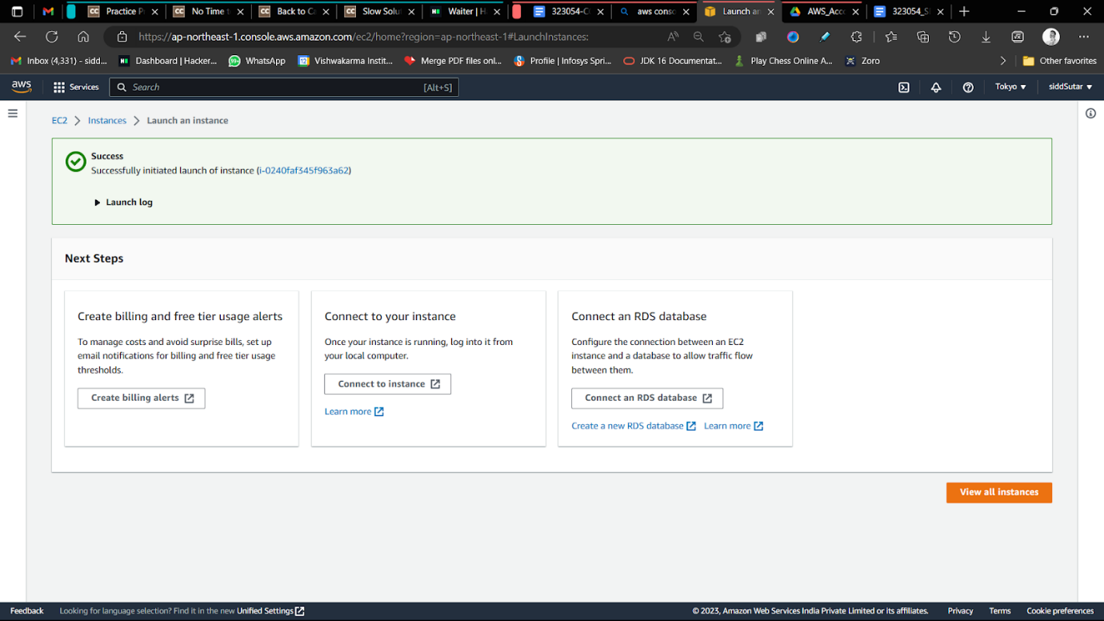

We will begin launching the instance after 2/2 status checks

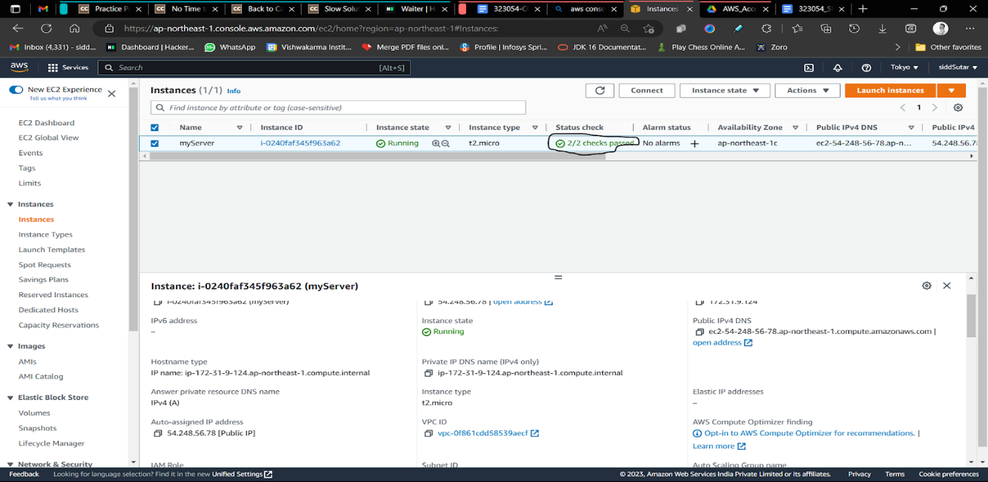

STEP 5

→ Launch the instance (Connect to the instance)

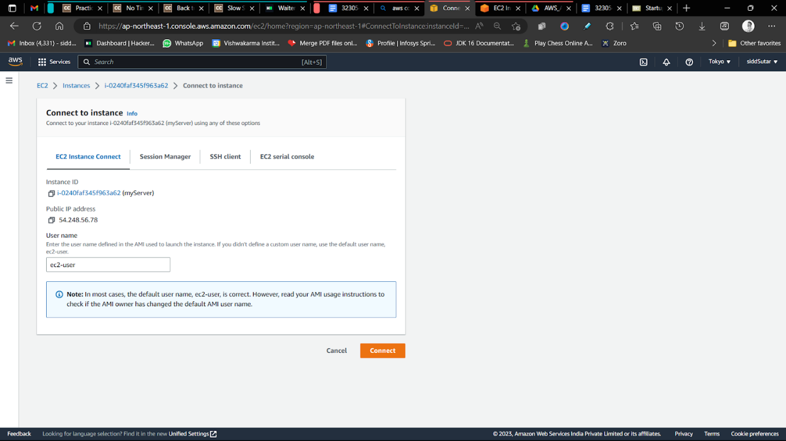

→ This terminal window shall open

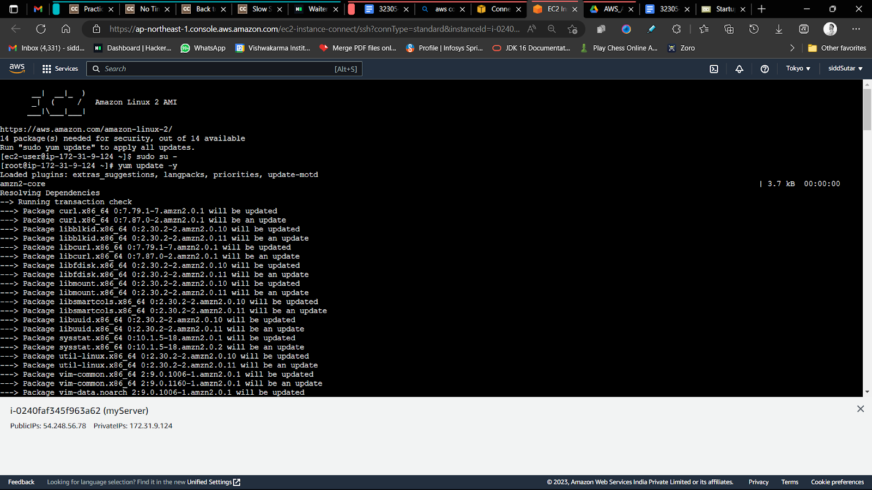

→ Put this commands in order

1. sudo su -



1. yum update -y

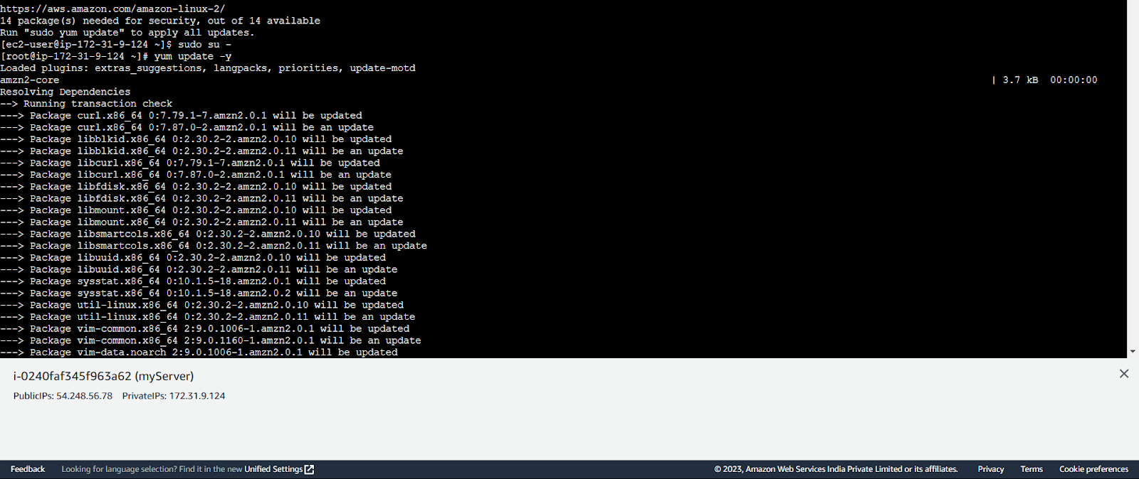

1. yum install -y httpd

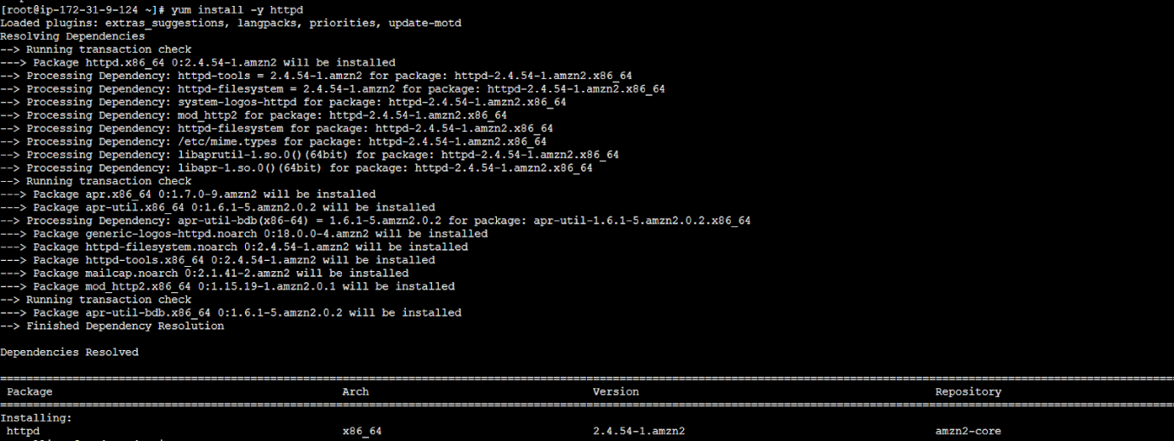

1. systemctl status httpd



1. mkdir temp | cd temp



1. wget <https://www.free-css.com/assets/files/free-css-templates/download/page288/startup.zip>
   1. As I’m no web developer so I took a template from <https://www.free-css.com/free-css-templates> remember to place the download link in front of wget

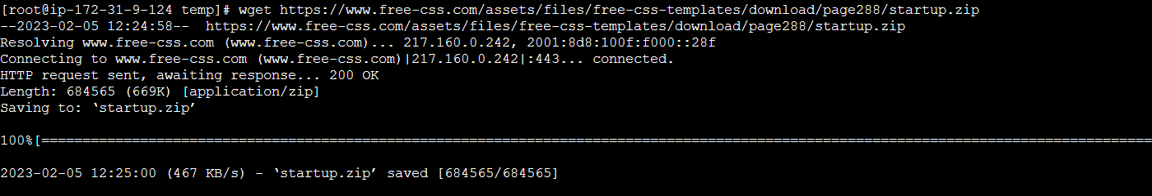

1. unzip startup.zip

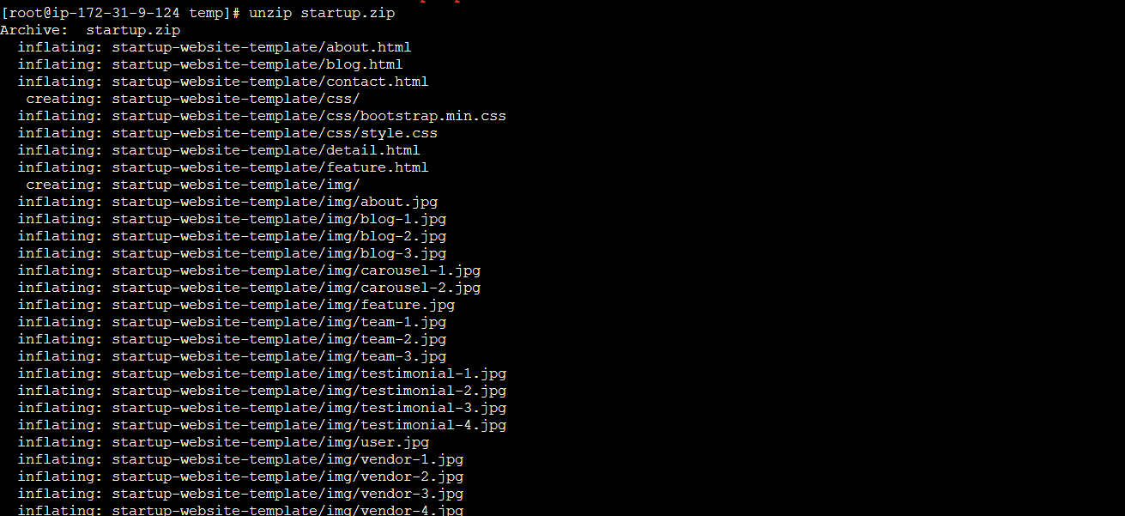

1. cd startup-website-template/

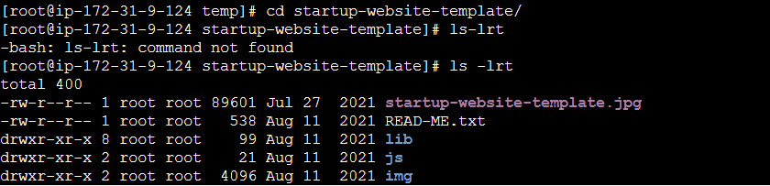

1. mv \* /var/www/html/



1. cd /var/www/html/

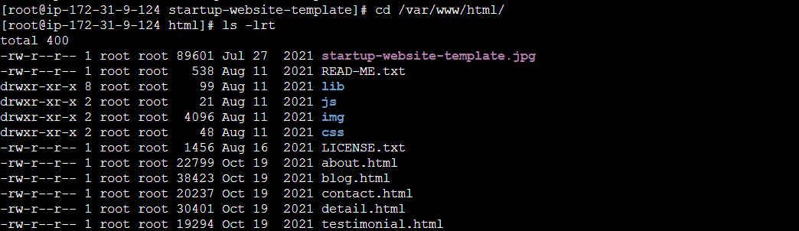

1. ls -lrt

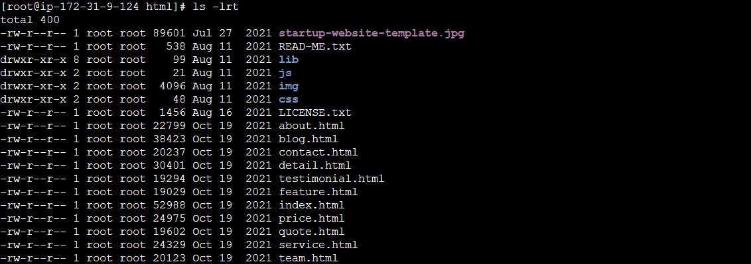

1. systemctl enable httpd | systemctl start httpd

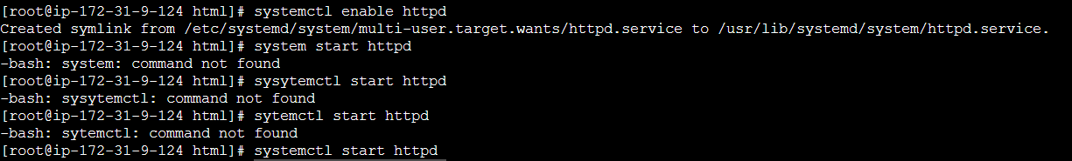

1. systemctl status httpd

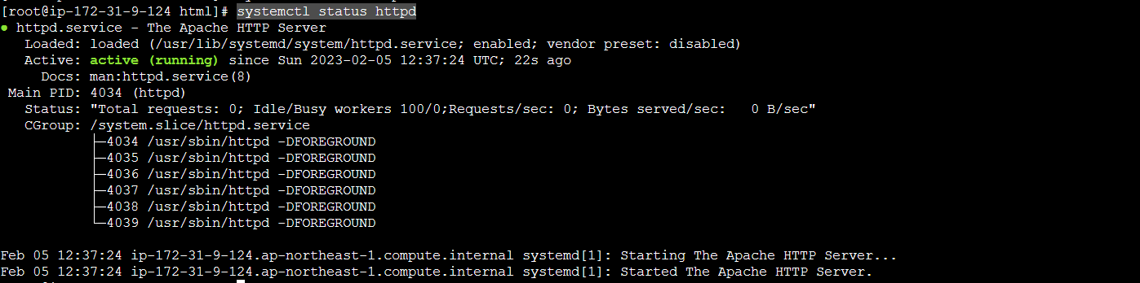

STEP 6

→ Change the inbound rules from security by simply clicking on launch wizard first

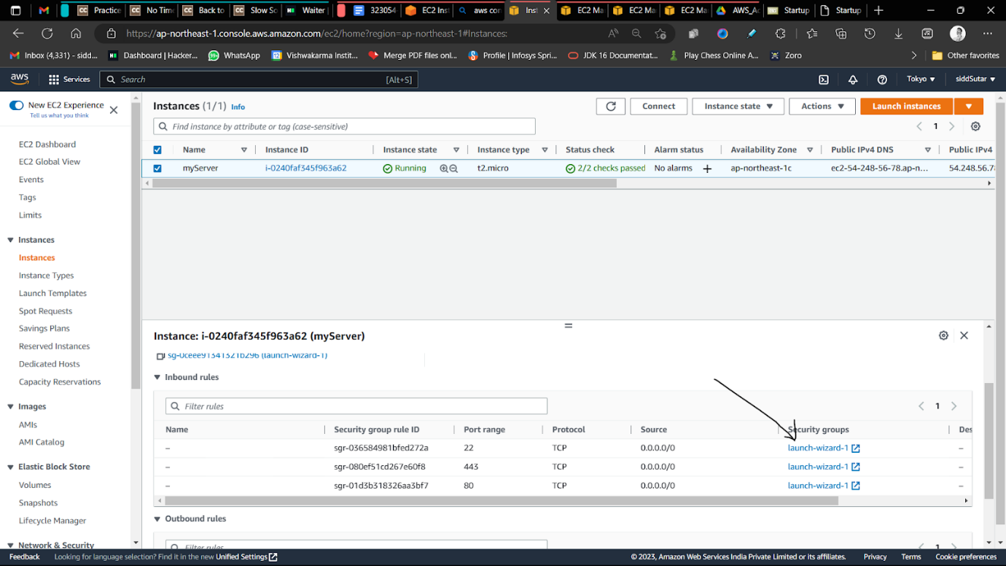

→ Click on edit inbound rules

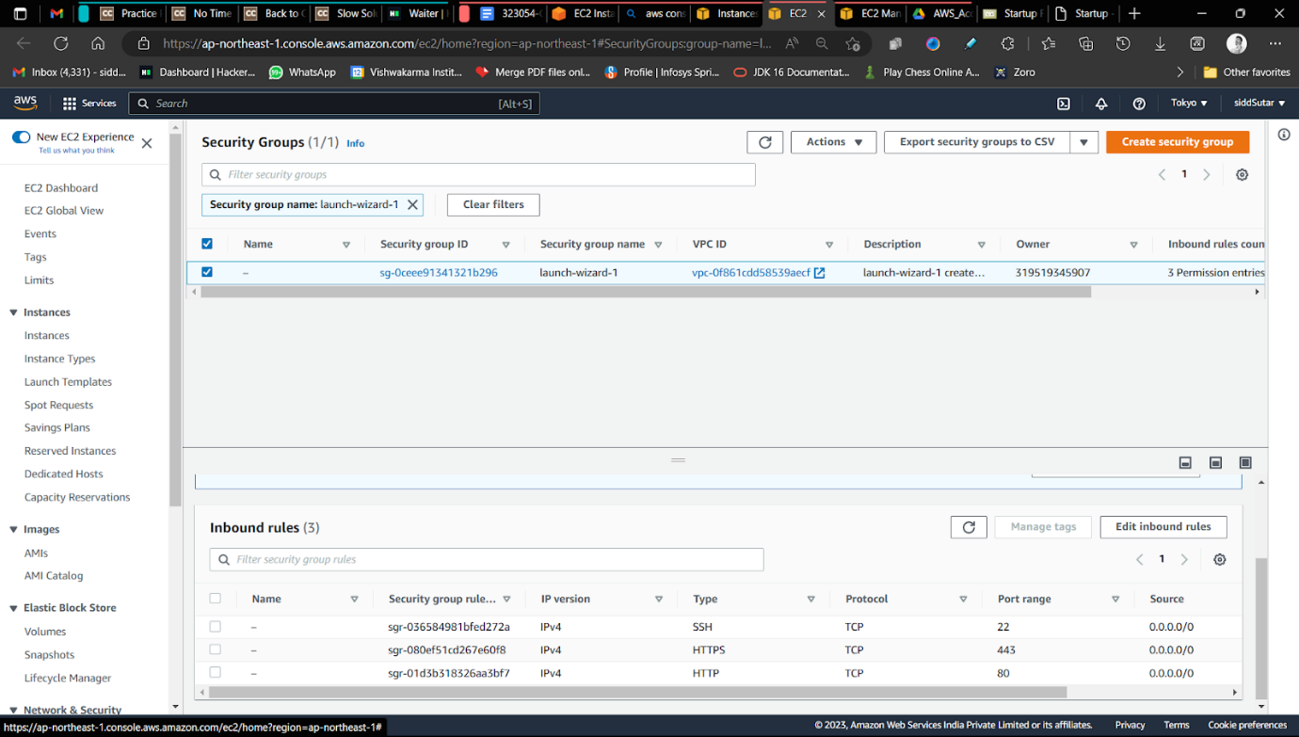

→ Add HTTP and HTTPS like the configuration given below

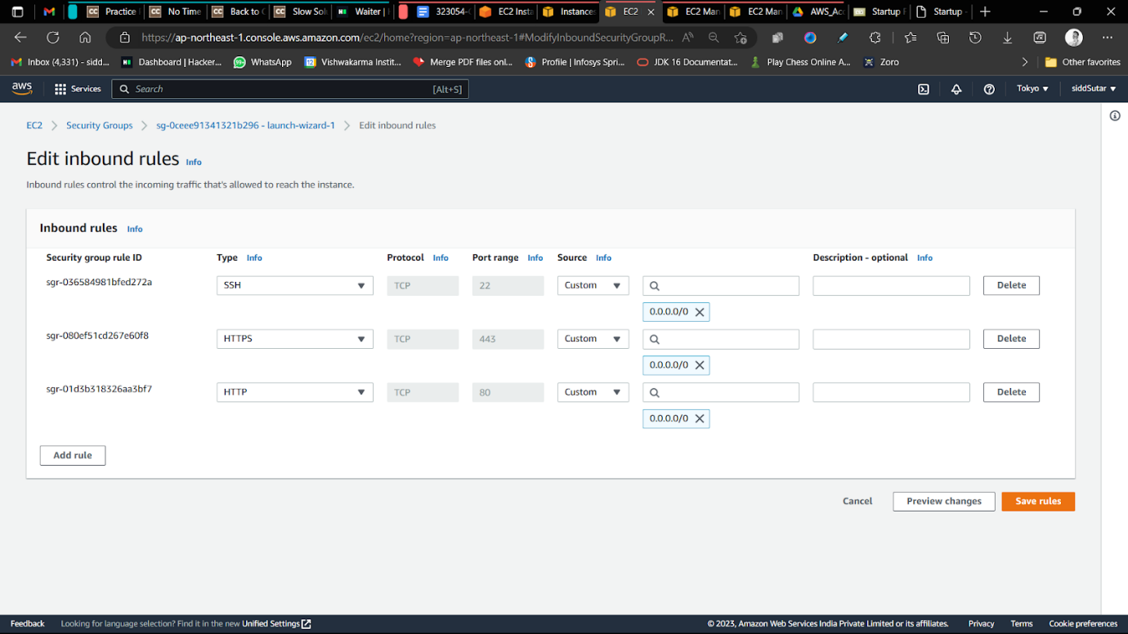

STEP 7

→ Copy and paste the public IP to the browser to see the web template hosted



STEP 8

→ Stop the instance & terminate it

