Name → Om Butala

Div → C

Roll No → 323071

PRN → 22120149

Subject → CC

# 

# Assignment No 4

# Deploy Web application using S3 Bucket (PHP/Python/Node.js any application)

# AIM

→ Deploy Web application using S3 Bucket

# Theory

→ What are the AWS S3 Bucket?

Amazon S3 (Simple Storage Service) is an object storage service provided by

Amazon Web Services (AWS) that enables you to store, secure, and manage your

data and static files in the cloud.

S3 is highly scalable, durable, and flexible, making it a popular choice for

businesses of all sizes. With S3, you can store unlimited amounts of data and

access it from anywhere in the world, through the internet. Some of the common

use cases for S3 include:

Backup and disaster recovery

Data archiving

Big data analytics

Static web hosting

Media hosting and streaming

S3 is also highly secure, with options for encryption and access control, allowing

you to ensure that your data is protected. Additionally, S3 is designed to offer

high availability, so you can be sure that your data will be accessible when you

need it.

Here are some of the key features and functionalities of Amazon S3 in detail:

1. Object-based storage: S3 stores data as objects, rather than as traditional

block-level or file-level storage. Each object consists of a data file and its

metadata, such as the file name, type, and access permissions. S3 supports

multiple types of data, including text, binary data, images, audio and video files,

and more.

2. Scalability: S3 is highly scalable, allowing you to store unlimited amounts of

data. You can easily increase or decrease your storage capacity as needed,

without any manual intervention.

3. Durability: S3 is designed to provide high durability by storing multiple

copies of your data across multiple geographic locations. By default, S3 stores

your data across multiple facilities within an AWS region, and you can choose to

store your data in multiple regions as well.

4. Accessibility: S3 provides several options for accessing your data, including

the AWS Management Console, the AWS CLI, and the S3 API. You can access

your data from anywhere in the world, through the internet.

5. Security: S3 provides a number of security features to help you protect your

data. You can encrypt your data at rest, in transit, and while it is being

processed, using encryption methods such as AES-256. You can also control

access to your data using S3's fine-grained access control system, which allows

you to set access policies for specific users or groups.

6. Cost: S3 pricing is based on the amount of data you store, the number of

requests you make to access your data, and the amount of data you transfer out

of S3. S3 also offers several cost optimization features, such as Amazon S3

Transfer Acceleration and Amazon S3 Intelligent-Tiering, which can help you

reduce your storage costs.

7. Integration with other AWS services: S3 integrates with a number of other

AWS services, such as Amazon EC2, Amazon EBS, Amazon Redshift, and Amazon

S3 Transfer Acceleration, allowing you to easily store and manage your data in

the cloud.

These are some of the key features and functionalities of Amazon S3 in detail. S3

is a highly reliable and secure cloud storage service, which makes it a popular

choice for businesses and individuals looking to store their data and static files

in the cloud.

# 

# Steps for Hosting Website

## STEP 1

→ Open AWS console and search & create S3 bucket

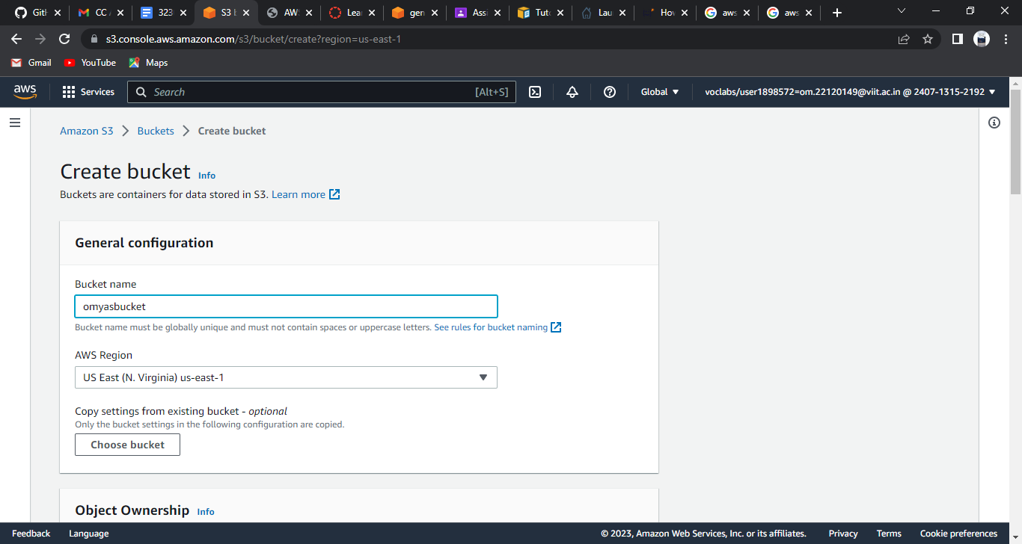

Note: Untick the block all access from public & acknowledge the public access off

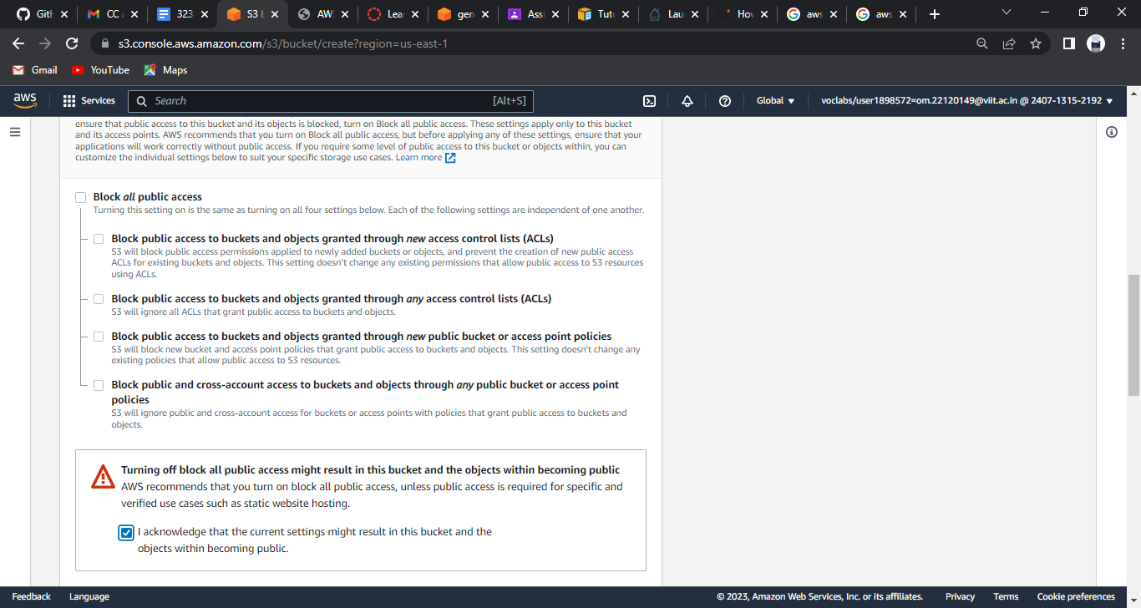

Now create Bucket

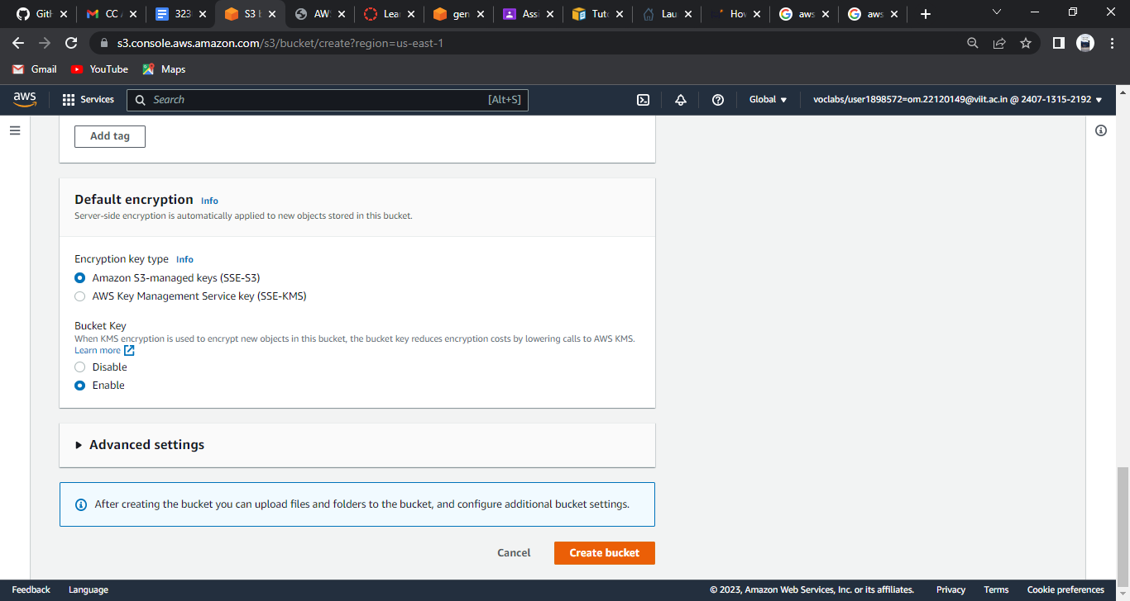

## STEP 2

→ Click on bucket name

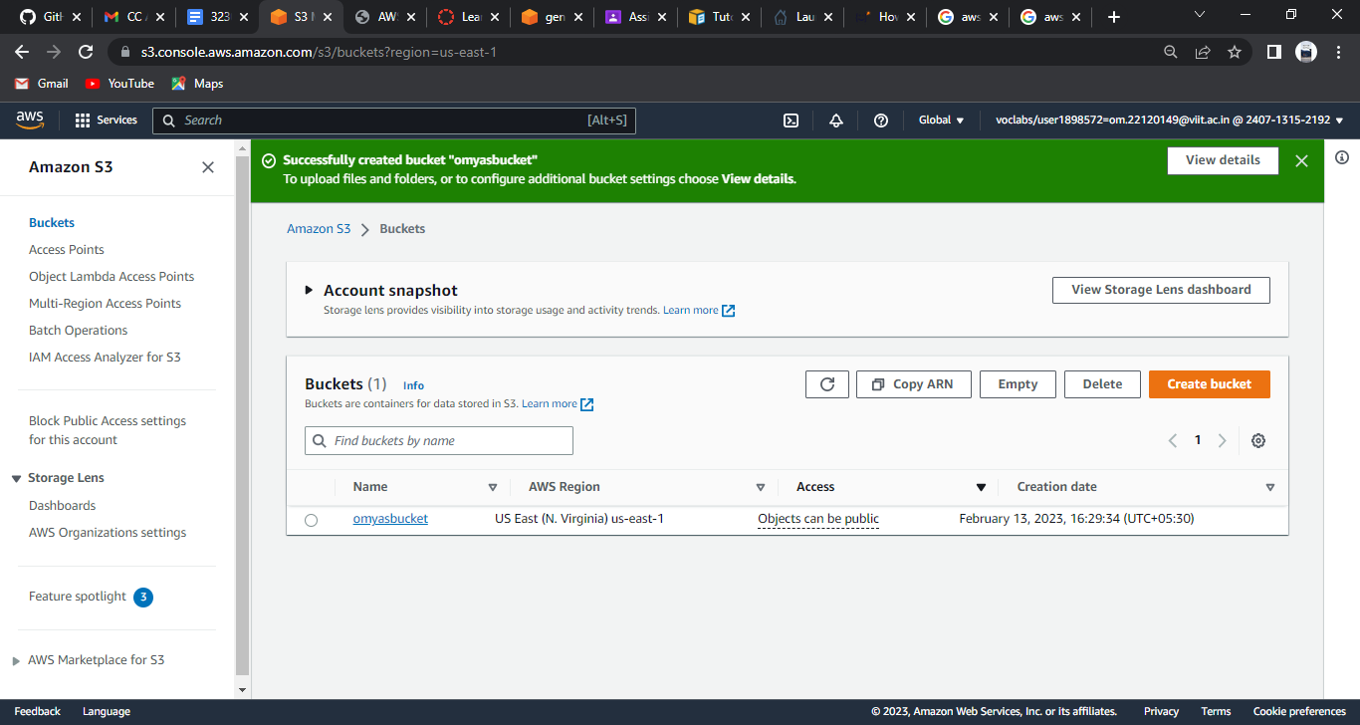

→ Open the properties of the bucket & edit the static hosting property

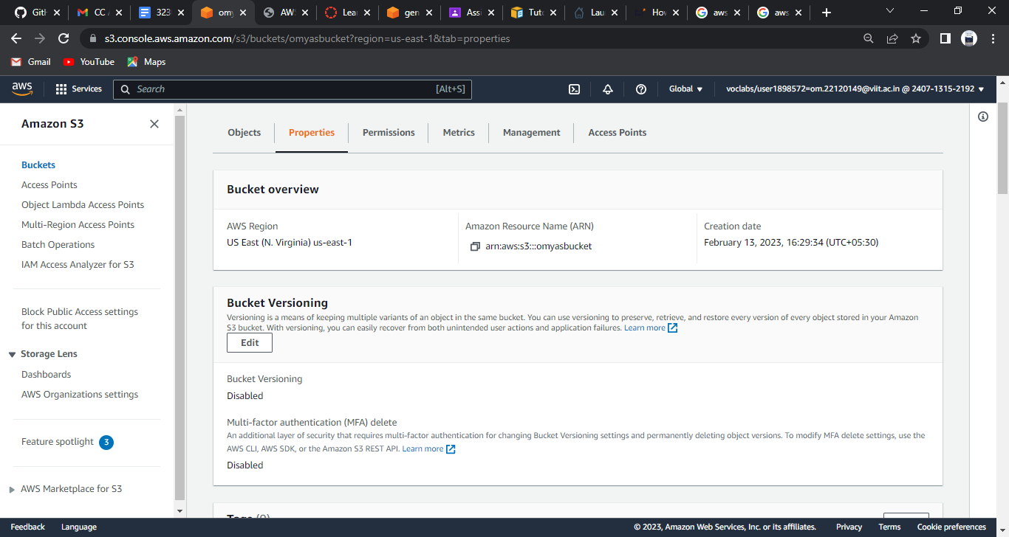

## STEP 3

→ Enable static web hosting & add name of index document as index.html

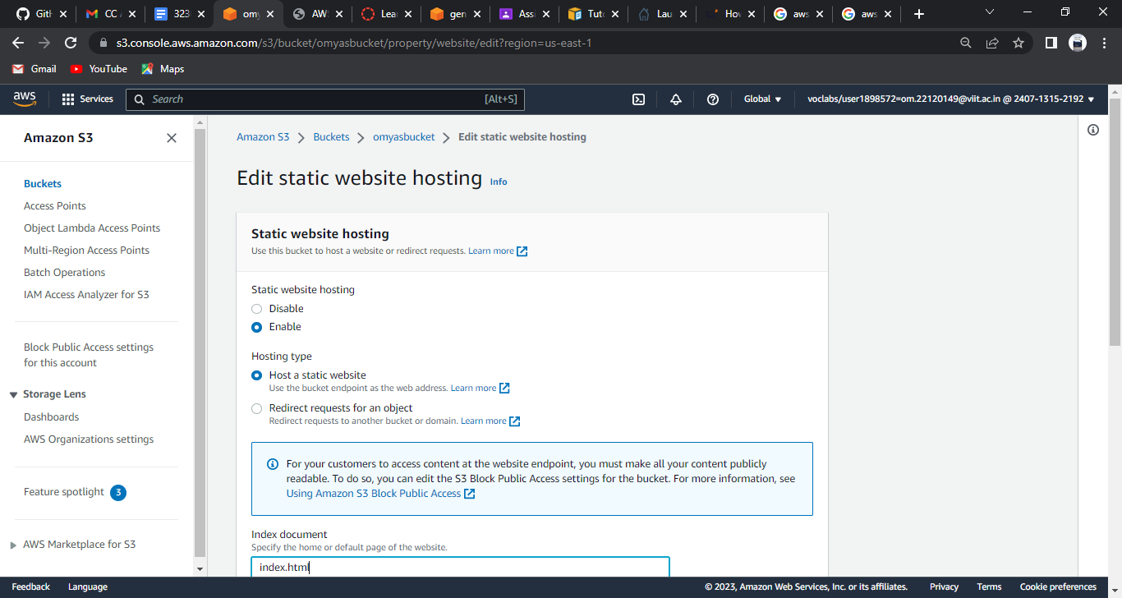

## STEP 4

→ Go to the permissions of the bucket & and generate a new policy for our bucket (We can use aws policy generator or can get a basic template for web hosting on aws)

(Add the asked things and click on add statement and generate policy)

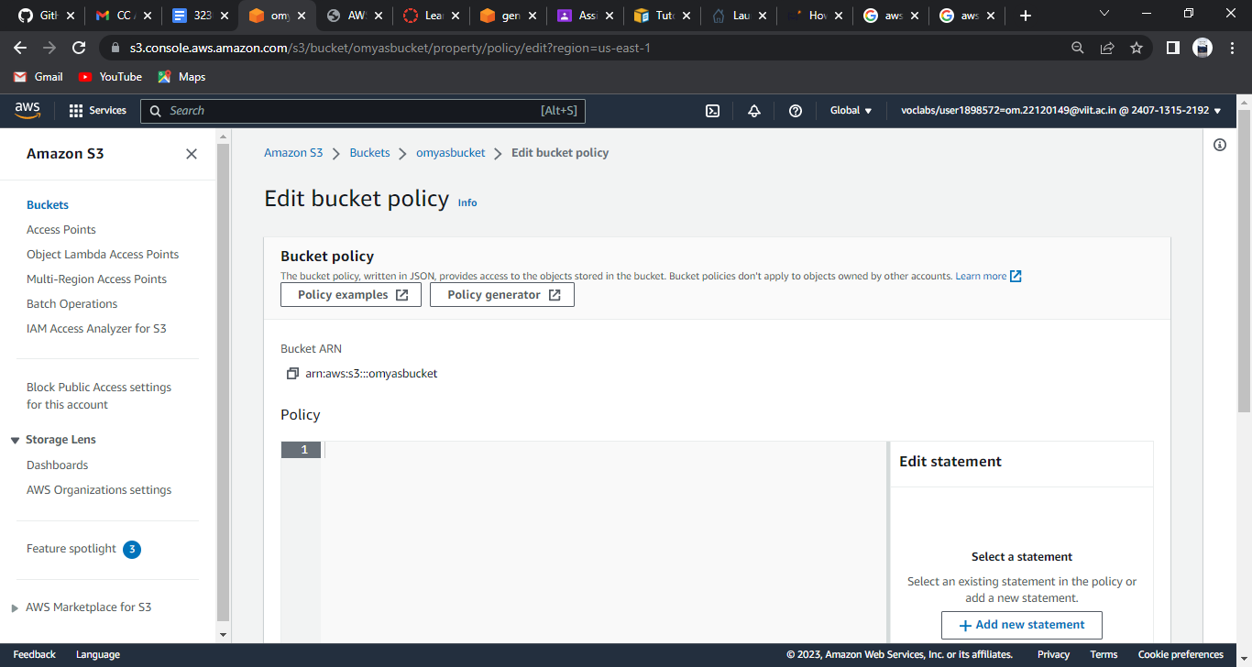

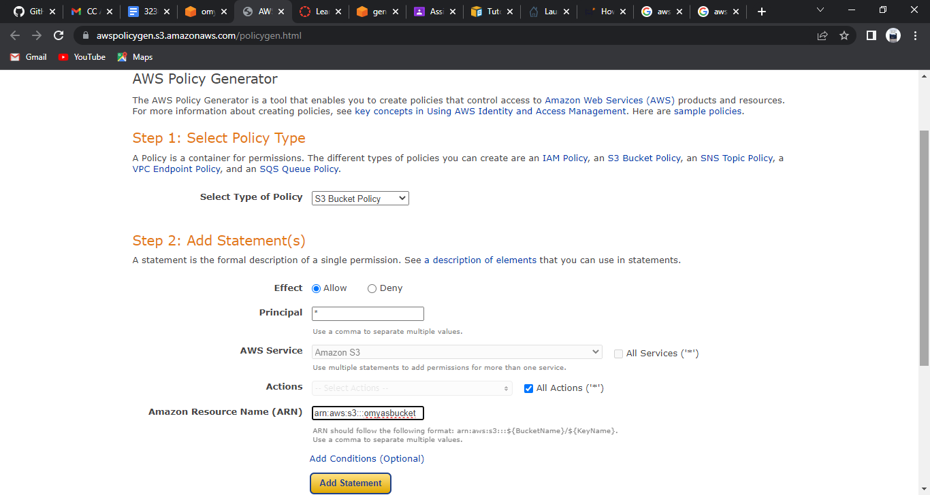

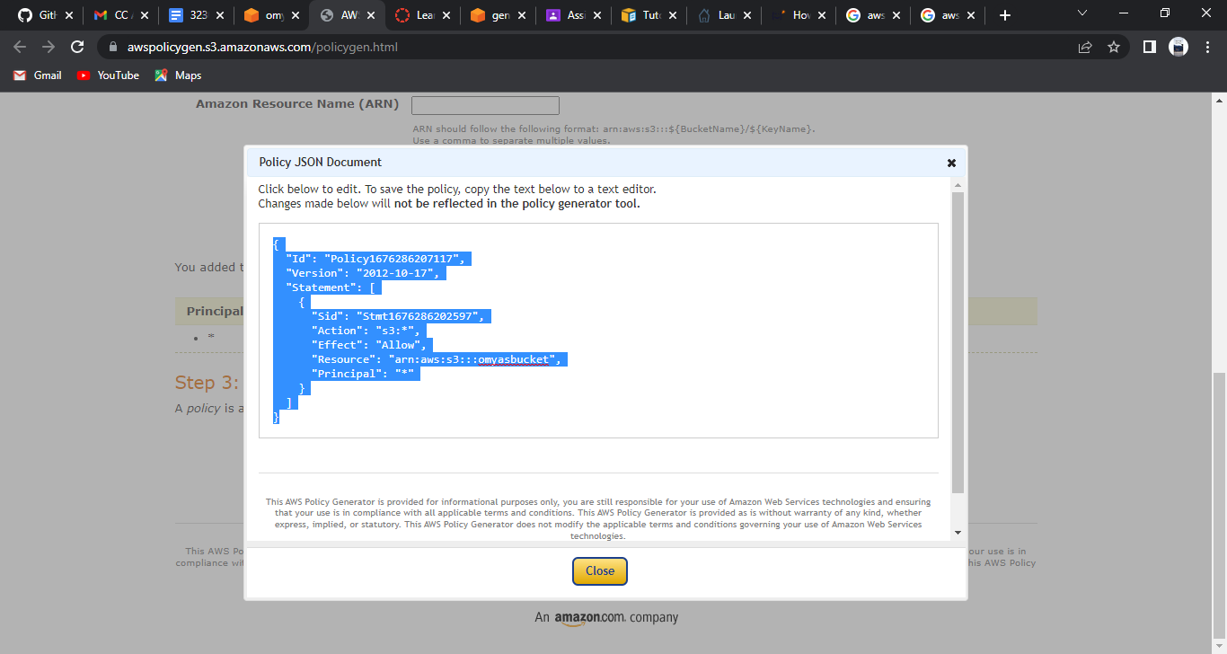

(Add the policy here)

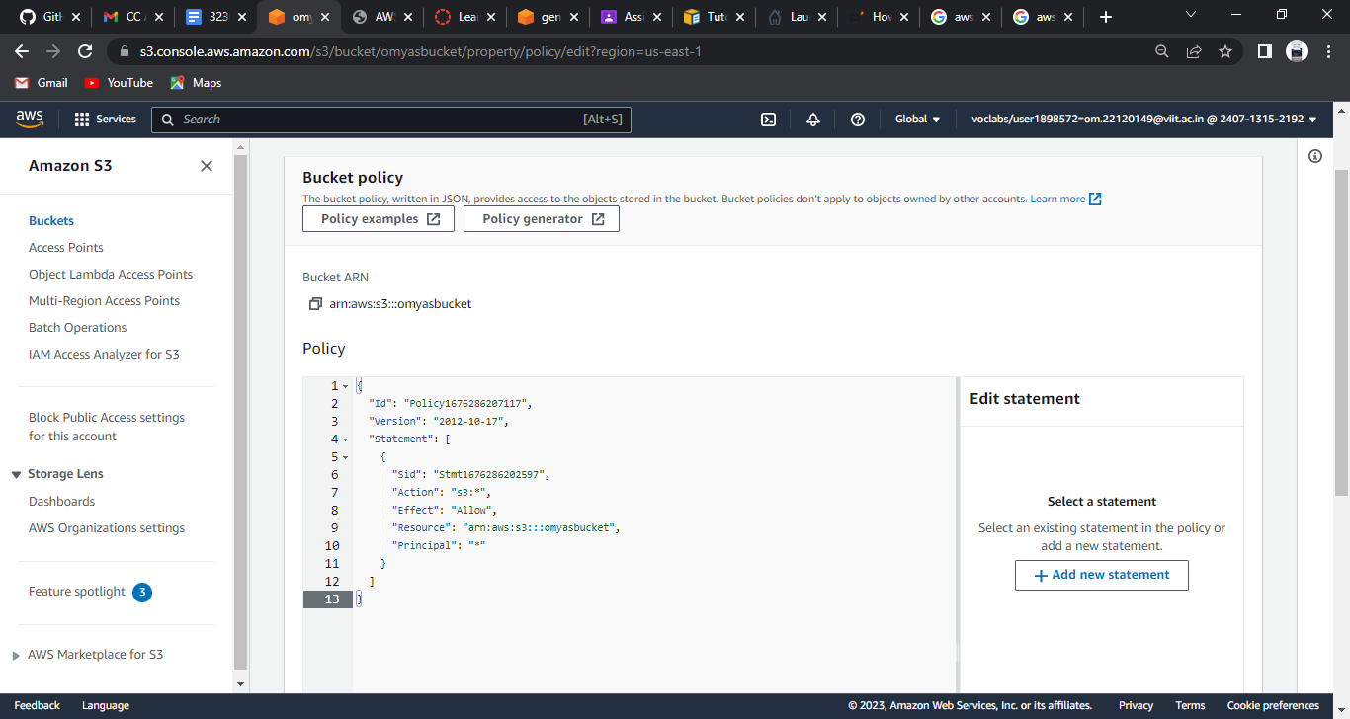

(Save the policy here with adding /* after the bucket name)

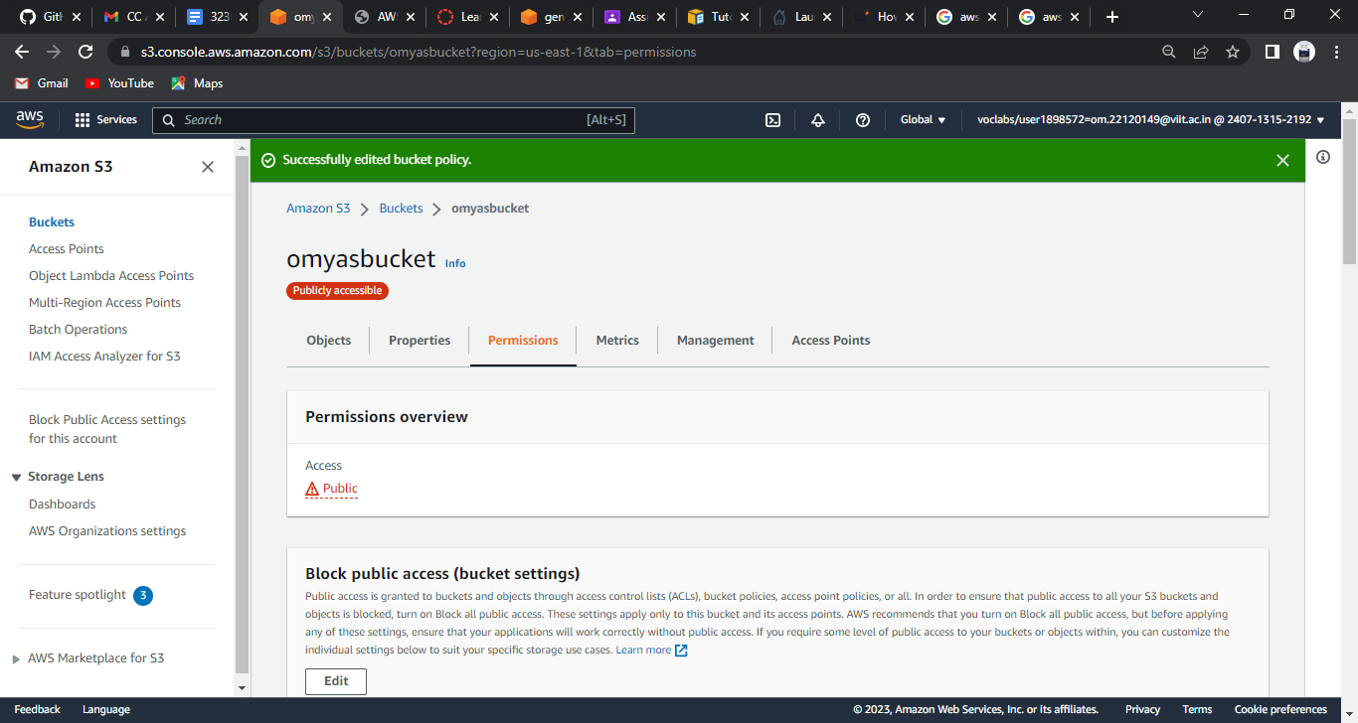

STEP 4

→ Open the bucket you are using & click on upload

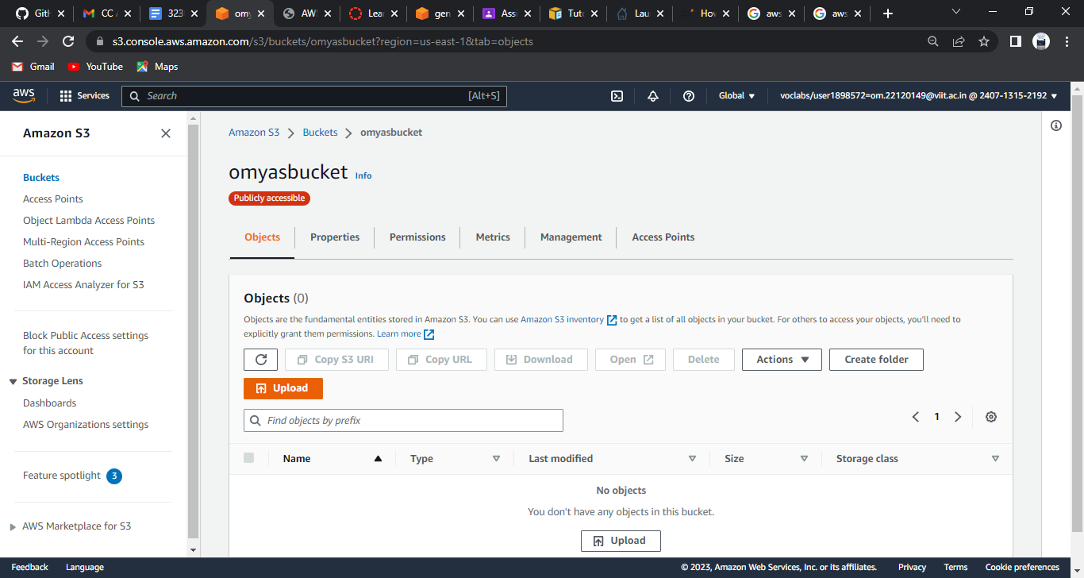

→ Click on add file, then also add folder

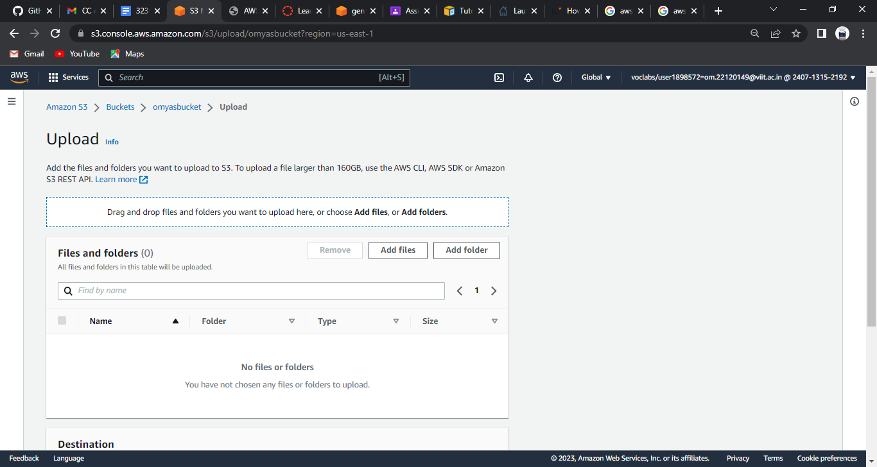

→ Upload and save the files

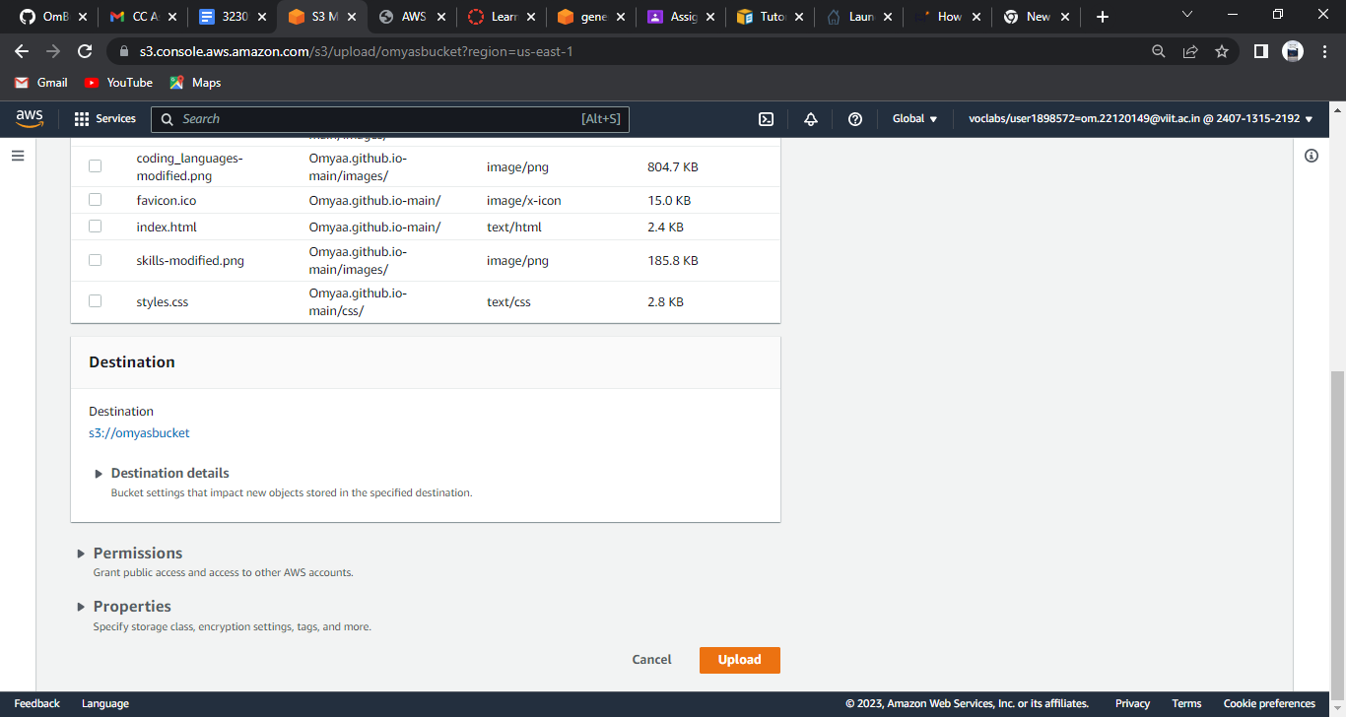

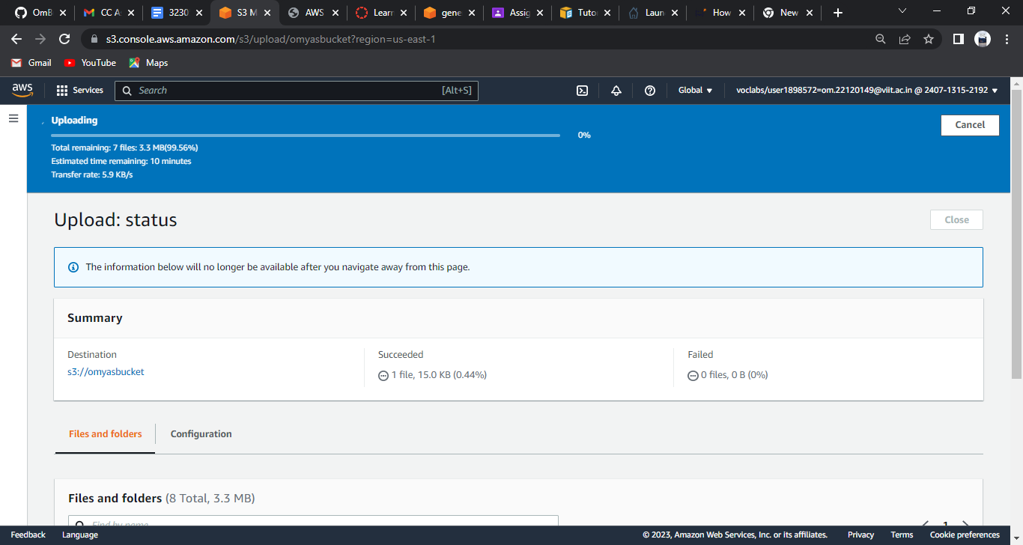

## STEP 5

→ Click on this link

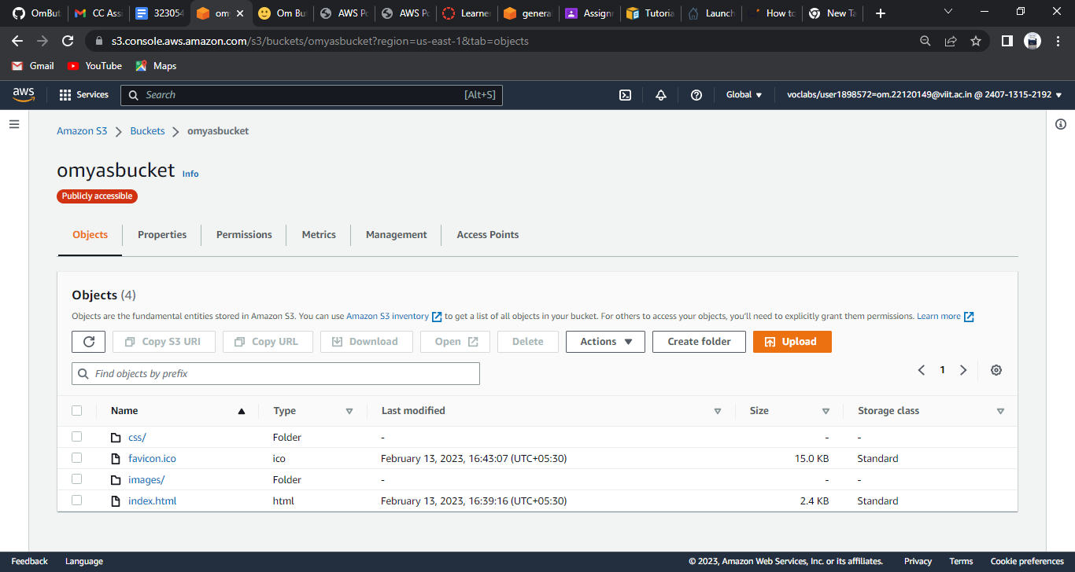

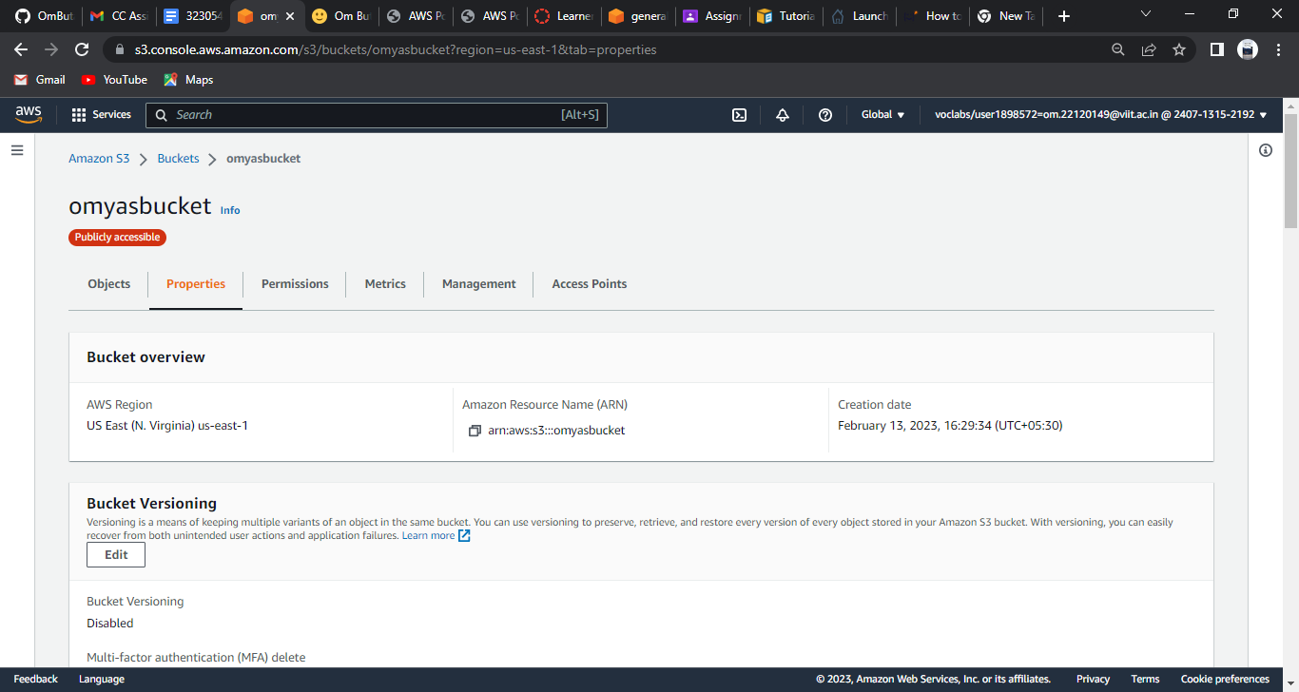

→ When clicked on this link we get this website

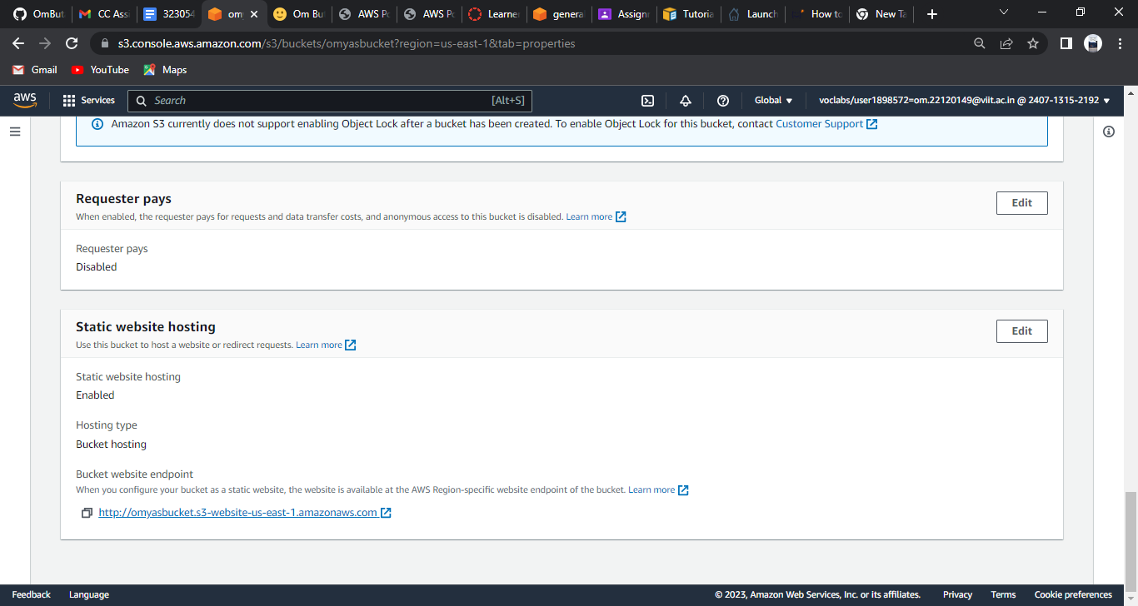

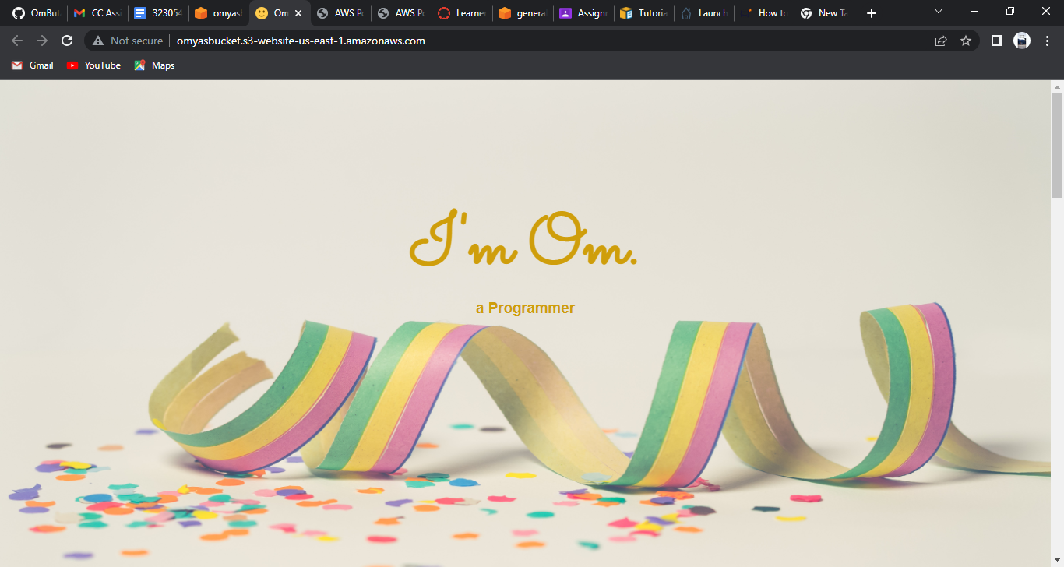

## STEP 6

→ Empty the bucket first

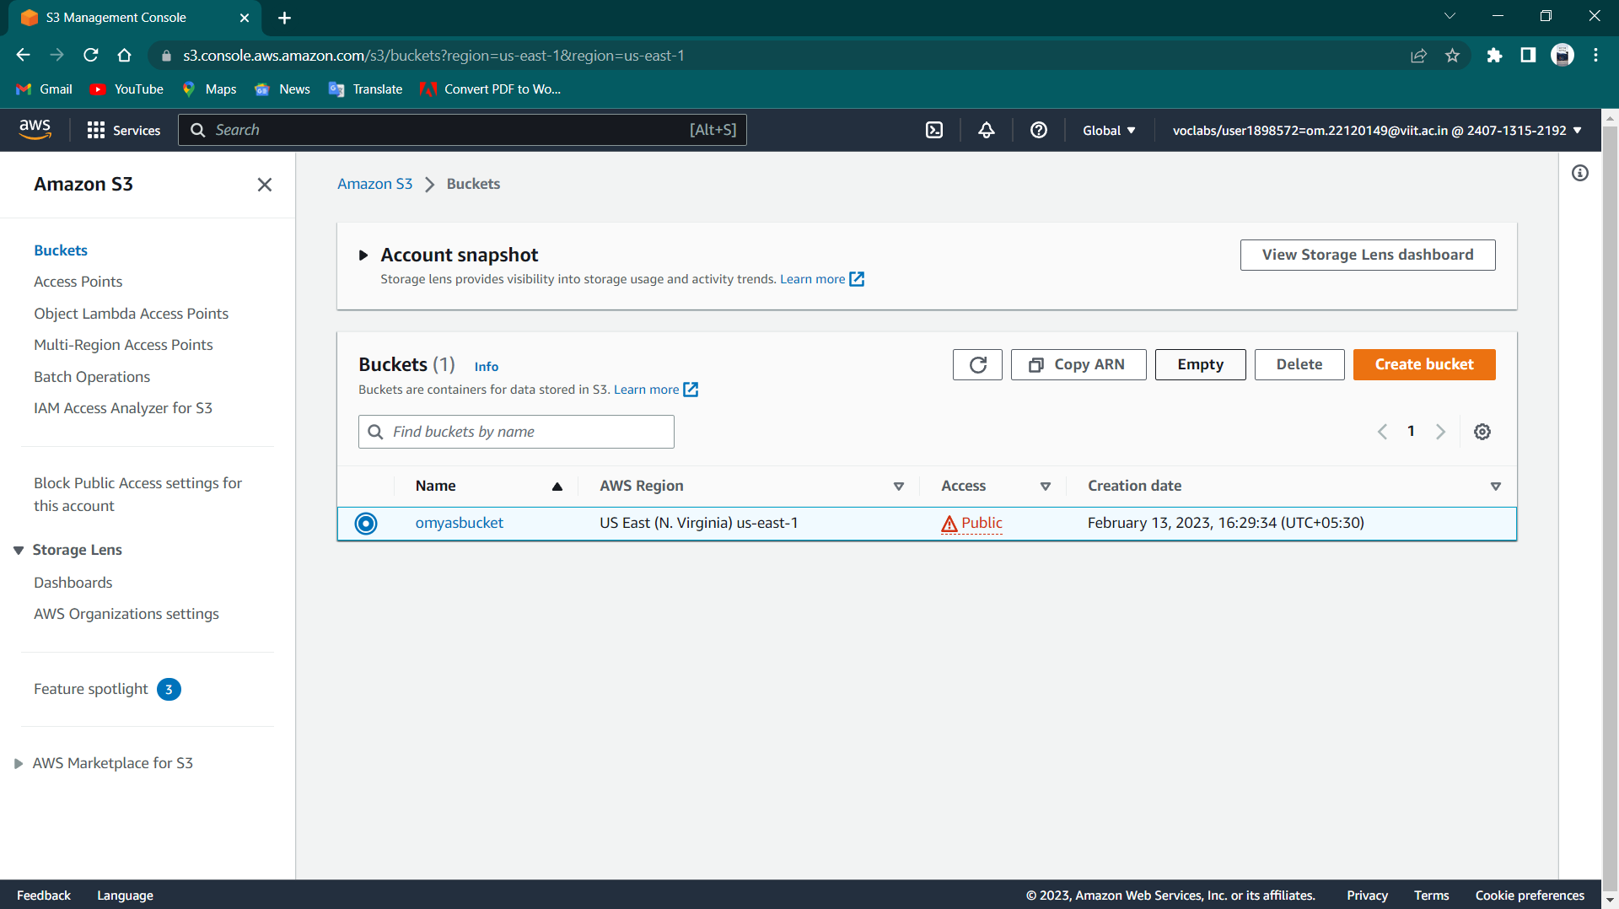

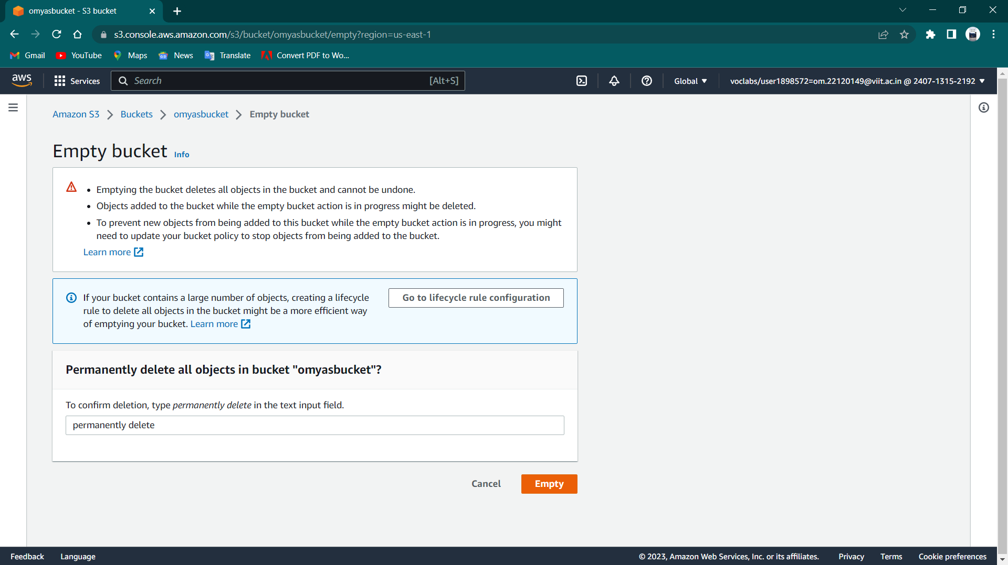

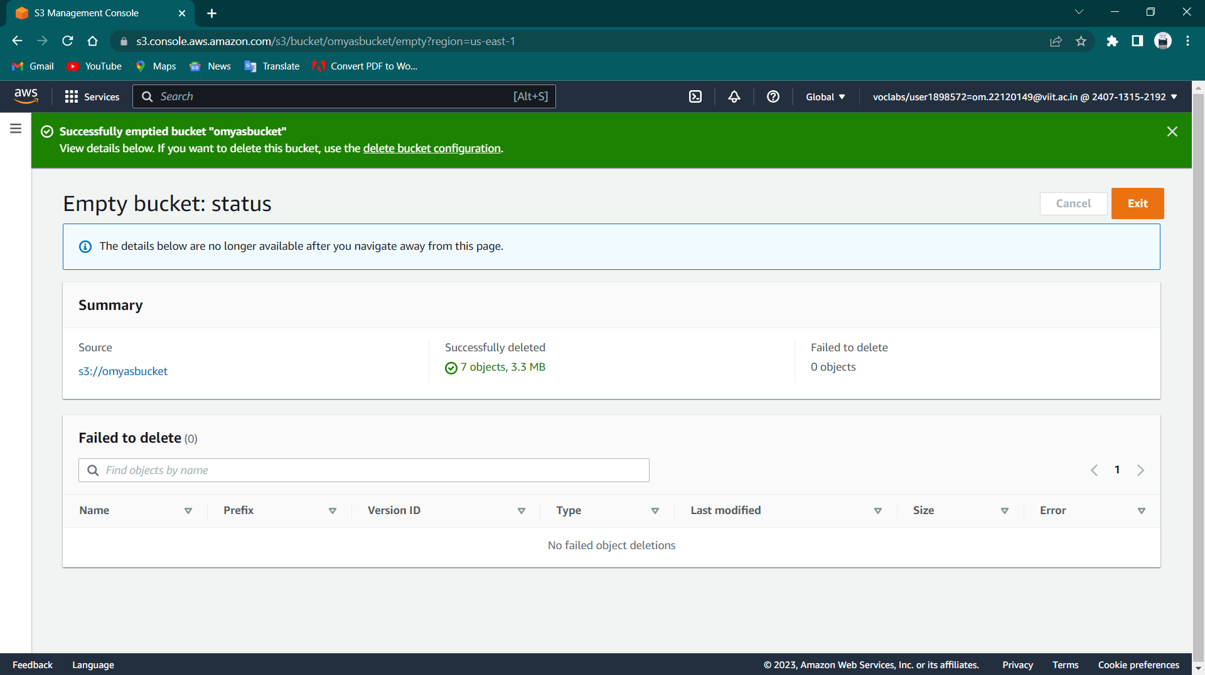

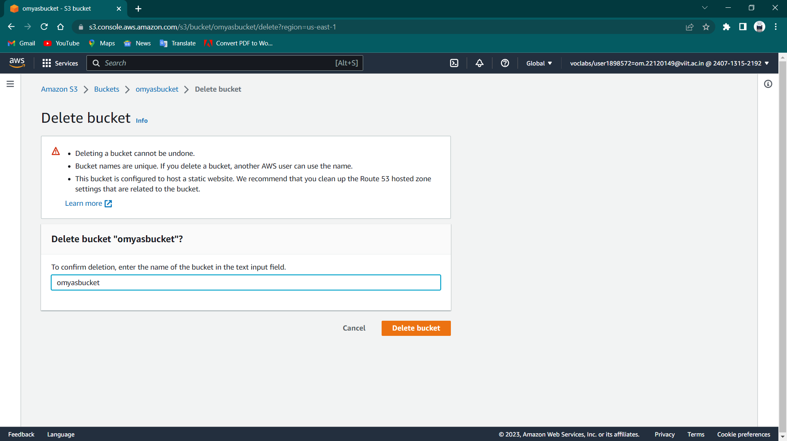

Click on delete bucket

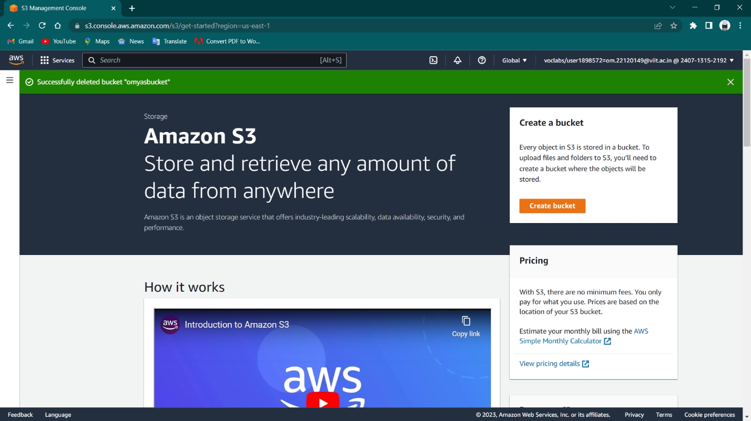

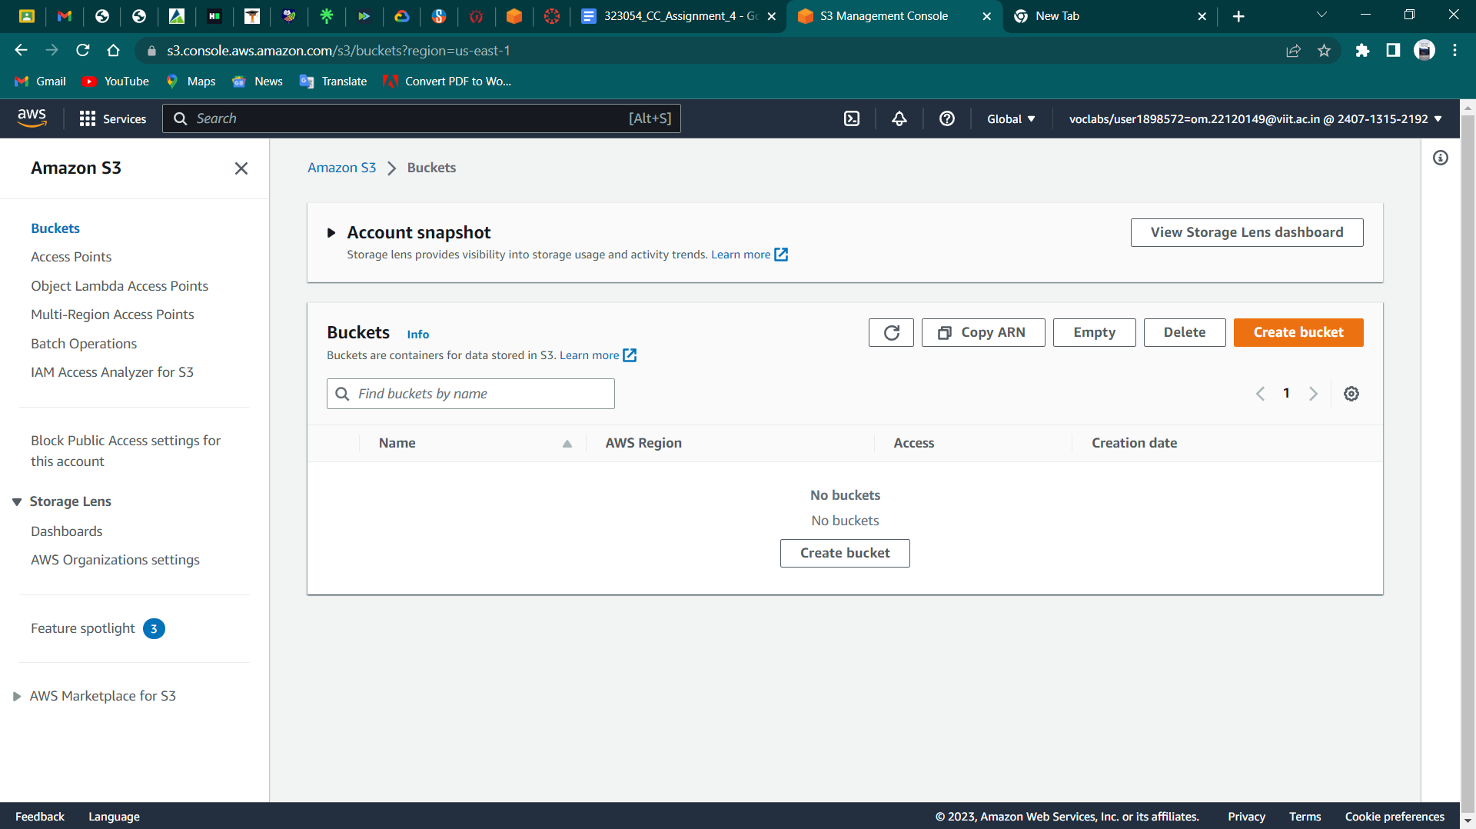

Finally done!