Name → Om Butala

ROLL NO → 323071

PRN → 22120149

Subject → Cloud Computing

# Assignment No 5

# 

# Write IaC using terraform to create EC2 machine on AWS or azure or google cloud. (Compulsory to use Input and output variable files)

# AIM

→ Use terraform to create an EC2 instance

# Theory

→ What is terraform?

→ Terraform Cloud enables infrastructure automation for provisioning, compliance, and management of any cloud, datacenter, and service.

→ It is an open-source tool for provisioning and managing cloud infrastructure. Terraform can provision resources on any cloud platform.

→ Terraform allows you to create infrastructure in configuration files(tf files) that describe the topology of cloud resources.

→ These resources include virtual machines, storage accounts, and networking interfaces or virtually any resource you want

# Step-by-step screenshot to install and configure Terraform

1. Download terraform from the [website](https://www.terraform.io/)

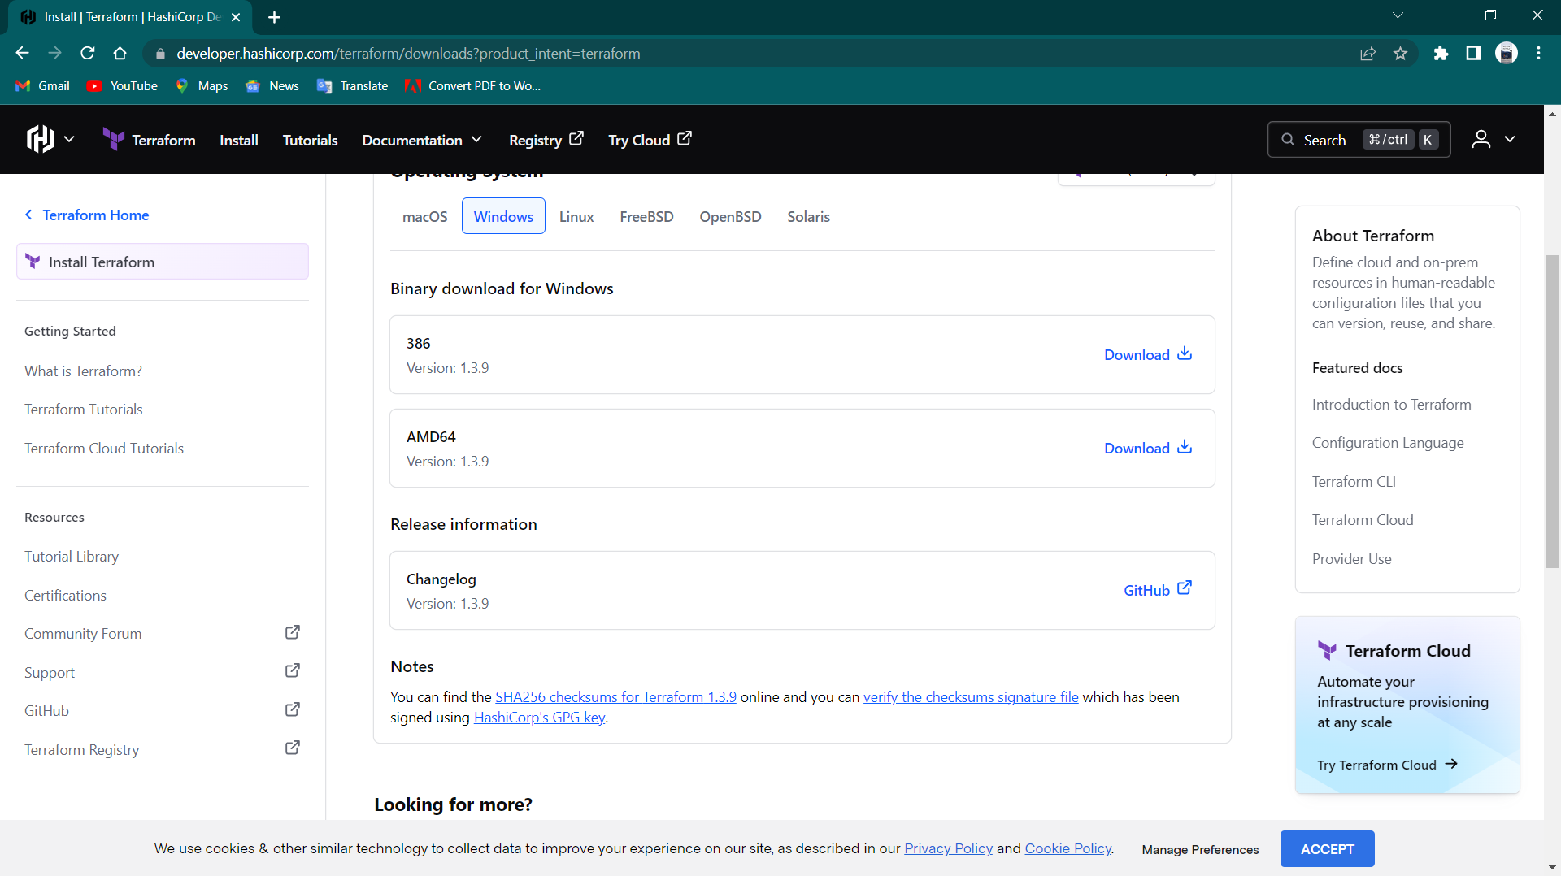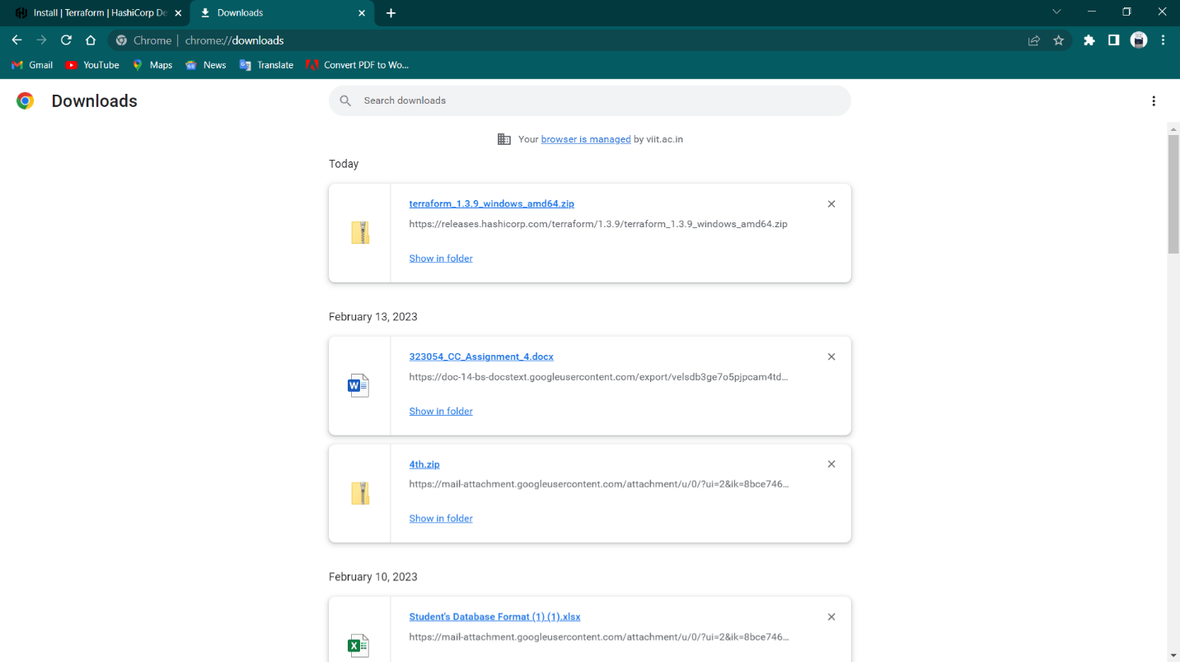

1. Install according to your machine

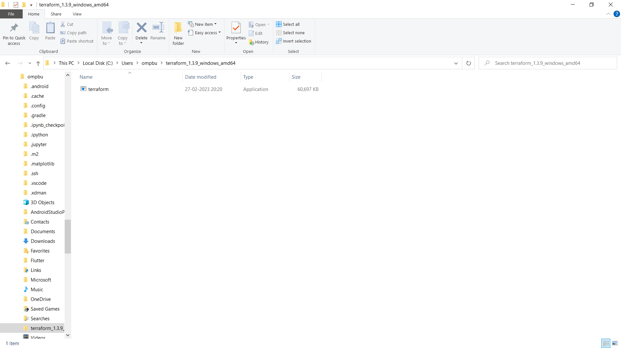

1. Download and extract it somewhere



1. Add this folder to the path & check its version using (terraform --version)

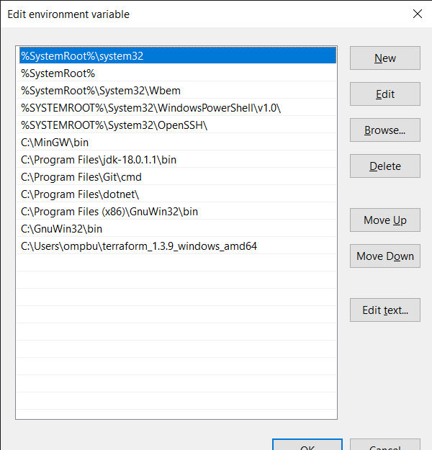

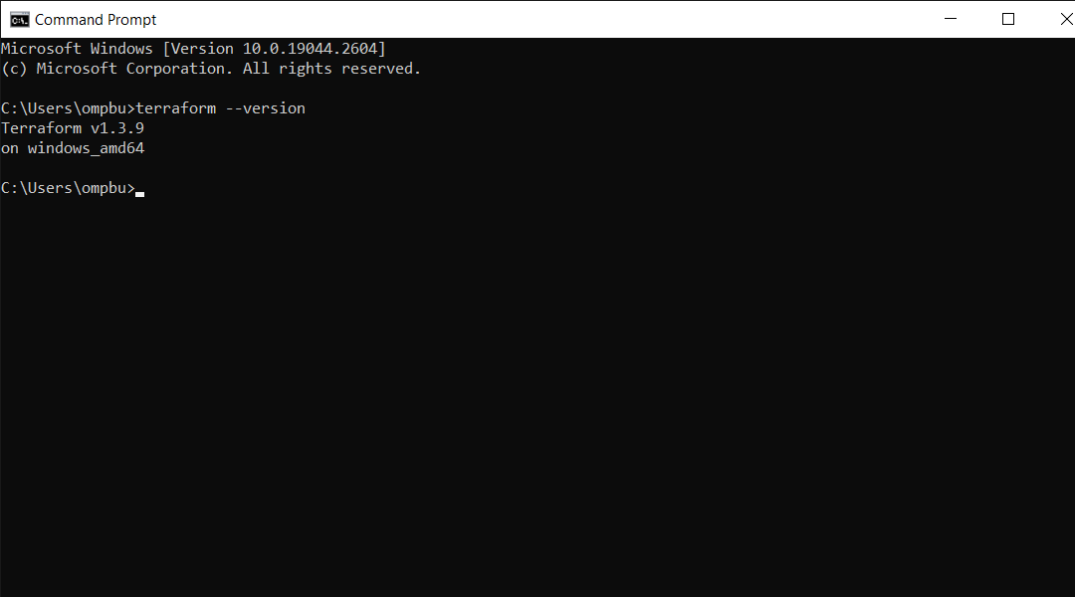

1. Download [AWS command line tool](https://aws.amazon.com/cli/) & install it

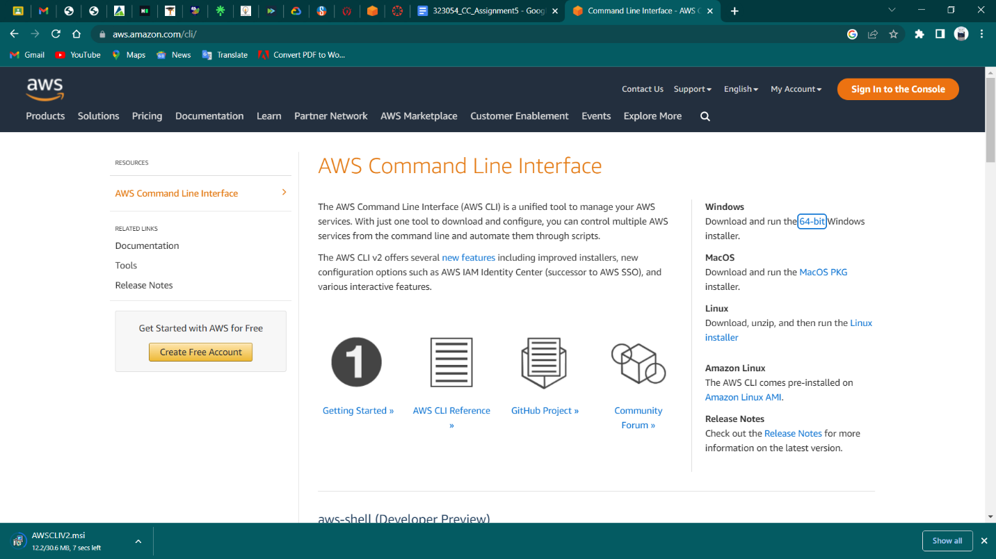

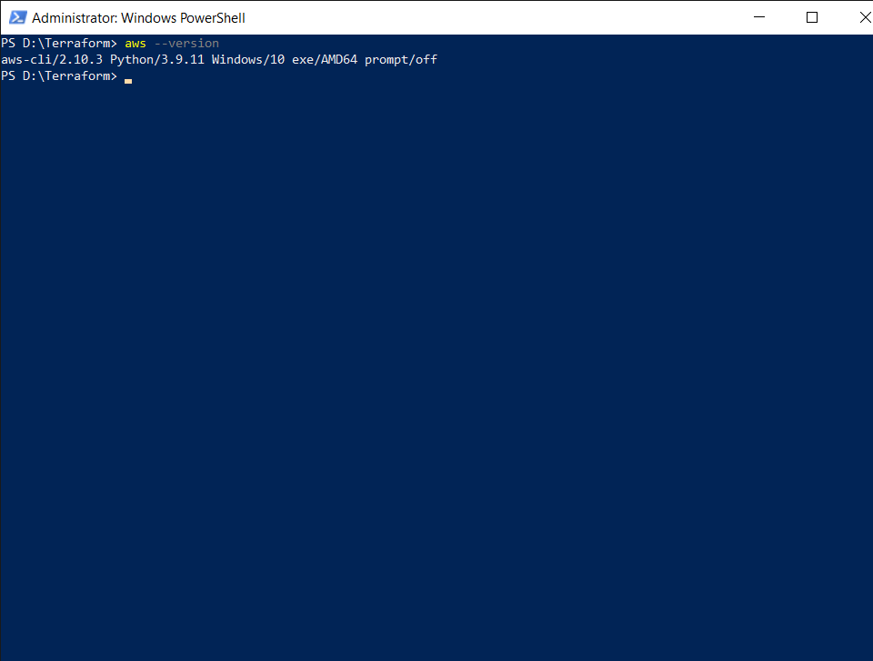

1. Login to aws & find IAM service
2. 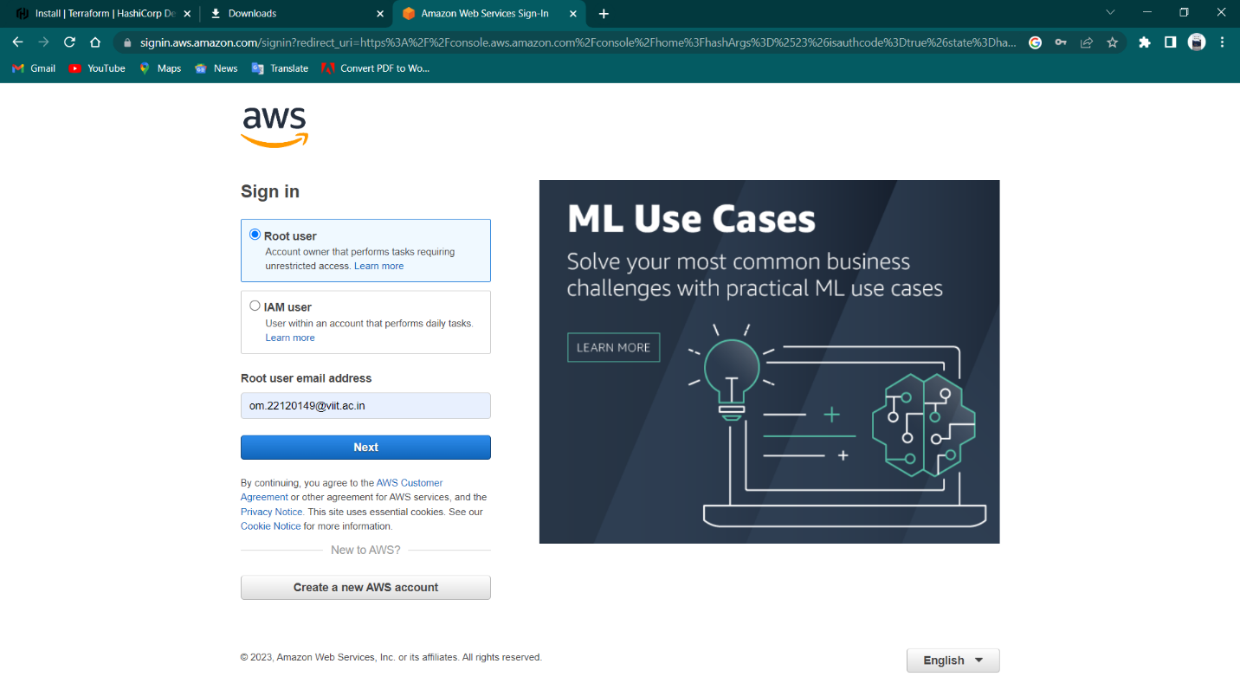

Click on all services & find + click IAM in security, Identity & compliance 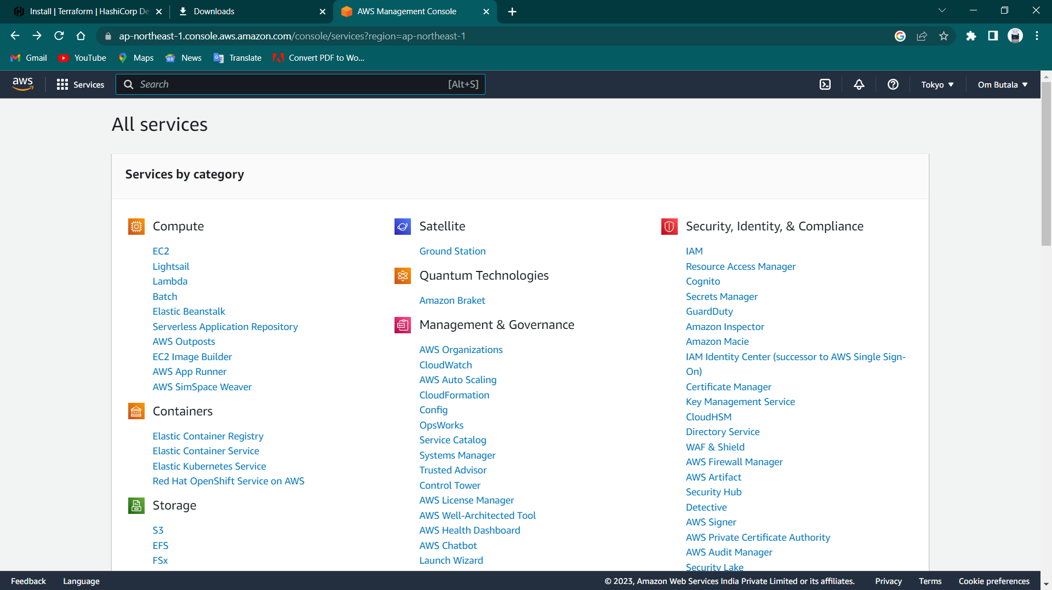

1. Create a user if you don’t have one. In my case I have a user so I will be copying the access keys for later use (Note you will also need secret key so make sure you download the access keys .csv file when access keys are created)

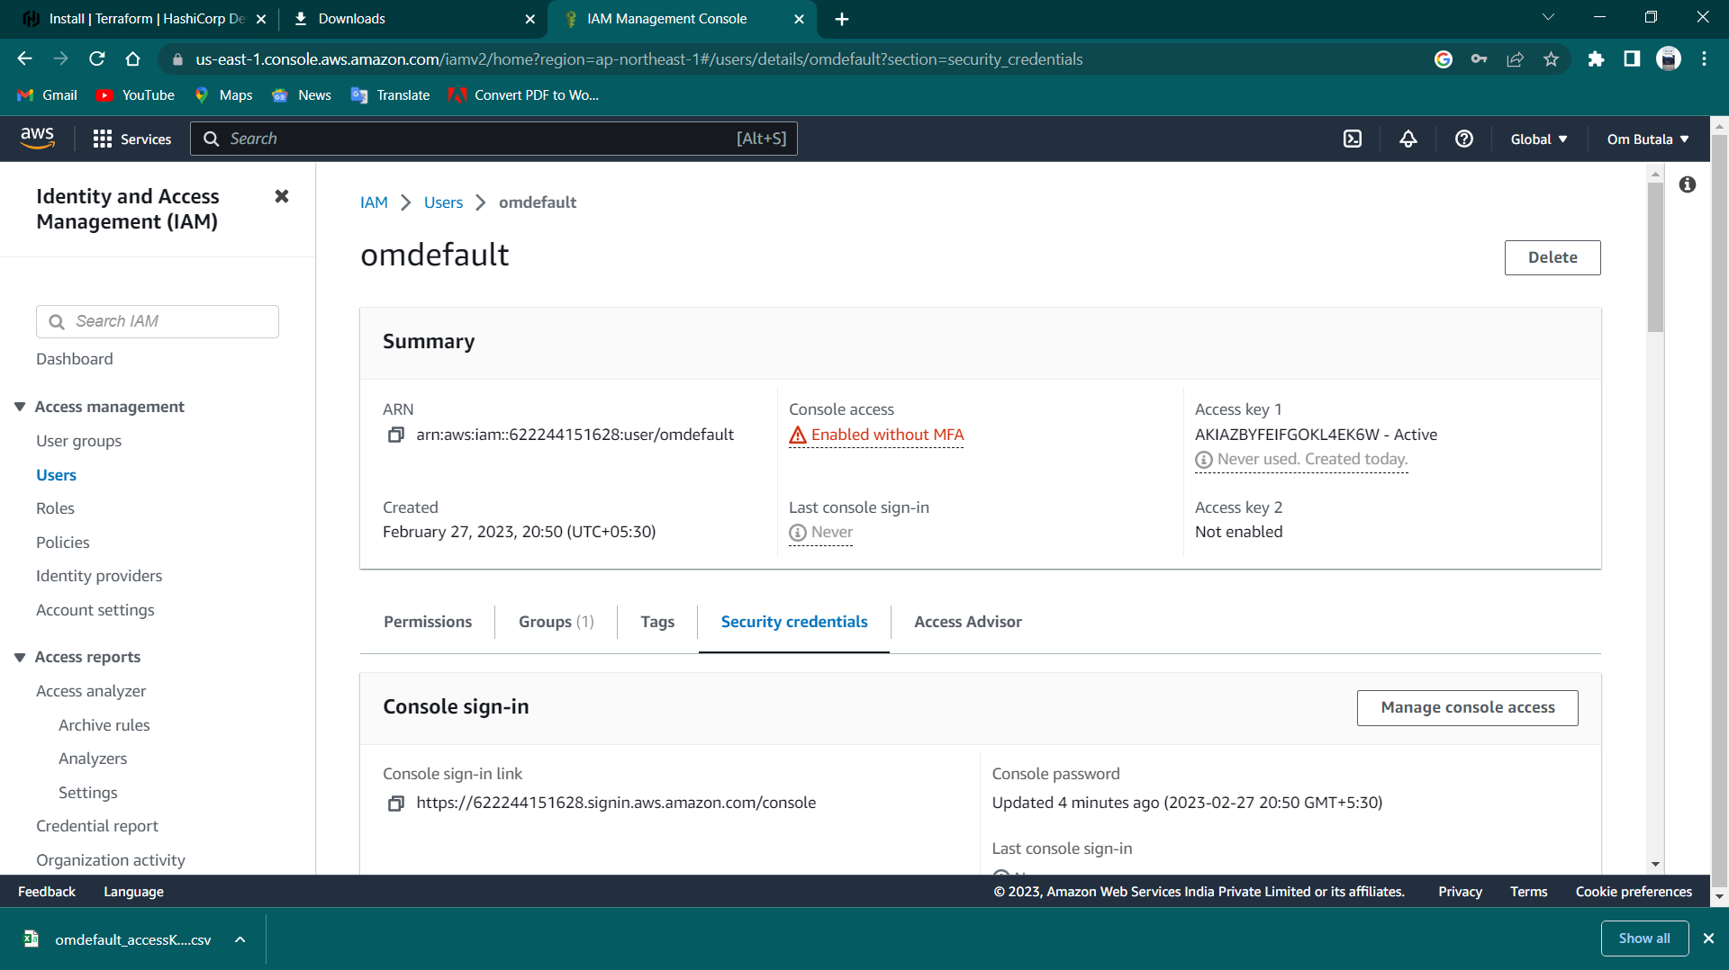



1. Add secret key & access key to aws cli (I have already added it so I will just press enter here)



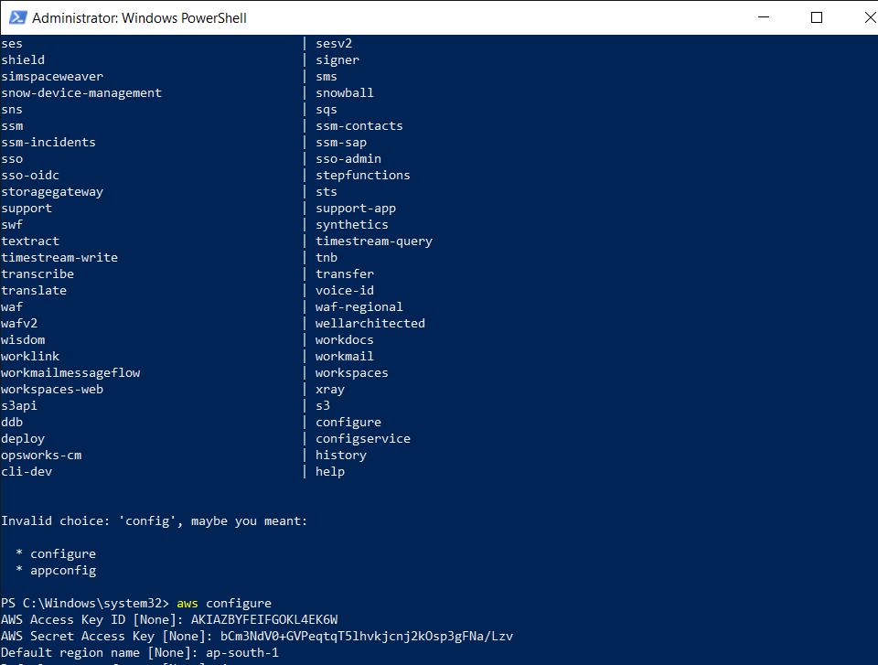



1. Create a folder named anything & create a terraform .tf file

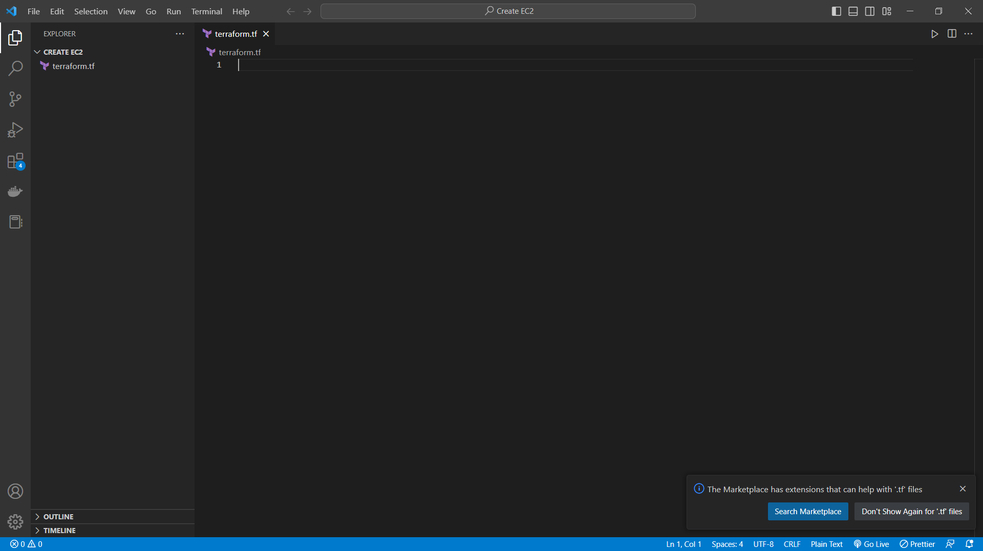

1. Write json code to create an EC2 instance & select the AMI ID for the machine

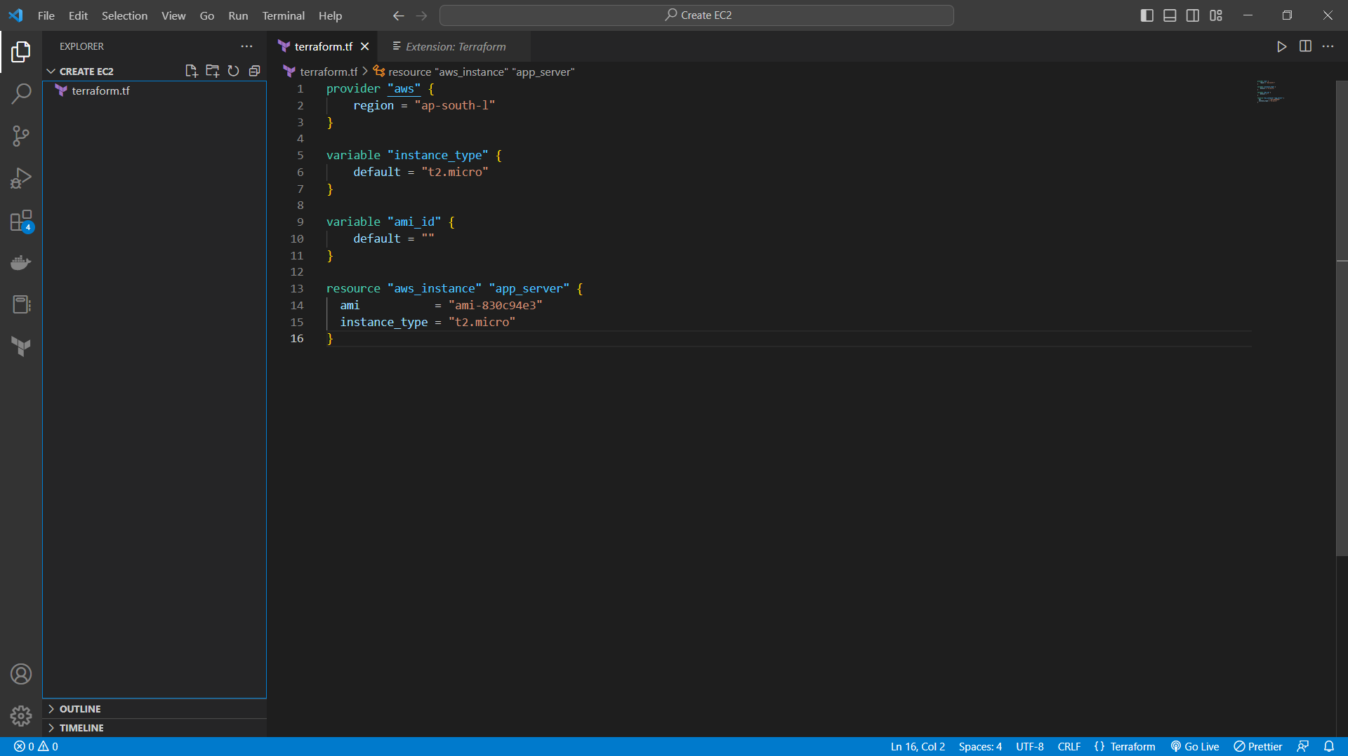

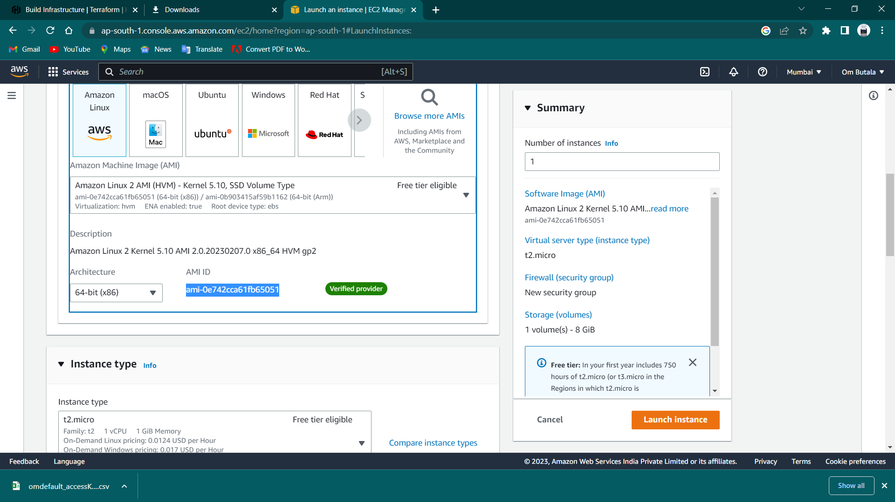

Copy the ami id to our json file



Now as we done with the setup we will move to terraform script

# Terraform commands

1. Change the directory & enter command terraform init

1. Put command terraform plan & terraform apply to create EC2 instance

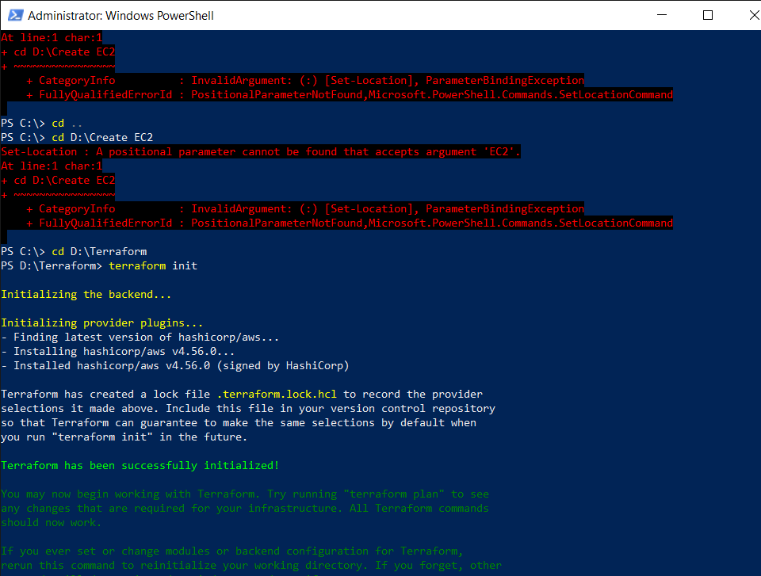

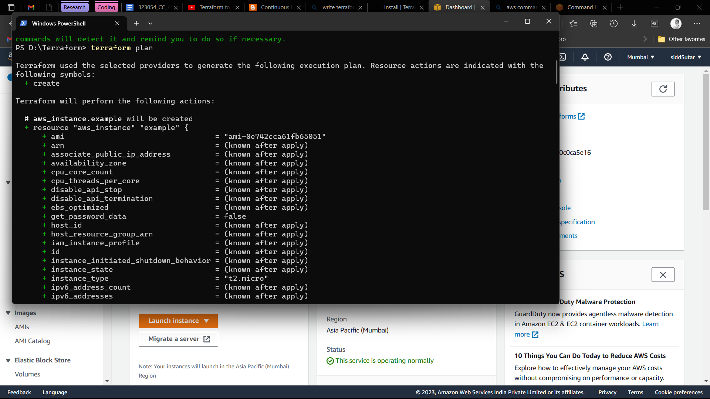

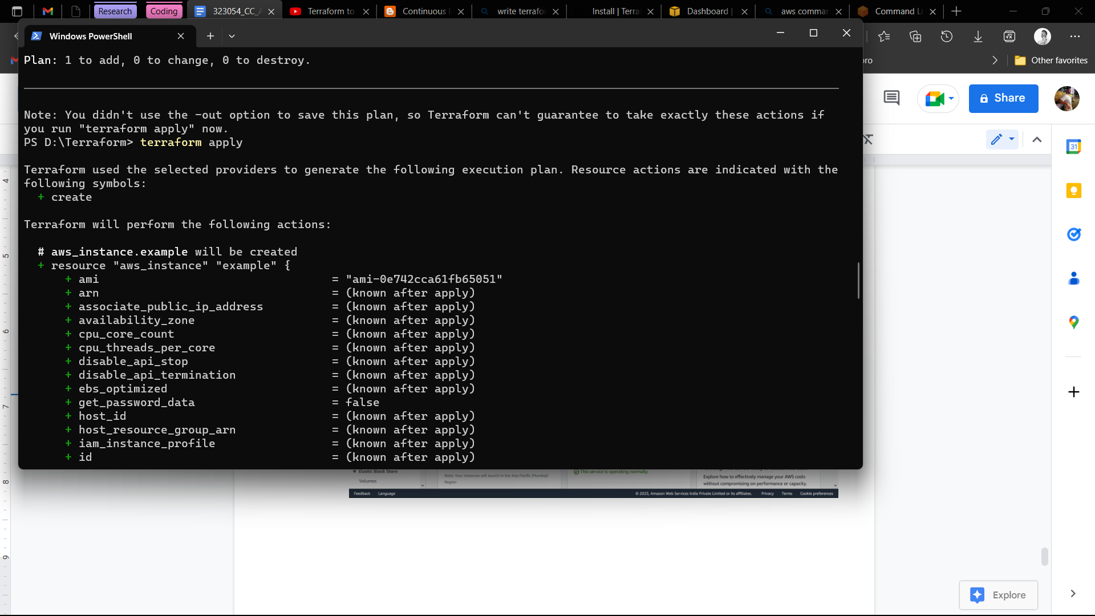

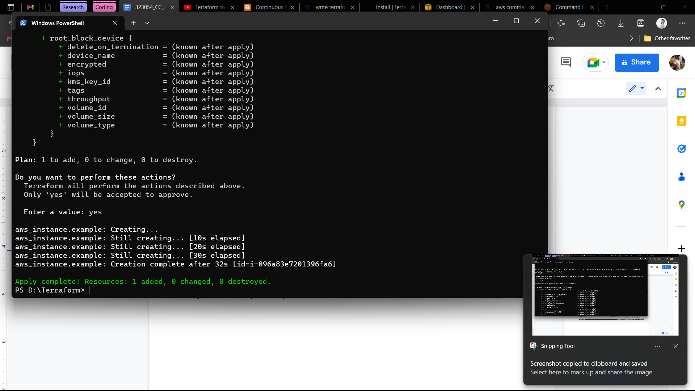

See the create AWS “example” instance

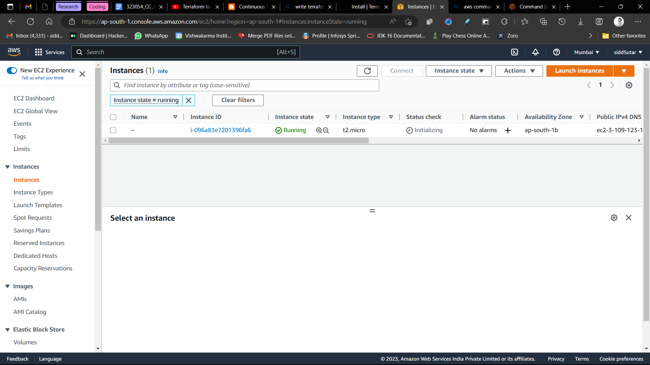

1. Put command terraform destroy to delete/stop the instance

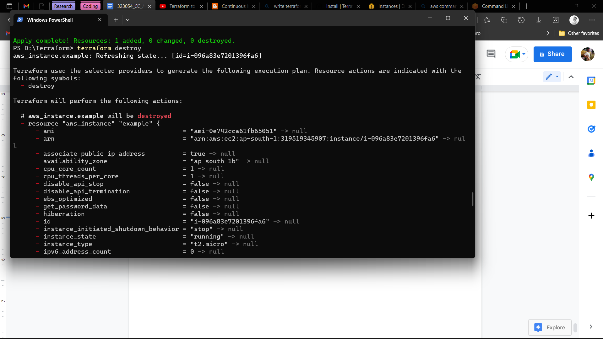

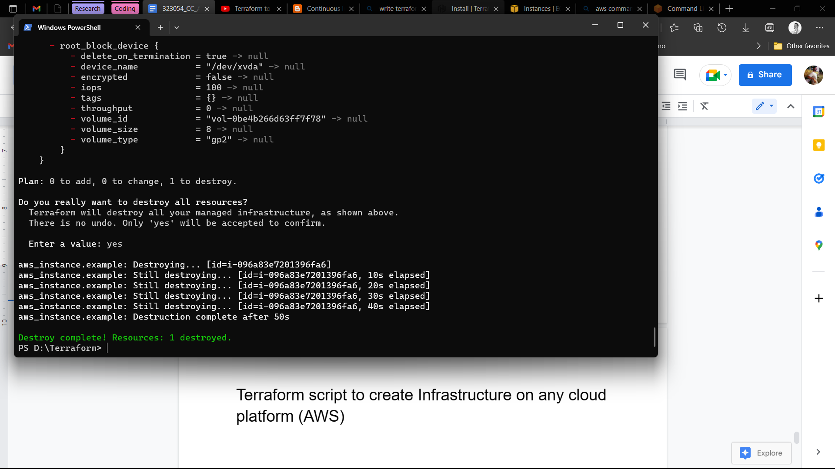

Let’s check whether the instance is properly terminated or not

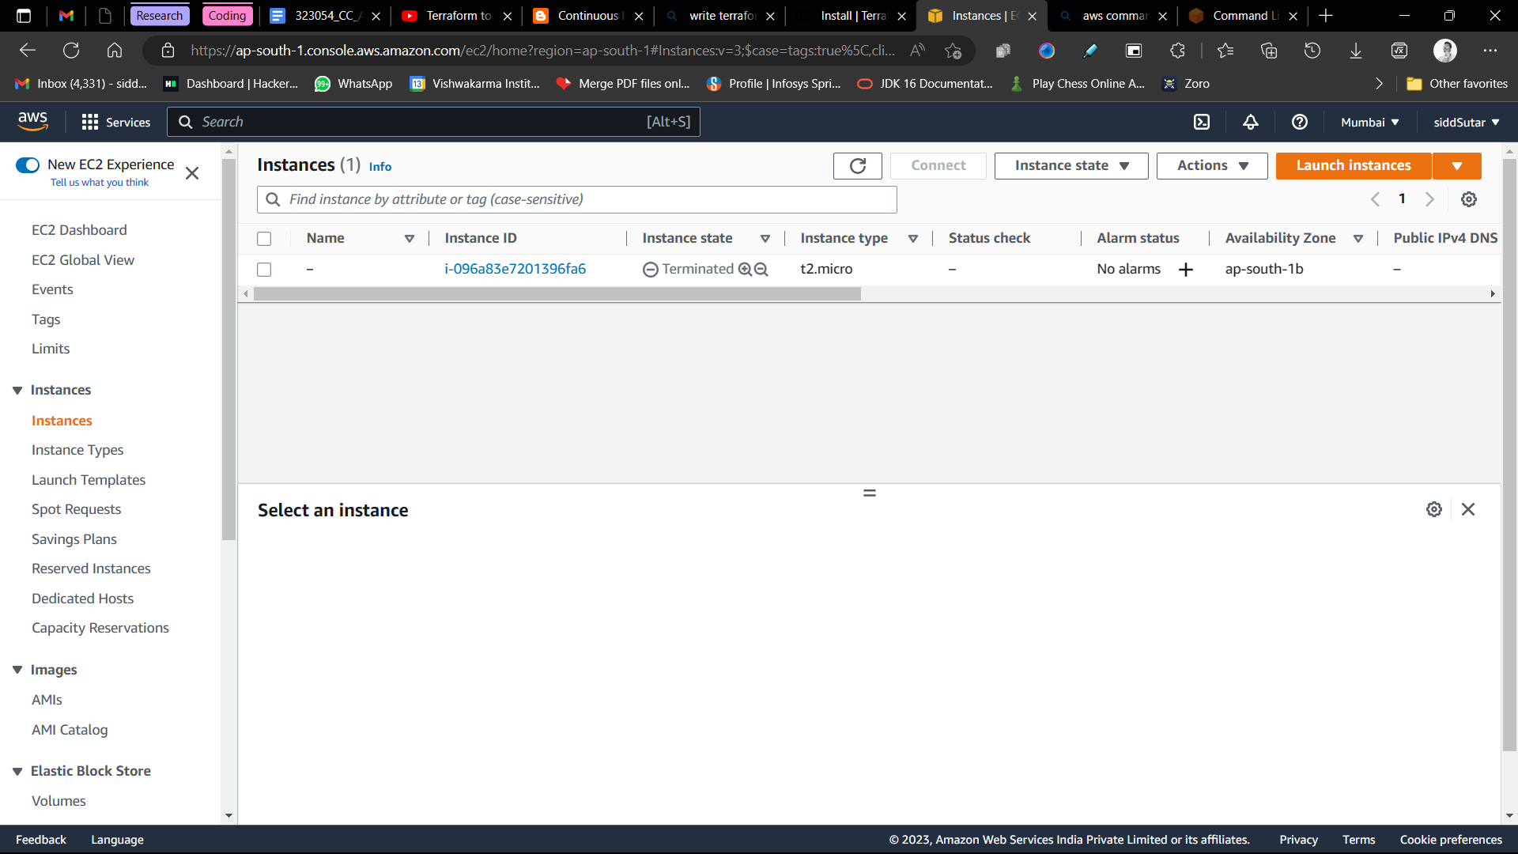

1. The final file should look like this



# Terraform json code



# Conclusion

→ Terraform is understood alongside its basic commands.