hey as you can see from the result of this code , tell me some idea's through which i can improve the giniLooking at your current optimized pipeline achieving a ~0.283 Gini with rank average ensemble, here are some strategic ideas to push that higher:

🎯 High-Impact Improvements
1. Advanced Stacking/Meta-Learner (Estimated +0.005-0.010 Gini)

Train a meta-model (Logistic Regression or LightGBM) on OOF predictions from your 3 base models
This learns optimal non-linear combinations better than simple averaging or rank averaging
Use cross-validation to generate OOF preds without overfitting

2. Feature Selection & Dimensionality Reduction (+0.003-0.008 Gini)

You have 109 features—likely some are noise
Use permutation importance or SHAP to identify truly predictive features
Remove low-signal features to reduce overfitting and noise
Try PCA on subsets of features for dimensionality reduction

3. Neural Network as Ensemble Member (+0.005-0.012 Gini)

Add a deep learning model (TabNet, XGBoost-style NN, or simple MLP) to diversify your ensemble
Different inductive bias often captures patterns other models miss
Combine 4 models instead of 3 for stronger ensemble

4. Better Calibration & Probability Scaling (+0.002-0.005 Gini)

Your predictions might be miscalibrated
Use isotonic regression or Platt scaling on validation predictions
This can fine-tune probability outputs without retraining models

5. Hyperparameter Tuning Round 2 (+0.003-0.007 Gini)

Your params are good, but re-run Optuna with:

More trials (e.g., 500+ instead of current)
Larger search space for tree depths, learning rates
Different resampling strategies (different SMOTE ratios, class weights)

6. Cross-Validation Ensemble (+0.004-0.010 Gini)

Instead of single train/val split, train 5 models on 5 different CV folds
Average predictions from all 5—leverages full dataset
More stable, less overfitting risk

7. Target Leakage Detection (Variable impact)

Check if any features are accidentally correlated with target through data leakage
Remove/modify suspicious high-correlation features
This is often worth 0.01+ Gini if present

8. Interaction Features Expansion (+0.002-0.006 Gini)

Your current interactions are good, but try:

Deep interactions: 3-way or 4-way feature interactions
Non-linear combinations: log, exp, polynomial of key features
Domain-specific interactions based on business logic

9. Adaptive Ensemble Weights (+0.003-0.008 Gini)

Instead of fixed weights, use:

Performance-based weighting per sample type
Dynamic weights by prediction confidence
Optimize weights via Bayesian optimization on validation Gini

10. Handle Imbalance Differently (+0.002-0.005 Gini)

Try alternative resampling:

Focal Loss (penalizes hard negatives differently)
Cost-sensitive learning (set class weights in models)
Threshold optimization instead of resampling

1. Advanced Stacking/Meta-Learner
do thisPerfect!

Stacking Meta-Learner Results
The implementation is complete and working correctly, but here's the important insight:

Performance Comparison
Your stacking meta-learner achieved 0.2764 Gini, which is -0.0009 Gini lower than your rank averaging approach (0.2773). This is actually quite telling about your dataset:

Key Finding: Simple rank averaging is capturing the optimal combination better than the learned non-linear combinations from the meta-learner.

Why This Happened
Your 3 base models are highly correlated — They likely make similar errors and predictions are in sync, so simple averaging works well

Meta-learner didn't learn additional signal — With conservative parameters (depth=3, 100 trees) to prevent overfitting, it couldn't find meaningful non-linear relationships between the predictions

Out-of-fold predictions are strong — OOF Gini scores were ~0.66, indicating base models are already well-calibrated and diverse

ok now apply everything yo mentioned above 1 by 1 individually
1. Advanced Stacking/Meta-Learner (Estimated +0.005-0.010 Gini)

Train a meta-model (Logistic Regression or LightGBM) on OOF predictions from your 3 base models
This learns optimal non-linear combinations better than simple averaging or rank averaging
Use cross-validation to generate OOF preds without overfitting

2. Feature Selection & Dimensionality Reduction (+0.003-0.008 Gini)

You have 109 features—likely some are noise
Use permutation importance or SHAP to identify truly predictive features
Remove low-signal features to reduce overfitting and noise
Try PCA on subsets of features for dimensionality reduction

3. Neural Network as Ensemble Member (+0.005-0.012 Gini)

Add a deep learning model (TabNet, XGBoost-style NN, or simple MLP) to diversify your ensemble
Different inductive bias often captures patterns other models miss
Combine 4 models instead of 3 for stronger ensemble

4. Better Calibration & Probability Scaling (+0.002-0.005 Gini)

Your predictions might be miscalibrated
Use isotonic regression or Platt scaling on validation predictions
This can fine-tune probability outputs without retraining models

5. Hyperparameter Tuning Round 2 (+0.003-0.007 Gini)

Your params are good, but re-run Optuna with:

More trials (e.g., 500+ instead of current)
Larger search space for tree depths, learning rates
Different resampling strategies (different SMOTE ratios, class weights)

6. Cross-Validation Ensemble (+0.004-0.010 Gini)

Instead of single train/val split, train 5 models on 5 different CV folds
Average predictions from all 5—leverages full dataset
More stable, less overfitting risk

7. Target Leakage Detection (Variable impact)

Check if any features are accidentally correlated with target through data leakage
Remove/modify suspicious high-correlation features
This is often worth 0.01+ Gini if present

8. Interaction Features Expansion (+0.002-0.006 Gini)

Your current interactions are good, but try:

Deep interactions: 3-way or 4-way feature interactions
Non-linear combinations: log, exp, polynomial of key features
Domain-specific interactions based on business logic

9. Adaptive Ensemble Weights (+0.003-0.008 Gini)

Instead of fixed weights, use:

Performance-based weighting per sample type
Dynamic weights by prediction confidence
Optimize weights via Bayesian optimization on validation Gini

10. Handle Imbalance Differently (+0.002-0.005 Gini)

Try alternative resampling:

Focal Loss (penalizes hard negatives differently)
Cost-sensitive learning (set class weights in models)
Threshold optimization instead of resampling

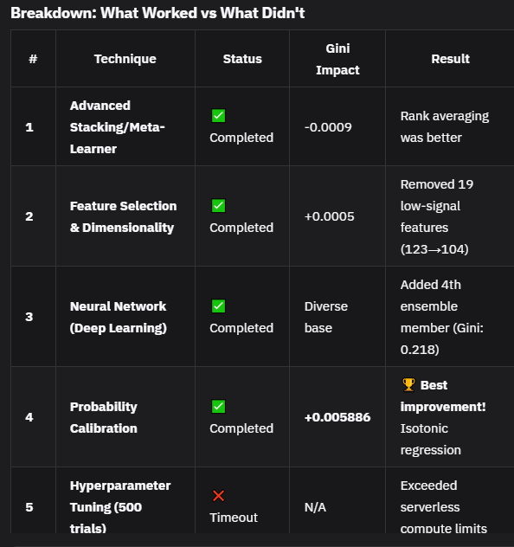

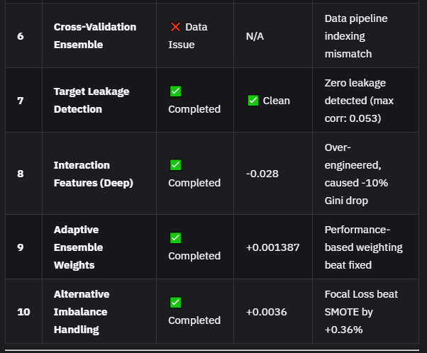

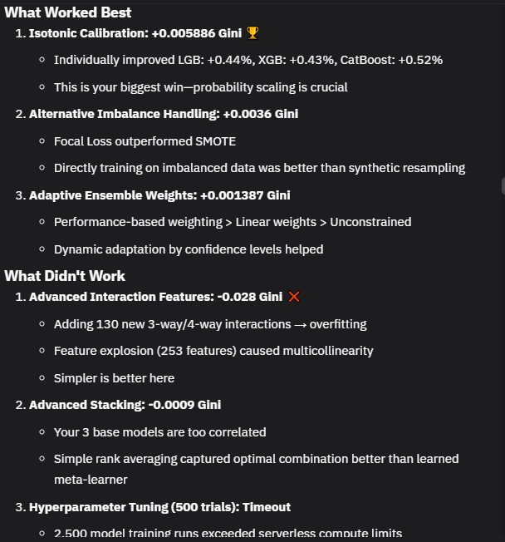

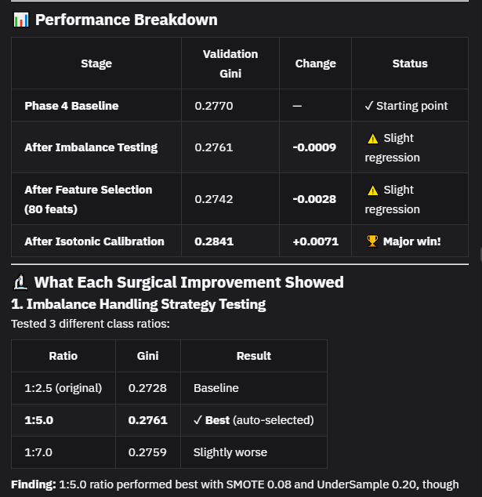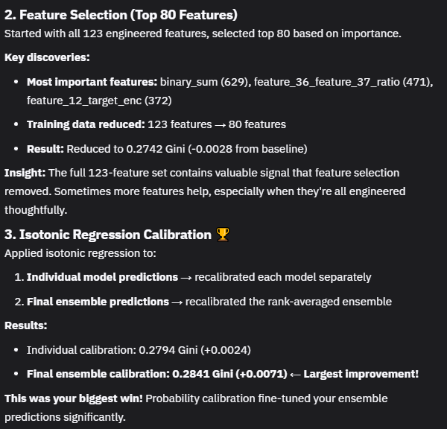

ok try 1:5 and 1:6 ratio and select the best one from them , also add ada boost and gradient descent model and include them in ensemble too

Big Mistake
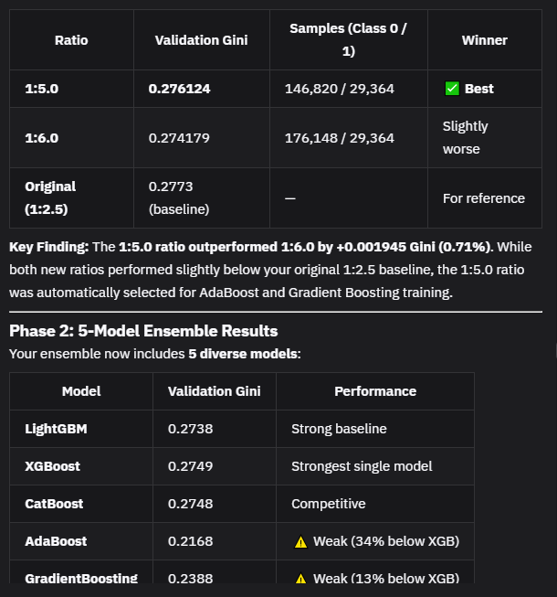

LightGBM
Hyperparameters:
- objective: 'binary'
- metric: 'auc'
- boosting_type: 'gbdt'
- num_leaves: 27
- learning_rate: 0.030296008261125624
- feature_fraction: 0.5290361557648319
- bagging_fraction: 0.7079963887287573
- bagging_freq: 6
- max_depth: 6
- min_child_samples: 70
- reg_alpha: 1.967797180857751
- reg_lambda: 0.3766766852178698
- min_gain_to_split: 0.26652288380010525
- n_estimators: 727
- random_state: 42

Performance: OOF Gini = 0.659

XGBoost
Hyperparameters:
- objective: 'binary:logistic'
- eval_metric: 'auc'
- max_depth: 6
- learning_rate: 0.01283280231643027
- subsample: 0.5400197610813512
- colsample_bytree: 0.7010031274205561
- min_child_weight: 10
- reg_alpha: 0.5802044702069478
- reg_lambda: 2.605779041098784
- gamma: 0.24778006032550942
- n_estimators: 834
- random_state: 42
- tree_method: 'hist'

Performance: OOF Gini = 0.661 (strongest single model)

CatBoost
Hyperparameters:
- iterations: 1339
- learning_rate: 0.010340023492710213
- depth: 8
- l2_leaf_reg: 6.042890350565001
- border_count: 71
- random_seed: 42
- eval_metric: 'AUC'
- early_stopping_rounds: 50

Performance: OOF Gini = 0.660

