PRACTICAL No. 1
Aim: 2D Linear Convolution, Circular Convolution between two 2D matrices.

2D Linear Convolution Example 1:
Code:
clc; x=[4,5,6;7,8,9]; h=[1;1;1];
disp(x,"x=");
disp(h,"h="); y=conv2(x,h);
disp(y, '2D Linear Convolution result: y =' );

Output:
x=

4. 5. 6.
7. 8. 9.

h=

1.
1.
1.

2D Linear Convolution result: y =

4. | 5. | 6.
11. | 13. | 15.
11. | 13. | 15.
7. | 8. | 9.

Example 2:

Code:
clc; x=[1,2,3;4,5,6;7,8,9];
h=[1,1;1,1;1,1];
disp(x,"x=");
disp(h,"h="); y=conv2(x,h);
disp(y, '2D Linear Convolution result: y =' );

Output:
x=

1. 2. 3.
4. 5. 6.
7. 8. 9.

h=

1. | 1.
1. | 1.
1. | 1.
2D Linear Convolution result: y = 1. 3. 5. 3.
5. 12. 16. 9.
12. 27. 33. 18.
11. 24. 28. 15.
7. 15. 17. 9.

2D Circular Convolution Example 1:
Code:
clc ; x=[1,2;3,4];
h=[5,6;7,8];
disp(x,'x=');
disp(h,'h='); X=fft2(x); H=fft2(h); Y=X.*H;
y=ifft(Y);
disp(y, '2D Circular Correlation Result: y =' );

Output:
x=

1. 2.
3. 4.

h=

5. 6.
7. 8.
2D Circular Correlation Result: y = 70. 68.
62. 60.

Example 2:

Code:
clc ; x=[1,2,3;4,5,6;7,8,9];
h=[1,1,1;1,1,1;1,1,1];
disp(x,'x=');
disp(h,'h='); X=fft2(x); H=fft2(h); Y=X.*H;
y=ifft(Y);
disp(y, '2D Circular Correlation Result: y =' );

Output:
x=

1. 2. 3.
4. 5. 6.
7. 8. 9.

h=

1. 1. 1.
1. 1. 1.
1. 1. 1.

2D Circular Correlation Result: y =

45. | 45. | 45.
45. | 45. | 45.
45. | 45. | 45.

PRACTICAL No. 2
Aim: Circular Convolution expressed as Linear Convolution plus alias.

Code:
clc ;
x =[1,2;3,4];
h=[5,6;7,8];
y=conv2(x,h); y1=[y(:,1)+y(:,$),y(:,2) ];
y2=[y1(1,:)+y1($,:);y1(2,:)];
disp(y, 'Linear Convolution Result: y=');
disp(y2 , 'Circular Convolution expressed as Linear Convolution =' );

Output:
Linear Convolution Result: y=

5. 16. 12.
22. 60. 40.
21. 52. 32.
Circular Convolution expressed as Linear Convolution = 70. 68.
62. 60.

PRACTICAL No. 3
Aim: Linear Cross correlation of a 2D matrix, Circular correlation between two signals and Linear auto correlation of a 2D matrix, Linear Cross correlation of a 2D matrix
- Linear Cross correlation of a 2D matrix Code:
clc;
x = [3,1;2,4];
h1 = [1,5;2,3];
h2 = h1(:,$:-1:1);
h = h2($:-1:1,:);
y = conv2(x,h)
disp(y, 'Linear cross Correlation result y=')

Output:
Linear cross Correlation result y= 9. 9. 2.
21. 24. 9.
10. 22. 4.
- Circular correlation between two signals Code:
clc;
x = [1,5;2,4];
h = [3,2;4,1];
h = h(:,$:-1:1);
h = h($:-1:1,:);
X = fft2(x); H = fft2(h); Y = X.*H;
y = ifft(Y);
disp(y,'Circular Correlation result y=')

Output:
Circular Correlation result y= 37. 23.
35. 25.

- Linear auto correlation of a 2D matrix

Code:
clc;
x1 = [1,1;1,1];
x2 = x1(:,$:-1:1);
x2 = x2($:-1:1,:);
x = conv2(x1,x2)
disp(x,'Linear auto Correlation result x=')

Output:
Linear auto Correlation result x= 1. 2. 1.
2. 4. 2.
1. 2. 1.

- Linear Cross correlation of a 2D matrix Code:
clc;
x = [1,1;1,1];
h1 = [1,2;3,4];
h2 = h1(:,$:-1:1);
h = h2($:-1:1,:);
y = conv2(x,h)
disp(y, ' Linear cross Correlation result y=')

Output:
Linear cross Correlation result y= 4. 7. 3.
6. 10. 4.
2. 3. 1.

PRACTICAL No. 4
Aim: Perform DFT of a 4x4 gray scale image.

Code:
clc; x=[1,1,1,1;1,1,1,1;1,1,1,1;1,1,1,1];
X=fft(x,-1); disp(X,"X[k]=");

Output:
X[k]=

16. | 0. | 0. | 0.
0. | 0. | 0. | 0.
0. | 0. | 0. | 0.
0. | 0. | 0. | 0.

PRACTICAL No. 5

AIM:- Compute discrete cosine transform, Program to perform KL transform for the given 2D matrix.

Code:-

clear; clc;
X=[4,3,5,6;4,2,7,7;5,5,6,7];
[m,n]=size(X);
A=[];
E=[];
for i=1:n A=A+X(:,i); E=E+X(:,i)*X(:,i)';
end mx=A/n; E=E/n;
C=E-mx*mx'; [V,D]=spec(C);
d=diag(D); [d,i]=gsort(d); for j=1:length(d)
T(:,j)=V(:,i(j));
end T=T'
disp(d,' Eigen Values are U = ') disp(T,'The eigen vector matrix T =') disp(T,'The KL tranform basis is =') for i=1:n
Y(:,i)=T*X(:,i);
end
disp(Y,'KL transformation of the input matrix Y =') for i=1:n
x(:,i)=T'*Y(:,i);
end
disp(x,'Reconstruct matrix of the given sample matrix X =')

Output:-
Eigen Values are U = 6.1963372
0.2147417
0.0264211

The eigen vector matrix T =

0.4384533 | 0.8471005 | 0.3002988
0.4460381 | - 0.4951684 | 0.7455591
- 0.7802620 | 0.1929481 | 0.5949473

The KL tranform basis is =

0.4384533 | 0.8471005 | 0.3002988
0.4460381 | - 0.4951684 | 0.7455591
- 0.7802620 | 0.1929481 | 0.5949473

KL transformation of the input matrix Y =

6.6437095 | 4.5110551 | 9.9237632 | 10.662515
3.5312743 | 4.0755729 | 3.2373664 | 4.4289635
0.6254808 | 1.0198466 | 1.0190104 | 0.8336957

Reconstruct matrix of the given sample matrix X =

4. | 3. | 5. | 6.
4. | 2. | 7. | 7.
5. | 5. | 6. | 7.

PRACTICAL No. 6

AIM:- Brightness enhancement of an image, Contrast Manipulation, image negative.

Install Image Processing and Signal Processing packages and restart scilab. Run this command on console: atomsRemove('scicv')
Restart scilab And run code

Brightness Enhancement

Code:-
Clc; close;
a=imread('C:\Users\ADMIN\Desktop\flower.jpg'); a=rgb2gray(a);
b=double(a)+50; b=uint8(b); figure(1); imshow(a);
title("Original Image") figure(2);
imshow(b); title("Enhanced Image")

Output:-

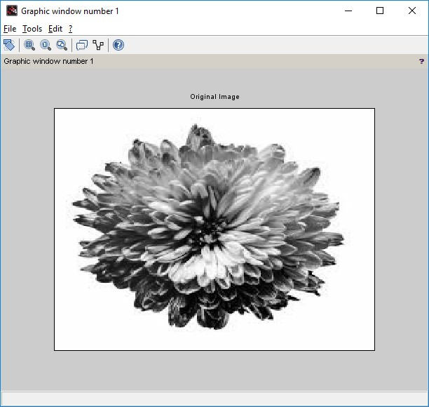
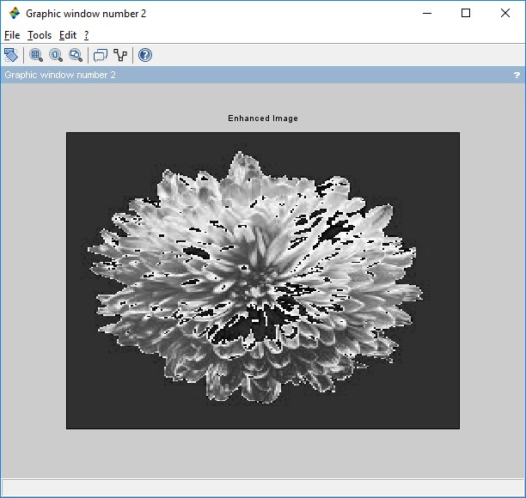

Contrast Manipulation
clc ; close ;
a = imread('C:\Users\ADMIN\Desktop\flower.jpg'); a = rgb2gray(a);
b = double(a)*0.5; b = uint8 (b)
c = double(b)*2; c = uint8(c) figure(1) imshow(a);
title('Original Image') figure(2)
imshow(b); title('Decreased Contrast' ) figure(3)
imshow(c); title('Increased Contrast')

Output:-

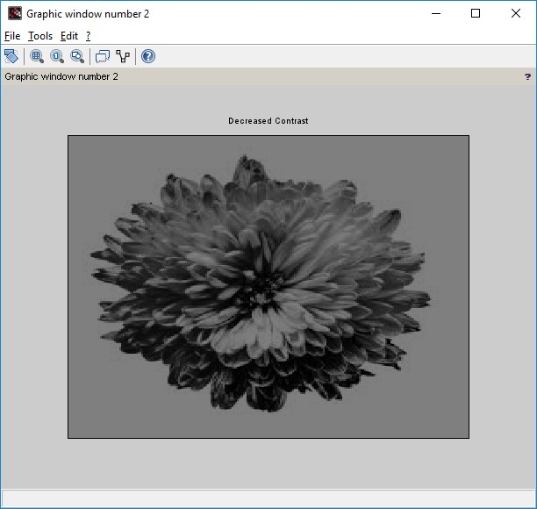
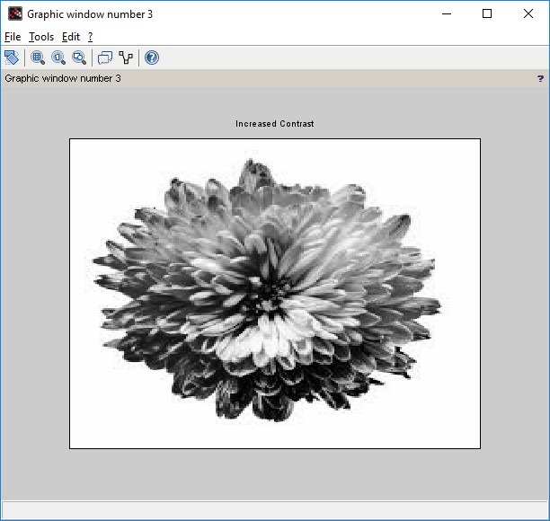

Image Negative
Code:- clc; close;
a = imread('C:\Users\ADMIN\Desktop\flower.jpg'); k = 255-double(a);
k = uint8(k); figure(1) imshow(a);
title('Original Image') figure(2)
imshow(k);
title('Negative of Original Image')

Output:
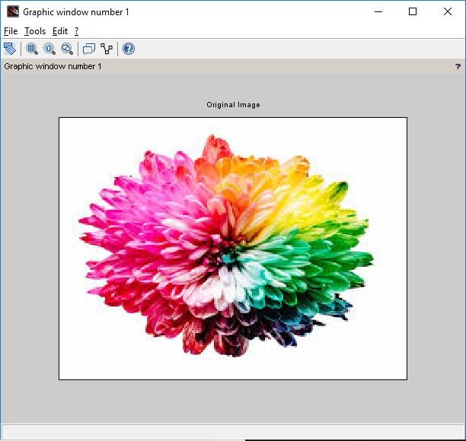

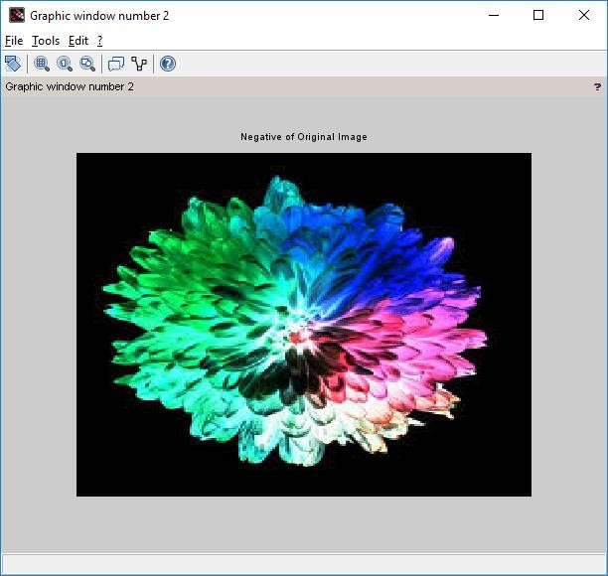

PRACTICAL No. 7

AIM:- Perform threshold operation, perform gray level slicing without background.

Install Image Processing and Signal Processing packages and restart scilab. Run this command on console: atomsRemove('scicv')
Restart scilab And run code

Threshold Operation Code:-

clc; close;
a = imread('C:\Users\ADMIN\Desktop\flower.jpg'); a = rgb2gray(a);
[m n] = size(a);
t = input('Enter threshold parameter: '); for i = 1:m
for j = 1:n if(a(i,j)<t)
b(i,j)=0; else
b(i,j) =255;
end end
end figure(1) imshow(a);
title('Original Image') figure(2)
imshow(b); title('Threshold Image')
xlabel(sprintf('Threshold Value is %g ',t))

Output:
Enter threshold parameter: 140

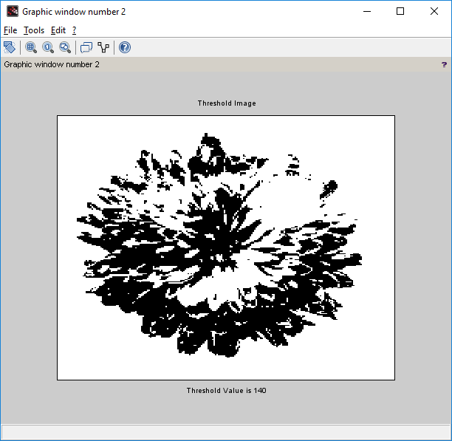

Gray Level Scaling without background. Code:-

clc ;
x = imread('C:\Users\ADMIN\Desktop\flower.jpg'); x = rgb2gray(x);
y = double(x); [m,n]= size(y);
L = max(max(x)); a = round(L/2) ;
b = L;
for i =1: m for j =1: n
if(y(i,j)>=a & y(i,j)<=b) z(i,j) = L;
else
z(i,j)=0; end
end end
z = uint8(z); figure(1) imshow(x);
title('Original Image') figure(2)
imshow(z);
title('Gray Level Slicing without preserving background')

Output:

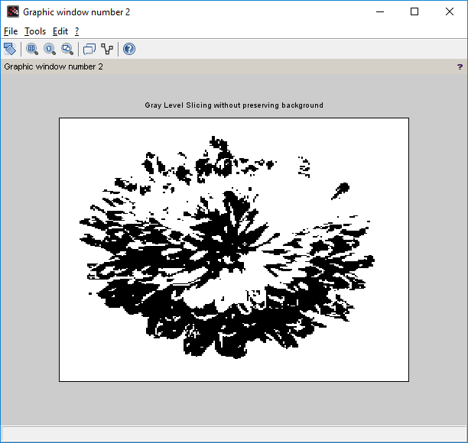

PRACTICAL No. 8

AIM:- Image Segmentation.

Install Image Processing and Signal Processing packages and restart scilab. Run this command on console: atomsRemove('scicv')
Restart scilab And run code
- Differentiation of Gaussian function. clc ;
close ;
sigma = input('Enter the value of sigma: ') i = -10:.1:10;
j = -10:.1:10;
r = sqrt(i.*i+j.*j);
y = (1/(sigma^2))*(((r.*r)/sigma^2)-1) .* exp(-r.*r/2*sigma^2); plot(i,y)
legend(sprintf('The sigma value is %g',sigma)) xtitle('Differentiation of Gaussian function')

Output:-
Enter the value of sigma: 1
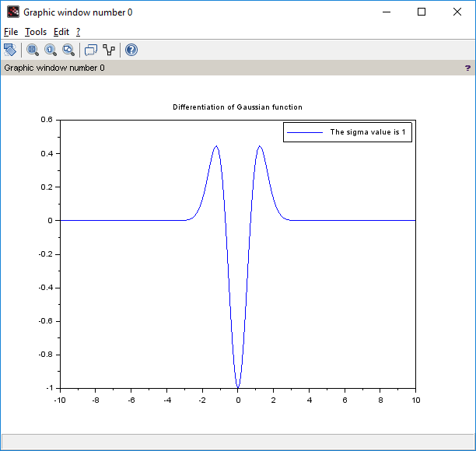

- Differentiation of Gaussian Filter function

clc ; close ;
sigma1 = input('Enter the value of sigma1: ') sigma2 = input ('Enter the value of sigma2: ') i = -10:.1:10;
j = -10:.1:10;
r = sqrt(i.*i+j.*j);
y1 = (1/( sigma1^2))*(((r.*r)/sigma1^2)-1) .* exp(-r.*r/2*sigma1^2); y2 = (1/( sigma2^2))*(((r.*r)/sigma2^2)-1) .* exp(-r.*r/2*sigma2 ^2); y = y1-y2;
plot(i,y)
xtitle('Shape of DOG Filter ')

Output:

Enter the value of sigma1: 4 Enter the value of sigma2: 1
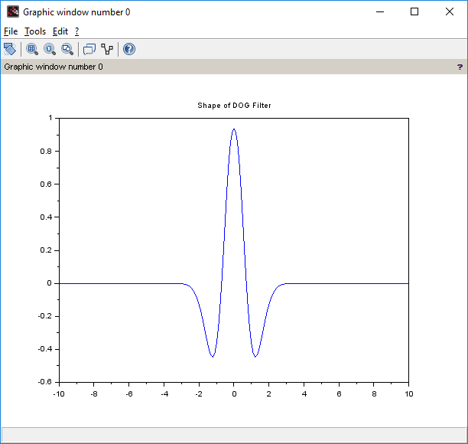

- Edge Detection using Different Edge detectors

close ; clc ;
a = imread('C:\Users\ADMIN\Desktop\flower.jpg'); a = rgb2gray(a);
c = edge(a,'sobel');
d = edge(a,'prewitt'); e = edge(a,'log');
f = edge (a,'canny'); imshow(a) title('Original Image') figure
imshow(c) title('Sobel') figure imshow(d) title('prewitt') figure imshow(e) title('Log') figure imshow(f) title('Canny')

Output:
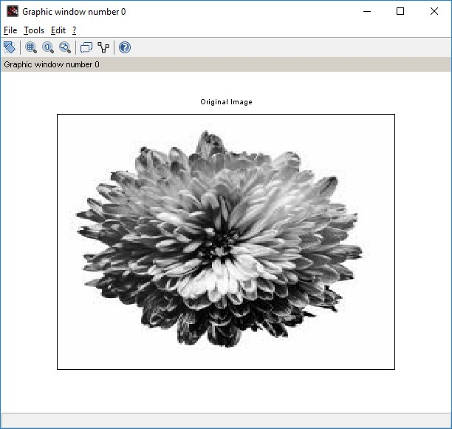

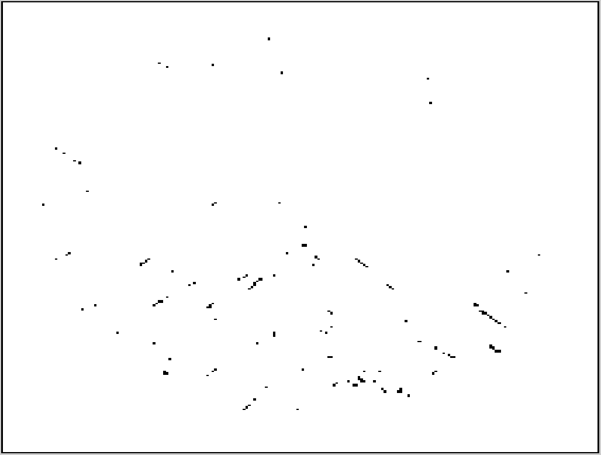
Graphic window number 1
Graphic wind ow number 1
File Tools Edit *
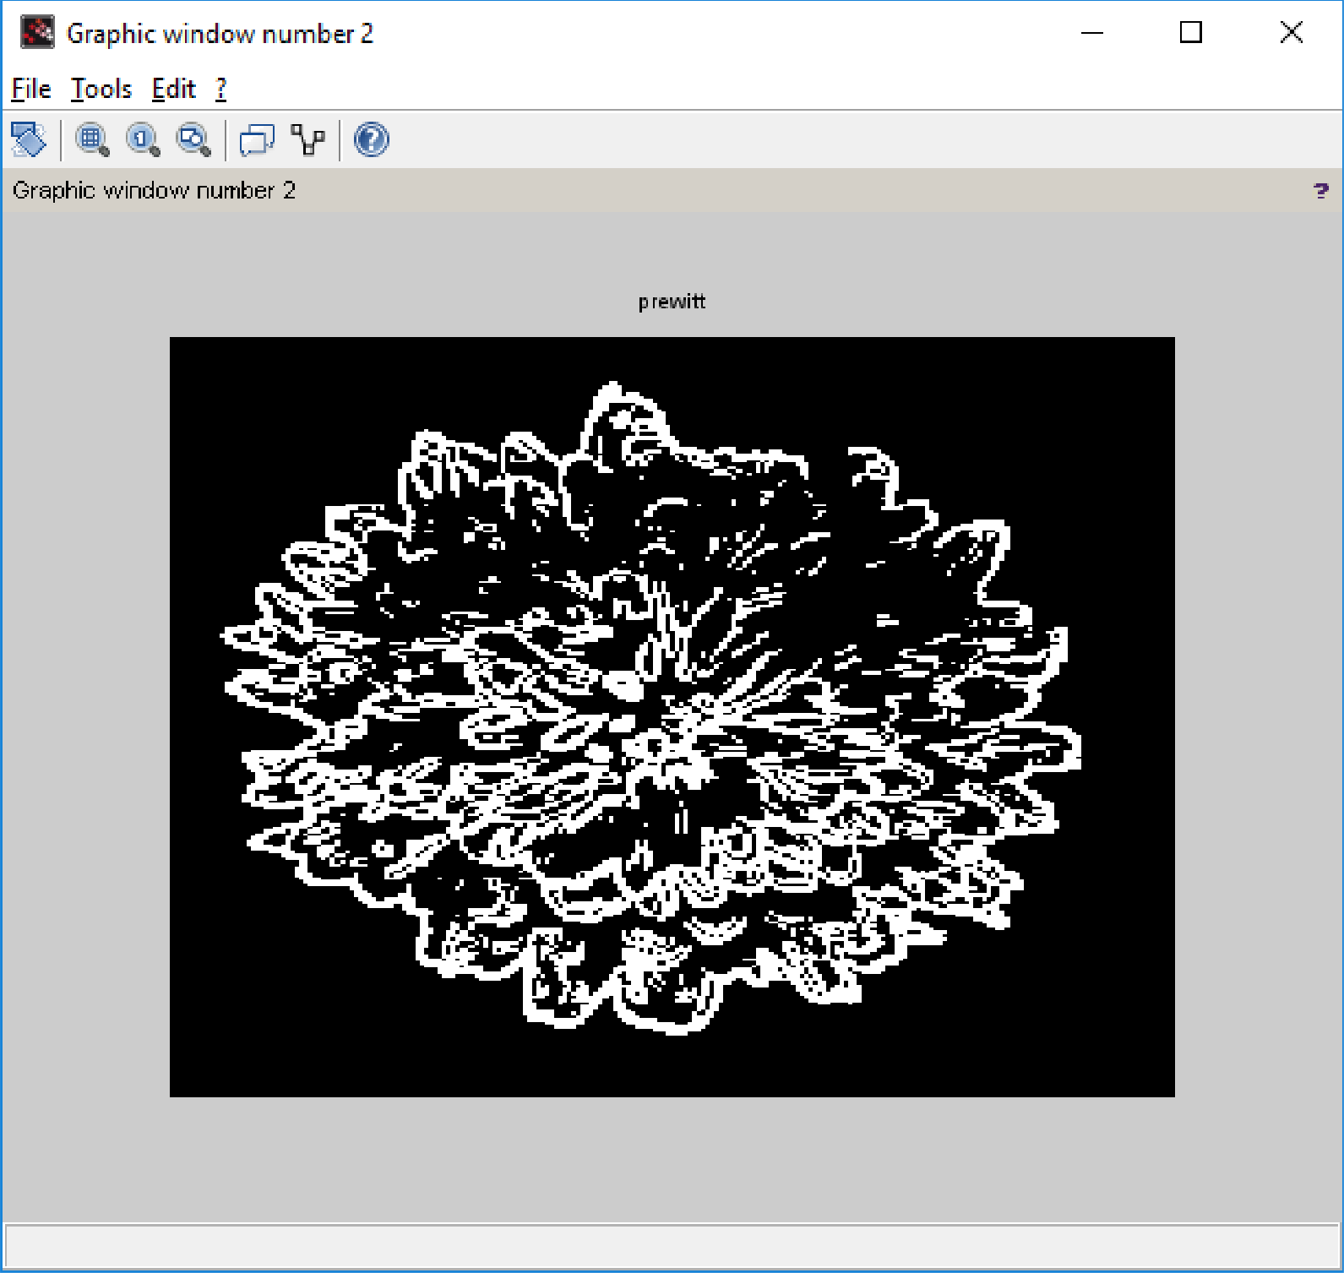

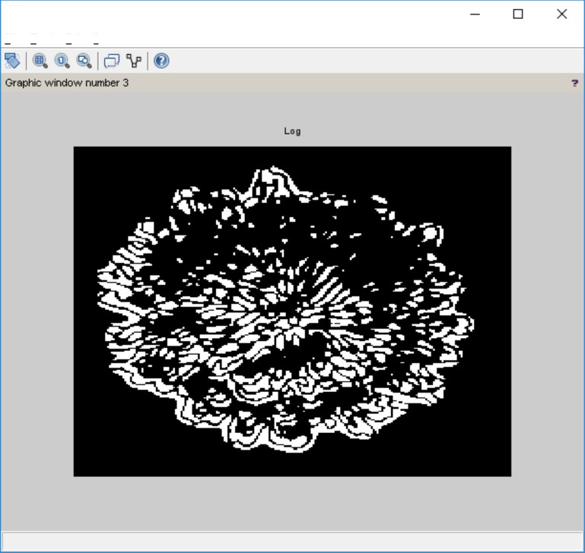
Graphic window number 3
File Tools Edit ?
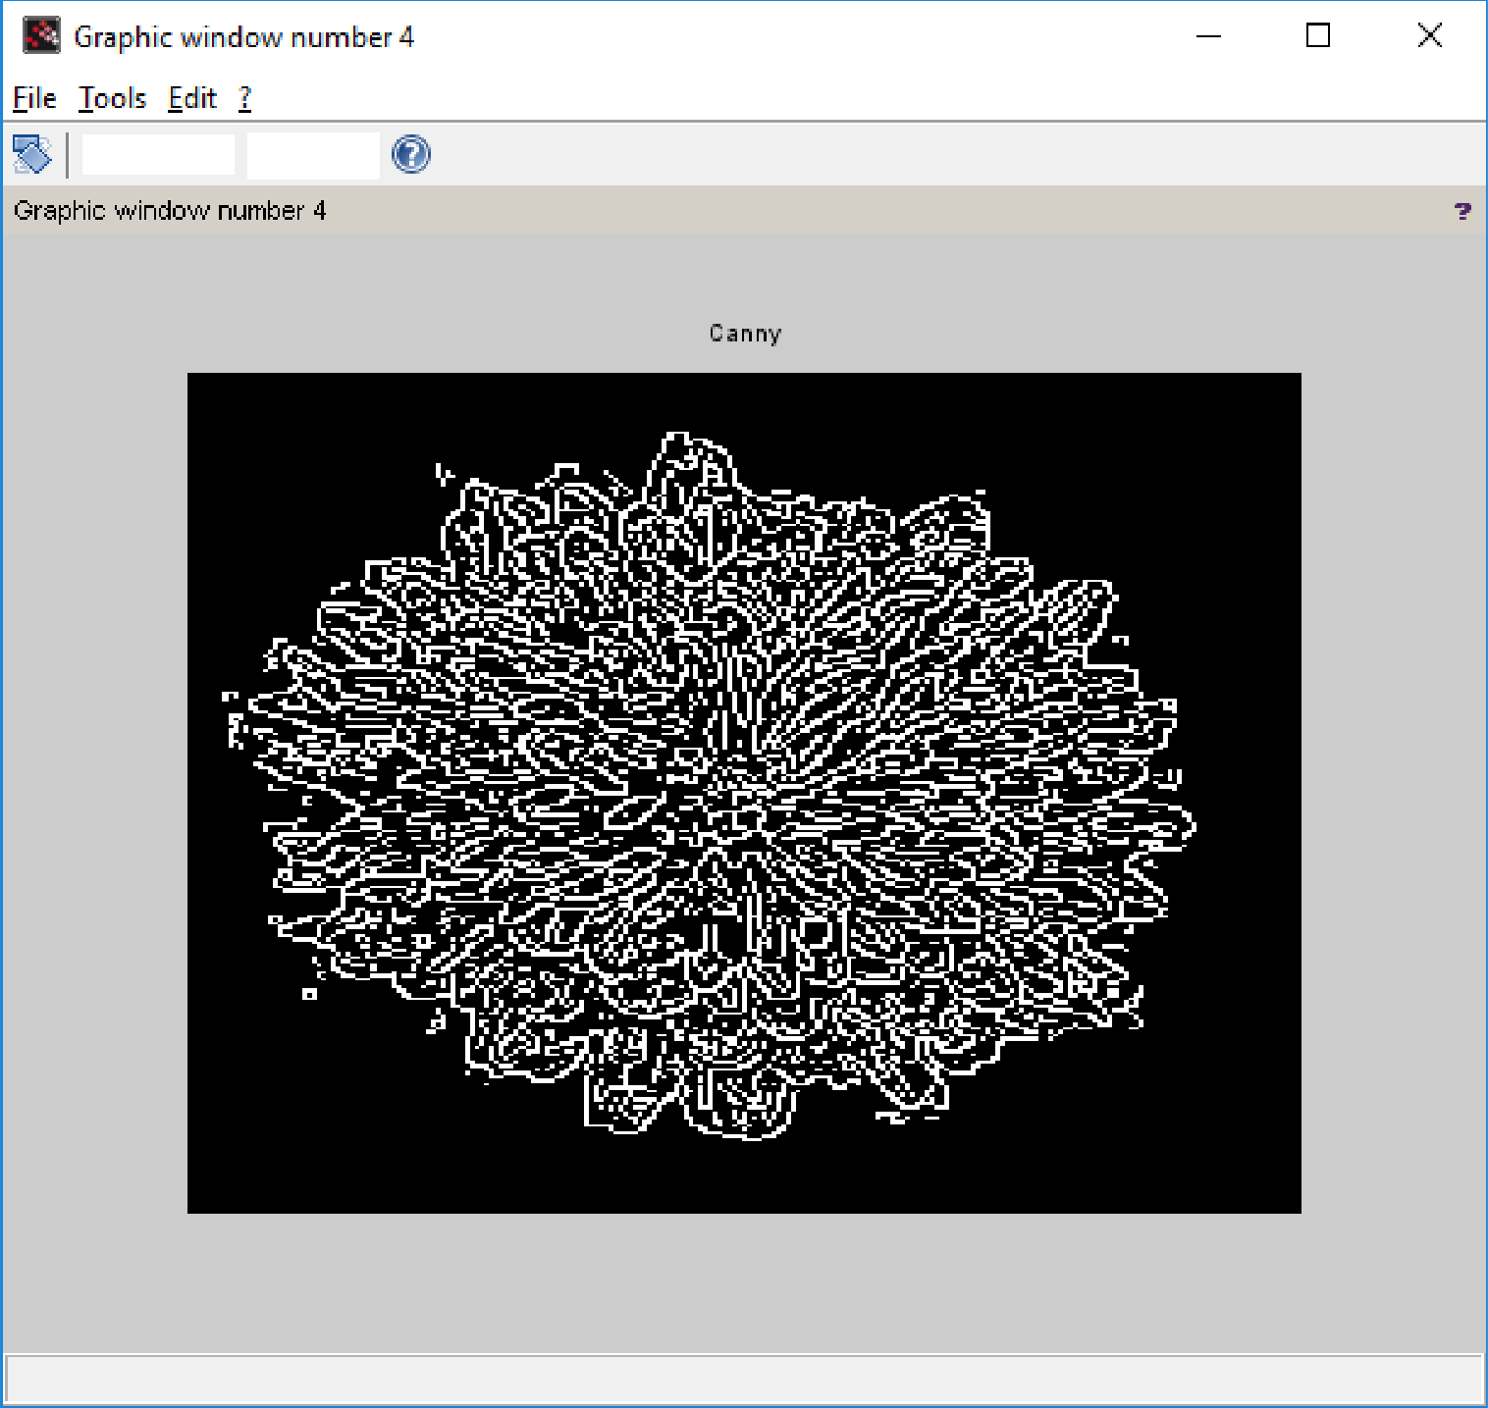

PRACTICAL No. 9

AIM:- Image Compression.

Install Image Processing and Signal Processing packages and restart scilab. Run this command on console: atomsRemove('scicv')
Restart scilab And run code

  - Block Truncation Coding BTC (Output in the form of Matrix).

Code:-

close; clear; clc;
x=[65,75,80,70;72,75,82,68;84,72,62,65;66,68,72,80];
disp(x,"Original Block is x = " ); [ m1 n1 ] = size(x);
blk = input("Enter the block size: "); for i = 1:blk:m1
for j = 1:blk:n1
y = x(i:i+(blk-1),j:j+(blk -1)); m = mean(mean(y)); disp(m,"mean value is m = "); sig = stdev(y);
disp(sig,"Standard deviation of the block is = "); b = y>m;
disp(b,"Binary allocation matrix is B= "); K = sum(sum(b));
disp(K,"number of ones = "); if(K~=blk^2)&( K~=0)
ml = m-sig*sqrt(K/((blk^2)-K)); disp(ml,"The value of a = ");
mu = m+sig*sqrt(((blk^2)-K)/K); disp(mu,"The value of b = ");
x(i:i+(blk-1),j:j+(blk-1))=b*mu+(1-b)*ml; end
end end
disp(round(x),"Reconstructed Block is x = " );

Output
Original Block is x = 65. 75. 80. 70.
72. 75. 82. 68.
84. 72. 62. 65.
66. 68. 72. 80.
Enter the block size: 4

mean value is m = 72.25
Standard deviation of the block is = 6.6282225
Binary allocation matrix is B=

F T T F F T T F T F F F F F F T

number of ones = 6.
The value of a = 67.115801
The value of b = 80.806998
Reconstructed Block is x =

67. | 81. | 81. | 67.
67. | 81. | 81. | 67.
81. | 67. | 67. | 67.
67. | 67. | 67. | 81.

PRACTICAL No. 10

AIM:- Binary Image Processing and Colour Image processing.
Install Image Processing and Signal Processing packages and restart scilab. Run this command on console: atomsRemove('scicv')
Restart scilab And run code

- Dilation and erosion process.

Code:- close ; clear ; clc ;
a = imread('C:\Users\ADMIN\Desktop\letter.png');
b = imcreatese('rect',7,7); //Structuring element value can be either rect, ellipse, cross
a1 = imdilate(a,b); a2 = imerode(a,b); figure(1) imshow(a);
title('Original Image') figure(2) imshow(a1); title('Dilated Image') figure(3) imshow(a2); title('Eroded Image')

Output:-
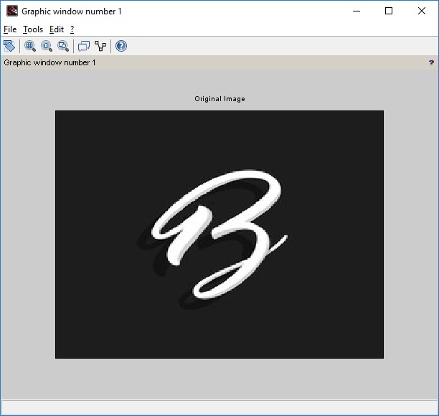

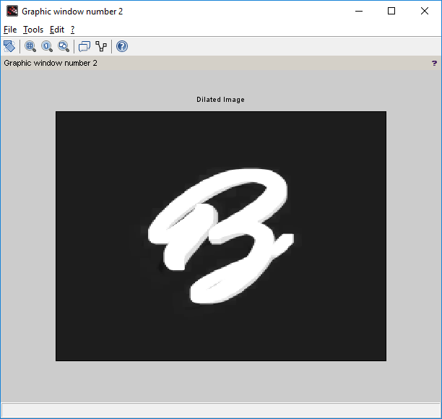
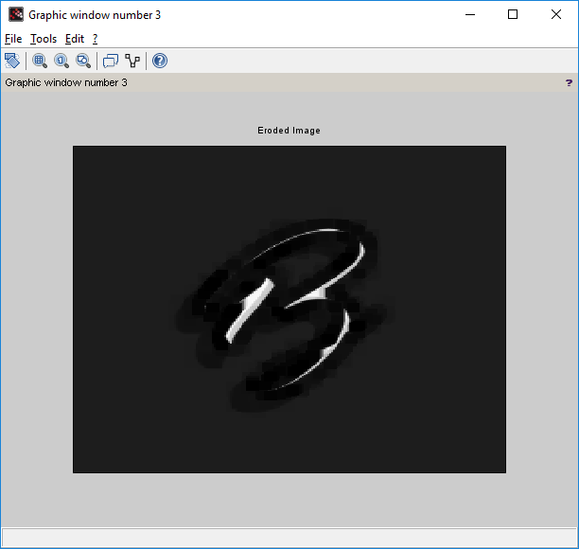

- opening and closing operation on the image.

Code:- close ; clear ; clc ;
a = imread('C:\Users\ADMIN\Desktop\letter.png');
b = imcreatese('rect',7,7); //Structuring element value can be either rect, ellipse, cross
a1 = imopen(a,b); a2 = imclose(a,b); figure(1) imshow(a);
title('Original Image') figure(2) imshow(a1);
title('Opening Operation') figure(3)
imshow(a2); title('Closing Operation')

Output:-

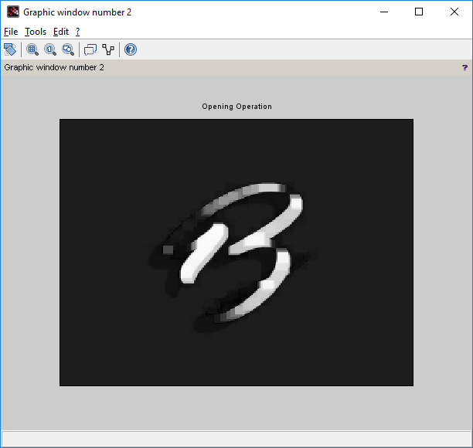

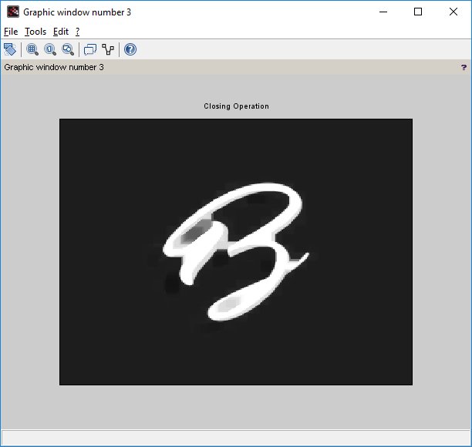

- Read an RGB image and extract the three colour components red, green and blue.

Code:-

clc; close ;
RGB = imread('C:\Users\ADMIN\Desktop\flower.jpg'); R = RGB;
G = RGB; B = RGB; R(: ,: ,2) =0;
R(: ,: ,3) =0;
G(: ,: ,1) =0;
G(: ,: ,3) =0;
B(: ,: ,1) =0;
B(: ,: ,2) =0;
figure(1) imshow(RGB);
title('Original Color Image'); figure(2)
imshow(R);
title('Red Component'); figure(3)
imshow(G);
title('Green Component'); figure(4)
imshow(B);
title('Blue Component')

Output:-
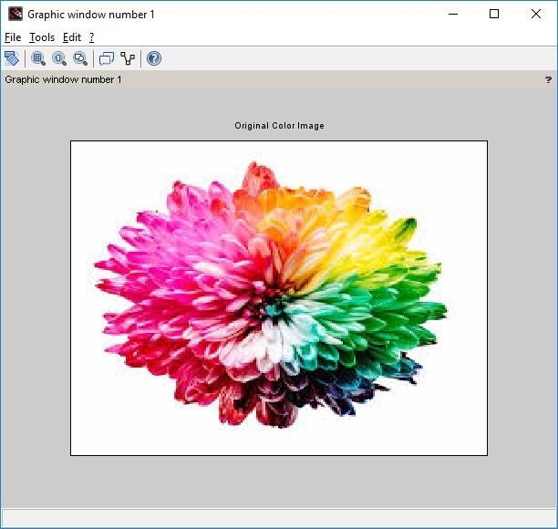

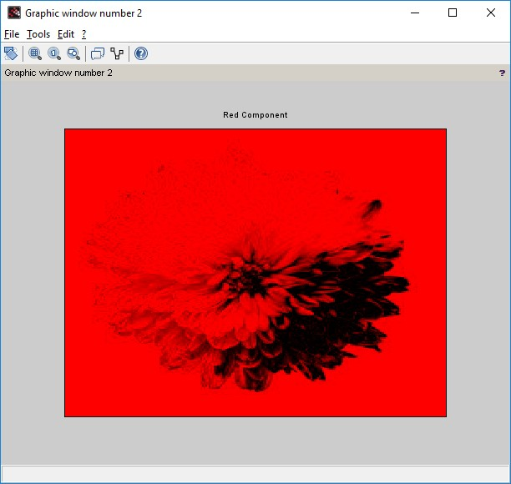
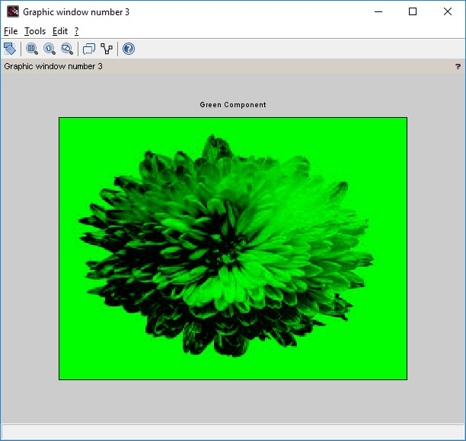

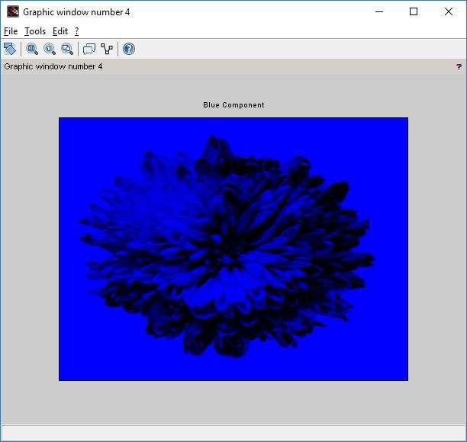

- Read a Colour image and separate the colour image into red green and blue planes.

Code:-

clc; close ;
RGB = imread('C:\Users\ADMIN\Desktop\flower.jpg'); R = RGB;
G = RGB; B = RGB; R(: ,: ,1) =0;
G(: ,: ,2) =0;
B(: ,: ,3) =0;
figure(1) imshow(RGB);
title('Original Color Image'); figure(2)
imshow(R);
title('Red Component Missing'); figure(3)
imshow(G);
title('Green Component Missing'); figure(4)
imshow(B);
title('Blue Component Missing')

Output:-
