BUSINESS ANALYSIS REPORT
E-Commerce Performance & Cart Abandonment Risk Assessment

1. Executive Summary
This report presents a comprehensive analysis of an eCommerce company facing concerns regarding high cart abandonment and declining sales performance.
Using SQL-based data analysis, business process modelling (BPMN), and interactive Tableau dashboards, the study evaluated revenue trends, customer behaviour, operational efficiency, and abandonment proxy indicators.
While direct cancellation-based abandonment was measured at approximately 0.63%, operational inefficiencies — particularly delivery delays — were found to significantly influence customer dissatisfaction and potential long-term churn risk.
The analysis suggests that although abandonment is not currently critical, structural weaknesses could escalate into revenue decline if not addressed proactively.

2. Problem Statement
The organization is experiencing:
• Concerns of high cart abandonment
• Volatile sales performance
• Customer dissatisfaction
The objective of this analysis was to:
- Validate whether sales decline exists
- Identify operational and behavioural bottlenecks
- Infer abandonment indicators from available data
- Recommend actionable business improvements
Since the dataset does not include explicit cart activity logs, abandonment was inferred through behavioural and transactional signals.
3. Data Overview
The analysis was conducted using transactional data across:
• Orders
• Payments
• Order Items
• Customers
• Reviews
• Products
Key metrics derived:
• Monthly Revenue
• Order Volume
• Average Order Value
• Cancellation Rate
• Delivery Days
• Customer Lifetime Revenue
Data period analysed: October 2016 – August 2018
Data set used: Olist ecommerce dataset Kaggle
Data set link: https://www.kaggle.com/datasets/olistbr/brazilian-ecommerce

4. SQL Analysis Findings
4.1 Revenue Trends
Revenue demonstrated:
• Strong growth throughout 2017
• Peak performance in November 2017
• Volatility during 2018
While not a continuous decline, instability indicates sensitivity to operational and seasonal factors.

4.2 Cart Abandonment Proxy
Cancellation-based abandonment rate:
0.63%
This indicates low direct checkout failure. However, cancellation alone does not fully capture abandonment behaviour.

4.3 Delivery Performance Impact
Delivery time analysis revealed strong correlation with review scores:
• 1-star reviews → Average delivery ~20.85 days
• 5-star reviews → Average delivery ~10.22 days
This suggests operational inefficiency significantly impacts customer satisfaction and future purchasing behaviour.

4.4 Customer Segmentation
Customers were segmented into:
• High Value
• Medium Value
• Low Value
Revenue concentration among high-value customers highlights retention importance. Exposure of these customers to service delays may increase churn probability.

5. Business Process Modelling (BPMN Findings)
Two models were developed:
• Current State (AS-IS) Checkout Process
• Future State (TO-BE) Optimized Process
5.1 Identified Bottlenecks
- Payment gateway exit point
- Lack of structured retry mechanism
- Seller dispatch delays
- No SLA monitoring
- Limited post-delivery engagement
The current process is reactive rather than proactive.
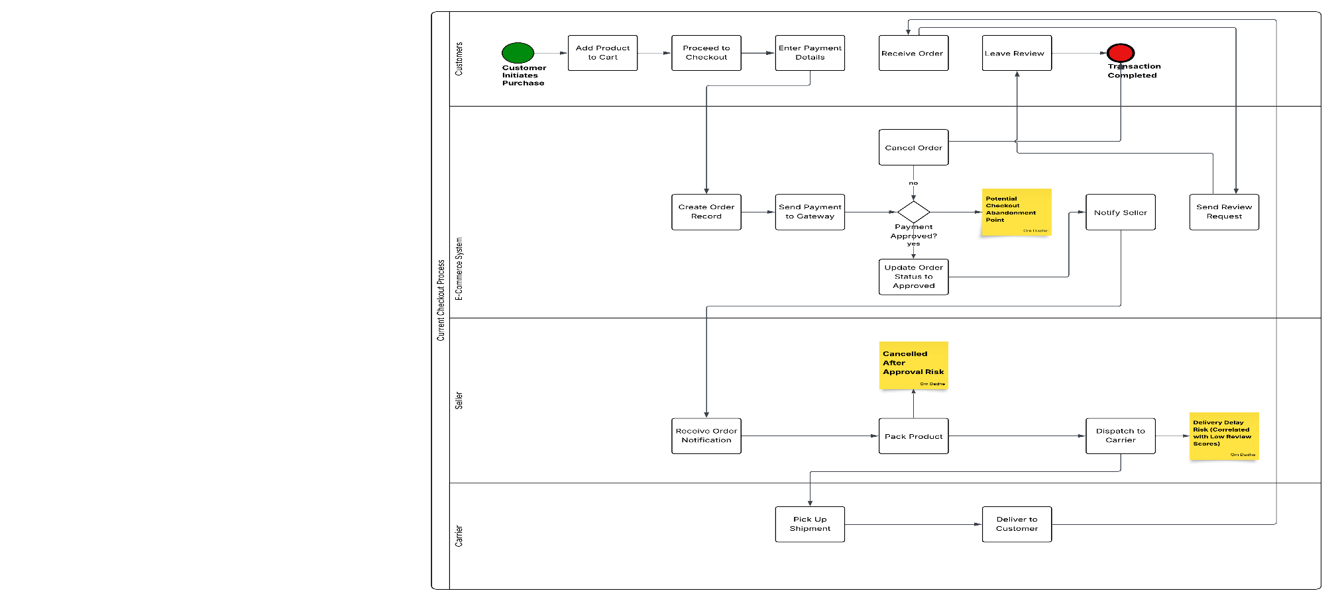

5.2 Future State Improvements
The redesigned process introduced:
• Transparent pricing before checkout
• Payment retry loop
• Seller SLA monitoring
• Escalation triggers
• Post-delivery retention campaigns
These improvements directly address abandonment risk escalation.
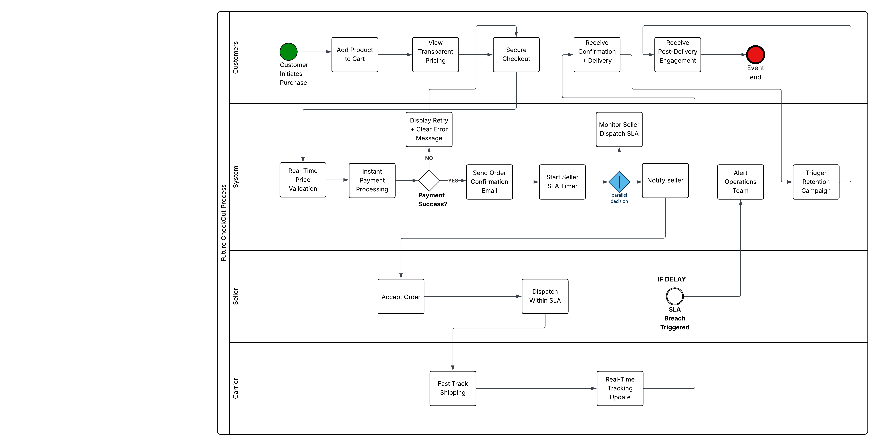

6. Dashboard Insights
Three interactive dashboards were developed:
6.1 Executive Overview
Displayed:
• Total Sales
• Total Orders
• Cart Abandonment Rate
• Average Delivery Days
• Monthly Revenue Trend
Key Insight:
Revenue is not collapsing, but performance volatility requires monitoring.
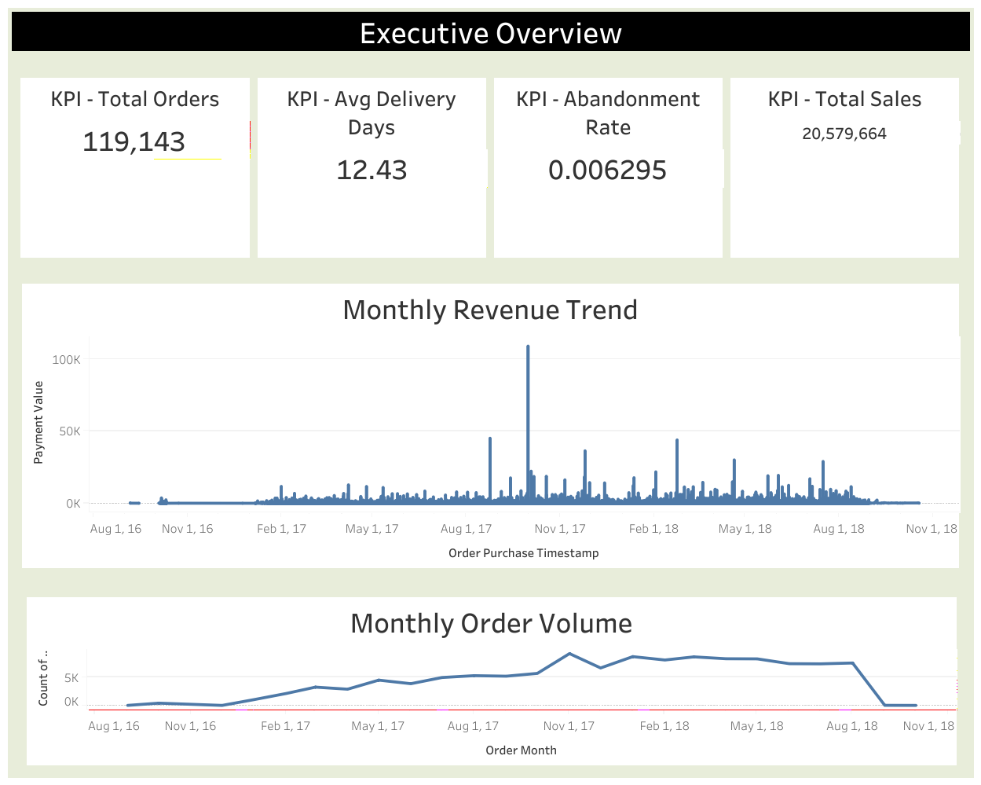

6.2 Customer & Experience Analysis
Displayed:
• Revenue by Customer Segment
• Abandonment Trend
• Delivery Time vs Review Score
Key Insight:
Delivery delays significantly influence satisfaction and potential churn.
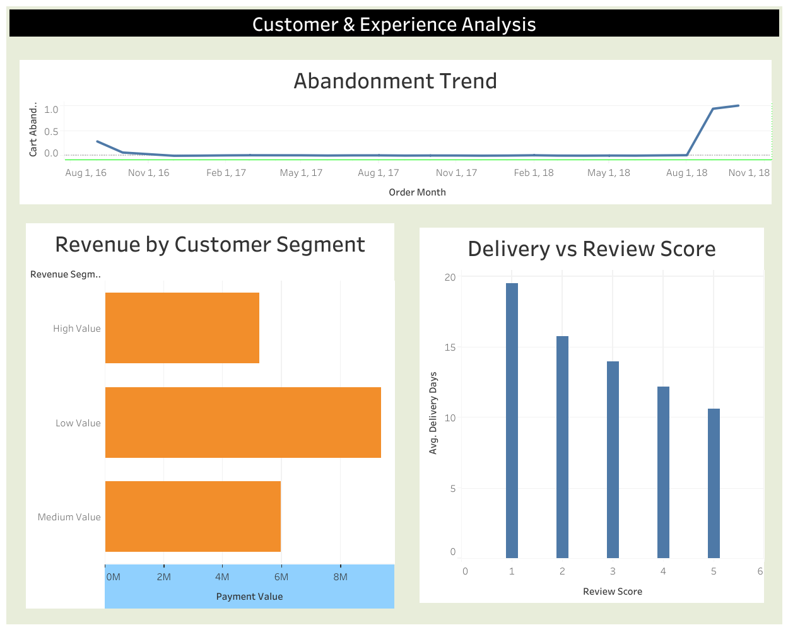

6.3 Operational Performance
Displayed:
• Revenue by State
• Delivery Distribution
Key Insight:
Operational inconsistencies may contribute to medium-term abandonment risk.
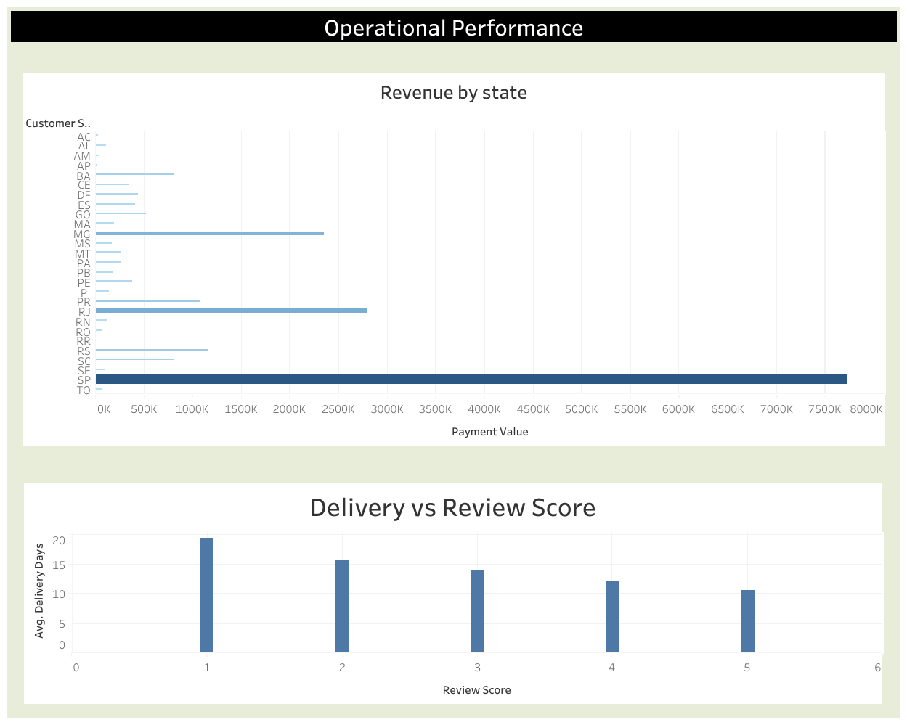

7. Interpretation Aligned with Scenario
Although immediate abandonment (0.63%) appears low, the following structural risks exist:
• Long delivery times reduce customer satisfaction
• Revenue volatility indicates operational sensitivity
• High-value customers exposed to delays increase churn risk
• Absence of cart-level monitoring hides early-stage abandonment signals
Therefore, abandonment risk should be treated as preventive priority rather than reactive crisis.

8. Strategic Recommendations
8.1 Improve Delivery SLAs
Establish performance thresholds for seller dispatch and carrier timelines.
Why this works:
Delivery delays directly correlate with low review scores and future churn risk.

8.2 Implement Checkout Recovery Mechanisms
Introduce:
• Payment retry functionality
• Real-time validation messaging
• Abandoned cart email triggers
Why this works:
Reduces friction at payment stage and improves completion rate.

8.3 Introduce Customer Retention Programs
Launch:
• Loyalty programs
• Targeted remarketing
• Engagement campaigns for high-value customers
Why this works:
High-value customers contribute disproportionate revenue.

8.4 Operational Monitoring Dashboard
Implement real-time monitoring for:
• Delivery delays
• Cancellation spikes
• Seller SLA breaches
Why this works:
Early detection prevents abandonment escalation.

8.5 Segment-Based Retargeting
Identify:
• High-value customers with delayed deliveries
• Customers with low review scores
Proactively target them with incentives.
Why this works:
Prevents silent churn.

9. Conclusion
The analysis indicates that while current cancellation-based abandonment is relatively low, operational inefficiencies and delivery delays present structural risks.
Revenue volatility combined with customer dissatisfaction signals that without proactive intervention, abandonment risk could escalate.
The recommended strategic interventions focus on:
• Process optimization
• SLA monitoring
• Checkout friction reduction
• Customer retention strengthening
This blended analytical approach ensures alignment with both the project scenario and actual data findings.

