QuriioHQ — Marketing Brief
Oct 10, 2026 ·
Build the ad around one idea: QuriioHQ ends the crowded OPD corridor by telling every patient exactly where they stand in the queue — on WhatsApp, in their own language, with no app. The ward (IPD) module then carries the same patient from admission to a clean, itemised discharge bill.
This brief describes what is built in the product today. Two things in the original request do not match the product, and the ad must not use them: see Claims guardrails below.

What it is and who it is for
QuriioHQ is cloud software for small and medium hospitals and clinics in rural and semi-urban India. A typical customer sees 150–200 outpatients a day, works in Marathi, Hindi and English, and has patients on budget Android phones and patchy internet.
The core problem it solves is uncertainty, not booking. A patient does not know if their turn is 20 minutes or 3 hours away, so they never leave the building. By 10am the corridor is full, reception is answering "how much longer?" all morning, and consultations get interrupted.
Audience | What they care about | Lead with
Hospital owner (usually a doctor) | A calm OPD, honest numbers on how the day ran, no new IT headache | Calm corridor, one dashboard, reports
Hospital administrator / manager | Less desk chaos, clean billing, staff accountability | One-button queue, audit trail, gap-free bills
Doctors | Fewer interruptions, faster prescriptions | Own queue on their phone, repeat-last prescription
Solo doctors and small clinics | Works without a receptionist | Doctor advances the queue from their own phone
The main reader is a doctor who owns a hospital. They are not shopping for software; they are tired of the crowd outside their door. Write to that person.

How it works
The whole product fits in six steps, and this is the story the ad should tell. A doctor should understand QuriioHQ from this flow alone.
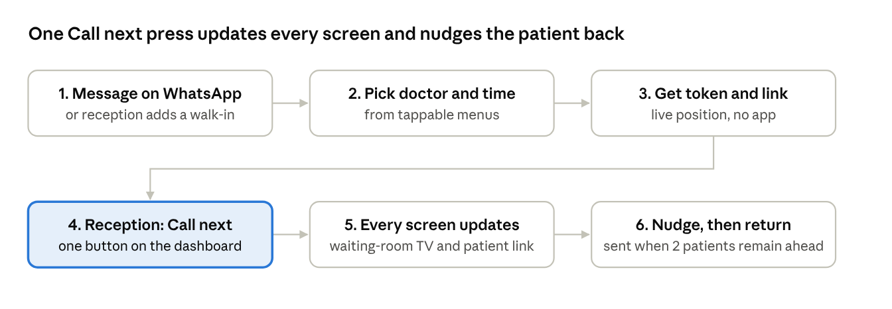
patient journey · 6 steps
Step 4 is the hero moment: one press at the desk changes what the patient, the TV and the doctor all see. Between steps 3 and 6 the patient is free to wait anywhere.

Features by module
Only the Ready rows are safe to advertise as available today. Built, not live means coded and tested but not yet switched on for a hospital; ask the founder before featuring it.
Module | What it does | Status (10 Oct 2026)
WhatsApp booking | Patient messages the hospital, picks doctor and time from tappable menus, gets a token number and a live queue link | Ready — runs end-to-end on Meta's live WhatsApp API
Live queue page | Patient sees their position on a web link: no app, no login, Marathi / Hindi / English | Ready
Reception dashboard | One Call next button; skip, hold, recall, priority insert, walk-in registration | Ready
"Come back now" nudge | Patient is messaged automatically when two patients remain ahead | Ready
Waiting-room TV display | "Now serving" numbers readable across the room, with audio | Ready
Solo-doctor mode | Doctor runs the queue from their own phone, no receptionist needed | Ready
Reports and audit | Patients seen, waits, consultation times; who moved which token and when | Ready
OPD billing | Consultation fee per doctor, one-tap Paid / Unpaid, "Seen today" list | Ready

Benefits by audience
The three benefits to lead with — efficiency, patient experience and cost control — map to concrete product behaviour, not measured results. Describe how it works; no percentages (see guardrails).
Benefit | For whom | What makes it true
A calm corridor | Owner, patients | Patients know their position, so they wait outside, at a tea stall or at home, and return when nudged
Fewer interruptions | Doctors | Nobody needs to ask "how much longer?" — the answer is on the patient's phone and the TV
One button at the desk | Reception | Call next replaces the paper register and shouting names; walk-ins added in seconds
Honest numbers | Owner | Reports show how the day actually ran: patients seen, median wait, median consultation
Accountability | Owner, administrator | Audit log of every queue move; in IPD, every bedside entry is signed by the nurse's own login
No lost charges | Owner, billing desk | In IPD, every bedside entry becomes a bill line instantly; bed charges added nightly; bill numbers have no gaps
Respect for the patient | Patients and families | No app to install, their own language, a running-bill link for the family
Predictable cost | Owner | Monthly plan sized to patient volume; no hardware beyond a phone and an optional TV
Quick start | Reception | Designed to be learned in about 15 minutes; sits beside existing hospital software rather than replacing it

Claims guardrails
A single false claim ends a healthcare sale the moment a doctor asks "which hospital said that?". These rules come from the product's own landing-page brief and from what is actually built.
Do not say | Why | Say instead
"Reduces wait times by 30%" or any other percentage | The 30% and "saved thousands" examples are from other hospitals' projects. QuriioHQ has no measured results yet — it has not run in a live waiting room | Describe how it works: "patients see their exact position and come back when called"
Testimonials, hospital logos, "trusted by N hospitals", star ratings | There are no paying customers yet; one pilot hospital is in progress | Nothing — cut the section until a pilot hospital agrees to be named
"Real-time inventory management" | Not built. There is a medicine and charge price list, not stock tracking | Leave out
"Integrated electronic health records (EHR)" | Not built as an EHR. Prescriptions and ward records are being added, but it is not a full EHR and does not integrate with other systems | "Works alongside your existing hospital software"
"Automated scheduling" or "staff scheduling" | Patients book a doctor and time on WhatsApp, but there is no staff rostering | "Book on WhatsApp"
"Never stores medical data" | True for the OPD queue alone, but the newer prescription and IPD modules do store clinical records | "Patient data is isolated per hospital and every access is logged"
"Trained in 15 minutes" as a fact | It is a design goal, not yet measured | "Built to be learned in one short session"
Any medical or clinical-outcome claim | It is an operations tool, not a clinical device | Talk about flow, time and billing
"Data stored in India" | Patient data is currently hosted in Singapore; a move to India is planned | Leave out until the move is done

