**PROJECT REPORT: BLOG WEBSITE - TECH BLOG’S**

# By

# OM KOKANE

# ID: MST04-0037

**Abstract**

The Blog Website project is a modern and user-friendly platform designed to provide users with an engaging and intuitive blogging experience. Built using React and Vite, it offers a robust and efficient framework for creating, managing, and sharing blog content. The website features dynamic content rendering, responsive design, and seamless navigation to ensure a smooth user experience across devices.

With a focus on performance and scalability, the Blog Website project enables bloggers and businesses to share their ideas effectively, connect with audiences, and expand their digital footprint. This platform is tailored to meet the diverse needs of content creators, making it a cornerstone for impactful storytelling in the digital era.

In summary, the Blog Website project represents the integration of advanced web technologies and user-focused design, empowering content creators to thrive in an ever-evolving online space.

# Table of Contents:

1. Introduction
2. Project Overview
3. Technologies Used
4. System Architecture
5. Implementation Details
6. Challenges Faced
7. Future Enhancements
8. Conclusion
9. References

# Introduction:

The Blog Website project is a responsive and interactive platform developed using the React framework. It includes key features such as a Navbar with static search and share buttons, and an Admin Login Page secured through Firebase authentication. Once logged in, the admin can access a Dashboard to manage blog functionalities.

Although the project focuses on the frontend, it showcases features like simulating blog creation and deletion (with actual functionality planned for future scope). The admin's profile and profile picture disappear upon logout, ensuring a secure and seamless experience. The site is fully optimized for mobile devices, providing users with a smooth browsing experience.

This project highlights the use of modern web development practices to create dynamic and user-friendly platforms, setting a strong foundation for future enhancements.

# Project Overview:

The Blog Website project is a modern and responsive platform developed using the React framework, integrating Firebase for secure admin authentication and real-time functionality. The design ensures optimal performance and accessibility across all devices, offering a seamless experience for users.

Key features include a Navbar with static search and share buttons, an Admin Login Page secured via Firebase, and an Admin Dashboard for managing blogs. While the current implementation simulates blog creation and deletion, these features are prepared for future backend enhancements. Additional functionalities include automatic admin session management, ensuring the profile and picture are cleared upon logout for security.

The platform is designed with scalability in mind, making it a strong foundation for expanding into a fully integrated blog management system. Its focus on usability and responsiveness makes it a reliable solution for modern content management needs.

* 1. **Technologies Used:**

- React.js

- Firebase Authentication

- CSS (for styling)

- HTML

- JavaScript

- React Router (for navigation)

- Responsive Design (Mobile-First)

- Axios (for handling HTTP requests)

- Vite (for fast development build)

- Firebase Fire store (planned for future backend integration)

**React.js:**

React is a JavaScript library for building user interfaces, particularly single-page applications. It allows developers to create reusable UI components and manage application state efficiently.

**Firebase Authentication:**

Firebase provides a secure and easy-to-use authentication system for web and mobile apps. It supports various authentication methods, including email/password, social media login, and more.

**CSS:**

CSS (Cascading Style Sheets) is used to style the visual presentation of web pages. It controls the layout, colors, fonts, and overall appearance, ensuring that the website is aesthetically pleasing and user-friendly.

**HTML:**

HTML (Hypertext Markup Language) forms the backbone of web content, defining the structure of web pages. It includes elements such as headings, paragraphs, links, and images that provide the content and layout of the page.

**JavaScript:**

JavaScript is a versatile programming language that adds interactivity and dynamic behavior to websites. It enables tasks such as form validation, event handling, and AJAX requests for a smoother user experience.

**React Router:**

React Router enables dynamic navigation between pages in React applications. It allows for single-page app behavior, keeping the user experience seamless without reloading the entire page.

**Vite:**

Vite is a fast development build tool and bundler, providing an optimized workflow for React applications. It enhances the development experience with faster build times and hot module replacement.

**Axios:**

Axios is a promise-based HTTP client for JavaScript, used to make requests to the backend and handle responses in React applications. It simplifies making AJAX requests and interacting with APIs.

# System Architecture:

The system architecture follows a typical React component-based structure, where components handle the rendering of UI elements, and state management is used to manage the application's behavior. React Router is used for navigation between different pages, ensuring a seamless single-page application experience.

While the frontend is the primary focus, Firebase Authentication is integrated for secure user login and session management. Future backend integration will enable the dynamic handling of blog data.

The platform’s architecture is designed to be flexible and scalable, enabling easy extension as more features, like blog creation and deletion, are implemented. The application is also fully responsive, ensuring an optimal user experience across all devices.

# Implementation Details:

**Home Page:**

The home page displays a welcoming interface where users can easily navigate the site and view featured blog posts. Using React, CSS, and JavaScript, the page dynamically renders content, providing an engaging and interactive experience. It also includes a static search and share button, allowing users to explore blog topics and share content effortlessly.

**Admin Login Page:**

This page is dedicated to logging in for admin users. It provides fields for entering email and password, with authentication handled securely through Firebase. Once logged in, the admin is redirected to the dashboard for managing blog content.

**Admin Dashboard:**

After successful login, the admin is taken to a dashboard where they can view and manage blogs. Currently, the admin can simulate the creation and deletion of blogs (front-end only), with real backend functionality planned for future implementation. The dashboard is designed to be intuitive and easy to navigate.

**Blog Creation Page:**

This page allows the admin to add new blog posts. It includes a form where blog titles, content, and other details can be entered. However, this is a simulated feature, with actual blog creation functionalities planned for future backend integration.

**Blog Deletion (Simulated):**

In this section, the admin can simulate the deletion of blog posts. While the blogs aren’t deleted from the database yet, this feature is set up for future enhancements that will allow actual blog deletion functionality.

**Logout:**

When the admin logs out, the session is cleared, ensuring that the admin profile and profile picture are removed from the UI for security and privacy.

**Responsive Design:**

The entire platform is fully responsive, ensuring that the website adapts seamlessly to various screen sizes, including mobile devices. The user experience is consistent across all devices, enhancing accessibility and usability.

Fig 1: Home page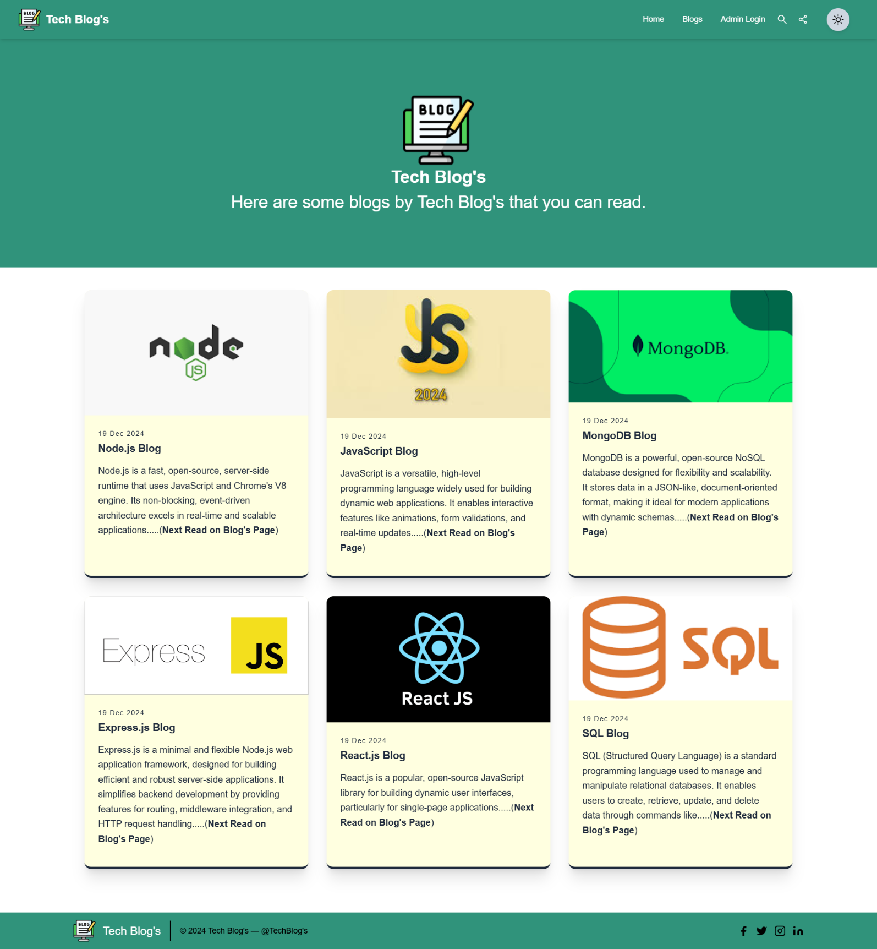

Fig2.Blog’s Page

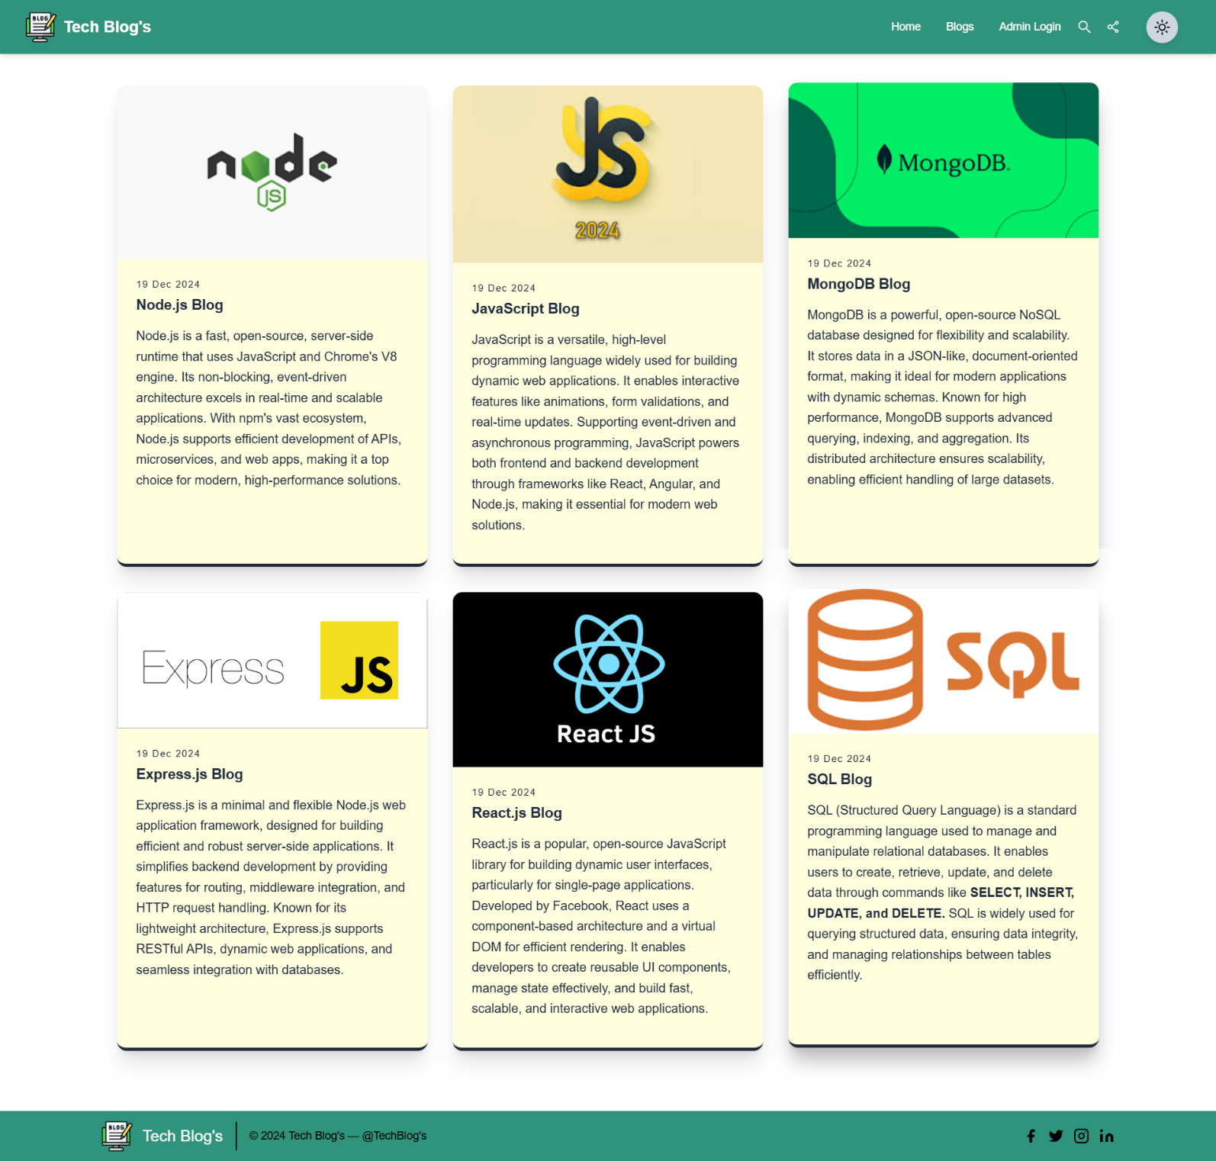

Fig 3. Dark Mode Page

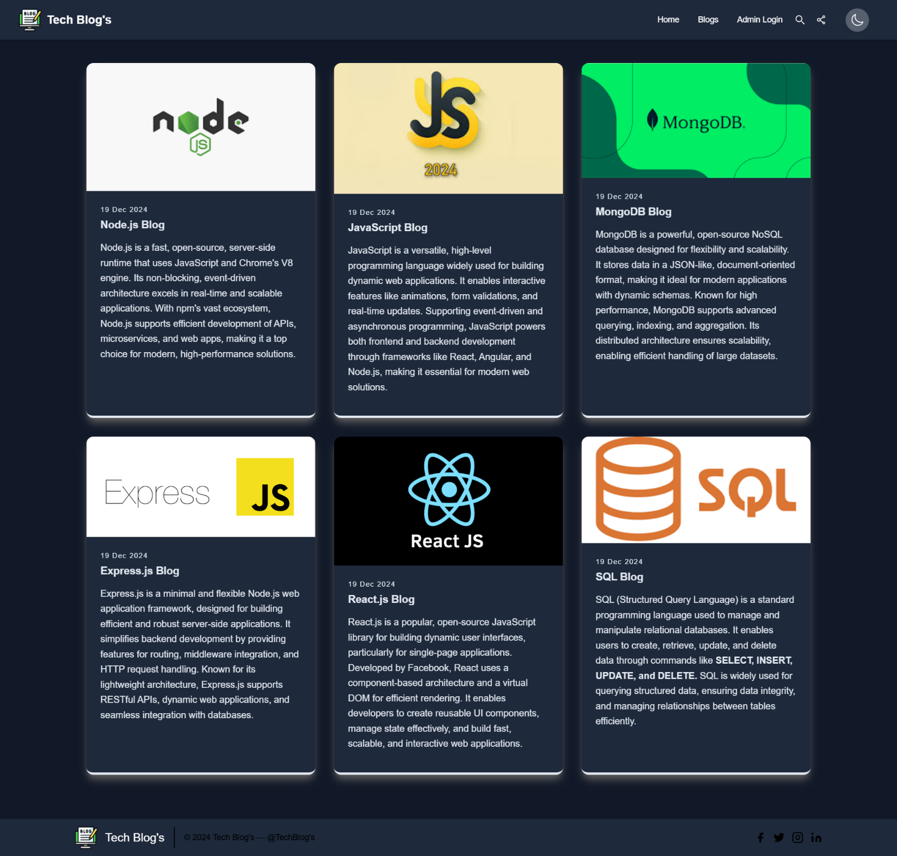

Fig4.Dashboard Features

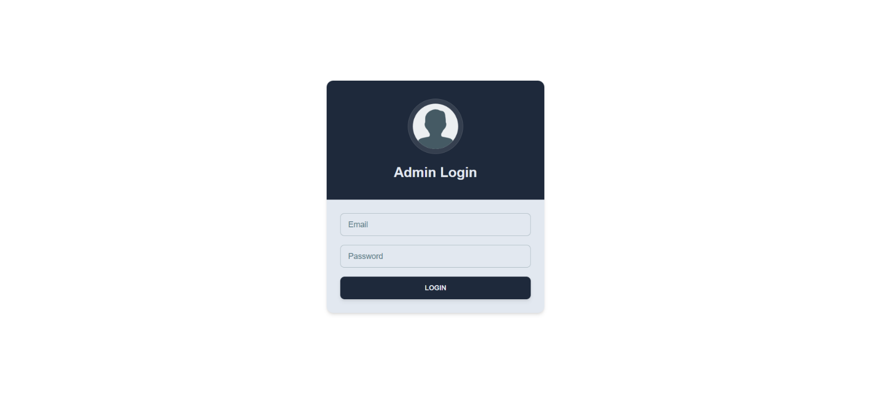

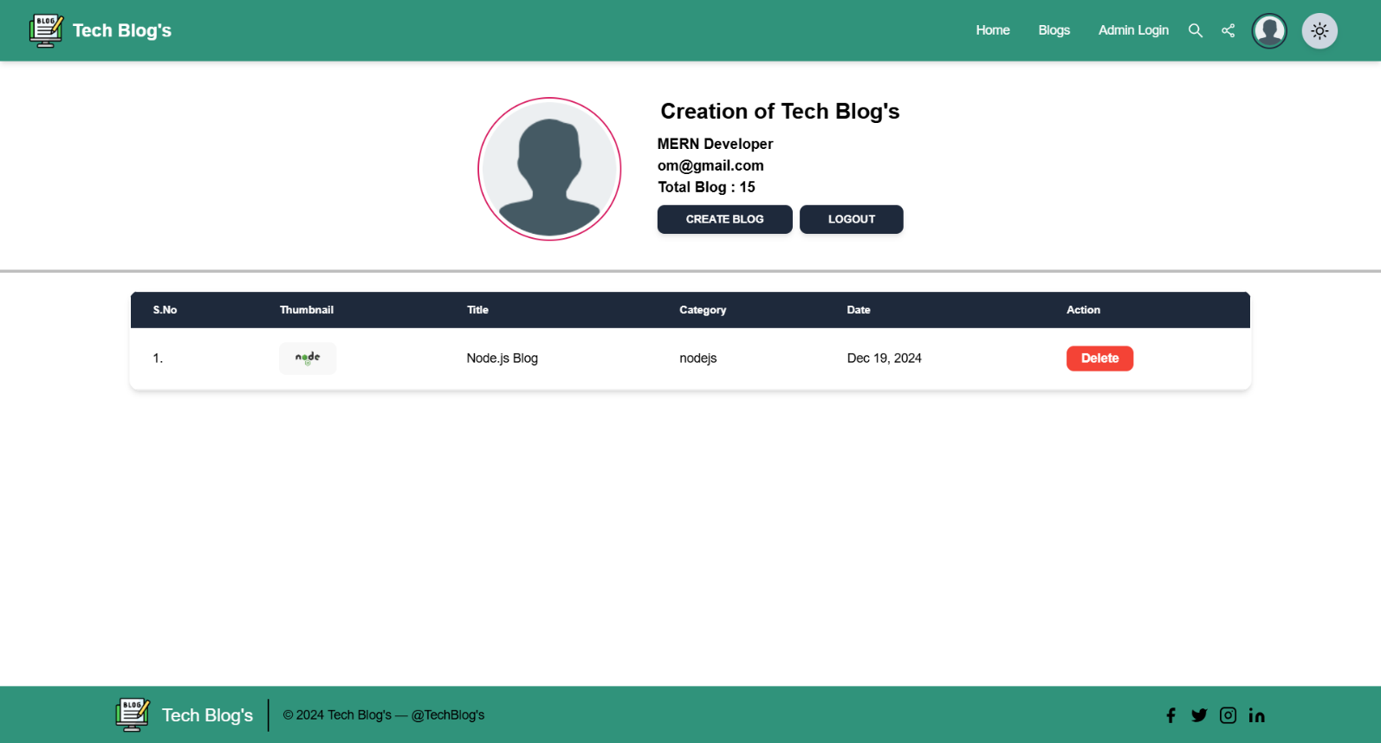

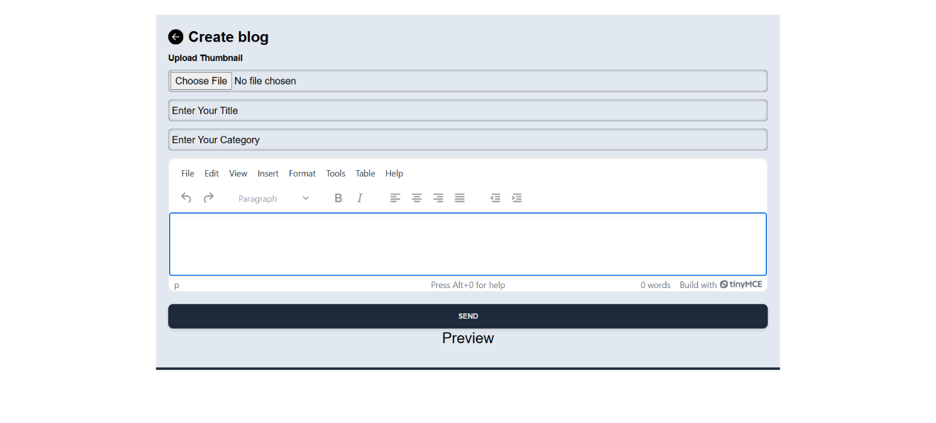

**Home Page:**

**Functionality:**

The home page serves as the main entry point for users, displaying featured blogs and a simple search bar. Users can search for blogs by title or category. The interface is intuitive, with easy access to login and registration options.

**Technologies Used:**

**-** Frontend: HTML, CSS, JavaScript

- Backend: React (for dynamic rendering and navigation)

- Middleware: Firebase Authentication (for user login and session management)

import React from 'react'

import Layout from '../../components/layout/Layout'

import HeroSection from '../../components/heroSection/HeroSection'

import BlogPostCard from '../../components/blogPostCard/BlogPostCard'

import Footer from '../../components/footer/Footer'

import Loader from '../../components/loader/Loder'

function Home() {

  return (

    <Layout>

      <HeroSection/>

      <BlogPostCard/>

    </Layout>

  )

}

export default Home

# Blog’s Page:

**Functionality:**

The page renders a list of blog posts in a responsive layout using React and CSS. Each post is displayed with its title, description, and relevant metadata. The grid system ensures that the content adapts seamlessly across devices, with a smooth, responsive layout. Users can easily navigate through different blog categories.

**Technologies Used:**

**-** Frontend: HTML, CSS, React, Bootstrap (for responsive layout)

- Backend: React (for dynamic content rendering)

- Localization**: Firebase Authentication (for secure user management)

import React, { useContext } from "react";

import myContext from "../../context/data/myContext";

import Layout from "../../components/layout/Layout";

function AllBlogs() {

  const context = useContext(myContext);

  const { mode } = context;

  return (

    <Layout>

      <section className="text-gray-600 body-font">

        <div className="container px-5 py-10 mx-auto max-w-7xl ">

          {/* Main Content  */}

          <div className="flex flex-wrap justify-center -m-4 mb-5">

            {/* Card 1  */}

            <div className="p-4 md:w-1/3">

              <div

                style={{

                  background:

                    mode === "dark" ? "rgb(30, 41, 59)" : "lightyellow",

                  borderBottom:

                    mode === "dark"

                      ? " 4px solid rgb(226, 232, 240)"

                      : " 4px solid rgb(30, 41, 59)",

                }}

                className={`h-full shadow-lg  hover:-translate-y-1 cursor-pointer hover:shadow-gray-400

               ${mode === "dark" ? "shadow-gray-700" : "shadow-xl"}

               rounded-xl overflow-hidden`}

              >

return (

    <Layout>

      <section className="text-gray-600 body-font">

        <div className="container px-5 py-10 mx-auto max-w-7xl ">

          {/* Main Content  */}

          <div className="flex flex-wrap justify-center -m-4 mb-5">

            {/* Card 1  */}

            <div className="p-4 md:w-1/3">

              <div

                style={{

                  background:

                    mode === "dark" ? "rgb(30, 41, 59)" : "lightyellow",

                  borderBottom:

                    mode === "dark"

                      ? " 4px solid rgb(226, 232, 240)"

                      : " 4px solid rgb(30, 41, 59)",

                }}

                className={`h-full shadow-lg  hover:-translate-y-1 cursor-pointer hover:shadow-gray-400

               ${mode === "dark" ? "shadow-gray-700" : "shadow-xl"}

               rounded-xl overflow-hidden`}

              >

                {/* Blog Thumbnail  */}

                <img

                  className=" w-full"

                  src={

                    "https://encrypted-tbn0.gstatic.com/images?q=tbn:ANd9GcTQ-sdRIvQxSBfArITwaURCNiCo1hu9Vf_uEQ&s"

                  }

                  alt="blog"

                />

 {/* Blog Description  */}

                  <p

                    className="leading-relaxed mb-3"

                    style={{

                      color:

                        mode === "dark"

                          ? "rgb(226, 232, 240)"

                          : " rgb(30, 41, 59)",

                    }}

                  >

                    Node.js is a fast, open-source, server-side runtime that uses JavaScript and Chrome's V8 engine. Its non-blocking, event-driven architecture excels in real-time and scalable applications. With npm's vast ecosystem, Node.js supports efficient development of APIs, microservices, and web apps, making it a top choice for modern, high-performance solutions.

                  </p>

                </div>

              </div>

            </div>

HeroSection: -

import { Typography } from '@material-tailwind/react'

import React, { useContext } from 'react'

import myContext from '../../context/data/myContext';

function HeroSection() {

    const context = useContext(myContext);

    const { mode } = context;

    return (

        <section

            style={{ background: mode === 'dark' ? 'rgb(39, 45, 59)' : '#30937b' }}>

            {/* Hero Section  */}

            <div className="container mx-auto flex px-5 py-24 items-center justify-center flex-col">

                {/* Main Content  */}

                <main>

                    <div className="text-center">

                        <div className="mb-2">

                            {/* Image  */}

                            <div className="flex justify-center">

                                <img src="https://cdn-icons-png.flaticon.com/128/3685/3685253.png" alt="" />

                            </div>

                            {/* Text  */}

                            <h1 className=' text-3xl text-white font-bold'>Tech Blog's</h1>

                        </div>

                        {/* Paragraph  */}

                        <p

                            style={{ color: mode === 'dark' ? 'white' : 'white' }}

                            className="sm:text-3xl text-xl font-extralight sm:mx-auto ">

                            Here are some blogs by Tech Blog's that you can read.

                        </p>

                    </div>

                </main>

            </div>

        </section>

    )

}

# Admin Page:

## Functionality:

## The admin dashboard allows the management of blog posts. Admins can simulate adding and removing blog posts. Currently, this is a frontend-only feature, with actual backend functionality planned for future development. The admin can also view a list of existing posts, edit post content, and manage blog categories. These features enable efficient content management, though they are currently placeholders for the full backend integration.

## Technologies Used:

Frontend: React, CSS, JavaScript

import React, { useContext, useState } from "react";

import {

    Card,

    CardHeader,

    CardBody,

    Input,

    Button,

    Typography,

} from "@material-tailwind/react";

import myContext from "../../../context/data/myContext";

import { useNavigate } from "react-router";

import toast from "react-hot-toast";

import { signInWithEmailAndPassword } from "firebase/auth";

import { auth } from "../../../firebase/FirebaseConfig";

export default function AdminLogin() {

    const context = useContext(myContext);

    const { mode } = context;

    const navigate = useNavigate();

    const [email, setEmail] = useState('');

    const [password, setPassword] = useState('');

**6. Challenges Faced:**

**Integration of Firebase Authentication and Admin Dashboard:**

1. Implemented Firebase Authentication for secure login functionality. This involved integrating Firebase’s authentication system with the React frontend to manage user login and registration securely. Although the project doesn't yet have full backend integration, the admin features simulate blog creation, deletion, and management. The admin dashboard customization was a challenging task, as it involved handling various state changes, form rendering, and UI component updates, which required more effort than initially expected.

**Customization of Admin Dashboard:**

1. The admin dashboard required substantial customization to fit the specific needs of blog management. Designing and rendering the forms and templates took more effort than anticipated, especially when working with dynamic data and state management in React. However, it provided a robust and user-friendly interface, giving the admin easy access to blog management features..

# 7. Future Enhancements:

**1. Integration of Firebase Authentication for User Login:**

Implemented Firebase Authentication for secure user login, ensuring personalized experiences for admins and future users. Although the backend functionality for user-related features is not yet fully integrated, Firebase enables secure access to the admin dashboard and other management features.

**2. Admin Dashboard with Customization:**

The admin dashboard was customized to allow easy management of blog posts. This involved creating a user-friendly interface for blog creation, editing, and deletion. The process was more complex than anticipated due to the need for dynamic data handling, state management in React, and real-time updates, but it resulted in an efficient content management system.

**3. Blog Post Creation & Management Features:**

Simulated the functionality for blog post creation, deletion, and management from the admin dashboard. This enables a streamlined approach for admins to manage content, with future plans for backend integration to handle these actions more dynamically. While the features are currently only frontend-based, they lay the foundation for future expansion.

**4. Email Verification & Notifications:**

While the email verification and activation features are part of the planned backend functionality, the integration of email notifications using Firebase (for user login and admin interactions) is also a key aspect. This functionality will be expanded to include order confirmations and other communication features in future updates.

# Conclusion:

The Blog Website project successfully delivers an engaging and intuitive experience for users, leveraging the React framework and Firebase authentication. Its modular design, integration of frontend technologies, and focus on user interaction make it a valuable platform for managing and interacting with blog content. The dynamic features, such as admin login, blog management, and future backend integrations, provide a strong foundation for a fully interactive content management system.

# References:

1. React Documentation: [https://docs.react.com/en/5.0/]
2. Bootstrap Documentation: [https://getbootstrap.com/docs/4.1/getting- started/introduction/