DEPARTMENT OF COMPUTER ENGINEERING
Academic Year 2026-27
Name of the Course: Database Management System (DBMS)
DBMS MICRO PROJECT REPORT

Amazon Style Store Database
Relational database, online orders, and role based access

Submitted by: ____________________________________
Roll number: _____________________________________
Division / class: __________________________________
Submitted to: ____________________________________
Project scope: a classroom prototype using fictional store data

INDEX
No. | Section | Report pages
1 | Introduction and Background | 3-4
2 | Problem Statement | 5-6
3 | Objectives and Scope | 7-8
4 | Requirements and Data Requirements | 9-12
5 | ER Diagram | 13-16
6 | Flow Diagram and System Architecture | 17-19
7 | Implementation and Database Operations | 20-23
8 | Results and Working System Screenshots | 24-25
9 | Conclusion and Future Scope | 26
 | References | 27
10 | Appendices | 27-28

This report describes an educational online retail database implemented in two forms: a local SQLite prototype and a connected Supabase PostgreSQL demonstration. It explains the entities and relationships, SQL operations, and user permissions. The deployed Supabase version uses Auth, Row Level Security, and database functions to enforce role-based access.
Page numbers refer to the report pages after this index. Replace the cover page blanks with the student and course details before submission. Insert screenshots captured from the running application in Section 8 if the instructor requires original screen captures.

1. Introduction and Background

1.1 Introduction
An online retail service must organize a large set of related facts. It stores products and categories, customer accounts, orders, the items included in each order, and inventory quantities. A database provides a structured way to store these facts, connect them through keys, and retrieve the right information when a customer browses or a staff member checks stock.
This micro project builds a small Amazon-style storefront for learning database management concepts. The word “Amazon-style” describes the familiar online shopping workflow only. The project does not connect to Amazon, copy its internal systems, or use real customer or payment information. All names, accounts, products, and prices in the demonstration are fictional.
The prototype is centered on PostgreSQL and Supabase as a practical cloud path, while its ready-to-run demonstration uses SQLite and Python. SQLite is a relational database engine that stores data in a local database file. It lets a student run the interface and SQL examples without cloud credentials. The included Supabase schema uses PostgreSQL tables and Row Level Security policies to demonstrate database-enforced access control.

1.2 Background
A relational database represents information in tables. A row represents one instance of an entity, and a column represents one attribute. A primary key identifies a row. A foreign key links one table to another. For example, a product row stores its category_id as a foreign key, while an order row stores the customer_id of the person who placed it. These relationships reduce repeated data and make joined queries possible.
An online order is naturally represented by an orders table and an order_items table. The order identifies the customer and overall status. Each order item records a product, quantity, and unit price captured at the time of purchase. Keeping line items separate allows an order to contain multiple products without repeating order-level information in every row.

1. Introduction and Background (continued)

1.3 Why this project matters
The project connects database theory to a familiar activity. When a customer places an order, the system must verify that the product exists and has sufficient stock, create an order and its detail rows, and reduce the available quantity. Those changes belong together in a transaction: if any step fails, the database should not leave a half-created order or an incorrect stock balance.
The prototype also shows that access control is part of database design. A customer should view their own orders, an inventory worker should update stock, and an administrator should maintain the product catalogue. Hiding buttons in a user interface is not sufficient protection. The server and, for the Supabase version, the database policies must check the user’s role before allowing the operation.

1.4 Project summary
Element | Description
Application | A small responsive storefront with catalogue search, demo sign-in, order history, and staff controls.
Local database | SQLite database file initialized and seeded by the Python application.
Cloud database path | PostgreSQL schema for Supabase with Auth-linked profiles and RLS policies.
Core entities | Profiles, categories, products, orders, and order items.
Demonstrated DBMS ideas | Primary and foreign keys, constraints, indexes, views, joins, aggregation, transactions, and authorization.
Data safety | Fictional records only; no real payment processing or personal data.

A successful demonstration should make the data visible in both the interface and SQL results. The student can show the product catalogue, place an order as a customer, query the order and its line items, and then show that an inventory account can update stock while the customer account cannot.

2. Problem Statement

2.1 Existing problem
A small online store must keep product information, stock, customer orders, and order details consistent. If these facts are kept in separate files or duplicated manually, the same information may be entered more than once. The product name could differ between a catalogue and an order record, inventory may not be reduced after a purchase, and staff may not know which order belongs to which customer.
The store also has different kinds of users. A customer needs to browse products and see their own orders. Inventory staff need to correct stock quantities. An administrator needs wider catalogue maintenance access. If every user can update every table, mistakes or unauthorized changes can affect the whole system. If the system only hides interface controls without checking requests on the server, a user can attempt to call the underlying operation directly.

2.2 Problem statement
The problem addressed by this project is to design and implement a small relational database system for an online store that stores catalogue, inventory, customer, and order information accurately; supports common retrieval and reporting queries; and restricts actions according to user role.

2.3 Proposed solution
The project uses normalized tables connected by primary and foreign keys. The local SQLite app demonstrates the shopping workflow through a Python server, including transactions for order creation and stock reduction. In the Supabase version, the browser calls PostgreSQL through Supabase Auth and the Data API; RLS policies and database functions enforce cloud permissions.
The deployed Supabase schema links profiles to Supabase Auth users and enables Row Level Security on all five public tables. Customers, inventory staff, analysts, and administrators have different database permissions. This is the version used to demonstrate database-enforced access; the local SQLite comparison performs role checks in Python.

2.4 Expected outcome
- A working product catalogue with fictional sample records.
- A customer checkout flow that writes order and order-item rows and reduces stock.
- Separate customer, inventory, and administrator capabilities.
- SQL examples demonstrating joins, filtering, aggregation, and stock reports.
- A report and architecture that explain how the data is stored and used.

3. Objectives and Scope

3.1 Objectives
The main objective is to develop a compact database-backed online retail prototype that demonstrates how a DBMS supports a real-life shopping workflow. The project aims to:
- Identify the main entities involved in product browsing and order processing.
- Design relational tables with primary keys, foreign keys, appropriate data types, and integrity constraints.
- Insert fictional sample data and execute useful SELECT, JOIN, UPDATE, and aggregate queries.
- Create a basic user interface connected to the database through a server API.
- Apply role-based permissions so customers, inventory staff, and administrators have different access.
- Show how a transaction keeps order creation and stock updates consistent.
- Prepare a PostgreSQL/Supabase schema that uses authentication and Row Level Security.
- Document results, limitations, and sensible future improvements.

3.2 Included scope
The included application supports catalogue browsing and text search, four seeded demo roles, customer order placement, customer order history, staff stock updates, read-only analyst access to order records, administrator product creation, and an order list visible to staff. The data model includes categories, profiles, products, orders, and order items. Prices are stored as integer paise to avoid floating point rounding.

3.3 Excluded scope
This is a learning prototype. It does not connect to Amazon services, process card payments, calculate tax or delivery, handle returns, send messages, or provide production-grade account recovery. It does not implement a warehouse network, marketplace sellers, product reviews, or real customer privacy workflows. Supabase setup requires a project controlled by the student and is not provisioned by this package.

3.4 Assumptions
The local demo runs on one computer using Python 3.10 or later and a modern browser. Demo data is fictional. The local SQLite version checks roles in Python; SQLite does not provide per-user Row Level Security. The Supabase page connects to PostgreSQL, where Auth users, RLS policies, and database functions enforce roles.

4. Requirements and Data Requirements

4.1 Functional requirements
ID | Requirement | Acceptance evidence
FR-01 | Display active products with category, description, price, and stock. | Catalogue cards and product query.
FR-02 | Search products by name, category, or description. | Search field filters the displayed products.
FR-03 | Allow a customer to sign in and place an order. | Order and order-item rows appear in the database.
FR-04 | Reduce stock for all products in an order. | Stock quantity is lower after successful order.
FR-05 | Let customers view only their own order history. | Customer API query filters by customer ID.
FR-06 | Let inventory staff update product stock. | Staff stock control persists a database update.
FR-07 | Let administrators add products and view all orders. | Admin product form inserts a product row.
FR-08 | Reject invalid quantities and unauthorized operations. | Server returns an error for invalid requests or roles.

4.2 Non-functional requirements
- Usability: clear labels, visible roles, readable products, and a responsive layout.
- Integrity: foreign keys and CHECK constraints prevent invalid relationships and negative prices or stock.
- Security: the local app checks roles in Python; the Supabase page relies on PostgreSQL grants, RLS, and role-checked functions. It uses no service-role key in the browser.
- Portability: local application uses Python standard-library modules and SQLite.
- Maintainability: schema, UI assets, queries, and deployment SQL are stored in separate files.

4. Requirements and Data Requirements (continued)

4.3 Data dictionary
Entity | Important attributes | Purpose
profiles | Supabase: id, full_name, role, created_at; email is in auth.users. Local SQLite: email and password_hash are stored in its profiles table. | Demo identity and permission role; in Supabase the ID refers to auth.users.
categories | id, name, description | Groups products for browsing and reports.
products | id, category_id, name, price_paise, stock_quantity, is_active | Catalogue item and current inventory quantity.
orders | id, customer_id, status, total_paise, created_at | Customer purchase header and current status.
order_items | id, order_id, product_id, quantity, unit_price_paise | Products purchased and the unit price captured for the order.

4.4 Integrity rules
Each table has a primary key. Email and category name are unique. Product category_id refers to a category. An order customer_id refers to a profile, and each order item refers to an order and a product. Product prices, stock quantities, and order totals cannot be negative; item quantity must be greater than zero. The pair (order_id, product_id) is unique in the demonstration so the same product appears once per order with a combined quantity.
Prices are stored in integer paise. For example, ₹2,499.00 is stored as 249900. This avoids storing a decimal currency amount as binary floating point. The user interface formats paise as Indian rupees for display. Order items retain the price at the time of purchase, so a later catalogue price change does not rewrite an earlier order.

4.5 Derived data and indexes
The order total is calculated from the selected products and quantities when the order is placed. The line total in reports is quantity multiplied by unit_price_paise. Indexes support category lookups, customer order history sorted by creation time, and retrieval of line items by order. The product_catalogue view joins products and categories and hides inactive products from the public catalogue.

4. Requirements and Data Requirements (continued)

4.6 Database user types
User type | How the user accesses data | Project example
Naive or parametric user | Uses fixed forms and buttons; does not write SQL. | Customer browses and checks out; inventory staff updates stock.
Sophisticated user | Understands the data model and runs ad hoc read-only queries. | Analyst uses run_sql.py and the supplied SQL reports.
Store administrator | Uses catalogue screens for business data maintenance. | Adds products; does not administer database schema or security.
Database administrator | Manages schema, roles, policies, backups, and database settings. | Project owner uses the Supabase dashboard or local database tools.
Application programmer | Builds the forms and code that send authorized requests. | Maintains the Python API and browser interface.

These are different responsibilities. The store administrator works with catalogue data. The database administrator manages schema, roles, policies, backups, and settings through trusted database tools. The project application demonstrates the customer, inventory, analyst, and store administrator roles; the Supabase SQL Editor is an administrative tool, not a normal app-user session.

5. ER Diagram

5.1 Entity relationship overview
The ER design contains five main entities. A category classifies many products. A customer profile can place many orders. Each order contains one or more order items. Each order item refers to one product. This is a normalized structure: order-level facts are kept in orders, while product quantities and purchase-time prices are stored in order_items.
Figure 1. Supabase schema overview inspected in the live project
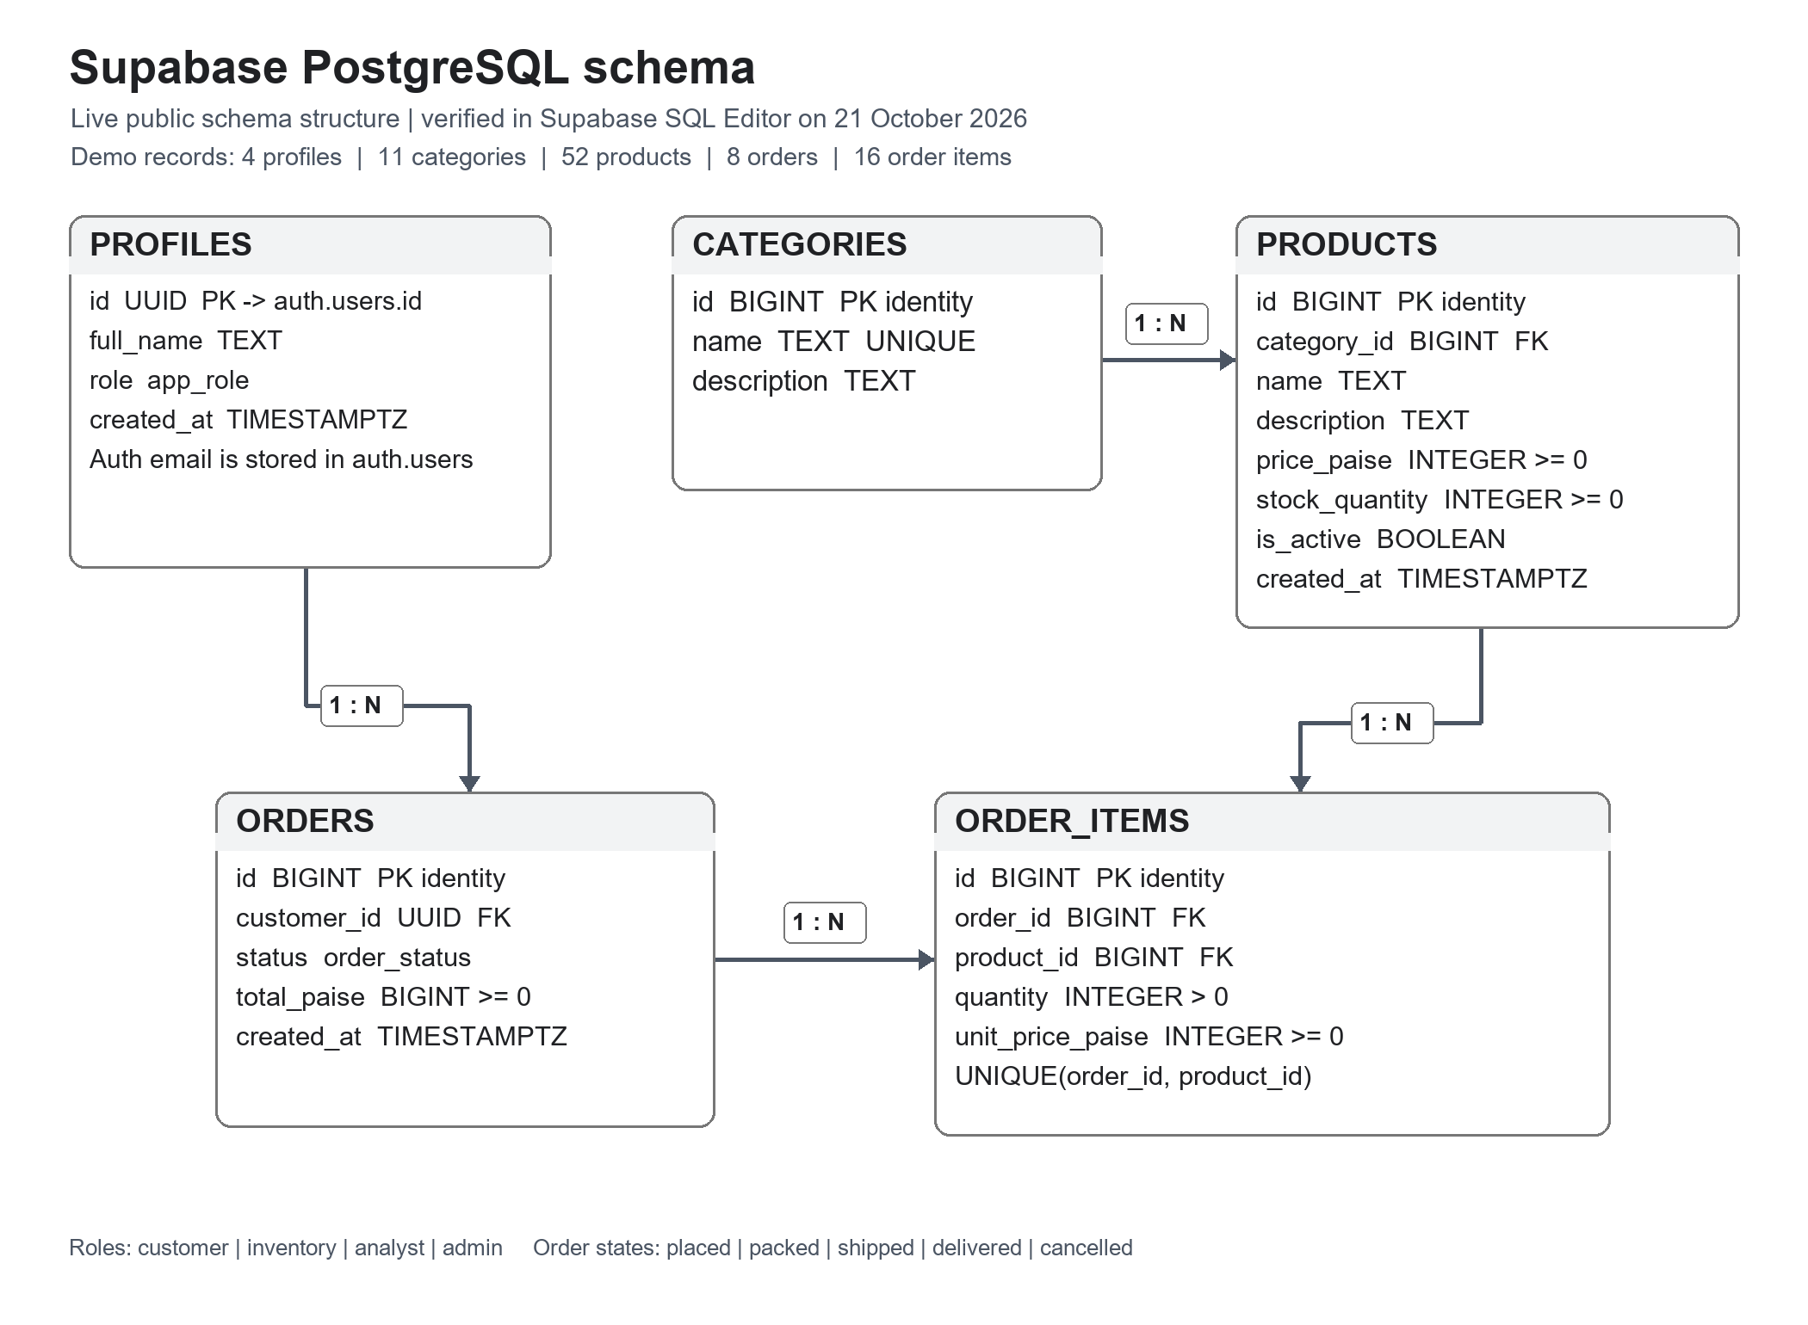
Entity A | Relationship | Entity B | Meaning
CATEGORIES | 1 to many | PRODUCTS | One category can contain many products; each product belongs to one category.
PROFILES | 1 to many | ORDERS | One customer can place many orders; each order has one customer.
ORDERS | 1 to many | ORDER_ITEMS | One order has multiple line items; each line item belongs to one order.
PRODUCTS | 1 to many | ORDER_ITEMS | A product can appear in many order lines over time; each line refers to one product.

5.2 ER structure
Figure 2. Entity relationship diagram
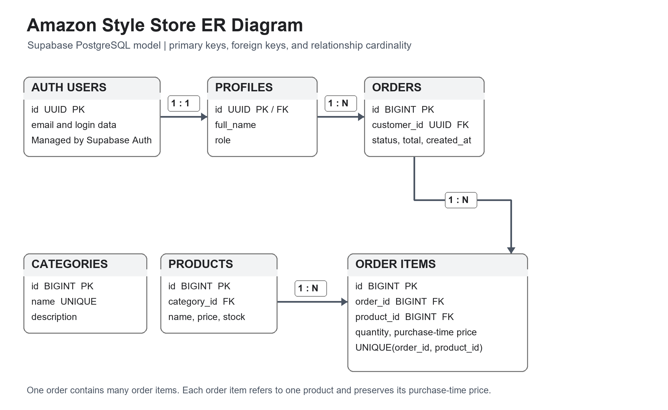
Entity | Primary key | Foreign key | Selected attributes
PROFILES | id | id references auth.users(id) | full_name, role, created_at; email is managed by Supabase Auth
CATEGORIES | id | None | name, description
PRODUCTS | id | category_id → CATEGORIES.id | name, description, price_paise, stock_quantity, is_active
ORDERS | id | customer_id → PROFILES.id | status, total_paise, created_at
ORDER_ITEMS | id | order_id → ORDERS.id; product_id → PRODUCTS.id | quantity, unit_price_paise

5. ER Diagram (continued)

5.3 Relational schema notation
PROFILES(id PK/FK -> auth.users.id, full_name, role, created_at)
CATEGORIES(id PK, name UNIQUE, description)
PRODUCTS(id PK, category_id FK, name, description, price_paise, stock_quantity, is_active, created_at)
ORDERS(id PK, customer_id FK -> PROFILES.id, status, total_paise, created_at)
ORDER_ITEMS(id PK, order_id FK -> ORDERS.id, product_id FK -> PRODUCTS.id, quantity, unit_price_paise)
The primary key (PK) uniquely identifies a row. In Supabase, profiles.id is also a foreign key to auth.users.id; Supabase Auth stores login email and credentials separately. The unique category name prevents duplicate categories, and the order-item unique constraint allows one consolidated line per product in an order. The local SQLite demo stores email and a password hash in its own profiles table.

5.4 Normalization
The design follows the core ideas of first, second, and third normal form for this project’s data. Each table stores one kind of entity. Columns hold single values rather than lists. Non-key product attributes depend on the product key, while category details are stored in categories rather than copied into every product. Customer details are stored once in profiles rather than repeated in each order. Order-item quantities belong to the relationship between an order and a product.
The order item stores unit_price_paise even though the current product price is also available in products. This is an intentional historical snapshot: the price charged for an earlier order must remain stable even if the catalogue price changes. This value describes the purchase event and is not a duplicate current catalogue value.

5.5 Cardinality examples
If a category has five products, one categories row is referenced by five products rows. If a customer places three orders, the profile row is referenced by three orders rows. If an order contains a lamp and a bottle, it has two order_items rows, each referencing a product. These relationships support joined reports without duplicating product names or customer details in the order header.

6. Flow Diagram and System Architecture

6.1 System components
Layer | Component | Responsibility
Presentation | Browser UI (HTML, CSS, JavaScript) | Displays catalogue, login choices, cart/order controls, and staff forms.
Application | Python HTTP server and JSON API | Authenticates demo users, checks roles, validates inputs, and runs transactions.
Database | SQLite local file | Persists profiles, categories, products, orders, and line items.
Cloud alternative | Supabase Auth and PostgreSQL | Provides managed authentication and database-level Row Level Security.

6.2 Request flow
The browser first requests the active product catalogue. When a user selects a demo account, the browser sends the email and password to the login endpoint. The server checks the salted password hash and sets an HttpOnly session cookie. Subsequent requests include this cookie. The server looks up the corresponding account and role before it performs a protected action.
For order placement, the customer sends product IDs and quantities. The server validates that the signed-in role is customer, checks that each product is active and has enough stock, and then performs the order insert, order-item inserts, and stock reductions within one database transaction. The database commits all operations together. The response includes the new order ID and total.
Figure 3. High level request flow
Step | Flow
1 | Customer / staff → browser interface
2 | Browser → Python API request with session cookie
3 | API → role and input validation
4 | API → SQLite query or transaction
5 | SQLite → API response
6 | API → browser updates catalogue and order view

6. Flow Diagram and System Architecture (continued)

6.3 Cloud architecture with Supabase
The deployed Supabase schema maps the local model to PostgreSQL. Supabase Auth manages sign-in identities and email addresses. Each identity has a profiles row whose id references auth.users(id) and whose role controls application permissions. The five public tables are profiles, categories, products, orders, and order_items. Row Level Security is enabled on each table; policies apply to the signed-in user, while role-checked PostgreSQL functions perform order placement, stock changes, and administrator product creation.
Actor | Allowed operations in project model
Guest | Read active catalogue and category names.
Customer | Read active catalogue; read own profile and orders; create own order.
Inventory staff | Read catalogue and all orders; update product stock.
Analyst | Read catalogue and order records; no write actions.
Store administrator | Add products and perform catalogue maintenance in the interface.
Database administrator | Manage schema, roles, policies, and database settings in trusted tools.

6.4 Security boundary
SQLite does not provide separate database logins for this local demo, so the Python API checks the application roles. In Supabase, signed-in requests use the user JWT and PostgreSQL checks grants, RLS policies, and function role checks. The browser contains only the project URL and publishable key; it never contains a service-role key or database password.
The role column is sensitive authorization data. Users should not be allowed to change their own role. In Supabase, an administrator or trusted setup process creates the profile with its role. In a real deployment, role assignment should be handled only through a protected administrative process.

6.5 Limitations of the prototype
The local demo keeps sessions in memory and signs them out when the server restarts. It is intended for a single-computer classroom demonstration, not public deployment. The Supabase schema includes database functions for order placement, stock updates, and administrator product creation. Before production use, the policies and functions would still need careful role-by-role validation and operational controls for account management, monitoring, and backups.

7. Implementation and Database Operations

7.1 Tools and files
The local web application uses Python’s built-in HTTP server and sqlite3 module, so it has no third-party Python package requirement. The user interface is built with HTML, CSS, and JavaScript. The files are arranged so the application, local schema, SQL query examples, and Supabase deployment schema can be read independently.
File | Purpose
app.py | Initializes the SQLite database, serves static files and API routes, handles login, order transactions, and role checks.
sql/schema.sql | Creates local tables, constraints, indexes, and product_catalogue view.
sql/queries.sql | Examples for catalogue search, joins, sales summaries, and low-stock reporting.
supabase/schema.sql, demo_data.sql | PostgreSQL schema, RLS policies, role-checked functions, and expanded sample data.
static/index.html, app.js, cloud.html, cloud.js, styles.css | Storefront pages, client requests, styling, and role-specific controls.
run_sql.py | Interactive prompt to execute SQL directly against the local database.

7.2 Local startup
python app.py
Open http://127.0.0.1:8000

python run_sql.py
SQL> SELECT id, name, stock_quantity FROM products;
On first run, app.py creates amazon_store.db, executes the local schema, inserts four demo accounts, and seeds categories and products. The sample accounts are listed in the project README. The browser can use the customer account to place a fictional order, the inventory account to change stock, the analyst account to inspect orders, and the administrator account to add a product.

7. Implementation and Database Operations (continued)

7.3 Table creation and constraints
The schema uses integer primary keys for the local SQLite version and generated identity keys for PostgreSQL. Foreign key constraints connect the tables. CHECK constraints ensure a non-negative price, stock quantity, and order total and a positive item quantity. The product catalogue view joins products to categories and filters inactive products.
CREATE TABLE products (
id INTEGER PRIMARY KEY,
category_id INTEGER NOT NULL REFERENCES categories(id),
name TEXT NOT NULL,
price_paise INTEGER NOT NULL CHECK (price_paise >= 0),
stock_quantity INTEGER NOT NULL CHECK (stock_quantity >= 0),
is_active INTEGER NOT NULL DEFAULT 1
);

7.4 CRUD operations
Operation | Example | Use
Create | INSERT INTO categories(name) VALUES ('Accessories'); | Add a category.
Read | SELECT name, price_paise FROM products WHERE is_active = 1; | Display active catalogue items.
Update | UPDATE products SET stock_quantity = 20 WHERE id = 1; | Correct an inventory count.
Delete | DELETE FROM categories WHERE id = 999; | Remove a disposable category with no dependent products.

The user interface uses parameterized database statements for values. This separates user input from SQL syntax. The interactive prompt is included for teaching and should be used carefully because it intentionally provides direct database access.

7.5 Transactional order operation
Order placement first validates the complete cart. It then inserts an orders row, inserts one order_items row per product, and subtracts ordered quantities from product stock inside a single transaction. If any product is unavailable or quantity is invalid, the operation is rejected and the database transaction does not leave a partial order.

7. Implementation and Database Operations (continued)

7.6 Example join and aggregate query
SELECT o.id AS order_id, p.full_name AS customer,
pr.name AS product, oi.quantity,
oi.unit_price_paise / 100.0 AS unit_price_rupees
FROM orders o
JOIN profiles p ON p.id = o.customer_id
JOIN order_items oi ON oi.order_id = o.id
JOIN products pr ON pr.id = oi.product_id
ORDER BY o.id;
This query combines the order header, customer profile, order line, and product tables. It demonstrates how foreign keys let the database reconstruct a useful order view while keeping the stored records normalized.

7.7 Low stock and category sales
SELECT name, stock_quantity
FROM products
WHERE is_active = 1 AND stock_quantity < 10
ORDER BY stock_quantity;

SELECT c.name AS category,
SUM(oi.quantity * oi.unit_price_paise) / 100.0 AS sales_rupees
FROM order_items oi
JOIN products p ON p.id = oi.product_id
JOIN categories c ON c.id = p.category_id
JOIN orders o ON o.id = oi.order_id
WHERE o.status <> 'cancelled'
GROUP BY c.name ORDER BY sales_rupees DESC;

7.8 Supabase deployment outline
The live Supabase project has 4 profiles, 11 categories, 52 products, 8 orders, and 16 order_items. All five public tables have Row Level Security enabled. For a fresh setup, run supabase/schema.sql once in the SQL Editor, create Supabase Auth users and matching profile rows with roles, then run supabase/demo_data.sql. Open /static/cloud.html, enter the project URL and publishable key, and sign in. The app calls place_order, update_stock, and admin_add_product; PostgreSQL policies and function checks enforce access.
Supabase combines PostgreSQL with Auth and Row Level Security. Policies decide which rows an authenticated request may access, while grants determine which operations the database role may perform. A safe design requires both layers to match the application’s intended behavior.

8. Results and Working System Screenshots

8.1 Demonstration results
The local and cloud demo catalogues contain 52 fictional products across 11 categories, including electronics, computers, home, kitchen, books, sports, beauty, toys, office, fashion, and grocery. The live Supabase database currently contains 4 profiles, 11 categories, 52 products, 8 sample orders, and 16 order-item rows. Supabase RLS is enabled on profiles, categories, products, orders, and order_items.
Demonstration | Expected database effect
Sign in as customer and place an order. | One row in orders; one or more rows in order_items; product stock decreases.
Open the customer order history. | The customer sees only orders whose customer_id matches their profile.
Sign in as inventory staff and edit stock. | The product stock_quantity field is updated.
Try a staff action as a customer. | The API rejects the request because the role is not authorized.
Sign in as administrator and add a product. | A category is found or created and a new products row is inserted.
Run the SQL join query. | The result combines customer, order, line item, and product data.

8.2 Screenshot checklist
The two schema figures below are generated from the deployed Supabase table definitions inspected in the dashboard. Capture screenshots from the running application for the final classroom submission if your instructor also requires interface evidence. Never include credentials or private Auth details in screenshots.
- Figure 4: product catalogue before sign-in.
- Figure 5: signed-in customer with a placed order and order history.
- Figure 6: inventory staff editing stock quantity.
- Figure 7: administrator adding a product.
- Figure 8: SQL query output showing order details or a low-stock report.
Add each screenshot below its caption in this section, or append a screenshot page for each required result. Do not include real passwords, personal customer details, or actual payment information in screenshots.

8. Results and Working System Screenshots (continued)

8.3 Sample query result format
After creating a sample order from the customer account, run the order-detail join query. The expected columns are shown below. Values will depend on the products selected during the local demonstration.
order_id | customer | product | quantity | unit_price_rupees
1 | Maya Customer | Wireless Headphones | 1 | 2499.00
1 | Maya Customer | Insulated Bottle | 1 | 699.00

Figure 9. Illustrative SQL result layout; run the query for actual data.

8.4 Role verification
Use separate Supabase Auth accounts to demonstrate database-enforced roles. Customers place orders and read only their own history; inventory staff update stock; analysts read permitted order data; and administrators add products. These actions are checked inside PostgreSQL through RLS policies and role-checked functions. The local SQLite page provides a comparison, with role checks in Python. A database administrator manages schema, roles, and security through trusted tools.

8.5 Evaluation
The project demonstrates relational tables, keys, constraints, indexes, views, joins, aggregation, and order transactions. The local version runs with Python and SQLite. For database-enforced role demonstrations, the Supabase page sends requests to hosted PostgreSQL, where RLS policies and checked functions control access.
For final evidence, the student should run the application, execute the included queries, and capture the actual result screens. This makes the screenshots reflect the final database state and allows the student to explain each result during evaluation.

9. Conclusion and Future Scope

9.1 Conclusion
This micro project demonstrates how a relational database can support the main workflow of an online store. The design separates profiles, categories, products, order headers, and order lines, then links them using primary and foreign keys. Constraints protect important values, indexes support common retrieval patterns, and SQL joins and aggregate queries answer questions about orders, products, and sales.
The local interface makes database operations visible, and its Python server checks roles before protected actions. The Supabase page connects to PostgreSQL and uses Auth, RLS, and database functions to enforce roles inside the database. Together, the two versions show a simple local prototype and a cloud design suited to demonstrating database-side authorization.
The project is intentionally limited to fictional classroom data. It is not Amazon’s actual database and is not a production commerce system. Its value is as a clear, hands-on demonstration of DBMS concepts and a starting point for further development.

9.2 Future scope
- Add address and delivery tables and model shipment tracking.
- Add product reviews with one-review-per-customer constraints.
- Add product images through Supabase Storage with suitable access policies.
- Add order status updates and a cancellation workflow that restores stock safely.
- Add automated database policy checks for both permitted and denied role actions.
- Add pagination and indexes for a larger catalogue.
- Improve session expiry, password recovery, audit logging, and production deployment security.

References
The following official documentation informed the database and Supabase implementation choices:
- Supabase. “Database.” https://supabase.com/docs/guides/database/overview (accessed 21 October 2026).
- Supabase. “Row Level Security.” https://supabase.com/docs/guides/database/postgres/row-level-security (accessed 21 October 2026).
- Supabase. “Auth.” https://supabase.com/docs/guides/auth (accessed 21 October 2026).
- Supabase. “JavaScript Client Library.” https://supabase.com/docs/reference/javascript/installing (accessed 21 October 2026).
- Supabase. “Use Supabase with Next.js.” https://supabase.com/docs/guides/getting-started/quickstarts/nextjs (accessed 21 October 2026).
- Python Software Foundation. “sqlite3 — DB-API 2.0 interface for SQLite databases.” https://docs.python.org/3/library/sqlite3.html (accessed 21 October 2026).
- SQLite. “SQLite Documentation.” https://www.sqlite.org/docs.html (accessed 21 October 2026).

Appendix A. Demo accounts
Role | Email | Demo password
Customer | maya@example.test | customer123
Inventory staff | ivan@example.test | stock123
Analyst | sam@example.test | analytics123
Administrator | admin@example.test | admin123

These credentials are intentionally simple and exist only in the fictional local demo database. Do not reuse real passwords or publish a real credential in a report.

Appendix B. Project package
The accompanying project ZIP contains the Python application, UI files, SQLite schema, example queries, Supabase PostgreSQL schema, and this report. See README.md in the extracted folder for startup and Supabase setup instructions.

