Enterprise Student Record and Academic Management Platform
Unit 1: Product Engineering & Design Thinking
Careertiq Training & Engineering Division

1. Introduction to Software Product Development
In modern organizations, software products are built using structured engineering frameworks rather than ad-hoc programming. Coding is merely one execution phase within a larger engineering lifecycle that spans research, architecture, user experience design, quality assurance, automated deployment, and continuous monitoring.
1.1 Comparative Analysis: Programming vs. Software Engineering
Dimension | Programming / Coding | Software Product Engineering
Primary Goal | Translating logic/algorithms into executable code syntax. | Building scalable, maintainable, and valuable systems for end users.
Scope | Isolated functions, micro-tasks, or single scripts. | Full lifecycle (SDLC), architecture, CI/CD, database schemas, security.
Success Metric | Code compiles and passes basic test inputs. | User adoption, high availability, performance metrics, business outcome.
Mindset | Technology-Centric ("How do I write this function?"). | Product-Centric ("What core problem are we solving for our users?").
1.2 Root Causes of Software Project Failures
Software projects rarely fail due to bad syntax. Major failure vectors include:
- Misaligned Requirements: Building features that users do not need or want.
- Technology-Centric Bias: Choosing technologies based on industry hype rather than suitability for business domain problems.
- Communication Silos: Separation between business analysts, software developers, and DevOps infrastructure teams.
- Lack of Iterative Feedback: Delaying user testing until late development stages, making pivot costs prohibitively high.
System Development Lifecycle (SDLC) Workflow Diagram
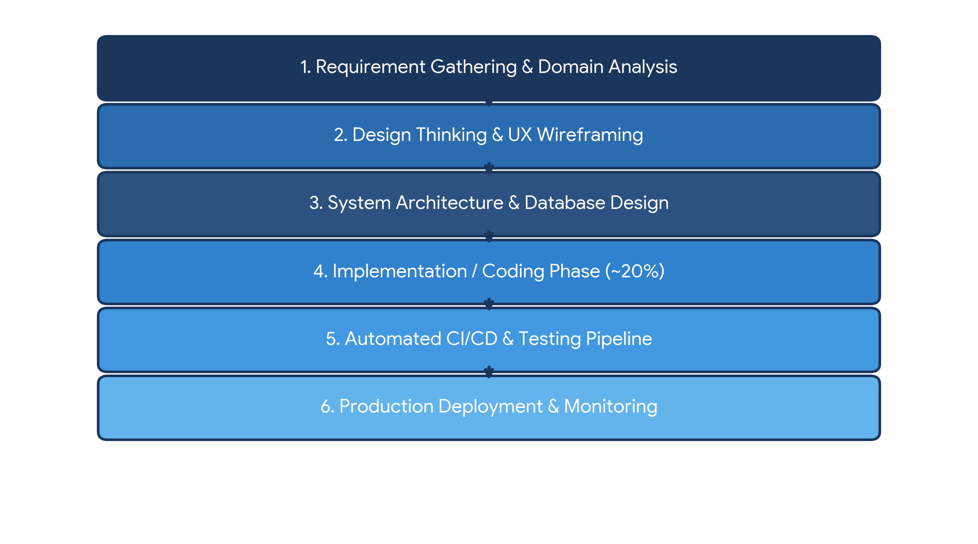
2. Business Understanding: Higher Education & Academic Operations
Before writing code or provisioning infrastructure, engineers must master the business operations of the target environment.
2.1 Core Operations in Academic Institutions
- Student Onboarding & Profile Management: Enrolling students, capturing permanent registration numbers (PRN), establishing degree paths, and managing demographic data.
- Course Enrollment & Curriculum Mapping: Allocating course electives, managing semester course offerings, and assigning faculty subject tracks.
- Attendance Tracking Workflow: Recording daily lecture logs, calculating attendance percentages, generating threshold warnings, and logging leave requests.
- Examination & Grading Operations: Conducting continuous assessments, processing end-semester marks, calculating GPA/CGPA rubrics, and executing revaluation workflows.
- Administrative & Compliance Reporting: Generating consolidated grade sheets, transcript verification, audit logs, and institutional accreditation reports.
2.2 Manual Process Challenges vs. Automated Software Solutions
Manual Operational Bottleneck | Automated Platform Solution | Business Outcome Metric
Physical paper ledgers for daily lecture attendance | Mobile and web-based continuous attendance logging | Attendance tracking time reduced from 15 min/class to <1 minute
Manual calculation of semester GPA/CGPA grades | Engine-driven grading pipeline with configurable rubrics | Result generation speed improved by 90%
Physical mark sheet distribution and transcript tracking | Centralized student self-service portal for real-time grade publishing | Operational transcript issuance delays reduced by 70%
Siloed records leading to lost student files & reporting errors | Relational database with strict integrity and audit constraints | Academic record accuracy brought to 99.9%
3. Introduction to Design Thinking
Design Thinking is an iterative, human-centered problem-solving framework that prioritizes deep empathy for users before evaluating technological constraints.

4. Applying the Five Stages of Design Thinking
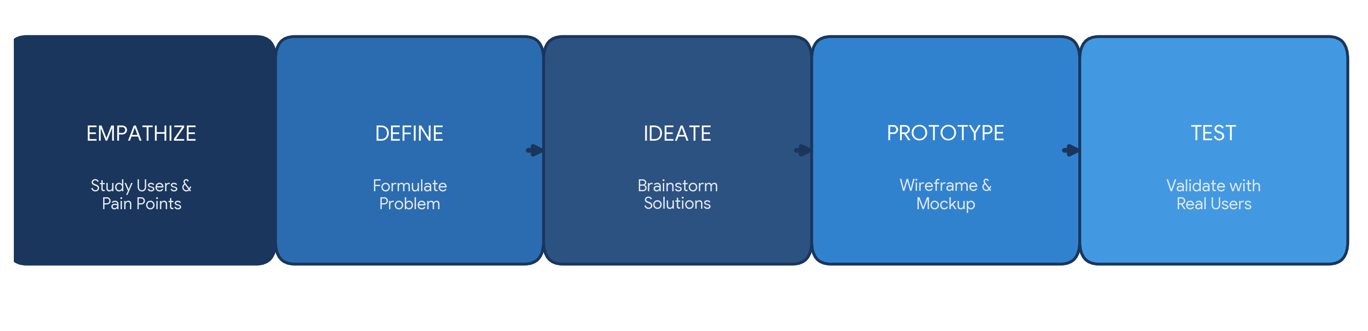
Stage 1: Empathize
Engineers and designers observe users in their daily academic workflows. Key user categories analyzed include: Students, Faculty Members, Academic Administrators, Examination Cell Staff, and IT Personnel.
Stage 2: Define
Data collected during empathy building is organized into a definitive core problem statement:
CORE PROBLEM STATEMENT:
"Students and administrative personnel experience severe operational delays in handling course enrollments, attendance tracking, mark publishing, and official transcript validation due to fragmented manual record handling. Concurrently, faculty and examination cell staff lack real-time centralized visibility, leading to high error rates, compliance risks, and administrative friction."
Stage 3: Ideate
Unconstrained feature brainstorming yields high-value capabilities: Automated low-attendance notifications via SMS/email, digital student identity cards, faculty grading portals, real-time CGPA progress trackers, and dynamic transcript generators.
Stage 4: Prototype
Low-fidelity wireframing of core UI modules: Student Portal Dashboard, Faculty Attendance Entry Page, Exam Cell Grading Panel, and Administrative Analytics Hub.
Stage 5: Test
Paper prototypes and interactive mockups are demonstrated to students, professors, and academic deans to evaluate workflow clarity, layout accessibility, and task completion speed prior to technical implementation.

5. Enterprise Expansion: IBM Design Thinking
IBM Design Thinking scales human-centered design for large-scale enterprise delivery through three core pillars:
- Focus on User Outcomes: Shifting technical goals to measurable human metrics.
• Feature Goal: "Build a student database query endpoint."
• Outcome Focus: "Enable academic advisors to lookup a student's full 4-year grade transcript in under 2 seconds."
- Restless Reinvention: Treating software continuous deployment (CD) as an ongoing refinement cycle—constantly analyzing production usage to optimize UX patterns and database response latency.
- Diverse Empowered Teams: Cross-functional collaboration across Product Managers, Front-End Engineers, Database Architects, Exam Cell Domain Experts, and DevOps Teams.
6. The IBM Loop Engine (Observe -> Reflect -> Make)
The platform is engineered using the continuous cycle of Observe -> Reflect -> Make.
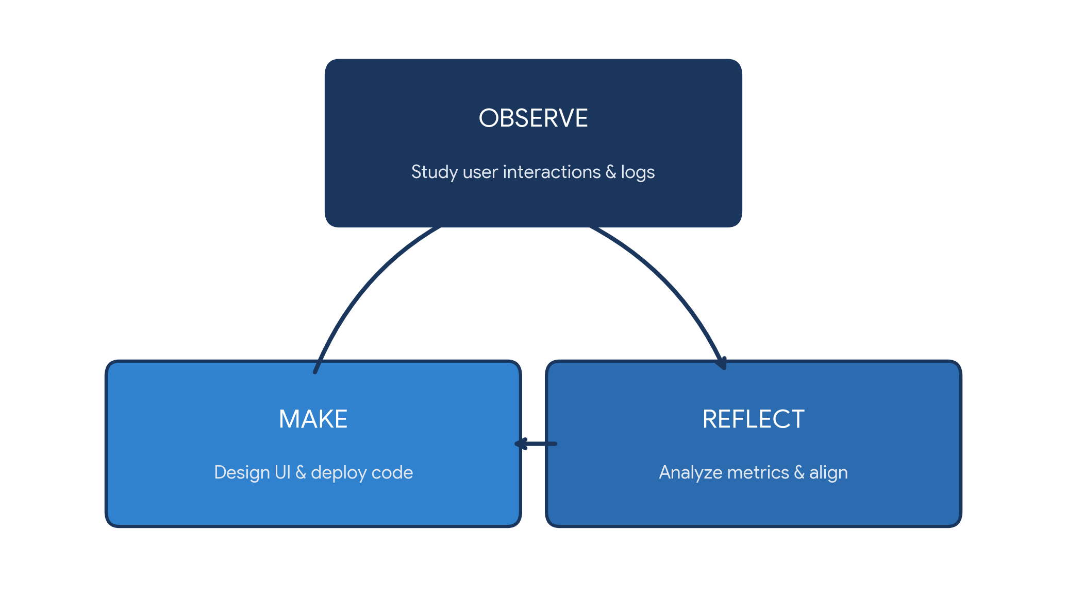

7. Stakeholder User Personas
User Persona | Primary Objectives | Key Frustrations & Pain Points | Target Platform Feature
Priya (Student) | Track real-time attendance, view semester results instantly, apply for electives. | Lack of attendance transparency; delayed result publications. | Responsive student dashboard, grade visibility portal, attendance alerts.
Prof. Sharma (Faculty Member) | Record daily lecture attendance easily; enter continuous evaluation marks. | Tedious paper register management; double entry of marks during finals. | Quick-click attendance logger, bulk grade entry tool, student deficit tracker.
Dr. Kapoor (Exam Cell Admin) | Process institutional results securely; generate transcripts and compliance audits. | High risk of manual mark entry errors; long processing cycles for grade cards. | Automated GPA engine, RBAC secure grading workflows, 1-click transcript export.
8. Stakeholder Matrix
Stakeholder Group | Key Roles | Responsibilities & Project Expectations
Business Stakeholders | Academic Deans, Department Heads, Students, Registrar Office | Define institutional goals, validate workflow adherence, ensure compliance with education standards.
Engineering Stakeholders | Software Engineers, UI/UX Designers, QA Specialists | Architect system backend, construct intuitive user interfaces, ensure test coverage and security.
Operations Stakeholders | System Administrators, Database Administrators, DevOps Team | Maintain database uptime, enforce role-based access control (RBAC), automate deployment pipelines.
9. Requirements Engineering Specification
9.1 Functional Requirements (FRS)
- FR-01 Authentication & RBAC: Secure Role-Based Access Control enforcing permissions for Student, Faculty, Academic Admin, and Exam Cell roles.
- FR-02 Student Profile & Admission Management: Complete profile maintenance, personal details, PRN assignment, and course mapping.
- FR-03 Course & Enrollment Engine: System capability for students to register for active semester electives and core courses.
- FR-04 Attendance Management Module: Digital attendance entry interface for faculty with real-time percentage calculation and dynamic low-attendance alerts.
- FR-05 Examination & Result Engine: Automated processing of internal and external marks to generate SGPA/CGPA with instant PDF report generation.
9.2 Non-Functional Requirements (NFRS)
- NFR-01 Security: Industry-standard password encryption (Bcrypt/Argon2), JWT token session handling, HTTPS encryption, and strict RBAC isolation.
- NFR-02 Performance: Sub-500ms API response time for record lookups and mark submissions under peak usage.
- NFR-03 Scalability & Availability: Cloud-native modular architecture guaranteeing 99.9% availability during peak exam result query traffic.
- NFR-04 Usability & Accessibility: Fully responsive UI design complying with WCAG 2.1 AA standards for seamless access on desktop and mobile devices.
10. Product Vision & Minimum Viable Product (MVP) Scope
PRODUCT VISION STATEMENT:
"To deliver a unified, enterprise-grade Student Record and Academic Management Platform that eliminates manual administrative overhead, accelerates result publishing, and empowers academic communities with seamless, secure access to real-time educational metrics."
MVP Release Scope (Sprint 1–4)
To maintain agility, non-essential capabilities (such as alumni portal integration, hostel management, or AI performance predictions) are deferred. The MVP includes:
- Secure User Login & RBAC Role Provisioning
- Student Profile & Course Registration Engine
- Daily Digital Attendance Entry & Percentage Tracker
- Assessment Marks Processing & SGPA Calculation
- Standard Academic Transcript & Report Generation
11. Enterprise Engineering Roadmap
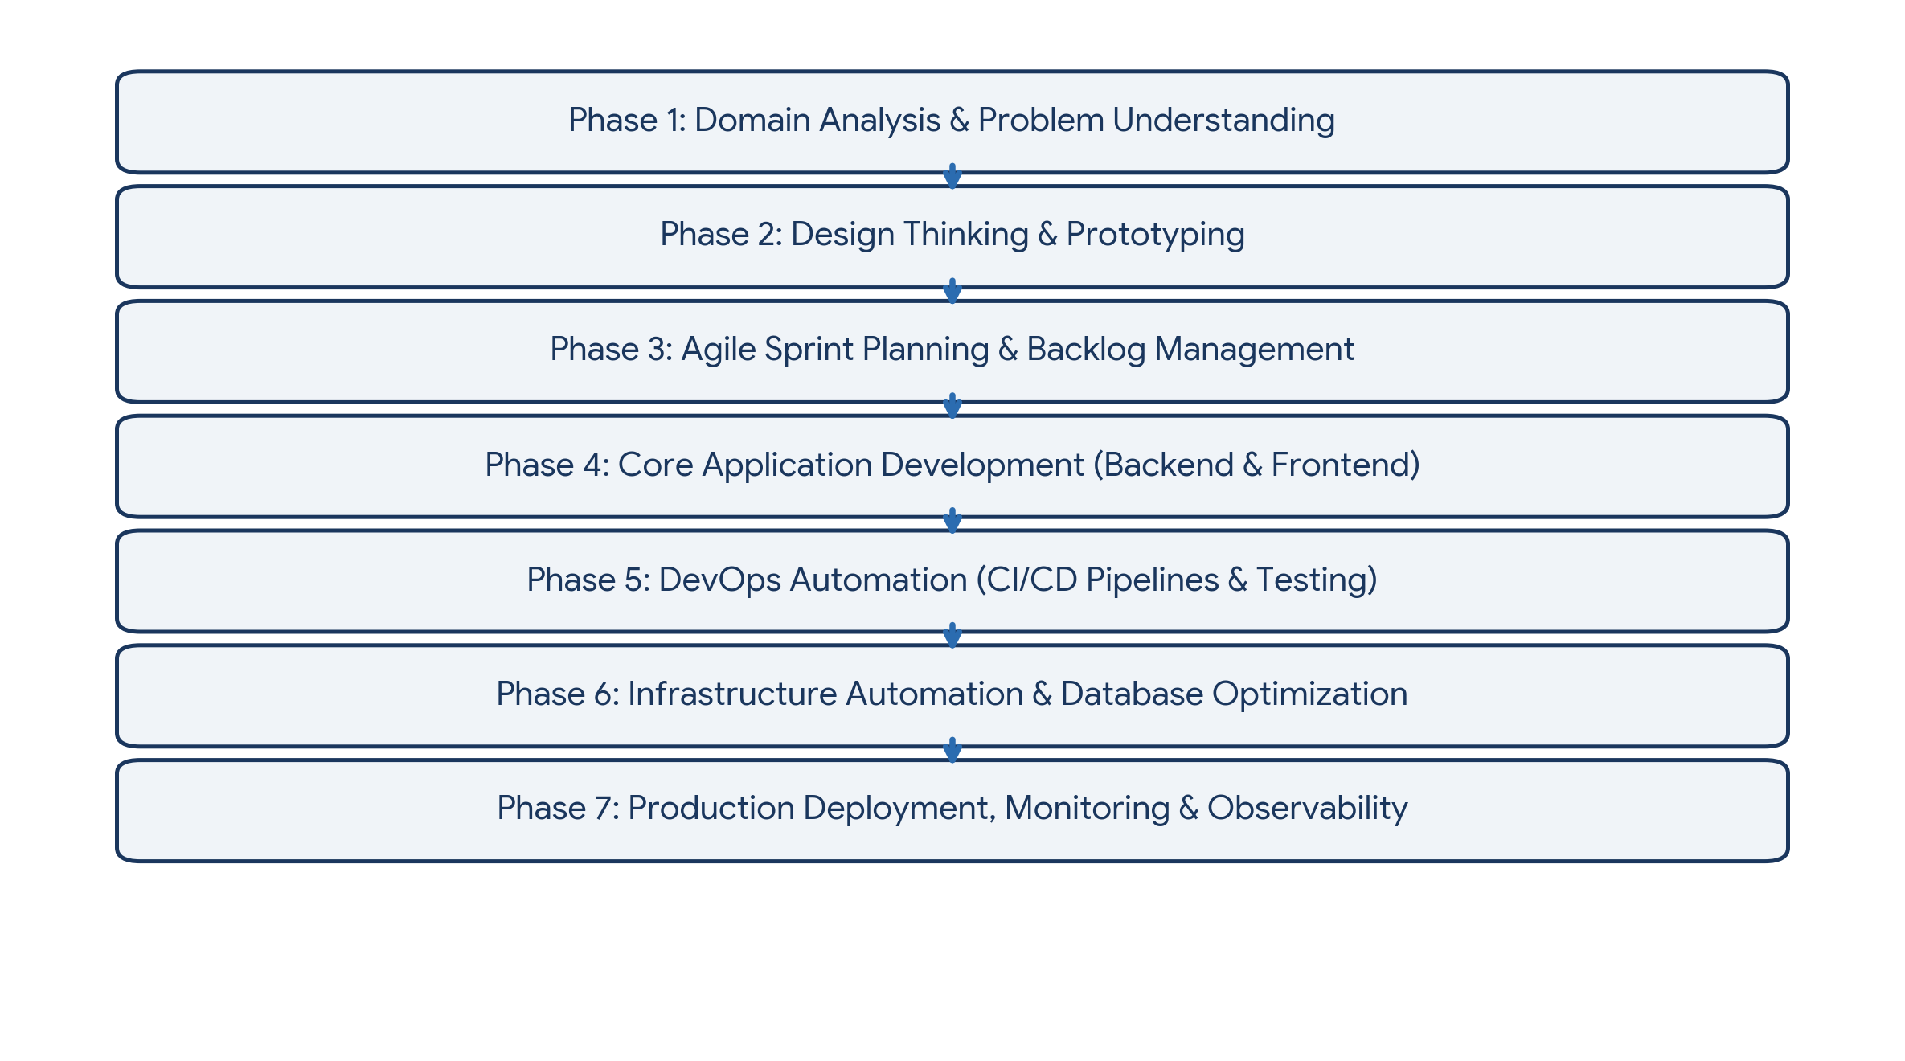
12. System Architecture & Repository Structure
Repository Hierarchy
student-record-academic-platform/
├── .github/ # CI/CD Workflows (GitHub Actions)
├── app/ # Application Source Code
│ ├── modules/ # Business Logic (Students, Attendance, Marks, Courses)
│ ├── database/ # Schemas, Migrations, & ORM Models
│ └── tests/ # Automated Unit & Integration Tests
├── docs/ # Architecture Diagrams, FRS/NFRS Specs, & Design Reports
├── docker/ # Dockerfiles & Multi-Container Compose Setup
├── kubernetes/ # K8s Manifests (Deployments, Services, Ingress)
├── terraform/ # Cloud Infrastructure Provisioning Scripts
├── ansible/ # Configuration Management Playbooks
├── monitoring/ # Prometheus & Grafana Dashboard Configs
└── README.md # Project Onboarding & Setup Instructions
Trainer Execution Deliverables Checklist
- [x] Business Problem Statement & Business Justification Report
- [x] Product Vision Statement & MVP Feature Matrix
- [x] Stakeholder Responsibility Matrix & User Persona Profiles
- [x] Functional (FRS) and Non-Functional (NFRS) Requirements Specs
- [x] Design Thinking Report (Empathize, Define, Ideate, Prototype, Test)
- [x] IBM Design Thinking & IBM Loop Execution Specs
- [x] Multi-Phase Product Engineering Roadmap
- [x] System Architecture Diagram Concept Specs
- [x] Initialized Git Repository & Standardized Folder Architecture

13. Visual Flowcharts and System Diagrams
The following diagrams provide a visual representation of the product discovery, design thinking, academic workflow, system architecture and IBM continuous improvement cycle. Flowcharts are useful for communicating process steps and data flow, while architecture diagrams show system components and their relationships. citeturn0search0turn0search2

13.1 Design Thinking Process Flowchart
This flowchart summarizes the five stages applied to the student academic management problem.
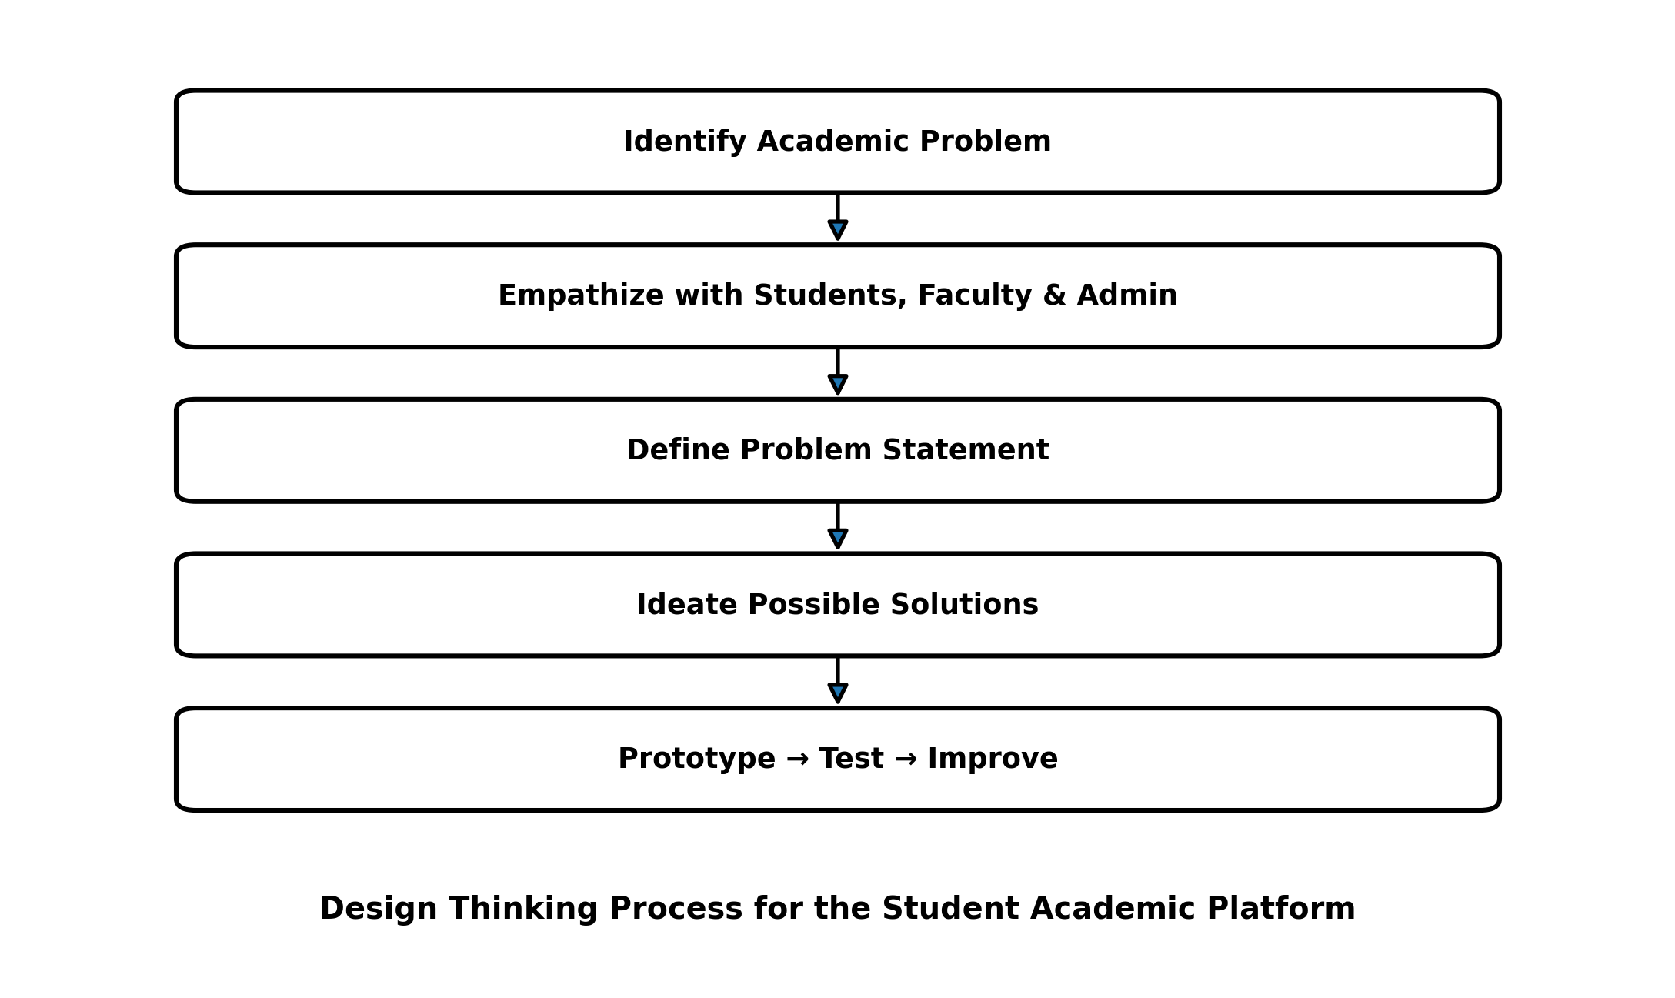
Figure 13.1: Design Thinking Process Flowchart

13.2 Initial System Architecture Diagram
The architecture connects the main user groups to the interface, application/API layer, academic modules and centralized database.
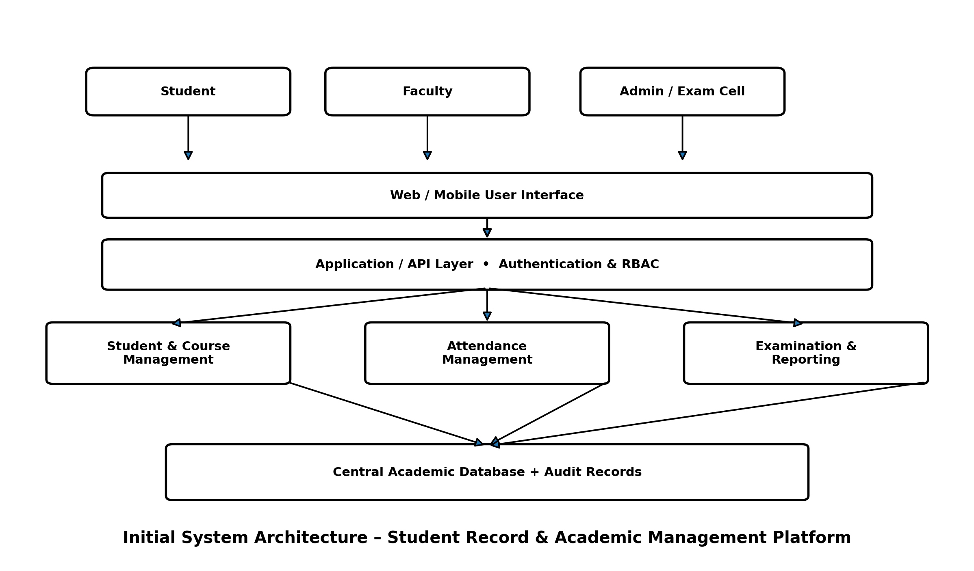
Figure 13.2: Initial System Architecture

13.3 Student Academic Management Workflow
The workflow shows how academic information moves from student admission and course registration through attendance and examination processing to academic reports.
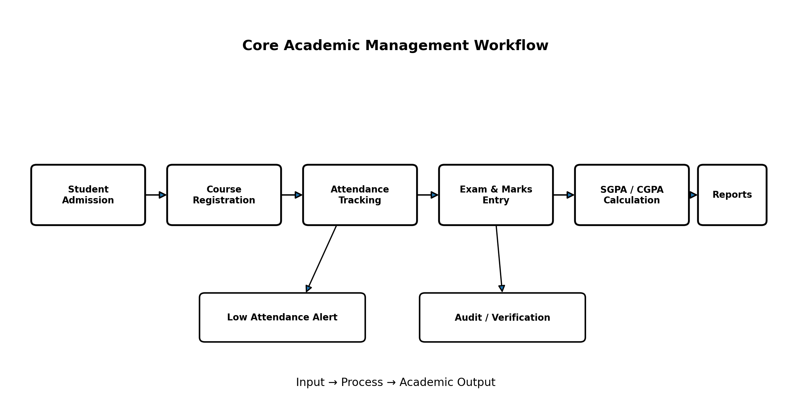
Figure 13.3: Core Academic Management Workflow

13.4 IBM Design Thinking Loop
The loop represents continuous observation, reflection, making and feedback for iterative product improvement.
