MACHINE LEARNING LABORATORY (LA2) — MINI PROJECT REPORT
Automated Resume Intelligence and Job-Role Prediction Using PDF Extraction and Comparative Machine Learning
Classifying resumes into 25 job categories with TF-IDF features, six classifiers, and a Streamlit web application
Class / Batch: A4 / B4
Team: Om Jaiswal (Roll No. A4-B4-57), [Team Member 2], [Team Member 3]
Institution: Ramdeobaba University (RCOEM), Nagpur
Abstract
Recruiters receive far more resumes than they can read, so a first-pass screening tool that assigns each resume to a job category is useful. This project builds such a tool end to end: text is extracted from PDF resumes with pdfplumber, cleaned with regular expressions, converted to sublinear TF-IDF features (unigrams and bigrams, 3,000 terms), and classified into 25 job categories by six models (Linear SVM, RBF SVM, Random Forest, Decision Tree, K-Nearest Neighbours, Multinomial Naive Bayes). A Streamlit application exposes the trained model together with a skill-matching view for a chosen target company. The dataset has 962 resumes, and the original 80:20 split gave 98.96–100% accuracy for every model. While preparing this report we found that only 166 of the 962 resumes are unique, and that 192 of the 193 test resumes have an identical copy in the training set, so those scores measure memorisation. After removing duplicates and re-evaluating with a hold-out split and repeated stratified cross-validation, accuracy falls to 34–82%, with K-Nearest Neighbours (81.6 ± 4.2%), Random Forest (78.0 ± 5.3%) and Linear SVM (75.1 ± 4.8%) leading. This report presents both sets of results and the corrected ranking.

1. Introduction

1.1 Background and motivation
Online job portals let candidates apply to many positions with a single upload, so a single opening can attract hundreds of applications. Reading each one is slow and inconsistent: reviewers tire, and the same resume can be judged differently on different days. Applicant tracking systems (ATS) address this by parsing resumes and ranking or routing them automatically. A basic building block of such a system is resume classification: given the free text of a resume, decide which job family it belongs to (for example Java Developer, HR, or Civil Engineer).
Resume text is a good fit for classical text-classification methods. Resumes use strongly role-specific vocabulary (“hibernate” for Java, “autocad” for civil engineering), so sparse TF-IDF vectors with a linear or instance-based classifier are a standard and inexpensive baseline. Recent work has moved toward transformer models, which need more data and compute. This project asks how far a lightweight, interpretable pipeline can go on a small public dataset, and how reliably that can be measured.

1.2 Problem statement and objectives
Given the text of a resume (typed or extracted from a PDF), predict one of 25 job categories and present the result in an interface that a non-technical user can operate. The objectives are:
- Extract text from PDF resumes and clean it so that formatting noise, links and contact details do not influence the classifier.
- Convert the cleaned text into TF-IDF feature vectors and train at least four different classifiers on them.
- Compare the classifiers with accuracy, weighted precision, recall and F1, macro-F1, training time and inference latency.
- Check that the evaluation is trustworthy, and report results under a protocol that avoids train-test leakage.
- Deploy the best pipeline in a Streamlit web application with PDF upload, role prediction and a skill-match view.

1.3 Contributions
- An end-to-end, reproducible pipeline (PDF extraction, cleaning, TF-IDF, six classifiers, saved models, web interface) in a small repository.
- A data-quality finding: the public 962-resume dataset contains only 166 distinct resumes. The original split leaks 192 of 193 test resumes into training.
- A corrected benchmark using a de-duplicated hold-out split and 3-fold cross-validation repeated five times, with mean and standard deviation for every metric.
- An honest description of the application, including which of its scores are learned and which are hand-set heuristics.

1.4 Organisation of the report
Section 2 reviews five recent papers. Section 3 describes the method. Section 4 covers the dataset, cleaning and the duplicate analysis. Section 5 reports and discusses results. Section 6 compares the models side by side. Section 7 describes the user interface and deployment. Section 8 concludes, and the references follow.

2. Literature Review
Resume classification has been studied with classical machine learning, recurrent and convolutional networks, and, more recently, pre-trained transformers. We review five papers published between 2022 and 2024 and compare them on data, method and reported result. Reported figures are those stated by the authors and come from different datasets, so they indicate a trend and are not directly comparable.
Table 1. Summary of the five reviewed papers
# | Paper | Data | Methods | Main reported result | Limitation relevant to this work
[1] | Pal et al., 2022 | Resumes collected from Kaggle, Glassdoor and Indeed; 70% used for training | TF-IDF with Naive Bayes, SVM and Random Forest | Random Forest best, about 70% accuracy | Low accuracy; no interface or latency study
[2] | Ali et al., 2022 | 962 resumes, 25 categories (the dataset used here) | TF-IDF with nine models: SVM variants, Naive Bayes variants, KNN, Logistic Regression | SVM family best, above 96% accuracy | Same small dataset; no discussion of duplicate records found in the sources we read
[3] | Skondras et al., 2023 | 4,791 LLM-generated and 1,533 Indeed resumes, 15 categories | BERT and a feed-forward network on Universal Sentence Encoder embeddings; synthetic data for augmentation | BERT with Indeed-augmented data reached 92% accuracy | Depends on synthetic text quality; GPU-based models
[4] | Jalili et al., 2024 | Over 2,400 LiveCareer resumes, 21 categories | Bidirectional LSTM with word embeddings | 72.4% accuracy | Lower than classical baselines on other data; no deployment
[5] | Heakl et al., 2024 (ResuméAtlas) | 13,389 resumes, 43 categories, OCR-extracted | BERT and Gemma 1.1 2B vs TF-IDF classical models | BERT 91.2%, Gemma 92.0% top-1; best classical (TF-IDF + XGBoost) 83.5% | Needs GPUs; first 300 words only; large scraped dataset

2.1 Discussion of the papers
Classical models with TF-IDF. Pal et al. [1] compared Naive Bayes, SVM and Random Forest on resumes gathered from several job sites and found Random Forest best, but only at about 70% accuracy, which shows how much results depend on the data source. Ali et al. [2] evaluated nine classifiers on the same 962-resume, 25-class dataset that we use and found that SVM-based models exceeded 96% accuracy using a one-vs-rest strategy. This is the closest published comparison to our work, and our original (pre-correction) numbers of 99–100% are in the same range.
Neural and transformer models. Jalili et al. [4] applied a BiLSTM to over 2,400 LiveCareer resumes in 21 classes and reached 72.4%, which is below what linear models reach on cleaner datasets, a reminder that a deeper network does not help by itself. Skondras et al. [3] attacked the shortage of labelled data by generating synthetic resumes with a large language model; BERT trained with the augmented Indeed data reached 92%, ahead of a feed-forward network on sentence embeddings. Heakl et al. [5] assembled the largest dataset (13,389 resumes, 43 classes) and showed that fine-tuned BERT (91.2%) and Gemma 1.1 2B (92.0%) beat every TF-IDF baseline they tried, the best of which, TF-IDF with XGBoost, scored 83.5%.

2.2 Comparison and research gap
Aspect | Classical TF-IDF models [1], [2] | Neural / transformer models [3], [4], [5] | This project
Typical data size | Under about 1,000 resumes | 1,500 to 13,000 resumes | 962 records (166 unique)
Compute | CPU, seconds to train | GPU for fine-tuning | CPU, seconds to train
Interpretability | High (keywords) | Low | High (keywords)
Reported accuracy | About 70% to above 96% | 72% to 92% | 34–82% (corrected), 99–100% (original)
Deployment shown | Rarely | Rarely | Streamlit app

Three observations follow. First, transformers lead when the dataset is large and varied [5], whereas on a small dataset a classical model is cheaper and often sufficient. Second, accuracy values are strongly tied to the dataset, so a 96% figure on a 962-resume dataset and a 92% figure on a 13,000-resume dataset are not comparable. Third, none of the reviewed papers presents a working interface alongside a model comparison, and the papers that use small datasets do not, in the portions we reviewed, check for duplicate resumes. This project fills the second and third gaps: it ships a usable interface and it audits the evaluation for leakage.

3. Methodology

3.1 System pipeline
The system has six stages (Fig. 1): a resume is uploaded as PDF or text; pdfplumber extracts its text; regular expressions clean it; a TF-IDF vectoriser turns it into a sparse vector; a classifier predicts the job category; and the Streamlit interface shows the prediction together with a skill-match view. The same cleaning function and fitted vectoriser are used in training and in the application.
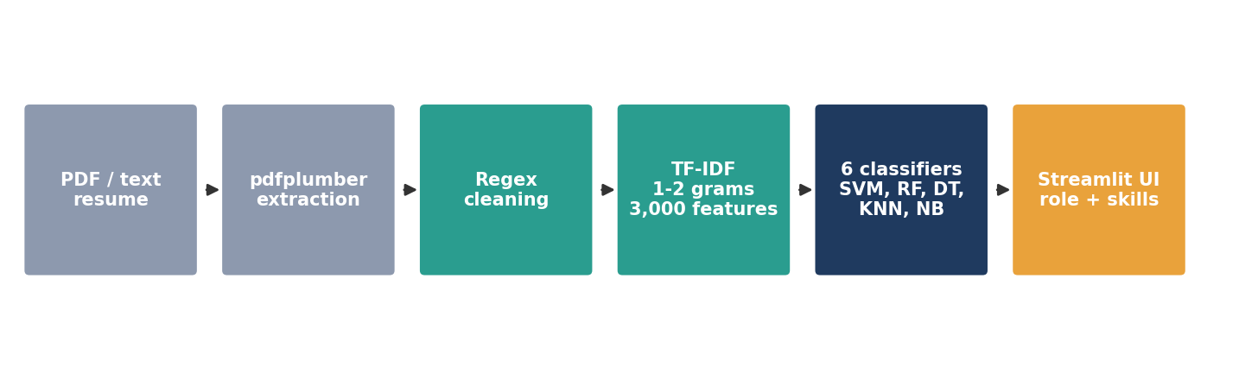
Fig. 1. End-to-end pipeline from resume upload to prediction and display.

3.2 Feature extraction: TF-IDF
Each cleaned resume is represented by a TF-IDF vector using scikit-learn’s TfidfVectorizer with sublinear term frequency, English stop-word removal, unigrams and bigrams, and the 3,000 most frequent terms. For term t in document d:
tf(t, d) = 1 + ln f(t, d) idf(t) = ln[(1 + n) / (1 + df(t))] + 1 w(t, d) = tf(t, d) · idf(t)
Each vector is then scaled to unit Euclidean length. The vectoriser is fitted on training documents only and applied unchanged to test documents.

3.3 Classifiers
Six classifiers from scikit-learn were trained on the same features. Hyperparameters are the defaults or the values in the project code; none were tuned, which matters for the interpretation of results in Section 5.
Table 2. Classifiers and hyperparameters used
Model | Hyperparameters | Idea
Linear SVM | C = 1.0, linear kernel | Finds the maximum-margin hyperplane between classes in the sparse feature space [8]
RBF SVM | C = 1.0, RBF kernel, gamma = “scale” | Same objective with a non-linear kernel exp(−γ‖x − x′‖²)
Random Forest | 100 trees, max depth 20 | Majority vote of decision trees trained on bootstrap samples and random feature subsets [7]
Decision Tree | Entropy criterion, max depth 25 | Single tree choosing splits by information gain
KNN | k = 5, cosine distance | Assigns the majority label of the five most similar training resumes
Multinomial Naive Bayes | alpha = 0.1 | Class-conditional word probabilities with a naive independence assumption (baseline)

3.4 Evaluation metrics
We report accuracy, weighted precision, weighted recall and weighted F1 (each class weighted by its number of test resumes), and macro-F1 (all classes weighted equally, which is more sensitive to small classes). We also record training time and inference latency per resume. With F1 = 2PR / (P + R) computed per class and then averaged, macro-F1 is the stricter number when classes are imbalanced, as they are here.

3.5 Evaluation protocols
Three protocols are used, and keeping them apart is the central point of this report:
- Protocol A: original split. Stratified 80:20 split of all 962 records (769 train, 193 test), random seed 42, as in the project code.
- Protocol B: de-duplicated hold-out. Exact duplicate resumes are removed first (166 remain), then a stratified 80:20 split (132 train, 34 test), seed 42.
- Protocol C: repeated stratified cross-validation. On the 166 unique resumes, 3-fold stratified cross-validation repeated 5 times (15 folds). Three folds is the largest number possible because the smallest class has only three unique resumes. The vectoriser is re-fitted inside every fold.
Protocol B has only 34 test resumes, so one error changes accuracy by about 2.9 percentage points. Protocol C is therefore the primary basis for conclusions.

4. Data Cleaning and Preprocessing

4.1 Dataset
The data is the public “UpdatedResumeDataSet” resume collection (file UpdatedResumeDataSet.csv), which has two columns: Resume (free text) and Category (one of 25 job labels). It holds 962 records. Resume length averages about 3,100 characters, ranging from 134 to 14,614. The categories include software roles (Java, Python, DotNet, DevOps, Hadoop, ETL, Blockchain, Database, SAP), testing roles, management and operations roles (Business Analyst, PMO, Operations Manager, HR, Sales), core engineering (Mechanical, Civil, Electrical) and others (Web Designing, Arts, Advocate, Health and fitness, Network Security Engineer).

4.2 Text cleaning
The cleaning function in train_models.py is applied to every resume, and an equivalent function is used in the web application. It performs these steps in order:
- Remove URLs (any token starting with http).
- Remove the stray tokens “RT” and “cc”.
- Remove hashtags and @-mentions.
- Remove e-mail addresses and runs of 10 to 12 digits (phone numbers).
- Remove punctuation and special characters, then all non-ASCII characters.
- Collapse repeated whitespace and convert to lower case.
Cleaning all 962 resumes takes well under a second on a laptop. Stop-word removal and n-gram extraction are done by the vectoriser (Section 3.2).

4.3 Class distribution
The raw dataset is moderately imbalanced, from 84 records for Java Developer to 20 for Advocate (Fig. 2). The distribution of the unique resumes is quite different: Java Developer still leads with 13, but the smallest class, PMO, has only 3 and Operations Manager and Web Designing have 4 each. Several categories therefore have far fewer distinct examples than their raw counts suggest.
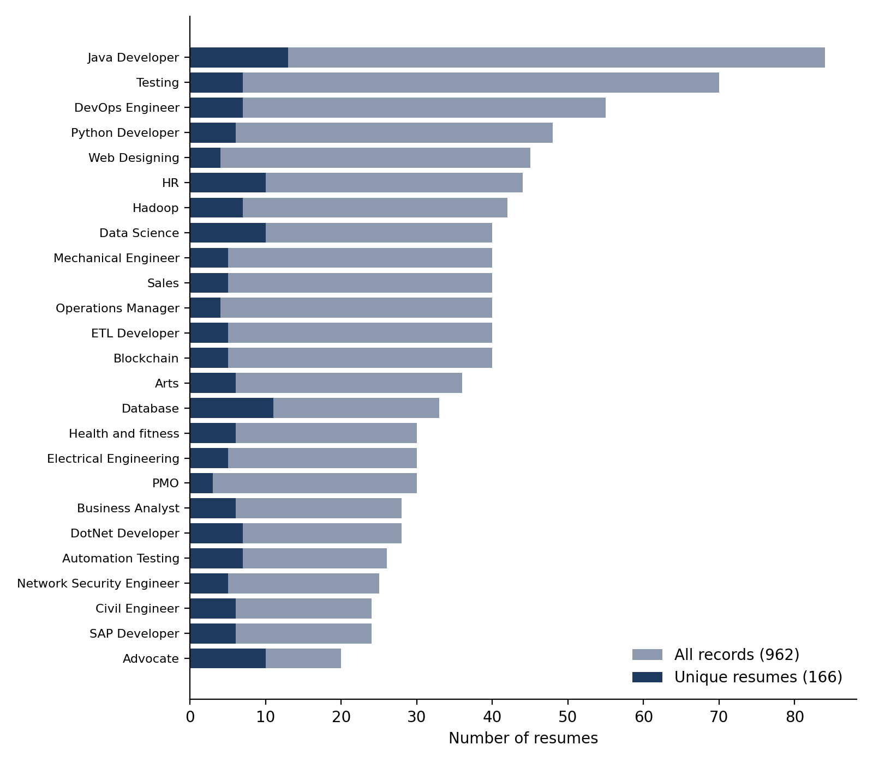
Fig. 2. Number of resumes per category: all records (grey) versus unique resumes (blue).

4.4 Duplicate analysis and data leakage
While checking the splits we compared resume texts and found that 796 of the 962 records are exact copies of another record, leaving 166 unique resumes. Duplicated resumes never carry conflicting labels, so no labelling noise was introduced; the issue is repetition alone. The cleaned texts give the same count of 166.
Because the original split was random, duplicates fell on both sides of it. Of the 193 test resumes, 192 have an identical copy in the training set. A classifier that simply memorises the training texts will therefore score almost perfectly (Fig. 3). Scores from Protocol A reflect memorisation more than the ability to classify unseen resumes.
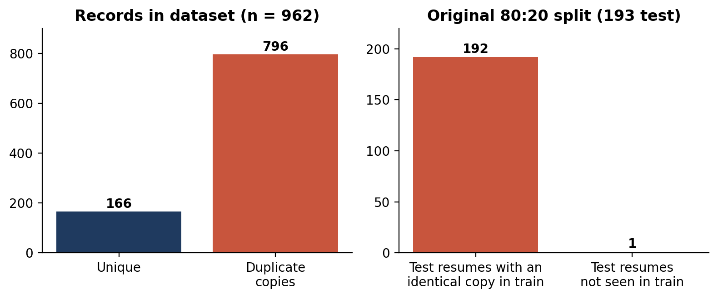
Fig. 3. Left: unique versus duplicate records. Right: test resumes that also appear in the training set under the original split.
To obtain a trustworthy evaluation we removed duplicates before any splitting. The corrected hold-out uses 132 training and 34 test resumes, and every test resume is unseen by construction. The TF-IDF vocabulary is also fitted on the training portion only, which prevents a second, smaller form of leakage through inverse-document-frequency statistics.

5. Results and Discussion

5.1 Results under the original protocol (A)
Table 3 reproduces the scores produced by the project’s training script. Every model scores between 98.96% and 100%, and two models (Linear SVM and Decision Tree) classify all 193 test resumes correctly. Given the leakage described in Section 4.4, these numbers are not evidence that the problem is solved.
Table 3. Original results (Protocol A, 193 test resumes, duplicates included)
Model | Acc. (%) | Precision (w) % | Recall (w) % | F1 (w) % | F1 (macro) % | Train (s) | Latency (ms/resume)
Linear SVM | 100.0 | 100.0 | 100.0 | 100.0 | 100.0 | 1.453 | 0.261
RBF SVM | 99.48 | 99.57 | 99.48 | 99.49 | 99.45 | 1.77 | 0.313
Random Forest | 99.48 | 99.54 | 99.48 | 99.48 | 99.57 | 0.406 | 0.087
Decision Tree | 100.0 | 100.0 | 100.0 | 100.0 | 100.0 | 0.127 | 0.004
KNN (k=5, cosine) | 98.96 | 99.11 | 98.96 | 98.96 | 98.75 | 0.001 | 0.08
Naive Bayes (baseline) | 98.96 | 99.11 | 98.96 | 98.96 | 98.75 | 0.005 | 0.005

5.2 Results under the corrected protocols (B and C)
Tables 4 and 5 give the corrected results. Table 4 is the de-duplicated hold-out and Table 5 is the repeated cross-validation, which is the more reliable of the two.
Table 4. De-duplicated hold-out (Protocol B, 34 test resumes)
Model | Acc. (%) | Precision (w) % | Recall (w) % | F1 (w) % | F1 (macro)* | Train (s)
Linear SVM | 79.41 | 74.26 | 79.41 | 74.71 | – | 0.054
RBF SVM | 38.24 | 28.60 | 38.24 | 30.27 | – | 0.046
Random Forest | 79.41 | 73.43 | 79.41 | 73.87 | – | 0.267
Decision Tree | 52.94 | 48.53 | 52.94 | 47.94 | – | 0.047
KNN (k=5, cosine) | 85.29 | 81.13 | 85.29 | 81.58 | – | 0.001
Naive Bayes | 76.47 | 72.41 | 76.47 | 71.47 | – | 0.004
* Macro-F1 is reported only for the cross-validation (Table 5): on 34 test resumes spread over 25 classes, most classes have a single test example and the macro average is unstable.
Table 5. Repeated stratified 3-fold cross-validation (Protocol C, 15 folds, mean ± std)
Model | Accuracy (%) | Precision (w) % | Recall (w) % | F1 (w) % | F1 (macro) %
Linear SVM | 75.1 ± 4.8 | 73.2 ± 6.3 | 75.1 ± 4.8 | 71.0 ± 5.5 | 67.0 ± 5.8
RBF SVM | 34.4 ± 5.7 | 28.0 ± 3.3 | 34.4 ± 5.7 | 27.1 ± 4.9 | 19.2 ± 3.9
Random Forest | 78.0 ± 5.3 | 77.5 ± 5.7 | 78.0 ± 5.3 | 74.7 ± 5.6 | 72.0 ± 6.4
Decision Tree | 39.1 ± 5.7 | 40.8 ± 6.0 | 39.1 ± 5.7 | 37.7 ± 5.0 | 31.3 ± 4.5
KNN (k=5, cosine) | 81.6 ± 4.2 | 79.2 ± 5.2 | 81.6 ± 4.2 | 78.0 ± 4.9 | 75.8 ± 5.7
Naive Bayes | 69.4 ± 2.7 | 68.5 ± 5.1 | 69.4 ± 2.7 | 64.7 ± 3.2 | 61.4 ± 3.7

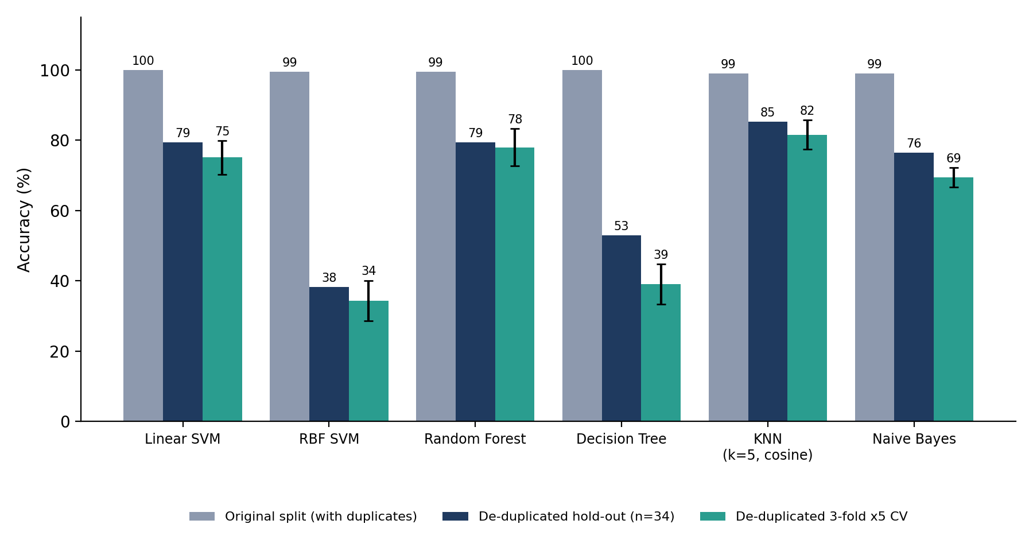
Fig. 4. Accuracy of the six classifiers under the original split and the two corrected protocols (error bars: standard deviation over 15 folds).

5.3 Discussion
The drop is large and consistent. Every model loses between 17 and 65 percentage points once duplicates are removed (Fig. 4). The ranking also changes. Under Protocol A the Decision Tree is tied for first place; under Protocol C it is fifth of six at 39.1%. A model that memorises exact copies looks excellent on leaked data, but generalising to a new resume is a different task.
KNN, Random Forest and Linear SVM lead. With cosine distance, KNN reaches 81.6 ± 4.2% accuracy and 75.8% macro-F1, the best of the six. Random Forest follows (78.0 ± 5.3% accuracy, 72.0% macro-F1) and Linear SVM is third (75.1 ± 4.8%, 67.0%). The gaps between these three are smaller than their standard deviations, so with 166 resumes we cannot claim that any one of them is truly better. Multinomial Naive Bayes, the baseline, is within about 6 to 12 points of them (69.4%) while training in milliseconds.
Why the Decision Tree and RBF SVM fail. A single tree with 132 training examples and 3,000 features overfits quickly and splits on a few high-variance words, giving 39.1% and the largest fold-to-fold spread. The RBF SVM scores only 34.4%. We did not tune C or gamma; with TF-IDF vectors of unit length and a small training set, the default settings give a nearly flat kernel, so the model predicts a few majority classes. We therefore treat this result as “untuned RBF SVM fails here”, not as a statement about RBF kernels in general; a grid search over C and gamma is the obvious next experiment.
Where the errors occur. The best hold-out model (KNN, Fig. 5) makes five mistakes on 34 resumes: Mechanical Engineer and DevOps Engineer were labelled Business Analyst, PMO was labelled Operations Manager, Web Designing was labelled Java Developer, and Testing was labelled Automation Testing. Most of these pair categories that share vocabulary (testing and automation testing; project and operations management; web design and Java front-end work). Random Forest and Linear SVM make seven errors each, and Web Designing → Java Developer and Blockchain → Java Developer recur in both. These confusions are plausible for overlapping job families.
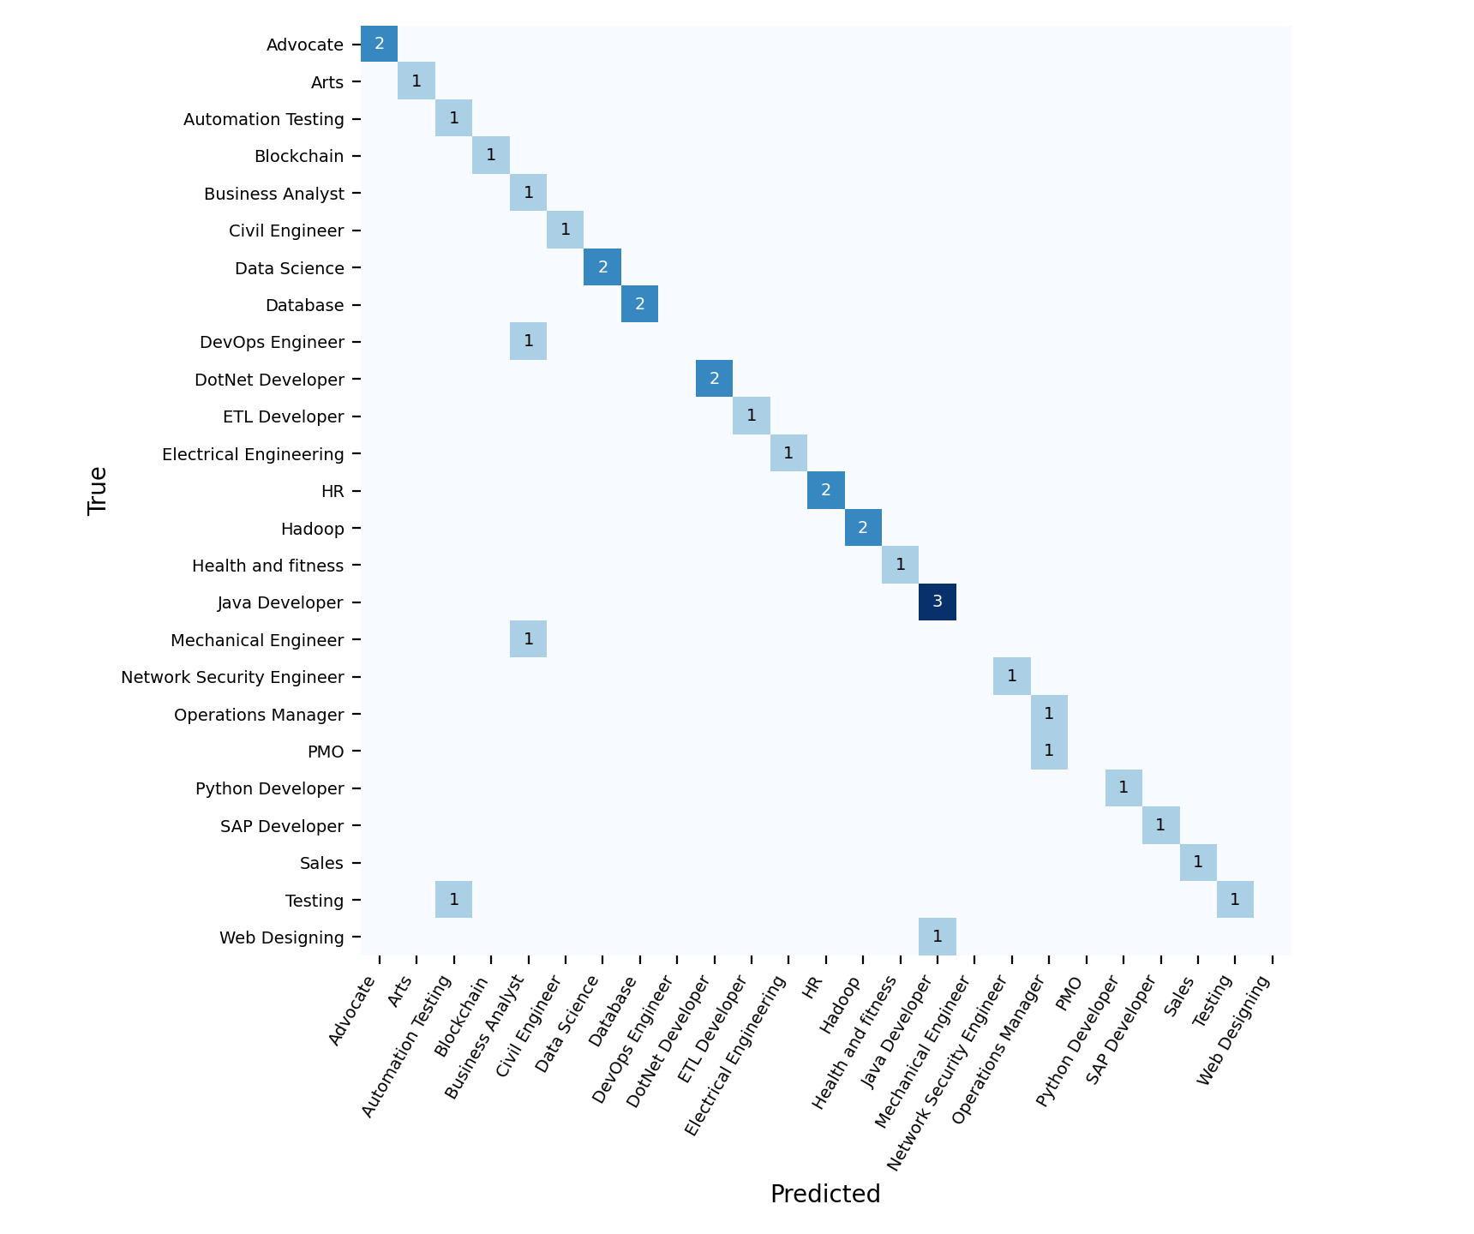
Fig. 5. Confusion matrix of the KNN classifier on the de-duplicated hold-out set (34 resumes).
Relation to the literature. Our corrected accuracies of 75–82% for the best models are lower than the above-96% reported by Ali et al. [2] on this same dataset and closer to the 70–92% range of the other studies [1], [3], [4], [5]. Because we found that the dataset is more than 80% duplicated and the reviewed sources do not describe de-duplication, it is possible that published scores on this dataset are inflated in the same way. We cannot confirm this without their code and splits, so we state it as a possibility.
Limitations. (i) 166 unique resumes are few for 25 classes, with 3 to 13 per class, so standard deviations are 4 to 6 points. (ii) Hyperparameters were not tuned. (iii) The remaining unique resumes may still be near-duplicates (for example templates with small edits), which would make even the corrected scores somewhat optimistic. (iv) Only one dataset was used.

6. State-of-the-Art Models Comparison
We compare six models, which exceeds the minimum of four: Linear SVM, RBF SVM, Random Forest, Decision Tree, KNN and the Naive Bayes baseline. Table 6 collects the main numbers side by side. The leftmost metric is the original (leaky) accuracy, shown only to illustrate how the evaluation protocol changes the picture.
Table 6. Side-by-side comparison of all six models
Model | Original acc. (%) | Hold-out acc. (%) | CV acc. (%) mean ± std | CV macro-F1 (%) | Train (s, orig.) | Latency (ms/resume)
Linear SVM | 100.0 | 79.4 | 75.1 ± 4.8 | 67.0 | 1.453 | 0.261
RBF SVM | 99.48 | 38.2 | 34.4 ± 5.7 | 19.2 | 1.77 | 0.313
Random Forest | 99.48 | 79.4 | 78.0 ± 5.3 | 72.0 | 0.406 | 0.087
Decision Tree | 100.0 | 52.9 | 39.1 ± 5.7 | 31.3 | 0.127 | 0.004
KNN (k=5, cosine) | 98.96 | 85.3 | 81.6 ± 4.2 | 75.8 | 0.001 | 0.08
Naive Bayes | 98.96 | 76.5 | 69.4 ± 2.7 | 61.4 | 0.005 | 0.005
Highlighted row: best cross-validated model. Train time and latency come from the original run (769 training / 193 test resumes); they do not depend on the leakage and are only indicative.
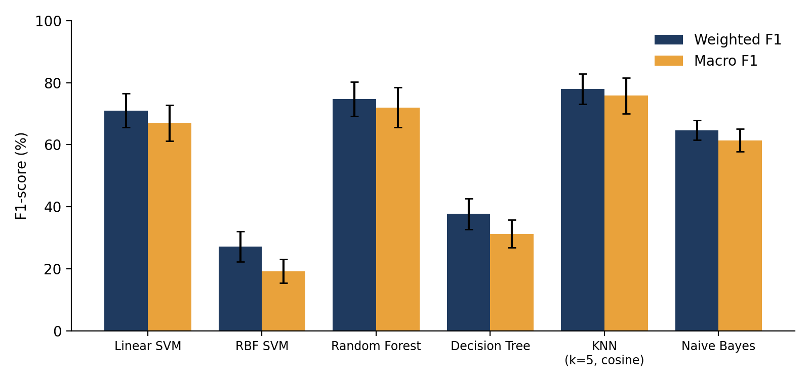
Fig. 6. Cross-validated weighted and macro F1 for each model (mean ± standard deviation).
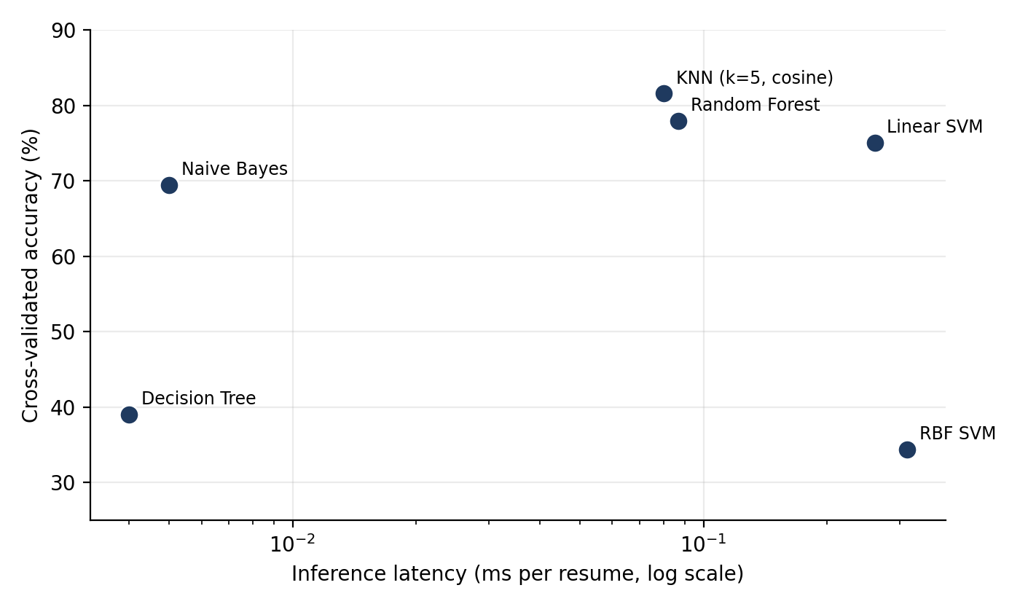
Fig. 7. Trade-off between cross-validated accuracy and inference latency (log scale).

6.1 Reading the comparison
- Accuracy. KNN and Random Forest are the most accurate; Linear SVM is close behind. Decision Tree and the untuned RBF SVM are clearly weaker.
- Speed. All models respond in well under a millisecond per resume. The Decision Tree and Naive Bayes are fastest (about 0.004–0.005 ms), Random Forest and KNN are about 0.08–0.09 ms and the SVMs about 0.26–0.31 ms, which is negligible for an interactive tool. KNN stores the whole training set and needs no training, so its cost grows with data size.
- Interpretability. Random Forest exposes feature importances (on the original model the most informative terms are role words such as “java”, “hr”, “testing engineer” and “mechanical”, which suggests the classifier leans heavily on job titles and role keywords written in the resume), and linear models expose per-term weights, which suits an HR tool that must explain its output.
- Recommendation. On this evidence Random Forest or KNN is a better default than the Linear SVM currently deployed, and Linear SVM remains a reasonable choice if calibrated probabilities are wanted. The deployed model was selected by the original benchmark, so re-running the selection under Protocol C is a recommended change.

6.2 Context from the literature
Table 7 places our results next to the numbers Heakl et al. [5] report for classical and transformer models on their own 13,389-resume dataset. The datasets differ, so the table shows a pattern and is not a ranking of our models against theirs.
Table 7. Reported results on a large resume dataset [5] (for context only)
Method (as reported in [5]) | Accuracy (%) | Precision (%) | F1 (%)
TF-IDF + Random Forest | 78.5 | 75.2 | 78.6
TF-IDF + SVM | 79.2 | 76.5 | 80.0
TF-IDF + Naive Bayes (multinomial) | 81.3 | 79.5 | 82.8
TF-IDF + XGBoost | 83.5 | 82.1 | 85.8
BERT (top-1) | 91.2 | 90.5 | 91.6
Gemma 1.1 2B | 92.0 | 91.5 | 92.3

Classical models land at 78–84% there, and the four best classical models land at 69–82% here, so the two sets of results agree in range. Transformers add roughly 8 to 13 points but need GPUs and far more data; extending this project with a small sentence-embedding model is a sensible next step (Section 8).

7. User Interface Development and Deployment

7.1 Technology and structure
The interface is a single-file Streamlit application (app.py) that loads the saved artefacts (TF-IDF vectoriser, label encoder, dictionary of trained models and the metrics table) with joblib, caches them, and uses pdfplumber for PDF text extraction. Streamlit was chosen because it turns a Python script into a web page with no front-end code and runs on a laptop or on Streamlit Community Cloud. The layout is shown in Fig. 8.
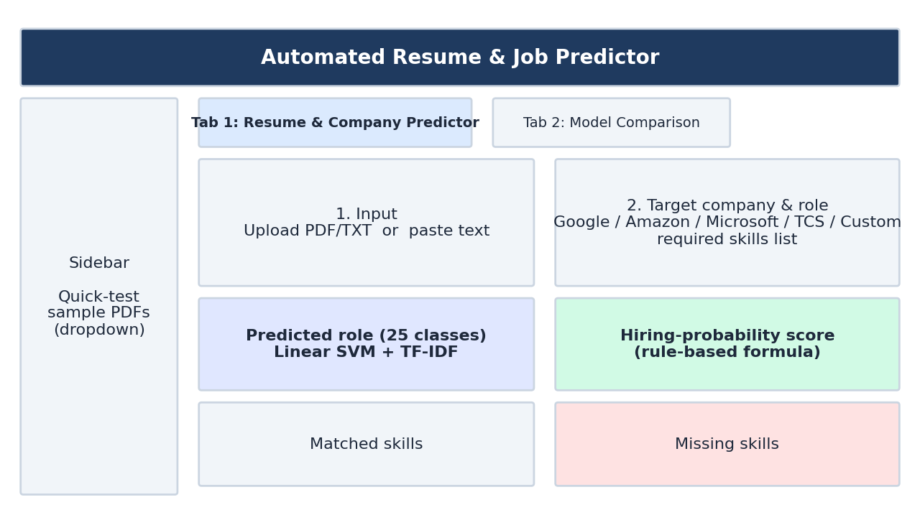
Fig. 8. Layout of the application: a sidebar with sample resumes and two tabs (schematic, not a screenshot).

7.2 Features
Tab 1: Resume & Company Predictor. The user uploads a PDF or text file, picks a sample PDF from the sidebar, or pastes text. They then choose a target company (Google, Amazon, Microsoft, TCS / Infosys, or a custom company with a free-text role and skill list). Pressing the button runs the cleaning function and the TF-IDF vectoriser, and the Linear SVM predicts the job category. The page then shows:
- the predicted role out of 25 categories;
- a skill match: each required skill that appears as text in the cleaned resume is listed as matched, and the others as missing;
- a suitability score and a hiring-probability percentage for the chosen company.
Tab 2: Model Comparison. Shows the metrics table for the four lab models (SVM, Random Forest, Decision Tree, KNN) and the stored figures: metric bars, confusion matrix, keyword importances, class distribution and a decision-tree diagram.

7.3 How the company score is computed
The role prediction is a trained model; the company score is not. It is a hand-written formula, and the report should not present it as a learned hiring model. With sim the cosine similarity between the resume vector and a vector built from the target role and skills, s the fraction of required skills found in the resume, and p a fixed per-company “strictness” penalty (0.05 to 0.12):
logit = −1.0 + 3.0·sim + 3.2·s − 2.0·p P(hire) = sigmoid(logit), clipped to 15–98%
suitability = 40 + 35·sim + 25·s (out of 100)
The coefficients were chosen by hand; no hiring outcomes were used to fit them. The numbers are best read as a keyword-compatibility indicator between a resume and a requirement list. The interface labels the output as a probability, and we recommend renaming it (for example “skill-match score”) before any public release, because it could mislead users about their real chances.

7.4 Verification on the sample resumes
We ran the application’s own pipeline (pdfplumber, cleaning, TF-IDF, Linear SVM) on the four sample PDFs shipped with the project. All four are assigned to the correct category, but the model’s class probabilities are only 22–47%, not the 100% quoted in the project README. That is expected for a 25-class problem with a probability-calibrated SVM trained on 166 distinct resumes, and the report therefore quotes the measured values.
Table 8. Application output on the four sample resumes
Sample file | Words extracted | Predicted category | Top-class probability
Sample_Data_Scientist_Resume.pdf | 219 | Data Science | 0.47
Sample_DevOps_Engineer_Resume.pdf | 202 | DevOps Engineer | 0.28
Sample_HR_Manager_Resume.pdf | 198 | HR | 0.22
Sample_Java_Developer_Resume.pdf | 208 | Java Developer | 0.35

7.5 Deployment
Local run. Install the dependencies in requirements.txt (streamlit, pdfplumber, scikit-learn, pandas, numpy, matplotlib, seaborn, fpdf2, joblib) and start the app with “streamlit run app.py”; it opens at http://localhost:8501. Models are pre-trained and stored under models/ (about 7 MB in total), so no training is needed to run it; “python train_models.py” regenerates the models, metrics and figures.
Cloud deployment. The repository is already laid out for Streamlit Community Cloud: push the folder to GitHub, sign in to Streamlit Community Cloud, choose the repository, set app.py as the main file, and deploy. The pre-trained model files are small enough to be committed directly. Add the public URL here once deployed: [deployment URL].

7.6 Known limitations of the application
- PDFs without a text layer (scans) return no text, since no OCR step is included.
- The training cleaner removes the tokens “RT” and “cc” but the application’s cleaner does not, a small mismatch that could be removed by importing one shared function.
- The stored metrics table and figures in Tab 2 come from the original, leaky evaluation. Regenerating them with Protocol C would make the interface consistent with this report.
- The model predicts only the 25 categories in the dataset; a resume from any other field will still be forced into one of them.

8. Conclusion and Future Work
We built a complete resume-classification system: PDF text extraction, regex cleaning, TF-IDF features, six trained classifiers and a Streamlit interface. The original benchmark reported 99–100% accuracy for every model, but a duplicate check showed that only 166 of the 962 resumes are distinct and that 192 of 193 test resumes also appear in the training set. After removing duplicates and re-evaluating with repeated stratified cross-validation, KNN (81.6%), Random Forest (78.0%) and Linear SVM (75.1%) lead, Naive Bayes follows at 69.4%, and the Decision Tree (39.1%) and the untuned RBF SVM (34.4%) perform poorly. The most important lesson is methodological: on a small, repetitive dataset the choice of evaluation protocol matters more than the choice of model.
Future work. (1) Collect more distinct resumes, or use a larger public dataset such as the one in [5]. (2) Tune C, gamma, k and tree depth with nested cross-validation. (3) Add sentence embeddings or a small transformer for comparison with the TF-IDF baseline. (4) Add OCR for scanned resumes. (5) Replace the hand-set hiring formula with a clearly labelled skill-match score, or train a real model if labelled hiring outcomes become available. (6) Regenerate the interface’s stored metrics and figures under the corrected protocol.

References
[1] R. Pal, S. Shaikh, S. Satpute and S. Bhagwat, “Resume classification using various machine learning algorithms,” ITM Web of Conferences, vol. 44, art. 03011, 2022, doi: 10.1051/itmconf/20224403011.
[2] I. Ali, N. Mughal, Z. H. Khand, J. Ahmed and G. Mujtaba, “Resume classification system using natural language processing and machine learning techniques,” Mehran University Research Journal of Engineering and Technology, vol. 41, no. 1, pp. 65–79, 2022.
[3] P. Skondras, P. Zervas and G. Tzimas, “Generating synthetic resume data with large language models for enhanced job description classification,” Future Internet, vol. 15, no. 11, art. 363, 2023.
[4] A. Jalili, H. Tabrizchi, J. Razmara and A. Mosavi, “BiLSTM for resume classification,” in Proc. IEEE 22nd World Symposium on Applied Machine Intelligence and Informatics (SAMI), Jan. 2024, pp. 519–524.
[5] A. Heakl, Y. Mohamed, N. Mohamed, A. Elsharkawy and A. Zaky, “ResuméAtlas: Revisiting resume classification with large-scale datasets and large language models,” Procedia Computer Science, 2024; arXiv:2406.18125.
[6] F. Pedregosa et al., “Scikit-learn: Machine learning in Python,” Journal of Machine Learning Research, vol. 12, pp. 2825–2830, 2011.
[7] L. Breiman, “Random forests,” Machine Learning, vol. 45, no. 1, pp. 5–32, 2001.
[8] C. Cortes and V. Vapnik, “Support-vector networks,” Machine Learning, vol. 20, no. 3, pp. 273–297, 1995.
[9] K. Sparck Jones, “A statistical interpretation of term specificity and its application in retrieval,” Journal of Documentation, vol. 28, no. 1, pp. 11–21, 1972.
[10] J. Devlin, M.-W. Chang, K. Lee and K. Toutanova, “BERT: Pre-training of deep bidirectional transformers for language understanding,” arXiv:1810.04805, 2018.
[11] Kaggle, “Resume dataset” (UpdatedResumeDataSet.csv), 962 labelled resumes in 25 categories; copy used from the project repository.
[12] J. Singer-Vine, “pdfplumber: Plumb a PDF for detailed information about each text character, rectangle, and line,” GitHub repository, https://github.com/jsvine/pdfplumber.
[13] Streamlit Inc., “Streamlit documentation,” https://docs.streamlit.io.

