A MINI-PROJECT REPORT
ON
“Design and Develop a Tool for Digital Forensic of Images”
SUBMITTED TO THE SAVITRIBAI PHULE PUNE UNIVERSITY, PUNE
IN PARTIAL FULFILMENT OF THE REQUIREMENTS FOR THE AWARD OF THE DEGREE OF
BACHELOR OF COMPUTER ENGINEERING
SUBMITTED BY
Om Jangam
Prashant Karad
Carlton Rodrigues
Akash Varma

Academic Year: 2025–26
FOR THE CYBER SECURITY & DIGITAL FORENSIC COURSE
COMPUTER ENGINEERING
P.E.S. MODERN COLLEGE OF ENGINEERING
SHIVAJINAGAR, PUNE – 411005

Progressive Education Society’s Modern College of Engineering Department of Computer Engineering Shivajinagar, Pune - 411005.
CERTIFICATE
This is to certify that Om Savalaram Jangam from Fourth Year Computer Engineering has successfully completed his mini-project work titled “Digital Image Forensics Tool” at P.E.S. Modern College of Engineering in partial fulfilment of the requirements for the award of the Bachelor’s Degree in Computer Engineering under Savitribai Phule Pune University.

Date:

Ms. Vidya Deshmukh Prof. Dr. Mrs. S. A. Itkar
Guide H.O.D
Dept. Of Computer Engineering

ACKNOWLEDGEMENT

It gives me great pleasure to present this mini-project report on “Digital Image Forensics Tool.”

Firstly, I would like to express my sincere gratitude to my project guide, Ms. Pooja Hande, for her constant guidance, valuable suggestions, and encouragement throughout the development of this project and the preparation of this report. Her support played an important role in the successful completion of this work.

I would also like to express my gratitude to Prof. Dr. Mrs. S. A. Itkar, Head of the Computer Engineering Department at P.E.S. Modern College of Engineering, for her cooperation and encouragement.

I extend my sincere thanks to our Principal, Prof. Dr. Mrs. K. R. Joshi, and all the faculty members for their valuable support and cooperation. I am also thankful to the laboratory assistants for their assistance during the implementation of this project.

Last but not least, I would like to thank my parents and friends for their constant support, motivation, and encouragement, which have been a source of confidence and inspiration throughout this journey.

Om Savalaram Jangam

Abstract

Digital images are widely used as evidence in social media, journalism, legal investigations, and digital communication. However, images can be edited, recompressed, or modified, making it difficult to determine whether their contents are trustworthy. Digital image forensics involves examining an image's properties and technical characteristics to identify possible signs of manipulation.
The proposed Digital Image Forensics Tool is a web-based application developed using Python and Stream lit. It allows users to upload images and analyse their file properties, available EXIF metadata, MD5 and SHA-256 hashes, JPEG compression differences using Error Level Analysis (ELA), and pixel intensity statistics. The system also generates a downloadable JSON report containing the analysis results. The tool assists users in conducting preliminary forensic examinations, but its findings must be interpreted alongside other evidence because no individual indicator conclusively proves image manipulation.

TABLE OF CONTENTS

TABLE OF CONTENTS
Contents | Page No.
1. Introduction | 7
2. Literature Survey | 11
3. Details of Design | 15
4. Results | 23
5. Discussions | 32
6. Conclusion | 38
7. References | 40

LIST OF FIGURES

Figure 3.1: Initial Interface of the Digital Image Forensics Tool — 16

Figure 4.1: File Integrity Hashes and Metadata Analysis — 25

Figure 4.2: Error Level Analysis Output — 26

Figure 4.3: Pixel Statistics — 27

Figure 4.3: JSON Forensic Report Download Option — 28

LIST OF TABLES

Table 4.1: Comparative Analysis of Manual Image Examination and the Proposed Tool — 30

LIST OF ABBREVIATIONS
Abbreviation | Full Form
ELA | Error Level Analysis
EXIF | Exchangeable Image File Format
MD5 | Message-Digest Algorithm 5
SHA-256 | Secure Hash Algorithm 256-bit
JSON | JavaScript Object Notation
UI | User Interface
RGB | Red, Green, Blue
JPEG | Joint Photographic Experts Group
PNG | Portable Network Graphics
TIF | Tagged Image File Format
BMP | Bitmap Image File
WEBP | Web Picture Format
Python | High-Level Programming Language
Streamlit | Python Framework for Web Applications

Chapter 1
Introduction

INTRODUCTION

1.1 Background and Significance of Digital Image Forensics

Digital images play an important role in communication, documentation, journalism, social media, and digital investigations. However, the availability of powerful image-editing tools has made it increasingly easy to modify digital images without leaving obvious visible signs. As a result, determining the authenticity and integrity of an image has become an important challenge.

Digital image forensics involves examining digital images to identify useful information about their origin, properties, and possible modifications. Various techniques, such as metadata extraction, cryptographic hash generation, Error Level Analysis (ELA), and pixel intensity analysis, can help examine image characteristics and identify potential inconsistencies.

The Digital Image Forensics Tool provides a unified platform for performing these analyses. It extracts available image metadata and EXIF information, generates MD5 and SHA-256 hashes, performs Error Level Analysis, and calculates pixel intensity statistics. The tool also supports exporting the analysis results as a JSON report for further examination and documentation.

Digital image forensics is useful in situations where image integrity and authenticity need to be investigated. Although individual forensic techniques cannot always establish whether an image is genuine or manipulated, combining multiple analytical methods can provide useful evidence for further investigation.

1.2 Problem Statement

Digital images can be modified, compressed, or processed in ways that may not be immediately noticeable to ordinary users. Manually examining image properties and identifying potential signs of manipulation can be time-consuming, particularly when multiple forensic techniques must be applied separately.

Furthermore, image metadata may be missing or altered, and visual inspection alone may not reveal all modifications. There is a need for a simple and accessible tool that combines multiple image analysis techniques and presents their results in an understandable format.

This project addresses these challenges through the development of a Digital Image Forensics Tool using Python and Stream lit. The proposed system allows users to upload digital images and perform several forensic examinations through a single web-based interface.

The system supports the following operations:

Metadata and EXIF Extraction: Retrieves available image properties and embedded metadata.

Hash Generation: Generates MD5 and SHA-256 hashes to support file integrity verification and comparison.

Error Level Analysis (ELA): Produces an analytical representation of JPEG compression differences that may help identify suspicious regions.

Pixel Intensity Analysis: Examines pixel intensity statistics to provide additional information about the image.

JSON Report Generation: Exports the analysis results in a structured format for documentation and further investigation.

The primary aim is to simplify image examination by integrating these techniques into one application. The tool provides analytical evidence and indicators rather than making a definitive automated decision about whether an image has been manipulated.

1.3 Motivation

The motivation behind developing this project arises from the increasing use of digital images as sources of information and evidence. Images are frequently shared through online platforms and used in news reports, academic work, personal communication, and digital investigations. However, the possibility of editing or altering these images creates concerns regarding their authenticity and reliability.

Traditional manual examination may require users to employ multiple tools to inspect metadata, compare file hashes, and analyze image characteristics. Integrating these functions into a single application can make the examination process more convenient and accessible.

Another motivation is to understand the practical application of image processing, cryptographic hashing, and digital forensic techniques. By combining these concepts in a Python-based application, the project demonstrates how software can assist users in examining image properties and identifying potential signs of irregularities.

The project can be useful for educational purposes, preliminary digital investigations, and image integrity checks. It also provides a foundation for future improvements, such as advanced image manipulation detection, automated classification, and additional forensic analysis techniques.

1.4 Objectives

The main objective of this project is to design and implement a user-friendly Digital Image Forensics Tool that combines multiple techniques for examining digital images and presenting their analytical results.

The specific objectives are as follows:

O1: Develop a web-based application using Python and Streamlit that allows users to upload digital images for forensic examination.

O2: Extract available image metadata and EXIF information to examine the properties and embedded details of uploaded images.

O3: Generate MD5 and SHA-256 cryptographic hashes to support image file integrity verification and comparison.

O4: Implement Error Level Analysis (ELA) for JPEG images to visualize compression differences that may indicate potentially suspicious regions.

O5: Perform pixel intensity analysis to calculate and present statistical information about the image.

O6: Generate structured JSON reports containing the results of the forensic analysis for documentation and further examination.

Chapter 2

Literature Survey

Literature Survey

2.1 Fundamentals of Digital Image Forensics
Digital image forensics is a field of digital investigation that focuses on examining images to assess their authenticity, integrity, and possible history of modification. With the widespread availability of image-editing software, detecting unauthorized changes to digital images has become an important research area. Researchers have developed various techniques to analyze image properties and identify inconsistencies that may indicate manipulation.
Image forensic methods can be broadly classified into active and passive techniques. Active techniques rely on embedded information, digital signatures, or watermarks, whereas passive techniques examine the image itself without requiring any prior authentication information. Metadata analysis, compression analysis, statistical examination, and pixel-level analysis are examples of passive forensic techniques.
The Digital Image Forensics Tool applies selected image analysis techniques to help users examine image characteristics. By combining metadata extraction, cryptographic hashing, Error Level Analysis (ELA), and pixel intensity analysis, the system provides multiple forms of information that can support preliminary forensic investigation.

2.2 Image Metadata and EXIF Analysis
Image metadata contains information about a digital image, such as its dimensions, file format, creation details, and other properties. Exchangeable Image File Format (EXIF) metadata may also include camera model, capture settings, date and time, and GPS information, depending on the image and the device used to create it.
Metadata analysis is a useful initial step in digital image forensics because it provides contextual information about an image. Differences between expected and available metadata may help investigators identify details that require further examination. However, metadata can be removed, edited, or incorrectly preserved during image processing and sharing. Therefore, its presence or absence alone cannot establish whether an image is authentic.
The proposed system extracts available image metadata and EXIF information and presents it to the user. This functionality provides a convenient way to inspect embedded information without requiring separate forensic utilities.

2.3 Cryptographic Hashing for Image Integrity Verification
Cryptographic hash functions generate a fixed-length value from the contents of a digital file. Even a small change in the file generally produces a different hash value, making hashing useful for file integrity verification and comparison.
The MD5 and SHA-256 algorithms are commonly used to generate hash values for digital files. MD5 produces a 128-bit hash, whereas SHA-256 produces a 256-bit hash. Although MD5 can be useful for basic file comparison, it is not considered collision-resistant enough for security-sensitive applications. SHA-256 is generally preferred when stronger cryptographic integrity verification is required.
In digital image forensics, hash values can be recorded before and after file transfer or analysis to determine whether the file contents have changed. However, hashing does not identify the location or nature of an image modification and cannot independently establish the authenticity of the original image.
The proposed Digital Image Forensics Tool generates MD5 and SHA-256 hashes for uploaded images. These values can be included in the generated report to support documentation and subsequent file comparisons.

2.4 Error Level Analysis for Image Examination
Error Level Analysis (ELA) is a technique used to examine differences in JPEG compression levels. When a JPEG image is resaved, compression introduces changes to its pixel values. ELA compares the original image with a recompressed version and visualizes differences that may help identify regions requiring further investigation.
In some cases, regions with different compression histories may exhibit different error levels. These variations can provide useful clues about possible image editing or compositing. However, naturally occurring image details, previous compression, resizing, and other processing operations can also create differences. Consequently, ELA results must be interpreted carefully and should not be treated as definitive proof of manipulation.
The proposed system implements ELA to generate a visual representation of compression differences in JPEG images. This output helps users inspect potentially suspicious regions and complements the information obtained from metadata and other analysis techniques.

2.5 Pixel Intensity Analysis and Statistical Examination
Pixel intensity analysis examines the numerical intensity values of pixels within an image. In grayscale images, intensity values typically range from 0 to 255, while color images contain separate intensity values for their color channels. Statistical measures can summarize the distribution of these values and provide information about the image's visual characteristics.
Pixel intensity statistics can help describe brightness distribution, contrast, and variations across an image. Such measurements may also support further forensic analysis when combined with other methods. Nevertheless, ordinary intensity variations are common in genuine images and may result from lighting, shadows, camera settings, or image processing. Therefore, these statistics alone cannot determine whether an image has been manipulated.
The proposed system calculates and displays pixel intensity statistics to provide additional analytical information about uploaded images. This functionality complements metadata extraction, hashing, and ELA by presenting a different perspective on the image's properties.

2.6 Integration of Digital Forensic Techniques and Report Generation
Individual forensic techniques provide different types of information and have their own limitations. Metadata analysis examines embedded contextual information, hashing supports file integrity comparison, ELA visualizes JPEG compression differences, and pixel intensity analysis summarizes image characteristics. Integrating these techniques into a single application can simplify preliminary examination and reduce the need to use multiple independent tools.
A structured forensic report is also important because it records the results of an examination in a format that can be stored, reviewed, and shared. JSON (JavaScript Object Notation) is a lightweight data-interchange format that represents information using structured key-value pairs and arrays. It is suitable for storing machine-readable analysis results.
The proposed Digital Image Forensics Tool integrates the selected techniques into a Python-based Streamlit application and supports exporting the results as a JSON report. This design provides users with a centralized interface for conducting basic image examinations and preserving the corresponding analytical output.

2.7 Research Gaps and Challenges
The reviewed techniques demonstrate that digital image forensics can benefit from examining multiple image properties rather than relying on a single indicator. However, several challenges remain.
- Metadata Reliability: Metadata may be missing, altered, or removed during image processing and sharing.
- Limitations of Hashing: Hash values help compare file contents but do not identify manipulated regions or verify the truthfulness of image content.
- Interpretation of ELA: Compression differences may arise from legitimate processing and do not necessarily indicate tampering.
- Statistical Ambiguity: Pixel intensity variations can result from ordinary image characteristics as well as editing.
- Need for Integrated Tools: Using separate utilities for metadata extraction, hash generation, and image analysis can make preliminary examination less convenient.
- Need for Advanced Detection: More sophisticated manipulation detection may require additional techniques, such as copy-move detection, image splicing analysis, or machine-learning-based classification.
The proposed project addresses the need for an integrated and accessible preliminary forensic analysis tool by combining metadata and EXIF extraction, MD5 and SHA-256 hashing, ELA, pixel intensity analysis, and JSON report generation. The current system provides analytical indicators rather than an automated definitive verdict on image authenticity. Future enhancements could incorporate additional forensic methods to improve the depth of analysis.

CHAPTER 3

Details Of Design

Details Of Design

3.1 Overall System Design

The proposed Digital Image Forensics Tool is designed as a Python-based web application that integrates multiple image examination techniques into a single interface. The system enables users to upload digital images, analyse their properties, examine potential indicators of modification, and export the results for documentation.

The application uses Streamlit to provide the user interface and Python libraries to perform image processing and forensic analysis. The system follows a sequential workflow in which the uploaded image is validated and processed by different analysis modules. The outputs of these modules are presented to the user and can be exported as a structured JSON report.

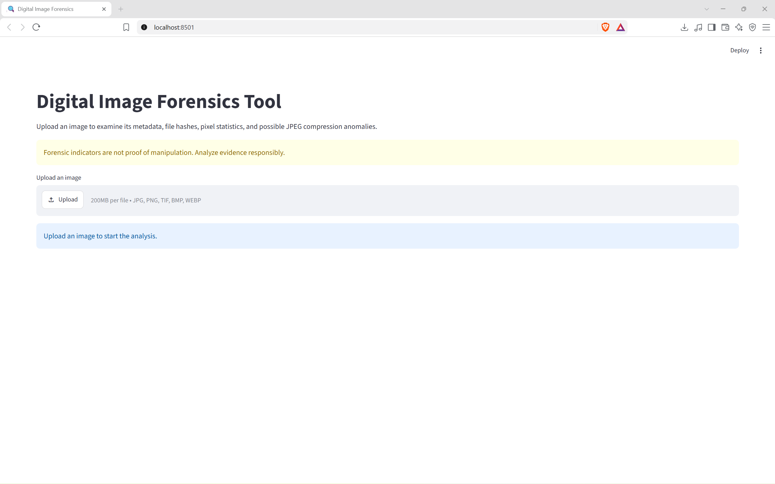

Figure 3.1: Initial interface of the Digital Image Forensics Tool.

The major stages of the system are as follows:

Image Upload: The user uploads an image through the web interface.

Image Validation: The system checks the uploaded file and prepares it for analysis.

Metadata Extraction: Available image properties and EXIF information are retrieved.

Hash Generation: MD5 and SHA-256 hashes are calculated for file integrity comparison.

Error Level Analysis: JPEG compression differences are analyzed and visualized.

Pixel Intensity Analysis: Pixel intensity statistics are calculated to describe image characteristics.

Report Generation: The collected analysis results are presented and exported in JSON format.

This design provides a modular approach to image examination and allows different forensic techniques to operate within one application.

3.2 Metadata Extraction and Image Property Analysis

Metadata extraction is an important component of the proposed system because it provides contextual information about an uploaded image. Digital images may contain information such as file format, dimensions, color mode, and other embedded properties. Depending on the image and its processing history, EXIF metadata may also contain camera information, timestamps, and other details.

Implementation Strategy

Image Property Retrieval: The system reads basic image properties, including dimensions and format.

EXIF Extraction: Available EXIF information is retrieved and presented in a readable format.

Metadata Presentation: The extracted information is displayed through the Stream lit interface.

Missing Metadata Handling: If metadata is unavailable, the system reports the information that can be retrieved rather than assuming that the image is invalid.

Design Advantages

Metadata extraction allows users to inspect the available information associated with an image without using separate utilities. It provides useful context for further analysis and may reveal inconsistencies that require investigation. However, metadata can be removed or modified, so it cannot independently establish image authenticity.

3.3 Cryptographic Hash Generation

The proposed system generates MD5 and SHA-256 hash values for uploaded images. A cryptographic hash represents the contents of a file as a fixed-length value and can be used to compare files and identify changes in their digital contents.

Implementation Strategy

File Input: The system receives the uploaded image as input.

MD5 Calculation: An MD5 hash is calculated from the image file contents.

SHA-256 Calculation: A SHA-256 hash is generated from the same file contents.

Result Display: Both hash values are displayed to the user.

Report Integration: The generated hashes can be included in the forensic report for future reference.

Design Advantages

Hash generation provides a simple method of checking whether two files have identical contents by comparing their hash values. SHA-256 provides stronger collision resistance than MD5 and is generally more suitable for security-sensitive integrity checks. Hashing does not, however, identify manipulated regions or determine whether the original image content is genuine.

3.4 Error Level Analysis (ELA)

Error Level Analysis is used to visualize differences associated with JPEG recompression. When a JPEG image is recompressed, the resulting pixel values may differ from those of the original file. ELA highlights these differences and provides a visual representation that can help users examine potentially suspicious areas.

Implementation Strategy

Image Preparation: The uploaded JPEG image is prepared for analysis.

Recompression: A recompressed version of the image is generated.

Difference Calculation: Differences between the original and recompressed images are calculated.

Visualization: The resulting differences are processed into an ELA output for display.

User Interpretation: The user examines the output alongside metadata and other forensic results.

Design Advantages

ELA provides a visual aid for examining compression inconsistencies and can help identify regions that deserve closer inspection. However, variations may also arise from legitimate editing, image quality, or previous compression. Therefore, ELA results are treated as indicators rather than conclusive proof of manipulation.

3.5 Pixel Intensity Analysis

Pixel intensity analysis examines the numerical values of image pixels to summarize their distribution and characteristics. In color images, these values may be represented through individual color channels, while grayscale images contain intensity values representing brightness.

Implementation Strategy

Pixel Data Extraction: The image is processed to access its pixel values.

Statistical Calculation: Relevant pixel intensity statistics are calculated.

Result Presentation: The calculated values are displayed in the application.

Combined Interpretation: The statistics can be considered alongside metadata, hashes, and ELA results.

Design Advantages

Pixel intensity analysis provides additional information about the image's brightness and pixel-value distribution. It complements the other implemented techniques by examining image characteristics at the pixel level. Nevertheless, ordinary lighting conditions, shadows, and image processing can affect pixel values, so statistical differences alone cannot confirm manipulation.

3.6 JSON Report Generation

The proposed system includes a report-generation feature that exports forensic analysis results in JSON (JavaScript Object Notation) format. JSON provides a structured representation of data that can be stored, read by software applications, and used for subsequent analysis.

Implementation Strategy

Result Collection: The outputs from the implemented forensic modules are collected.

Structured Formatting: Available results are organized into JSON-compatible fields.

Report Export: The structured information is provided as a downloadable report.

Documentation: The report can be retained for reference, comparison, or further examination.

Design Advantages

JSON report generation makes it easier to preserve and share analysis results in a structured format. It also provides a foundation for future integration with other forensic tools or automated workflows.

3.7 Security, Reliability, and Design Considerations

The Digital Image Forensics Tool is designed to provide consistent and accessible preliminary image analysis. Its reliability depends on appropriate handling of uploaded files, correct execution of analysis operations, and clear presentation of the resulting information.

Key Design Considerations

Input Validation: Uploaded files should be checked to ensure that they can be processed as supported image formats.

Consistent Analysis: Each analysis module should operate on the intended image data and produce results corresponding to that input.

File Integrity: Hash values should be calculated from the uploaded file contents to support accurate file comparison.

Error Handling: Unsupported files or unavailable metadata should be handled without unnecessarily interrupting the application.

Result Interpretation: The application should present analytical outputs without treating individual indicators as definitive proof of tampering.

Report Accuracy: Exported JSON data should accurately represent the results generated by the analysis modules.

Architectural Advantages

The proposed design integrates several forensic techniques into a single web-based application, reducing the need to switch between separate utilities. Its modular structure supports easier maintenance and future enhancement. Additional capabilities, such as copy-move forgery detection, image splicing analysis, and machine-learning-based classification, could be incorporated in future versions.

The current implementation focuses on metadata and EXIF extraction, MD5 and SHA-256 hash generation, JPEG Error Level Analysis, pixel intensity statistics, and JSON report export. These capabilities provide a foundation for preliminary digital image examination while acknowledging that a definitive assessment of image authenticity may require additional forensic evidence.

CHAPTER 4

Results

Results

4.1 Evaluation Overview and Metrics

The performance evaluation of the proposed Digital Image Forensics Tool focuses on the functionality of its image analysis modules and the presentation of forensic results. The application is developed using Python and Streamlit and provides a web-based interface for examining uploaded digital images.

The evaluation considers three primary aspects:

Functional Correctness: Examining whether the application successfully uploads images, extracts available metadata, generates file hashes, performs Error Level Analysis (ELA), and calculates pixel intensity statistics.

Analysis and Result Presentation: Evaluating whether the generated hash values, metadata, ELA output, and pixel statistics are displayed clearly through the application interface.

Report Generation: Verifying the availability of the JSON report download feature for storing and reviewing the analysis results.

The application was tested locally through a web browser using a sample JPEG image. The results presented in this chapter are based on the displayed application interface and its observed outputs.

4.2 System Modules and UI Behaviour

The Digital Image Forensics Tool consists of multiple analysis modules integrated into a single interface. The user uploads an image, after which the application presents the available forensic information through separate sections.

4.2.1 Image Upload Interface

The application provides an image upload interface that allows users to select images for examination. The displayed interface supports JPG, PNG, TIF, BMP, and WEBP formats, with a stated file-size limit of 200 MB per file.

After an image is uploaded, the application begins the analysis process and presents the results in the corresponding sections.

4.2.2 File Integrity Hashes and Metadata Analysis

The File Integrity Hashes module generates MD5 and SHA-256 hash values from the uploaded image. These values can be recorded and compared with hashes calculated from another copy of the file to help determine whether its contents have changed.

The Metadata Analysis module displays information such as image format, width, height, and color mode. It also attempts to retrieve available EXIF information.

In the sample output, the image was identified as a JPEG file with a width of 640 pixels, a height of 471 pixels, and RGB color mode. The displayed metadata contained no standard EXIF tags. The absence of EXIF information does not necessarily indicate image manipulation.

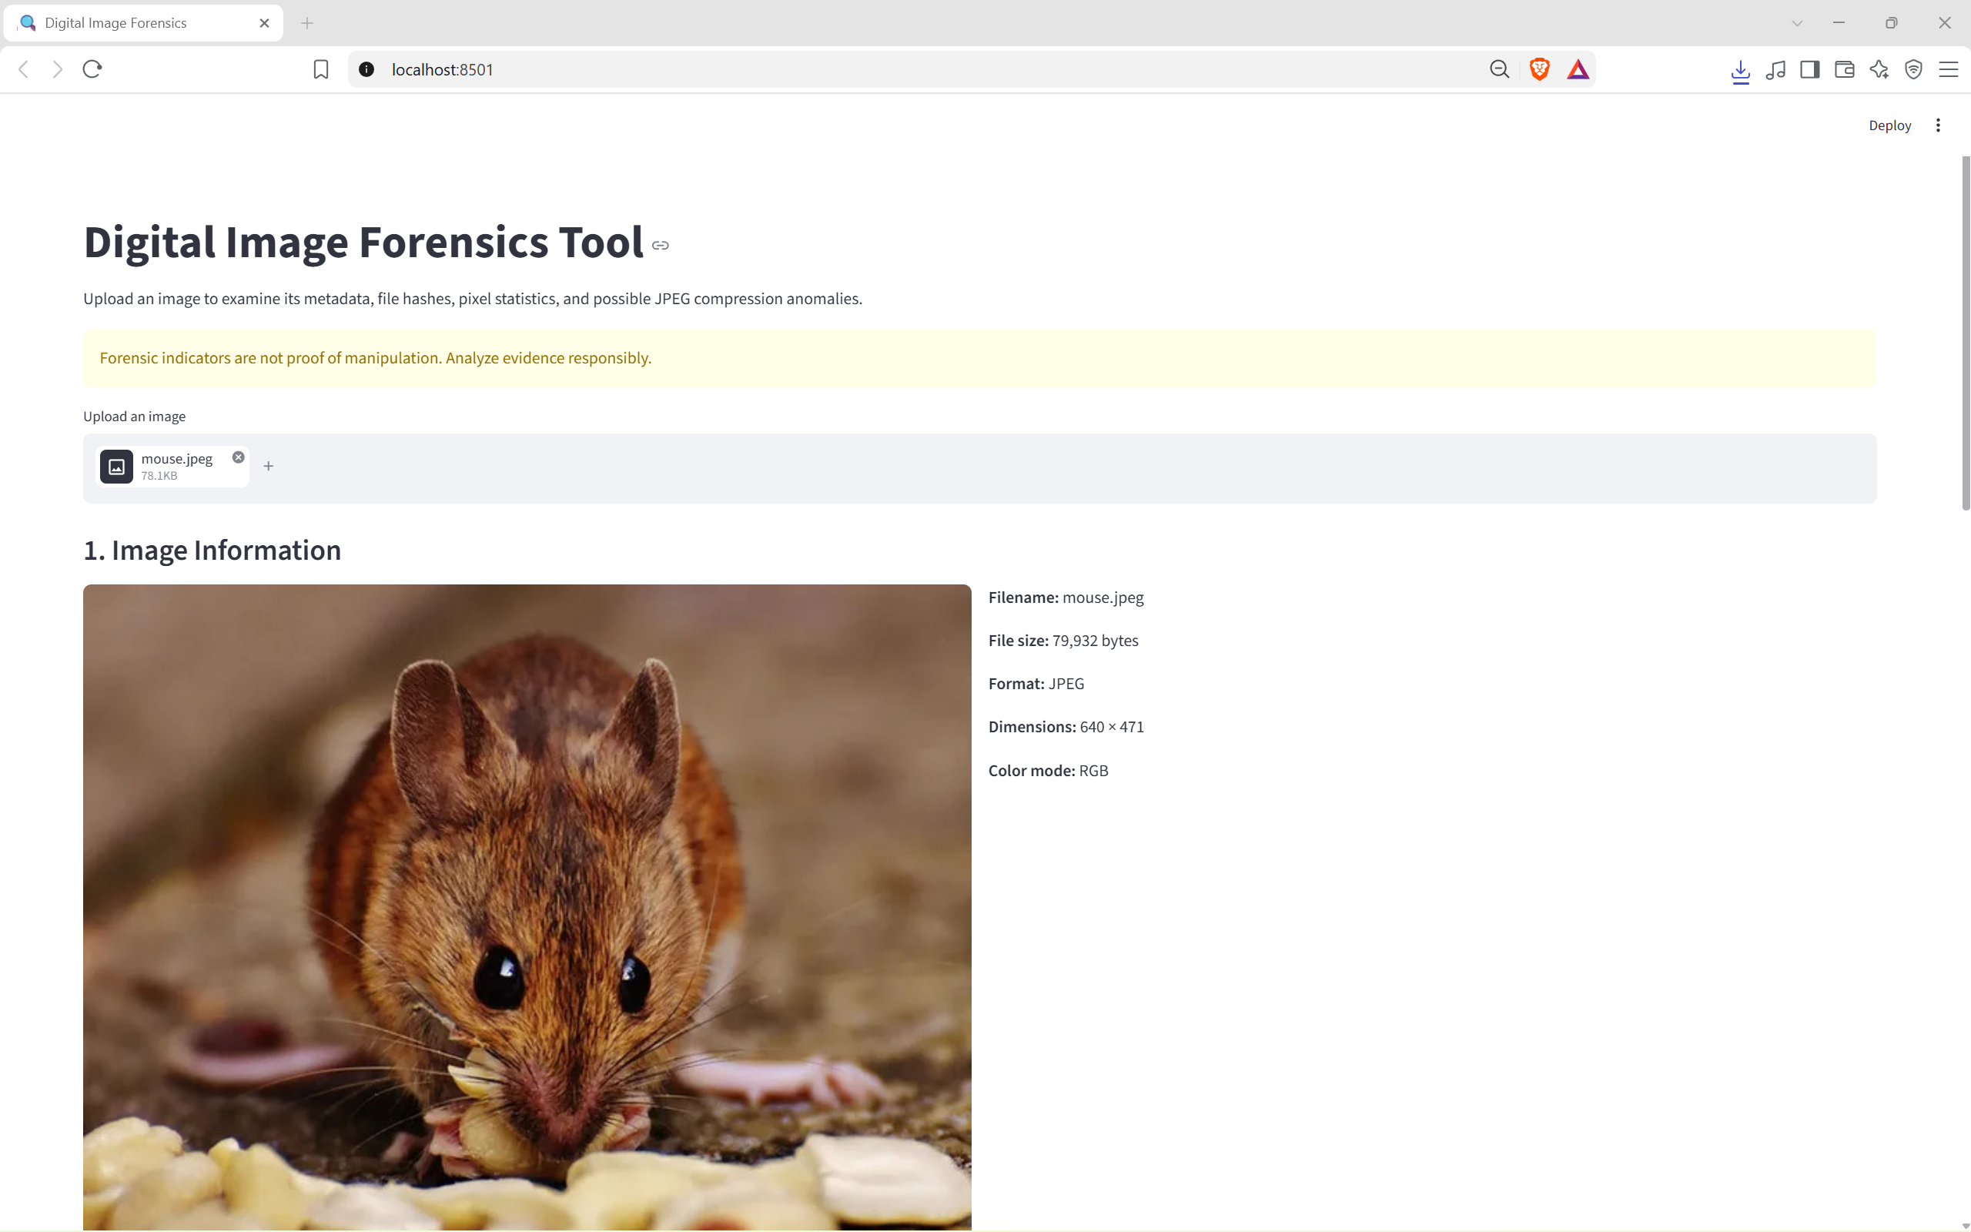

Figure 4.1: File Integrity Hashes and Metadata Analysis

4.2.3 Error Level Analysis (ELA)

The Error Level Analysis module compares a JPEG image with a recompressed version and visualizes the resulting differences. The application displays the original image alongside the ELA output, allowing users to examine compression variations.

In the sample output, the ELA image displays a predominantly dark background with visible localized variations. These differences may help identify regions that require further examination. However, compression history, image quality, and legitimate image processing can also affect the results.

Therefore, ELA is used as an analytical aid rather than definitive evidence of image manipulation.

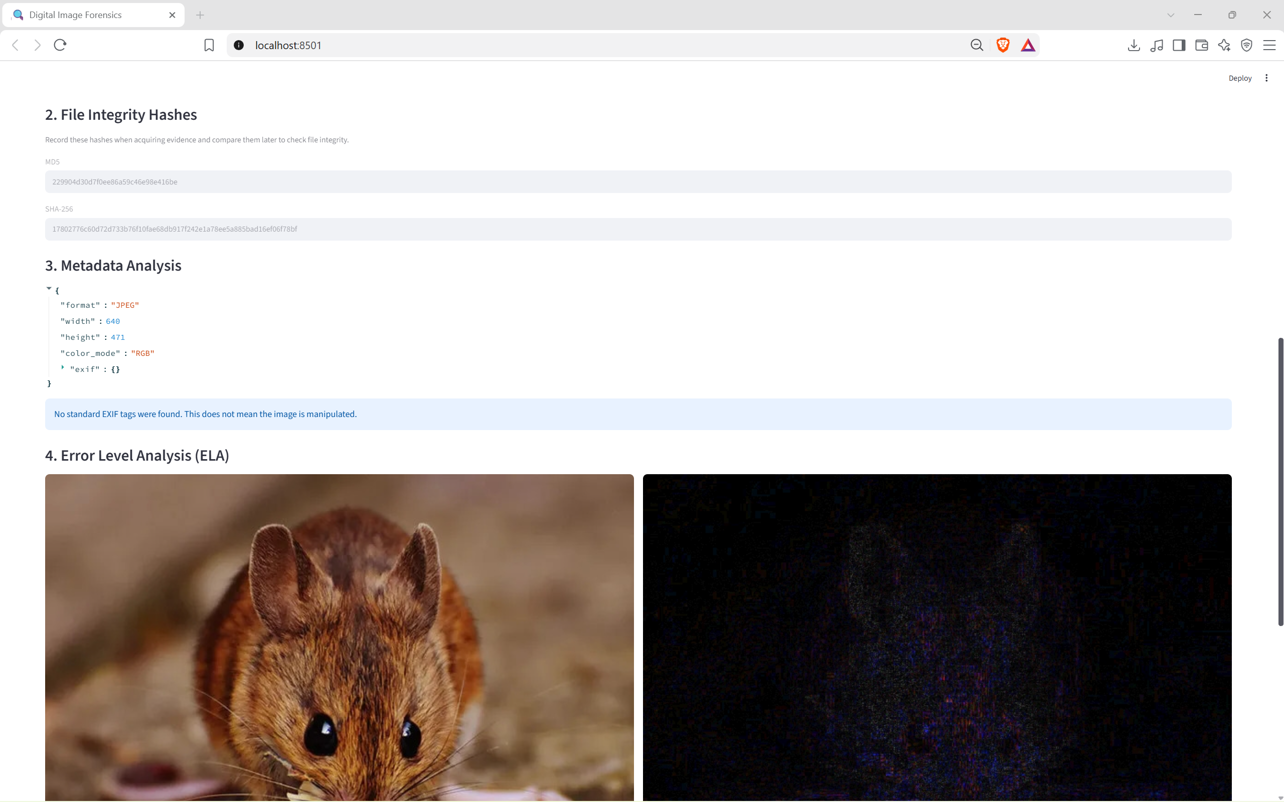
Figure 4.2: Error Level Analysis Output

4.2.4 Pixel Intensity Statistics

The Pixel Statistics module calculates and displays intensity measurements for the uploaded image. The interface presents the mean, minimum, and maximum intensity values, providing a numerical summary of the image's pixel characteristics.

For the sample image, the application displayed the following results:
Metric | Observed Value
Mean Intensity | 99.29 / 255
Minimum Intensity | 0
Maximum Intensity | 255

The mean intensity summarizes the average intensity value, while the minimum and maximum indicate the lowest and highest values observed in the analyzed pixel data. These statistics provide additional information about the image but cannot independently establish whether it has been modified.

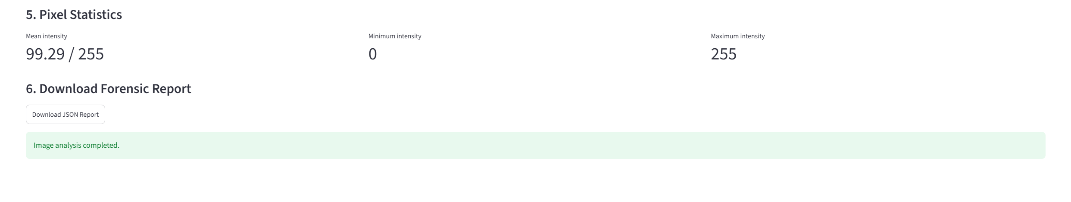

Figure 4.3: Pixel Statistics

4.2.5 JSON Forensic Report Generation
The application provides a Download JSON Report button after the analysis is completed. This feature allows users to export the collected analysis results in a structured, machine-readable format.
The JSON report can be retained for documentation, reviewed later, or used by another application for further processing. The interface also displays a confirmation message stating that image analysis has completed.
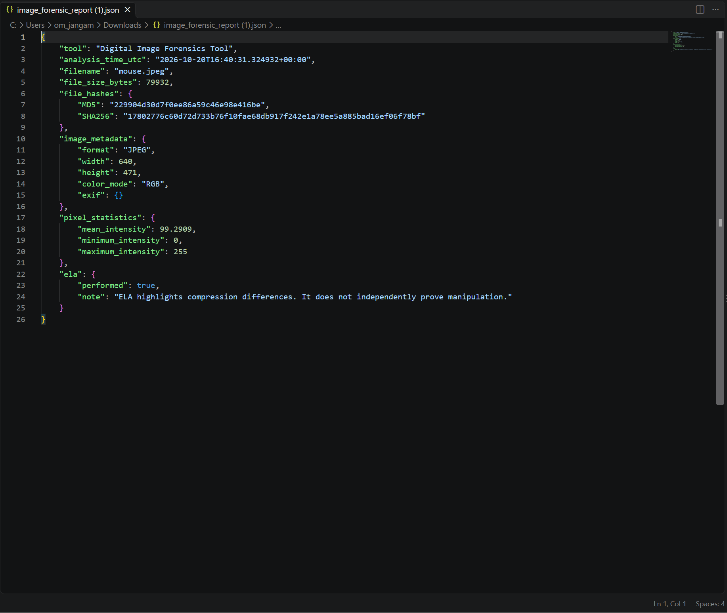
Figure 4.3: JSON Forensic Report Download Option

4.3 Analysis and Key Observations

Observation 1: Integration of Forensic Techniques

The application combines metadata extraction, file integrity hashing, ELA, and pixel intensity analysis within a single interface. This integration simplifies preliminary image examination by reducing the need to use separate utilities for each operation.

Observation 2: File Integrity and Metadata Information

The application generates MD5 and SHA-256 hashes and displays the available metadata of the uploaded image. Hash values support file comparison, while metadata provides contextual information about image properties. Neither feature independently proves that the image is authentic.

Observation 3: Visual and Statistical Analysis

ELA provides a visual representation of JPEG compression differences, while pixel intensity statistics provide numerical information about the image. These methods examine different characteristics and can complement one another during preliminary analysis. Their results require careful interpretation because legitimate image processing can also produce variations.

Observation 4: Structured Report Generation

The JSON report feature provides a way to preserve analysis results in a structured format. This improves the convenience of documentation and provides a foundation for future integration with other digital forensic tools.

4.4 Comparative Evaluation

The following table compares the proposed tool with a basic manual image examination approach.

Table 4.1: Comparative Analysis of Manual Image Examination and the Proposed Tool
Feature | Manual Image Examination | Proposed Digital Image Forensics Tool
Metadata Inspection | Requires manual inspection or a separate utility | Integrated metadata and EXIF analysis
Hash Generation | Requires a separate hashing utility or command | Generates MD5 and SHA-256 hashes
JPEG Compression Analysis | Requires a suitable external tool | Integrated ELA visualization
Pixel Statistics | May require separate image-processing software | Displays mean, minimum, and maximum intensity
Result Presentation | Information may be spread across multiple tools | Results presented in one interface
Report Generation | May require manual documentation | Provides JSON report export
Manipulation Detection | Depends on the methods used and examiner interpretation | Provides forensic indicators for further examination
Definitive Authenticity Verdict | Cannot be established through visual inspection alone | Not provided by the current implementation

The comparison highlights the convenience of integrating multiple analysis techniques into one application. However, the proposed tool is intended for preliminary examination and does not replace a comprehensive forensic investigation.

4.5 Summary of Results

The observed results demonstrate that the Digital Image Forensics Tool provides a unified interface for performing the implemented image examination operations. The application displays file hashes, image metadata, ELA output, and pixel intensity statistics and provides an option to export the analysis results as a JSON report.

The sample image was identified as a 640 × 471 JPEG image with RGB color mode. Its displayed mean intensity was 99.29 out of 255, with a minimum of 0 and a maximum of 255. No standard EXIF tags were found in the sample.

These results demonstrate the application's implemented functionality for the tested image. Further testing with different image formats, compression histories, and known manipulated and unmanipulated images would be required to evaluate the broader accuracy and reliability of its forensic indicators.

Chapter 5
Discussions

Discussions

5.1 Analysis Performance and Processing Considerations

The performance of the proposed Digital Image Forensics Tool depends on the image size, file format, processing requirements, and the operations performed during analysis. Unlike blockchain-based applications, the proposed system primarily performs local image processing and metadata examination using Python libraries within a Streamlit web interface.

The main processing operations include metadata extraction, cryptographic hash generation, JPEG recompression analysis, pixel intensity calculation, and JSON report generation.

The processing requirements of these operations differ:

Metadata Extraction: Retrieving image properties and available EXIF information generally requires limited processing because the application primarily reads existing image information.

Hash Generation: Calculating MD5 and SHA-256 hashes requires reading the image file contents. Processing time can increase with larger files because the entire file must be processed.

Error Level Analysis: ELA requires recompressing the JPEG image and calculating differences between the original and recompressed versions. Its processing time depends on the image dimensions, compression settings, and available system resources.

Pixel Intensity Analysis: Calculating pixel statistics requires examining pixel values. Larger images contain more pixels and may therefore require additional processing time and memory.

JSON Report Generation: Preparing the report involves organizing the collected analysis results into a structured format. The processing requirements depend on the amount of information included in the report.

The application successfully displayed the analysis results for the sample image shown in Chapter 4. However, numerical benchmarks for processing time, memory consumption, and performance across different image sizes were not recorded. Therefore, further testing would be necessary to quantify the application's performance under different workloads.

5.2 System Bottlenecks and Design Constraints

Image Processing and Memory Usage

One potential bottleneck is the processing of large images. High-resolution images require more memory to store pixel data and intermediate results. Operations such as JPEG recompression and ELA may require additional temporary image representations, increasing resource consumption.

Possible improvements include:

Resizing images for selected analytical operations where appropriate, while preserving the original file for integrity verification.

Processing image data efficiently to reduce unnecessary memory usage.

Handling large files carefully and providing informative messages when an image cannot be processed.

Measuring execution time for each analysis module to identify operations that require optimization.

Image Format and Metadata Compatibility

Different image formats store image properties and metadata differently. EXIF information may be absent, incomplete, or removed during ordinary image processing and sharing. Some forensic operations, particularly JPEG-based ELA, are not directly applicable to every image format.

The application must therefore distinguish between unavailable metadata and evidence of manipulation. The absence of EXIF tags does not establish that an image has been modified. Similarly, the ELA method should be applied and interpreted according to the supported image format and the processing performed.

Interpretation of Forensic Results

Another important constraint is the interpretation of analysis outputs. Hash values can support file integrity comparison, but they do not reveal which regions of an image have been modified. ELA can highlight compression differences, but those differences may also arise from legitimate editing or previous compression.

Pixel intensity statistics describe numerical image characteristics but cannot independently determine authenticity. Consequently, the application presents these results as forensic indicators rather than a definitive classification of an image as genuine or manipulated.

Reliability of Report Generation

The JSON report provides a structured record of the generated analysis results. Its reliability depends on whether the collected values are represented accurately and consistently. Future improvements could include adding analysis timestamps, file names, processing details, and clear descriptions of the limitations of each technique.

5.3 Limitations and Future Scope

1. Advanced Image Manipulation Detection

The current implementation provides metadata and EXIF extraction, MD5 and SHA-256 hash generation, ELA, and pixel intensity statistics. It does not independently detect every type of image manipulation or provide an automated, definitive authenticity verdict.

Future improvements could include:

Copy-Move Forgery Detection: Identifying regions that may have been copied and pasted within the same image.

Image Splicing Detection: Examining whether content from different images may have been combined.

Machine-Learning-Based Analysis: Investigating trained models that can classify certain types of image manipulation, subject to suitable datasets and evaluation.

Additional Statistical Techniques: Incorporating more advanced image noise, compression, and consistency analysis.

2. Performance and Scalability Improvements

Processing time and memory consumption may increase when large or high-resolution images are analyzed. Future versions could improve performance through optimized image-processing operations, more efficient memory management, and testing across different image sizes and file formats.

A systematic evaluation could record average processing time, peak memory consumption, successful processing rates, and behavior when handling unsupported or corrupted images.

3. User Interface and Usability Enhancements

The current Streamlit interface combines image uploading, analysis results, and report downloading. Further improvements could make the examination process easier to understand and navigate.

Possible enhancements include:

Providing a progress indicator while the image is being analyzed.

Displaying clearer explanations alongside individual forensic results.

Supporting side-by-side comparisons of multiple images.

Allowing users to compare hash values from different files.

Improving the layout of downloadable reports for documentation.

4. Forensic Reporting and Evidence Management

The existing JSON export feature provides a foundation for retaining analysis results. Future versions could extend the report with additional information, including analysis timestamps, file properties, processing parameters, and module-specific observations.

An evidence management feature could also maintain organized records of examined files and their corresponding hash values. Such an extension would require appropriate safeguards to preserve original files and document the handling of evidence.

5. Comparative Evaluation and Research Outlook

The proposed tool demonstrates how multiple preliminary forensic techniques can be integrated into one accessible application. Compared with examining image properties through separate utilities, the integrated approach simplifies access to metadata, hash values, ELA output, pixel statistics, and structured reports.

However, the effectiveness of the tool depends on the image characteristics and the limitations of the implemented techniques. Future research should evaluate the system using a diverse collection of authentic and manipulated images with known ground truth. Such testing could help determine how reliably different techniques identify suspicious content and how frequently they produce misleading indicators.

The long-term direction of the project is to extend the current application into a more comprehensive image examination platform. By incorporating additional forensic methods, improving processing efficiency, and conducting systematic evaluations, future versions could provide more detailed analytical support for digital image investigations.

Chapter 6

Conclusion

Conclusion

The Digital Image Forensics Tool demonstrates how multiple image analysis techniques can be integrated into a single application to support preliminary digital image examination.
By combining metadata and EXIF extraction, MD5 and SHA-256 hash generation, Error Level Analysis (ELA), and pixel intensity statistics, the system provides useful information for examining image properties and identifying potential forensic indicators. The JSON report feature further supports the structured documentation of analysis results.
Although the tool provides convenient access to several forensic techniques, its findings must be interpreted carefully. Missing metadata, compression differences, and pixel intensity variations do not independently prove that an image has been manipulated.
The current implementation also does not provide a definitive authenticity verdict. Future enhancements, such as copy-move forgery detection, image splicing analysis, machine-learning-based techniques, and improved forensic reporting, could expand its capabilities and analytical accuracy. Overall, the project establishes a foundation for an accessible image examination tool that can be further developed to support more comprehensive digital forensic investigations.

Chapter 7

References

References

• Stallings, W. (2018). Computer Security: Principles and Practice (4th Edition). Pearson Education. – Provides foundational concepts on computer security and digital forensics.
• Nelson, B., Phillips, A., & Steuart, C. (2020). Guide to Computer Forensics and Investigations (6th Edition). Cengage Learning. – Explains key methods used in forensic analysis, including digital image forensics.
• Casey, E. (2019). Digital Evidence and Computer Crime: Forensic Science, Computers and the Internet (4th Edition). Academic Press. – Discusses forensic methodologies for analyzing and preserving digital evidence.
• Farid, H. (2016). Photo Forensics. MIT Press. – Focuses specifically on techniques used to detect image manipulation and forgery.
• Mahdian, B., & Saic, S. (2009). “Using noise inconsistencies for blind image forensics.” Image and Vision Computing, 27(10), 1497–1503. – Research paper detailing how noise patterns can help identify tampered regions in images.
• OpenCV Documentation. (2024). Open Source Computer Vision Library. Retrieved from https://docs.opencv.org/ – Official documentation used for implementing image analysis and processing tasks.
• Python Software Foundation. (2024). Python Standard Library Documentation. Retrieved from https://docs.python.org/3/library/ – Reference for Python libraries such as NumPy, Pillow, and Regular Expressions used in the project.
• ExifRead Documentation. (2024). Metadata Extraction from Images in Python. Retrieved from https://pypi.org/project/ExifRead/ – Used to understand how to extract and interpret EXIF data from image files.
• Matplotlib Developers. (2024). Matplotlib: Visualization with Python. Retrieved from https://matplotlib.org/ – Documentation for creating ELA visualizations and image analysis plots.
• Kaur, S., & Kaur, P. (2021). “Digital Image Forgery Detection Techniques: A Review.” International Journal of Advanced Research in Computer Science, 12(3), 20–26. – A comprehensive review of existing image forgery detection algorithms and approaches.

