Project Title : **‘** Men’s **Tailor Website ’**

Project Website name : **‘** TailorBird **’**

Project Demo Screenshot :

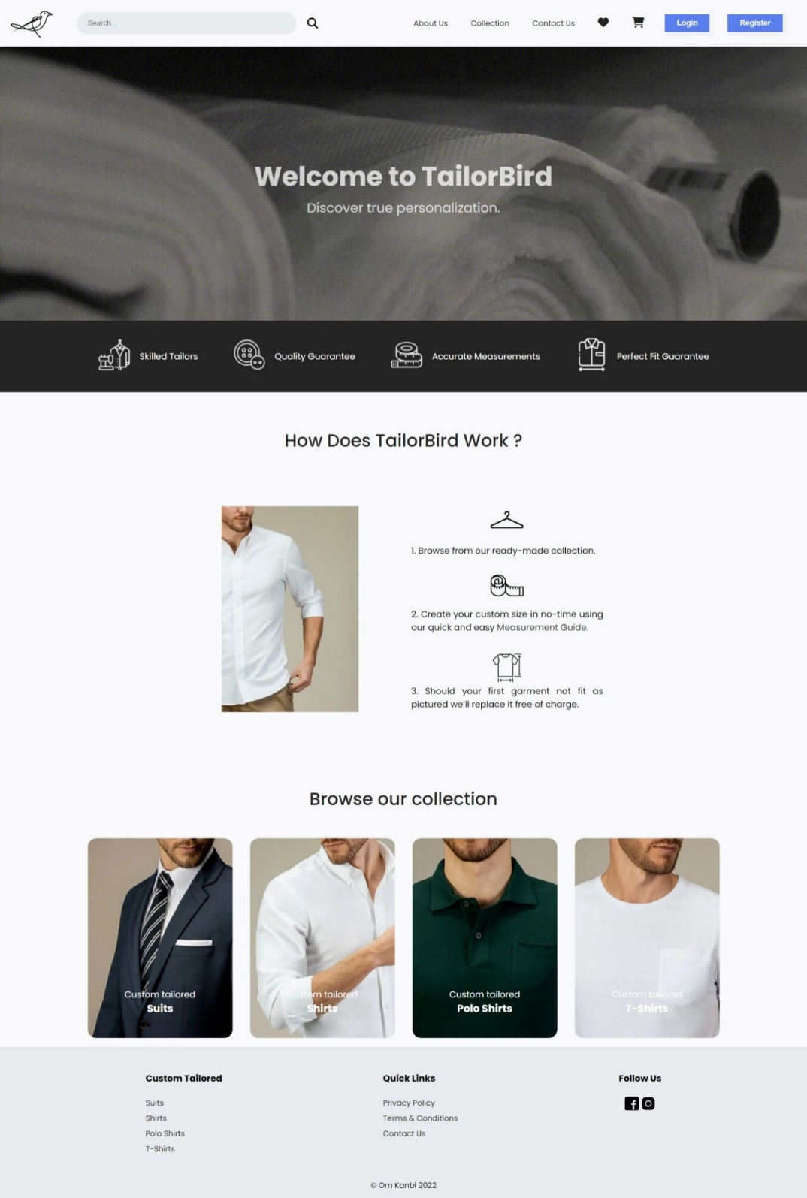

Overview :

The COVID-19 pandemic has led to a surge in e-commerce worldwide. Clients can order customized clothing for men with ease through our website. We guarantee a perfect fit for every customized clothing you order which is made by our finest tailors with high quality materials.

Logo :

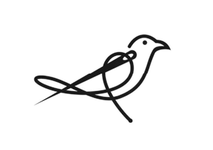

Structure :

* Login / Sign up page or pop-up
* Home page
* Listing page
* Product page
* Payment page

Database :

* MongoDB

Backend :

* NodeJS
* Express

Frontend :

* HTML
* CSS
* Bootstrap
* ReactJS