SECURENOTES
A DevSecOps Secure CI/CD Pipeline with AI-Powered Remediation
Detailed Project Report
Submitted by
Siddhant Shukla -16010123330
Siddhant Raut -16010123331
B.Tech Computer Engineering, Final Year
K.J. Somaiya School of Engineering, Mumbai
DevOps Mini Project
October 2026
Repository: github.com/Siddhantshukla1657/SecureNotes_Devops_Miniproject

Abstract
Security checks in many delivery pipelines run late, after code has already been merged or deployed. Findings then reach developers as long tickets that are slow to triage and easy to postpone. This project builds a small web application, SecureNotes, and wraps it in a pipeline that tries to move those checks to the point where code is committed.
SecureNotes is a Flask notes application served by Gunicorn inside a Docker container. A four-stage GitHub Actions workflow builds and tests it. Stage 1 runs a pytest suite with coverage and submits the code to SonarCloud for static analysis and secret detection, and the SonarCloud quality gate must pass. Stage 2 builds the image and scans it with Trivy, failing on any fixable HIGH or CRITICAL vulnerability. Stage 3 pushes the image to Docker Hub only if both gates passed. Stage 4 runs when either gate fails: a Python agent sends the findings to NVIDIA Nemotron 70B through the NVIDIA NIM API, receives a patch with a plain-language explanation, and opens a pull request.
The agent can open pull requests but cannot merge them, push to main, or approve its own changes, so a developer reviews every proposed fix. Four demonstration profiles (vulnerable, fixed, agent-secret-only, agent-image-only) and reset scripts make the failure-and-repair cycle repeatable. The report documents the design, the pipeline stages, the agent, the test suite, the threat model and the limitations of the current implementation.
Keywords: DevSecOps, shift-left security, CI/CD, SonarCloud, Trivy, Docker, large language models, automated remediation, human-in-the-loop.

Table of contents
1. Introduction 8
1.1 Background 8
1.2 Problem statement 8
1.3 Objectives 8
1.4 Scope 9
2. Background and related concepts 10
2.1 DevSecOps and shift-left security 10
2.2 Static application security testing 10
2.3 Container vulnerability scanning 10
2.4 LLM-assisted remediation 10
2.5 Human-in-the-loop control 10
3. Technology stack 11
3.1 Components 11
3.2 Python dependencies 12
4. System architecture 13
4.1 Pipeline architecture 13
4.2 Job dependencies 14
4.3 Trigger conditions 14
4.4 Repository structure 14
5. Application design 15
5.1 Features 15
5.2 Endpoints 15
5.3 Data model 16
5.4 Note lifecycle 17
6. DevSecOps CI/CD pipeline 18
6.1 Stage 1: code quality and secret scan 18
6.2 Stage 2: container build and vulnerability scan 18
6.3 Stage 3: registry delivery 19
6.4 Gate behaviour 19
7. Containerisation and demonstration profiles 24
7.1 Dockerfile 24
7.2 Demonstration profiles 24
7.3 Reset tooling 25
8. Environment configuration 26
9. End-to-end workflow 28
10. Conclusion and future work 32
10.1 Conclusion 32
10.2 Future work 32
References 33

List of figures
Figure 1: Technology stack by layer
Figure 2: High-level CI/CD pipeline architecture
Figure 3: Job dependency graph
Figure 4: Endpoint map and request handling
Figure 5: In-memory data model
Figure 6: Note lifecycle from page load to redirect
Figure 7: Remediation agent workflow

List of tables
Table 1: Technology components and roles
Table 2: Dependency matrix
Table 3: Pipeline triggers
Table 4: Route summary
Table 5: Stage 1 steps
Table 6: Stage 2 steps
Table 7: Security layer summary
Table 8: Agent modes
Table 9: Test cases
Table 10: Dockerfile instructions

1. Introduction

1.1 Background
Continuous integration and delivery have shortened the time between writing code and running it in production. Security practice has not always kept pace. Vulnerability scans are often scheduled before a release or after an incident, and the person who introduced a flaw may be working on something else by the time it is reported. The cost of fixing a defect generally grows the later it is found, which is the argument behind the shift-left approach: run the checks where the change is made.
Two further difficulties remain even when scanners are present in the pipeline. The first is volume: a scanner can report dozens of findings, and developers must decide which matter. The second is effort: even a well-understood finding, such as a hardcoded credential or an outdated base image, needs someone to find the file, write the change and open a review. Recent large language models can read a finding together with the affected file and propose a targeted change, which makes it practical to automate the first draft of a fix.

1.2 Problem statement
Software delivery pipelines commonly treat security as an afterthought. Vulnerabilities surface in production, remediation is manual and slow, and developers get little feedback on the security effect of the code they have just written. This project addresses three gaps:
- Detection happens at deployment time instead of commit time.
- Remediation depends on manual triage, which delays fixes.
- Where automation is introduced, it risks acting without human oversight.

1.3 Objectives
- Build a containerised Flask application that can serve as a realistic target for security checks.
- Enforce two independent gates, static code analysis and container vulnerability scanning, before any image is published.
- Implement an agent that turns gate failures into reviewable pull requests containing a patch and an explanation.
- Restrict the agent so that every change it proposes passes through human review.
- Provide repeatable demonstration states, so that the whole cycle can be shown from a clean starting point.

1.4 Scope
The application is deliberately small. Notes are held in memory and are lost when the container restarts, and there is no user authentication. The effort of the project went into the pipeline and the remediation workflow rather than the application. The seeded vulnerabilities are limited to a hardcoded secret, duplicated validation code and an outdated base image, which are the classes of problem that the chosen scanners and the agent are designed to handle.

2. Background and related concepts

2.1 DevSecOps and shift-left security
DevSecOps extends the DevOps practice of automating build, test and release by adding security checks to the same automation. NIST's Secure Software Development Framework (SP 800-218) describes the practices involved, including reviewing code, testing for vulnerabilities and managing the components that go into a build [1]. Shift-left security applies this idea to timing: the earliest checks run on the developer's change, before an artifact exists, and later checks run on the built artifact.

2.2 Static application security testing
Static analysis examines source code without running it. It can find injection-prone constructs, unsafe API use, duplicated logic and credentials committed to the repository. SonarCloud implements these checks as rules, and a quality gate turns the results into a pass or fail decision for a build [2]. The rule that matters most for this project is python:S2068, which flags hardcoded credentials. Detecting a secret in the source is cheaper than detecting it after it has spread into container layers or git history.

2.3 Container vulnerability scanning
A container image carries an operating system layer and language packages, and either may contain known vulnerabilities. Scanners such as Trivy compare the installed package versions against public vulnerability databases and report findings by severity [3]. Choosing a current, minimal base image removes many findings at once, because fewer packages are installed and the remaining ones are patched.

2.4 LLM-assisted remediation
A language model given a finding, the affected file and a clear output format can propose a patch. The proposal can be wrong, can fix the symptom without the cause, or can introduce a new defect. For that reason this project treats the model output as a draft that enters the same review process as any contribution from a colleague.

2.5 Human-in-the-loop control
Human-in-the-loop design places a person at the decision point where an automated system could cause harm. Here the decision point is the merge. The agent holds only the permissions needed to create a branch and a pull request, so even a faulty or manipulated model response cannot reach the main branch without a reviewer approving it.

3. Technology stack
The stack is grouped into five layers (Figure 1): the application, the container, the CI/CD orchestration, the security tooling and the AI layer. Docker Hub is the final destination for images that pass every gate.
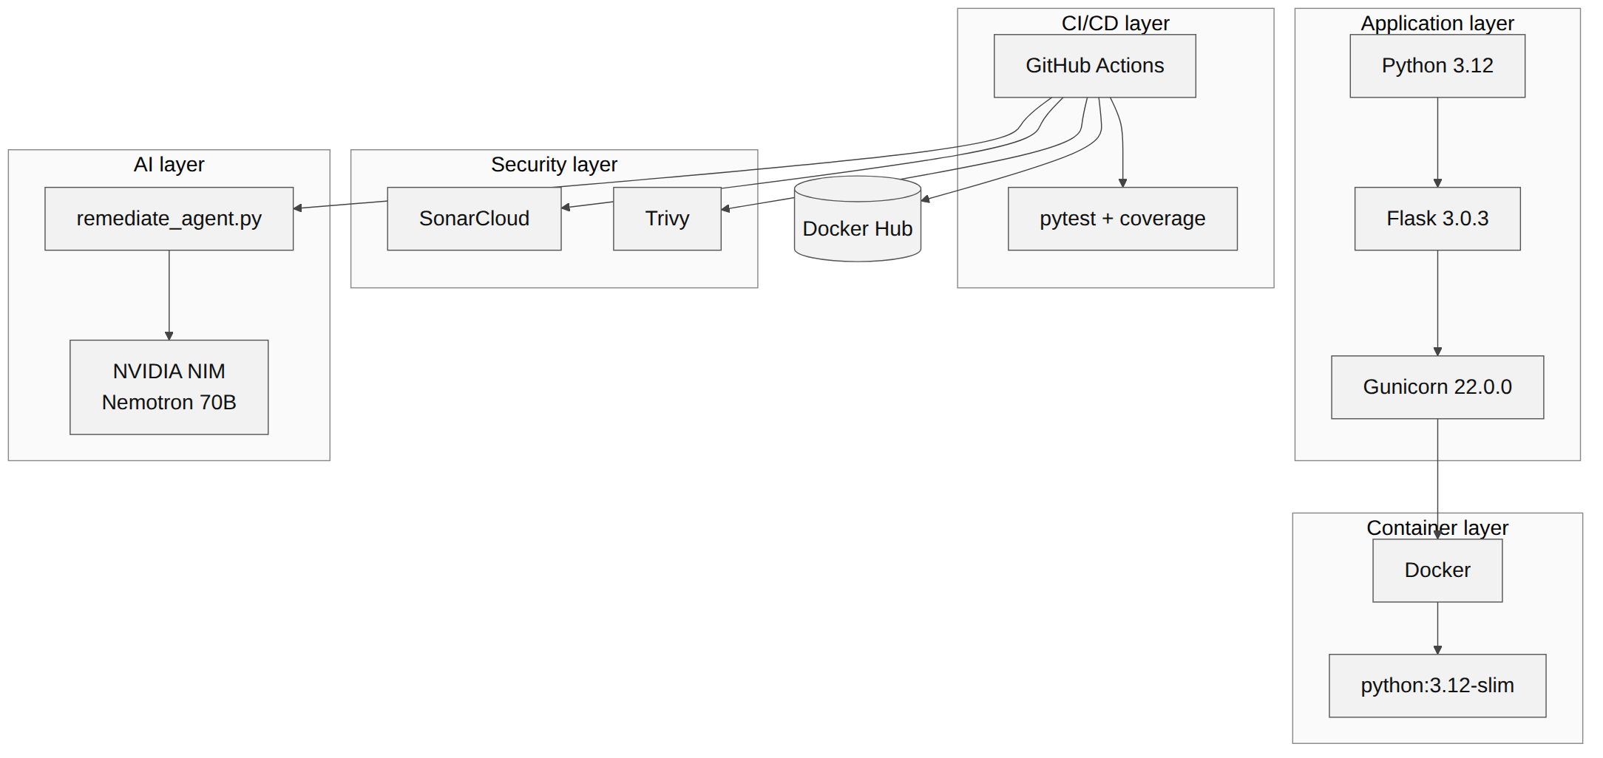
Figure 1: Technology stack by layer

3.1 Components
Table 1: Technology components and roles
Component | Role in the project
Flask 3.0.3 | Web framework, routing and template rendering
Gunicorn 22.0.0 | Production WSGI HTTP server inside the container
Python 3.12 | Runtime for the application and the remediation agent
Docker, python:3.12-slim | Containerisation on a minimal Debian base image
GitHub Actions | Pipeline orchestration and job dependency management
pytest, coverage | Test execution and coverage measurement
SonarCloud | Static analysis, secret detection and quality gate
Trivy | Container image and library vulnerability scanning
NVIDIA NIM, Nemotron 70B | Hosted model used to generate patches
Docker Hub | Registry for images that pass both gates

3.2 Python dependencies
Table 2: Dependency matrix
Package | Version | Purpose
Flask | 3.0.3 | Web framework, routing, template rendering
Gunicorn | 22.0.0 | Production-grade WSGI HTTP server
pytest | 8.2.2 | Automated test runner
requests | 2.32.3 | HTTP client used by the remediation agent
python-dotenv | 1.0.1 | Loading of environment variables from a .env file
coverage | 7.5.4 | Code coverage measurement
pytest-cov | 5.0.0 | Coverage plugin for pytest

4. System architecture

4.1 Pipeline architecture
Figure 2 shows the complete flow. A push to the main branch, a pull request against it, or a manual dispatch starts the workflow. Stage 1 analyses the code. If its quality gate passes, Stage 2 builds and scans the image. If that also passes, Stage 3 publishes it. A failure at either gate sends control to Stage 4, which produces a remediation pull request. Merging that pull request starts a new run.
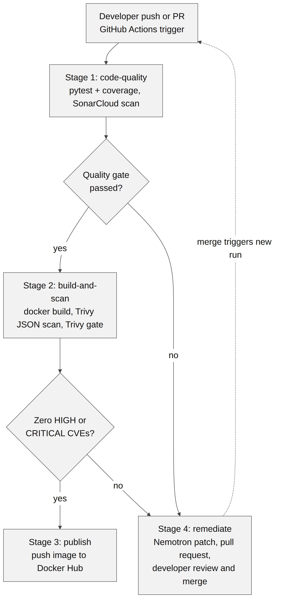
Figure 2: High-level CI/CD pipeline architecture

4.2 Job dependencies
The four jobs form a small dependency graph (Figure 3). The build job needs the code-quality job, the publish job needs the build job, and the remediate job is conditioned on failure() of either earlier job. Because secrets are caught in Stage 1, a leaked credential is rejected before the more expensive image build begins.
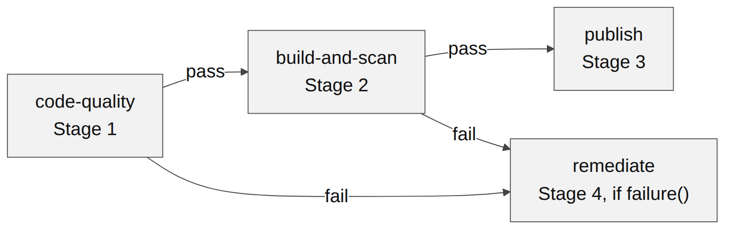
Figure 3: Job dependency graph

4.3 Trigger conditions
Table 3: Pipeline triggers
Trigger | Description
Push to main | Runs the full pipeline on every commit to the main branch
Pull request to main | Runs the gates on proposed changes before they merge
workflow_dispatch | Manual start with a force_remediate flag, used to demonstrate the agent

4.4 Repository structure
The repository separates application code, pipeline definition, scripts, tests and demonstration states:
SecureNotes_Devops_Miniproject/
app.py Flask application core
Dockerfile container image definition
requirements.txt Python dependencies
sonar-project.properties SonarCloud scan configuration
pytest.ini pytest configuration
run.bat, reset-demo.bat Windows launcher and reset wrapper
.github/workflows/pipeline.yml 4-stage GitHub Actions pipeline
scripts/remediate_agent.py NVIDIA NIM remediation agent
scripts/reset-demo.ps1, .sh demo reset scripts
tests/test_app.py 6 pytest cases
templates/index.html Jinja2 template
static/ CSS and static assets
demo-states/ vulnerable, fixed,
agent-secret-only, agent-image-only
docs/PROJECT_REPORT.md base report

5. Application design

5.1 Features
- Note management: notes are created, listed and deleted through a server-rendered page.
- Input validation: the server rejects empty, whitespace-only and malformed input.
- Ephemeral store: notes live in a thread-safe in-memory list that is mutated in place and exists for the lifetime of the container.
- Health endpoint: /health returns JSON that container readiness probes can use.
- Interface: Google Fonts (Inter) and inline SVG icons, with no external CSS framework.
- Launcher: run.bat on Windows finds Python, activates a virtual environment, installs dependencies and opens the browser.

5.2 Endpoints
The application exposes four routes (Figure 4). The two mutating routes pass their input through one function, validate_note_input, and always answer with a redirect to the index page, which keeps the page free of form-resubmission problems.
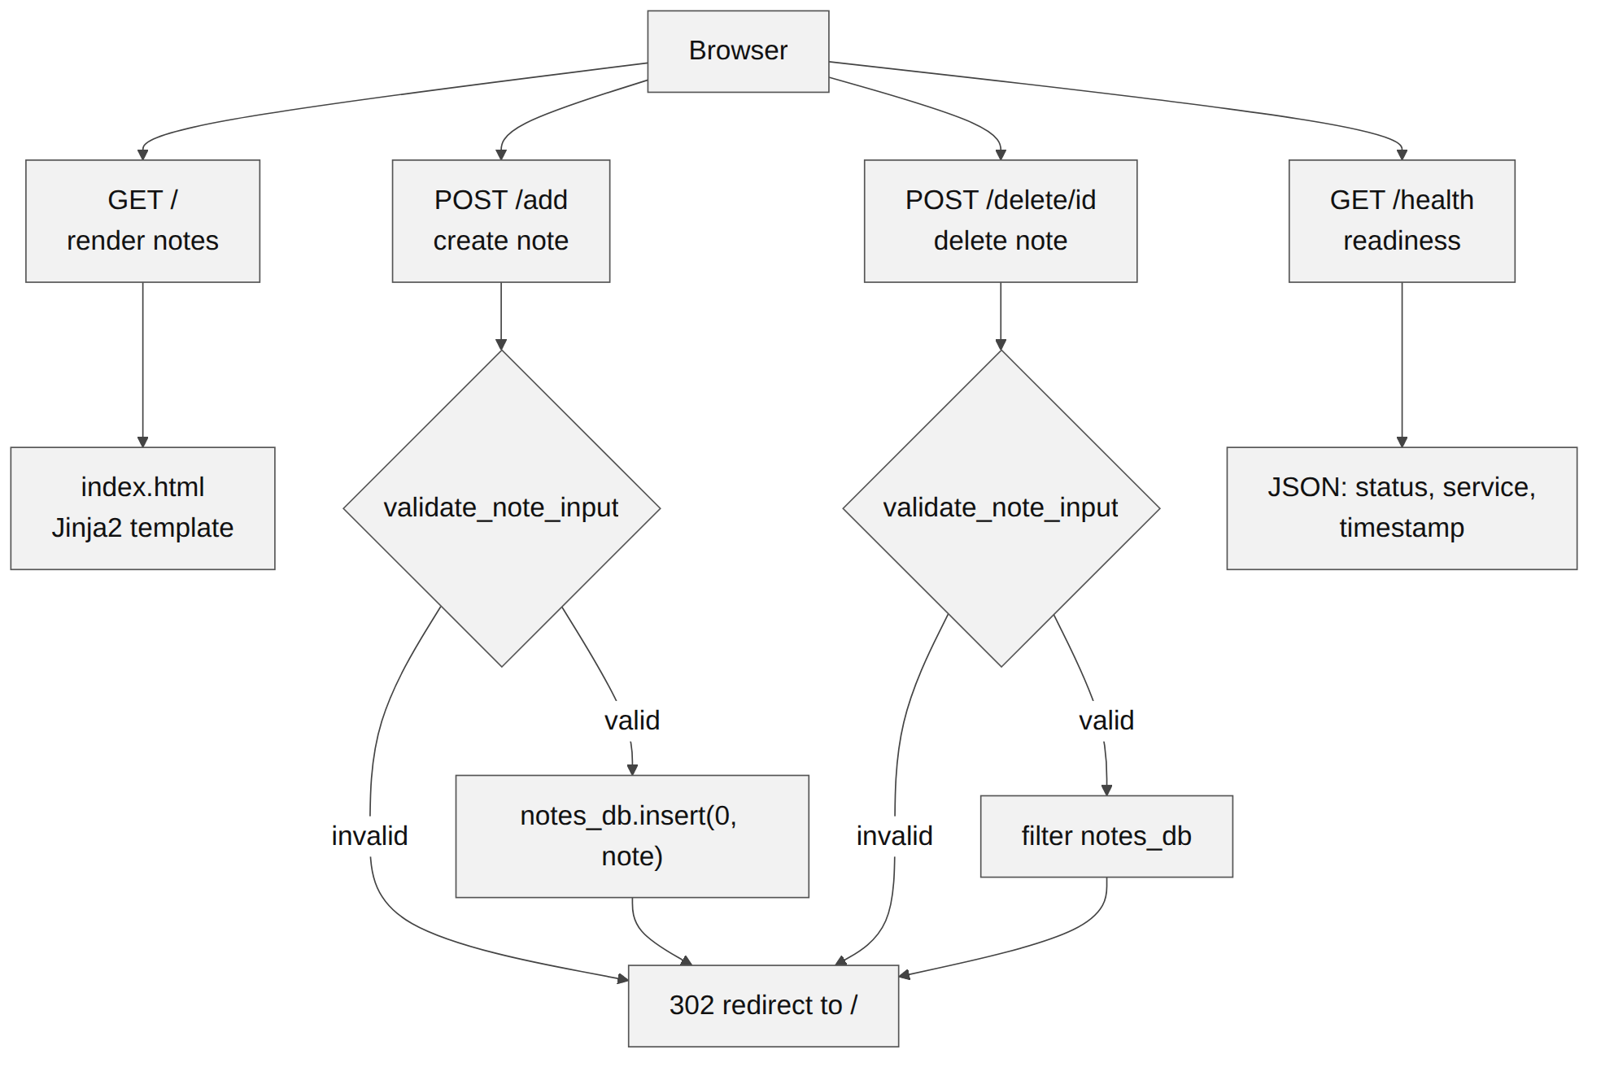
Figure 4: Endpoint map and request handling
Table 4: Route summary
Method | Route | Behaviour
GET | / | Renders the notes list from index.html
POST | /add | Validates the text, creates a note with an 8-character id and timestamp, inserts it at the head of the list, redirects to /
POST | /delete/<id> | Validates the id, removes the matching note, redirects to /
GET | /health | Returns JSON with status, service and an ISO timestamp

5.3 Data model
Each note has an identifier taken from the first eight characters of a UUID4, the stripped note text, and a creation timestamp (Figure 5). New notes are inserted at index 0, so the list is always ordered newest first. The store is intentionally not persistent. A production version would replace it with a database, and the route handlers would then need transactional writes and an authenticated user model.
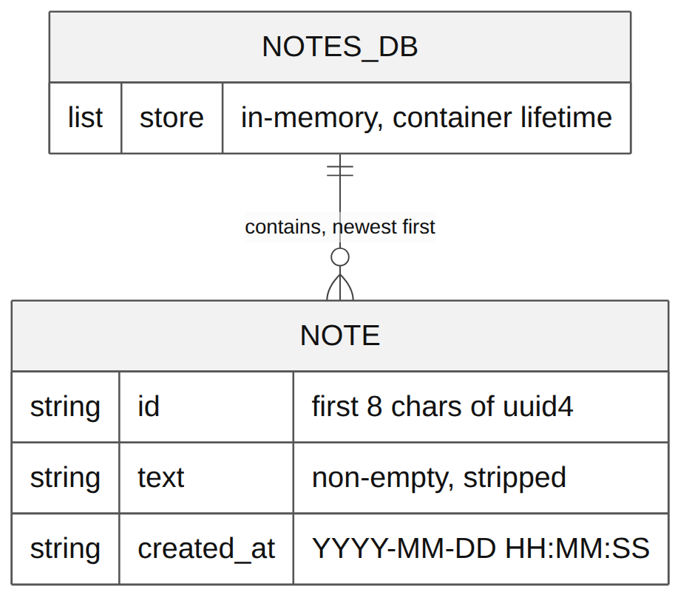
Figure 5: In-memory data model

5.4 Note lifecycle
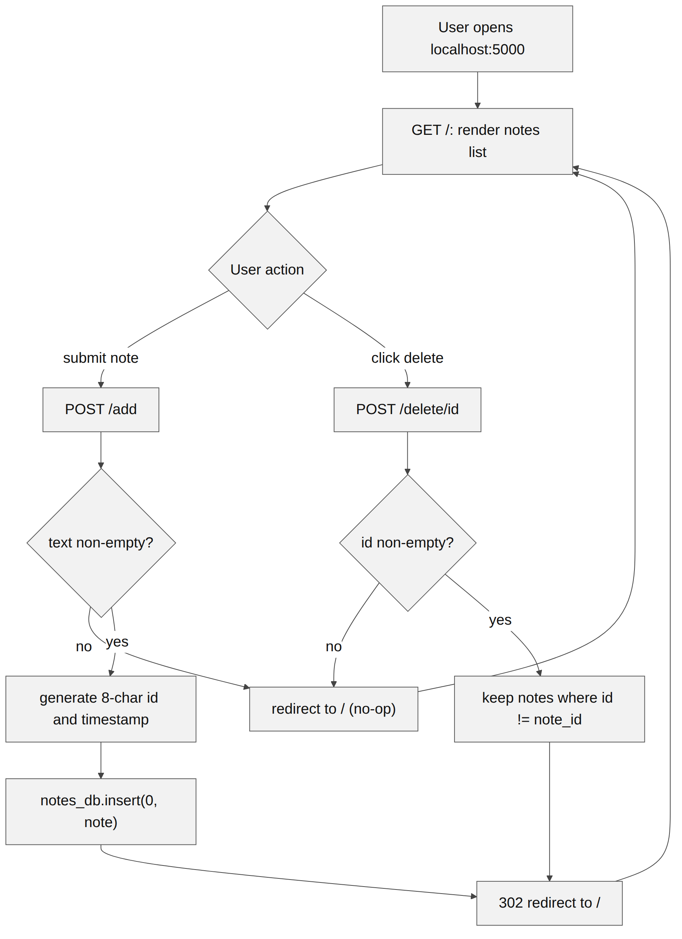
Figure 6: Note lifecycle from page load to redirect

6. DevSecOps CI/CD pipeline

6.1 Stage 1: code quality and secret scan
The code-quality job runs on ubuntu-latest. It checks out the full git history (fetch-depth 0), which SonarCloud needs for blame information and new-code detection. It sets up Python 3.12 with a pip cache, installs the requirements, and runs the tests under coverage. The resulting coverage.xml is passed to the SonarCloud scan action, and a separate quality-gate action waits up to five minutes for the verdict.
Table 5: Stage 1 steps
No. | Action | Purpose
1 | actions/checkout@v4, fetch-depth 0 | Full history for analysis
2 | actions/setup-python@v5, Python 3.12 | Runtime with dependency caching
3 | pip install -r requirements.txt | Install application and test dependencies
4 | coverage run -m pytest tests; coverage xml | Run tests, produce coverage.xml
5 | sonarsource/sonarqube-scan-action@v4 | SAST, secret detection, code smells
6 | sonarqube-quality-gate-action@v1.1.0 | Fail the job if the gate fails (5 minute timeout)

The rules relevant to the seeded defects are python:S2068 for hardcoded credentials and the duplication and complexity checks that produce code smells. The quality gate blocks the pipeline on unresolved security hotspots.

6.2 Stage 2: container build and vulnerability scan
The build-and-scan job needs the code-quality job. It builds the image as sample-app:latest and then runs Trivy twice. The first run writes a JSON report restricted to CRITICAL and HIGH severities, with unfixed vulnerabilities ignored, and uploads it as the trivy-scan-results artifact with seven days of retention. The second run produces a table and exits with code 1 if any matching vulnerability is found in either OS packages or libraries, which is what fails the gate. The JSON artifact is uploaded before the gate is evaluated so that the remediation job can still download it when the gate fails.
Table 6: Stage 2 steps
No. | Action | Purpose
1 | actions/checkout@v4 | Fetch the source
2 | docker/setup-buildx-action@v3 | Prepare the Docker builder
3 | docker build -t sample-app:latest . | Build the image under test
4 | trivy-action, format json, severity CRITICAL,HIGH, ignore-unfixed | Produce machine-readable findings
5 | actions/upload-artifact@v4 | Keep the JSON for the remediation agent
6 | trivy-action, format table, exit-code 1, vuln-type os,library | Enforce the gate

6.3 Stage 3: registry delivery
The publish job needs the build-and-scan job, so it only runs when both gates have passed. It logs in to Docker Hub with the DOCKERHUB_USERNAME and DOCKERHUB_TOKEN secrets, then builds and pushes the image tagged username/securenotes:latest.

6.4 Gate behaviour
The pipeline follows a zero-trust model for artifacts: nothing reaches the public registry unless it passes both SonarCloud and Trivy. Table 7 summarises what each layer detects and what happens on failure.
Table 7: Security layer summary
Layer | Tool | Detects | On failure
Code / SAST | SonarCloud | Hardcoded secrets (python:S2068), code smells, duplication | Blocks pipeline, triggers remediation
Container OS | Trivy | CVEs in Debian base packages and libraries | Blocks pipeline, triggers remediation
AI boundary | Human review | Unreviewed AI changes | Developer must approve; agent cannot merge

un time and is not fixed in this report.

7. Containerisation and demonstration profiles

7.1 Dockerfile
Table 10: Dockerfile instructions
Instruction | Effect
FROM python:3.12-slim | Minimal Debian base; the change proposed by the remediation agent
WORKDIR /app | Sets the working directory
RUN apt-get update && apt-get upgrade -y | Applies current Debian security patches at build time
COPY requirements.txt; RUN pip install --no-cache-dir | Installs Python dependencies without keeping the pip cache
COPY . . | Copies application source
EXPOSE 5000 | Documents the listening port
CMD gunicorn --bind 0.0.0.0:5000 app:app | Starts the production WSGI server

Table 11: Base image states
State | Base image | Risk | Trivy gate
Vulnerable | python:3.8 | HIGH and CRITICAL Debian CVEs | Blocks
Hardened | python:3.12-slim with apt-get upgrade | Minimal exposure | Passes

The commands for building and running the image locally are:
docker build -t securenotes:local .
docker run -d -p 5000:5000 --name securenotes-container securenotes:local
curl http://localhost:5000/health
docker stop securenotes-container && docker rm securenotes-container

7.2 Demonstration profiles
To show the pipeline failing and recovering, the repository holds four states under demo-states/. The vulnerable state carries every seeded defect. The fixed state carries none. The two agent states isolate one defect each, so that the secret fix and the image fix can be demonstrated separately (Figure 9, Table 12).
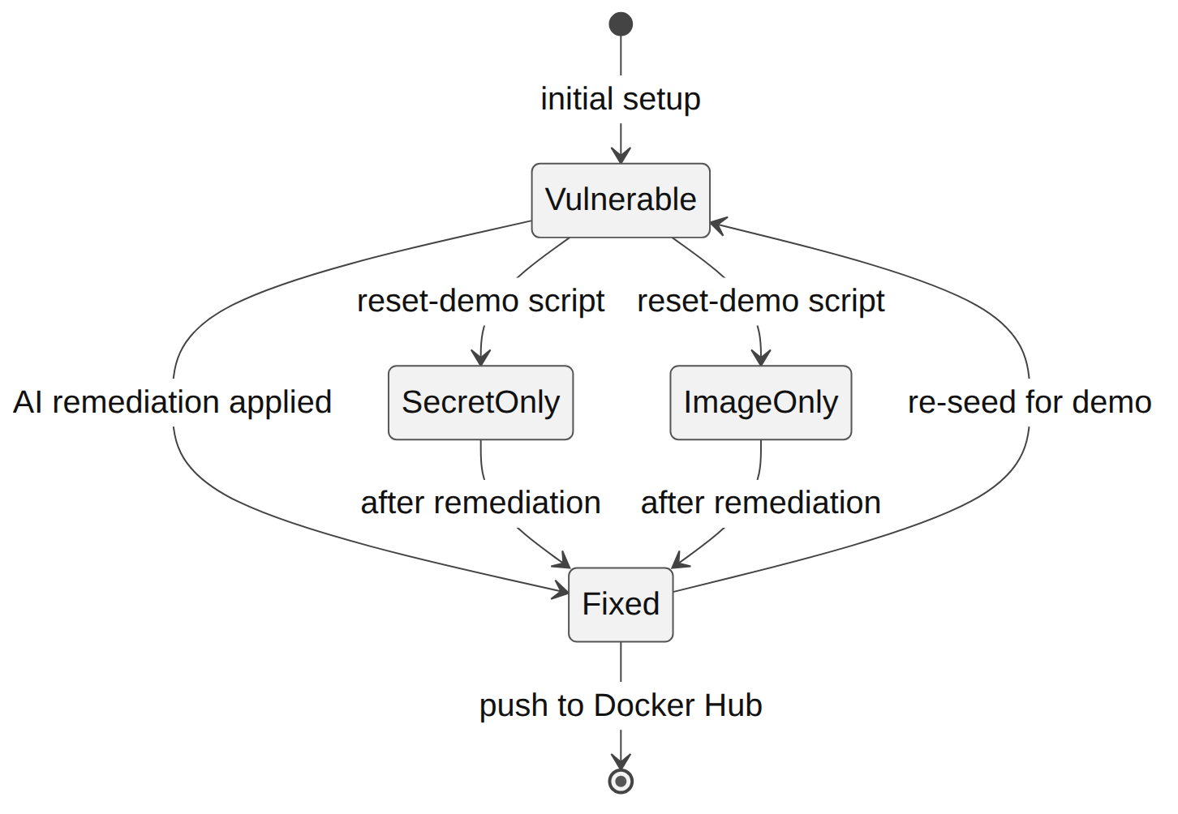
Figure 9: Demonstration state transitions
Table 12: Demonstration profiles
Profile | Folder | Base image | Secret in app.py | Validation
vulnerable | demo-states/vulnerable/ | python:3.8 | Hardcoded literal | Duplicated inline
fixed | demo-states/fixed/ | python:3.12-slim | os.environ.get(...) | validate_note_input()
agent-secret-only | demo-states/agent-secret-only/ | python:3.12-slim | Hardcoded literal | Duplicated inline
agent-image-only | demo-states/agent-image-only/ | python:3.8 | os.environ.get(...) | validate_note_input()

7.3 Reset tooling
PowerShell and Bash scripts copy a chosen profile into the working tree:
# Windows PowerShell
.\scripts\reset-demo.ps1 -State vulnerable
.\scripts\reset-demo.ps1 -State fixed
.\scripts\reset-demo.ps1 -State agent-secret-only
.\scripts\reset-demo.ps1 -State agent-image-only

# Linux, macOS, Git Bash
./scripts/reset-demo.sh vulnerable
./scripts/reset-demo.sh fixed

8. Environment configuration
Credentials used by the pipeline are stored as GitHub repository secrets. Values used only when the application runs locally are read from a .env file, and a .env.example documents the variables without holding real values (Figure 10).
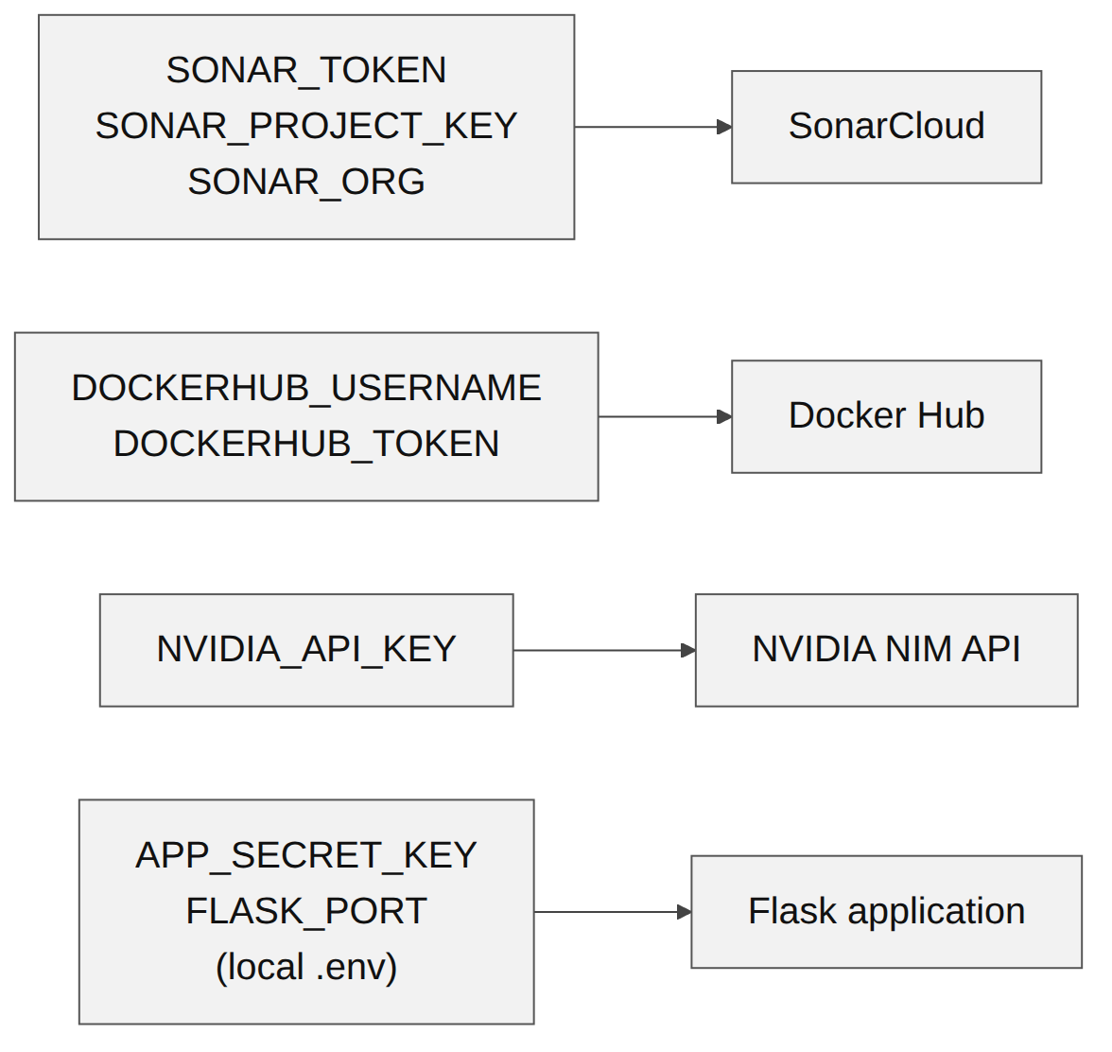
Figure 10: Secrets and configuration sources
Table 13: Configuration reference
Variable | Required | Default | Purpose
SONAR_TOKEN | Yes | none | SonarCloud authentication
SONAR_PROJECT_KEY | Yes | Siddhantshukla1657_SecureNotes_Devops_Miniproject | SonarCloud project identifier
SONAR_ORG | Yes | siddhantshukla1657 | SonarCloud organisation key
DOCKERHUB_USERNAME | Yes | none | Docker Hub account name
DOCKERHUB_TOKEN | Yes | none | Docker Hub read/write access token
NVIDIA_API_KEY | Yes | none | NVIDIA NIM API authentication
NVIDIA_MODEL | No | nvidia/llama-3.1-nemotron-70b-instruct | Model used for remediation
APP_SECRET_KEY | No | default-dev-key | Flask session and authentication key
FLASK_PORT | No | 5000 | HTTP listener port

9. End-to-end workflow
Figure 11 follows one change through every participant. The developer pushes, GitHub Actions runs the tests and uploads the analysis, and SonarCloud returns the gate result. On a pass, Trivy scans the image and the image is either published or sent to remediation. On a failure at either gate, the agent obtains the findings, calls NVIDIA NIM and opens a pull request. The developer reviews and merges it, which starts a fresh run of the pipeline.
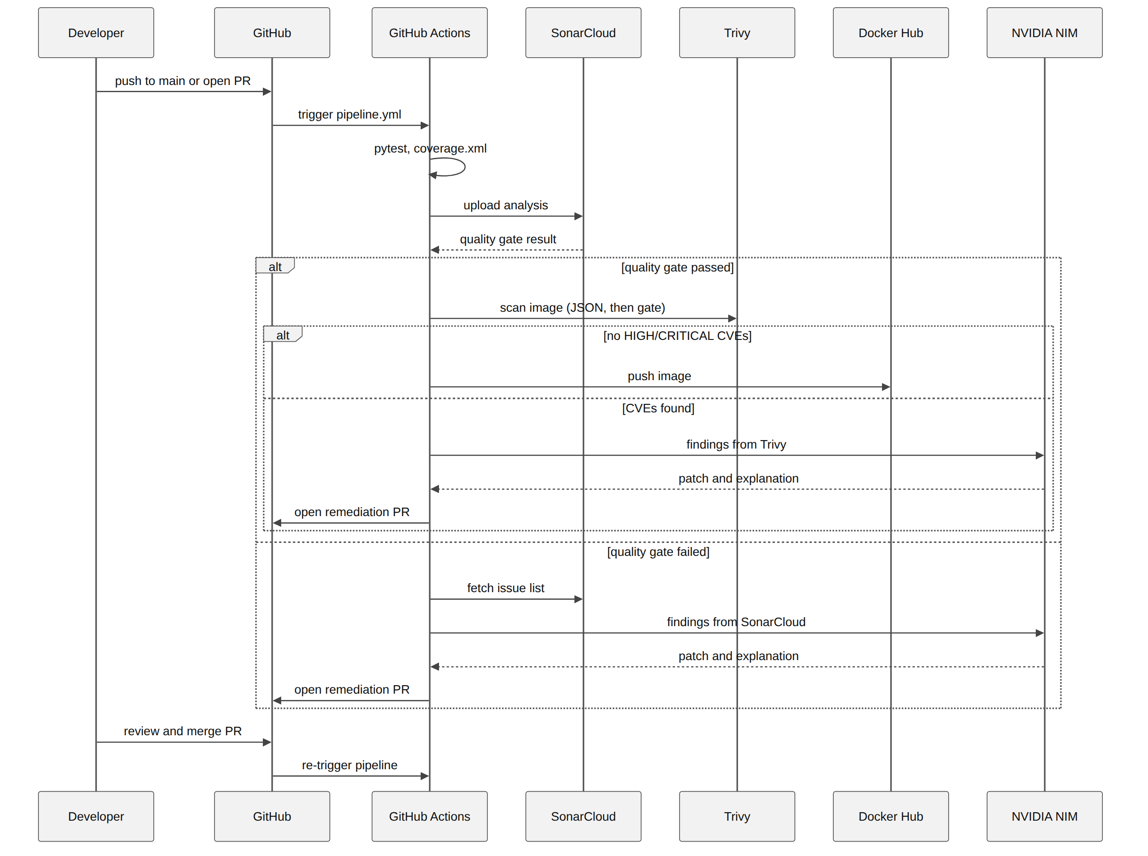
Figure 11: End-to-end developer workflow

10. Conclusion and future work

10.1 Conclusion
SecureNotes combines a Flask application, a four-stage GitHub Actions pipeline and an AI remediation agent. Secrets and code smells are caught in Stage 1, before an image is built. Known vulnerabilities in the image are caught in Stage 2, and only an image that passes both gates is published. When a gate fails, the agent drafts a fix and opens a pull request that a developer must approve. The four demonstration profiles and the reset scripts allow the full cycle, from a vulnerable commit to a merged fix, to be repeated on demand.

10.2 Future work
- Replace the in-memory store with a database and add authentication.
- Pin all third-party actions to release tags or commit hashes.
- Tag published images with the commit SHA as well as latest.
- Evaluate the agent over a larger set of seeded and real findings, recording how often a patch passes the gates without edits.
- Add a re-scan step to the remediation pull request so that the patch is verified before a reviewer opens it.
- Extend the agent to dependency upgrades reported by Trivy for Python packages.

References
[1] M. Souppaya, K. Scarfone and D. Dodson, "Secure Software Development Framework (SSDF) Version 1.1," NIST Special Publication 800-218, National Institute of Standards and Technology, 2022.
[2] SonarSource, "SonarCloud documentation: quality gates and rules," https://docs.sonarsource.com/sonarqube-cloud/.
[3] Aqua Security, "Trivy documentation," https://trivy.dev/.
[4] GitHub, "GitHub Actions documentation," https://docs.github.com/actions.
[5] Pallets Projects, "Flask documentation," https://flask.palletsprojects.com/.
[6] Docker, Inc., "Docker documentation," https://docs.docker.com/.
[7] NVIDIA, "NVIDIA NIM APIs," https://build.nvidia.com/.
[8] OWASP Foundation, "OWASP Top 10," https://owasp.org/www-project-top-ten/.

