Theory:
Categorical Feature Analysis is a part of Exploratory Data Analysis (EDA) that focuses on understanding how categorical variables influence the target variable. Categorical features represent qualitative data such as employment status, education level, and property area, which are important in decision-making processes. Visualization techniques like grouped bar charts and stacked percentage bar charts are commonly used to compare categories. Grouped bar charts help in comparing counts or values across different categories, while stacked percentage charts show the proportion of each category contributing to the target outcome. These visualizations make it easier to identify patterns, trends, and relationships between categorical features and the target variable. In real-world scenarios such as loan approval, factors like stable employment, higher education levels, and urban property areas often have a significant impact. Using pandas groupby operations, data can be aggregated to calculate counts and percentages for better analysis. Proper interpretation of these visualizations helps in deriving meaningful business insights and supports effective model building. Overall, categorical analysis enhances understanding of how qualitative factors affect outcomes.

Program Code:
import pandas as pd
import matplotlib.pyplot as plt

# Step 2: Load Dataset
df = pd.read_csv('silver_prices_data.csv')

print("\n===== DATASET LOADED ====")
print(df.head())

# --------------------------------------------
# Step 3: Convert Date and Extract Categories
# --------------------------------------------
if 'Date' in df.columns:
df['Date'] = pd.to_datetime(df['Date'])
df['Year'] = df['Date'].dt.year
df['Month'] = df['Date'].dt.month

# --------------------------------------------
# Step 4: Identify Categorical Features
# --------------------------------------------
cat_cols = ['Year', 'Month'] # derived categorical features

print("\nCategorical Features:", cat_cols)

# --------------------------------------------
# Step 5: Value Counts
# --------------------------------------------
for col in cat_cols:
print(f"\n===== VALUE COUNTS: {col} ====")
print(df[col].value_counts())

# --------------------------------------------
# Step 6: Bar Charts
# --------------------------------------------
for col in cat_cols:
plt.figure()
df[col].value_counts().sort_index().plot(kind='bar')
plt.title(f"Distribution of {col}")
plt.xlabel(col)
plt.ylabel("Count")
plt.show()

# --------------------------------------------
# Step 7: Group Analysis (Category vs Target)
# --------------------------------------------
target = 'Close'

for col in cat_cols:
print(f"\n===== AVERAGE {target} BY {col} ====")
print(df.groupby(col)[target].mean())

df.groupby(col)[target].mean().plot(kind='bar')
plt.title(f"{col} vs Average {target}")
plt.xlabel(col)
plt.ylabel(f"Average {target}")
plt.show()

Stepwise output:
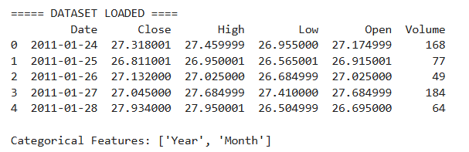
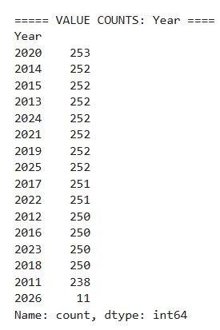
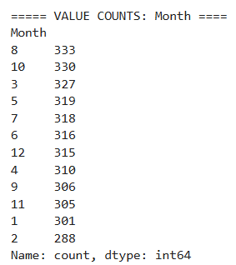
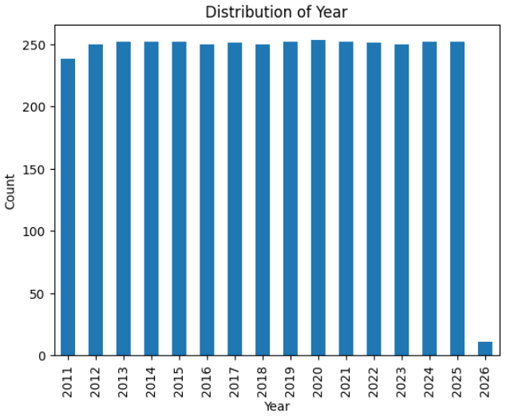
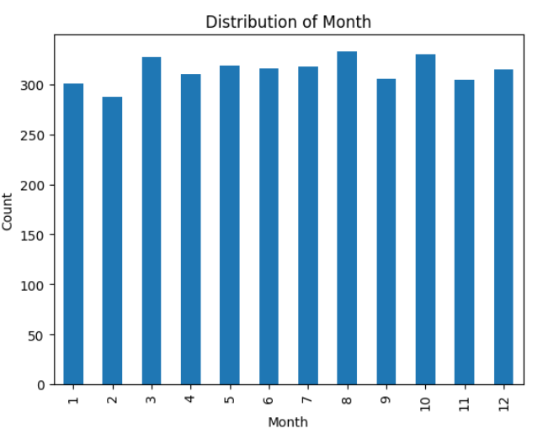
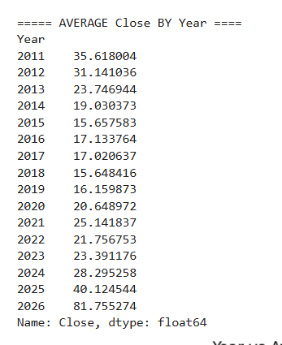
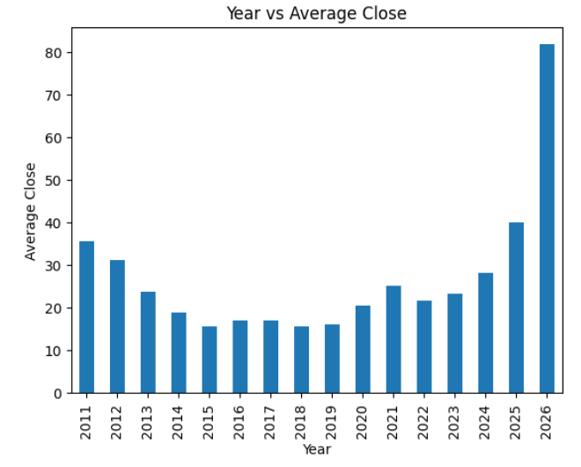
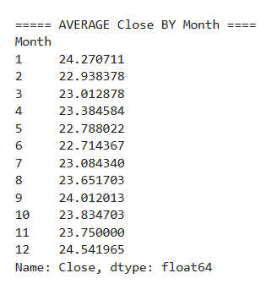
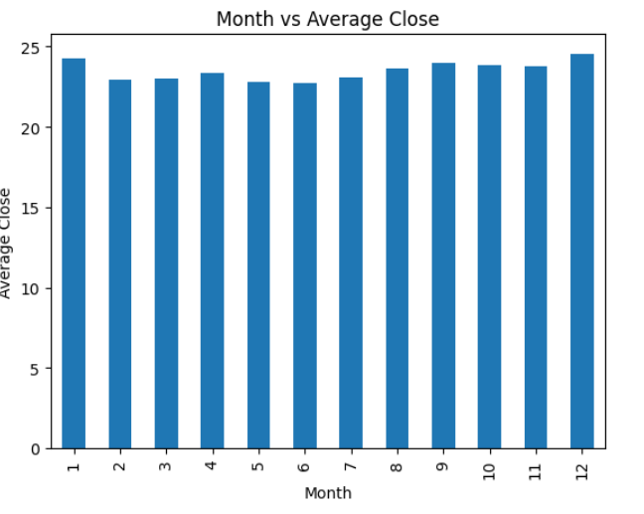
Conclusion:
Categorical feature analysis helps in understanding how qualitative factors influence the target variable. Visualization methods like grouped and stacked bar charts make patterns easy to interpret. Derived categories such as market trends and time-based features provide useful insights into silver price behavior. This analysis helps identify key influencing factors for predictive modeling. Overall, it improves data understanding and supports better decision-making in machine learning applications.

