Theory:
Correlation analysis is a statistical technique used to measure the strength and direction of the relationship between variables. It helps in identifying how one feature changes with respect to another. The correlation coefficient ranges from -1 to +1, where +1 indicates a strong positive relationship, -1 indicates a strong negative relationship, and 0 indicates no linear relationship. In machine learning, correlation analysis is useful for feature selection, as highly correlated features with the target variable are often more important for prediction. The correlation matrix is computed using functions like df.corr(), which calculates pairwise correlations between numerical variables. To better visualize these relationships, a heatmap is used, where colors represent the strength of correlation. Darker shades indicate stronger relationships, while lighter shades indicate weaker ones. By analyzing the heatmap, we can identify the most influential features as well as redundant features that may cause multicollinearity. However, correlation analysis only captures linear relationships and may fail to detect complex non-linear patterns. Therefore, it should be used along with other analysis techniques for better understanding.

Program Code:
import pandas as pd
import numpy as np
import matplotlib.pyplot as plt

# Step 2: Load Dataset
df = pd.read_csv('silver_prices_data.csv')

print("\n===== DATASET LOADED ====")
print(df.head())

# --------------------------------------------
# Step 3: Select Numerical Columns
# --------------------------------------------
num_cols = df.select_dtypes(include=[np.number]).columns
print("\nNumerical Columns:", list(num_cols))

# --------------------------------------------
# Step 4: Correlation Matrix
# --------------------------------------------
corr_matrix = df[num_cols].corr()

print("\n===== CORRELATION MATRIX ====")
print(corr_matrix)

# --------------------------------------------
# Step 5: Heatmap Visualization
# --------------------------------------------
plt.figure()
plt.imshow(corr_matrix)
plt.colorbar()

plt.xticks(range(len(num_cols)), num_cols, rotation=90)
plt.yticks(range(len(num_cols)), num_cols)

plt.title("Correlation Heatmap")
plt.show()

Stepwise output:
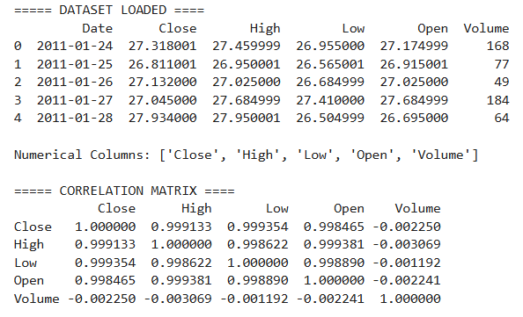
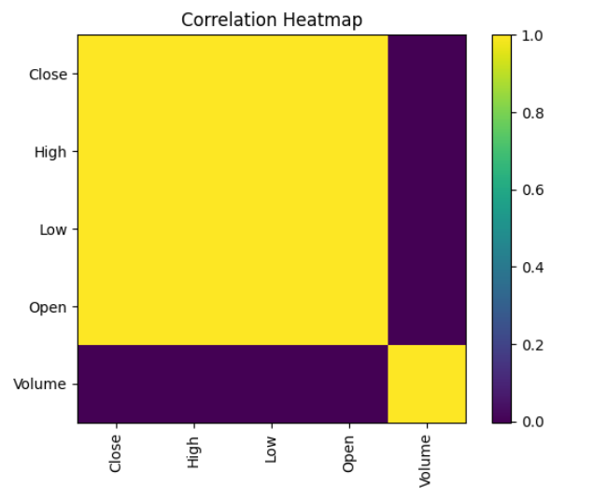

Conclusion:
Correlation analysis helps in identifying important relationships between features and the target variable. The heatmap provides a clear visual representation of these relationships, making it easier to interpret patterns. Features like Open, High, and Close prices usually show strong positive correlation, while some engineered features may show weak or negative relationships. This analysis helps in selecting relevant features and improving model performance. However, correlation does not capture non-linear relationships, so additional techniques are required for deeper analysis.

