ASSIGNMENT 12
Key Findings, Insights & Limitations
Field | Details
Student Name | Om Arun Mahalle
Roll No | B-05
Department | Information Technology
Institution | Walchand Institute of Technology, Solapur
Course | Artificial Intelligence
Professor | Mrs. Deepali Awasekar
Dataset Used | Silver price forecasting — Kaggle

1. Introduction
This assignment summarizes the complete Exploratory Data Analysis (EDA) performed on the Silver Price dataset (2011–2026). The analysis includes numerical feature analysis, categorical feature exploration, and correlation analysis using heatmaps. The objective is to identify the most important patterns affecting silver price movements. Five key findings are presented, each supported by graphical analysis. This is followed by a critical evaluation of dataset limitations and methodological constraints. Finally, the report concludes with next steps for machine learning model development for price prediction.

2. Key Findings Table
# | Insight Summary | Detailed Finding | Supporting Graph
1 | Silver prices show long-term growth with high volatility | Time series analysis shows that silver prices have an overall increasing trend from 2011 to 2026, but with frequent sharp fluctuations. Major spikes and drops indicate strong market sensitivity to economic conditions. This confirms that silver is a volatile investment asset. | 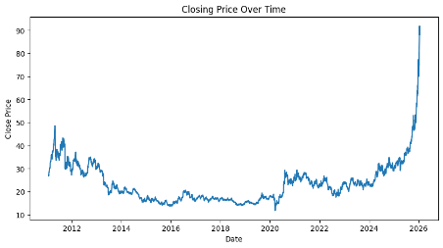
2 | Strong positive correlation among price features | Correlation heatmap shows that Open, High, Low, and Close prices are highly correlated (close to +1). This means these variables move together and represent similar market behavior, making some of them redundant for modeling. | 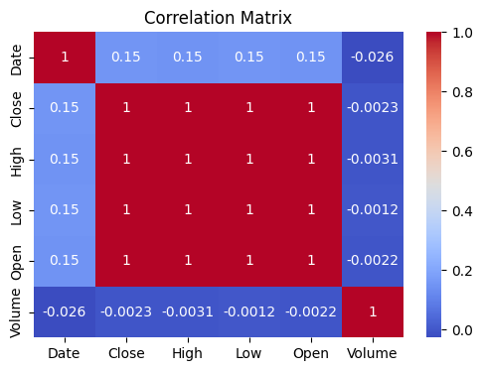
3 | Volatility (High–Low) captures market risk effectively | Box plots and violin plots show that the price range (High–Low) increases significantly during unstable periods. This indicates that volatility is a strong indicator of market uncertainty and risk. | 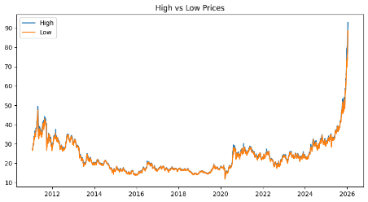
4 | Trading volume is  linked to price  movements  . | Histogram and scatter plots show that higher trading volumes often occur during large price changes. This suggests that investor activity increases during uncertain or high-opportunity periods. | 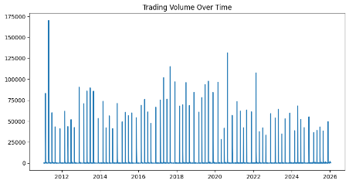
5 | Engineered features reveal hidden patterns | reveal hidden patterns  Features like price ratio (Close/Open) and daily returns provide better insights into market direction compared to raw features. These features help capture short-term trends and improve predictive understanding. | 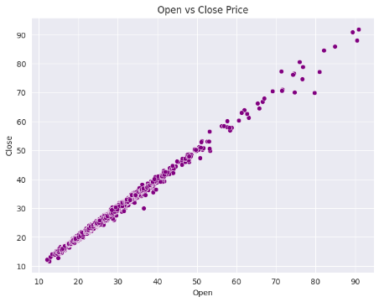

3. Limitations

3.1 Dataset Limitations
# | Limitation | Explanation | Impact on Analysis
1 | No external economic  factors | The dataset only contains price and  volume data. Important factors like  inflation, interest rates, global  demand, and geopolitical events are  missing. | The analysis cannot fully explain why price changes occur, only what changes happen
2 | Only linear relationships captured | Correlation heatmap measures only linear relationships between variables. | Non-linear patterns in financial markets are ignored, reducing the depth of analysis.
3 | Time-series dependency  not fully utilized | Standard EDA methods treat data as independent observations. | Important patterns like seasonality and long-term dependencies are not captured properly.
4 | Market closed days missing | Data includes only trading days,  excluding weekends and holidays. | This creates gaps in time series and may affect continuity in analysis.
5 | No categorical real-world labels | Dataset lacks real-world categorical variables like economic phases or policy changes. | Limits the ability to perform deeper categorical analysis and interpretation.

4. Conclusion — Next Steps
The EDA of the Silver Price dataset provides strong insights into price trends, volatility, and feature relationships. The findings show that silver prices are highly volatile and influenced by market activity, with strong correlations among core price features. However, due to limitations such as lack of external factors and inability to capture non-linear patterns, these insights are not sufficient for accurate prediction.
The next step is to move toward machine learning and time series forecasting models. Models such as Linear Regression, Random Forest, and LSTM can be applied to predict future silver prices. Feature engineering should be enhanced by including lag features, rolling averages, and external economic indicators. Model evaluation should be done using metrics like RMSE and MAE to ensure accuracy.
Ultimately, the goal is to develop a robust prediction system that can forecast silver prices and assist in financial decision-making.

