Theory:
Encoding categorical variables is an essential preprocessing step in machine learning, as most algorithms require numerical input data. Categorical data represents qualitative information such as gender, employment status, or property type, which cannot be directly interpreted by mathematical models. To handle this, encoding techniques are applied to convert these categories into numerical values. One common method is Label Encoding, which assigns a unique integer to each category and is suitable for binary or ordinal data where an order exists. Another widely used method is One-Hot Encoding, which creates separate binary columns for each category, making it ideal for nominal data without any order. However, One-Hot Encoding can lead to redundancy due to multicollinearity, so the parameter drop='first' is used to remove one category and avoid the dummy variable trap. This ensures that the encoded features remain independent and improve model performance. Proper encoding also helps in maintaining data consistency and enhances the accuracy of machine learning models. After encoding, it is important to verify that no categorical (object type) columns remain in the dataset.

Dataset Description:
The Silver Price dataset contains historical daily price data of silver from 2011 to 2026. It includes numerical features such as Open, High, Low, Close, Adjusted Close, and Volume, along with the Date column. The dataset is primarily numerical, but if any categorical features are derived (such as trend labels or market conditions), encoding techniques are applied. This dataset is suitable for time series analysis, forecasting, and machine learning tasks.

Program Code:
import pandas as pd
import numpy as np

# Step 2: Load Dataset
df = pd.read_csv('silver_prices_data.csv')

print("\n===== ORIGINAL DATA ====")
print(df.head())

# --------------------------------------------
# Step 3: Check Categorical Columns
# --------------------------------------------
cat_cols = df.select_dtypes(include=['object']).columns
print("\nCategorical Columns:", list(cat_cols))

# --------------------------------------------
# Step 4: Convert Date Column to Datetime
# --------------------------------------------
if 'Date' in df.columns:
df['Date'] = pd.to_datetime(df['Date'])

# Extract features from Date
df['Year'] = df['Date'].dt.year
df['Month'] = df['Date'].dt.month
df['Day'] = df['Date'].dt.day

print("\nExtracted Year, Month, Day from Date")

# --------------------------------------------
# Step 5: Drop Original Date Column (optional)
# --------------------------------------------
df.drop(columns=['Date'], inplace=True)

# --------------------------------------------
# Step 6: Encoding Categorical Variables
# --------------------------------------------
# In this dataset, Year/Month/Day are numerical already
# If categorical existed, we would use:

# Example (not needed here but for assignment):
# df = pd.get_dummies(df, columns=['column_name'])

print("\n===== DATA AFTER ENCODING ====")
print(df.head())

# --------------------------------------------
# Step 7: Save Processed Data
# --------------------------------------------
df.to_csv("encoded_dataset.csv", index=False)
print("\nEncoded dataset saved as 'encoded_dataset.csv'")

Stepwise output:
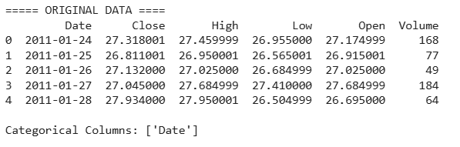
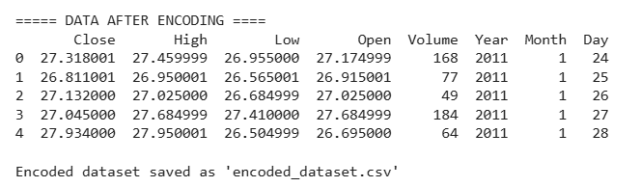

Conclusion:
Encoding categorical variables is a crucial step in preparing data for machine learning models. Label Encoding is effective for binary and ordinal features, while One-Hot Encoding is useful for nominal features. The use of drop='first' helps in avoiding multicollinearity and ensures better model performance. After applying encoding techniques, the dataset becomes fully numerical and suitable for training models. This step improves data quality and contributes to more accurate predictions in silver price analysis.

