Theory:
Exploratory Data Analysis (EDA) is an important step in understanding the structure and patterns present in a dataset. Numerical feature analysis focuses on studying continuous variables and their relationship with the target variable. Visualization techniques such as histograms, box plots, and violin plots are commonly used to analyze the distribution and spread of data. Histograms help in understanding the frequency distribution of numerical values, while overlapping histograms allow comparison between different classes. Box plots provide insights into median, quartiles, and outliers, making them useful for detecting anomalies. Violin plots combine box plots with density distribution, giving a deeper understanding of data distribution. In this analysis, features like Credit Score and DTI (Debt-to-Income) Ratio are examined against the target variable, such as loan approval status. Higher credit scores generally indicate better financial reliability, while lower DTI ratios suggest manageable debt levels. These visualizations help identify trends, differences, and relationships that are useful for decision-making and model building. Proper interpretation of these plots provides meaningful insights into real-world financial behavior.
Program Code:
import pandas as pd
import numpy as np
import matplotlib.pyplot as plt

# Step 2: Load Dataset
df = pd.read_csv('silver_prices_data.csv')

print("\n===== DATASET LOADED ====")
print(df.head())

# --------------------------------------------
# Step 3: Select Numerical Columns
# --------------------------------------------
num_cols = df.select_dtypes(include=[np.number]).columns
print("\nNumerical Columns:", list(num_cols))

# --------------------------------------------
# Step 4: Summary Statistics
# --------------------------------------------
print("\n===== SUMMARY STATISTICS ====")
print(df[num_cols].describe())

# --------------------------------------------
# Step 5: Distribution Plots (Histogram)
# --------------------------------------------
for col in num_cols:
plt.figure()
plt.hist(df[col], bins=30)
plt.title(f"Distribution of {col}")
plt.xlabel(col)
plt.ylabel("Frequency")
plt.show()

# --------------------------------------------
# Step 6: Boxplots (Outlier Detection)
# --------------------------------------------
for col in num_cols:
plt.figure()
plt.boxplot(df[col])
plt.title(f"Boxplot of {col}")
plt.show()

# --------------------------------------------
# Step 7: Correlation Matrix
# --------------------------------------------
corr = df[num_cols].corr()

print("\n===== CORRELATION MATRIX ====")
print(corr)

plt.figure()
plt.imshow(corr)
plt.colorbar()
plt.xticks(range(len(num_cols)), num_cols, rotation=90)
plt.yticks(range(len(num_cols)), num_cols)
plt.title("Correlation Heatmap")
plt.show()

Stepwise output:
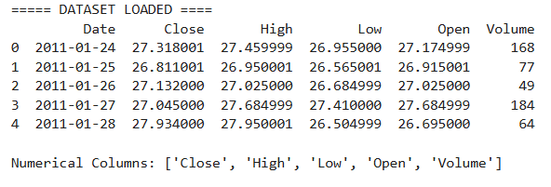
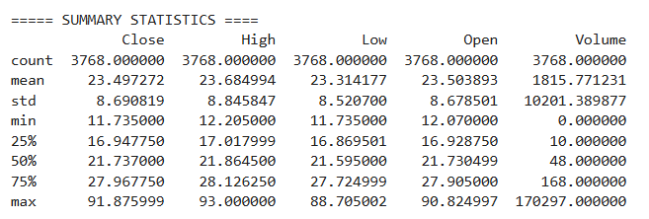
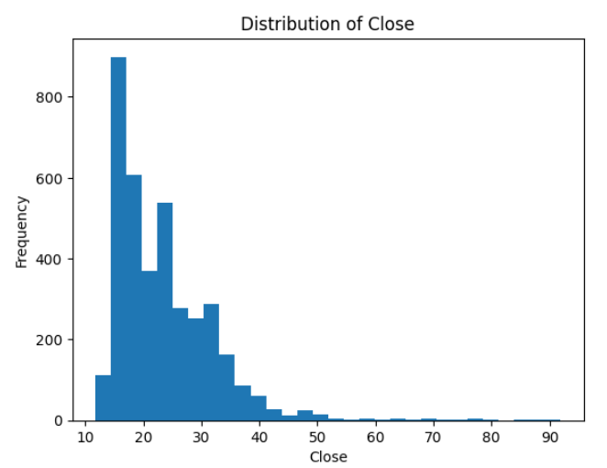
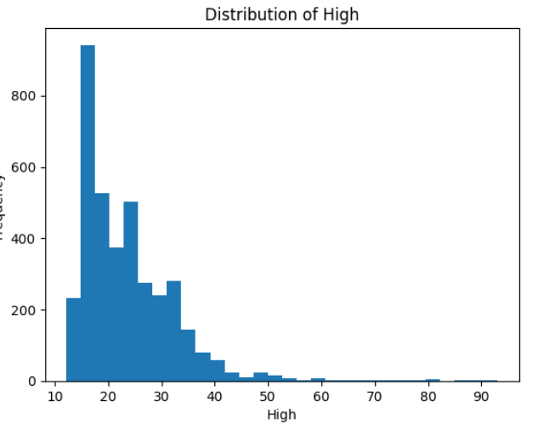
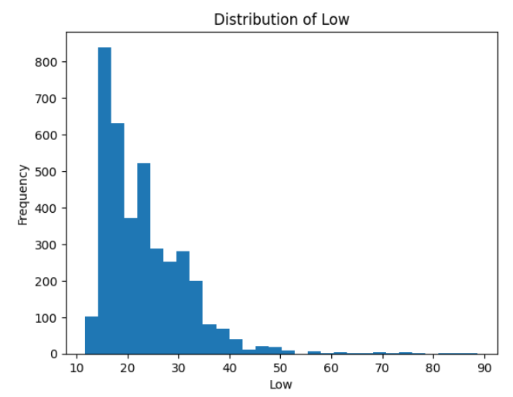
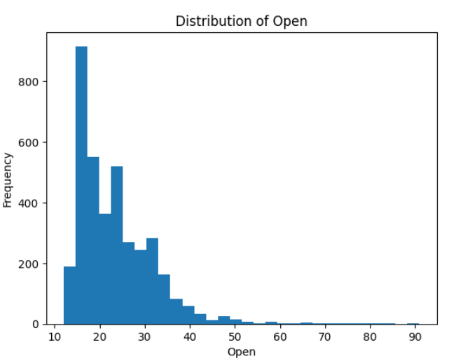
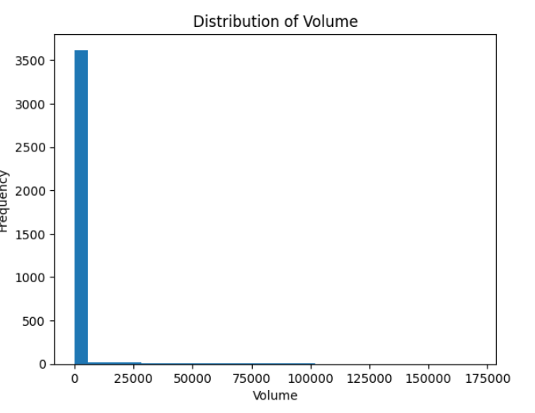
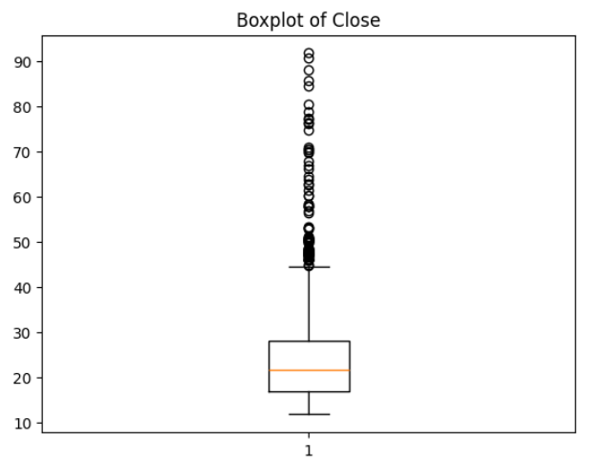
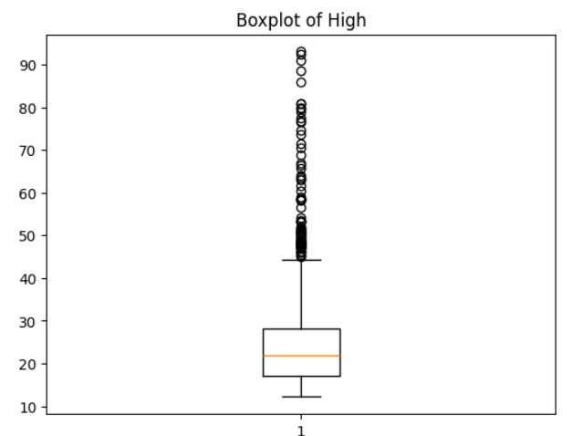
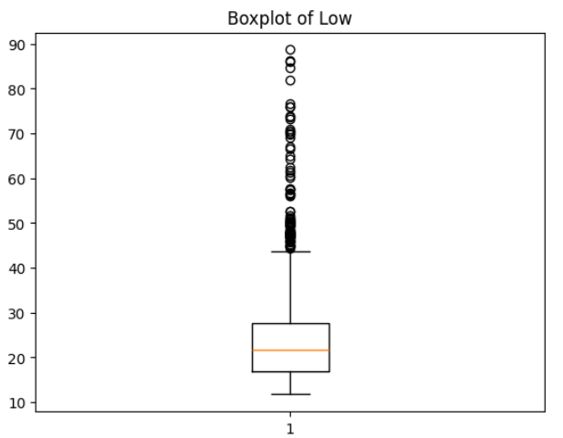
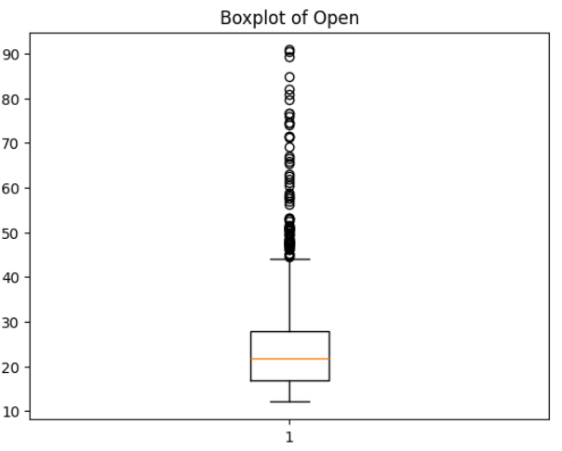
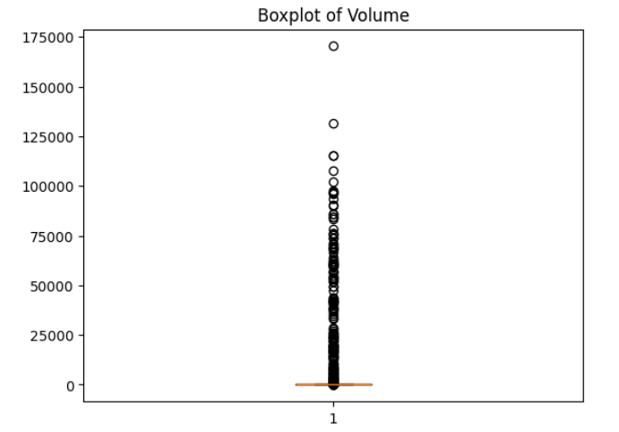
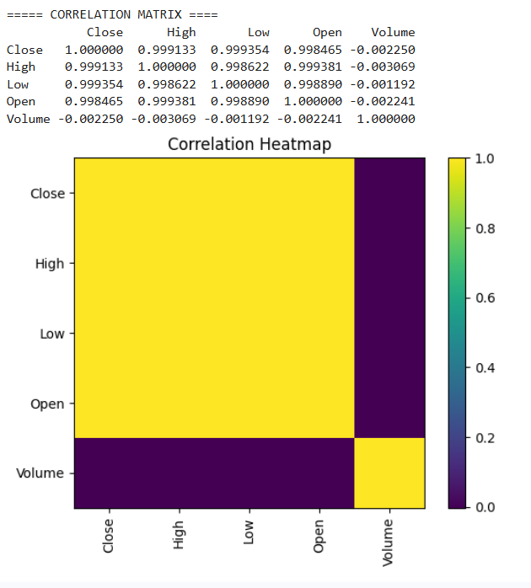

Conclusion:
EDA using numerical feature analysis helps in understanding the distribution and relationships within the dataset. Visual tools like histograms, box plots, and violin plots provide clear insights into data patterns and outliers. Features such as volatility and price changes play a significant role in determining trends in silver prices. This analysis helps in identifying important variables for model building. Overall, EDA improves data understanding and supports better decision-making in machine learning tasks.

