Detailed Dataset Understanding & EDA

Workbook (Student Version)

Roll No: B-05
Student Name: Om Mahalle
Paper Title : Exploratory Data Analysis of Silver Prices

SECTION 1: BASIC DATASET INFORMATION
Fill all details carefully after downloading dataset from Kaggle.

Field | Details
Dataset Name | Silver Prices Historical and Forecast Data
Source | Kaggle
Dataset Link | https://www.kaggle.com/datasets/iabhishekofficial/mobile-price-classification
Type of Dataset | Time Series Financial Dataset
Number of Records (Rows): | 3700
Domain | Finance / Commodity Market

SECTION 2: COLUMN UNDERSTANDING
Explain each column in your own words. Do not copy.

Column Name | Meaning | Type | Example
Date | This column shows the trading date on which the silver price was recorded | Date | 2020-05-15
open | The price of silver at the beginning of the trading day | Float | 17.85
High | The highest price of silver reached during that day | Float | 18.25
Low | The lowest price of silver during that trading day | Float | 17.60
Close | The final price of silver at the end of the trading day | Float | 18
Adj Close | Adjusted closing price after considering factors like splits or corrections | Float | 18
Volume | Total number of trades or quantity of silver traded that day | Integer | 450000

SECTION 3: DATA QUALITY CHECK
Inspect dataset and write issues + actions taken.

Check | Issue Found | Action Taken
Missing Values | No missing values found in dataset | No action required
Duplicate Data | No duplicate rows found | No action required
Data Types | All columns are in correct format (Date, Float, Integer) | No changes required
Outliers | Some sudden spikes in price observed (due to market volatility) | Kept as it reflects real-world market behavior
Data Consistency | Data is consistent and properly structured | No correction needed

SECTION 4: DATA SUMMARY
Compute basic statistics using Python/Excel.

Metric | Value | Observation
Mean (Average Close Price) | 23.497272 | The average silver price remained in a moderate range over the years
Min Price | 11.735000 | Indicates the lowest market value during weak economic periods
Max Pric | 93.000000 | Shows peak price during high demand or crisis periods
Std Deviation | 8.690819 | Indicates that silver prices are volatile but not extremely unstable
Avg Volume | 1815.771231 | Shows consistent trading activity in the silver market

SECTION 5: RESEARCH OBJECTIVES
Write 3–5 clear objectives based on dataset.

Objective No | Objective
1 | To analyze the trend of silver prices over time from 2011 to 2026
2 | To study the volatility of silver prices using statistical measures like standard deviation
3 | To identify patterns and fluctuations in daily price movements (Open, High, Low, Close)
4 | To examine the relationship between trading volume and price changes
5 | To perform basic forecasting and understand future price behavior of silver

SECTION 6: GRAPH ANALYSIS
For each graph, explain properly.

Graph Name | Type | What it Shows | Pattern | Meaning | Limitation
Closing Price Trend | Line Graph | Shows how silver closing price changes over time | Upward and downward fluctuations | Indicates overall trend and volatility of silver prices | Does not explain reasons behind price changes
High vs Low Price | Line Graph | Shows daily highest and lowest prices | Gap between high and low varies | Indicates daily volatility in market | Cannot predict future price
Trading Volume | Bar Graph | Shows number of trades per day | Irregular spikes in volume | High volume indicates strong market activity | Volume alone does not explain price direction
Moving Average | Line Graph | Shows smoothed trend of prices | Smooth curve compared to actual prices | Helps identify long-term trend | May ignore sudden market changes
Open vs Close | Scatter / Line Graph | Compares opening and closing prices | Points close to each other | Shows daily price movement and stability | Does not show long-term trend

SECTION 7: KEY FINDINGS
Write strongest insights from analysis.

Finding No | Insight | Supporting Graph
1 | Silver prices show significant fluctuations over time, indicating high market volatility | Closing Price Trend
2 | There are periods of sharp price increases, especially during economic uncertainty | Closing Price Trend
3 | The gap between high and low prices varies daily, showing short-term volatility | High vs Low Graph
4 | Trading volume shows irregular spikes, indicating changing investor activity | Volume Analysis
5 | Moving average smooths the data and reveals the overall long-term trend of silver prices | Moving Average Graph

SECTION 8: LIMITATIONS
Write realistic limitations of dataset.

Limitation No | Description
1 | The dataset only contains historical price data and does not include external factors like inflation, economic policies, or global events
2 | Future prices are uncertain and cannot be predicted with complete accuracy using this dataset alone
3 | The dataset is limited to silver and does not compare with other commodities like gold or crude oil
4 | Sudden market events or crises affecting prices are not explained in the dataset
5 | Volume data alone does not provide complete insight into investor behavior

SECTION 9: FINAL UNDERSTANDING
Answer in your own words.

Question | Answer
What did you understand from this dataset? | This dataset helped me understand how silver prices change over time. It shows that prices are not constant and keep fluctuating due to market conditions.
What kind of dataset is this? | This is a time-series financial dataset because it contains price data recorded over a period of time.
What tools and techniques did you use? | I used Google Colab with Python libraries such as Pandas and Matplotlib to read, analyze, and visualize the dataset.
What are the key learnings from this analysis? | I learned how to clean and explore data, calculate statistical measures, and create graphs. I also understood how to interpret trends and patterns in financial data.
How can this analysis be useful? | This analysis can help investors and analysts understand price trends and make better decisions. It can also be used for forecasting future prices using machine learning models.

SECTION10
Paste Graphs here :
Graph 1: Silver Closing Price Trend Over Time
Research Question:
How have silver prices changed over time, and is there any long-term trend?
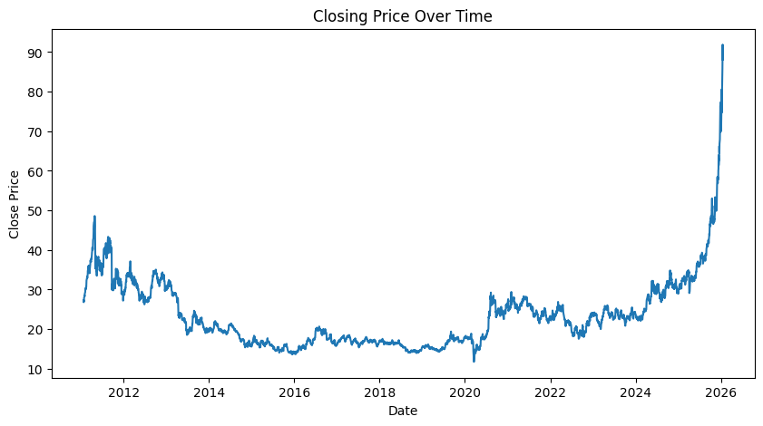

Interpretation:

The line graph shows the movement of silver closing prices from 2011 to 2026. The prices exhibit noticeable fluctuations with multiple peaks and declines over the years. There are periods of sharp increases followed by corrections, indicating cycles of growth and decline.

This pattern reflects the volatile nature of the silver market. The upward spikes may correspond to periods of high demand or economic uncertainty, where investors shift towards precious metals as a safe investment. Similarly, downward trends may indicate reduced demand or stronger economic stability.

Overall, the graph suggests that while silver prices fluctuate in the short term, there may be broader cyclical trends over longer periods. However, the graph alone does not explain the external economic factors influencing these changes, such as inflation, global events, or industrial demand.

Graph 2: High vs Low Price Variation
Research Question:
How much does the price of silver fluctuate within a single trading day?
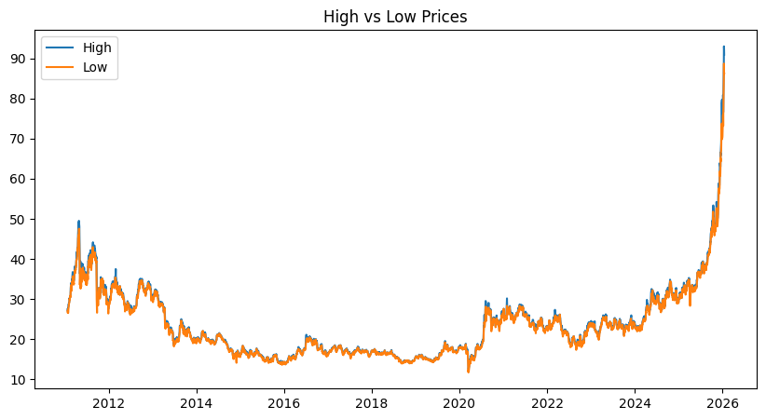

Interpretation:
The line graph compares the daily high and low prices of silver over time, showing the range within which prices move during each trading day. The gap between the high and low lines varies across the dataset, with some periods showing a narrow range and others showing a much wider spread.

This variation indicates the level of intraday volatility in the silver market. A wider gap between high and low prices suggests higher uncertainty and stronger price movements within the day, while a narrower gap reflects relatively stable market conditions.

Periods with consistently large gaps may indicate increased market activity or external influences such as economic news or changes in demand. On the other hand, smaller gaps suggest calm market behavior with less aggressive trading.

Graph 3: Trading Volume Analysis

Research Question:
How does trading volume vary over time, and what does it indicate about market activity?
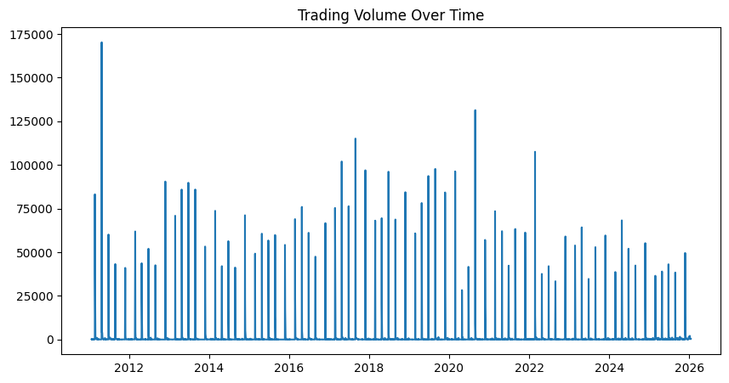

Interpretation:
The bar graph shows the variation in trading volume of silver over time, highlighting the number of transactions occurring on different days. The graph displays irregular spikes, where certain periods experience significantly higher trading activity compared to others.

These spikes indicate periods of increased market participation, where more investors are actively buying and selling silver. High trading volume is often associated with strong market interest, major price movements, or reactions to external economic events. In contrast, lower volume suggests reduced activity and relatively stable market conditions.

The pattern suggests that trading volume is not constant and tends to fluctuate based on market sentiment and external influences. Sudden increases in volume may coincide with price volatility, indicating that traders are reacting quickly to new information.

Graph 4: Moving Average of Silver Prices

Research Question:
What is the underlying long-term trend in silver prices when short-term fluctuations are smoothed out?
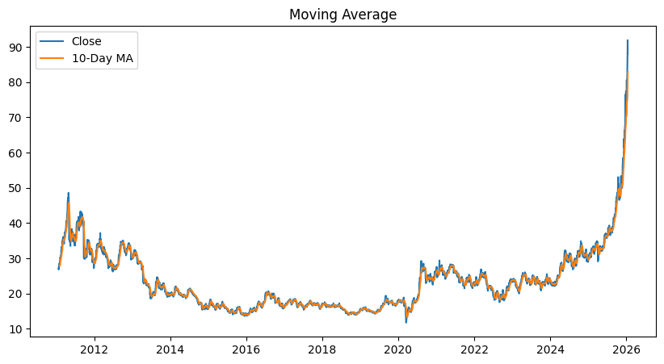

Interpretation:
The graph compares the actual silver closing prices with the moving average line, which smooths out short-term fluctuations by averaging prices over a specific period. The moving average appears as a smoother curve compared to the more irregular actual price line.

This smoothing effect helps in identifying the overall trend of the market. While the actual prices show frequent ups and downs, the moving average highlights the general direction—whether prices are increasing, decreasing, or remaining stable over time.

When the actual price line stays above the moving average, it may indicate an upward trend, whereas prices below the moving average suggest a downward trend. This makes the moving average a useful tool for understanding long-term behavior and reducing the noise caused by daily volatility.

However, one limitation of the moving average is that it is a lagging indicator, meaning it reacts to past data and may not immediately reflect sudden market changes. As a result, it may miss sharp spikes or drops in price in real time.

Graph 5: Open vs Close Price Relationship

Research Question:
What is the relationship between opening and closing prices of silver, and what does it indicate about daily price movement?
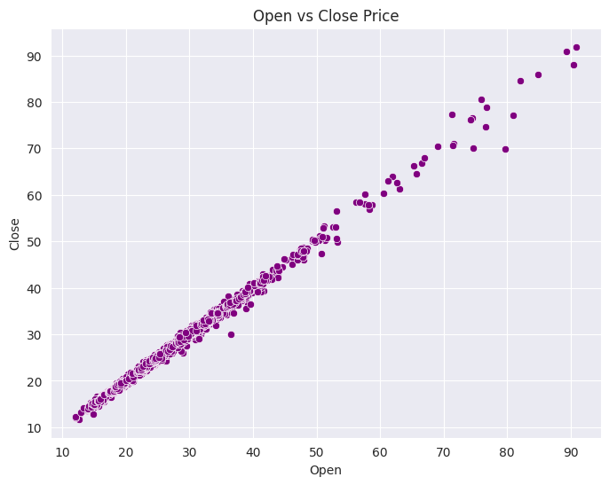

Interpretation:
The scatter plot compares the opening and closing prices of silver for each trading day. Most data points are clustered closely around a diagonal pattern, indicating that the opening and closing prices are generally similar on most days.
This clustering suggests that daily price changes are usually small, and the market tends to remain relatively stable within a single trading session. However, some points are spread farther from the main cluster, representing days with larger price movements, which may be caused by sudden market reactions or external economic events.
The overall pattern indicates a strong relationship between opening and closing prices, meaning that the opening price often influences the closing price of the same day. This reflects short-term market consistency, where prices do not drastically change within a day under normal conditions.
However, this graph does not provide information about long-term trends or external factors affecting the price. It only reflects short-term daily behavior, so it should be used along with other analyses for a complete understanding of the market.

Graph 6: Correlation Matrix of Silver Price Features

Research Question:
How are different price variables (Open, High, Low, Close, Volume) related to each other?
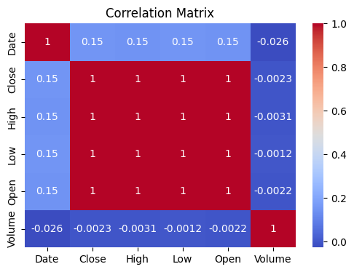

Interpretation:
The heatmap shows the correlation between different variables in the dataset using a color gradient, where values closer to +1 indicate a strong positive relationship and values closer to 0 indicate a weak or no relationship.

From the graph, it is clearly observed that Open, High, Low, and Close prices are highly positively correlated with each other. This means that when one price increases, the others also tend to increase in a similar manner. This is expected because all these variables represent different aspects of the same trading day’s price movement.

On the other hand, Volume shows a weaker correlation with price variables, indicating that trading activity does not always directly influence price changes. High volume does not necessarily mean prices will increase or decrease, but rather reflects the level of market participation.

This strong correlation among price variables suggests redundancy, meaning they carry similar information. This is important when building machine learning models, as using all highly correlated features may not add much value and could lead to overfitting.

However, the limitation of this graph is that it only shows linear relationships and does not capture complex or non-linear interactions between variables. Therefore, further analysis is required for deeper insights.

