DEPARTMENT OF COMPUTER ENGINEERING

SHAH AND ANCHOR KUTCHHI ENGINEERING COLLEGE CHEMBUR, MUMBAI – 400088.
2023 – 2024

Project Report on

Rotation of Earth using Blender

by

Class-Batch | Roll No | Nam e
SE_4 | 30 | Om Makwana
SE_4 | 33 | Tanishka More
SE_4 | 37 | Srishti Pandey

THEORY

- Introduction.

What’s Blender?

  - Blender is the free and open source 3D creation suite. It supports the entirety of the 3D pipeline—modeling, rigging, animation, simulation, rendering, compositing and motion tracking, even video editing and game creation.
  - Blender is cross-platform and runs equally well on Linux, Windows, and Macintosh computers. Its interface uses OpenGL to provide a consistent experience. To confirm specific compatibility, the list of supported platforms indicates those regularly tested by the development team.
  - As a community-driven project under the GNU (General Public Licence), the public is empowered to make small and large changes to the code base, which leads to new features, responsive bug fixes, and better usability. Blender has no price tag, but you can invest, participate and help to advance a powerful collaborative tool: Blender is your own 3D software.

Initially Blender look like this:-

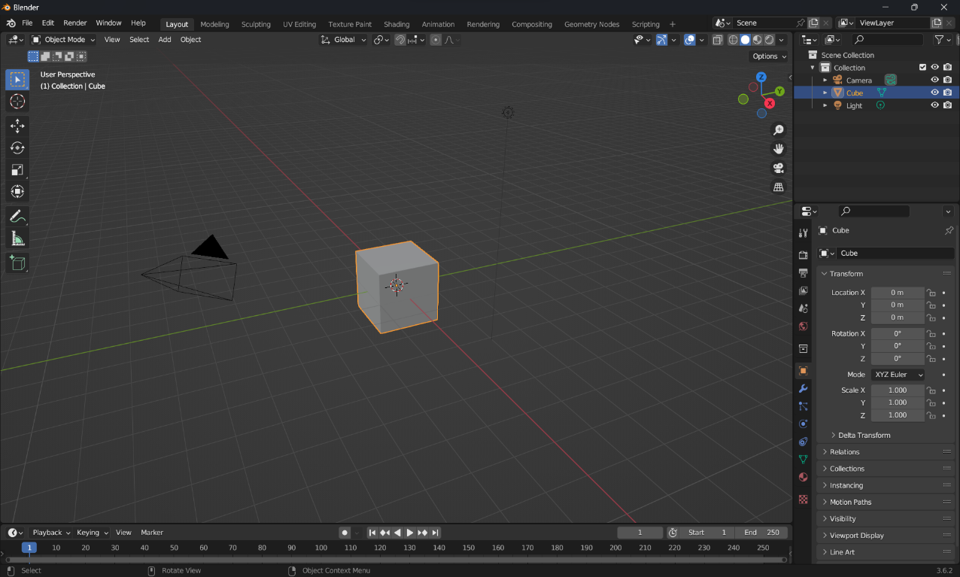

- Tools Used

In this project we have used Blender Software and some image textures from NASA.

III. Steps

Under Following steps we have created our project

Steps to create a Earth:-
- First delete the default cube.
- Press ctrl + A and add a UV Sphere.
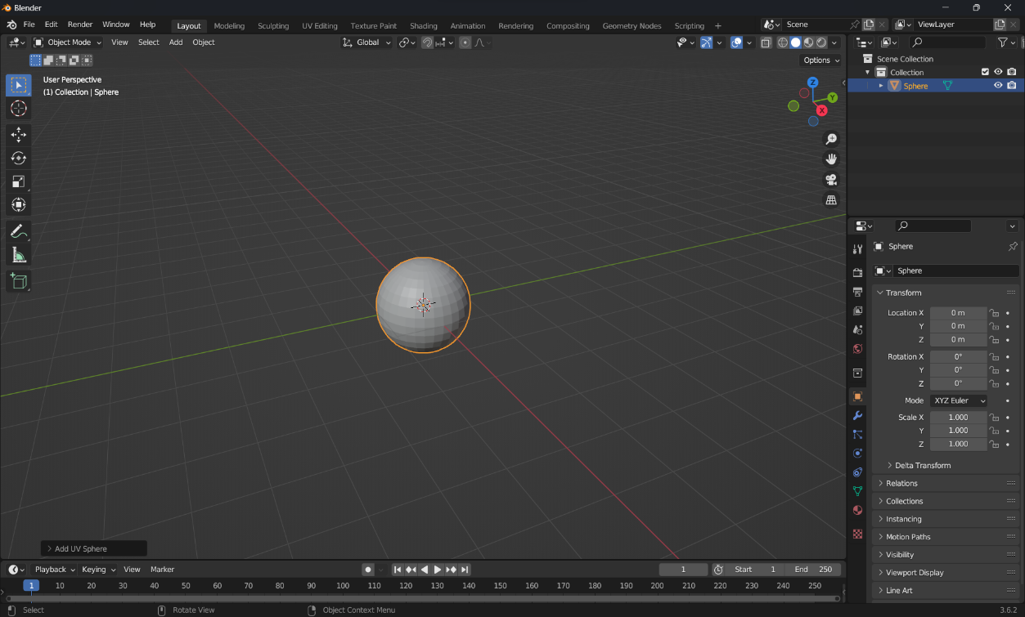

- As we know the Earth has 23.4 degree axial tilt, so we need to rotate the sphere 23.4 degrees on the Y-axis.
- Press right click, and select shade smooth. So our sphere looks like Earth.

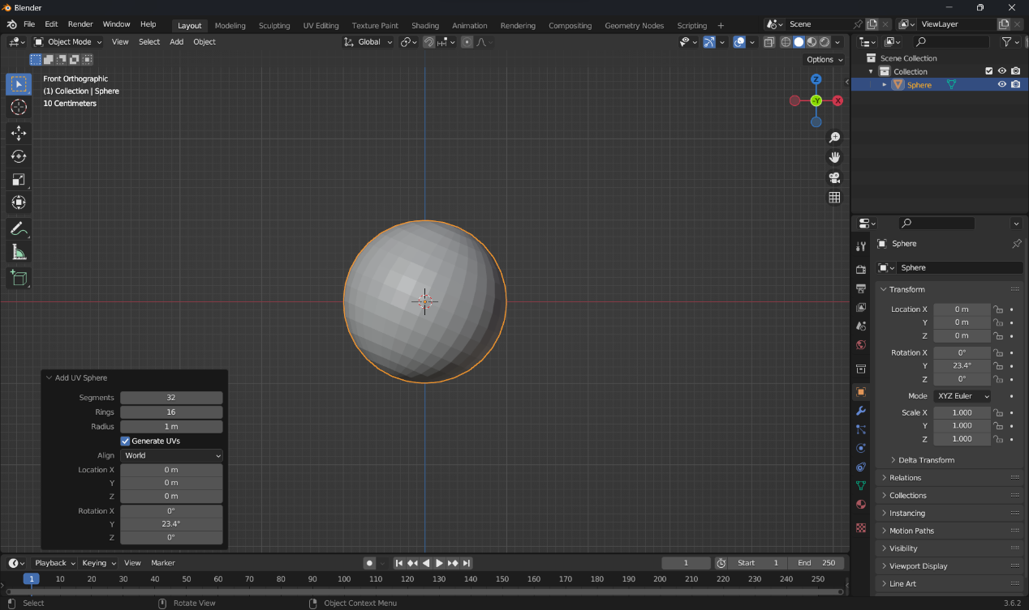

- Go to modifier tab and add “Subdivision Surface Modifier”.
- Set the subdivision level to 1 for the view port and render
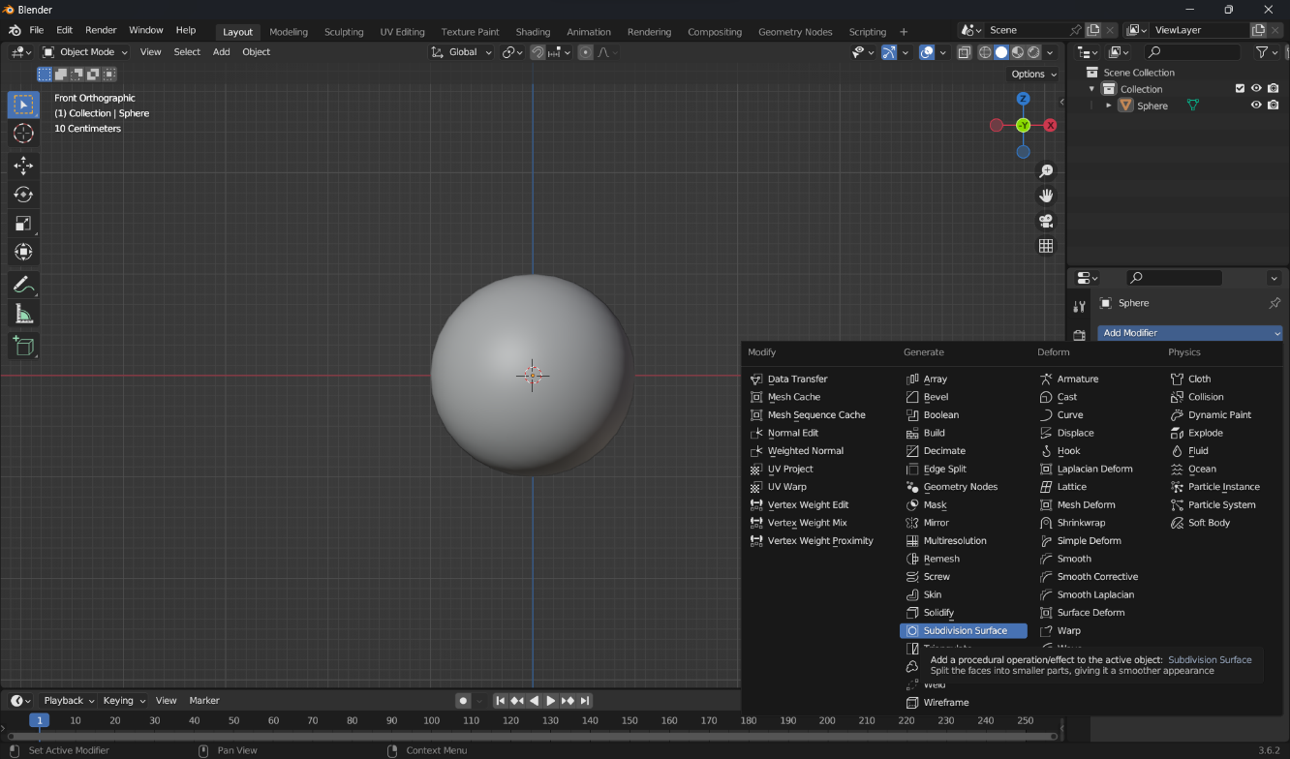
- Now lets add the Sun.
- Now lets move the sun into X-axis and rotate it by 90 degrees.
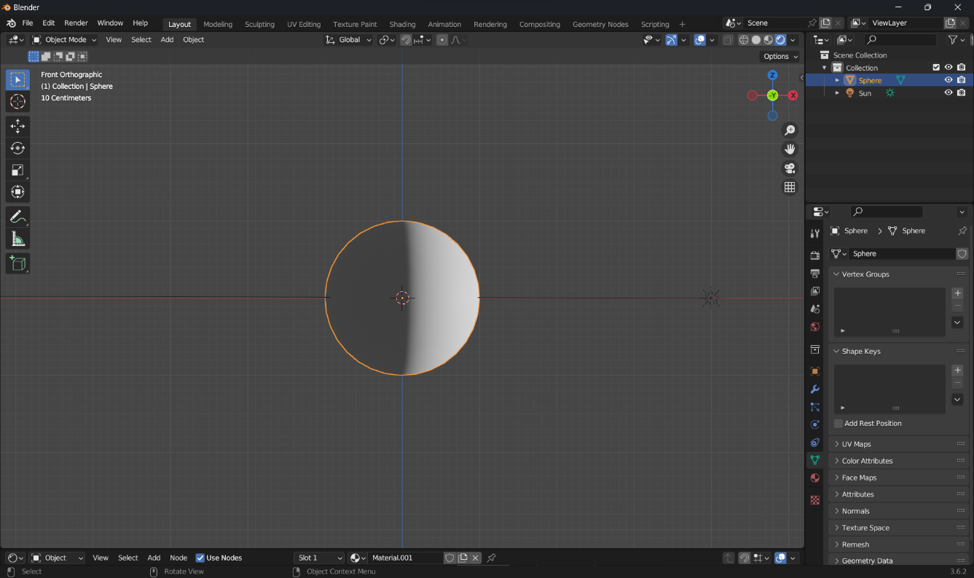
- Now lets add the textures. Go to Shader Editor and add the new material, then we add the image textures.

- First we add the Earth day map.
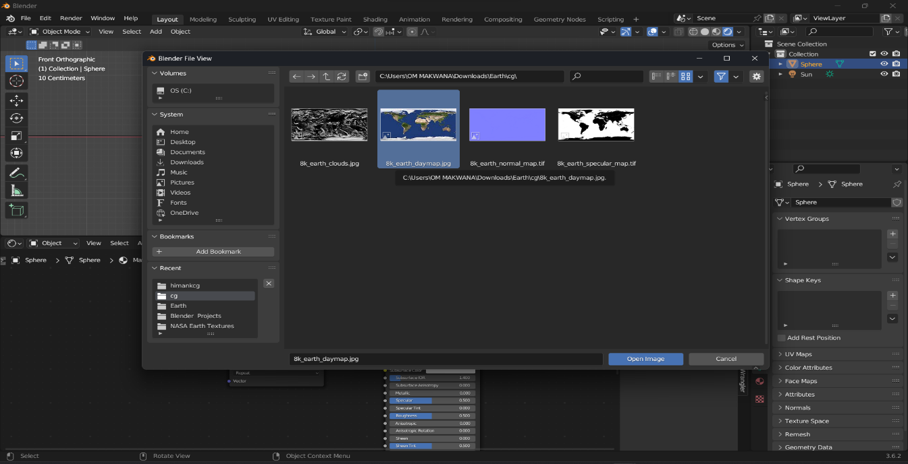

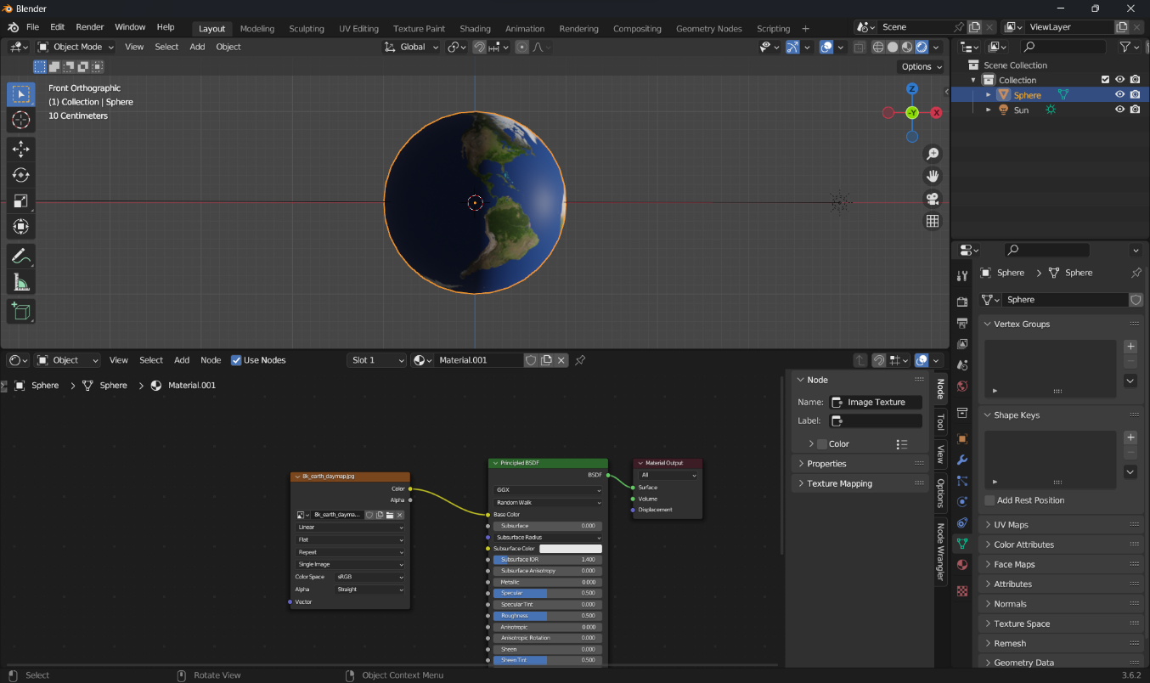

- Due the use of UV coordinates by blender, we can see some wrinkles on the poles.
- To fix this problems lets add texture coordinate node and mapping nodes(to do that select the Image texture node and press ctrl + t).
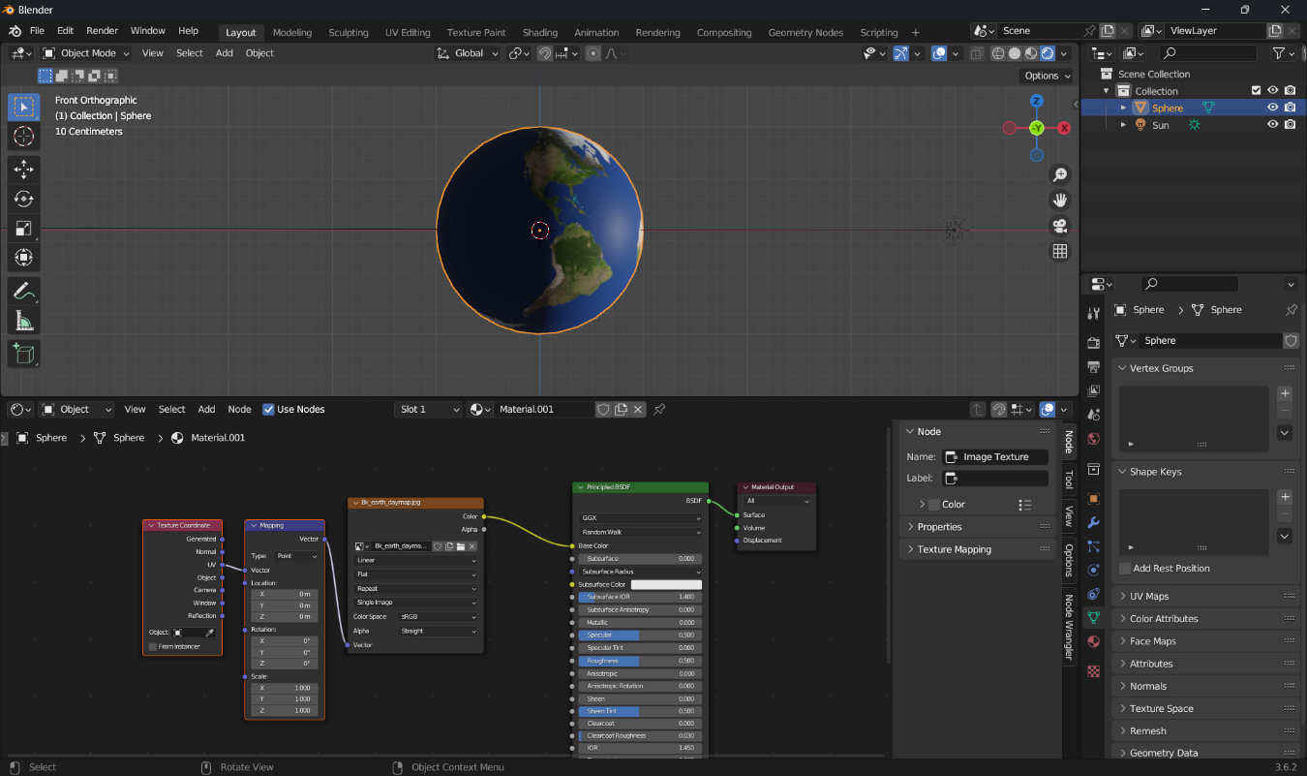

- Lets add cloud map now. Also plug the mapping node to cloud image texture.
- Here we need to mix both the images so we add a mix RGB node. Switch the blending node to add and plug the both images to RGB node and plug the mix RGB to Principle Shader.
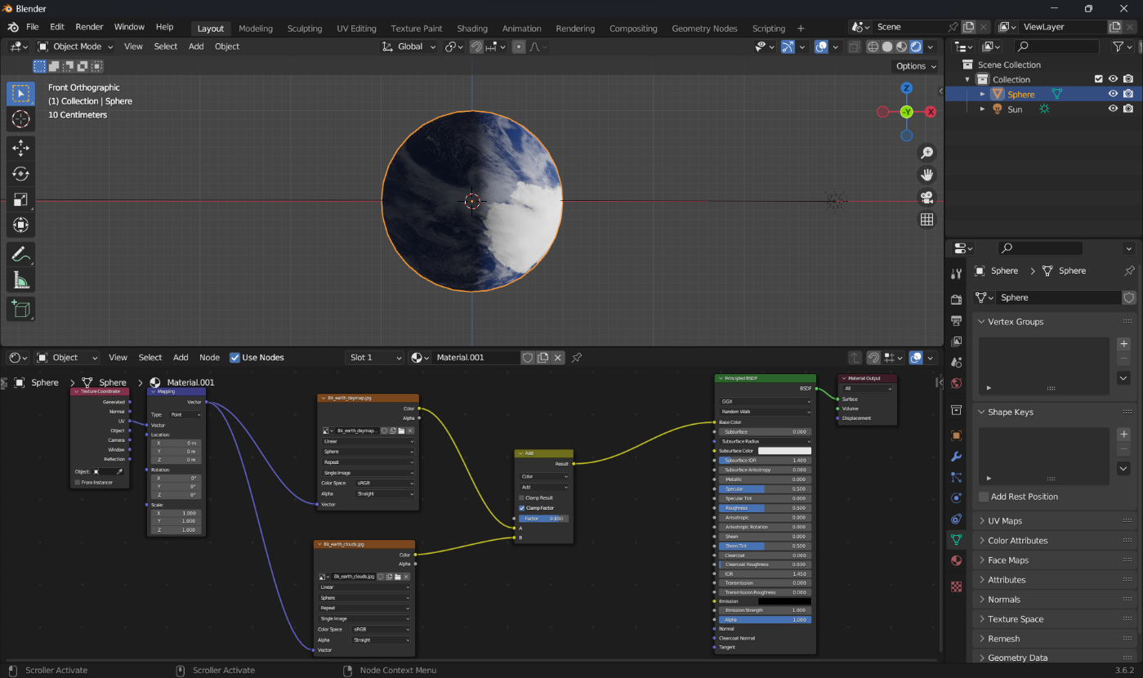
- Now add Earth’s Specular map in the same way and plug the mapping node.
- And now we add the Normal map.
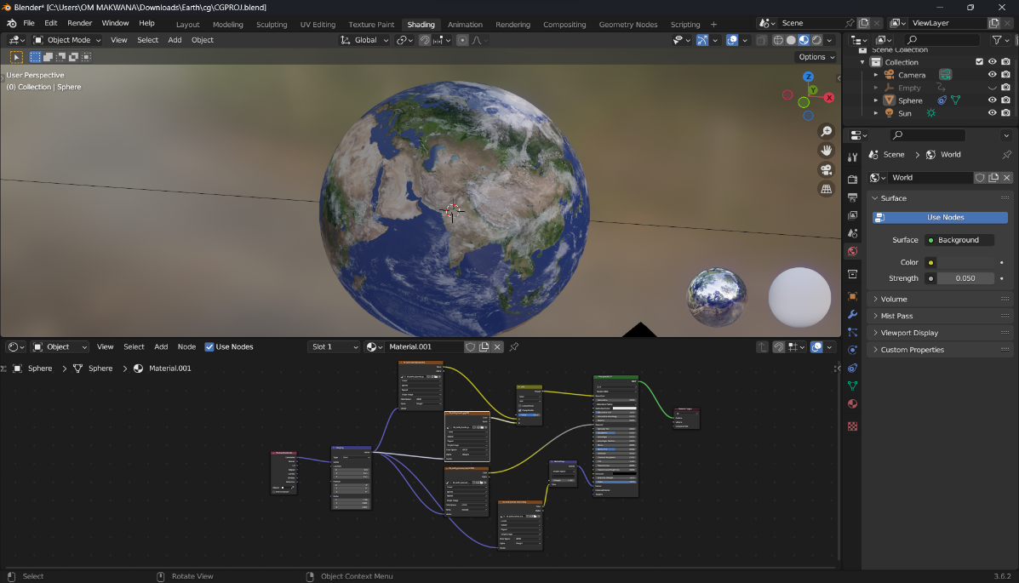
- Now our Earth is ready for Animation.
Steps to give animation:-
  - Press number pad 1 to go to front view, we need to rotate the Earth around its own axis.
  - Lets enable the rotation tool.
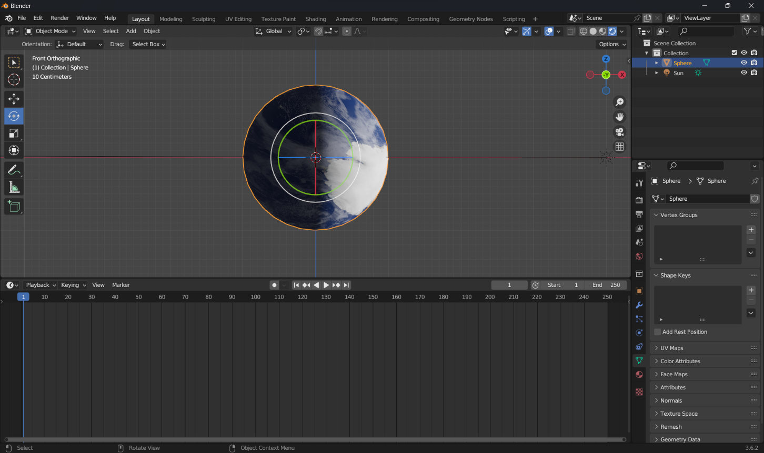

  - Now we add a Copy Rotation Constrain, and we disable the X and Y Rotations. We want the target to rotate on global Z-axis and the earth to local Z-axis.

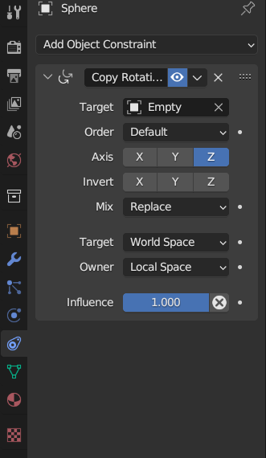

  - Make sure that you are at frame 1 at time line editor, then go over the Z rotation value press right click and Insert a Key Frame.
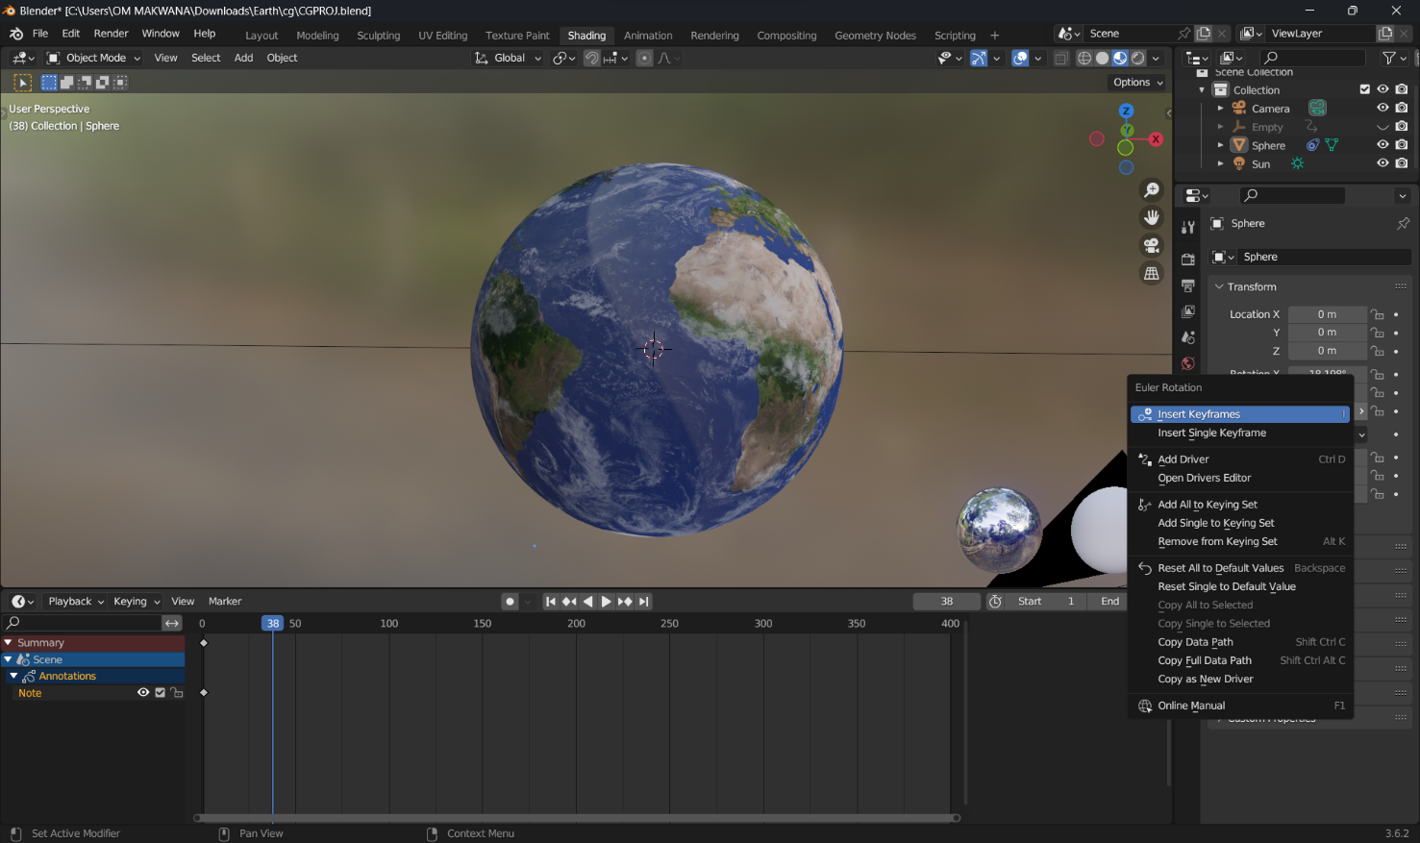
  - Then go to frame 100 and increase the value a little bit, right click and add a key frame.
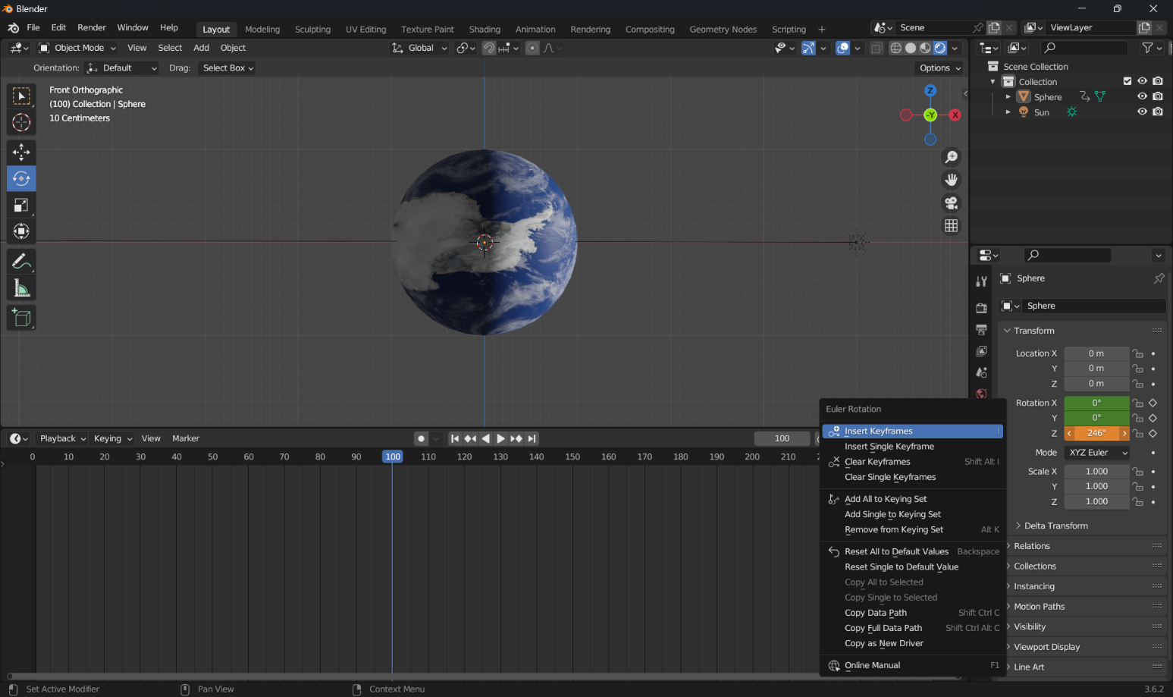
  - Here, the Earths starts rotating with an acceleration and stops with slow speed, to change this we go to graph editor and select the Z graph. Cycle the animation by adding a cycles modifier.

  - Now its time for rendering, first we go to World Properties’ tab and set the strength value to 0.05.

  - Lets add a camera, and press ctrl + alt + numpad 0, and align the camera to perspective.

  - Now click on the output properties’ tab and resolution to 1080p and select the output folder.
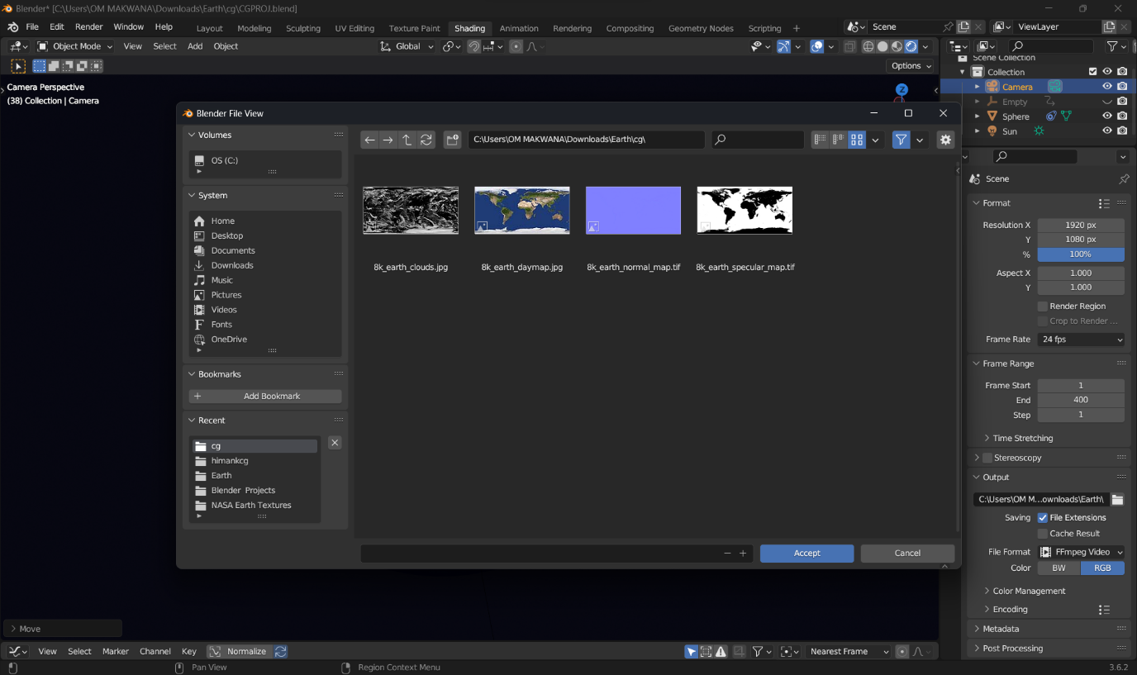

Conclusion
The main aim of our project was to study the basics of blender software, its functions and methods We studied the following topics to implement our project.
- How to model an object.
- Different modifier hotkeys.
- Adding textures to objects.
- Merging objects within an array.
- Using the curve modifier with an array.
- Using Edge loops to smooth curve modifier objects.
- Importing assets from your library into your scene.
- Deleting path curve points.
- Making a curve or path auto loop into itself.
- Animating the object.
- Setting objects to linear interpolation type to constant there speed.
- Make an object follow a path.
- Manually adjusting path objects.

We took help of sensei format also. Sensei Format comes with a free Blender asset library system which allows you to maximize reusability of your files, textures, images, models, imports and more. The Blender software has plethora of features like bridging objects, curving, smoothening them to create the required simulation. It also has features for following a specific object in motion/simulation and viewing it in a specific perspective. With the help of these effects and features on regular shapes, we were able to create objects and surroundings for the simulation of the project.
We also learned about the organization of the Blender Foundation and found this organization especially interesting. Most of the staff biographies provide that the Blender staff is made up of many young adults. The work of other young adults of my generation is increasingly relevant, and we are fascinated to learn that these people have created a program so intricate and detailed by working together so quickly after entering the work field.

