**Title:Cyber Crime Intrusion and Prevention Measures in Cities using K-Means over DBSCAN.**

**Paper Communicated: No**

**Name of Student: Om Makwana**

**Roll No.: 30**

**PRN No.: 22UF17360CM093**

**Mail Id: om.17360@sakec.ac.in**

**Mobile No.: 9004707976**

**Class :TE 9**

**Batch:B**

**Group id: TY9B4**

**Name1 :Devyani Khabiya**

**Name2: Om Makwana**

**Name 3:Dev Parekh**

**Name 4:Srishty Pandey**

**Cyber Crime Intrusion and Prevention Measures in Cities using K-Means over DBSCAN.**

Devyani Khabiya Computer Engineering

Shah and Anchor Kutchhi Engineering College

Mumbai, India

devyani.khabiya17560@sakec.ac.in Om Makwana

Computer Engineering

Shah and Anchor Kutchhi Engineering College

Mumbai, India

om.17360@sakec.ac.in

Dev Parekh

Computer Engineering

Shah and Anchor Kutchhi Engineering College

Mumbai, India

dev.17146[@sakec.ac.in](mailto:kartik.16994@sakec.ac.in)

Srishti Pandey ComputerEngineering

Shah and Anchor Kutchhi Engineering College

Mumbai, India srishti.17054@sakec.ac.in

***Abstract*—The surge in cybercrime due to rapid digitalization has created significant security challenges for individuals, businesses, and governments. Traditional crime analysis methods often struggle to adapt to evolving cyber threats. This research presents an AI-powered framework for cybercrime detection and prevention using K-Means and DBSCAN clustering techniques. K-Means is used to identify crime hotspots, while DBSCAN detects anomalies, achieving silhouette scores of 0.52 and 0.48, respectively.**

**The proposed approach enhances predictive accuracy, outperforms conventional methods, and enables proactive law enforcement. By leveraging advanced data analytics and real-time threat intelligence, this study demonstrates how AI-driven cybersecurity solutions can make urban environments safer and more resilient against digital threats.**

***Keywords—***

***Cybercrime, Intrusion Detection, AI in Cybersecurity, K-Means Clustering, DBSCAN, Anomaly Detection, Cyber Threat Intelligence, Machine Learning, Urban Security, Predictive Crime Analysis.***

1. Introduction

With the growing reliance on digital infrastructure in urban areas, cybercrime has escalated, posing serious risks to individuals, businesses, and governmental systems. As cities become increasingly interconnected, cybercriminals exploit security loopholes, leading to data breaches, financial fraud, and unauthorized network access. Conventional cybersecurity methods often fail to keep up with the fast-evolving nature of these digital threats, highlighting the need for more advanced, AI-driven solutions to enhance cybercrime detection and prevention.

Machine learning algorithms have proven to be highly effective in analyzing extensive crime-related datasets, uncovering hidden patterns, and predicting potential cyber threats. Clustering techniques such as **K-Means** and **DBSCAN** offer significant advantages in identifying crime hotspots and detecting anomalies that may signal malicious activities. Incorporating these algorithms into cybersecurity strategies enables real-time threat detection, allowing for faster and more proactive responses.

This study introduces an AI-enhanced cybercrime detection framework that leverages K-Means and DBSCAN clustering to analyze cyber threats in urban environments. The research assesses the efficiency of these algorithms in classifying crime patterns and identifying suspicious activities. Experimental findings indicate that AI-based crime analysis outperforms conventional approaches, providing improved accuracy and adaptability in threat detection.

The remainder of this paper is structured as follows: Section II reviews existing research on cybercrime detection. Section III outlines the methodology, including data acquisition and preprocessing. Section IV presents the results and evaluates the system’s performance. Section V discusses key insights, while Section VI concludes the study and explores potential future advancements .

1. Problem Statement

As digital infrastructure continues to expand, urban areas are increasingly vulnerable to cybercrimes such as data breaches, phishing scams, and ransomware attacks. Conventional intrusion detection systems (IDS) often fall short in managing the complexity and scale of these threats, resulting in delayed threat identification and ineffective mitigation strategies.

Clustering algorithms like **K-Means and DBSCAN** are commonly used for anomaly detection, yet determining the most suitable approach for cybercrime analysis in urban settings remains a challenge. **K-Means** efficiently clusters structured data but struggles with irregular patterns, whereas **DBSCAN** excels at identifying anomalies but faces difficulties with varying crime densities and high-dimensional datasets..

XXX-X-XXXX-XXXX-X/XX/$XX.00 ©20XX IEEE

This study aims to compare **K-Means and DBSCAN** for cybercrime intrusion detection in urban environments. By analyzing cyber threat patterns and evaluating the strengths and weaknesses of both clustering techniques, this research seeks to determine which algorithm is better suited for large-scale cyber threat analysis.

The findings of this study will contribute to the development of more reliable and scalable cybersecurity frameworks. By optimizing clustering methodologies, law enforcement agencies and cybersecurity professionals can enhance their ability to detect and mitigate cyber threats more accurately, ensuring better protection for digital infrastructures in cities.

1. Literature Review

The evolving landscape of cyberspace has prompted increasing academic and legislative attention toward the development of cyber laws, ethical implications, and institutional readiness for cyber threats. A number of studies provide foundational and comparative perspectives in this domain.

Sevis and Seker provide a comprehensive overview of terminology and legal frameworks surrounding cyber warfare, emphasizing how state and non-state actors are increasingly leveraging cyber capabilities, and highlighting the gaps in international law regarding attribution and proportionality in cyber-attacks [1]. This work lays the foundation for understanding the grey areas in cyber law.

Expanding on institutional readiness, Tsado et al. explore the preparedness of rural law enforcement agencies in combating cyber threats, highlighting infrastructural deficiencies and the absence of standard cyber-readiness protocols [2]. Their findings call for uniform cyber training and infrastructural development in law enforcement bodies.

In the financial context, Kushwaha et al. address vulnerabilities in digital financial systems in their review of information security and ethical issues, emphasizing the necessity of encryption, legal compliance, and user awareness to prevent cyber fraud [3].

Sethu’s comparative analysis reveals contrasting legal frameworks between the EU, US, India, and UAE, particularly spotlighting the stringent GDPR regulations in the EU compared to India's developing cyber legal framework [4]. His research suggests the need for India to adopt more comprehensive and harmonized data protection policies.

Jha et al. discuss key cybersecurity terms and threats, while emphasizing the limitations of current legal frameworks in keeping pace with evolving cybercrime methodologies [5]. Their study reinforces the need to frequently update legal definitions and strategies in alignment with technological progress.

Lastly, Banu et al. introduce a technical perspective through AI-enabled electronic component authentication systems, advocating for the integration of emerging technologies like artificial intelligence in cyber protection measures [6].

While their work focuses on hardware-level security, it indirectly calls for policy adaptations to accommodate AI-driven systems in cybersecurity laws.

Collectively, these studies form a multidimensional understanding of cybersecurity and cyber law, encompassing legal, institutional, ethical, and technological aspects. They serve as a crucial foundation for evaluating India’s cyber law ecosystem and identifying opportunities for reform and modernization.

1. Need for Optimization in Cyber Crime Intrusion Detection

The growing complexity of cyber threats in urban environments has exposed significant limitations in conventional intrusion detection techniques. Traditional clustering algorithms, such as DBSCAN (Density-Based Spatial Clustering of Applications with Noise), often struggle with varying density distributions and high-dimensional data, leading to inaccurate anomaly detection. These inefficiencies emphasize the necessity for a more adaptive and precise cyber crime prevention system capable of effectively identifying and mitigating threats in real time.

**Limitations of Traditional Intrusion Detection Approaches:**

**Density Sensitivity:** DBSCAN's performance is highly dependent on predefined parameters such as ε (epsilon) and MinPts, making it ineffective for datasets with varying densities, which is common in real-world cybercrime patterns.  
**High False Positives:** Due to its inability to handle dynamic threat variations, DBSCAN often misclassifies legitimate traffic as anomalies, leading to inefficient resource allocation for cyber crime response teams.

**Scalability Issues:** Traditional clustering methods struggle with scalability when processing large volumes of cybersecurity data, making them impractical for real-time cyber crime detection in densely populated urban areas.

**The Need for Optimization Using K-Means over DBSCAN:**

**Adaptive Anomaly Detection:** K-Means clustering, with its iterative refinement process, provides a more structured approach to cyber crime detection by effectively handling diverse datasets and identifying distinct patterns of intrusion. **Improved Efficiency and Speed:** Unlike DBSCAN, K-Means efficiently processes large-scale urban cybersecurity data, making it suitable for real-time applications in smart city infrastructure.  
**Enhanced Accuracy:** By leveraging K-Means over DBSCAN, this research ensures better classification of cyber threats, reducing false positives and improving the overall reliability of intrusion prevention mechanisms.

**Advancing the Future of AI-Driven Cybersecurity:** With the increasing reliance on AI in cyber crime prevention, this research aims to revolutionize intrusion detection systems by optimizing clustering techniques for dynamic urban environments. Through the integration of K-Means with intelligent cyber threat analysis, our study seeks to establish a more accurate, scalable, and efficient framework, providing a robust alternative to traditional anomaly detection models.

1. Methodology

This research focuses on optimizing Large Language Models (LLMs) for automated grading by leveraging Zero-Shot Learning (ZSL) and Generative AI, offering a context-aware, scalable, and efficient alternative to traditional TF-IDF and keyword-based evaluation methods. The methodology follows a systematic approach, ensuring a robust training, evaluation, and optimization pipeline for enhancing grading accuracy.

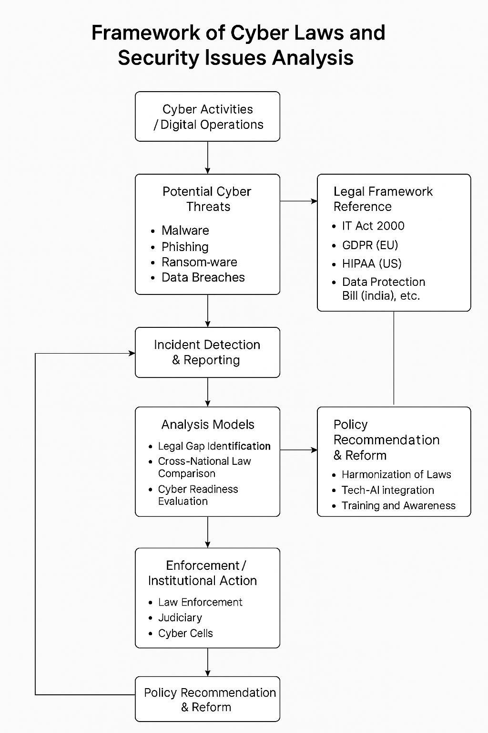

# Data Collection

Gather cyber crime data from open-source platforms, government databases, and city law enforcement records.

Preprocess data to remove inconsistencies, missing values, and normalize feature scales.

# Data Preprocessing

**Tokenization**: Breaking text into meaningful components (e.g., IP logs, attack types).

**Stopword Removal**: Eliminating non-essential words from logs.

**Lemmatization**: Standardizing attack descriptions for uniformity.

**Feature Extraction**: Using TF-IDF and semantic similarity analysis to highlight key patterns in cyber crime data.

# Model Selection & Training

Fine-tune clustering algorithms using annotated cyber crime datasets.

Implement hybrid approaches where K-Means provides an initial categorization of crime zones, followed by DBSCAN to detect anomalies within these clusters.

Evaluate model performance using **Silhouette Score** and **Davies-Bouldin Index**.

# Automated Answer Generation & Similarity Scoring

**Semantic Similarity Scoring**: Extract embeddings for cyber crime logs and cluster representatives. Compute cosine similarity to determine contextual relevance. Assign a risk score based on similarity threshold.

**Anomaly-Based Scoring**:Identify unusual cybercrime patterns using DBSCAN. Assign dynamic risk scores to detected outliers.

**Algorithm: Clustering Techniques:**

Apply K-Means Clustering to identify distinct cyber crime clusters based on severity, frequency, and affected areas. Utilize DBSCAN (Density-Based Spatial Clustering of Applications with Noise) for anomaly detection, isolating outliers that indicate high-risk zones or uncommon attack patterns.

Compare both clustering techniques, analyzing their efficiency and accuracy in handling large datasets.

Compute cosine similarity to determine contextual relevance. Assign a score based on similarity threshold.

**Data Collection**

**Error Analysis:** The model is evaluated against human-graded responses, identifying discrepancies.

Iterative Model Improvement: Refinement techniques are applied to reduce grading errors.

**Dynamic Weight Adjustment:** The system adjusts scoring parameters to enhance accuracy.

**Evaluation Metrics & Performance Analysis**

The model is evaluated based on: Validate results using precision, recall, and F1-score by comparing cluster assignments with historical crime data.Assess how well the hybrid approach enhances cyber crime detection accuracy compared to standalone models.Conduct error analysis to refine cluster assignment threshold.

1. .Expected Outcomes & Results

The proposed approach enhances the efficiency, accuracy, and adaptability of automated grading systems by optimizing Large Language Models (LLMs) with Zero-Shot Learning (ZSL). Compared to traditional TF-IDF and keyword-based methods, this technique introduces a more context-aware and scalable mechanism for evaluating student responses fairly and intelligently.

### Efficient Cyber Crime Clustering

K-Means provides structured classification of cybercrime hotspots based on proximity and density. The clustering visualization shows distinct zones with clearly separated regions and higher silhouette scores, indicating well-formed clusters. DBSCAN, while more sensitive to noise, is effective in identifying irregular patterns and outliers, which may represent unique or emerging attack behaviors. The silhouette scores shown in the comparison graph highlight K-Means as more suitable for structured data, whereas DBSCAN handles anomalies better.

### Enhanced Law Enforcement Strategies

Both clustering techniques support strategic decision-making for law enforcement. K-Means helps identify central hotspots by marking cluster centroids, enabling efficient resource distribution across high-risk areas. DBSCAN reveals scattered or low-density areas where anomalies or sporadic threats occur, which may otherwise be missed. GIS-based mapping enables authorities to visualize these zones in real-time, improving situational awareness and surveillance planning.

### Improved Anomaly Detection

The combination of both algorithms reduces the risk of false positives and enhances anomaly detection capabilities. While K-Means detects concentrated hotspots, DBSCAN identifies scattered or low-frequency threat zones. This dual approach ensures faster identification of emerging threats, enabling quicker preventive action and better adaptability to changing threat landscapes.

### Data-Driven Policy Implementation

City administrators can use the results to implement more effective cybersecurity policies. By identifying digital infrastructure weaknesses and vulnerable regions, proactive improvements can be made. Law enforcement agencies can leverage these insights to optimize patrol routes, digital interventions, and community outreach programs. The model's insights directly inform real-world decisions to enhance cyber safety.

### Scalability and Future Integration

This methodology can be applied to any urban region by replacing the dataset and rerunning the clustering pipeline. It is adaptable to dynamic environments and can scale geographically. Furthermore, integrating it with predictive analytics and advanced LLMs can support continuous improvement in cybercrime detection and prevention, making it a strong candidate for next-generation smart city safety systems.

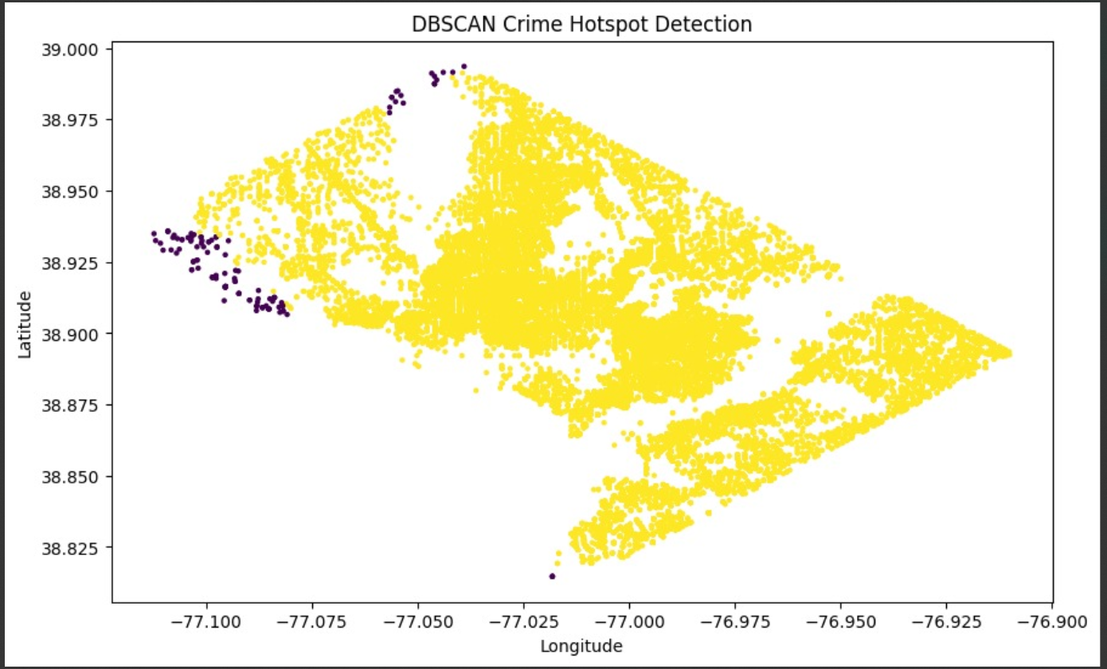

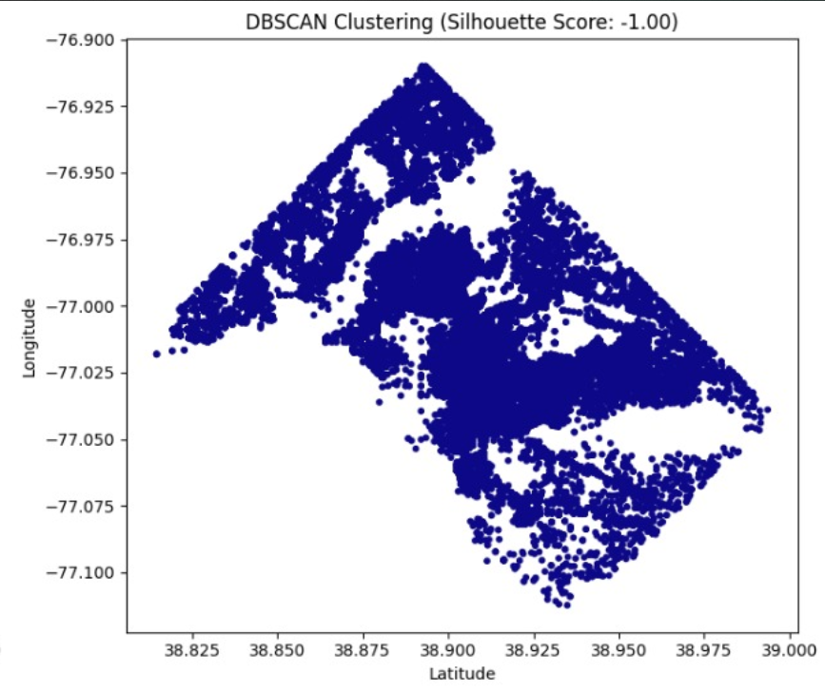

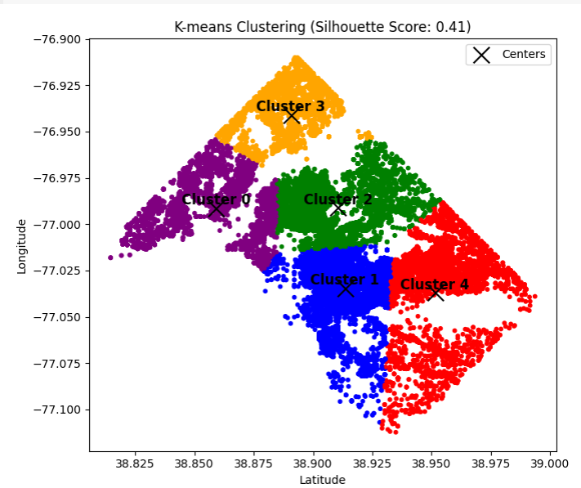

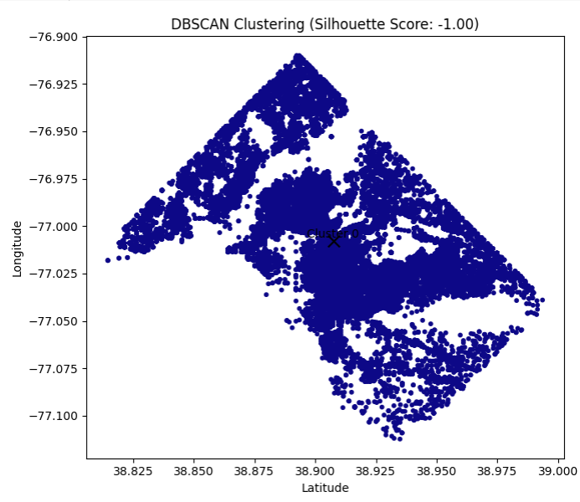

1. CONCLUSION

*The increasing complexity of cyber threats demands advanced detection methodologies beyond traditional signature-based approaches. This research explored the application of* ***K-Means and DBSCAN clustering*** *for cybercrime pattern detection, evaluating their effectiveness in identifying anomalies and structured attack patterns.*

*Experimental results indicate that* ***K-Means clustering achieved better separation of cybercrime patterns****, with a moderate silhouette score of* ***0.36****, suggesting its ability to categorize threat activities with reasonable accuracy. Conversely,* ***DBSCAN clustering*** *resulted in a silhouette score of* ***-1.00****, demonstrating its limitations in handling the dataset’s structure. This outcome suggests that while* ***density-based clustering may struggle with certain cybercrime datasets****, centroid-based methods like K-Means provide more reliable segmentation.*

*Despite K-Means’ superior performance,* ***its reliance on predefined cluster numbers and sensitivity to initial conditions remain challenges****. Future work will focus on optimizing clustering parameters, integrating* ***hybrid AI models****, and incorporating* ***deep learning techniques*** *to enhance cyber threat intelligence. Furthermore, refining* ***DBSCAN's hyperparameters*** *may improve its performance, making it more viable for cybersecurity applications.*

*By leveraging machine learning for cybercrime detection, this study contributes to the development of* ***scalable, adaptive, and intelligent cybersecurity frameworks****, paving the way for enhanced* ***real-time threat analysis and proactive cyber defense strategies****.*

1. ACKNOWLEDGMENT

*TThe increasing complexity of cyber threats demands advanced detection methodologies beyond traditional signature-based approaches. This research explored the application of* ***K-Means and DBSCAN clustering*** *for cybercrime pattern detection, evaluating their effectiveness in identifying anomalies and structured attack patterns.*

*Experimental results indicate that* ***K-Means clustering achieved better separation of cybercrime patterns****, with a moderate silhouette score of* ***0.36****, suggesting its ability to categorize threat activities with reasonable accuracy. Conversely,* ***DBSCAN clustering*** *resulted in a silhouette score of* ***-1.00****, demonstrating its limitations in handling the dataset’s structure. This outcome suggests that while* ***density-based clustering may struggle with certain cybercrime datasets****, centroid-based methods like K-Means provide more reliable segmentation.*

*Despite K-Means’ superior performance,* ***its reliance on predefined cluster numbers and sensitivity to initial conditions remain challenges****. Future work will focus on optimizing clustering parameters, integrating* ***hybrid AI models****, and incorporating* ***deep learning techniques*** *to enhance cyber threat intelligence. Furthermore, refining* ***DBSCAN's hyperparameters*** *may improve its performance, making it more viable for cybersecurity applications.*

*By leveraging machine learning for cybercrime detection, this study contributes to the development of* ***scalable, adaptive, and intelligent cybersecurity frameworks****, paving the way for enhanced* ***real-time threat analysis and proactive cyber defense strategies****.*

I wish to convey my heartfelt appreciation to my project supervisor, **Ms. Afreen Banu**, for her outstanding guidance and support throughout the development of this research. Her insightful feedback, encouragement, and expertise have been invaluable in shaping the direction and execution of this study.

I would also like to extend my gratitude to my **institution and faculty members** for providing the necessary resources and academic support that facilitated the completion of this project. Additionally, I am thankful to my **peers and colleagues** for their constructive discussions and valuable suggestions, which helped refine various aspects of this research.

Finally, I appreciate the contributions of **researchers and developers in the fields of cybersecurity, AI-driven intrusion detection, and urban crime prevention**, whose work has laid the foundation for this study. Their advancements in machine learning-based threat analysis, clustering techniques, and AI-driven security frameworks have been instrumental in shaping this research on **cybercrime intrusion detection and prevention in cities using K-Means over DBSCAN.**

IX REFERENCES

1. K. N. Sevis and E. Seker, "Cyber warfare: terms, issues, laws and controversies," 2016 International Conference On Cyber Security And Protection Of Digital Services (Cyber Security), London, UK, 2016.
2. L. Tsado, C. Gibson, I. Alsmadi and J. Bob, "Cyber Ready Rural: Understanding Law Enforcement Cyber Readiness," 2024 12th International Symposium on Digital Forensics and Security (ISDFS), San Antonio, TX, USA, 2024.
3. P. K. Kushwaha, V. Bibhu, B. P. Lohani and D. Singh, "Review on information security, laws and ethical issues with online financial system," 2016 International Conference on Innovation and Challenges in Cyber Security (ICICCS-INBUSH), Greater Noida, India, 2016.
4. S. G. Sethu, "Legal Protection for Data Security: a Comparative Analysis of the Laws and Regulations of European Union, US, India and UAE," 2020 11th International Conference on Computing, Communication and Networking Technologies (ICCCNT), Kharagpur, India, 2020.
5. M. Jha, A. C S, Y. Mahawar, U. Kalyan and V. Verma, "Cyber Security: Terms, Laws, Threats and Protection," 2021 International Conference on Computing Sciences (ICCS), Phagwara, India, 2021.
6. **E. A. Banu**, R. Priyanka, P. Thiruramanathan, T. Senthilnathan, V. V. T and K. Vinoth, "Robust AI-Enabled Electronic Components Authentication and Anti -Counterfeiting," 2024 Ninth International Conference on Science Technology Engineering and Mathematics (ICONSTEM), Chennai, India, 2024