BeeVM: step-by-step build guide
This guide lets anyone rebuild BeeVM from nothing, in the same order we built it. Every command is here, with what it does, why we do it, and the problems we hit (or that people commonly hit).
It grows with the project: each finished milestone adds a section.
Covered so far | Status
Part 0: what we are building | —
Part 1: prepare Windows and WSL2 | Done
Part 2: get the code, understand the layout | Done
Part 3: Milestone 1, a hand-booted MicroVM | Done
Part 4: Milestone 2, boot and stop a VM from Go | Done
Part 5: publishing to GitHub | Done
Appendix: cheat sheet, versions, numbers, troubleshooting | —

Part 0: what we are building
BeeVM is a Function-as-a-Service (FaaS) runtime, like a tiny AWS Lambda. A user uploads a function; BeeVM runs it inside its own Firecracker MicroVM (a very small virtual machine) so different users cannot affect each other. The grading targets are: cold start under 50 ms (via snapshots), tenant isolation, and VM density per machine.
On this laptop everything runs in layers:
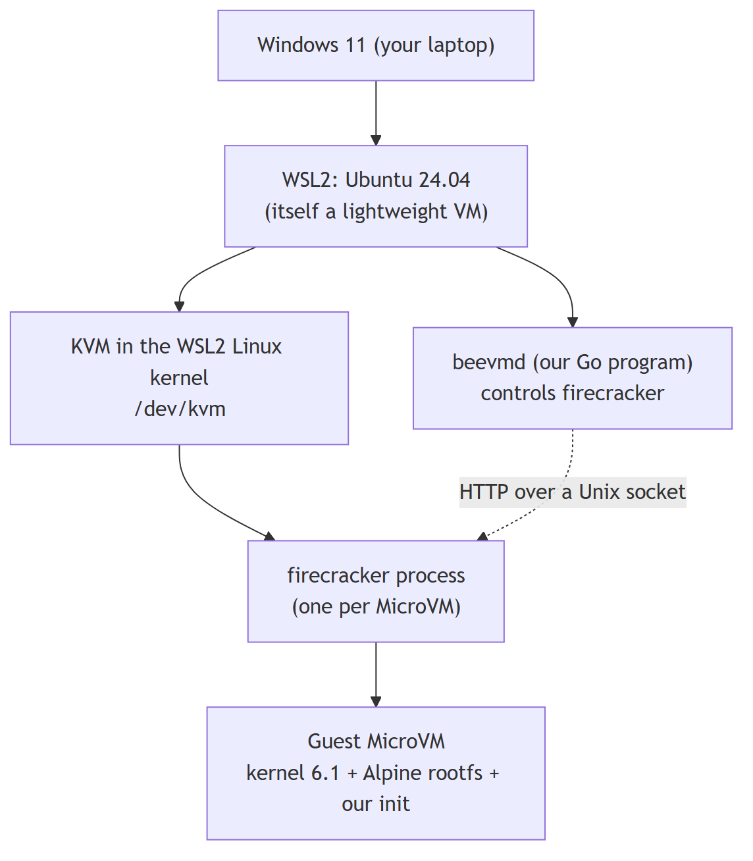
Why the layers matter: a MicroVM inside WSL2 is a VM inside a VM ("nested virtualization"). It works, but it is slower than on a real Linux server. That is why our boot numbers here (about 1.7 s) are only a development baseline.

Part 1: prepare Windows and WSL2

1.1 Check that the CPU supports virtualization
What: Intel VT-x or AMD-V must be turned on in the BIOS/UEFI.
Why: KVM (and so Firecracker) needs hardware virtualization.
In Windows: Task Manager → Performance → CPU → "Virtualization: Enabled". If it says Disabled, turn it on in the BIOS setup.

1.2 Install WSL2 with Ubuntu 24.04
In Windows PowerShell:
wsl --install -d Ubuntu-24.04
wsl -l -v
wsl -l -v must show VERSION 2. WSL1 has no real Linux kernel and no KVM.

1.3 Check that KVM works inside WSL2
In the WSL (Ubuntu) terminal:
uname -m # must print x86_64
ls -l /dev/kvm # must exist: crw-rw---- root kvm
cat /sys/module/kvm_intel/parameters/nested # Intel: Y means nested virtualization is on
cat /sys/module/kvm_amd/parameters/nested # AMD: 1 means on
On our laptop (i7-13620H, Windows 11) all of this worked without changing anything.
Common problems
Symptom | Cause | Fix
/dev/kvm: No such file | Nested virtualization off for WSL2 | Create C:\Users\<you>\.wslconfig with [wsl2] and nestedVirtualization=true, then wsl --shutdown in PowerShell
Still no /dev/kvm | Virtualization off in BIOS, or an old Windows build | Enable VT-x/AMD-V in BIOS; update Windows 11
nested file missing | Wrong CPU vendor file (Intel vs AMD) | Read the other one

Part 2: get the code and understand the layout

2.1 Clone the repository
In the WSL terminal (choose your own Windows folder):
cd /mnt/c/Users/<you>/Desktop
git clone https://github.com/om8P/BeeVM.git
cd BeeVM
/mnt/c/... is your Windows C: drive seen from Linux. Keeping the code there means you can edit it with Windows tools (VS Code, Claude) while building it in WSL.
The course case-study .docx is not in the repo (it is course material). Get it from the course page if you need it.

2.2 Two places on disk, on purpose
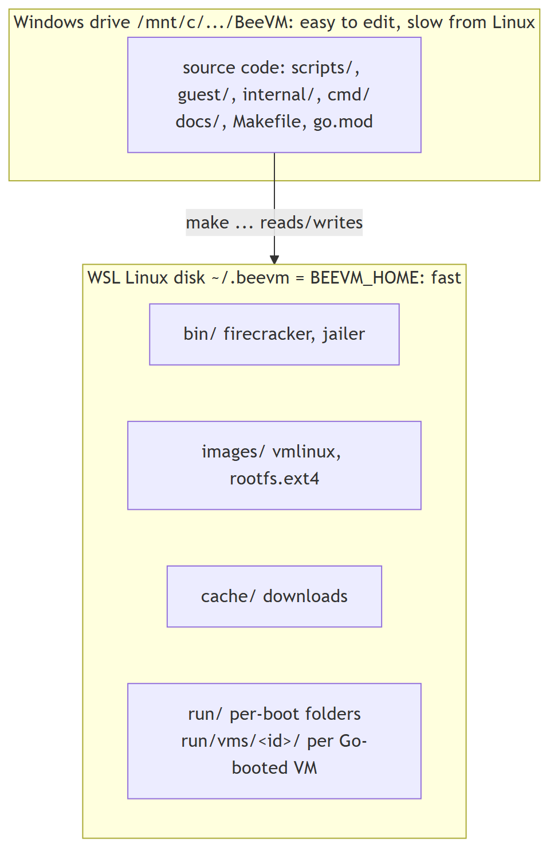
Why: reading files on /mnt/c from Linux goes through a slow translation layer. VM disk images and (later) snapshots need fast disk access, so they live in ~/.beevm. To put them elsewhere: export BEEVM_HOME=/some/linux/path before running make.

2.3 Line endings (a problem we hit)
Windows Git had core.autocrlf=true, which turns line endings into Windows-style CRLF on checkout. Bash then fails with errors like $'\r': command not found.
Fix (already in the repo): .gitattributes contains * text=auto eol=lf, which forces LF for every text file regardless of the Git settings. Check with:
git ls-files --eol | grep -E "\.sh|Makefile" # should show w/lf
If a script was already checked out with CRLF: sed -i 's/\r$//' path/to/script.sh.

Part 3: Milestone 1, a hand-booted MicroVM
Goal: prove KVM and Firecracker work, by booting a VM with the plain firecracker command and a JSON config file.

3.1 One-time setup: make setup
In the WSL terminal, in the repo folder:
make setup
It asks for your sudo password once. It runs scripts/setup-wsl.sh, which does these steps, each skipped if already done (so it is safe to run again):
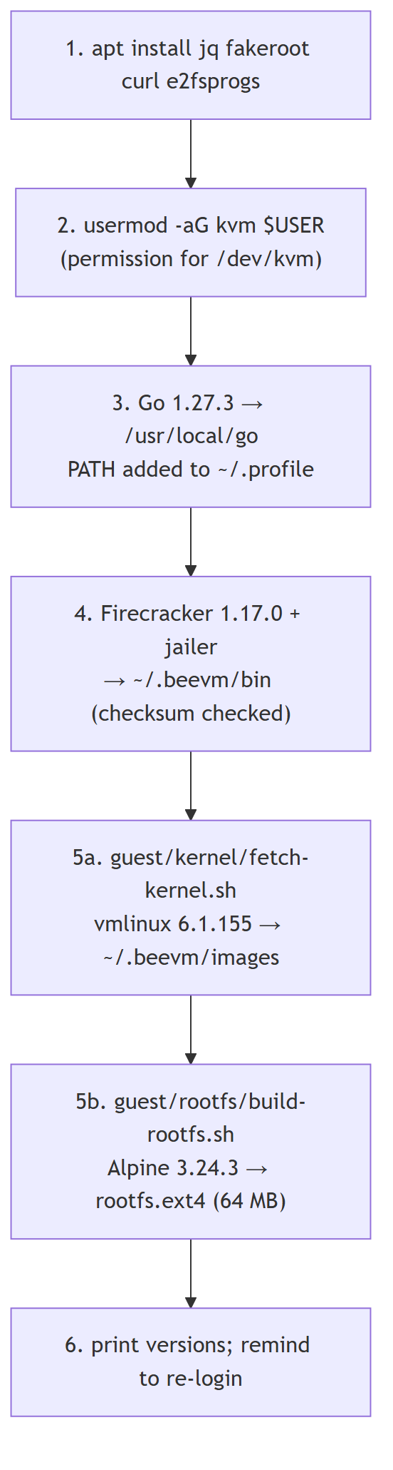
All versions and SHA-256 checksums are pinned in scripts/common.sh. Every download is checked against its checksum and refused if it does not match.
Then, once, in Windows PowerShell:
wsl --shutdown
and open the WSL terminal again. Why: adding a user to a group only takes effect at the next login. Check with id (must list kvm).
What each piece is:
- firecracker: the virtual machine monitor (VMM). It uses KVM to run a MicroVM with only a few emulated devices (serial port, disk, network, vsock), which is why it starts fast.
- jailer: Firecracker's sandboxing helper. Installed now, used in milestone 9.
- vmlinux: the guest Linux kernel as an uncompressed file. Firecracker loads it straight into guest memory; there is no BIOS or bootloader.
- rootfs.ext4: the guest's disk (its /), containing Alpine Linux plus our init script.

3.2 How the rootfs is built (no sudo, no Docker)
make rootfs # or: bash guest/rootfs/build-rootfs.sh
- Download alpine-minirootfs-3.24.3-x86_64.tar.gz (about 3.6 MB).
- Inside one fakeroot session: unpack it, copy guest/rootfs/init to /sbin/beevm-init, then run mkfs.ext4 -d <folder> rootfs.ext4 64M.
- mkfs.ext4 -d creates a filesystem image and fills it from a folder without mounting it, so no root rights are needed.
- fakeroot makes the files look owned by root inside that session, so they are root-owned inside the image (the guest expects that).
The image is rebuilt automatically when guest/rootfs/init changes.

3.3 The guest's init script (PID 1)
guest/rootfs/init is the first program the guest kernel runs. It mounts /proc, /sys, /dev, prints a banner, then acts on the beevm.mode= value in the kernel command line:
Mode | Used by | Behaviour
selftest | make boot-test | prints BEEVM_BOOT_OK, then reboot -f (VM exits)
idle | beevmd boot, Go tests (milestone 2) | prints BEEVM_READY, waits until stopped
none | make boot | gives you a shell; reboot -f exits

3.4 Boot a VM: make boot-test and make boot
make boot-test # automatic: boots, checks, prints the time
make boot # interactive: you get a shell inside the VM
scripts/boot-vm.sh makes a run folder ~/.beevm/run/<timestamp>/, copies rootfs.ext4 into it (the clean original is never changed), writes vm-config.json, and runs firecracker --no-api --config-file vm-config.json.
The kernel arguments it passes:
Argument | Meaning
console=ttyS0 | kernel messages go to the serial port, which Firecracker connects to your terminal
reboot=k | a guest reboot happens through the keyboard controller, which Firecracker treats as "exit"
panic=1 | if the kernel crashes, reboot after 1 s instead of hanging
pci=off | Firecracker has no PCI bus, so don't look for one
init=/sbin/beevm-init | run our script as PID 1
beevm.mode=... | our own flag, read by the init script

What happens during make boot-test:
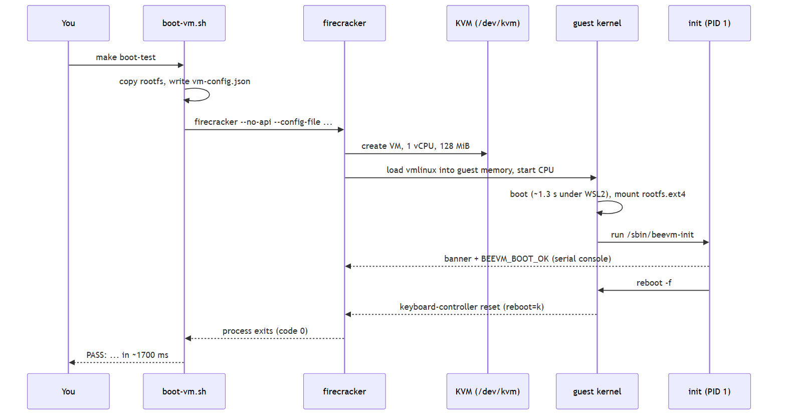
In make boot, check that you are really in a different system: uname -r shows 6.1.155 inside the VM but 6.6... in WSL.
Result: make boot-test passes in 1.7 to 2.0 s. make clean-images && make setup && make boot-test rebuilds everything from scratch and passes again.

3.5 Problems we hit in milestone 1
Problem | What happened | Fix
No kernel for Firecracker 1.17 | Firecracker's CI storage had no vmlinux-6.1 under v1.17 or v1.16 | Took vmlinux-6.1.155 from the v1.15 folder. The kernel does not depend on the Firecracker version
HTTPS certificate error listing the kernel bucket | https://spec.ccfc.min.s3.amazonaws.com fails, since bucket names with dots break the S3 certificate | Use the path-style URL https://s3.amazonaws.com/spec.ccfc.min/...
sudo needs a password | Automation tools cannot type it | You run make setup yourself; everything after it needs no sudo
Permission denied on /dev/kvm after setup | The group change is not active until next login | wsl --shutdown in PowerShell, reopen WSL
Shell scripts fail with \r errors | CRLF line endings from Windows Git | .gitattributes (Part 2.3)
Commands run from Windows into WSL lose $VARS and quotes | Each layer (Git Bash, wsl.exe, bash) re-parses the text; Git Bash also rewrites /mnt/... paths | Put commands in a script file and run wsl.exe -- bash file.sh, set MSYS_NO_PATHCONV=1, or just use make targets. Typing directly in the WSL terminal avoids all of this
Slow Alpine download | Mirror speed (about 130 KB/s once) | Only happens once; files are cached in ~/.beevm/cache

Other common problems
- make: command not found or strange errors: you ran it in PowerShell. Run it in the WSL terminal.
- firecracker not found: make setup did not finish. Run it again; finished steps are skipped.
- Boot hangs or FAIL: read the log path printed by the script (~/.beevm/run/<...>/console.log). The last lines usually say what went wrong.
- ls: cannot access /dev/kvm after a Windows update: check Part 1.3 again.

Part 4: Milestone 2, boot and stop a VM from Go
Goal: replace the shell script with Go code that the rest of BeeVM can call: create, start, stop, kill and clean up a VM, leaving nothing behind.

4.1 Go module and the Firecracker SDK
Already done in the repo; for a fresh clone you only need:
make build # downloads Go dependencies the first time, builds bin/beevmd
For the record, the module was created with:
go mod init github.com/om8P/BeeVM
go get github.com/firecracker-microvm/firecracker-go-sdk@6fb280e993d4
go mod tidy
- A Go module is a project with its own name (the module path) and a list of pinned dependencies (go.mod and checksums in go.sum).
- firecracker-go-sdk starts the firecracker process and talks to its API for us.
- Why a commit instead of a release? The SDK's last release (v1.0.0) is from 2022. Its main branch (December 2025) has updated, security-fixed dependencies. It is tested against Firecracker 1.4.1, but worked with our 1.17.0 without changes. It requires Go 1.24 or newer.
If go is "not found" in a new terminal: source ~/.profile, or use make (it calls /usr/local/go/bin/go directly).

4.2 The API socket: how Go controls Firecracker
In milestone 1 we used --no-api and a JSON file. Now Firecracker runs with --api-sock <file>: it listens on a Unix domain socket (a file that acts like a local network port) and is configured with HTTP requests:
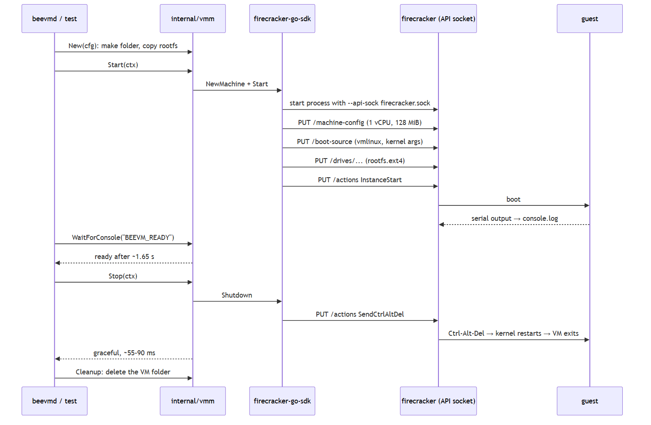

4.3 The VM lifecycle in internal/vmm
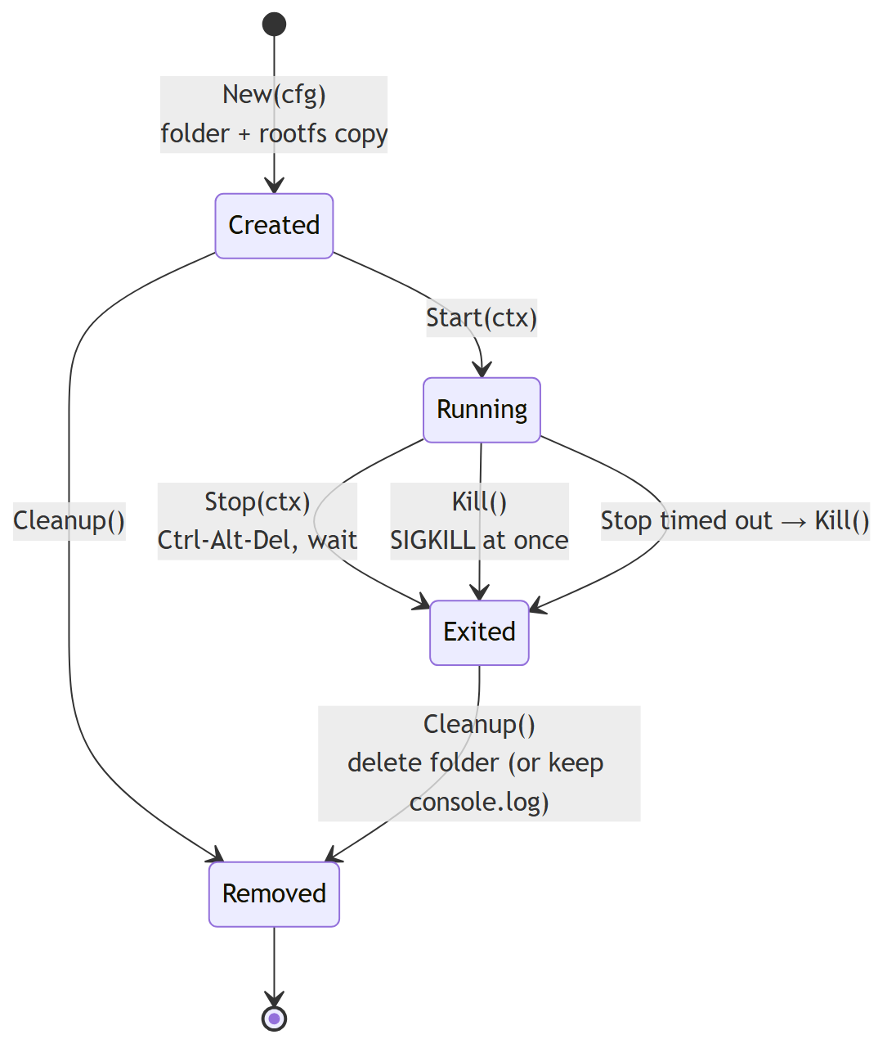
Files:
File | What it holds
internal/vmm/config.go | Config (paths, vCPUs, memory, extra kernel args), defaults, Validate(), the per-VM paths
internal/vmm/vm.go | New, Start, WaitForConsole, Stop, Kill, Cleanup, PID, Exited
internal/vmm/vm_test.go | 9 unit tests that need no KVM
internal/vmm/vm_kvm_test.go | 3 tests that boot real VMs (//go:build kvm)
cmd/beevmd/main.go | the beevmd boot command

Each VM gets its own folder ~/.beevm/run/vms/<id>/ with rootfs.ext4, firecracker.sock and console.log. The library never reads environment variables; the caller passes all paths. Only beevmd reads BEEVM_HOME.

4.4 Run it
make test # unit tests, no KVM needed
make test-kvm # boots real VMs: graceful stop, kill, cancelled start
make vet # Go's static checks
make build
./bin/beevmd boot # boot, show console, stop, clean up
./bin/beevmd boot --hold 30s # keep it running 30 s (Ctrl-C kills it)
./bin/beevmd boot --keep-logs # keep console.log afterwards
./bin/beevmd boot --mem 256 --vcpus 2 # different size
Check that nothing is left behind (after any of the above, including Ctrl-C):
pgrep -a firecracker || echo "no firecracker processes"
ls ~/.beevm/run/vms/
Result: all tests pass; ready in about 1.65 s, graceful stop in 55 to 90 ms; Ctrl-C exits with code 130; no leftovers in any case we tried.
Build tags: //go:build kvm at the top of vm_kvm_test.go means it is only compiled with go test -tags kvm. So make test passes on machines without KVM, and make test-kvm runs the real thing.

4.5 Problems we hit in milestone 2
Problem | Why | What we did
The VM would die when a start timeout expired | The SDK ties the firecracker process to the context used to start it | The VM gets its own long-lived context; the caller's timeout only limits how long Start waits
Calling Shutdown twice would panic | The SDK closes an internal channel in Shutdown | Stop wraps it in sync.Once
Ctrl-C in beevmd went straight to firecracker | The SDK forwards signals to firecracker by default | Set ForwardSignals to an empty list; beevmd decides (it kills the VM and cleans up)
StopVMM could hang | It sends SIGTERM and waits | Kill sends SIGKILL to the process directly and waits at most 5 s
Init's SIGINT handler never runs on stop | By default the kernel restarts immediately on Ctrl-Alt-Del, without telling PID 1 | Fine: the VM still exits cleanly. The handler stays as a safety net
The kernel takes ~1.3 s to boot | Partly WSL2 nesting; the log also shows a ~460 ms gap around clk: Disabling unused clocks | Noted for tuning in milestone 6
go mod tidy requires Go 1.24 | The SDK's main branch needs it | Fine with our Go 1.27.3; docs updated to "Go 1.24+"

Other common problems
- go: command not found: source ~/.profile or open a new WSL terminal.
- KVM tests print SKIP: /dev/kvm or the images are missing. Run make setup and check id for kvm.
- address already in use for the socket: a folder from a crashed run is left over. Delete ~/.beevm/run/vms/<id>.
- First make build is slow: Go is downloading dependencies; later builds are cached.

Part 5: publishing to GitHub
What we did, so you can do the same for your own fork or a new repo.
gh auth login # once: log the GitHub CLI in
gh repo create om8P/beevm --public --source=. --remote=origin --push
gh repo rename BeeVM --repo om8P/beevm --yes
git remote set-url origin https://github.com/om8P/BeeVM.git
- gh repo create ... --source=. --push creates the repo on GitHub, adds it as origin and pushes the current branch.
- After renaming the repo we also renamed the Go module to github.com/om8P/BeeVM (in go.mod and the import in cmd/beevmd/main.go) so they match.

5.1 Removing a file from history before going public
The first commit contained the course case-study .docx. Deleting it in a new commit would still leave it in the history, visible to anyone. So, before the first push, we rewrote the local history:
git branch backup-before-rewrite # safety copy of the old history (stays local)
git filter-branch -f --index-filter \
'git rm -q --cached --ignore-unmatch "Advanced Cloud System Software Design_ 30 Case Studies.docx"' -- main
rm -rf .git/refs/original
echo "Advanced Cloud System Software Design_ 30 Case Studies.docx" >> .gitignore
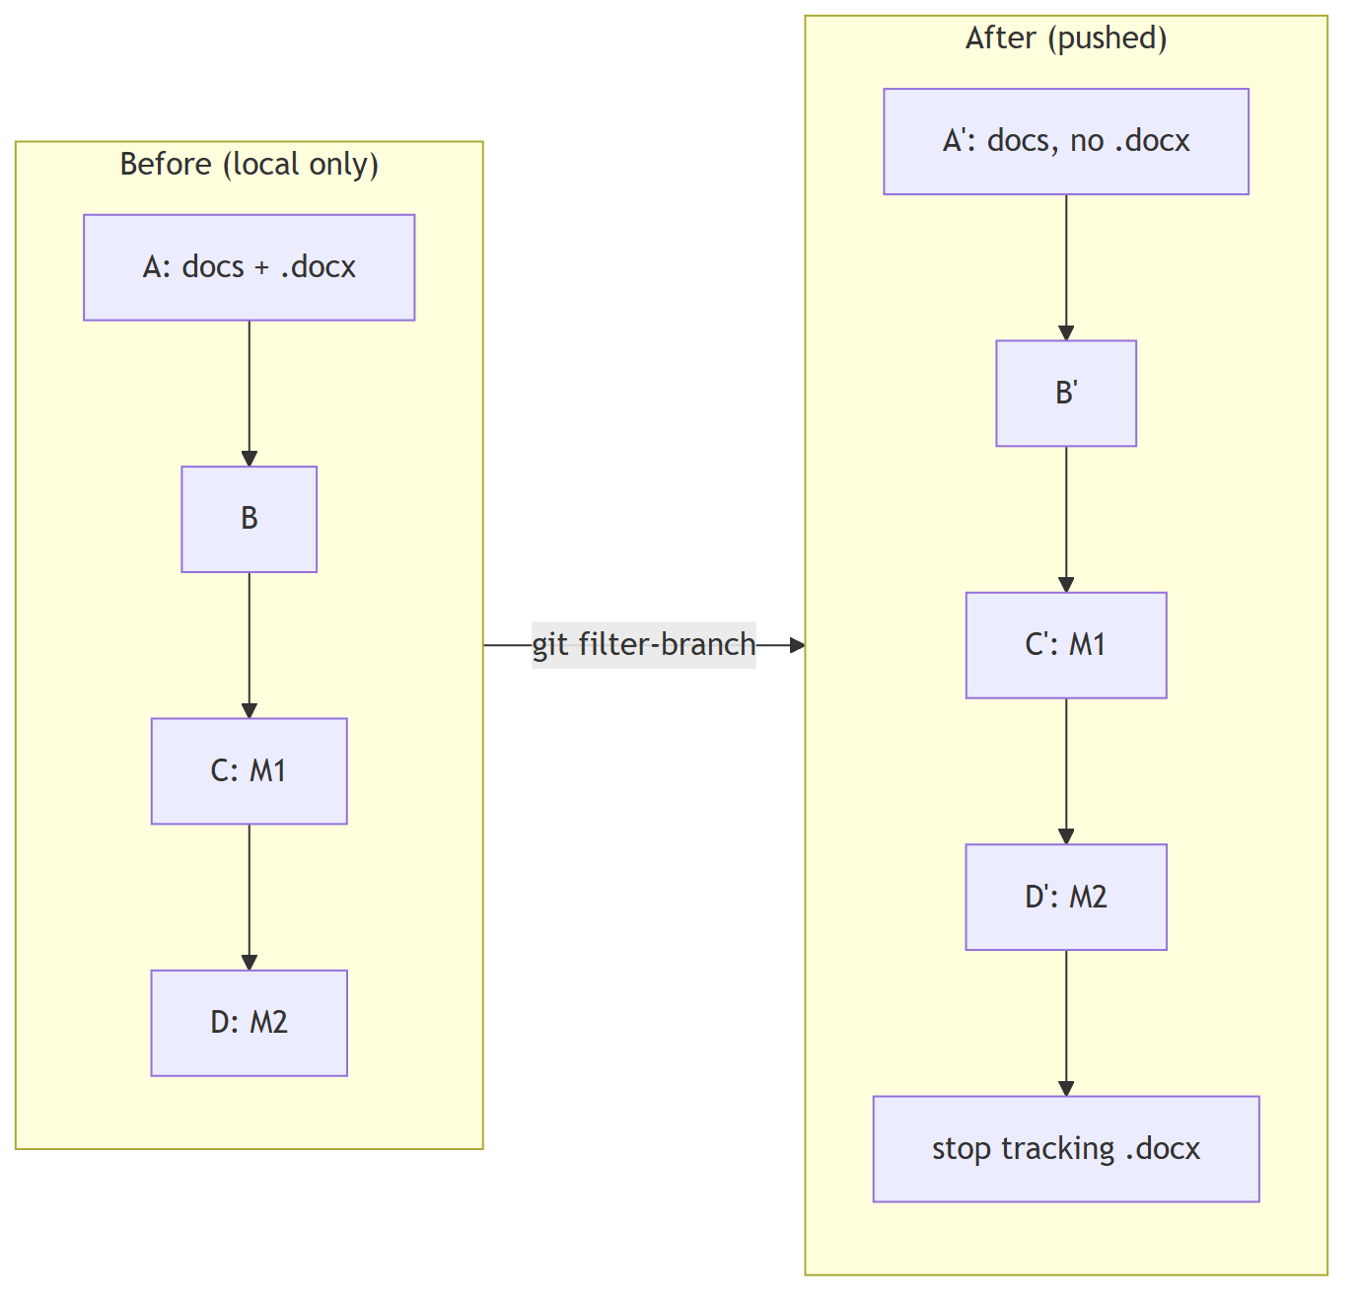
Things to know:
- Every rewritten commit gets a new hash. Only do this before anyone else has the old history.
- The rewrite deleted the file from the working folder (it was no longer tracked). We restored it with git show backup-before-rewrite:"<file>" > "<file>".
- Commit author emails are public on GitHub. To hide yours, use GitHub's no-reply address: git config user.email "<id>+<username>@users.noreply.github.com".
Current history on GitHub:
Commit | What
918d884 | planning docs and project setup
e6fdccb | 13-milestone session guide
e6dad4a | Milestone 1
bd71997 | Milestone 2
717a840 | stop tracking the course document
6364ecd | rename Go module to .../BeeVM

Appendix A: command cheat sheet
All in the WSL terminal, in the repo folder, unless marked PowerShell.
Command | What it does
make help | list targets
make setup | one-time install (sudo); safe to re-run
wsl --shutdown (PowerShell) | restart WSL so the kvm group takes effect
make images / make kernel / make rootfs | (re)build guest images only
make boot-test | milestone 1 automatic boot check
make boot | milestone 1 interactive VM (reboot -f to exit)
make build | build bin/beevmd
./bin/beevmd boot [--hold D] [--keep-logs] [--mem N] [--vcpus N] | milestone 2 Go boot
make test / make test-kvm / make vet | Go tests and checks
make clean-images | delete ~/.beevm/images and ~/.beevm/run
pgrep -a firecracker | find leftover VMs
id | check you are in the kvm group

Appendix B: pinned versions
Component | Version | Where pinned
Firecracker + jailer | 1.17.0 | scripts/common.sh
Go | 1.27.3 (module needs ≥ 1.24) | scripts/common.sh, go.mod
Guest kernel | vmlinux 6.1.155 (Firecracker CI, v1.15 folder) | scripts/common.sh
Alpine minirootfs | 3.24.3 | scripts/common.sh
firecracker-go-sdk | main @ 6fb280e993d4 (Dec 2025) | go.mod
Host | Windows 11, WSL2 Ubuntu 24.04.3, WSL kernel 6.6.87 | —

Appendix C: measured numbers (WSL2, i7-13620H, 1 vCPU, 128 MiB)
Measurement | Value | Milestone
Cold boot, shell script, process start to exit | 1.7 to 2.0 s | 1
Guest kernel reaches init | ~1.3 s | 1
Cold boot via Go, Start to BEEVM_READY | 1.58 to 1.71 s | 2
Graceful stop (Ctrl-Alt-Del) | 55 to 91 ms | 2
make setup re-run when all done | 0.6 s | 1
Target cold start (snapshot restore) | < 50 ms | 6 (to do)

Appendix D: general troubleshooting
- Where am I? Most problems come from running a command in the wrong place. Prompt PS C:\...> is PowerShell; user@host:~$ is WSL.
- Read the console log. Every boot writes one: ~/.beevm/run/<timestamp>/console.log (script) or ~/.beevm/run/vms/<id>/console.log (Go, with --keep-logs).
- Check KVM access: ls -l /dev/kvm and id.
- Start clean: make clean-images && make setup.
- Leftover processes: pgrep -a firecracker, then kill <pid>.

