**SVKM’s NMIMS**

**MUKESH PATEL SCHOOL OF TECHNOLOGY MANAGEMENT & ENGINEERING**

**MICROPROCESSOR AND MICROCONTROLLER**

**Term Work Project (Flow Chart)**

|  |  |
| --- | --- |
| Roll No: I067 Name: Om Trivedi | Course: MBA (Tech) Branch: INFORMATION TECHNOLOGY (IT) |
| Semester: IV Batch: A3 | SAP ID: 70411015062Date of Experiment/Practical: 23 MARCH 2018 |
| Group Members: I065 & I067 Group ID: G03 | Faculty In-Charge: **Prof. Bhisaji C. Surve** Grade/Remarks: |

**THE BOMB HAS BEEN DEFUSED**

**AIM: To design a bomb defusing kit with animation using minimal hardware and Emu8086.**

**FLOWCHART:** Following is the Flowchart design on steps to defuse a Bomb.

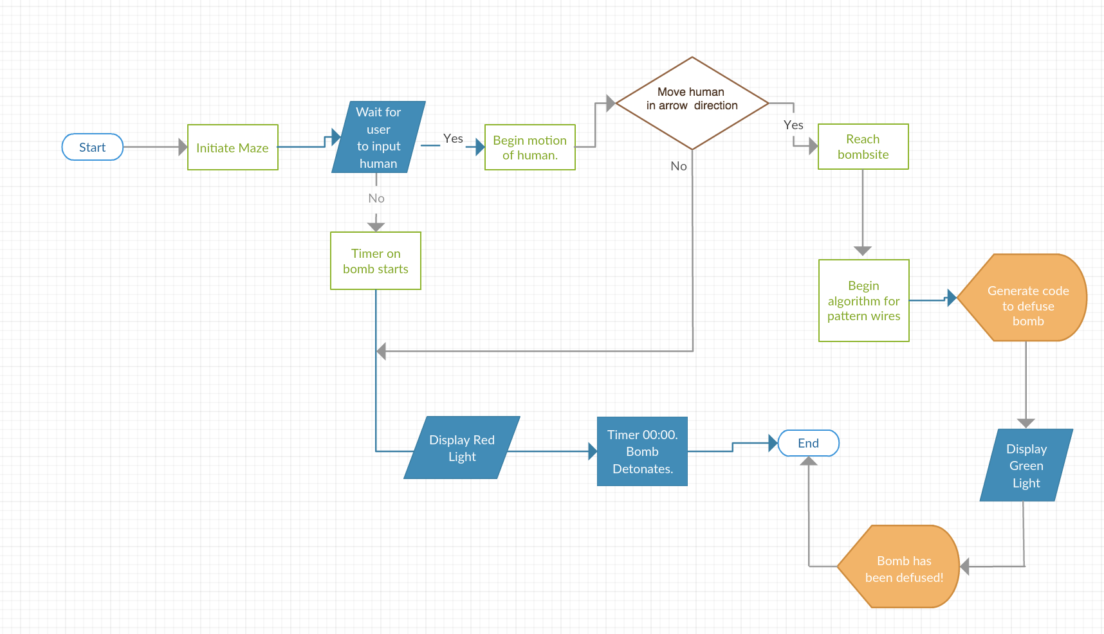

**Step-by-Step Instruction:**

1. As soon as the program starts, it will display the maze pattern in which the human and the bomb is to be set.

2. Once the human figure is established in the maze path, the figure will start to move in intended direction.

3. Timer on the bomb starts a countdown as soon as program executes.

4. From step 3, as the timer nears the last 5 seconds, a red light will display for warning. When the timer hits **00:00,** the bomb will detonate. From here, jump to **step 8.**

5. If human starts moving in intended direction, users will guide it to the bombsite upon which the ‘defusing’ process will begin.

6. When defusing starts, the algorithm to find a wire pattern is implemented which enables the figure to generate a code to defuse the bomb.

7. On successful generation, a green light is displayed and a message **“Bomb has been defused!”** is shown on screen.

8. The running program will then end.

**ALGORITHM**:

1. Start

2. Display maze pattern.

3. Human figure moves in bombsite direction.

4. Timer initialized **01:30. [T]**

5. Timer decremented.

6. No movement;

* *If T = 5s, go to Step 7.*

*Else*

* *Go to Step 8.*

7. Bomb displayed Red light.

8. T = 00:00, bomb Detonates.

9. Human reaches bombsite;

*If*

* *Go to step 10*

*Else*

* *Go to step 6.*

10. Human starts decoding wires and **Generates code. [G]**

11. **G = Bomb Code,**

*If*

* *Go to Step 12*

*Else*

* *Go to Step 8.*

12. Bomb displays Green light, bomb has been defused.

**CONCLUSION:**

Thus, we have implemented the Flowchart and Algorithm for **DEFUSING THE BOMB** and hence known how the program will look like and which process will be processed at what time and in which order. This is the detailed idea of the project.