Value of Signal variable:

- Signal > 550 Which is threshold value of BPM xd-58c. If Signal value goes beyond it, we show disconnected.
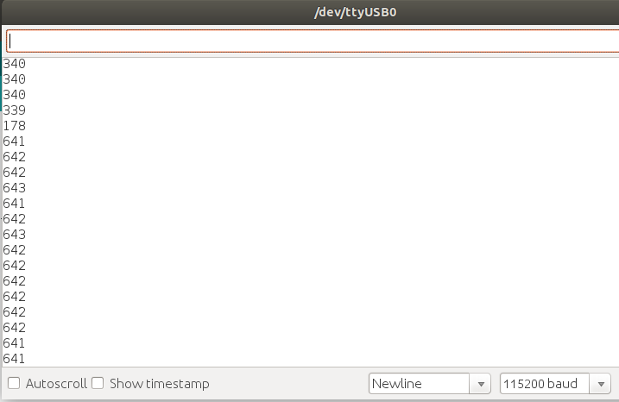

- Signal < 10 BPM sensor shows value below 10 when it is suddenly connected or get in touch to something living or non-living.
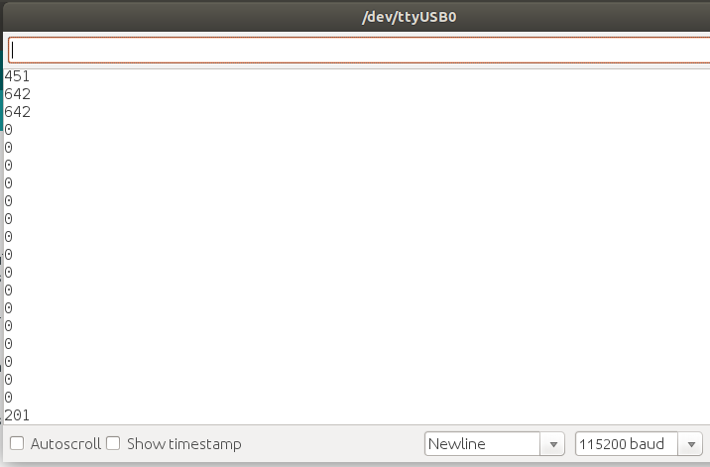

The above 2 observations dictate that the Sensor value is dependant upon intensity of incident ray and reflected way. Signal value might be subtraction of those two intensities.

- Constant Signal value around 340: Which shows that there has been a minimal noise and difference between incident and reflection is constant. Which dictates that is constant absorption of rays of bpm. So, while bpm is connected to something but it doesn’t show any variation in absorption. So, simply sensor is connected to a non-living thing.

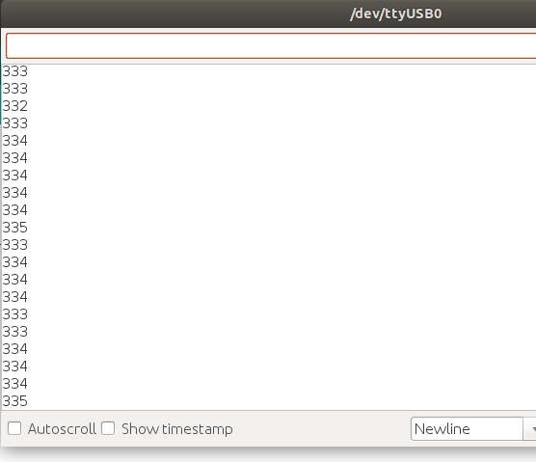
- Remarkable Variation in Signal value: Dictates circulation of oxigenated blood beneath the skin. A pulse sample is taken nearly for 5 seconds, prints alive for a living.
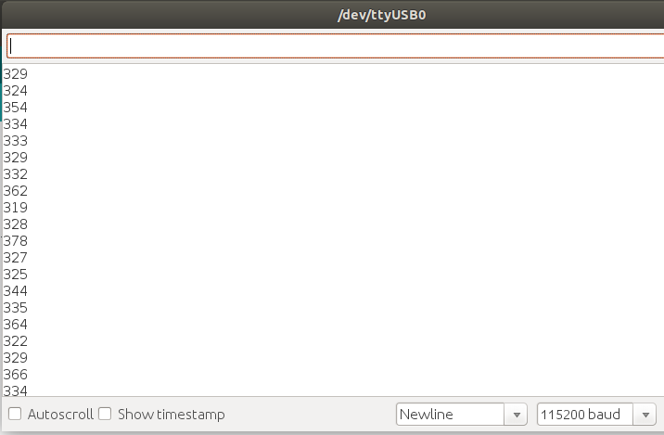

*There has been some error when suddenly connect to a living or a non living thing, but after 2 or 3 samples, the code shows the correct result.

