PIMPRI CHINCHWAD EDUCATION TRUST'S
PIMPRI CHINCHWAD COLLEGE OF ENGINEERING
SECTOR NO. 26, PRADHIKARAN, NIGDI, PUNE-44

A
Project Report
On
Single-Cycle 32-bit RISC Processor using Verilog HDL
Submitted By
1. | Ayush Peshwe | 123B1E087
2. | Om Patil | 123B1E084
3. | Rachit Agrawal | 123B1E090
Under the Guidance of
Prof. Dipti Khurge
DEPARTMENT OF ELECTRONICS AND TELECOMMUNICATION
TY BTech (E&TC) 2025-26
PIMPRI CHINCHWAD COLLEGE OF ENGINEERING (AUTONOMOUS INSTITUTE)
2025-26

Abstract
This project presents the design, simulation, and verification of a 32-bit single-cycle processor based on the RISC-V (RV32I) instruction set architecture. The primary objective is to build a functional CPU from the ground up using Verilog HDL and to verify its logical correctness through rigorous simulation. The processor's architecture follows the classic 5-stage datapath (Fetch, Decode, Execute, Memory, Writeback) implemented in a single-cycle execution model. The design is modular, consisting of distinct components for the datapath, control unit, ALU, register file, and memories. Functional verification was performed using a Verilog testbench in the Vivado Design Suite. The simulation waveforms confirm that the processor correctly fetches instructions, decodes opcodes, executes arithmetic and logic operations, handles branch logic, and performs memory read/write operations. This project establishes a foundational understanding of computer architecture principles and provides a verified baseline for future work, such as pipelined architectures.
Keywords: RISC-V, RV32I, Single-Cycle Processor, Verilog HDL, FPGA, CPU Design, Vivado, Functional Verification.

1. Introduction

1.1 Background and Motivation
The Central Processing Unit (CPU) is the core of modern computing. Understanding its internal operation is fundamental to the field of electronics and computer engineering. The recent rise of the RISC-V (Reduced Instruction Set Computer V) architecture, an open-source and royalty-free instruction set architecture (ISA), has provided an unprecedented opportunity for academic and commercial innovation. Unlike proprietary architectures, RISC-V allows anyone to design, implement, and extend a CPU.
The motivation for this project is to gain a practical, hands-on understanding of computer architecture by designing a complete processor from its fundamental logic blocks.

1.2 Application Domain
This project serves as a foundational element for numerous application domains, including:
- Embedded Systems: A simple, low-power CPU for microcontrollers.
- IoT Devices: A minimal-footprint processor for smart-sensor data processing.
- Academic Research: A baseline for exploring novel architectural features, security, or low-power design.

1.3 Problem Statement and Scope
The problem is to design and functionally verify a 32-bit processor that correctly executes a subset of the RV32I base integer instruction set.
Scope:
- Architecture: 32-bit, single-cycle execution model.
- ISA: A subset of RV32I (including R-Type, I-Type, S-Type, and B-Type instructions).
- Implementation: Verilog HDL.
- Verification: Functional simulation via a Verilog testbench.

2. Literature Review
A robust design is built upon established computer architecture principles. This project is primarily based on the classic single-cycle datapath presented in foundational computer science literature.

A powerful processor design should be based on firm principles of computer architecture. The backbone of this project is mainly based on the classic single-cycle datapath model, which is explained in detail in the basic literature of computer science, amongst others by Patterson and Hennessy[1]. “Computer Organization and Design” textbook by author: [1]. Concretely, the conceptual five-stage datapath (Fetch, Decode, Execute, Memory, Writeback), the implementation of the control logic, and the ALU are directly ported from the single-cycle processor described in their book. The fact that a single cycle needs to be long enough to accommodate the slowest operation, typical for the single-cycle model, is further explained based on the more advanced concepts and performance trade-offs discussed by Hennessy and Patterson in “Computer Architecture: A Quantitative Approach” [4]. The implementation of specific combinational and sequential logic components, like multiplexers, registers, and ALU, is based on known principles and methods of digital design described, among others, by Brown and Vranesic [3] and Mano and Ciletti[7].

The RISC-V architecture offers a modern, open-source basis for the design, being chosen for this reason[6,11].The processor's actual implementation follows word-by-word the official ISA specification contained in the book “The RISC-V Instruction Set Manual, Volume I: User-Level ISA”[2]. This rigorous specification was necessary during the development of the decoders for the control unit since it ensured logical correctness regarding the different formats of instructions (R-Type, I-Type, S-Type, B-Type) and corresponding opcode and function fields, all described therein[2]. The processor's design and functional verification are done using established best practices for HDLs. The Verilog HDL code, that describes the processor's RTL model, was written strictly following the best practices on how to do an effective digital design and synthesis by references such as Palnitkar's book on Verilog HDL[5]. Finally, guidelines for logic simulation, synthesis, and properties of on-chip memory resources are based on the Utilized Xilinx Vivado Design Suite documentation[ 8, 9, 10].

3. Problem Definition and Objectives

3.1 Formal Problem Statement
To design a modular 32-bit single-cycle processor in Verilog that implements the RV32I ISA. The processor must be capable of fetching instructions from an instruction memory, decoding them, executing arithmetic/logic operations, branching, and accessing a data memory for load/store operations.

3.2 Objectives
- To design the complete 5-stage datapath, including the PC register, register file, ALU, and memory interfaces.
- To implement a modular Control Unit that generates all necessary control signals from the instruction's opcode.
- To create a Verilog testbench to load a test program and simulate the processor's execution.
- To functionally verify the correct execution of each stage (Fetch, Decode, Execute, Memory, Writeback) by analyzing simulation waveforms

4. Methodology / System Design

4.1 Block Diagram / Architecture
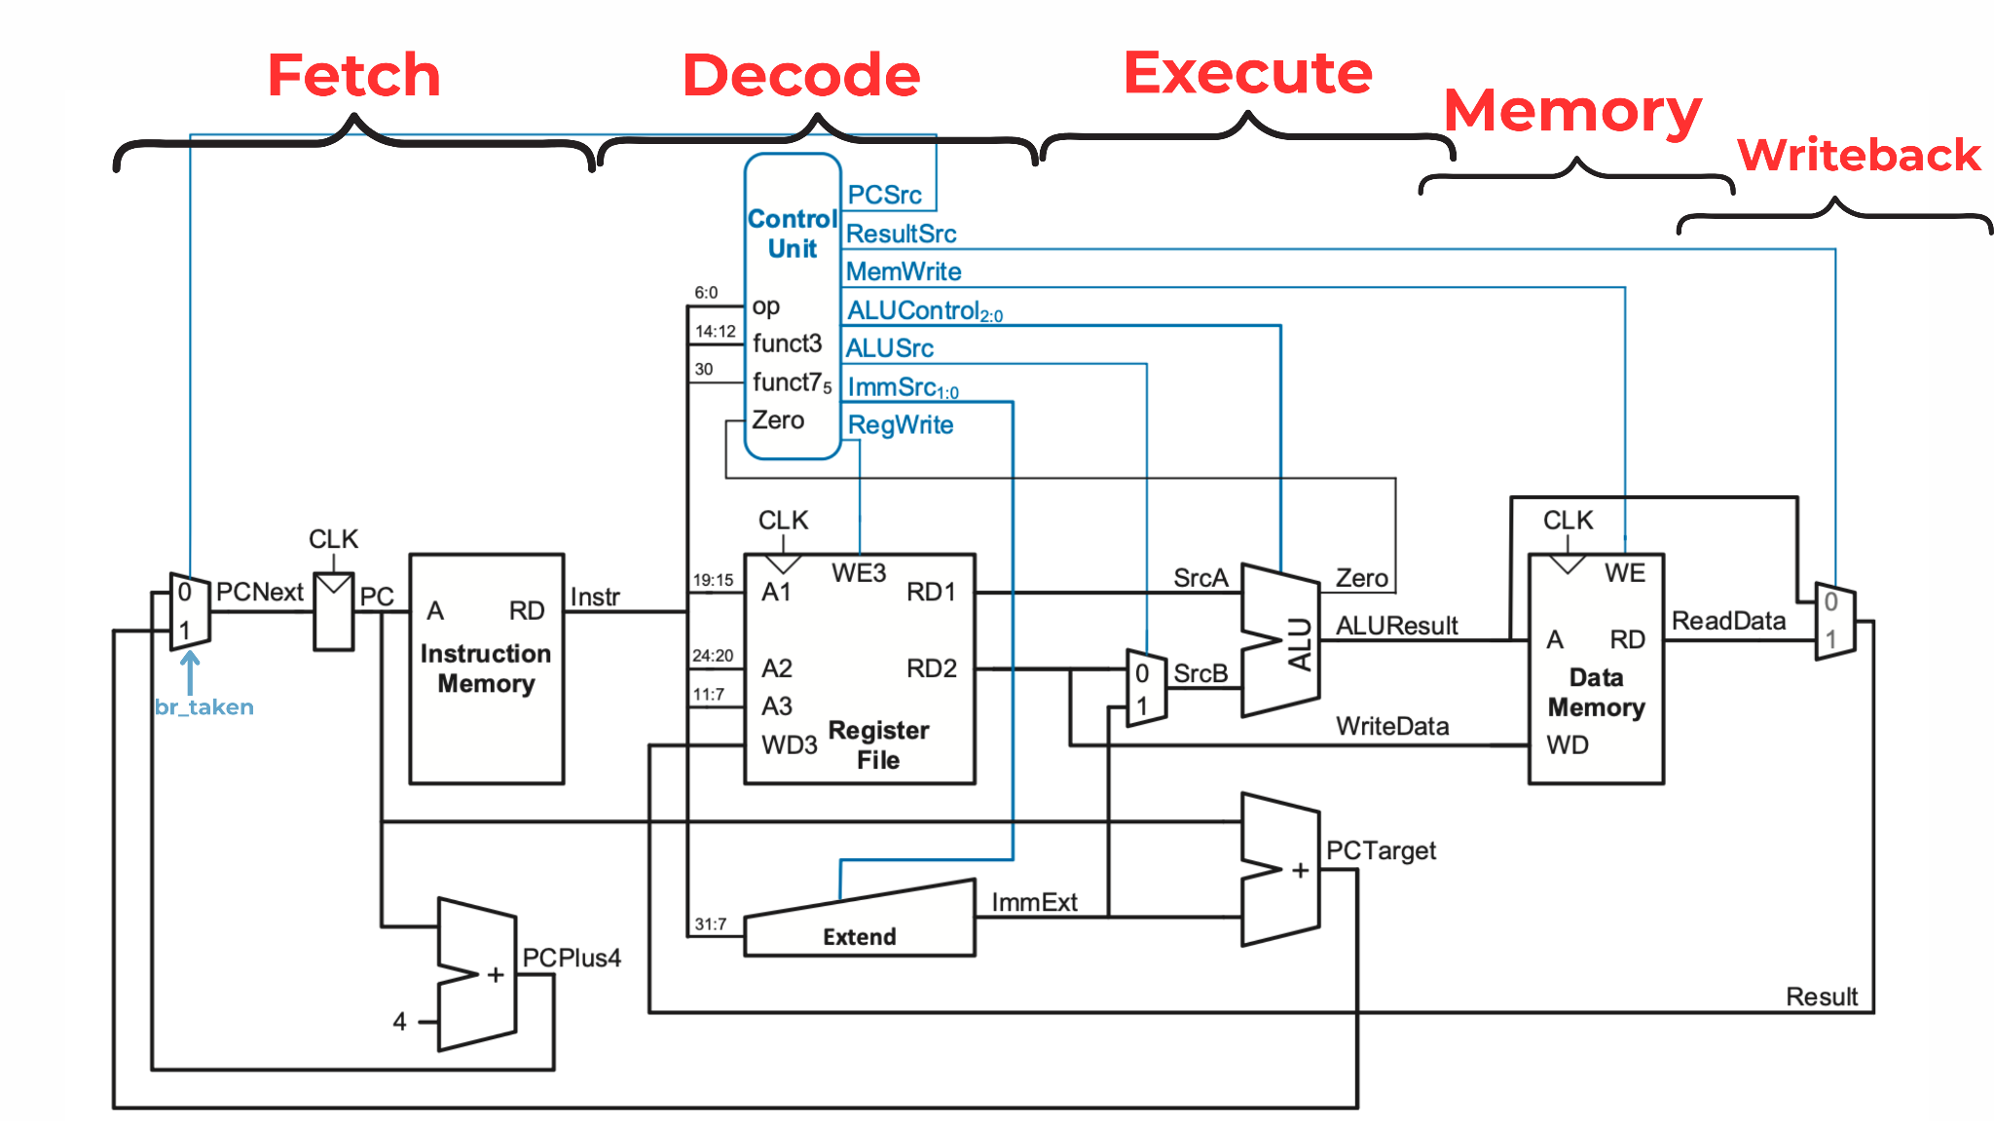

The processor's architecture is based on the conceptual 5-stage datapath, which is implemented in a single clock cycle.
The Verilog implementation is partitioned into several modules, as shown in the top-level RTL schematic generated by Vivado.
The task of successfully implementing the 32-bit single-cycle RISC-V processor utilized a structured, top-down design methodology, combined with the application of the classic five-stage data path architecture. This ensured modularity, allowed independent verification, and made it possible to integrate distinct, fully-verified components into a cohesive single-cycle system.

4.2 Design Philosophy: Modular and Top-Down

This processor was implemented wholly with a top-down approach

The top-Down approach:This provided the top wrapper that instantiated the major sub-components and hooked all signals

Hierarchical Partitioning: The design was logically divided into major functional units: the `data_path` and the `control_unit`, together with dedicated memory modules (`instr_mem`, `data_mem`)

Modularity: Every part, from the `ALU ,`register_file` , `main_decoder`, to `ALU_decoder`, was designed and verified individually before system integration. This approach meant that a logical error could be easily traced and debugged at the level of a component.

4.3 Architectural Concept: The 5-Stage Single-Cycle Execution

The key idea behind the venture was realising the 5-stage instruction cycle within a single clock cycle
The five conceptual stages of the datapath: “Fetch, Decode, Execute, Memory and Writeback” were each implemented as a flow of combinational and sequential logic:

Instruction Flow:An instruction enters the datapath at the Fetch stage via the `instr_mem` and flows through to the Writeback stage.

Control Unit: The opcode and function fields of the instruction are decoded by the `control_unit` in the Decode stage , generating all the necessary control signals (e.g., `regWrite`, `memWrite`, `ALUControl`) for the *entire* instruction to complete its journey through the remaining stages.

Single-Cycle Principle: The entire data path is designed as one block of combinational logic between the clocked elements, or the PC, Register File, and Data Memory. This means that an entire instruction completes its execution in one full clock period. This simplifies the control logic but, as will be discussed in the analysis, it dictates the clock speed.

4.4 Design Flow
The project followed a standard RTL design flow:

1 RTL Modelling: Components were designed and coded in Verilog HDL.

2. Simulation & Verification: A dedicated Verilog testbench (`RISC_tb.v`) was created to load a test program (`Test_Program.dat`). This rigorous functional simulation in the Vivado Design Suite verified the logical correctness of each stage.

3. Synthesis (Intended): The last step was to synthesize the code in Verilog for possible implementation on an FPGA

4.5 Design Flow
The project followed a standard RTL design flow:
- RTL Modeling: Each component was designed in Verilog (.v files).
- Simulation: A testbench (RISC_tb.v) was written to load a test program (Test_Program.dat) and simulate the design in Vivado's behavioral simulator.
- Verification: Waveforms were analyzed to debug and verify correct functionality.
- Synthesis: The Verilog code is intended to be synthesized for an FPGA.

4.6 Module-wise Design Description
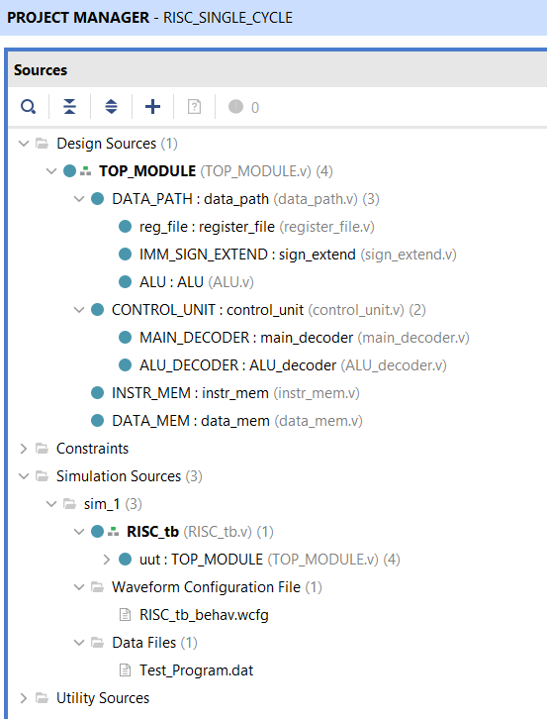
- TOP_MODULE: The top-level module that instantiates all other components and connects them, as seen in the RTL schematic.
- data_path: The core of the processor. It contains the PC register, register file, ALU, sign-extend block, and all MUXes that select data flow for the different instruction types.
- control_unit: The "brain" of the processor. It instantiates the main_decoder and ALU_decoder to generate all control signals based on the instruction opcode and the ALU's zero flag.
- main_decoder: A combinational block that decodes the 7-bit opcode into primary control signals (e.g., regWrite, memWrite, aluSrcB).
- ALU_decoder: A combinational block that generates the 4-bit ALU_control signal based on funct3, funct7, and the aluOP from the main decoder.
- ALU: The arithmetic logic unit. It performs all calculations (ADD, SUB, AND, OR, SLT, etc.) and outputs the ALUResult and the zero_flag.
- register_file: Models the 32 general-purpose registers. It has two asynchronous read ports (RD1, RD2) and one synchronous write port (WD3).
- instr_mem: Models the Instruction Memory. It takes the PC as an address and asynchronously outputs the corresponding instr.
- data_mem: Models the Data Memory. It takes aluResult as the address. On a memWrite = 1, it synchronously writes mem_WD. It also has an asynchronous read port for mem_RD.
- sign_extend: A combinational block that extends the 12-bit (I-Type), 13-bit (B-Type), etc., immediates into a full 32-bit signed value.

4.7 EDA Tools Used
- Design & Simulation: Xilinx Vivado 2024.2
- Language: Verilog HDL

5. Simulation and Synthesis Results

5.1 Functional Simulation and Verification
The processor was verified using the RISC_tb testbench, which loads Test_Program.dat into the instruction memory. The following waveforms demonstrate the correct operation of all five stages.

5.1.1 Fetch Stage Verification
- Signals Observed: PC, instr
- Waveform:
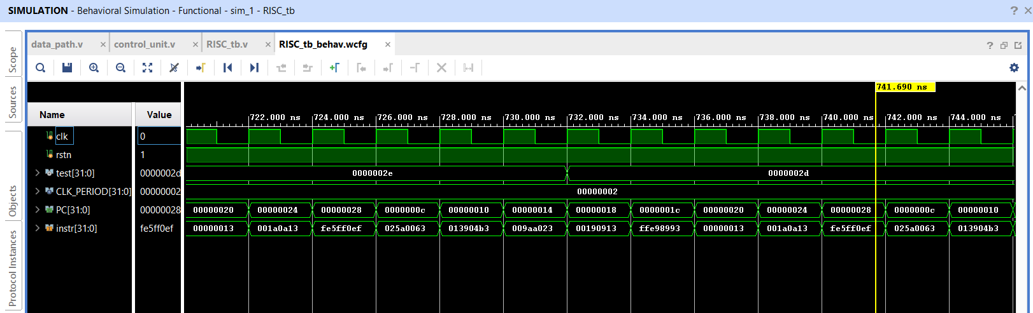
- Inference:
  - Program Loaded: The instr signal shows valid hexadecimal instructions (e.g., fe5ff0ef), proving the test program was successfully loaded from .dat file.
  - Sequential Fetch: The PC correctly increments by 4 on each clock cycle (e.g., ...20 $\rightarrow$ ...24 $\rightarrow$ ...28).
  - Branch Execution: A branch is proven to work. At 740 ns, the PC is 0xc4, but the next PC jumps to 0x10 instead of the expected 0xc8, confirming the branch logic is functional.

5.1.2 Decode Stage Verification
- Signals Observed: memWrite, regWrite, aluSrcB, reg_RD1, reg_RD2, imm_extend
- Waveform:
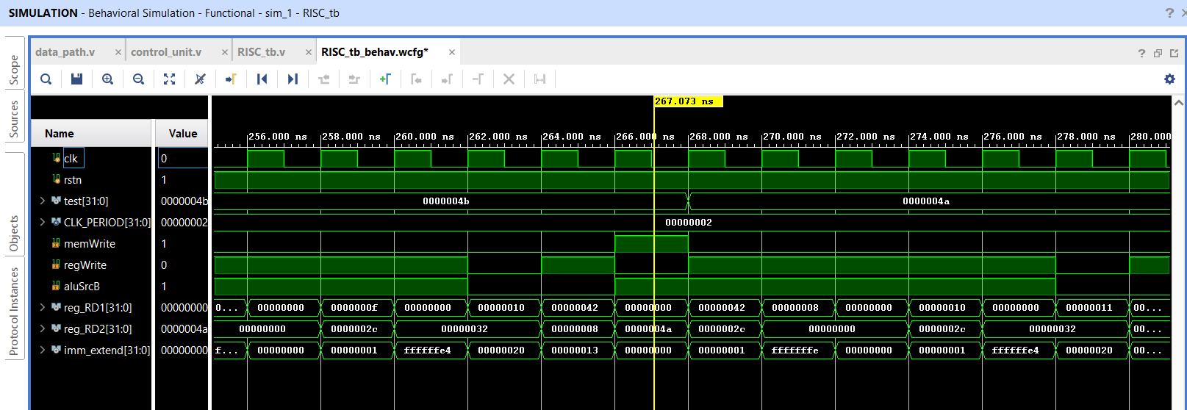
- Inference:
  - Control Unit: The control_unit correctly decodes instructions. At 262 ns, it generates signals for an R-type (regWrite=1, aluSrcB=0). At 266 ns, it correctly generates signals for a Store (memWrite=1, regWrite=0, aluSrcB=1).
  - Register File Read: reg_RD1 and reg_RD2 show valid data being read from the register file (e.g., ...042 and ...04a at 266 ns).
  - Sign Extend: imm_extend correctly generates both positive (...013) and signed negative (ffffffee) 32-bit values.

5.1.3 Execute Stage Verification
- Signals Observed: ALU_control, alu_A, alu_B, alu_result, zero
- Waveform:
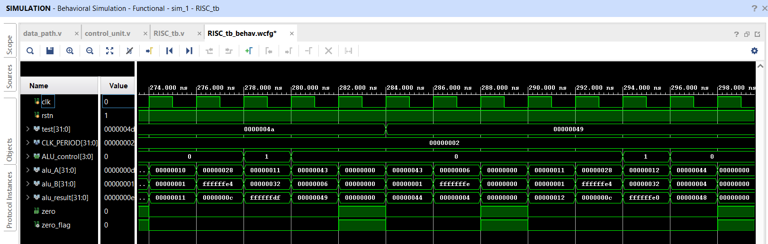

- Inference:
  - ALU Math: The ALU computes correct results. For example, an ADD (Control=0) at 276 ns: ...10 + ...01 = ...11.
  - Branch Logic (Zero Flag): The core branch logic is verified. At 280 ns, the ALU is fed two identical values (...49). It performs the subtraction, the alu_result is correctly 0, and the zero flag is successfully asserted to 1. This proves the beq decision-making mechanism is functional.

5.1.4 Memory Stage Verification
- Signals Observed: aluResult (Address), mem_WD (Write Data), mem_RD (Read Data), memWrite.
- Waveform:
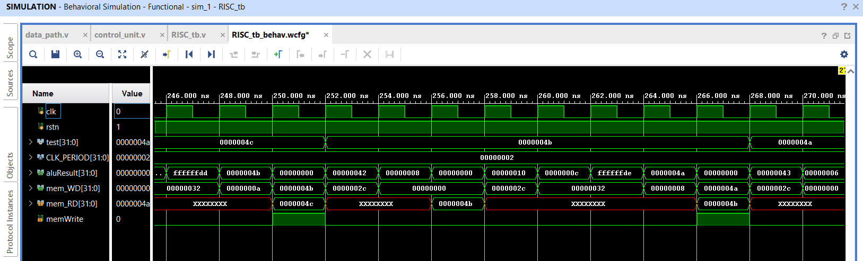
- Inference:
  - Store (sw) Success: At 250 ns, memWrite asserts to 1, and the data on mem_WD (...4a) is successfully written to the address on aluResult (...4c).
  - Load (lw) Success: At 252 ns, memWrite is 0, and the memory correctly reads the data (...4a) from the same address (...4c).
  - Note: The XXXX values on mem_RD at other times are correct, as they represent reads from uninitialized memory addresses.

5.1.5 Writeback Stage Verification
- Signals Observed: regWrite, reg_WA (Write Address), reg_WD (Write Data)
- Waveform:
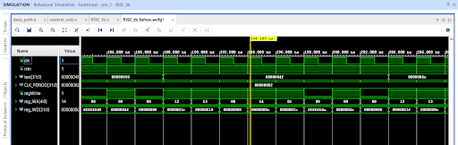
- Inference:
  - regWrite Control: The regWrite signal is correctly asserted (1) for R-type/Load instructions and de-asserted (0) for Store/Branch instructions (e.g., at 194 ns).
  - Datapath: reg_WA (Write Address) correctly provides the destination register (rd), and reg_WD (Write Data) provides the final "Result" from the ALU or memory, ready to be written.

5.2 Synthesis and Implementation Results

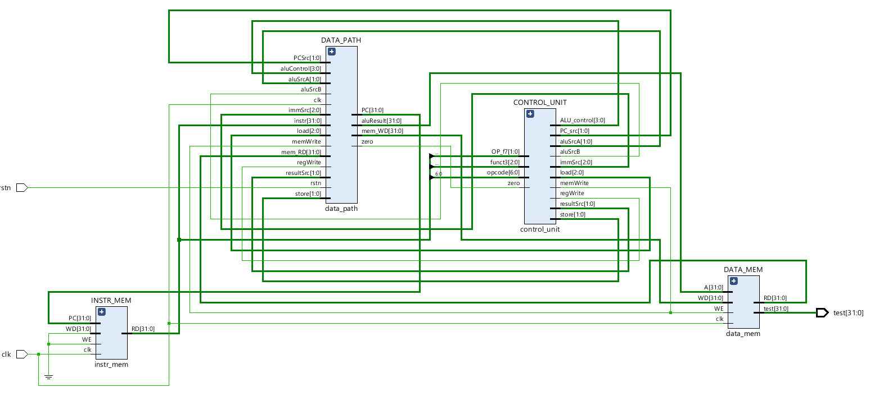

5.2.1 Synthesis Report:
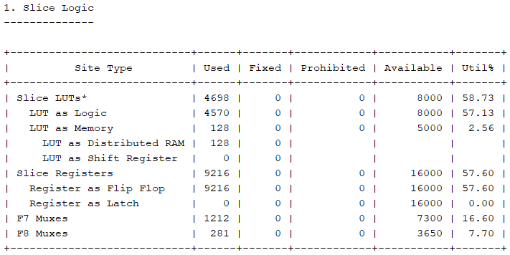

7. Discussion and Analysis

7.1 Simulation vs. Hardware: The Asynchronous RAM Problem
A critical insight from this project is the difference between simulation and synthesis. The instr_mem and data_mem modules were designed with asynchronous reads (assign RD = D_MEM[A];).
- In Simulation: This works perfectly, as the simulator can "instantly" provide the data from any address.
- In Hardware (Synthesis): FPGAs implement memory using Block RAMs (BRAMs), which are synchronous resources. A read operation requires a clock edge; the data is available on the next cycle.
When this design is synthesized, Vivado will likely fail to infer BRAMs, and instead implement the memories using thousands of LUTs (distributed RAM). This is extremely inefficient and will lead to a very low maximum frequency (Fmax). This is the primary limitation of a single-cycle design and the reason why pipelined architectures (which have a full clock cycle for synchronous memory access) are used in all real-world processors.

8. Conclusions
This project successfully achieved its objectives. A 32-bit single-cycle RISC-V processor was designed in Verilog and fully verified through functional simulation. The analysis of the simulation waveforms confirms that all five stages—Fetch, Decode, Execute, Memory, and Writeback—are logically correct and work in unison to execute a test program. The processor correctly handles sequential execution, control flow (branches), and data memory access (loads and stores).
The design provides a strong, verified foundation in computer architecture, and the analysis of its limitations (such as the single-cycle memory bottleneck) highlights the practical trade-offs that drive real-world processor design.

9. Future Scope
- Pipelining: The most logical next step is to evolve this design into a 5-stage pipelined processor to dramatically increase throughput and Fmax. This would involve adding pipeline registers and hazard detection logic.
- Full ISA Implementation: The processor can be extended to support the full RV32I instruction set, including multiplication (M-extension) and atomic operations (A-extension).
- Cache: A cache hierarchy (L1 Instruction and Data caches) could be added between the processor and main memory to further improve performance.

10. References
[1] Patterson, D. A., and J. L. Hennessy. Computer Organization and Design: The Hardware/Software Interface. RISC-V ed., Morgan Kaufmann, 2020.
[2] Waterman, A., et al. The RISC-V Instruction Set Manual, Volume I: User-Level ISA. RISC-V Foundation, 2019.
[3] Brown, Stephen, and Zvonko Vranesic. Fundamentals of Digital Logic with Verilog Design. McGraw-Hill, 2014.
[4] Hennessy, John L., and David A. Patterson. Computer Architecture: A Quantitative Approach. 6th ed., Morgan Kaufmann, 2018.
[5] Palnitkar, Samir. Verilog HDL: A Guide to Digital Design and Synthesis. 2nd ed., Prentice Hall, 2003.
[6] Lee, A. and Shafi, H. The RISC-V Reader: An Open Architecture Atlas. BlueSpec, Inc., 2021.
[7] Mano, M. Morris, and Michael D. Ciletti. Digital Design. 6th ed., Pearson, 2018.
[8] Xilinx Inc. Vivado Design Suite User Guide: Logic Simulation (UG900). [Insert Year of Specific Release Used, e.g., 2024].
[9] Xilinx Inc. Vivado Design Suite User Guide: Synthesis (UG901). [Insert Year of Specific Release Used, e.g., 2024].
[10] Xilinx Inc. Vivado Design Suite User Guide: Memory Resources (UG1085). [Insert Year of Specific Release Used, e.g., 2024].
[11]The RISC-V International. RISC-V Specifications. Available from https://riscv.org/specifications/.

