
A
Report on
“HOSTEL MANAGEMENT”
IN PARTIAL FULFILMENT OF REQUIREMENT OF DEGREE OF COMPUTER SCIENCE ENGINEERING
Project submitted by
Lukman Mushtaq Turekar (CSE60 )
Om Milind Retrakar (CSE48)
Mahesh Sakharam kshirsagar (CSE28 )

From Computer Department Second Year Engineering(B.E.)

Under the guidance
Of
Prof.M.S.Khadilkar

For Acadmic Year 2024-25
YASHWANTRA BHONSALE INSTITUTE OF TECHNOLOGY, SAWANTWADI



This is to certify that,
OM MILIND RETHAREKAR Roll No: CS48
LUKMAN MUSHTAQ TUREKAR Roll No: CS60
MAHESH SAKHARAM KSHIRSAGAR Roll No: CS28

Of Fourth semester of degree in COMPUTER SCIENCE ENGINEERING of Yashwantrao Bhonsale Institute of Technology, Sawantawadi has completed the HOSTEL MANAGEMENT satisfactorily in subject MINI
PROJECT – 1B for the academic year 2024-25 as prescribed in the curriculum.

Internal Examiner External Examiner

Internal Guide HOD Principal


Seal of

Institution

Introduction :

A Hostel Management System is a software application designed to streamline and automate the operations of managing a hostel. This includes allocation of rooms, maintaining student records, handling fee payments, tracking attendance, and managing staff. Traditionally, these tasks are handled manually, which often results in inefficiencies, errors, and difficulty in data retrieval. With the help of a digital management system, administrators can reduce paperwork, improve accuracy, and enhance overall productivity.

The system provides a user-friendly interface for hostel wardens, staff, and students to interact with real-time data. From assigning rooms to generating reports, the Hostel Management System ensures that hostel operations are transparent, accessible, and well-organized.

Problem Definition :
Managing hostel operations manually involves maintaining various registers and paperwork for room allocation, student details, fee management, and inventory. This traditional method is time-consuming, error-prone, and inefficient, especially when the number of students increases. It becomes difficult to track occupancy, manage student records, ensure timely fee collection, and handle room shifting or leave requests.
Additionally, retrieving specific data, generating reports, and ensuring the security of personal student information is challenging without a centralized system. This lack of automation can lead to mismanagement, data loss, and poor communication among hostel staff and students.
Therefore, there is a need for a digital Hostel Management System that can centralize and automate all hostel-related processes. The system should be capable of handling student admissions, room assignments, fee tracking, attendance, and communication effectively—while ensuring data accuracy, accessibility, and security.

Objectives:
- Automate Hostel Operations
To reduce manual work by automating tasks like room allocation, student registration, fee management, and attendance tracking.
- Centralized Data Management
To maintain all hostel-related data such as student records, room availability, and fee details in a centralized, easily accessible system.
- Improve Efficiency and Accuracy
To minimize human errors and streamline administrative tasks, ensuring faster and more accurate data processing.
- Enhance Transparency and Accountability
To maintain clear records of transactions, student movements, and hostel inventory, promoting transparency in hostel administration.
- Secure Student Information
To protect sensitive data through user authentication, access controls, and regular backups.
- Generate Reports and Analytics
To provide real-time reports and insights for hostel staff and management to aid in decision-making and planning.
- User-Friendly Interface
To offer an intuitive and easy-to-use interface for students, wardens, and administrative staff.
- Support Scalability and Integration
To build a system that can scale with increased student intake and potentially integrate with academic or library management systems.

Language Used:
- PHP.6,PHP7.x

Server:
- APPACHE

Database:
- MySql 5.x

User Interface Design:
- HTML
- AJAX
- JQUERY
- JAVASCRIPT

Web Browser:
- Mozilla
- Google Chrome
- IE8
- OPERA

Software:
- XAMPP

Source code:
<?php
session_start();
include('includes/config.php');
if(isset($_POST['login']))
{
$email=$_POST['email'];
$password=$_POST['password'];
$stmt=$mysqli->prepare("SELECT email,password,id FROM userregistration WHERE email=? and password=? ");
$stmt->bind_param('ss',$email,$password);
$stmt->execute();
$stmt -> bind_result($email,$password,$id);
$rs=$stmt->fetch();
$stmt->close();
$_SESSION['id']=$id;
$_SESSION['login']=$email;
$uip=$_SERVER['REMOTE_ADDR'];
$ldate=date('d/m/Y h:i:s', time());
if($rs)
{
$uid=$_SESSION['id'];
$uemail=$_SESSION['login'];
$ip=$_SERVER['REMOTE_ADDR'];
$geopluginURL='http://www.geoplugin.net/php.gp?ip='.$ip;
$addrDetailsArr = unserialize(file_get_contents($geopluginURL));
$city = $addrDetailsArr['geoplugin_city'];
$country = $addrDetailsArr['geoplugin_countryName'];
$log="insert into userLog(userId,userEmail,userIp,city,country) values('$uid','$uemail','$ip','$city','$country')";
$mysqli->query($log);
if($log)
{
header("location:dashboard.php");
}
}
else
{
echo "<script>alert('Invalid Username/Email or password');</script>";
}
}
?>

<!doctype html>
<html lang="en" class="no-js">
<head>
<meta charset="UTF-8">
<meta http-equiv="X-UA-Compatible" content="IE=edge">
<meta name="viewport" content="width=device-width, initial-scale=1, minimum-scale=1, maximum-scale=1">
<meta name="description" content="">
<meta name="author" content="">
<meta name="theme-color" content="#3e454c">
<title>Student Hostel Registration</title>
<link rel="stylesheet" href="css/font-awesome.min.css">
<link rel="stylesheet" href="css/bootstrap.min.css">
<link rel="stylesheet" href="css/dataTables.bootstrap.min.css">>
<link rel="stylesheet" href="css/bootstrap-social.css">
<link rel="stylesheet" href="css/bootstrap-select.css">
<link rel="stylesheet" href="css/fileinput.min.css">
<link rel="stylesheet" href="css/awesome-bootstrap-checkbox.css">
<link rel="stylesheet" href="css/style.css">
<script type="text/javascript" src="js/jquery-1.11.3-jquery.min.js"></script>
<script type="text/javascript" src="js/validation.min.js"></script>
<script type="text/javascript" src="http://code.jquery.com/jquery.min.js"></script>
<script type="text/javascript">
function valid()
{
if(document.registration.password.value!= document.registration.cpassword.value)
{
alert("Password and Re-Type Password Field do not match !!");
document.registration.cpassword.focus();
return false;
}
return true;
}
</script>
</head>
<body>
<?php include('includes/header.php');?>
<div class="ts-main-content">
<?php include('includes/sidebar.php');?>
<div class="content-wrapper">
<div class="container-fluid">

<div class="row">
<div class="col-md-12">

<h2 class="page-title">User Login </h2>

<div class="row">
<div class="col-md-6 col-md-offset-3">
<div class="well row pt-2x pb-3x bk-light">
<div class="col-md-8 col-md-offset-2">

<form action="" class="mt" method="post">
<label for="" class="text-uppercase text-sm">Email</label>
<input type="text" placeholder="Email" name="email" class="form-control mb">
<label for="" class="text-uppercase text-sm">Password</label>
<input type="password" placeholder="Password" name="password" class="form-control mb">

<input type="submit" name="login" class="btn btn-primary btn-block" value="login" >
</form>
</div>
</div>
<div class="text-center text-light">
<a href="forgot-password.php" class="text-light">Forgot password?</a>
</div>
</div>
</div>
</div>
</div>
</div>
</div>
</div>
</div>
</div>
</div>
<script src="js/jquery.min.js"></script>
<script src="js/bootstrap-select.min.js"></script>
<script src="js/bootstrap.min.js"></script>
<script src="js/jquery.dataTables.min.js"></script>
<script src="js/dataTables.bootstrap.min.js"></script>
<script src="js/Chart.min.js"></script>
<script src="js/fileinput.js"></script>
<script src="js/chartData.js"></script>
<script src="js/main.js"></script>
</body>

</html>

Output:

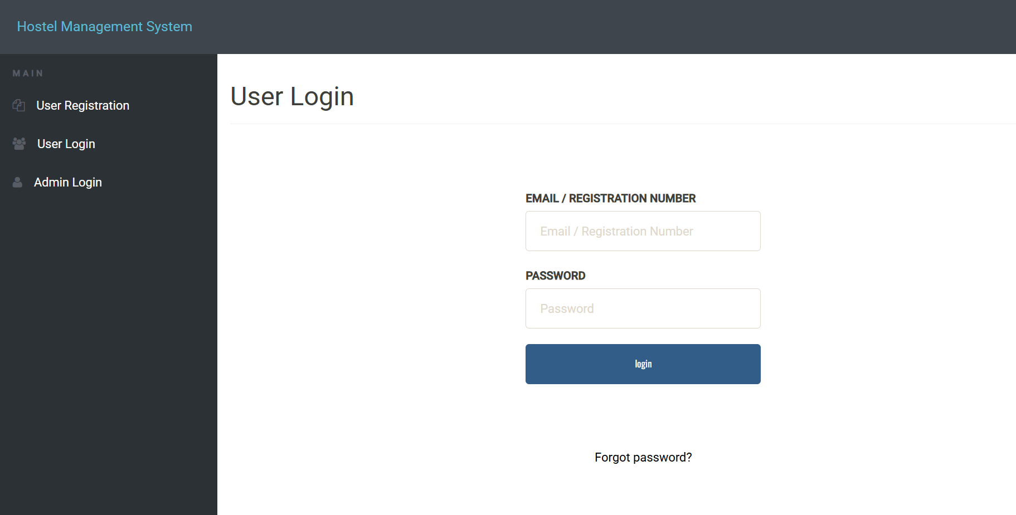

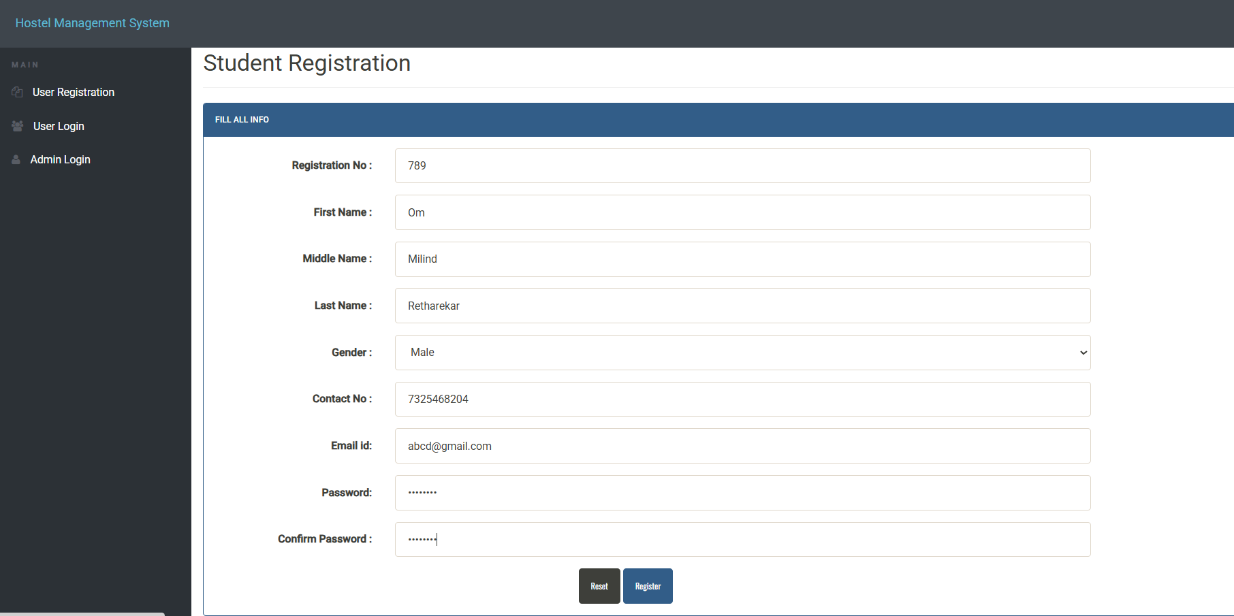

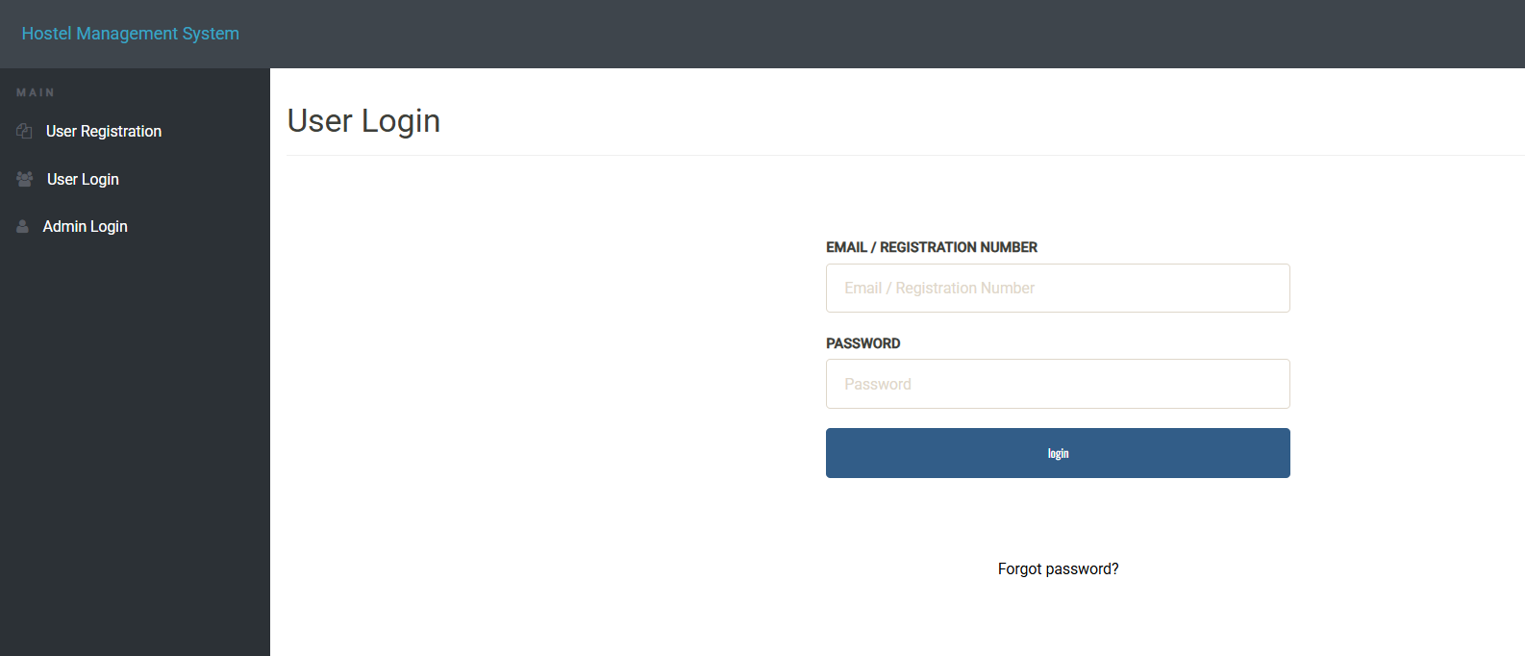

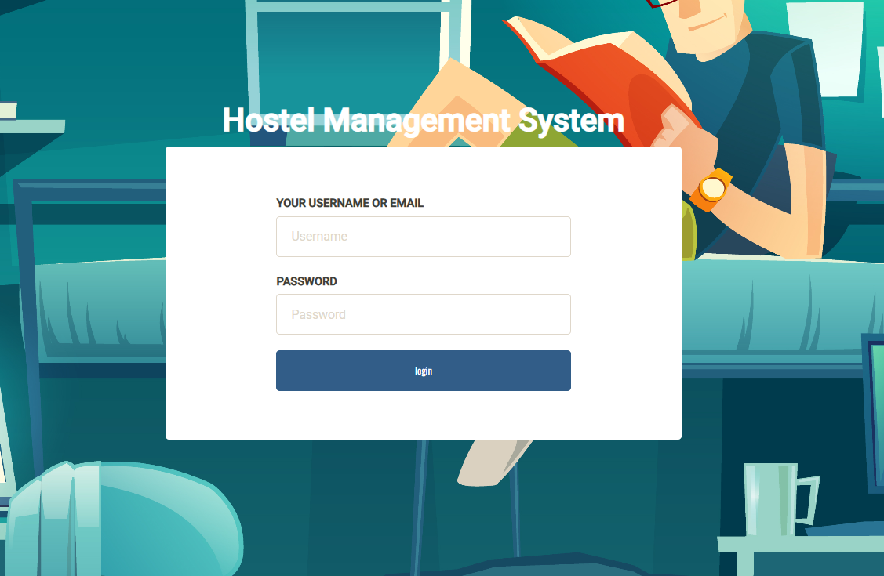

Declaration by Students -
We will put all best efforts to complete the assigned work within the specified time period. We will abide by all rules and Regulations. The Proposed work is original and if any violation of copyright is found we are solely responsible for the same and not the Concern Guide or
Institute.

SR NO. | ROLL NO. | STUDENT NAME | STUDENT SIGN WITH DATE
1 | CSE48 | OM MILIND RETRAKAR
2 | CSE60 | LUKMAN MUSHTAQ TUREKAR
3 | CSE28 | MAHESH KSHIRSAGAR

Guide's willingness /remark and signature with date:
Name of Guide: Prof. M.S.Khadilkar
Designation:
Remark:
Signature with Date:

