Assignment 10

210010033

Part 1:

1. Source IP: 10.200.94.15   
   Destination IP: 10.195.250.62
2. ICMP is a network layer protocol, hence it does not contain source, destination port number which are usually required in application and transport layer protocols.
3. 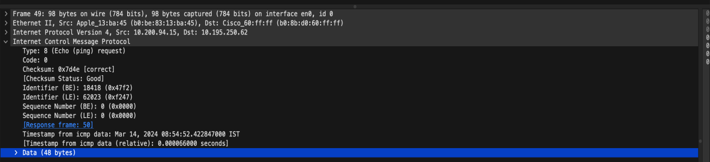  
     
   Type: 8 (Echo (ping) request)  
   Code: 0  
     
   Other fields include Checksum, Identifiers, Sequence Numbers, Timestamps, Data  
     
   Checksum is 2 bytes. Sequence number is 2 bytes and Identifier is 2 bytes
4. 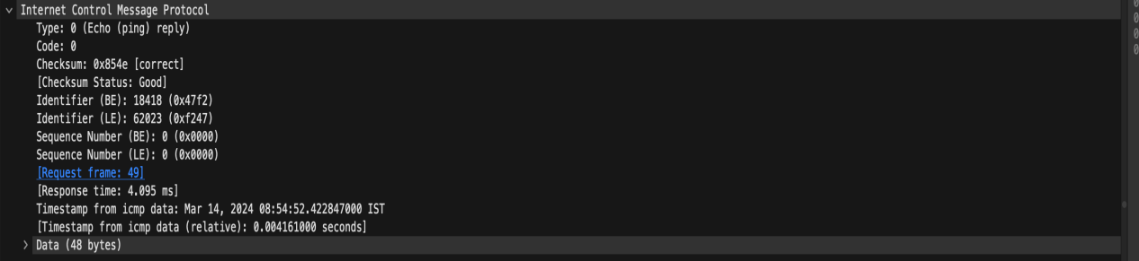  
     
   Type: 0 (Echo (ping) reply)  
   Code: 0  
   Other fields include Checksum, Identifiers, Sequence Numbers, Timestamps, Response Time and Data  
   Checksum, Sequence number and identifier are 2 bytes each.

Part 2:

1. Source IP:10.200.94.15   
   Destination IP: 142.250.183.132
2. 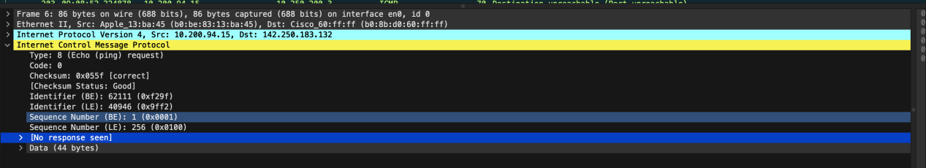If we use the UDP stream, the protocol number would be 17.
3. No Response Seen field was extra field compared to from the ICMP ping query packets in the first half of this lab. Also, values of identifiers, checksum were completely different.
4. 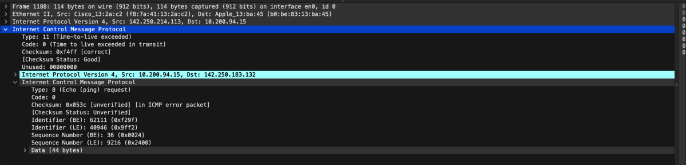  
     
   The error packet itself contains IP and ICMP information. Also it has an Unused field.
5. 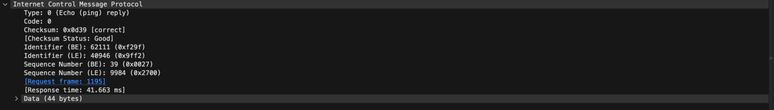

The error packets sent were type 11, compared to the last three packets which are of type 0. They are

different because they have all arrived before the TLL expires whereas the error packet exceeded its TTL.

1. 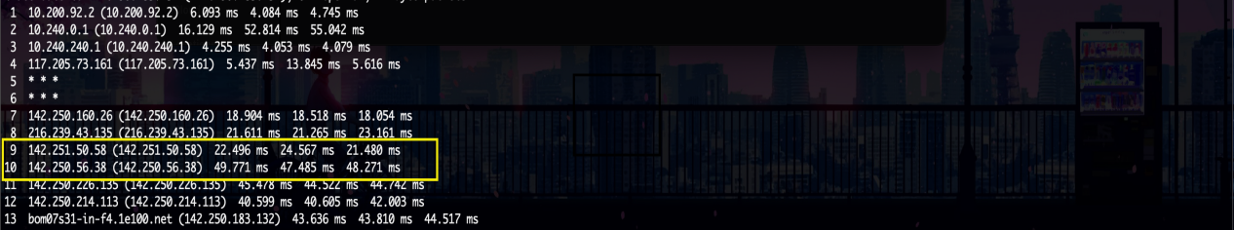  
     
   A larger time gap is seen between the 9th and 10th traceroute packets.