Assignment 14

210010033

Part 1:

1. Code submitted as 210010033_part1.cc
2. 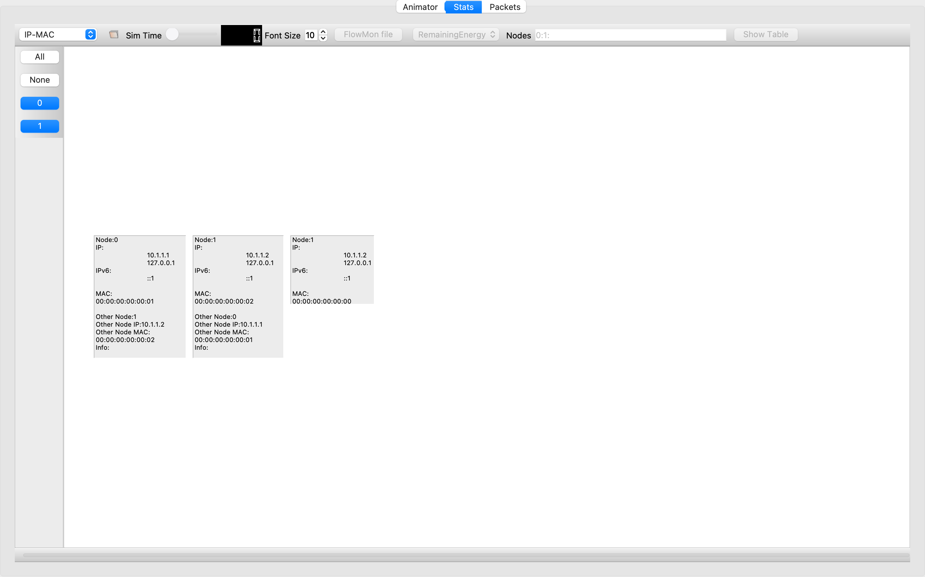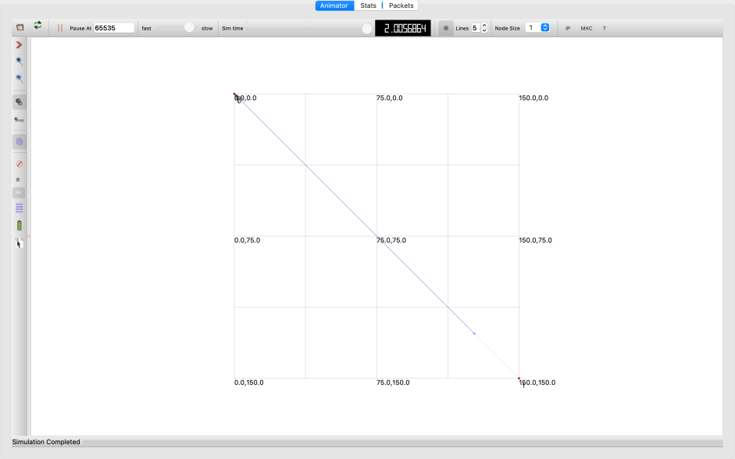

Part 2:

1. Code submitted as 210010033_part2.cc
2. 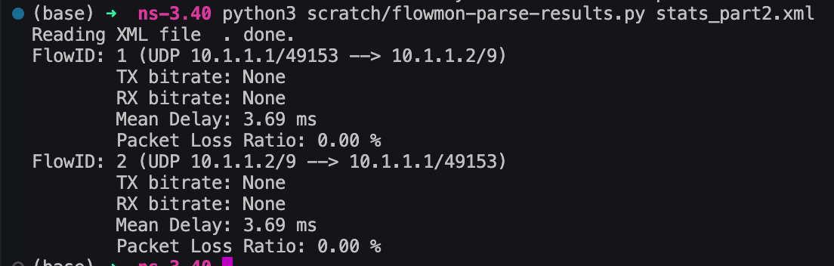  
   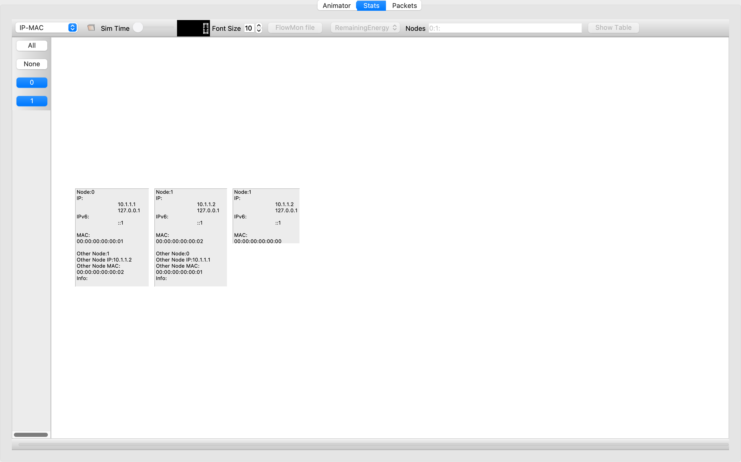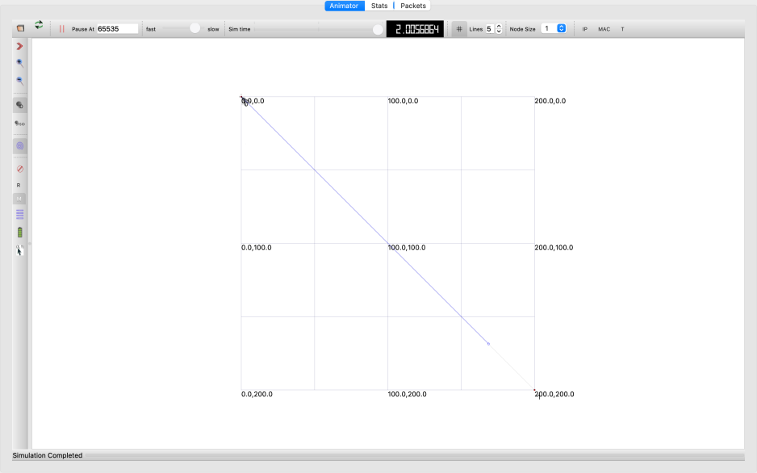  
     
     
   The stats obtained after parsing using ***flowmon-parse-results.py stats_part2.xml*** are as follows: