Assignment 4

Om Deshmukh

210010033

Part 1:

The ip address of [www.iitdh.ac.in](http://www.iitdh.ac.in) server is **10.195.250.62**

**The ip for**



The ip for gmail.com is **142.250.193.133**

Part 3

1. The packet are as follows: 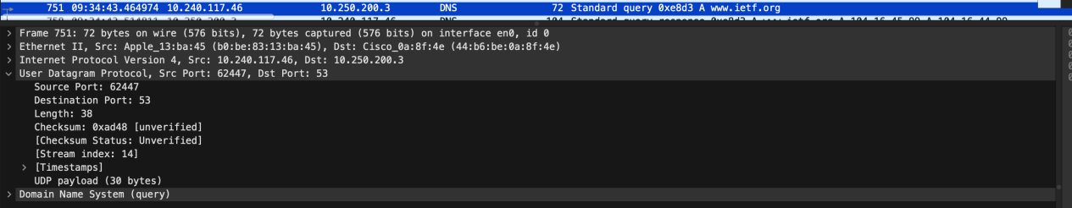

It follows the UDP stream.

The destination port for the DNS query message is **53**.

The source port of the DNS response message is **53**.

**10.240.117.46** is the ip to which the DNS query message was sent to.

**10.250.200.3** is the ip of the DNS server.

No, the two ip are completely different.

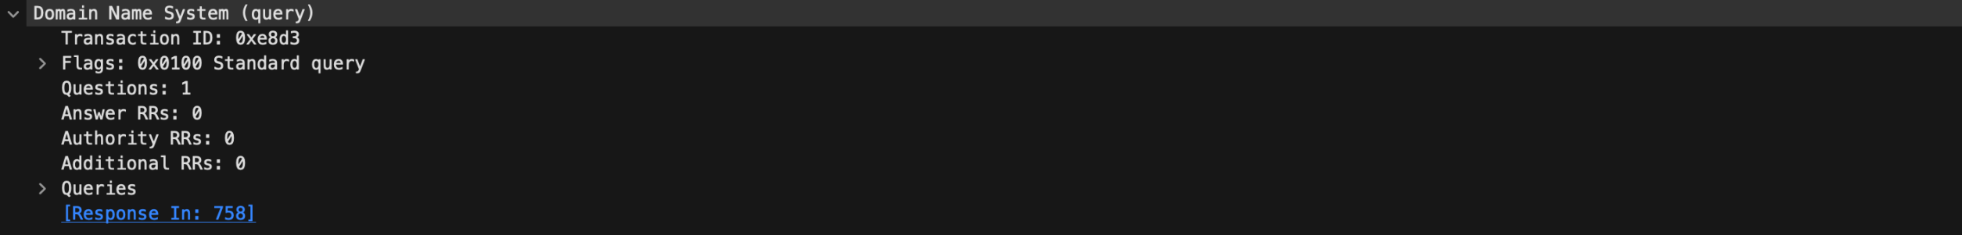

The type of the DNS message query is **Standard query.**

No, the query message does not contain any answers.

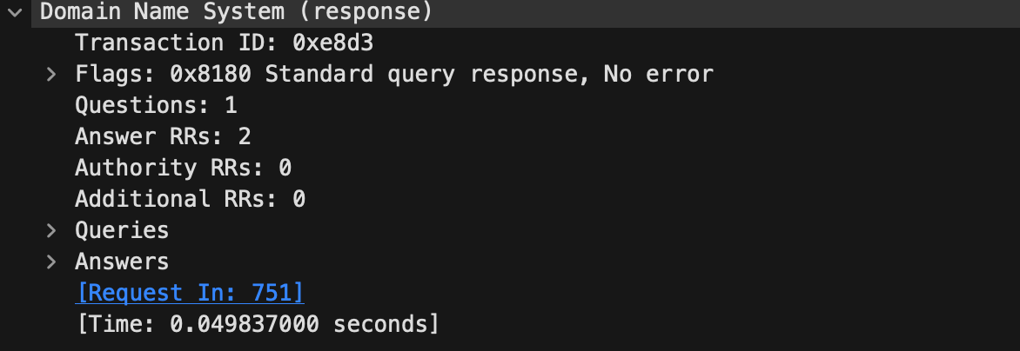

2 answers are provided in the DNS re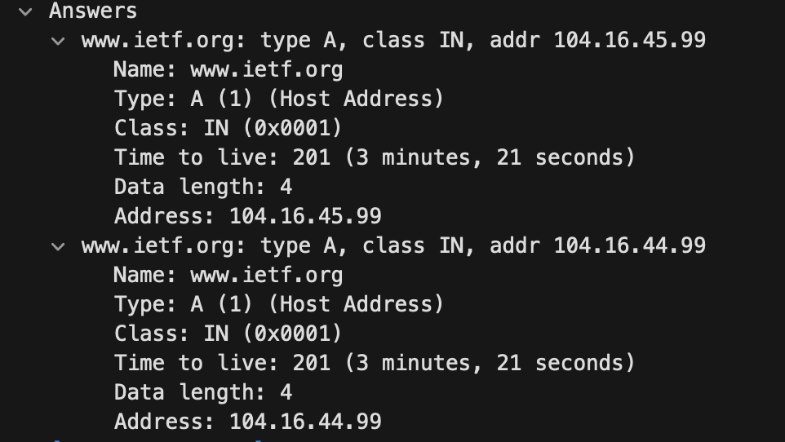sponse message.

The two answers contaied the name of the website, the type of host, the class, the time to live of the packet sent, the data length and the ip of [www.ietf.org.](http://www.ietf.org.)

The destination IP address of the SYN packet corresponds to the ip address of [www.ietf.org](http://www.ietf.org) which was mentioned in the answers of the query response message.

Since the destination ip remains the same in all the request query messages, we can say that all the images came from the same source, hence we can say that the host did no issue any new DNS queries.

**Part 4.1**

1. 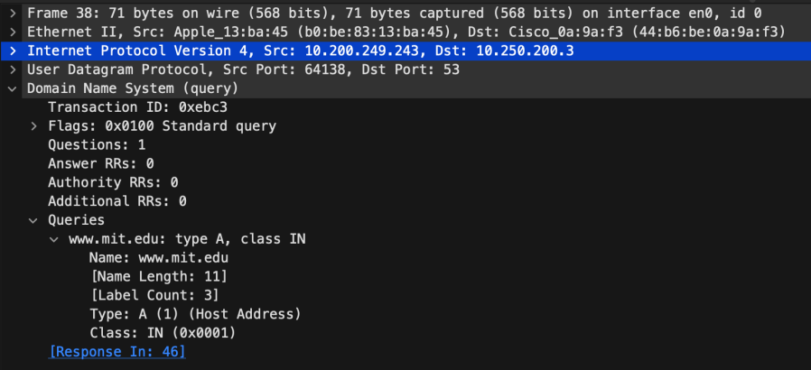

Dest:53

Source port: 53

1. sent to : 10.250.200.3

Yes it matches

1. No answers in the query message. Its has type A
2. 3 answers are provided to the response message

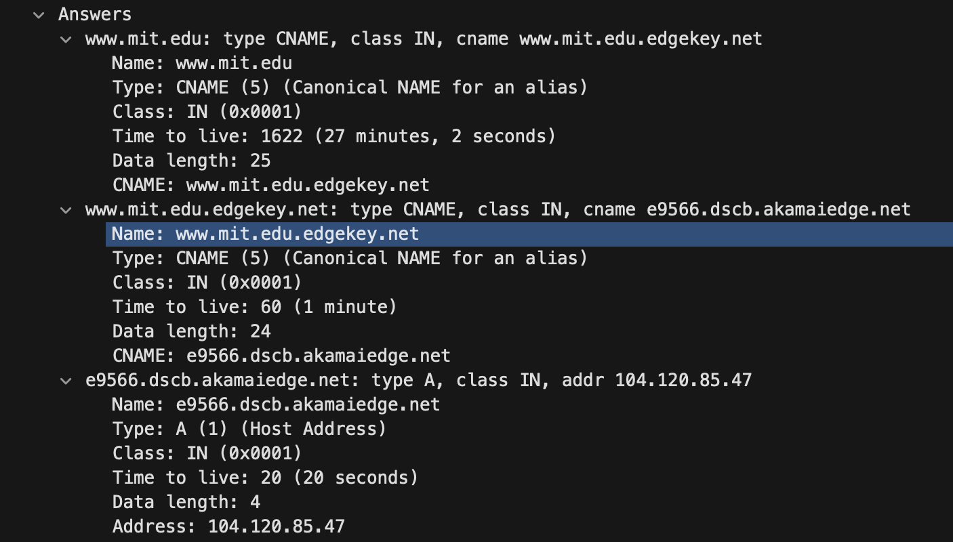

**Part 4.3**

1. Sent to 10.250.200.3 Yes it is same to the address of the DNS server.
2. Type A. No the query does not contain any answers.