Assignment 5

210010033

Om Deshmukh

Part 2:

1. IP of the source is 10.200.179.176  
   The TCP port number is 80
2. 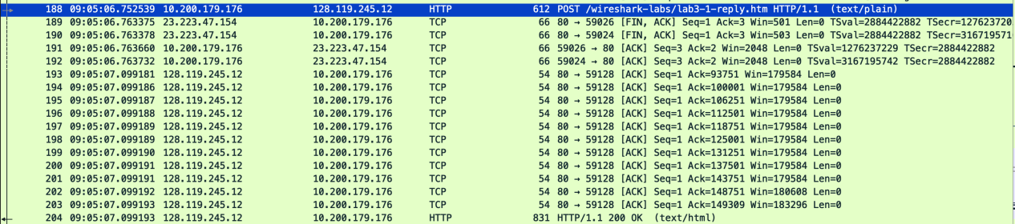IP of gaia.cs.umass.edu is 128.119.245.12  
   The source port is 80 and destination port is 59128

Part 3:

1. 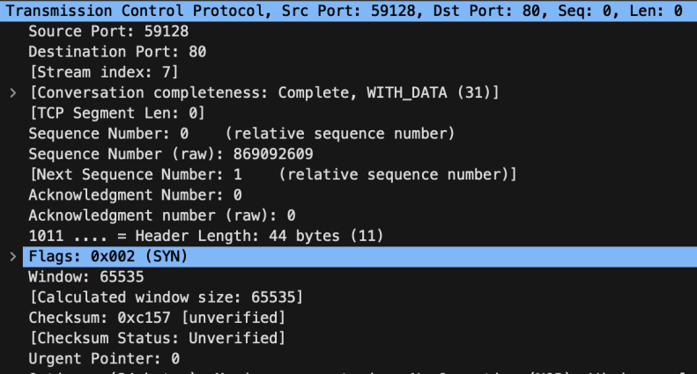  
   The raw sequence number of the TCP SYN packet that is 869092609 and the relative sequence number is 0. The flags in the TCP packet represent that it is an SYN segment.
2. 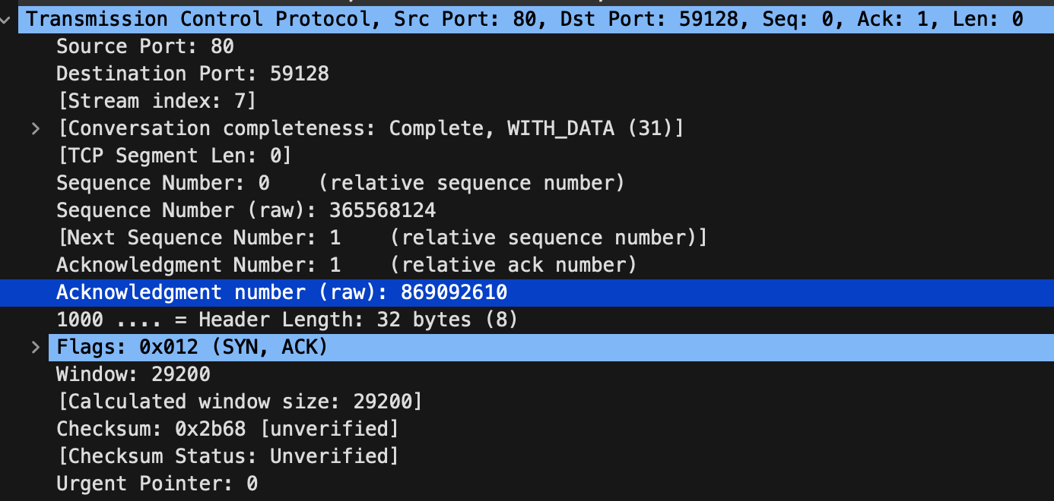  
     
   The raw sequence number of the TCP SYNACK packet that is 365568124and the relative sequence number is 0. The flags in the TCP packet represent that it is an SYNACK segment. The relative acknowledgment is 1 and the acknowledgment number (raw) is 869092610. The value of the acknowledgment number is (sequence number + 1).
3. 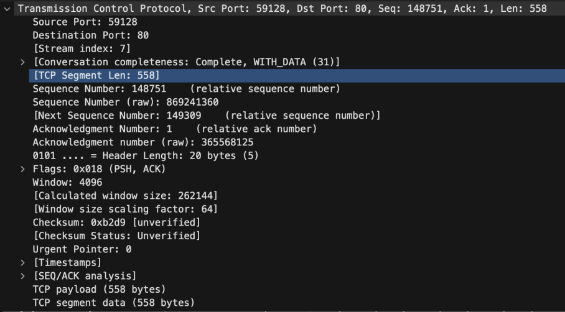  
   The raw sequence number of the TCP segment containing the header of the HTTP POST command packet that is 869241360 and the relative sequence number is 0148751. Size is 558 bytes in the payload. No, not all of the data of the alice.txt file was transferred in this single TCP segment.
4. 9:05:05.616466 am 7th Feb 2024
5. 9:05:05.878832 am 7th Feb 2024
6. rtt of the first package is 0.26212400 seconds.
7. rtt of the second package is 0.000258000 seconds.
8. 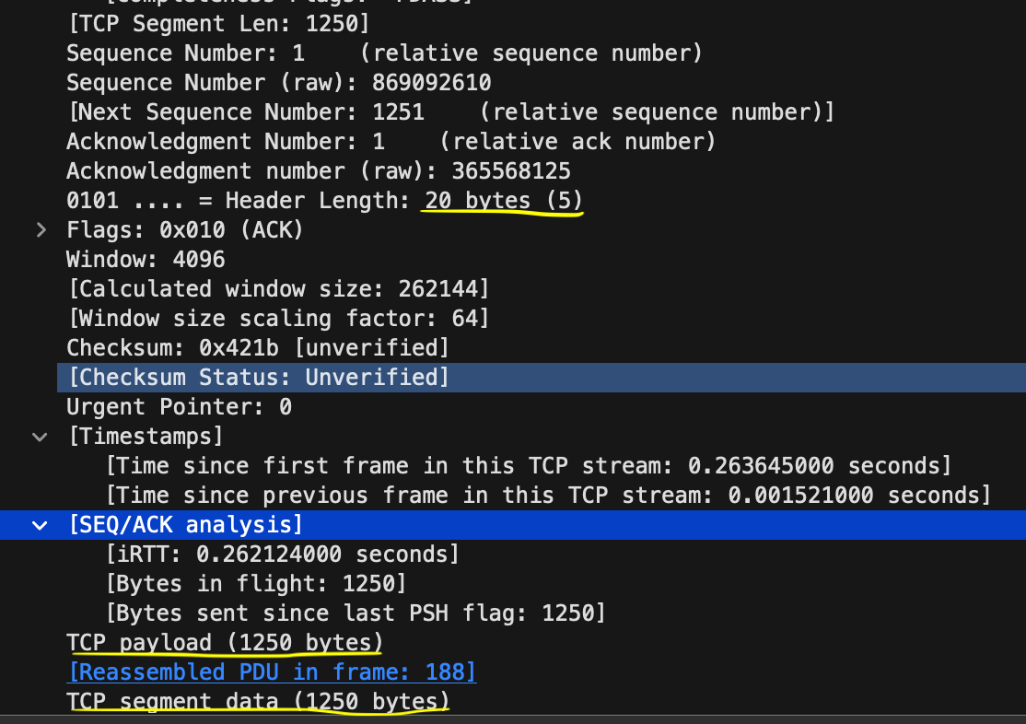The following are the first four data carrying TCP segments:  
     
   The length (header plus payload) of each of the first four data-carrying TCP is
9. Buffer size is 262144 bytes as advertised. Since it does not change among the first 4 packets, the buffer space never throttles the sender.
10. 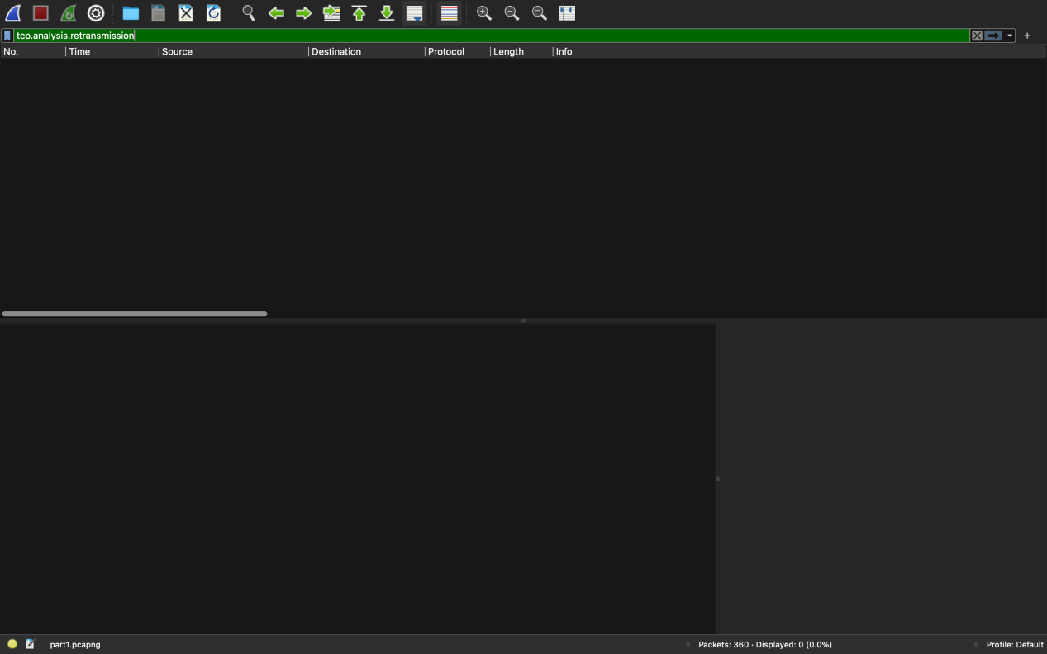No, there aren’t any retransmitted segments in the trace file. I checked this using **tcp.analysis.retransmission**  in the filter.
11. 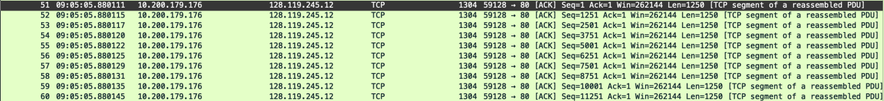  
    The receiver acknowledges 1 byte in the first packet and 1250 byte each in the last 9 packets.  
      
    The packet number 62 ACKS packet 55  
    The packet numerb 63 ACKS packte 60  
    Hence, I can find cases where the receiver is ACKing every other received segment among these first ten data-carrying segments
12. Screenshot 2024-02-07 at 10.41.25 PMScreenshot 2024-02-07 at 10.41.52 PMThe first package aknowledged 1 byte.  
      
    The last package aknowledged 149309 bytes.

Time between the first and last package is 12.018861- 5.880111 = 6.13875 seconds  
Throughput = 149308/6.13875  
 = 24322.3783 bytes/second

Part 4:

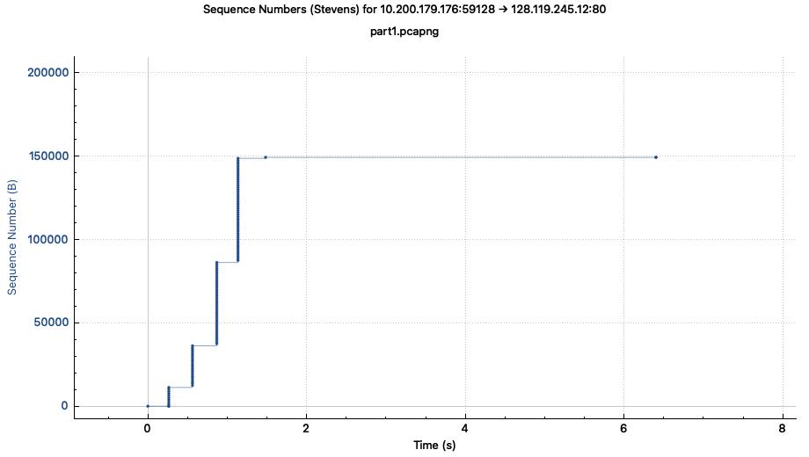

The following figure shows slow start till 0.85 seconds since each vertical grows exponentially is size:  
  
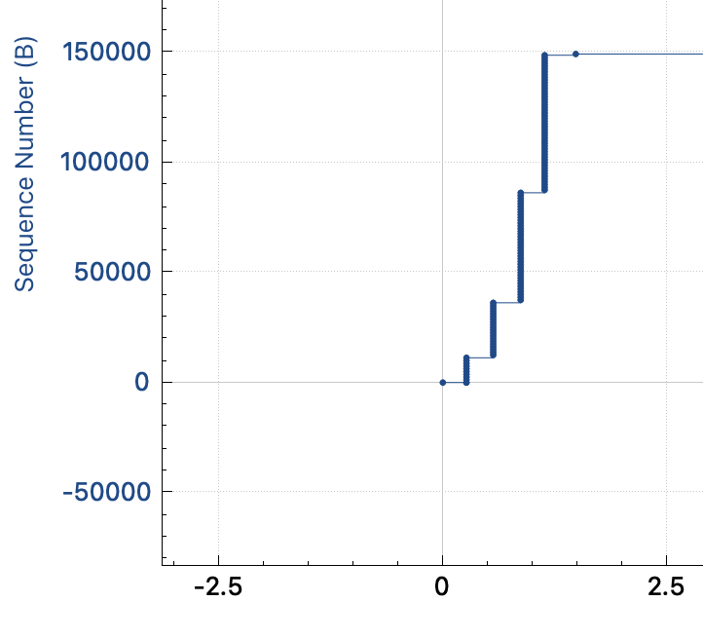

The following figure shows congestion avoidance at about 1.2 second since the difference in successive verticals(no. of bytes sent) at 0.85 and 1.2 seconds is not that much large as the start. :

