Assignment 6

210010033

Om Deshmukh

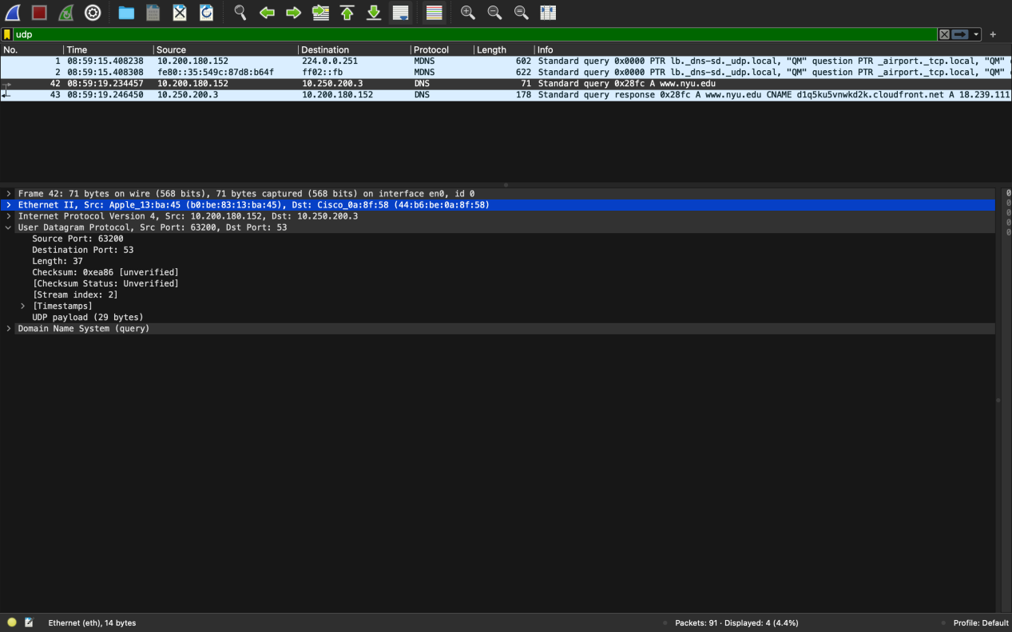Part 1:

1. 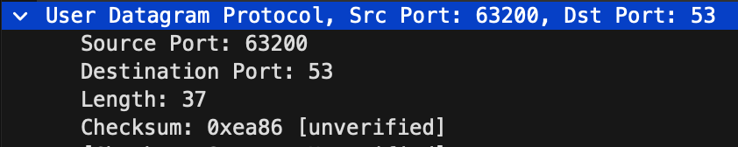Packet No. 42 is the first UDP segment in the trace. DNS is being carried in this UDP segment. There are 4 fields in the UDP header. These include Source Port, Destination Port, Length and Checksum.
2. Each of the UDP header fields have a length of 2 bytes.
3. The length of the UDP header is 37 bytes out of which 8 bytes is for the headers and remaining 29 bytes are for data to/from the application layers.
4. Since data sent in the UDP segment can be maximum of 216-1 bytes, out of which 8 bytes are taken by the headers. Hence, maximum size of the payload = (65535 - 8) bytes = 65527 bytes
5. Since source port has 2 bytes,  
    2 bytes = 16 bit  
   Largest 16 bit number = 216 -1 = 65535  
   Hence, largest source port number possible is 65535
6. Screenshot 2024-02-08 at 9.29.21 AMProtocol number of UDP is 17.
7. Packet number of the first one is 42. Packet number of the second one is 43. The source port number of the first one(63200) matchesScreenshot 2024-02-08 at 9.30.34 AM with the destination port number of the second one and source port number of the second one(53) matches with the destination port number of the first one.