LAB9

210010033

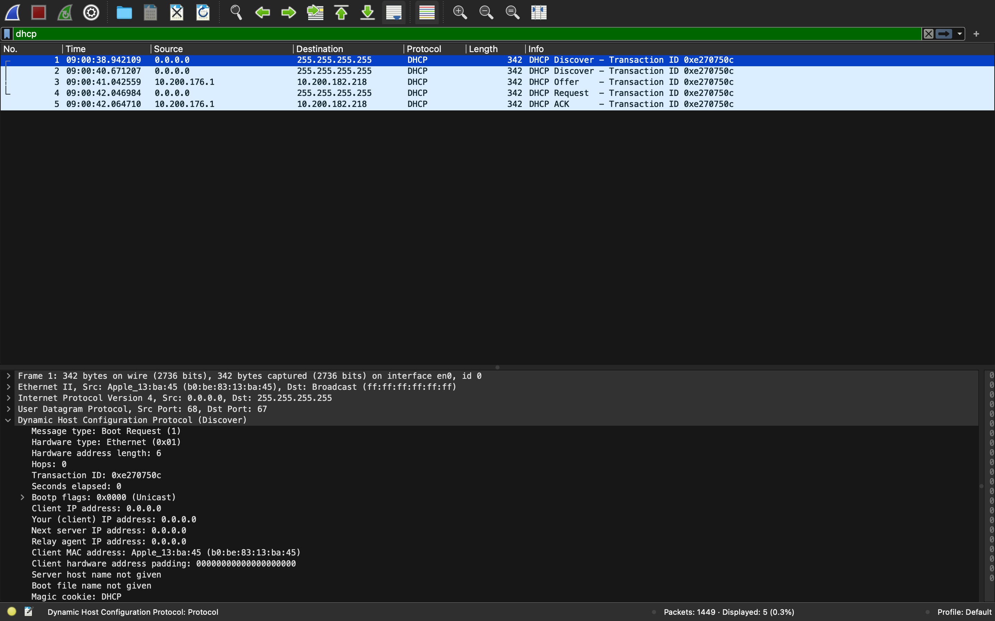

1. It is sent using the UDP protocol.
2. Source IP is 0.0.0.0
3. Destination IP is 255.255.255.255
4. Transaction ID is 0xe270750c
5. The other information that the client is requesting include Subnet Mask, Classless Static, Route Router, Domain Name Server, DHCP Captive-Portal, Domain Search
6. Both the Discover and Offer datagrams have the same transaction ID. Hence, we can say that this offer message is being sent in response to the previous mentioned DHCP Discover message
7. Source IP is 10.200.176.1
8. Destination IP is 10.200.182.218
9. Various information provided by the DHCP client are   
   Length: 4

DHCP Server Identifier: 10.200.176.1

Option: (51) IP Address Lease Time

Length: 4

IP Address Lease Time: 1 hour (3600)

Option: (58) Renewal Time Value

Length: 4

Renewal Time Value: 30 minutes (1800)

Option: (59) Rebinding Time Value

Length: 4

Rebinding Time Value: 52 minutes, 30 seconds (3150)

Option: (1) Subnet Mask (255.255.248.0)

Length: 4

Subnet Mask: 255.255.248.0

Option: (6) Domain Name Server

Length: 4

Domain Name Server: 10.250.200.3

Option: (3) Router

Length: 4

Router: 10.200.176.2

1. Source Port: 68  
   Destination Port: 67
2. Source IP is 0.0.0.0  
   All zeros
3. Destination IP is 255.255.255.255  
   All 255
4. Transaction ID is 0xe270750c  
   Yes, it matches with that of the offer and discover messages.
5. There is no difference in between the entries in the ‘parameter request list’ option in this Request message and the same list option in the earlier Discover message
6. Source IP is 10.200.176.1  
   Same as the Source IP in the DHCP offer datagram.
7. Destinaion IP is 10.200.182.218  
   Same as the Destination IP in the DHCP offer datagram.
8. Your (client) IP address is the name of the field in the DHCP ACK message (as indicated in the Wireshark window) that contains the assigned client IP address.
9. DHCP server assigned this IP address for 1 hour.
10. The IP address of the first hop router as provided by the DHCP message is 10.200.176.2