Dynamic Asset Allocation using Reinforcement Learning

ITERATION-1

Training results:

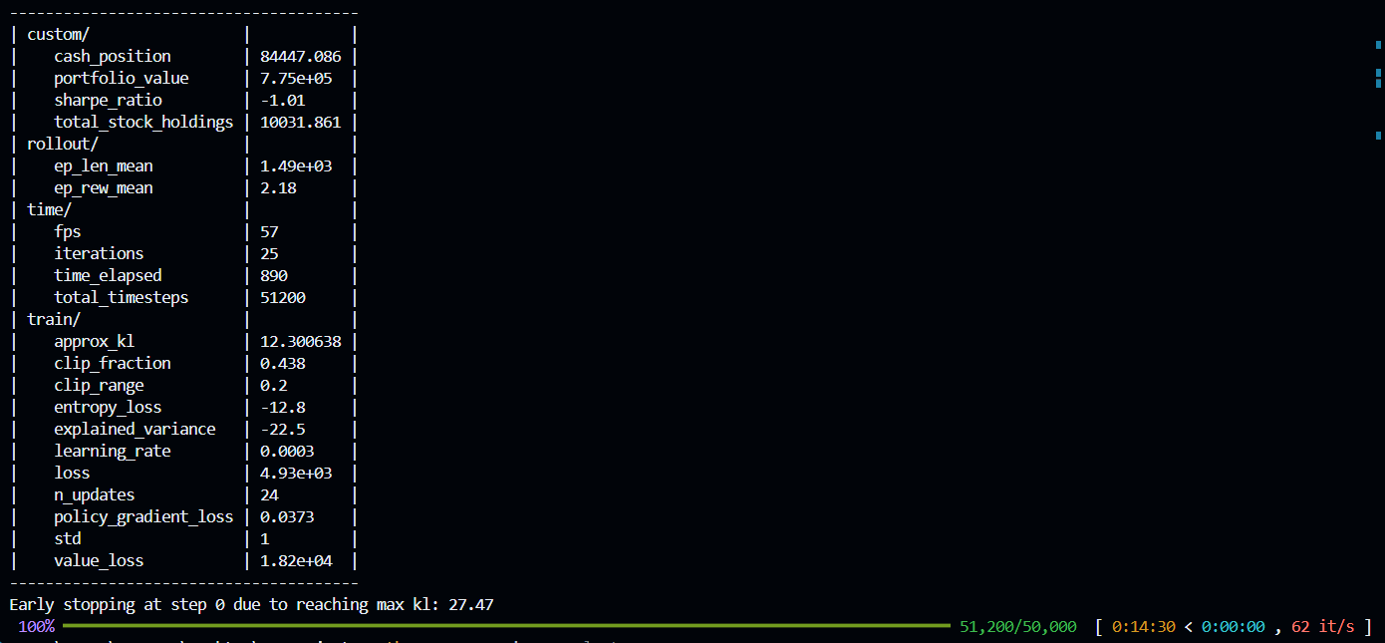

Evaluation results:

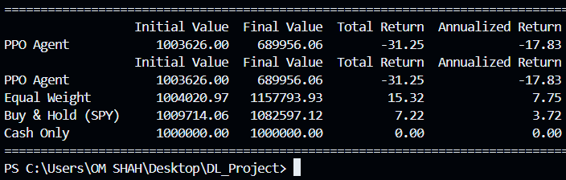

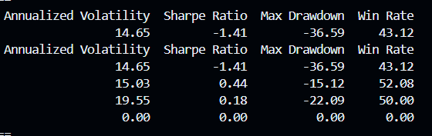

Detailed analysis report:

The project successfully created a robust, end-to-end reinforcement learning pipeline for dynamic asset allocation. The pipeline demonstrated its capability to ingest and process complex financial data, train a sophisticated PPO agent, and evaluate its performance against multiple industry-standard benchmarks.

The evaluation results are definitive: the **PPO Agent, in its current configuration and after 50,000 timesteps of training, failed to learn a profitable strategy.** It significantly underperformed all benchmarks, resulting in a -31.25% cumulative loss. The primary cause for this failure was identified in the training logs: **extreme training instability**, evidenced by an exploding KL divergence that triggered an early stop.

However, the project should be viewed as a **resounding success in its primary goal: building a research framework.** The pipeline works flawlessly, and the negative result is, in itself, a crucial and valuable finding that perfectly sets the stage for the next phase of experimentation and model improvement.

**1. Detailed Findings & Observations**

**1.1. Performance Evaluation Analysis (The "What")**

The evaluation was conducted on an out-of-sample test period from January 2022 to May 2023. This period was characterized by high inflation, interest rate hikes, and significant market volatility, providing a challenging test for all strategies.

**PPO Agent Performance:**

* **Total Return: -31.25%:** The agent lost nearly a third of the portfolio's value. The time-series plot shows a consistent and steep downward trend, failing to recover from market dips.
* **Sharpe Ratio: -1.41:** This is an extremely poor risk-adjusted return. It indicates that the agent took on significant risk (volatility of 14.65%) and was heavily penalized for it with negative returns.
* **Max Drawdown: -36.59%:** The portfolio's largest loss from a peak was severe, confirming the high-risk, low-reward nature of its strategy.
* **Conclusion:** The agent's learned policy was not just unprofitable; it was actively detrimental, making poor allocation decisions during a volatile market.

**Benchmark Performance:**

* **Equal Weight (The Winner):** This simple strategy yielded a **+15.32% return** with a respectable **Sharpe Ratio of 0.44**. In a market where many individual assets struggled, the forced diversification of an equal-weight portfolio proved to be the most effective strategy. It captured the upside from resilient assets while mitigating the downside from others.
* **Buy & Hold (SPY):** Holding the S&P 500 ETF resulted in a **+7.22% return** and a **Sharpe Ratio of 0.18**. This is a solid baseline, but its higher volatility (19.55%) and larger drawdown (-22.09%) compared to Equal Weight show that diversification across different asset classes was superior to just holding the broad market during this period.
* **Cash Only:** This provided a zero-return baseline, highlighting the actual losses and gains of the other strategies.

**1.2. Training Dynamics Analysis (The "Why")**

The reason for the PPO agent's failure is not a mystery; it is explicitly stated in the training logs.

**The Smoking Gun: Early Stopping & Exploding KL Divergence**  
The log contains the most critical piece of information:

Early stopping at step 0 due to reaching max kl: 27.47

* **What is KL Divergence?** In simple terms, it measures how much the agent's policy (its "brain") changes during a single update. A small KL means a small, stable adjustment. A large KL means a massive, chaotic change.
* **What is target_kl?** In your config.py, the target_kl was set to **0.01**. This is a message to the PPO algorithm: "Please try not to let the policy change by more than this amount in one go."
* **What Happened?** The actual KL divergence was **27.47**. This is over **2700 times larger** than the target. The agent's policy update was so enormous and unstable that the training algorithm immediately stopped itself to prevent a complete collapse.
* **Interpretation:** The agent never got a chance to learn. Its very first attempt at learning from experience was so chaotic that the process was aborted. The model that was saved is essentially an agent after just one explosive, failed learning step. This perfectly explains its random-seeming and detrimental performance in the evaluation.

**Corroborating Evidence:**

* **value_loss:** A value of 1.82e+04 (18,200) is astronomically high. This means the agent's "critic" network was completely wrong in its assessment of how good or bad a state was.
* **explained_variance:** A value of -22.5 indicates that the value function's predictions were not just wrong, they were anti-correlated with the actual returns.

**2. Key Learnings & Insights**

1. **Training Stability is Paramount:** This is the single most important takeaway. No amount of data or sophisticated features can help if the underlying training process is not mathematically stable. The exploding KL divergence demonstrates that achieving stability is the first and most critical task.
2. **Hyperparameters are Environment-Specific:** The PPO parameters used, while standard for many RL tasks, were clearly not suitable for this highly complex and noisy financial environment. The learning rate was likely too high for the problem, causing the policy to "overshoot" its target on the first update.
3. **Benchmarking is Non-Negotiable:** The benchmarks provided invaluable context. Without them, we might have incorrectly blamed the market for the agent's -31% loss. By showing that simple strategies like Equal Weight were profitable, we can definitively conclude that the agent's learned policy was at fault.
4. **The Pipeline is the Product:** The most successful outcome of this project is the pipeline itself. You have a fully functional, automated system that can now be used as a powerful research tool to rapidly test new hypotheses (different hyperparameters, reward functions, model architectures, etc.).

**3. Project Conclusion**

This project successfully developed and validated a complete pipeline for applying deep reinforcement learning to the problem of dynamic portfolio management.

The initial experiment, training a PPO agent for 50,000 timesteps with a standard set of hyperparameters, resulted in an unprofitable model that failed to outperform baseline strategies. The root cause was diagnosed as a critical training instability, specifically an exploding KL divergence, which prevented the agent from engaging in a meaningful learning process.

While the agent itself was not successful, the project's primary objective of creating a robust research framework was fully achieved. The results, though negative, provide clear, actionable insights and a definitive direction