Game Design Document

Fill up the Following document

1. Write the title of your project.

Crazy Driver

1. What is the goal of the game?

The goal of the game is to get the highest score by avoiding traffic.

1. Write a brief story of your game?

The driver (player) has to get to work. The driver is super late, so he/she

drives through on-coming traffic.

1. Which are the playing characters of this game?

* Playing characters are the ones which respond to the user based on the input from the user
* Cars, monkeys, dinos, wizards etc, are the playing characters in the game.

|  |  |  |
| --- | --- | --- |
| Number | Character Name | What can this character do? |
| 1 | Vehicle (Player) | The player can move up and down. |
| 2 |  |  |
| 3 |  |  |
| 4 |  |  |
| 5 |  |  |
| 6 |  |  |
| 7 |  |  |
| 8 |  |  |

1. Which are the Non Playing Characters of this game?

* Non Playing characters are the ones which don't have an action or a behaviour when the user interacts with the game.
* Hurdles, stones, bananas, coins, etc are non playing characters in the game.

|  |  |  |
| --- | --- | --- |
| Number | Character Name | What can this character do? |
| 1 | Traffic | These cars just drive on their own lanes at different speeds. |
| 2 |  |  |
| 3 |  |  |
| 4 |  |  |
| 5 |  |  |
| 6 |  |  |
| 7 |  |  |
| 8 |  |  |

Draw your imagination of this game. What does this game look like?

* Draw the game either on your computer or on paper,
* Add images of scenes of the game to show each of the playing and non-playing characters at least once.

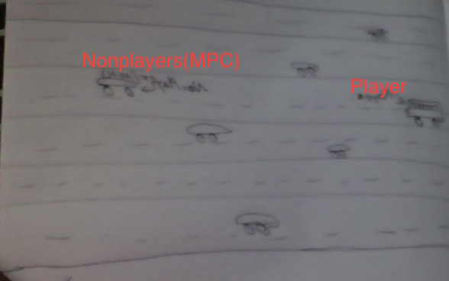

How do you plan to make your game engaging?

I plan to make my game engaging by making the traffic come faster and faster as the player plays, making the game harder. The player also will play the game to get the highest possible score.