 | Title : Project Registration & Progress Review |  | FF No. 180
Department: E&TC |  | Academic Year: 2025-26
Semester : 7 |  | Group No. : 1
Project Title: TechDocRAG: A Hybrid Retrieval-Augmented Generation Framework for Document Parsing and Multi-Document Reasoning
Project Area: Artificial Intelligence (AI) ,Natural Language Processing (NLP)
Group Members Details:

Sr. No. | Class & Div. | Roll No. | G.R.No. | Name of Student | Contact No. | Email ID
1 | ET-C | 50 | 12210606 | Anuj Udapure | 7588399605 | anuj.udapure22@vit.edu
2 | ET-C | 27 | 12211058 | Mohit Shinde | 9552655964 | mohit.shinde22@vit.edu
3 | ET-C | 52 | 12210696 | Om Umale | 8999780154 | om.umale22@vit.edu

Name of Internal Guide: prof. Vrinda Parkhi
Contact No. & Email ID: vrinda.parkhi@vit.edu

Project approved / Not approved

Guide Project Coordinator Head of Department

T
FF No 180

Synopsis:
This project aims to build an intelligent document parsing system using a Hybrid Retrieval-Augmented Generation (RAG) approach. The system can extract structured fields (like invoice numbers, dates) using rule-based methods and handle complex questions using RAG for unstructured data.
The system supports multi-document reasoning, enabling answers that require information from multiple documents (e.g., invoice + purchase order). It will also include a calculation engine to handle queries involving numeric reasoning, such as late payment penalties or discount calculations.
Key features include:
- Semantic chunking for better context handling.
- Vector-based retrieval for accurate search.
- Explainable AI with confidence scores and source tracing.
- Privacy controls for sensitive data.
The first implementation focuses on financial documents like invoices and purchase orders, with scope to expand into legal and healthcare domains.

System Architecture (Simplified Explanation)
- Document Upload & OCR – Handles PDFs, images, and extracts text.
- Preprocessing & Chunking – Cleans text and splits it into meaningful parts.
- Embedding & Vector Storage – Converts chunks into embeddings and stores them for fast search.
- Hybrid Retrieval – Combines keyword-based and semantic search to find the best information.
- Reasoning Engine – Includes:
  - Rule-based extraction for fixed fields.
  - LLM for complex questions and summaries.
  - Calculation module for numeric tasks.
- Multi-Document Support – Answers queries using multiple documents together.
- Explainability & Privacy – Provides confidence scores, highlights sources, and protects sensitive data.
- Output – Displays answers in text or structured JSON.

Arcitecture Diagram:
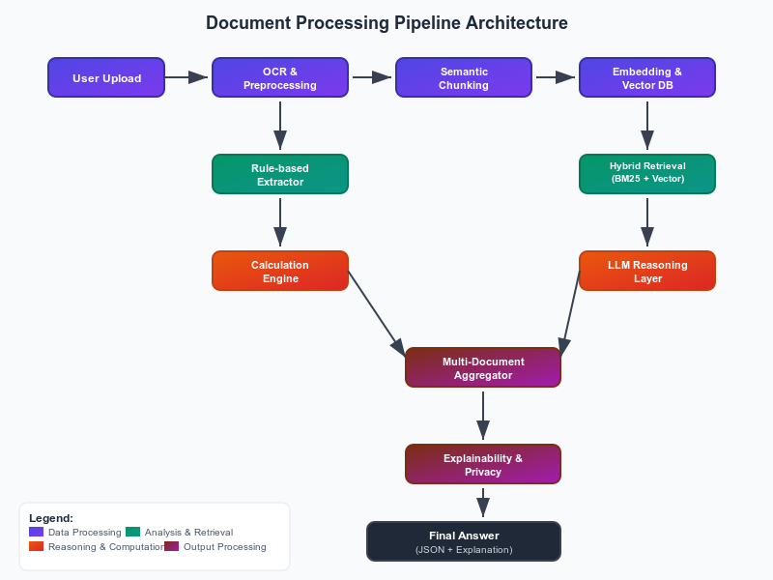

FF No 180

Group No.
Activity | Review Schedule | Progress Review Report submitted | Signature of Guide
Review 1 | Mid Sem. Semester | Yes / No
Review 2 | End of Semester | Yes / No

Format of Progress Review Report:

Review No.: 1 Group No.: Date:

Progress Review Report

Signature of Guide:

Review No.: 2 Group No.: Date:

Progress Review Report

Signature of Guide:

