
Program 1 - Print Today’s date and time using REPL.

Code
const now = new Date()
console.log("Date and Time", now);
console.log("Year:", now.getFullYear()); console.log("Month:", now.getMonth());
console.log("Date:", now.getDate());
console.log("Hours:", now.getHours());
console.log("Minutes:", now.getMinutes()); console.log("Seconds:", now.getSeconds());

Output
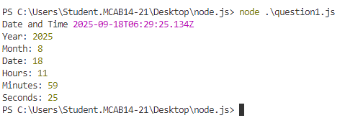

Program 2 - Write a program to print the given pattern.
1 2 3 4 5
1 2 3 4
1 2 3
1 2
1

Code
function printPattern(){
for(let i=5;i>=1;i--){ let out="";
for (let j = 1;j<=i;j++){ out+=j;
}
console.log(out); out="";
}
}
printPattern();

Output

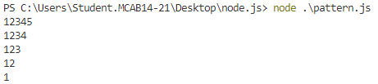

Program 3 - Write a program to print the first 20 Fibonacci numbers (take input through the command line).

Code
function isPrime(num) {
if (num <= 1) return false;
for (let i = 2; i <= Math.sqrt(num); i++) { if (num % i === 0) {
return false;
}
}
return true;
}
for (let i = 1; i <= 100; i++) { if (isPrime(i)) {
console.log(i);
}
}

Output
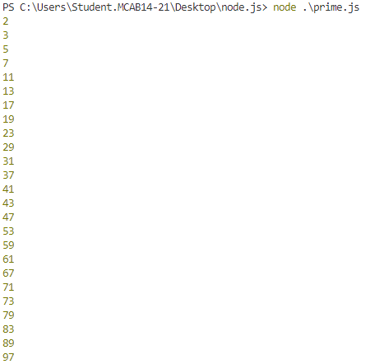

Program 4 - Write a program to prime numbers between 1 to 100.

Code
const readline =require('readline').createInterface({ input: process.stdin,
output: process.stdout
});
readline.question('Enter Number ', n => { let a = 0, b = 1;
console.log(a);
while (b <= +n) { console.log(b);
[a, b] = [b, a + b];
}
readline.close();
});

Output
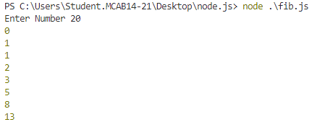

Conclusion : The above programs demonstrate the fundamental usage of Node.js for handling basic operations using loops, conditional statements, and the REPL environment. Leveraging
Chrome’s V8 engine, Node.js ensures code readability, simplicity, and efficiency, forming a solid foundation for building advanced applications.

Program 1 : Write a program to print information about the computer’s operating system using OS module. (Use any 5 module)

Code
const os = require('os'); console.log('OS Type:', os.type());
console.log('Platform:', os.platform()); console.log('CPU Info:', os.cpus()[0].model); console.log('Home Directory:', os.homedir()); console.log('Uptime in seconds:', os.uptime());
Output
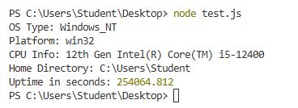

Program 2 : Print “Hello” every 500 milliseconds using the Timer Module. The message should be printed exactly 10 times. Use setInterval, ClearInterval and setTimeout methods.

Code
let count = 0;
const interval = setInterval(() => { console.log('Hello');
count++;
if (count === 10) { clearInterval(interval);
}
}, 500);

Output

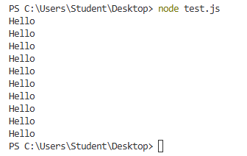
Program 3 : Create a Calculator Node.js module with functions add, subtract, multiply and divide. And use the Calculator module in another Node.js file.

Code
Calculator.js
function add(a, b) { return a + b;
}
function subtract(a, b) { return a - b;
}
function multiply(a, b) { return a * b;
}
function divide(a, b) { if (b === 0) {
throw new Error("Division by zero is not allowed.");
}
return a / b;
}
module.exports = { add, subtract, multiply, divide };
app.js
const readline = require('readline');
const calculator = require('./calculator'); const rl = readline.createInterface({
input: process.stdin, output: process.stdout
});
rl.question("Enter first number: ", (num1) => {
rl.question("Enter second number: ", (num2) => {
rl.question("Choose operation (add, subtract, multiply, divide): ", (operation) => {
const a = parseFloat(num1); const b = parseFloat(num2); let result;
try {
switch (operation.toLowerCase()) {

case 'add':
result = calculator.add(a, b); break;
case 'subtract':
result = calculator.subtract(a, b); break;
case 'multiply':
result = calculator.multiply(a, b); break;
case 'divide':
result = calculator.divide(a, b); break;
default:
console.log("Invalid operation!"); rl.close();
return;
}

console.log(`Result: ${result}`);
} catch (error) {
console.error(error.message);
}

rl.close();
});
});
});
Output
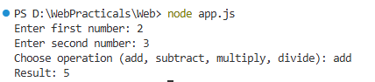

Program 4 : Create a circle module with functions to find the area and perimeter of a circle and use it.

Code

circle.js
const PI = Math.PI; function area(radius) {
return PI * radius * radius;
}
function perimeter(radius) { return 2 * PI * radius;
}
module.exports = { area, perimeter };

app1.js

const readline = require('readline'); const circle = require('./circle'); const rl = readline.createInterface({
input: process.stdin, output: process.stdout
});
rl.question("Enter the radius of the circle: ", (r) => { const radius = parseFloat(r);

if (isNaN(radius) || radius <= 0) {
console.log("Please enter a valid positive number for radius.");
} else {
console.log(`Area of circle: ${circle.area(radius).toFixed(2)}`); console.log(`Perimeter of circle:
${circle.perimeter(radius).toFixed(2)}`);
}

rl.close();
});

Output
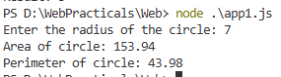

Conclusion : Modules are a core feature of Node.js that enable developers to break down programs into smaller, reusable components. Built-in modules such as os, fs, and http
provide direct access to system-level functionalities, while custom modules allow developers to
create and organize their own reusable code. This modular approach enhances efficiency, code reusability, and maintainability, thereby making Node.js a powerful platform for scalable application development.

Program 1 : Create functions to sort, reverse and search for an element in an array. Register and trigger these functions using events.
const EventEmitter = require('events'); const emitter = new EventEmitter();
let arr = [23, 5, 78, 12, 56, 9];
function sortArray() {
console.log("Original Array:", arr);
let sorted = [...arr].sort((a, b) => a - b); console.log("Sorted Array:", sorted);
}
function reverseArray() {
let reversed = [...arr].reverse();
console.log("Reversed Array:", reversed);
}
function searchElement(element) { let found = arr.includes(element);
console.log(found ? `Element ${element} found in array.` : `Element
${element} not found.`);
}

emitter.on('sortEvent', sortArray);
emitter.on('reverseEvent', reverseArray); emitter.on('searchEvent', searchElement);

emitter.emit('sortEvent');
emitter.emit('reverseEvent');
emitter.emit('searchEvent', 12);
Output :
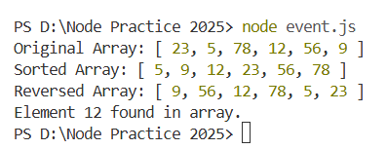

Title : Create an application to demonstrate Node.js Functions-timer function(displays every 10 seconds)

Aim : Create an application to demonstrate Node.js Functions-timer function(displays every 10 seconds)

Description :

An Asynchronous Timer in Node.js allows a function or block of code to be executed after a specific period of time or at regular intervals, without blocking the main thread.
These timers are part of Node.js’s asynchronous, event-driven architecture, enabling non-blocking execution of time-based operations.
Asynchronous timers use Node.js’s event loop to schedule tasks for future execution, ensuring that other code can continue to run while waiting for the timer to complete.
The Asynchronous Timers are :

setImmediate(): Executes a callback immediately after the current event loop phase completes, running as soon as possible but after I/O events.

setTimeout(callback, delay): Executes the callback once after a specified delay (in milliseconds).

setInterval(callback, interval): Executes the callback repeatedly every specified interval (in milliseconds) until cleared.

clearTimeout(), clearInterval(), clearImmediate(): These functions stop the corresponding timers from executing further.

Program 1 : Create an application to demonstrate Node.js Functions-timer function(displays every 10 seconds)
const displayMessage = () => { const now = new Date();
console.log(` Displaying message: Time is
${now.toLocaleTimeString()}`);
};
const intervalMilliseconds = 10000;

console.log('--- Node.js Timer Demo Started ---');

console.log(`This message will display every ${intervalMilliseconds / 1000} seconds.`);

const timerId = setInterval(displayMessage, intervalMilliseconds); const stopAfterMilliseconds = 60000;
setTimeout(() => {

clearInterval(timerId);
console.log('\n--- Timer Stopped ---');
console.log(`The timer was stopped after ${stopAfterMilliseconds / 1000} seconds.`);

}, stopAfterMilliseconds);

Output :
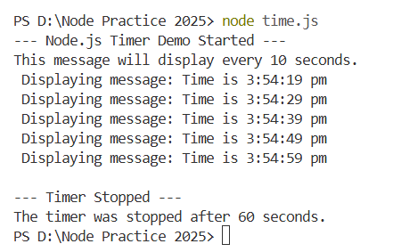

Conclusion : Timer functions in Node.js allow scheduling code to run immediately after I/O, once after a delay, or repeatedly at set intervals.

Title : Using File Handling demonstrate all basic file operations (Create, write, read, delete) Aim : Using File Handling demonstrate all basic file operations (Create, write, read, delete) Description :
fs.writeFile: Creates or overwrites a file with specified data asynchronously. fs.readFile: Reads the contents of a file asynchronously.
fs.appendFile: Adds data to the end of a file asynchronously, creating it if it doesn’t exist. fs.unlink: Deletes a file asynchronously.
Program 1 : Using File Handling demonstrate all basic file operations (Create, write, read, delete)
const fs = require('fs');
const filePath = './myfile.txt';

fs.writeFile(filePath, 'Hello, this is a demo file!', (err) => { if (err) return console.error('Error writing file:', err); console.log('File created and written.');

fs.readFile(filePath, 'utf8', (err, data) => {
if (err) return console.error('Error reading file:', err); console.log('File content:', data);

fs.appendFile(filePath, '\nAdding more text.', (err) => {
if (err) return console.error('Error appending file:', err); console.log('Data appended to file.');

fs.readFile(filePath, 'utf8', (err, updatedData) => {
if (err) return console.error('Error reading updated file:', err); console.log('Updated file content:', updatedData);

fs.unlink(filePath, (err) => {
if (err) return console.error('Error deleting file:', err); console.log('File deleted successfully.');
});
});
});
});
});

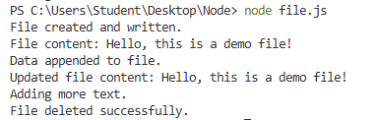

Conclusion : File handling in Node.js enables efficient reading, writing, and management of files using the built-in fs module. It supports both synchronous and asynchronous operations, ensuring fast and non-blocking file processing.

Program 1: Create a HTTP Server and serve HTML, CSV, JSON and PDF Files. Code:
Index.html
<html>
<head>
<title>file server</title>
</head>
<body>
<ul>
<li><a href="/index.html">HTML File</a></li>
<li><a href="/data.csv">CSV File</a></li>
<li><a href="/data.json">JSON File</a></li>
<li><a href="/sample.pdf">PDF File</a></li>
</ul>
</body>
</html>

Data.json

[
{ "id": 12, "name": "ABC", "age": 22 },
{ "id": 13, "name": "PQR", "age": 20 },
{ "id": 14, "name": "XYZ", "age": 28 }
]
Data.csv

id,subject,duration 21,Python,29 22,Sql,20
23,web,15

Server.js:

const http=require('http'); const fs=require('fs'); const path=require('path');
const server=http.createServer((req,res)=>{ if(req.url==='/index.html'){
serveFile('index.html', 'text/html', res);
} else if (req.url === '/data.csv') {
serveFile('data.csv', 'text/csv', res);
} else if (req.url === '/data.json') {
serveFile('data.json', 'application/json', res);
} else if (req.url === '/sample.pdf') {
serveFile('sample.pdf', 'application/pdf', res);}
else {
res.writeHead(404, { 'Content-Type': 'text/plain' });

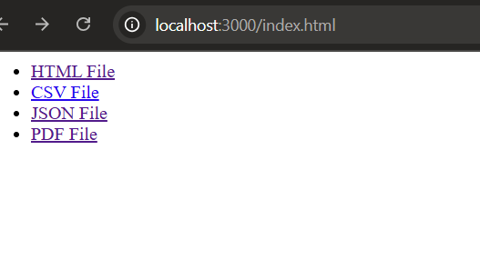
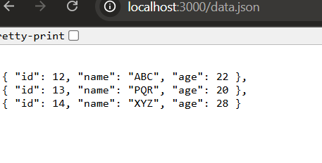
res.end('404 Not Found');
}});
function serveFile(filename,contentType,res){ const filepath=path.join( dirname,filename); fs.readFile(filepath,(err,data)=>{
if (err) {
res.writeHead(500, { 'Content-Type': 'text/plain' }); res.end('Internal Server Error');
} else {
res.writeHead(200, { 'Content-Type': contentType }); res.end(data);
}
});
}
const port=3000;
server.listen(port,()=>{
console.log(`Server running at http://localhost:${port}`);
});

Output:

- http://localhost:3000/index.html->

- http://localhost:3000/data.json->

Program 2 : Create a HTTP Server and stream a video file using piping. Code:
const http=require('http');

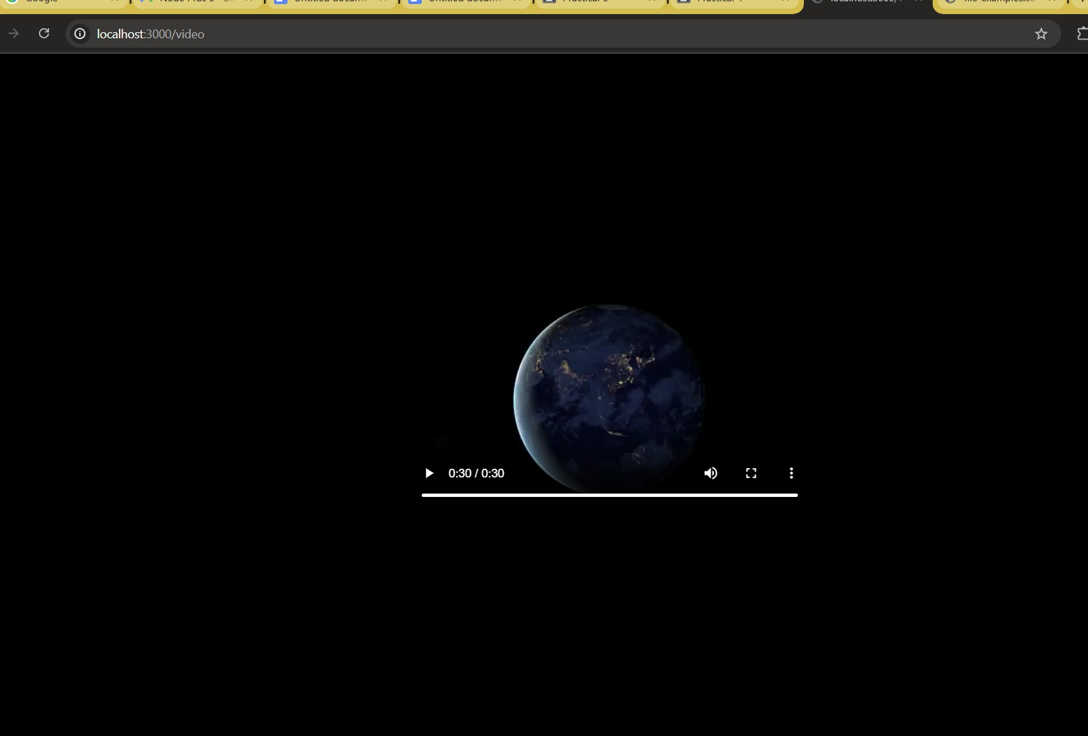
const fs=require('fs'); const path=require('path');
const server=http.createServer((req,res)=>{ if(req.url==='/video'){
const videopath=path.join( dirname,'sample.mp4'); res.writeHead(200,{'content-type':'video/mp4'}); const videostream=fs.createReadStream(videopath); videostream.pipe(res);
} else {
res.writeHead(200,{'content-Type':'text/html'}); res.end('<h1>Go to /video to stream</h1>');
}});
const PORT = 3000;
server.listen(PORT, () => {
console.log(` Server running at http://localhost:${PORT}`);
});

Output:

Program 3 : Develop 3 HTML Web Pages for college home page(write about college & dept),about me, contact.Create a server and render these pages using Routing.

Code:

Index.html
<!DOCTYPE html>
<html>
<head>
<title>College Home Page</title>
</head>
<body>
<h1>Welcome to XYZ College</h1>
<p>XYZ College is one of the leading institutions offering quality education and research opportunities.</p>

<p>Our departments include Computer Science, Electronics, and Mechanical Engineering.</p>
<nav>
<a href="/about">About Me</a> |
<a href="/contact">Contact</a>
</nav>
</body>
</html>

About.html
<!DOCTYPE html>
<html>
<head>
<title>About Me</title>
</head>
<body>
<h1>About Me</h1>
<p>Hello! I’m a student of XYZ College, currently pursuing my degree in Computer Science.</p>
<nav>
<a href="/">Home</a> |
<a href="/contact">Contact</a>
</nav>
</body>
</html>

Contact.html
<!DOCTYPE html>
<html>
<head>
<title>Contact</title>
</head>
<body>
<h1>Contact Information</h1>
<p>Email: student@xyzcollege.edu</p>
<p>Phone: +91 98765 43210</p>
<nav>
<a href="/">Home</a> |
<a href="/about">About Me</a>
</nav>
</body>
</html>

Server3.js:

const http = require('http'); const fs = require('fs'); const path = require('path');
const server = http.createServer((req, res) => {
if (req.url === '/' || req.url === '/index.html') { servePage('index.html', res);

} else if (req.url === '/about') { servePage('about.html', res);
} else if (req.url === '/contact') { servePage('contact.html', res);
} else {
res.writeHead(404, { 'Content-Type': 'text/plain' }); res.end('404 Page Not Found');
}
});
function servePage(page, res) {
const filePath = path.join( dirname, page); fs.readFile(filePath, (err, data) => {
if (err) {
res.writeHead(500, { 'Content-Type': 'text/plain' });
res.end('Internal Server Error');
} else {
res.writeHead(200, { 'Content-Type': 'text/html' }); res.end(data);
}});}
const PORT = 3000;
server.listen(PORT, () => {
console.log(`Server running at http://localhost:${PORT}`);
});

Output:

http://localhost:3001/index.html->

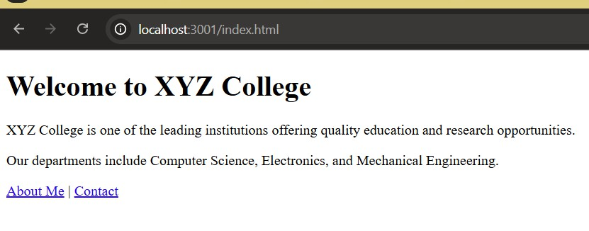

http://localhost:3001/about->

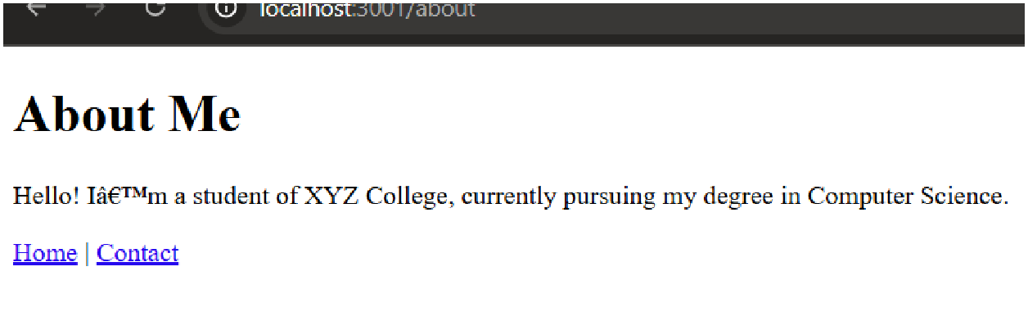
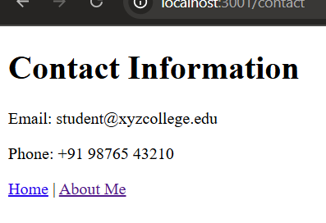

http://localhost:3001/contact->

Conclusion:

This demonstrates how Node.js can efficiently handle web server operations such as serving
various file types, streaming large video files, and implementing routing for multiple web pages. By using core modules like http, fs, and path, we learn how servers deliver content dynamically and manage different requests. Overall, the tasks provide a strong foundation in backend development and understanding how servers interact with clients on the web.

Program : Create a Node.js application that connects to a MySQL database named studentdb and performs the following operations on a table student(rollno, name, address):
Code:

const mysql=require("mysql2");
const connection=mysql.createConnection({ host:"localhost",
user:"root",
password:"root",
database:"studentdb"
});
connection.connect((err)=>{ if(err) throw err;
console.log("Connected to MySQL");
})
let insertQuery = `
INSERT INTO student (rollno, name, address) VALUES (11,'Sumit','Pune'),
(12,'xyz','Delhi'),
(13,'PQR','Mumbai'),
(14,'Nikhil','Chennai'),
(15,'Prathamesh','Nagpur'),
(16,'Om','Nashik'),
(17,'EFG','Hyderabad'),
(18,'Harsh','Bangalore'),
(19,'Ansh','Jaipur'),
(20,'Arun','Surat');
`;
connection.query(insertQuery,(err,result)=>{ if(err){
console.log("Record already inserted or error.");
}
else{
console.log("10 Records Inserted!");
}
let updateQuery="Update student SET address='Mumbai' WHERE rollno=5";
connection.query(updateQuery,(err,result)=>{ if(err) throw err;
console.log("Record updated for rollno=15");
let deleteQuery="DELETE FROM student where rollno=10"; connection.query(deleteQuery,(err,result)=>{
if(err) throw err;
console.log("Record Deleted where rollno=10"); connection.end();

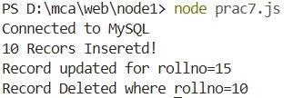
});
});
});
Output:
Conclusion: In this practical, we successfully connected a Node.js application with a MySQL database using the mysql2 module. We performed essential database operations including inserting multiple records, updating an existing record, and deleting a record. This demonstrates how backend applications interact with SQL databases to manage data efficiently..


Aim : To study and implement TypeScript installation, environment setup, and write programs based on decision-making, functions, and class & objects.
Description :

TypeScript is a strongly typed superset of JavaScript that provides features like type checking, interfaces, classes, and modern ES6+ support.
In this practical, we learn to:

- Install Node.js and TypeScript
- Set up TypeScript environment
- Compile & execute TypeScript programs
- Implement decision-making, functions, and class concepts

INSTALLATION & SETUP :

Step 1: Install Node.js

Download and install Node.js (LTS version) from the official website.

Step 2: Install TypeScript
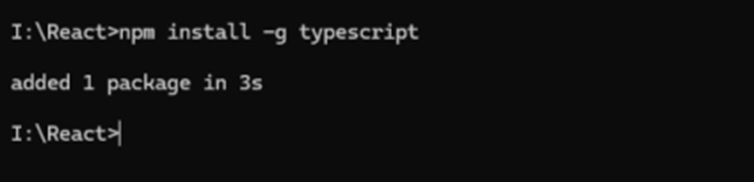

Step 3: Verify Installation
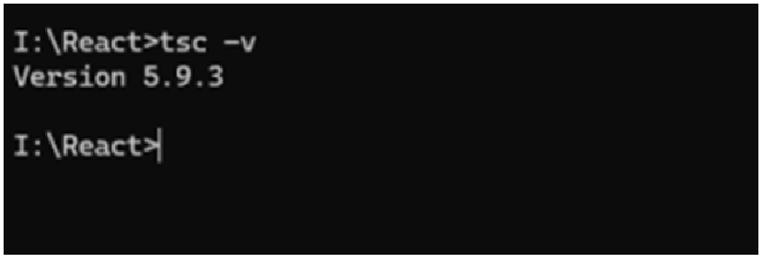
Step 4: Create a TypeScript File
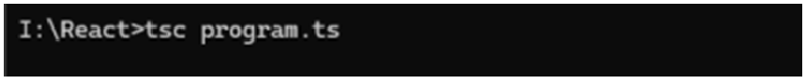

Step 5 : Run JavaScript Output
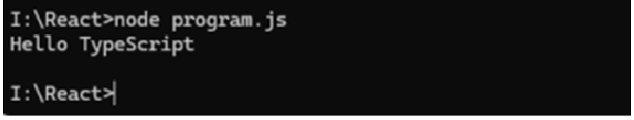

Program 1 : Write a TypeScript program to check whether a number is positive, negative, or zero.

Code :
let num: number = 10; if (num > 0) {
console.log(num + " is Positive");
} else if (num < 0) { console.log(num + " is Negative");
} else {
console.log("Number is Zero");
}

Output :
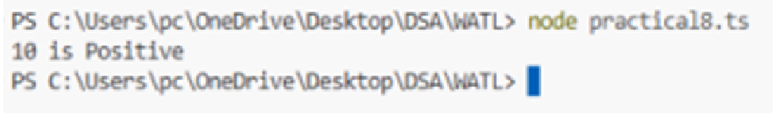
Program 2 : Write a TypeScript function to calculate the sum of two numbers.
Code :
function addNumbers(a: number, b: number): number { return a + b;
}
let result = addNumbers(5, 7); console.log("Sum = " + result);

Output :

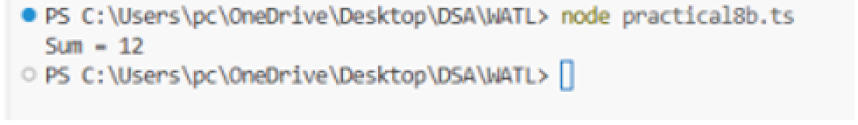
Program 3 : Write a TypeScript program using Class & Object.
Code :
class Student {
rollno: number;
name: string;
constructor(rollno: number, name: string) {
this.rollno = rollno;
this.name = name;
}
display(): void {
console.log("Roll No: " + this.rollno); console.log("Name: " + this.name);
}
}
let s1 = new Student(101, "student"); s1.display();

Output :
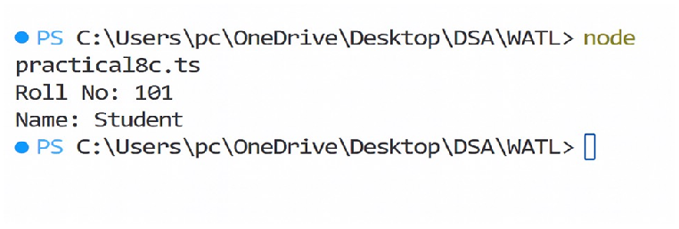
Conclusion : In this practical, we learned how to install and configure TypeScript, compile .ts files, and implement programs using decision-making, functions, and class concepts. This helped us understand how TypeScript adds type safety and object-oriented features to JavaScript.

Code:

app.Component.ts

import { Component } from '@angular/core'; @Component({
selector: 'app-root',
templateUrl: './app.component.html',
})
export class AppComponent { name: string = 'Angular Learner'; showMessage:
boolean = true;
fruits: string[] = ['Apple', 'Banana', 'Cherry']; today: Date = new Date();
}

app.component.html

<h1>Welcome, {{ name | uppercase }}</h1>
<!-- Structural Directive -->
<div *ngIf="showMessage">
<p>This message is visible because showMessage is true.</p>
</div>
<!-- Looping Directive -->
<ul>
<li *ngFor="let fruit of fruits">{{ fruit }}</li>
</ul>
<!-- Date Pipe -->

<p>Today's Date: {{ today | date:'fullDate' }}</p>
Output :
On CMD:
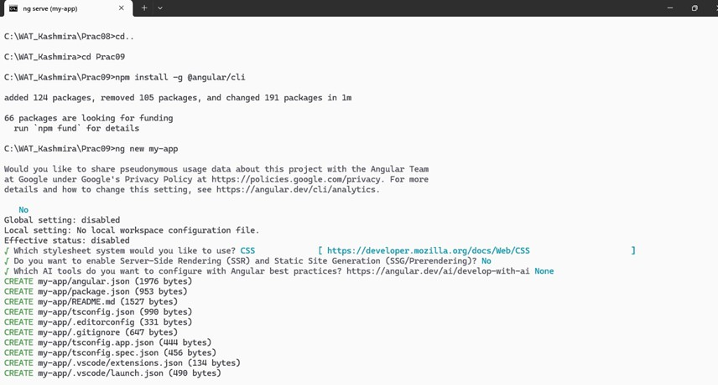
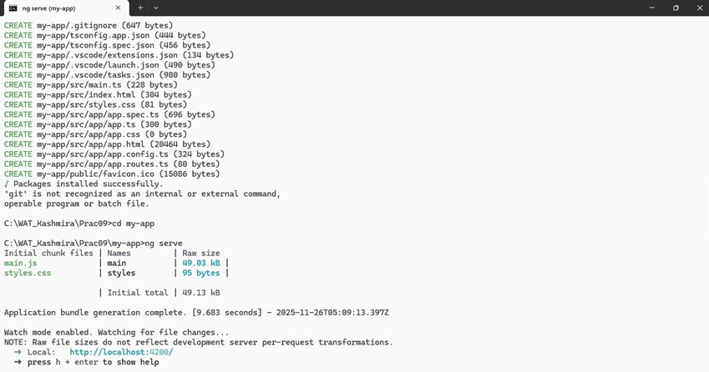

On http://localhost:4200

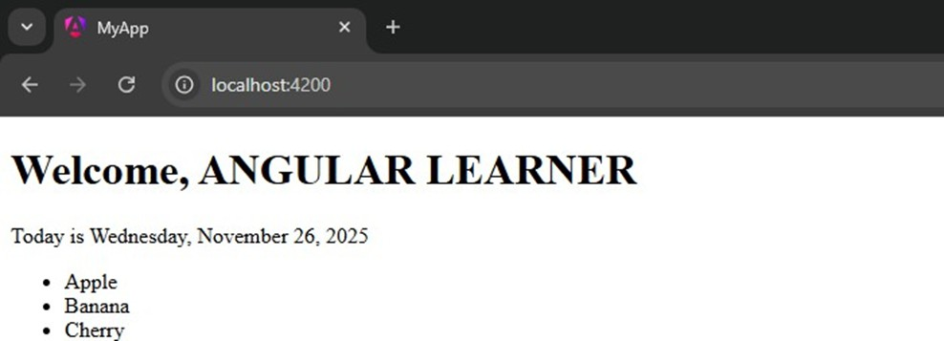

Conclusion : By importing CommonModule in a standalone AppComponent, Angular can use built-in directives and pipes, enabling the app to render correctly.


Aim : Demonstrate features of Angular forms with a program

Description :

Angular Forms allow easy management of user input, validation, error handling, and submission. In this practical, we use Template-Driven Forms, which rely on Angular directives such as:
- ngForm

- ngModel

- required

- minlength

- email

Program : Create an Angular application to demonstrate the use of Angular template-driven forms, including form creation, validation, and submission.
app.html

<h2>Angular Template-Driven Form</h2>
<form #studentForm="ngForm" (ngSubmit)="onSubmit()">
<label>Name:</label>
<input type="text" name="name"
[(ngModel)]="student.name" required
minlength="3" #name="ngModel">
<div class="error" *ngIf="name.invalid && name.touched"> Name is required (min 3 characters)
</div>
<br>
<label>Email:</label>
<input type="email" name="email"
[(ngModel)]="student.email" required
email #email="ngModel">
<div class="error" *ngIf="email.invalid && email.touched">

Enter a valid email
</div>
<br>
<label>Age:</label>
<input type="number" name="age"
[(ngModel)]="student.age" required
min="1" #age="ngModel">
<div class="error" *ngIf="age.invalid && age.touched"> Age must be above 0
</div>
<br>
<button type="submit" [disabled]="studentForm.invalid"> Submit
</button>
</form>
<div *ngIf="submitted">
<h3>Submitted Data:</h3>
<p><strong>Name:</strong> {{ student.name }}</p>
<p><strong>Email:</strong> {{ student.email }}</p>
<p><strong>Age:</strong> {{ student.age }}</p>
</div>
app.ts

import { Component } from '@angular/core'; import { FormsModule } from '@angular/forms';
import { CommonModule } from '@angular/common';

@Component({
selector: 'app-root',
standalone: true,
imports: [FormsModule],
templateUrl: './app.html',
styleUrl: './app.css'
})
export class App { student = { name: '',

email: '', age: null
};
submitted = false; onSubmit() { this.submitted = true;
}
}

Output :
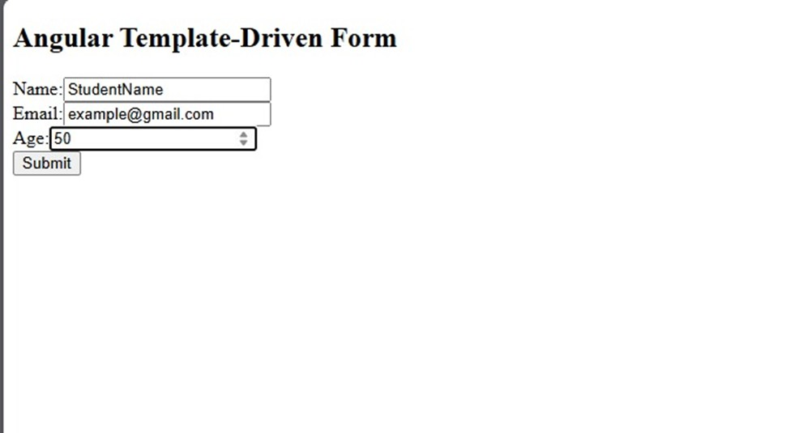

Conclusion : This practical successfully demonstrates Angular’s Template-Driven Forms, including input binding, validation, form state checking, and form submission using ngModel, ngForm, and Angular validation attributes.

Aim : Create an application to demonstrate SPA
Description :

A Single Page Application (SPA) loads a single HTML page and dynamically updates the content as the user interacts.
Angular provides a powerful routing module to create SPAs easily.

In this practical, we create three components (Home, About, Contact) and configure Angular routes so the application behaves as a SPA.
INSTALLATION & SETUP :

Step 1: Create a new Angular project Step 2: Run the project
Step 3: Create Components

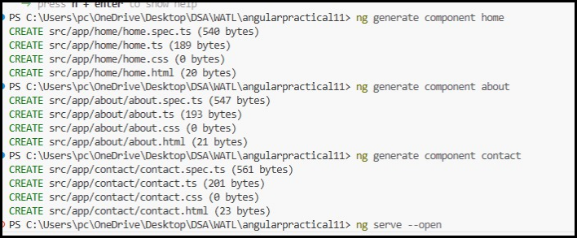

Program 1: Create an Angular application demonstrating SPA (Single Page Application) using routing and navigation between components.

app.routes.ts :

import { Routes } from '@angular/router'; import { Home } from './home/home';
import { About } from './about/about'; import { Contact } from './contact/contact'; export const routes: Routes = [
{ path: '', component: Home },

{ path: 'about', component: About },

{ path: 'contact', component: Contact }

];

app.html :

<h1>Angular SPA Demo</h1>

<nav>

<a routerLink="">Home</a> |

<a routerLink="about">About</a> |

<a routerLink="contact">Contact</a>

</nav>

<hr>

<router-outlet></router-outlet> home.html :

<h2>Home Page</h2>

<p>This is the Home component</p> about.html :
<h2>About Page</h2>

<p>This is the About component</p>

contact.html :
<h2>Contact Page</h2>

<p>This is the Contact component</p>

Output :
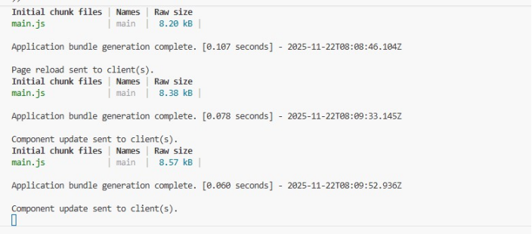

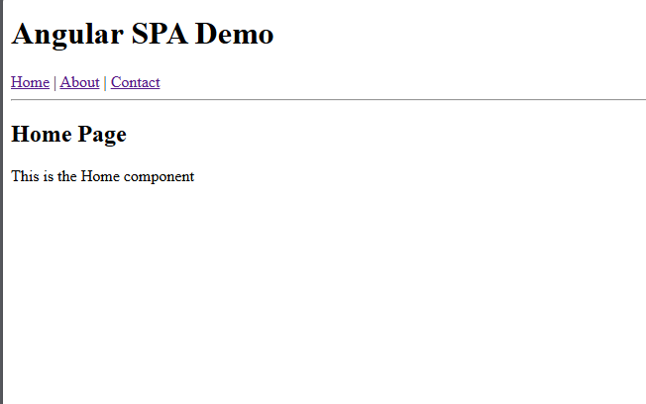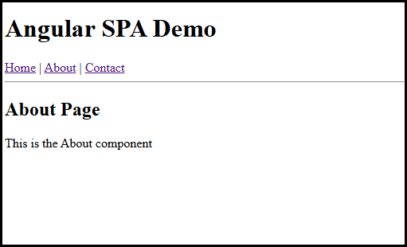

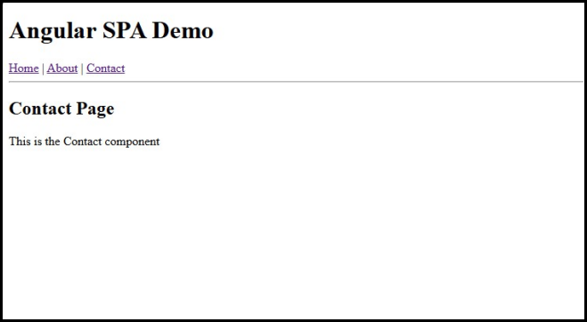

Conclusion:

In this practical, we successfully created an Angular Single Page Application using Angular Routing.
- We demonstrated:
- Navigation between pages
- Use of routerLink
- Dynamic content loading
- No page reload
This fulfills the requirements of an SPA using Angular.

