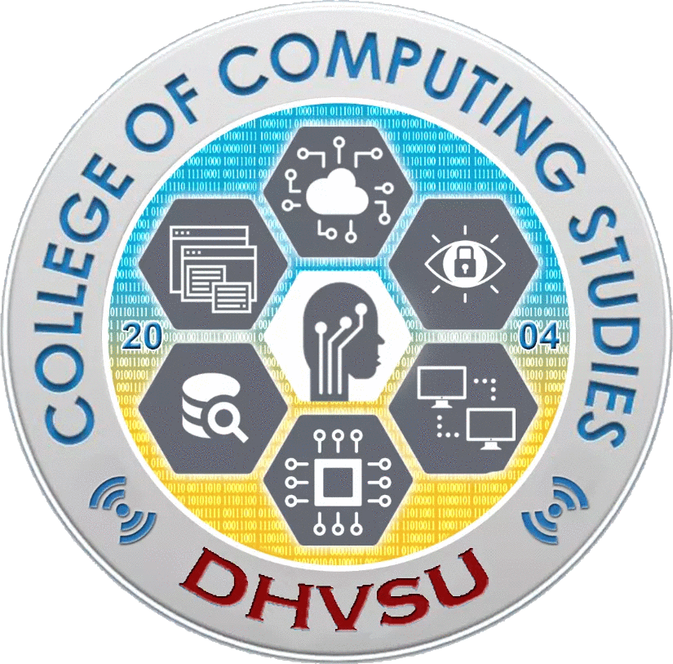

**Don Honorio Ventura State University**

Villa de Bacolor, Pampanga



Capstone Project 1 / Thesis Writing 1

CAP 323 / CSTW1 323

Activity # 2

**Activity:** RESEARCH TITLE PRESENTATION

**Instructions:** Prepare at least 3 title proposals for your Capstone Project/Thesis Writing. The succeeding pages contains the page template for each research section. At the end of this activity, each research group must have an approved research title.

Each topic proposal should have the following content:

1. Cover Page
2. Introduction
3. Statement of the Problem
4. Objectives of the Study
5. Scope and Delimitations
6. Target Respondents and Locale
7. Significance of the Study



**Don Honorio Ventura State University**

Villa de Bacolor, Pampanga



**E-PALitan: A Secured User-Friendly Mobile Trading Application for Residence of Becuran, Santa. Rita, Pampanga**

By:

Basilio, Crisanto, S.

Malveda, Limwell Jake P.

Pineda, Raymund Paolo I.

Ramirez, John Russel B.

Sanchez, Seinthe R.

Santos, Francis Ford L.

BS Computer Science-3A

June 23, 2021

1. **Introduction**

Have you ever attempted exchanging one thing for another? Have you been requested to provide a service and have been compensated for it? Yes? No? Well, did you know that those acts are considered bartering. Bartering is an act of trading for good services or items without money involve. Even as children, we unconsciously engage in bartering or trading without realizing it because we simply want to exchange the things we want or need for the things we no longer require.

Even in the ancient times, before the pre-hispanic, bartering have been going on our Ancestors in Zamboanga and Tawi-tawi.They trading with its neighbour countries for porcelein, iron, lead, tin, silks,etc in exhange of beeswax, and gold. During the Spanish Colonial, the Galleon trade was implemented for the global economy. Until today, bartering is still part of our global economy and going. Because of the currency that we now use as the primary mode of exchange, bartering has become less popular in our society over time.

In the present, we like to gather things, and when we no longer need the other item we obtained initially, our project will come in handy. With our E-Palitan, you can find others who are interested in that item and get an item you might need in exchange for the item that you don't need anymore.

1. **Statement of the Problem**

**General Problem:**

The researcher intends to create a more reliable and trustworthy method of trade by developing an application for residents of Barangay Becuran, Sta. Rita, Pampanga.

**Specific Problems:**

Introductory statement

1. How will the user determine whether or not the individual exchanging the item is trustworthy?

2. How this application differs from the other existing one?

3. How will the trade transaction follow health protocols that currently being implemented?

1. **Objectives of the Study**

**General Objective:**

The goal of the application is to give a platform where individuals may trade without fear of being scammed and where they can easily showcase items.

**Specific Objectives:**

Introductory statement

1. To create an easy-to-use bartering platform.

2. To satisfy the user to the application.

3. To make it secured and safety for the users in the application

.

**IV. Scope and Delimitations**

Mobile and tablet devices with an internet connection can simply access the suggested application. Even though it is widely accessible, only barangay residents who have been authenticated can exhibit an item they wish to trade and make an offer for an item that is posted. For more secure trading, the verification procedure will be conducted by barangay officials.

The main delimitation will be that even though the bartering rule states that no cash should be used in the deal, the barterers will still be in charge.

1. **Target Respondents and Locale**

The project primarily focused on the parents who have knowledge to mobile,tablet devices and have access to the internet. And those who are eager to engage and are interested in trading an item they no longer require.

1. **Significance of the Study**

The suggested application is advantageous to those who have a lot of stuff they don't need and are seeking for people who are interested in trading it for something else that is close by.Furthermore, the application will be come useful and make it easier for bartering in the future.

References:

<https://gulfnews.com/world/asia/philippines/ancient-trade-practice-to-move-philippines-forward-1.2297581>  
<https://mint.intuit.com/blog/personal-finance/guide-to-the-barter-economy-the-barter-system-history/>

<https://eh.net/book_reviews/after-the-galleons-foreign-trade-economic-change-and-entrepreneurship-in-the-nineteenth-century-philippines/>