|  |  |
| --- | --- |
| **ID** | **Name** |
| **20210359** | **زياد أمين حسين مسعود** |
| **20210377** | **زياد محمد مسعد عبد المتجلي** |
| **20210375** | **زياد محمد محمد ابو العطا** |
| **20210617** | **عمر محب ابراهيم حسين** |
| **20210158** | **اسلام عادل محمود محمد** |
| **20210881** | **محمود محي محمود محمد** |
| **20210331** | **رشاد سمير رشاد عيد** |

1. ***Stanford Dogs Dataset***

**Dataset link :**

**Link:** <http://vision.stanford.edu/aditya86/ImageNetDogs/main.html>

**About dataset :**

The Stanford Dogs dataset is a collection of images of various dog breeds, collected and annotated by researchers at Stanford University. It consists of photos of dogs belonging to 120 different breeds, with a total of around 20,000 images.

This dataset has been built using images and annotation from ImageNet for the task of fine-grained image categorization. Contents of this dataset:

**Implementation details :**

We used two algorithms **K-Means** and **Logistic Regression**

**Pre-Processing:**

Extracts features by HOG algorithm for train and test data, and make a resize for the images and Convert to grayscale if it has three channels

And split dataset into 20% test and 80% train by train_test_slpit

algorithm.

1. **K-Means:**

Goal: Classify Dogs into five breeds of dogs (0,1,2,3,4)

Explain Code: select K randomly and loop from 2 to 11 , in each

iteration save inertia in list after end loop compare all inertias and plot Elbow to select right K(loss curve)

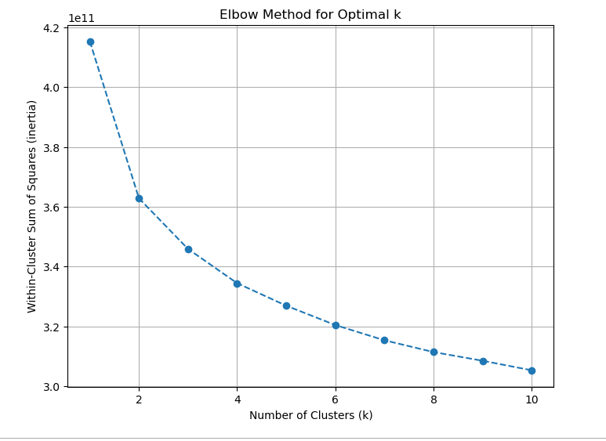

**Result:**

-The Inertia: 415316062447.3274

-Silhouette Score: 0.061699429101101474

-Visualize the cluster:

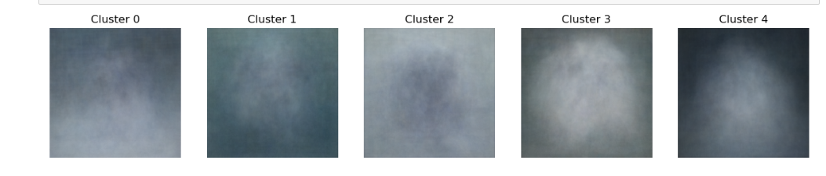

1. **Logistic Regression:**

**Goal:** Detect breed

**Explain Code**: We don't need to sum image features; we used

dataset with all image features.

**Train Score**: 0.5913272010512484

**Test Score**: 0.3717277486910995

**Classes is**: [0 1 2 3 4]

**Iterations is**: [132]

**Intercept is**: [-1.25949007]

**Confusion Matrix:**

[[16 8 8 4 7]

[ 5 23 16 2 12]

[ 5 9 36 11 14]

[ 3 5 14 5 13]

[ 8 13 21 6 22]]

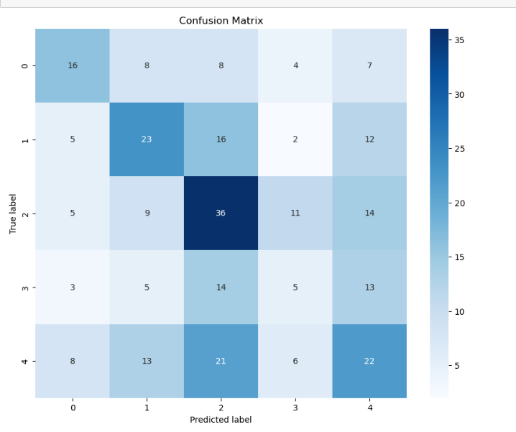

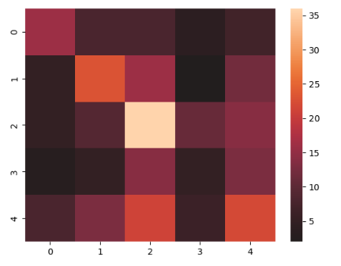

**Accuracy Score**: 0.3717277486910995

**Precision Score is**: 0.3717277486910995

**Precision Recall Score is**: ( (0.3717277486910995, 0.3717277486910995, 0.3717277486910995, None)

**Zero One Loss Value**: 120

**ROC curve**:

